# **EXERCISE 2: Building an Immutable OS Image (Locally)**

In this exercise we will basically continue where we left off from Exercise #1. In this exercise, we’ll create a basic blueprint, create an image.

**Technical requirements:**

You will need the RHEL 9 machine that was configured in the previous exercise along with another VM or baremetal machine that we can install our new immutable image. You will also need to have previously created a custom repository to host your images in.

Let’s get started. Using the same browser we just used in Exercise #1, log back into the web console, change your access level to administrative, and then navigate to the Image Builder tool set via the menu on the left side of the screen. First we’ll take a look at what sources our image may draw from. Click on the “Sources” tab. Note: We can easily add more sources, such as your own custom repositories.

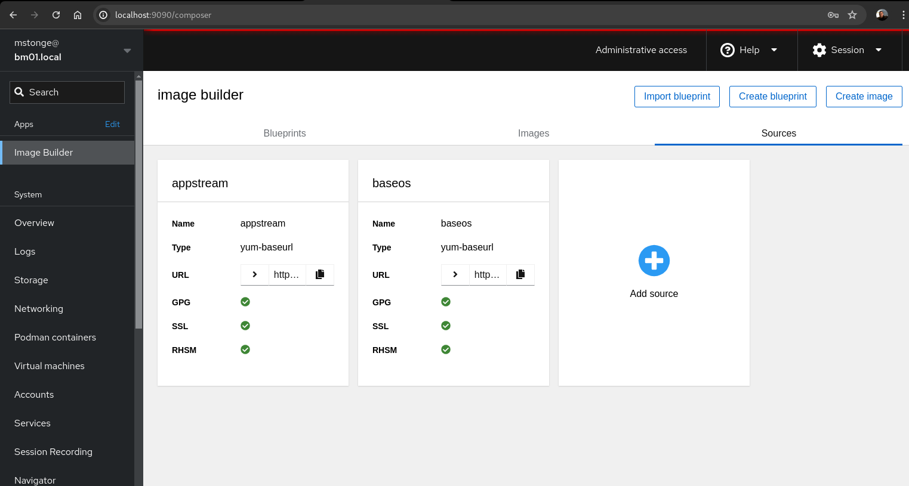

Next, click on the “Blueprints tab”

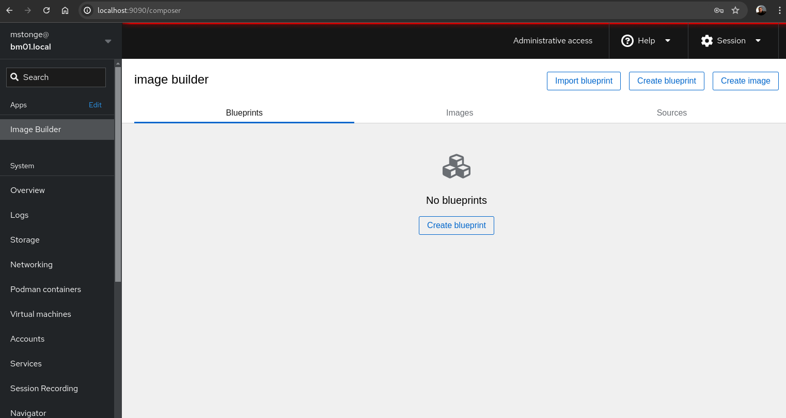

Next we’ll click on the “Create blueprint button. Then we’ll name our blueprint “***EmbBook***” and enter a brief description. Then Click “Next”.

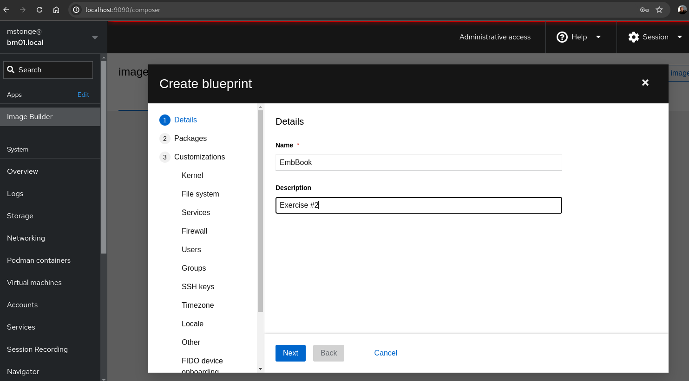

Add these packages to your blueprint: *Httpd, cockpit, cockpit-ostree, cockpit-packagekit, cockpit-pcp, cockpit-podman, cockpit-storaged, cockpit-system*. Once done adding all of the listed packages, click “Next”.

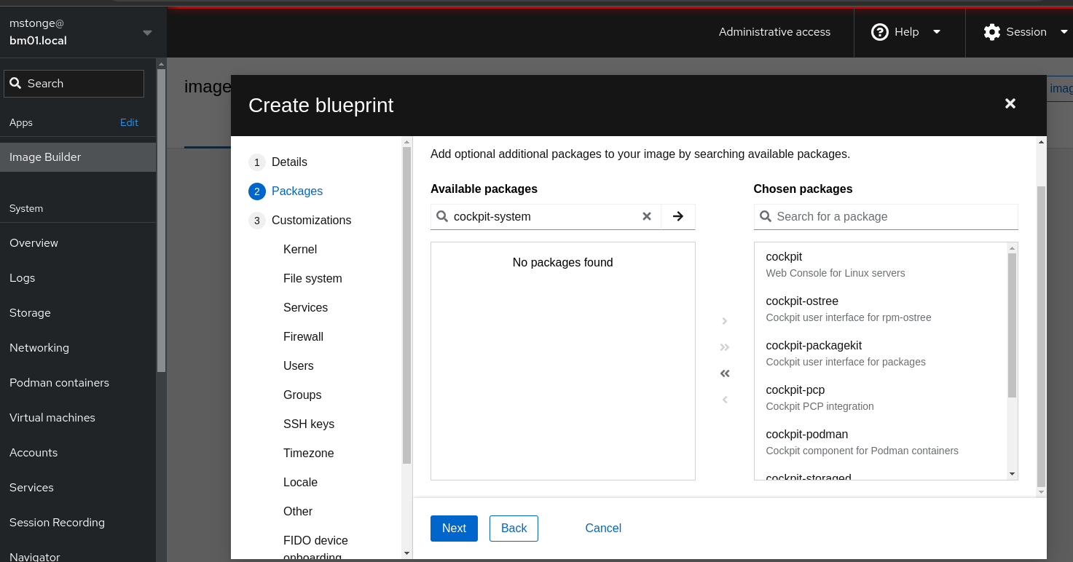

We will not be adding any kernel customizations. You can click “Next”.

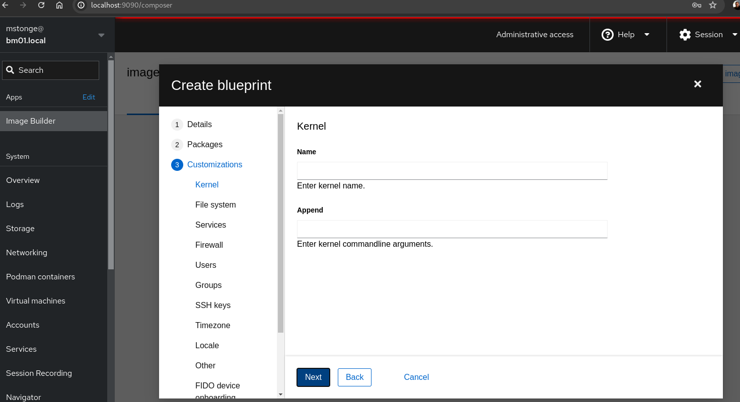

Ensure that automatic partitioning is selected, then click “Next”.

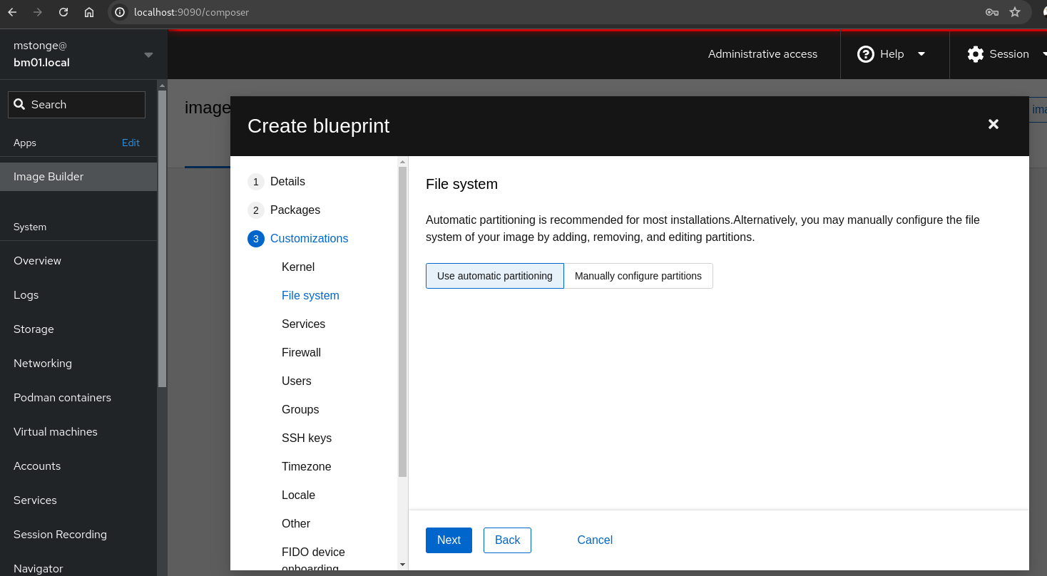

Ensure that ***sshd*** , ***cockpit.socket*** and ***httpd*** are enabled. Click “Next”.

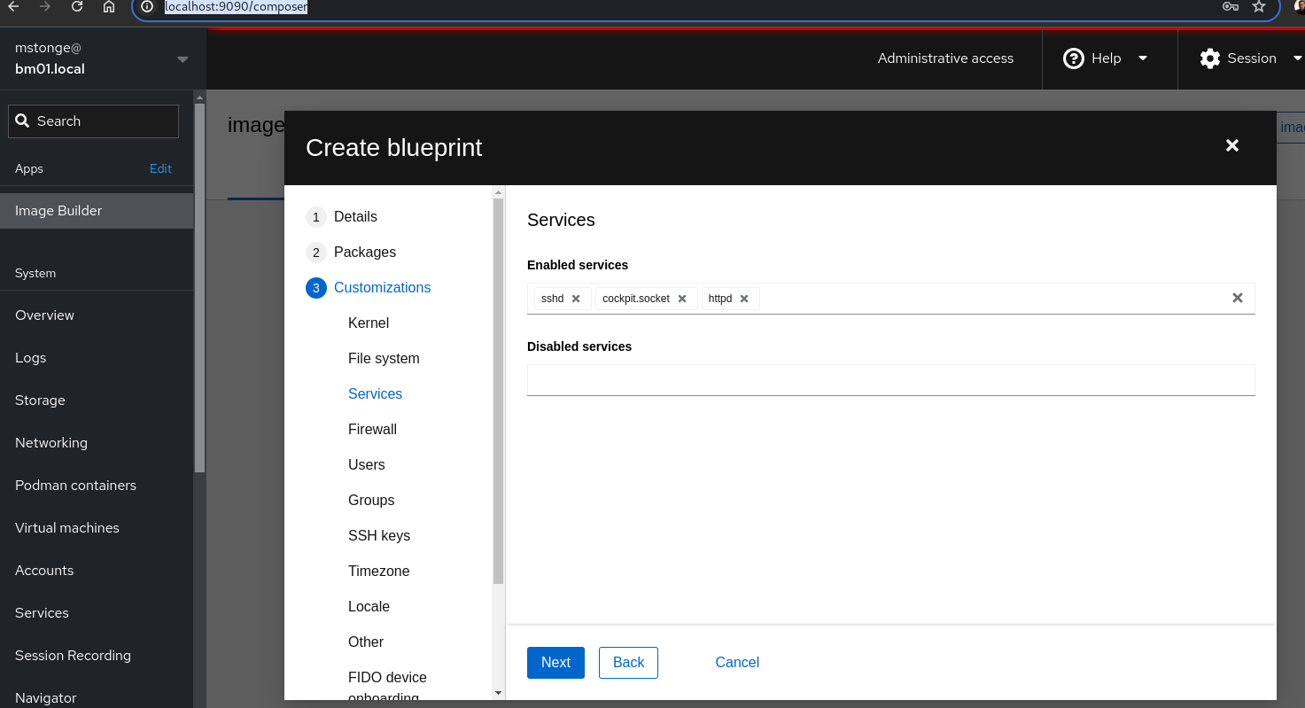

Ensure that port 9090tcp, ssh, and http are enabled in the firewall. Click “Next”.

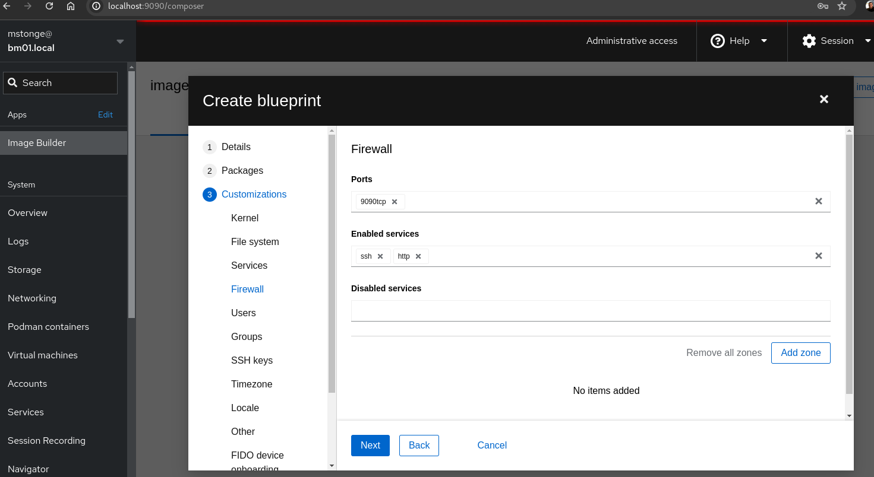

Next, we’ll add a user named ***testuser*** with the password of ***EmbB00k2024!*** We’ll also allow this user to be a server administrator.

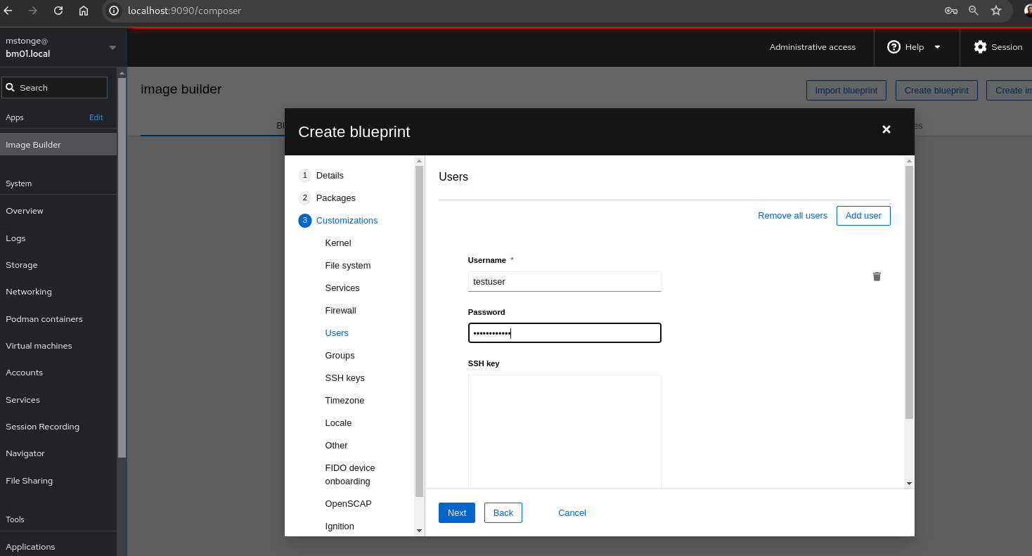

No custom groups will be added at this time. Click “next”.

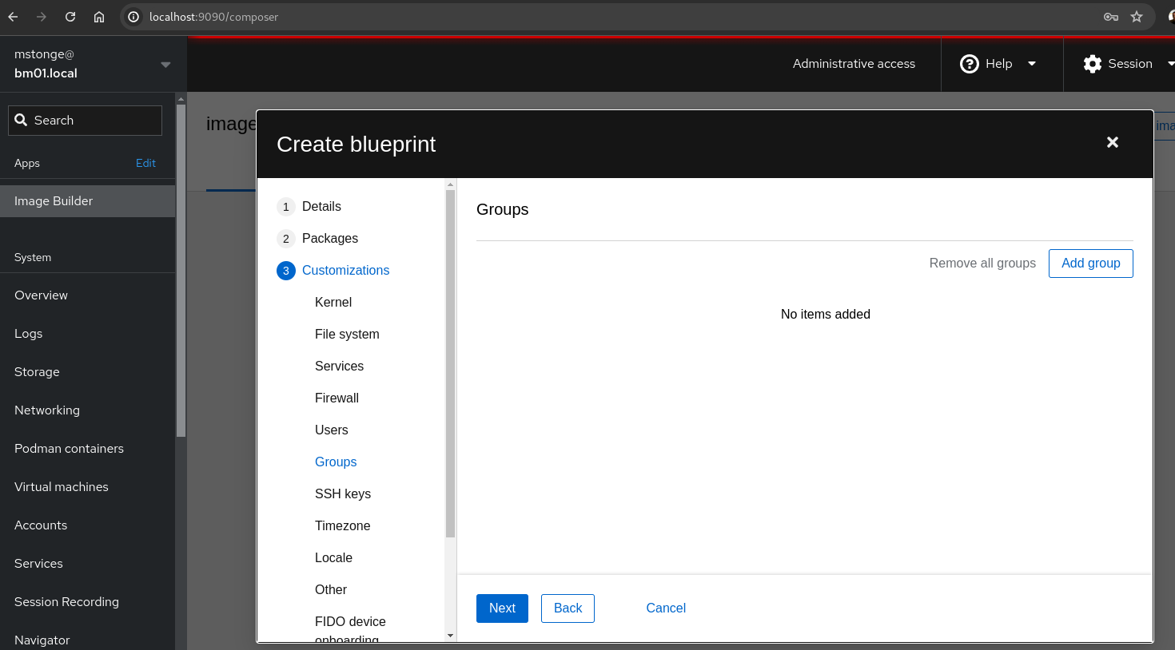

No custom ssh keys will be added at this time. Click “Next”.

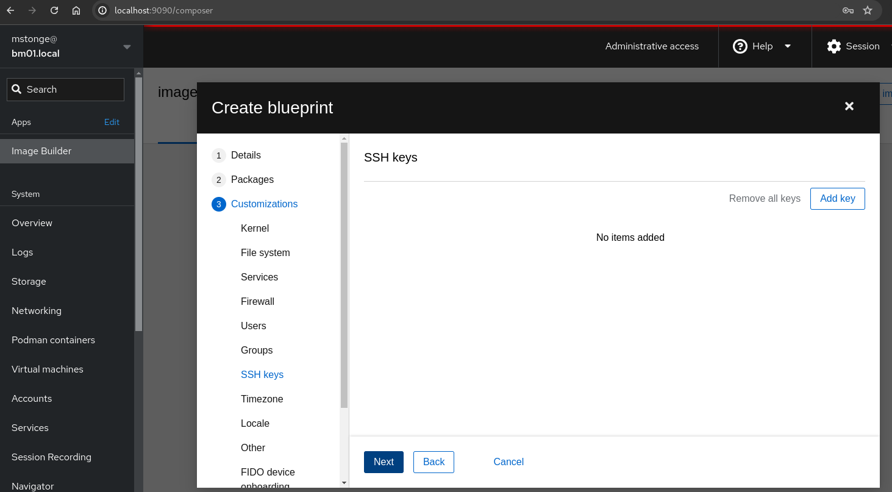

In this next step, set the appliance to ***your timezone*** and then set the NTP server to ***time.google.com***. Click “Next”.

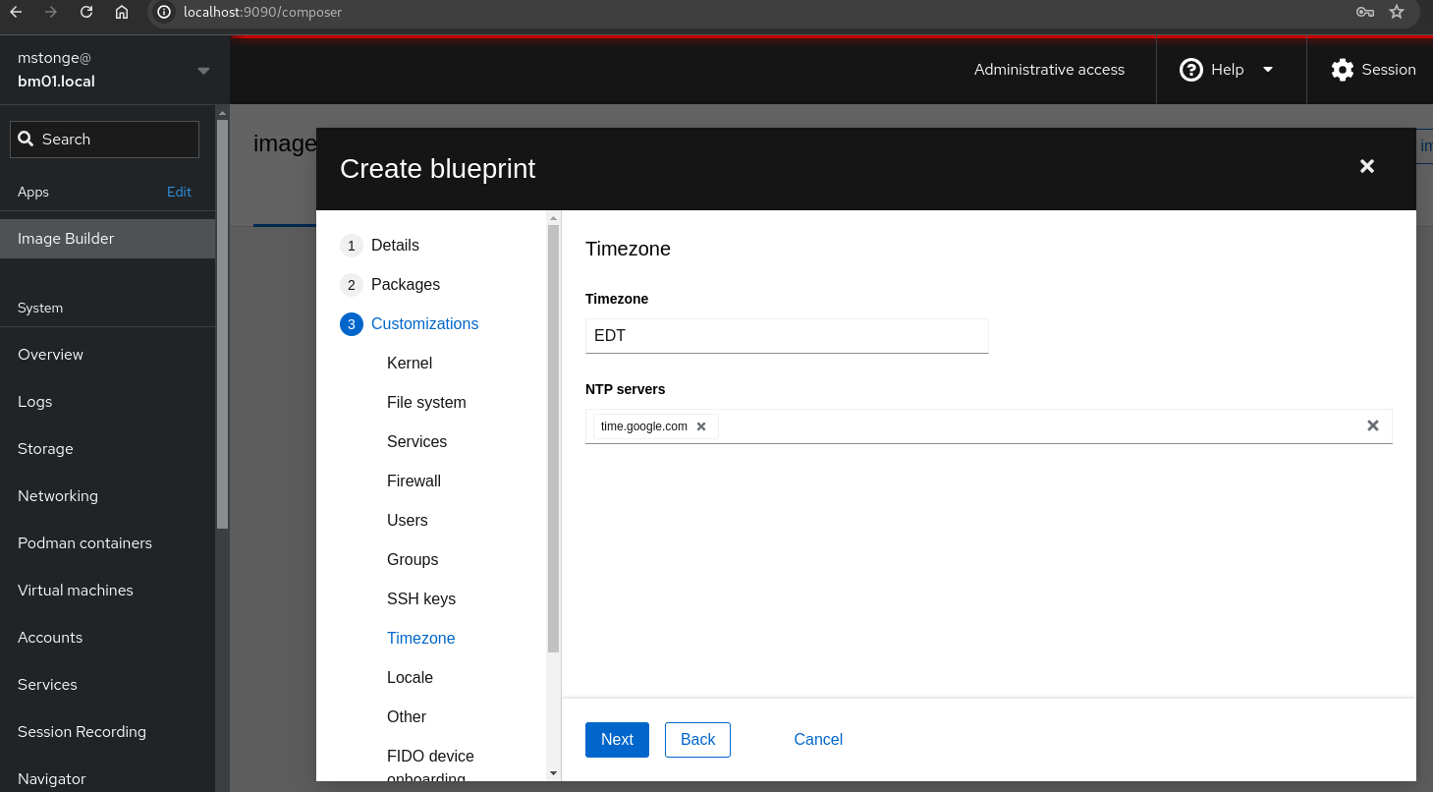

Set the keyboard to ***US*** and the layout to ***English***. Click “Next”.

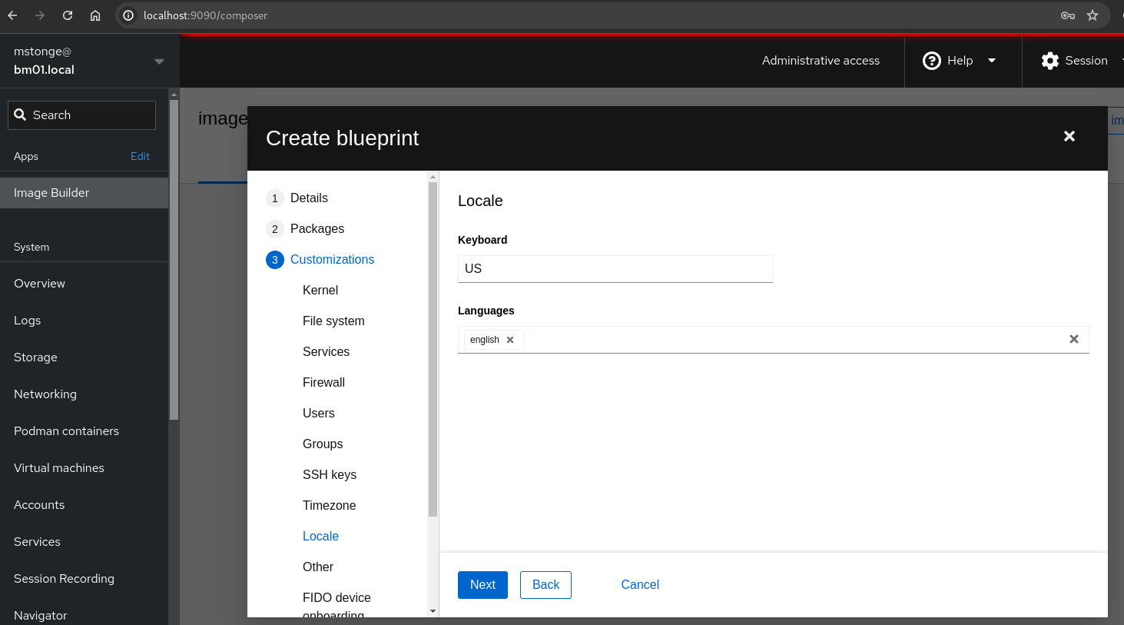

We won’t be setting anything here. Click “Next”.

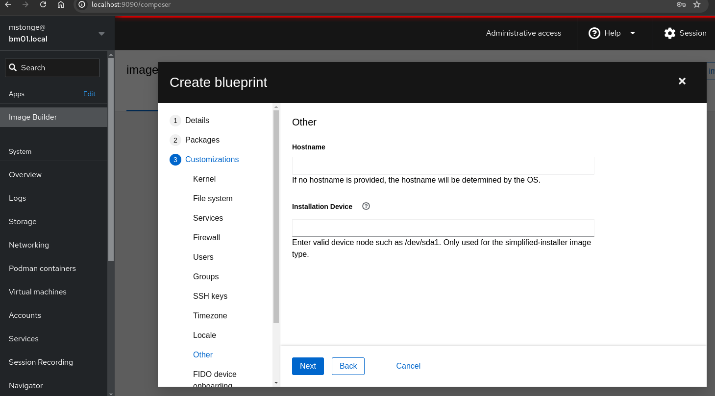

We won’t be setting anything here. Click “Next”.

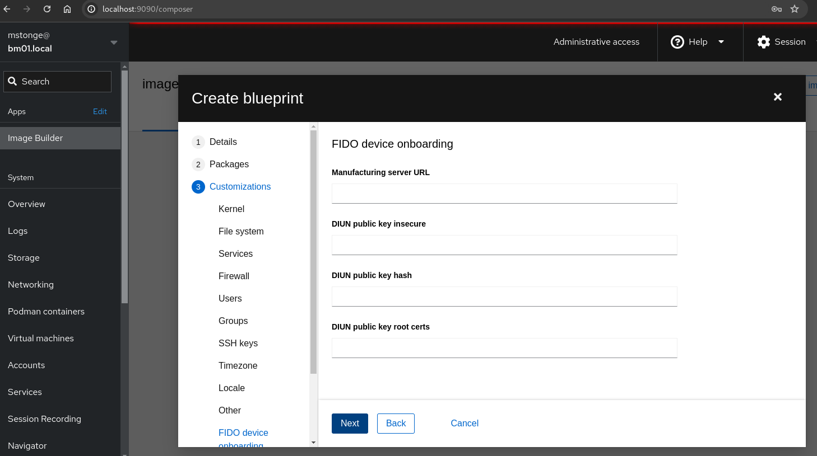

We won’t be setting anything here. Click “Next”.

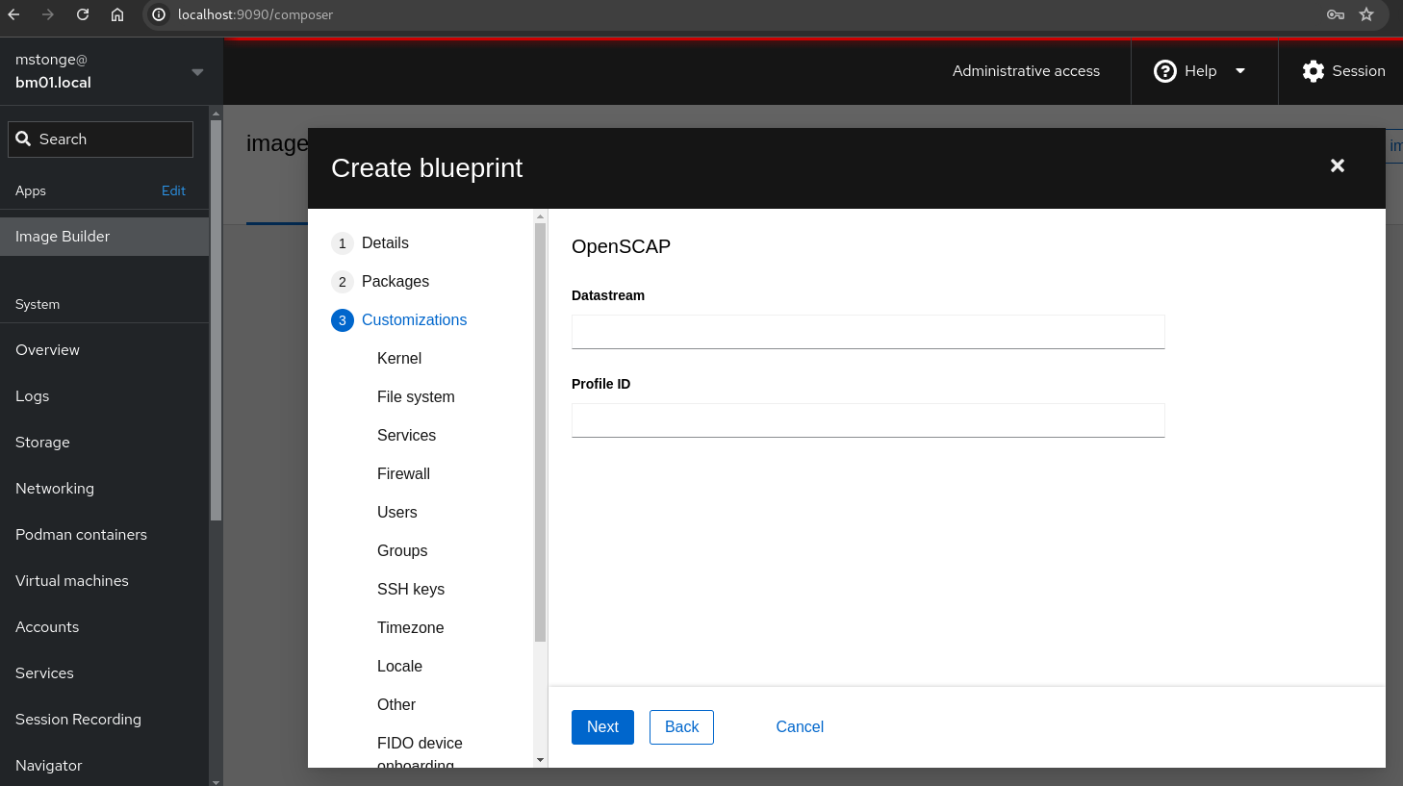

We won’t be setting anything here. Click “Next”.

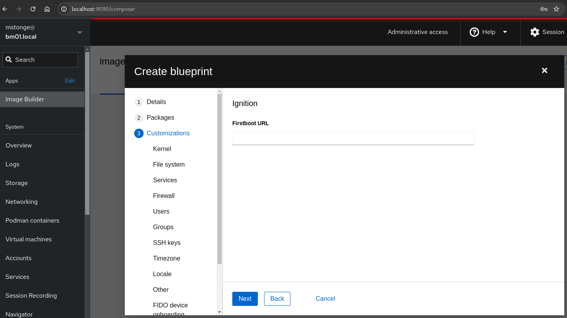

Feel free to review and verify all settings. When you are comfortable and ready. Click “Save”.

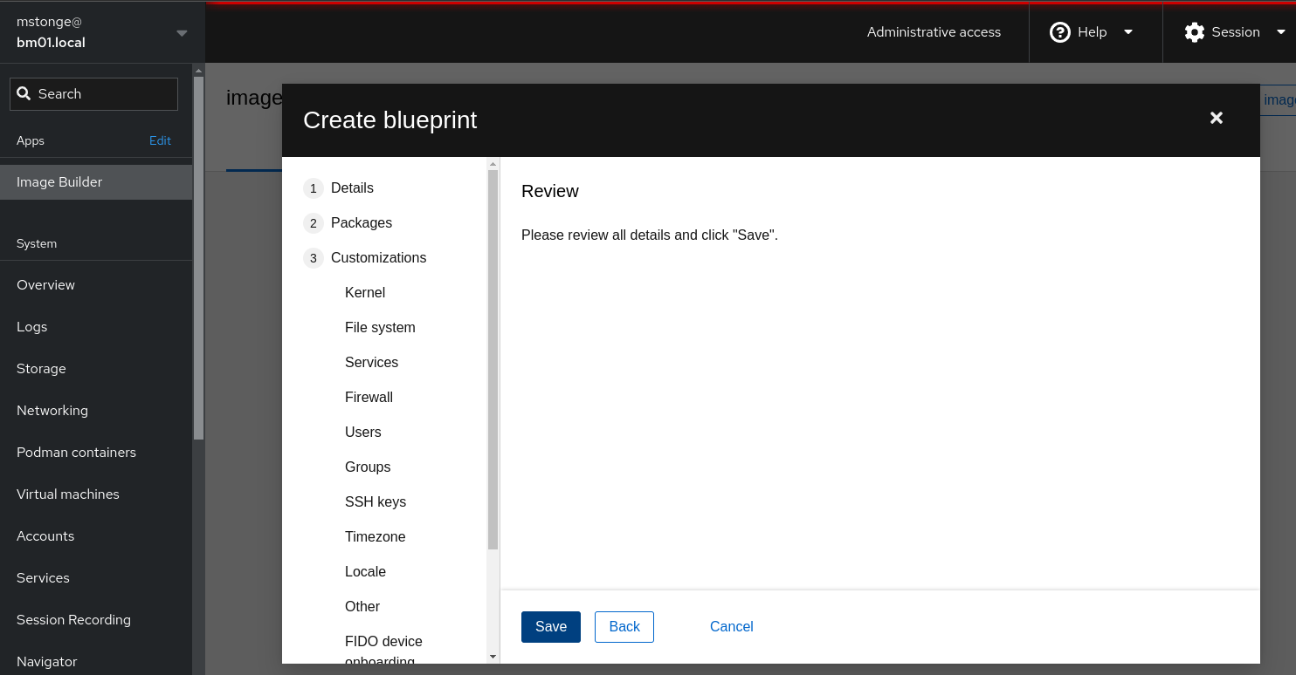

Once we save the blueprint, we can still view or edit any settings. 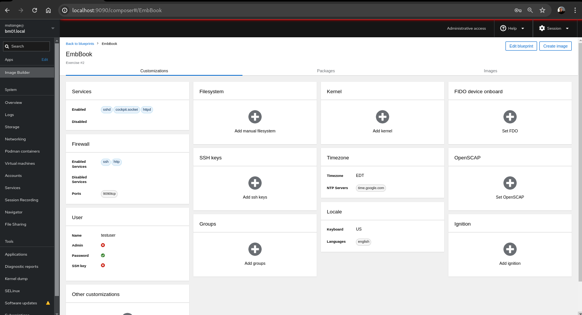

Now we are also presented with more options. Click “Create Image”.

Select the image that w’ve been working on ( ***EmbBook*** ). Set Image Type to ***RHEL for Edge Commit (.tar)***  then click “Next”.

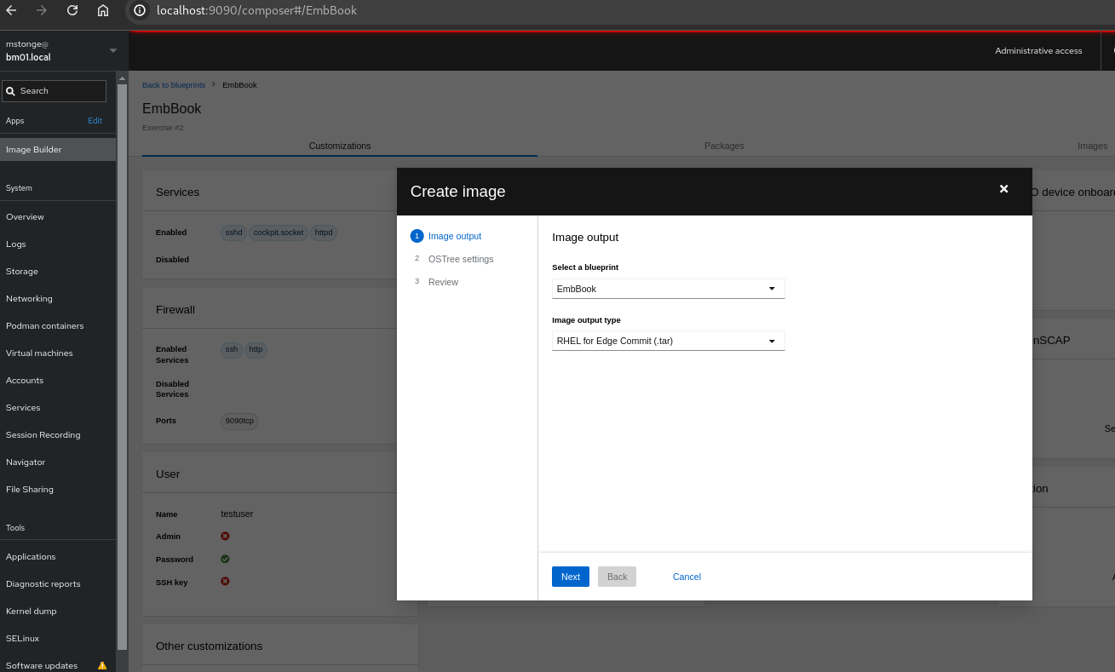

Here’s where we will set the repository URL information **later** in our next revision of the image. It will be the same host as the one we are using to build the initial image. For now, click “Next”.

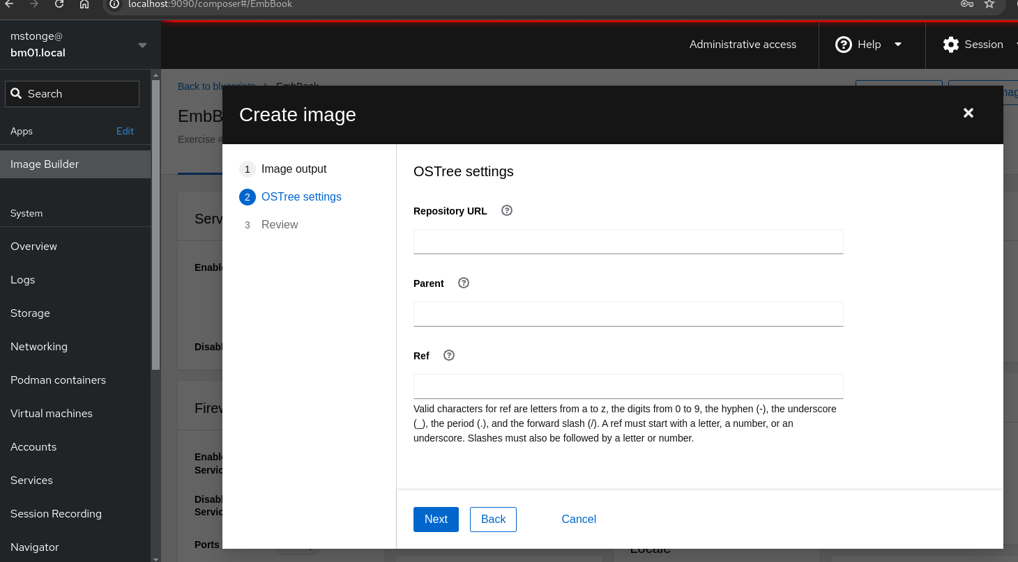

Now the moment of truth - Create the Image! Click “Create”.

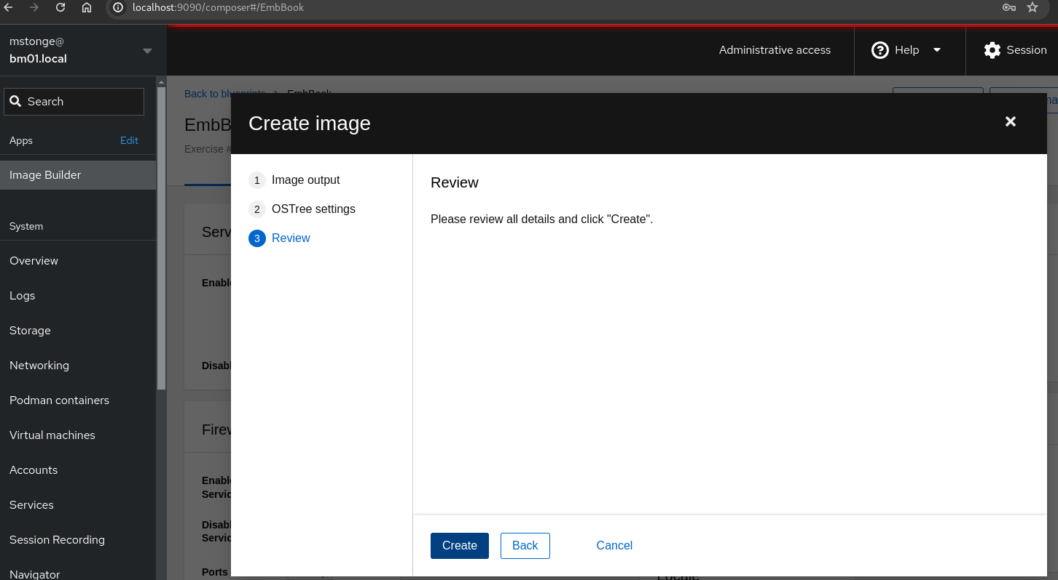

Be patient. It may take up to 15 minutes or more to render the new image file.