# Appendix 1

Target Audience Analysis

**Objective of this resource:** A quick at-a-glance guide to help you easily define your target learner audience.

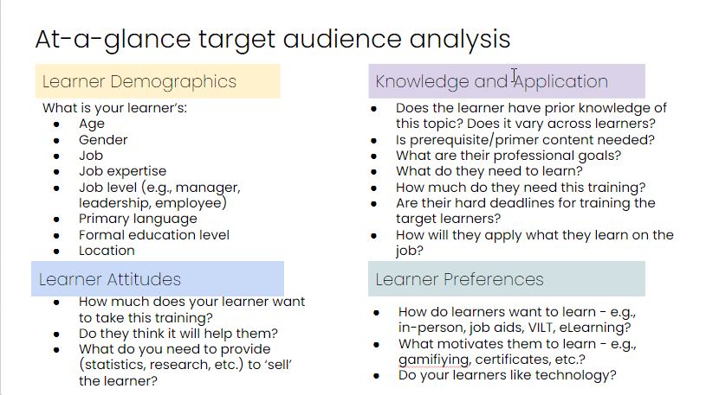

[Appendix 1 - Audience Analysis .pdf](https://packtservices.sharepoint.com/:b:/r/sites/prod.packtcloud/msdyn_project/2022/B19356_Instructional_Design_Career_Plan/Editorial_and_Production/Author/End%20matter%20(appendices,%20index)/Links%20to%20Appendices%20files/Appendix%201%20-%20Audience%20Analysis%20.pdf?csf=1&web=1&e=fiSNN0)

# Appendix 2

The ID Writing Assessment – source file and answers

**Objective of this resource:** Gauge your writing skills to see where your ID writing may fall short (also found in Chapter 3). The answers to the assessment are below.

[Appendix 2 - ID Writing Assessment.docx](https://packtservices.sharepoint.com/:w:/r/sites/prod.packtcloud/msdyn_project/2022/B19356_Instructional_Design_Career_Plan/Editorial_and_Production/Author/End%20matter%20(appendices,%20index)/Links%20to%20Appendices%20files/Appendix%202%20-%20ID%20Writing%20Assessment.docx?d=w766fc7cc050c4e1c967d5cc01e585052&csf=1&web=1&e=alk6pc)

## Answers to Activity 1: Measurable learning objectives

* Learners will hear lectures and attend discussions on future trends in medicine.

(Yes / No)

**The answer is No. The LO could benefit from revision.**

A better LO statement may be:

*Learners will review five lectures and participate in five related discussions to recognize future trends in medicine.*

*Why?*

“Hear” and “attend” aren’t really measurable verbs. Moreover, the number of lectures and discussions should be quantified.

* Learners will select examples of the concept of a growth mindset from a list of examples and non-examples. (Yes / No)

**The answer is No. The LO needs revision.**

A better LO statement is:

*Learners will be able to identify the concept of a growth mindset from a list of examples.*

*Why?*

“Select” is not a measurable outcome verb. However, “Identify” is. “A list of examples” is more concise language than “a list of examples and nonexamples.”

* Learners will understand the steps necessary for applying for a job. (Yes / No)

**The answer is No. The LO needs revision.**

A better LO statement may be:

Learners will be able to describe the steps necessary for applying for a job.

*Why?*

Again, we need a measurable verb. A common mistake is to use “Understand” instead of a more actionable Level One Bloom’s Taxonomy verb. The learning objective becomes more measurable when “understand” is replaced with “describe.”

* Learners will administer an allergy injection. (Yes / No)

**Once again, changes can be made. The answer is no.**

A better LO statement is:

Learners will be able to execute an allergy injection successfully.

Why?

“Administer” is not the most measurable verb. Using “execute” makes the learning objective more measurable. Furthermore, there are many wrong ways to give an injection; the LO’s verbiage needs to point to the ‘right way’ of doing it.

* Learners will compute the mean, range, and standard deviation of a series of ten numbers. (Yes / No)

**The answer is Yes! This LO is concise, clear, and measurable!**

* Learners will have acquired the ability to deal with conflict. (Yes / No)

**The answer is No. The LO needs revision.**

A better LO statement is:

Learners will be able to demonstrate the ability to deal with conflict by using the CARE strategy of conflict resolution.

Why?

This LO needs to be reworded into the active tense for clarity. “Acquiring the ability” is not measurable; better to use “demonstrate”. Lastly, there are loads of strategies to deal with conflict! Specifying which strategy is being taught yields a more concise LO.

## Answers to Activity 2: Passive vs. Active voice

Each of the passive-voice sentences below have been reworded into **the preferred active voice**.

Passive: The book is being read by most of the class.

**Active:** *Most of the class is reading the book.*

Passive: By then, the sound engineers will have completely remixed the soundtrack.

*Active:* *By then, the soundtrack will be completely remixed by the sound engineers.*

Passive: The user interface can be accessed from the desktop.

*Active:* *The user interface is accessible from the desktop.*

Passive: If you have questions, I can be reached at 555 555-5555.

*Active:* *You may reach me at 555-555-5555 with any questions.*

Passive: A path of destruction was left by the twister.

*Active:* *The twister left a path of destruction.*

Passive: Menu items can be added to existing OneClick menus.

*Active:* *Menu items are added to existing OneClick menus.*

Passive: The entrance exam was failed by one-third of the applicants.

*Active:* *One-third of the applicants failed the entrance exam.*

## Answers to Activity 3: Redundant writing

1. There is a possibility that the backup may not be successful.

*Rewrite: The backup may not be successful.*

*‘Possibility’ and ‘may not’ mean the same thing.*

1. Security must be increased to prevent violations.

*Rewrite: Increased security will prevent violations.*

*‘Must be’ is unnecessary here.*

1. The end result is exactly the same.

*Rewrite: The result is the same.*

*A ‘result’ is inherently ‘the end.’*

1. The majority of applications ran smoothly, taking into consideration the high risk.

*Rewrite: Considering the high risk, the majority of applications ran smoothly.*

*‘Taking into’ does not need to precede consideration.*

1. With better advance planning, we can improve our current status.

*Rewrite: With better planning, we can improve our status.*

*‘Advance’ and ‘planning’ mean the same thing in this context.*

1. Results recorded over a period of time showed that CD-ROM discs were not suitable for this purpose.

*Rewrite: Results over time showed that CD-ROM discs were not suitable for this purpose.*

*A ‘period’ means the same thing as ‘over time.’*

## Answers to Activity 4: Typos and spelling

## 

I’ve included the rewritten paragraph below *in italics,* with a brief explanation for each error.

Original paragraph:

If you think about it, their is alot of data transferring on the sever. Because we do not have enough hard disc space, the only solution is to simply the amount of data that users need to excess. We will provides the documentation for this training, rather then having it done internally. There for, we must setup some log ins for its employees. We will need to altar some of the privileges so that vitally information does not leek.

Rewritten paragraph:

*If you think about it, there (there vs. their) is a lot (two words) of data transferring on the server (misspelling from ‘sever’). Because we do not have enough hard disc space, the only solution is to simplify (verb vs. adverb ‘simply’) the amount of data that users need to access (‘to get’ vs. too much of ‘excess’). We will provide (singular vs. plural verb agreement) the documentation for this training, rather than (comparison vs. sequence of actions ‘then’) having it done internally. Therefore (misspelled), we must set up logins (one word or hyphenated vs. two words) for its employees. We will need to alter (verb ‘to change’ vs. religious ‘altar’) some of the privileges so that vital (adjective vs. adverb ‘vitally’) information does not leak (verb vs. vegetable ‘leek’).*

# Appendix 3

Mapping a Learner’s Journey

**Objective of this resource**: To dig even deeper into your target audience’s learning experience, create a design thinking-inspired journey map (https://www.creativeconfidence.com/). You can do this on your own, with a group of people, or even virtually using tools like Miro or Google Jamboard.

Journey maps help us to think systematically about our learners and how they interact with our learning experiences that we create. Thinking broadly about their full learning journeys allows us to identify more opportunities for improvement in the process.

[Appendix 3 - Learner Journey Mapping.pdf](https://packtservices.sharepoint.com/:b:/r/sites/prod.packtcloud/msdyn_project/2022/B19356_Instructional_Design_Career_Plan/Editorial_and_Production/Author/End%20matter%20(appendices,%20index)/Links%20to%20Appendices%20files/Appendix%203%20-%20Learner%20Journey%20Mapping.pdf?csf=1&web=1&e=iPn1uK)

**Step 1:** Choose the journey you’d like to map. In ID, it will most likely be the entire learning journey.

**Step 2:** Before you create a visualization, write down the steps. Remember to include all tiny steps the learner will be taking to understand all nuances that might ordinarily be overlooked.

**Step 3:** Now, organize these steps into a visual map /timeline. You can branch your map to show options, or keep it simple, based on the steps you’ve identified.

**Step 4:** Identify patterns that emerge, anything unexpected, and why certain steps happen in the order that they do. What insights do you glean from this analysis? How might you change the process?

Step 5: Share your journey map with stakeholders who are familiar with the learning journey and ask them for their feedback to see if you may have forgotten something, or have steps that seem out of sequence.

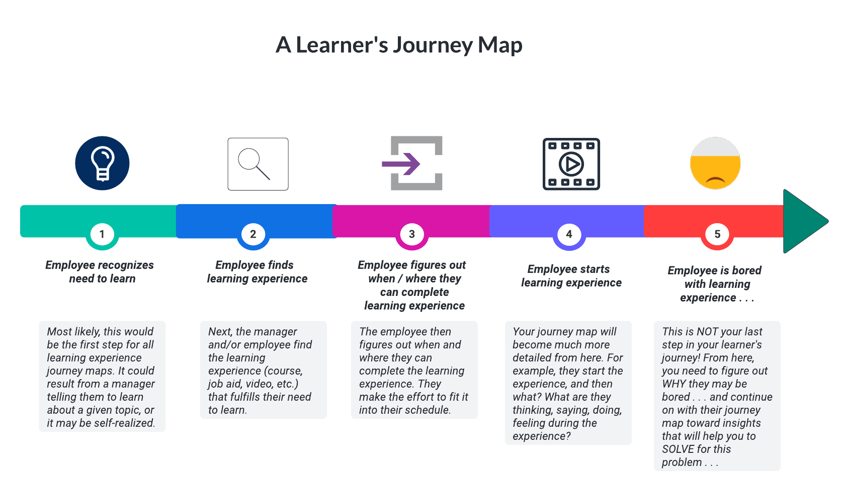

# Appendix 4

The ID Project Brief

**Objective of this resource**: To identify what the general scope of work is for a given ID project in a visually engaging, at-a-glance format (also found in Chapter 5).

[Appendix 4 - Sample Visual Project Brief .pptx](https://packtservices.sharepoint.com/:p:/r/sites/prod.packtcloud/msdyn_project/2022/B19356_Instructional_Design_Career_Plan/Editorial_and_Production/Author/End%20matter%20(appendices,%20index)/Links%20to%20Appendices%20files/Appendix%204%20-%20Sample%20Visual%20Project%20Brief%20.pptx?d=w9250cc159f7f450293f868317d2c8aee&csf=1&web=1&e=UFXvek)

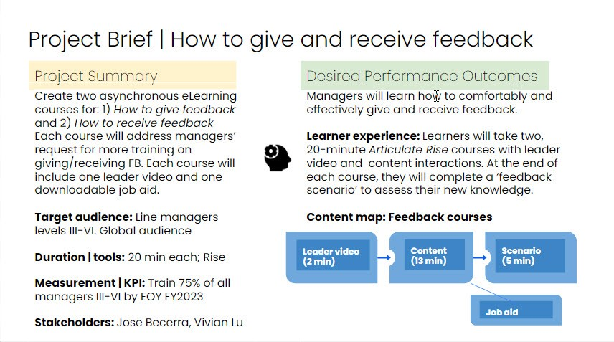

# Appendix 5

Project Kick-off deck

**Objective of this resource**: A template designed for you to customize for your own “savvy start” deck to use during your project kick-off meeting (Also found in Chapter 5).

[Appendix 5 - Sample Project Kick-off Deck .pptx](https://packtservices.sharepoint.com/:p:/r/sites/prod.packtcloud/msdyn_project/2022/B19356_Instructional_Design_Career_Plan/Editorial_and_Production/Author/End%20matter%20(appendices,%20index)/Links%20to%20Appendices%20files/Appendix%205%20-%20Sample%20Project%20Kick-off%20Deck%20.pptx?d=w96eb8a6cfc834cda8c6ec7ccbbff357c&csf=1&web=1&e=eM3jet)

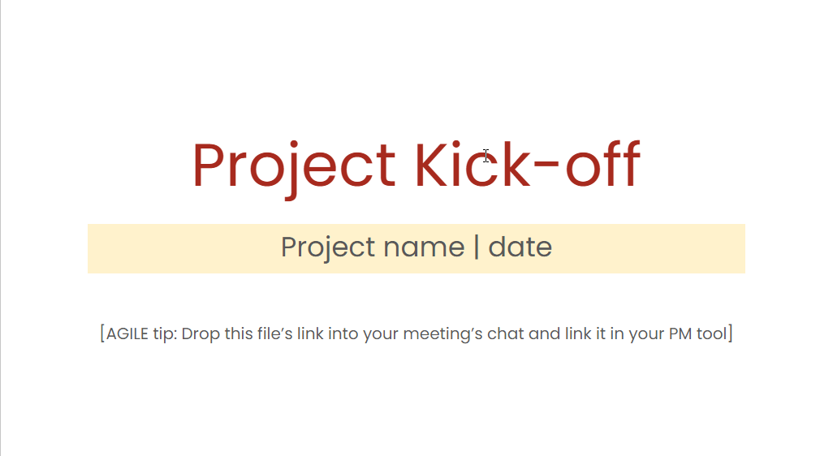

# Appendix 6

## Check your self-efficacy

**Objective of this resource**: If you’re still wondering about the difference between Bandura’s theory of Self-efficacy vs. Self-esteem – and where you may lie on a self-efficacy scale - check out the New General Self-Efficacy Scale created by psychology professors Gilad Chen, Stan Gully, and Dov Eden (<https://bit.ly/3J4dLt8>). This research-backed tool will enable you to measure your own level of self-efficacy.

[Appendix 6 - Measuring Your Self-Efficacy.pdf](https://packtservices.sharepoint.com/:b:/r/sites/prod.packtcloud/msdyn_project/2022/B19356_Instructional_Design_Career_Plan/Editorial_and_Production/Author/End%20matter%20(appendices,%20index)/Links%20to%20Appendices%20files/Appendix%206%20-%20Measuring%20Your%20Self-Efficacy.pdf?csf=1&web=1&e=EtNHZl)

# Appendix 7

Improve your self-efficacy

**Objective of this resource:** A quick visualization tool to empower you toward taking the steps necessary to build your self-efficacy and belief in your own ID capabilities.

[Appendix 7 - Improve Your Self-Efficacy.png](https://packtservices.sharepoint.com/:i:/r/sites/prod.packtcloud/msdyn_project/2022/B19356_Instructional_Design_Career_Plan/Editorial_and_Production/Author/End%20matter%20(appendices,%20index)/Links%20to%20Appendices%20files/Appendix%207%20-%20Improve%20Your%20Self-Efficacy.png?csf=1&web=1&e=3PeqZt)

