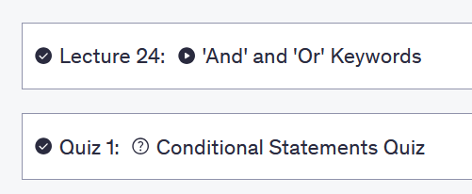

**Quiz1: Conditional Statements Quiz**

1. What is the difference between a single = and a double == ?

**A1. Single = is used as an assignment operator  
Double == is used to compare things**

A2. They can be used interchangeably

1. 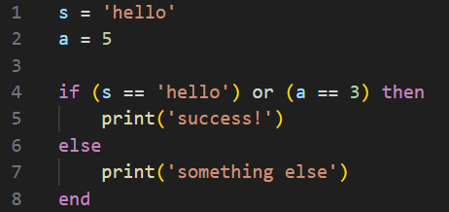  
   What will print when this code is run?

**A1. success!**

Feedback:   
That's right. Because the two conditions are separated by the word 'or', only one of the conditions needs to be true in order for line 5 to run  
  
A2. something else

1. What will print to the console when this code is run?

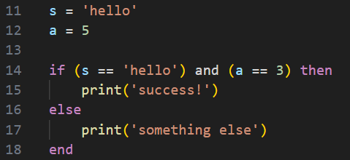

A1. success

**A2. something else**

Feedback: That's right. Because the two conditions are separated by the word 'and', this time Both of the conditions need to be true in order for line 15 to run. Because this is not the case, the statement will flow to the 'else' portion instead

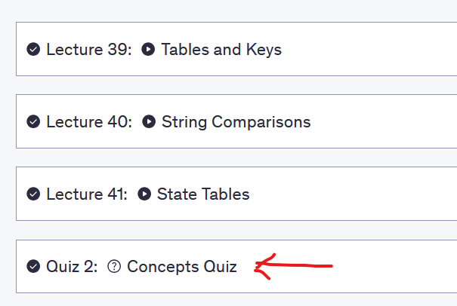

**Quiz 2: Concepts Quiz**

1. What would be printed when this code is run?

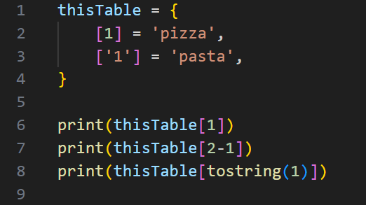

A1. The code would error

A2.

pizza  
-  
pasta

**A3   
pizza  
pizza  
pasta**

1. True or false, a string with a value of "hello" is equivalent to a string with a value of "Hello"?

A1. True

**A2. False**

Feedback: That's right. Computers see the character 'h' as different to 'H', therefore "hello" is seen as a completely different string to "Hello"

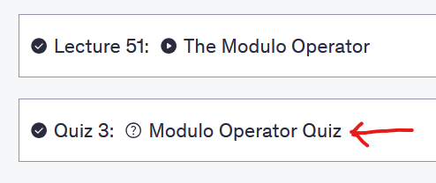

**Quiz 3: Modulo Operator Quiz**

1. What would be printed when this code is run?



A1. 3

**A2. 2**

Feedback: Yes. 5 - 3 = 2. Or perhaps, the correct way of thinking about this would be 5 divided by 3 equals 1 with a remainder of 2

1. What would print if this code was run?



**A1. 0**

Feedback: Yes. 5 divided by 5 equals 1 with 0 remainder

A2. 1

1. Which version of the function correctly prints out whether or not an input is odd or even?

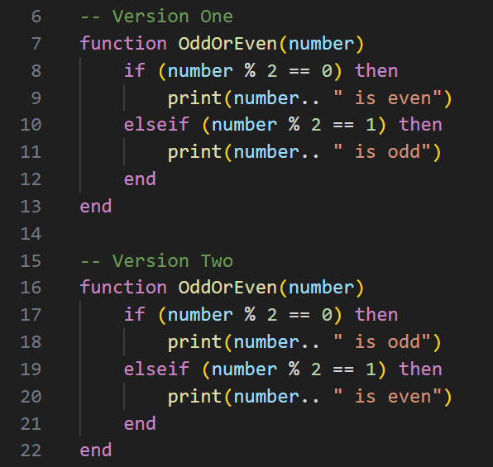

**A1. Version One**

A2. Version Two