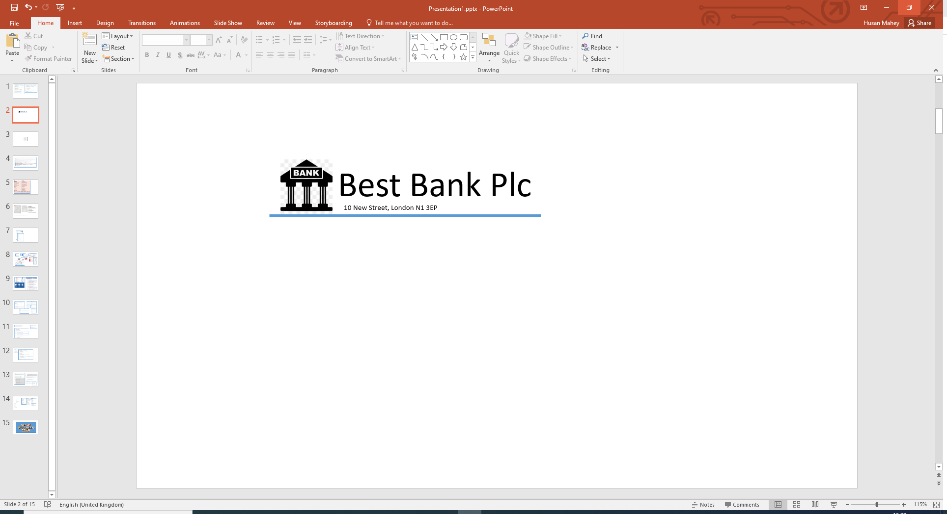

[Title] [Forename] [Surname]

[Address]

[City]

[County]

[Postcode]

Our Ref: [Ref]

Dear [Forename],

Congratulations! Based on the information provided by you, we are pleased to inform you that you have been pre-approved for your recent loan application.

**Loan Details**

Amount: [Amount]

Term: [Term] months

Interest Rate (APR): [Interest]

Total Payable: [Payable]

Monthly Payment: [Monthly]