ASCR-14: Tabletop Exercise - Semantic Failure in a VLA Warehouse System
Cross-Functional Exercise Script — Scenario Narrative, Inject Sequence, and Regulatory Decision Points for VLA Warehouse Environments

ASCR-14 definition

Artifact Type | Tabletop Exercise Scenario / Cross-Functional Training Script
Primary Use | First-exercise readiness validation for organizations beginning Physical AI security practice; cross-functional incident response rehearsal covering security, safety, operations, and compliance
Secondary Use | Executive and board-level awareness through the Exercise Overview, executive risk translation, and Facilitator Summary; practitioner onboarding for security architects, safety engineers, and OT security personnel joining agentic deployments
Operational Phase | Pre-incident · Post-incident
User Role | Exercise facilitator, security architect, safety engineer, operations lead, compliance officer, CISO
Update Cadence | Annual, or following a confirmed Physical AI incident involving VLA systems
Update Triggers | Confirmed or suspected VLA system compromise · Significant changes to warehouse robotics deployment architecture · Updates to IEC 62443, EU AI Act implementing regulations, or NIS2 national implementations that affect the regulatory inject content
Cross-References | Chapter 1 (VLA systems and ASCR-14 tabletop introduction) · Chapter 2 (cybersecurity, physical-safety, and operational-availability convergence; CPS architectural analysis; incident taxonomy) · ASCR-01 (risk-scoring methodology for exercise findings) · ASCR-04 (materialization and enforcement path for approved consequential-action controls) · ASCR-05 (deployment-specific enforcement-point mapping for CBF remediation) · ASCR-06 (verification outcomes relevant to consequential-action analysis) · ASCR-07 (decision-lineage and forensic evidence required for reconstruction) · ASCR-08 (agentic incident classification, containment, evidence-preservation, and recovery decision framework exercised through the response Decision Point in this tabletop) · ASCR-09 (follow-on technical and adversarial validation exercise program) · ASCR-12 (tracking of open exercise findings and remediation) · ASCR-13 (accountable role definitions for assigned findings) · Chapter 10 (ASCR Blueprint integration, Point-in-Time and Jurisdictional Scope Statement, and Localization Methodology)
Regulatory Relevance | EU AI Act Article 9 (risk management — exercise artifacts as evidence of ongoing assessment) · EU AI Act Article 17 (quality management records) · Organizations subject to IEC 62443 should map Phase 2 findings (Forensic Readiness) to Security Level verification requirements. Organizations with applicable functional-safety or machine-safety obligations should route safety-relevant findings from this exercise into the applicable safety lifecycle and management-of-change process. IEC 61511 applies specifically to safety instrumented systems in the process-industry sector and should be cited only where that scope applies.
Version | 1.0 — June 2026

Synthetic composite disclosure
The scenario narrative is a synthetic composite constructed from plausible VLA system failure modes and adversarial-equivalence considerations. No single incident is described. The core scenario is non-adversarial environmental and calibration drift; adversarial sensor manipulation is introduced only as a comparison case to test attribution and observability.

ASCR-14 operational toolkit: supporting specifications and operational extensions

Purpose and scope
ASCR-14 is the entry-level, discussion-only cross-functional tabletop for organizations beginning Physical AI security practice. It uses a synthetic VLA warehouse semantic-failure scenario to test whether security, operations, safety, compliance, and system owners recognize cross-layer evidence and control gaps, coordinate incident-response decisions, and identify remediation requirements. ASCR-14 does not execute live tests or replace verification, decision-lineage, incident-response, or follow-on validation activities governed by ASCR-06, ASCR-07, ASCR-08, and ASCR-09.

Before you operationalize this instrument
This instrument is a jurisdiction-neutral starting template. The Version 1.0 — June 2026 identifier is the artifact baseline, not a legal-currency date. Regulatory and standards references were re-verified during publication review and may therefore reflect authorities issued after June 2026. Scenario mechanics and deployment-specific values remain subject to the calibration requirements below. Re-verify all regulatory and standards references before reliance; see Chapter 10 for the full Point-in-Time and Jurisdictional Scope Statement and Localization Methodology.
Specific to ASCR-14:
- Jurisdiction-bound defaults: No findings. This instrument contains no default values, retention periods, caps, or thresholds calibrated to a specific legal regime (e.g., a limitation period or a directive-specific cap structure). Numeric values in this document (pallet weights, cycle timing, misclassification rates, maturity-score thresholds) are scenario mechanics, not jurisdiction-bound legal defaults.
- Enforceability-dependent mechanisms: No findings. The document contains no burden-shifting, presumption, or liability-allocation clauses whose legal effect depends on a chosen governing law.
- Citation currency risk: This instrument maps its Control Boundary Failure taxonomy and debrief questions to EU AI Act Articles 9, 15(5), and 17 and, where applicable, to the high-risk classification route established under Article 6 and the relevant Annex I or Annex III provisions, together with IEC 62443, applicable functional-safety or machine-safety standards, and NIS2. Applicability and effective dates must be re-verified at time of use. Regulation (EU) 2026/1744 currently stages the relevant high-risk requirements to 2 December 2027 for systems classified under Article 6(2)/Annex III and 2 August 2028 for systems classified under Article 6(1)/Annex I. Re-verify every cited article, control identifier, applicability date, and section number against the consolidated legal or standards text in force at time of use before relying on this exercise as compliance evidence.
- Unresolved or externally-defined cross-references: ASCR-06, ASCR-07, ASCR-08, and ASCR-09 are referenced but not redefined within this document. Resolve their current requirements from the applicable artifacts before using ASCR-14 findings as evidence that the corresponding verification, logging, incident-response, or validation capability is operational. ASCR-14 rehearses cross-functional recognition and decision making; it does not replace execution or validation under those artifacts. If a controlled fillable Facilitator's Scorecard worksheet is delivered with the ASCR-14 package, it may be used for data entry; otherwise, the scorecard tables contained in this document are authoritative. Chapter 10 contains the governing Point-in-Time and Jurisdictional Scope Statement and Localization Methodology and must be consulted from the current source instrument set.
- Industry/sector calibration: Before running or scoring the exercise, localize the scenario's pallet weight ranges, per-position staging limit, planning-cycle duration, pallet counts, total pallet-routing throughput, resulting misclassification percentage, camera mounting height, loaded-stack height, angular drift, projected-dimension error, pallet-classification threshold, attribution-time objective, AI/ML incident-response procedure review interval, immediate-remediation target, short-term-remediation target, and Phase 1-4 maturity targets. These values are illustrative parameters drawn from a synthetic tier-2 distribution-center / VLA picking scenario and do not transfer automatically to other facilities, throughput profiles, or sectors. Do not score the exercise as a maturity assessment until the applicable values have been localized, and do not use the physical misclassification mechanism unless the configured geometry closes.

Artifact structure and usage
Use the Exercise overview and Scenario background to brief participants; the Technical walkthrough as practitioner pre-read; the Exercise timeline and three injects as the facilitator delivery sequence; the Tabletop exercise debrief framework and Facilitator’s scorecard as the authoritative assessment; and the Facilitator summary, Hotwash and after-action, and recommendations to capture and route remediation. Localize the deployment-specific values identified under Before you operationalize this instrument before scoring the exercise. ASCR-14 is discussion-only; follow-on technical and adversarial validation belongs in ASCR-09.

1. Exercise overview
This tabletop exercise uses a synthetic scenario built from plausible calibration-drift, semantic-validation, and cross-layer observability failure modes in an automated logistics environment. No single real incident is described. The initiating condition is progressive camera-mounting drift that introduces a perspective and calibration error and biases pallet classification. The facility-specific physical parameters are exercise mechanics and must be validated during localization before the scenario is used as an engineering or maturity-assessment instrument.
Primary concepts illustrated: This exercise operationalizes five concepts through the scenario: how an action-token drift score that passes per cycle can mask multi-cycle drift; how the absence of context_hash_before and cross-layer correlation identifiers degrades forensic traceability; how cross-layer observability differs from API-layer monitoring; how the semantic gap between VLA inference and WMS database state enables silent misrouting; and why environmental sensor drift and adversarial sensor manipulation can remain indistinguishable in the available telemetry without preserved cross-layer evidence.
Note: The action_token_drift_score used in this exercise measures the statistical distance between the action-token probability distribution generated at a planning cycle and a rolling baseline distribution over preceding normal-operation cycles. It is an exercise-local behavioral-drift measure and is distinct from the normative ASCR-07 divergence_score, which is derived from plan_embedding relative to the authorized-objective centroid. A per-cycle action_token_drift_score within threshold is expected; the failure mode targeted here is a gradual multi-cycle trend that remains below the single-cycle threshold and therefore requires cross-cycle trend analysis.

Target participants: Exercise Facilitator, CISO, Cyber Architect, OT Security Manager, SOC Lead, Safety Engineer or applicable machine/functional-safety representative, Operations Lead, Compliance Officer, WMS Integration Owner, and VLA System Owner. Designate one participant or observer as exercise scribe.
Audience routing: Executive and board participants should use the Exercise Overview, Inject outcomes, executive risk translation table, and Facilitator Summary. The Scenario Background and Technical Walkthrough are practitioner pre-read material for security, AI/ML, OT, safety, and integration roles.
Estimated duration: 90–120 minutes.
Exercise clock and scenario clock. E+ denotes facilitator elapsed time; S+ denotes simulated incident time. A full 120-minute run uses E+00–10 for briefing, E+10–30 for Inject 1, E+30–55 for Inject 2, E+55–80 for Inject 3, E+80–105 for debrief and scoring, and E+105–120 for hotwash and action capture. A compressed 90-minute run may shorten discussion but must not reinterpret S+ scenario time as elapsed exercise time.
Facilitation method. ASCR-14 follows a facts-first tabletop structure. The SITUATION and INJECT portions of each exercise inject contain the scenario facts delivered by the facilitator. The role-directed prompts that follow are Decision Points, not additional inject facts. Facilitators should deliver the factual inject before presenting the Decision Points and should first allow participants to identify relevant questions, decisions, and evidence needs without prompting. The listed Decision Points may then be used to ensure that the exercise covers its intended readiness objectives. This preserves the ASCR-09 facts-first exercise principle while retaining the guided format appropriate to ASCR-14's entry-level cross-functional readiness purpose.
Relationship to ASCR-09. ASCR-14 is the entry-level cross-functional readiness exercise for organizations beginning Physical AI security practice. It tests whether security, operations, safety, compliance, and system owners recognize the semantic-failure problem, identify the required evidence and control gaps, and coordinate an appropriate response. ASCR-09 is the follow-on validation program. It exercises and validates the technical detection, enforcement, evidence, and adversarial-response capabilities under production-representative conditions. Completion of ASCR-14 does not substitute for ASCR-09 validation; ASCR-14 findings should inform the controls and scenarios subsequently validated through ASCR-09.

1.1 Exercise objectives, scope, and success criteria
Objectives:
- 1. Determine whether monitoring can detect a semantic failure that produces no infrastructure-layer alert.
- 2. Determine whether retained evidence can reconstruct the perception→reasoning→actuation chain without manual cross-system correlation.
- 3. Determine whether pre-actuation controls reconcile AI inference against independent physical ground truth before execution.
Scope: ASCR-14 is a discussion-only tabletop. No live or staging system interaction, production change, live log query, actuation-path demonstration, or fault injection is part of this exercise. Any proposed live activity is out of scope and must be moved to a separately authorized test or exercise with documented stop conditions, named halt authority, and appropriate safety/security approval.
Success criteria: Each objective is supported by current evidence or recorded as a gap; the authoritative Facilitator's Scorecard is completed; and every remediation finding has a named owner and target date.

2. Scenario background
A tier-2 distribution center operates an OpenVLA-based robotic picking system: a 7B-parameter vision-language-action model fine-tuned on the facility’s SKU catalog for pick-and-place tasking, integrated with a Warehouse Management System (WMS) via MCP (Model Context Protocol) tool calls for inventory allocation and conveyor routing. The perception stack includes overhead wide-angle cameras for pallet identification and articulated-arm cameras for individual item recognition.
Over six weeks of summer operation, repeated diurnal thermal cycling causes incremental relaxation at the camera bracket/fastener interface on two overhead sensors, producing a small non-recovering rotation away from calibrated vertical. EUR-1/EPAL 1 and EUR-2/EPAL 2 differ in footprint and height: EPAL 1 is 800 × 1,200 × 144 mm and EPAL 2 is 1,200 × 1,000 × 162 mm. In this synthetic scenario, the resulting perspective and calibration bias causes the geometric dimension estimate of some partially obscured EUR-1 loads to cross the configured EUR-2 classification threshold. Before exercise use, the facilitator must populate and verify deployment-specific values for camera mounting height, loaded-stack height, angular drift, resulting projected-dimension error, and the pallet-classification threshold. The scenario must not be used with geometry that does not close.
The VLA model infers pallet type using a combination of dimension estimates and barcode reads. For partially obscured pallets, which are common at the facility’s load heights, the fused embedding passed to the action decoder is influenced more strongly by the vision encoder’s geometric estimate than by the barcode read. This is not an explicit weighting decision; it is an emergent property of how attention distributes across input features during training and inference.
The model does not expose a reliable uncertainty signal for the geometric estimate; affected action tokens therefore appear operationally valid even when the underlying measurement is distorted. The deployment also lacks ensemble-based uncertainty inference, calibrated prediction intervals, or comparable physical-prior checks that could flag the ambiguous observation.
The WMS validates the inferred pallet type against staging capacity for that type but does not reconcile the inference against the SKU's authoritative weight record. That missing cross-domain check is the propagation path from semantic error to routing action.

3. Technical walkthrough
Traditional cybersecurity monitoring is designed to detect failures in infrastructure, communications, or software execution. Vision-Language-Action (VLA) systems introduce an additional failure domain: semantic reasoning. In these systems, an incorrect interpretation of the physical environment can propagate through otherwise healthy software and operational workflows without triggering conventional security or operational alarms. The resulting failure is not caused by unavailable services, failed API calls, or compromised infrastructure. Instead, it arises because the system consistently reasons from an incorrect understanding of physical reality.
The objective of this walkthrough is to trace that progression from initial perception error to physical consequence. Using the EUR-1/EUR-2 pallet misclassification scenario introduced earlier, the walkthrough follows a single semantic error as it traverses the complete perception-to-actuation pipeline, identifying where independent verification, telemetry, monitoring, and operational reconciliation controls should have interrupted the failure.
Rather than examining the AI model in isolation, the walkthrough treats the deployment as an integrated cyber-physical system comprising perception, reasoning, orchestration, operational technology (OT), and industrial actuation. At each stage, the analysis identifies a corresponding Control Boundary Failure (1 through 5) where the absence of an independent control permits the corrupted semantic state to progress to the next operational layer. CBF-1 through CBF-5 are exercise-local Control Boundary Failure identifiers representing missing, degraded, or ineffective controls at defined cyber-physical trust boundaries in this VLA scenario. They are not IEC 62443 identifiers and do not replace ASCR-05 enforcement-point IDs. During remediation, each CBF finding must be mapped to the applicable deployment-specific ASCR-05 enforcement point or points; no one-to-one mapping is implied.
This progression is intentional. Each Control Boundary Failure represents an opportunity where the system could have detected, challenged, or contained the erroneous semantic state before it influenced downstream decision making. The unsafe physical outcome is therefore not attributable to a single incorrect inference. It emerges because multiple independent control boundaries fail sequentially, allowing an initially localized perception error to become an operational decision and, ultimately, a physical action.
CBF Label | Control Boundary Failure Definition
CBF-1 | Independent physical-state validation (sensor and actuation assurance)
CBF-2 | Semantic confidence enforcement
CBF-3 | Context integrity and auditability
CBF-4 | Behavioral monitoring and drift detection
CBF-5 | Cross-domain semantic reconciliation
Table 3.1. Exercise-local Control Boundary Failure taxonomy used across the VLA semantic failure exercise
The table defines the canonical meaning of CBF-1 through CBF-5 used consistently in the textual analysis and architectural annotations within this walkthrough. Each CBF represents a distinct class of missing or ineffective control spanning perception, reasoning, context integrity, behavioral monitoring, and cross-domain operational reconciliation.
Specifically, the analysis follows five stages:
- Perception and Embedding introduce the initial semantic error through environmental calibration drift and insufficient physical validation.
- Context Assembly and AI Reasoning preserve and amplify the incorrect semantic state because telemetry integrity and multi-cycle monitoring controls are absent.
- Operational Integration accepts the AI-generated decision as operationally valid without reconciling it against authoritative physical records.
- Industrial Actuation executes the resulting command without an independent mechanism to validate that the requested action remains physically safe.
- Operational Outcome demonstrates how infrastructure monitoring can remain nominal while an unsafe physical condition develops undetected.
The result is a complete perception-to-actuation failure chain in which every individual software component behaves according to its design, yet the overall cyber-physical system produces an unsafe operational outcome. This distinction is fundamental to Physical AI security: correctness of component execution does not guarantee correctness of system behavior.

3.1 Semantic failure propagation across the VLA operational pipeline
Figure ASCR-14A traces the complete lifecycle of the corrupted semantic state from initial sensor observation through physical warehouse execution, identifying the specific Control Boundary Failure associated with each stage of the operational pipeline.
Figure ASCR-14A therefore answers one specific forensic question: “Where did the semantic failure propagate?”
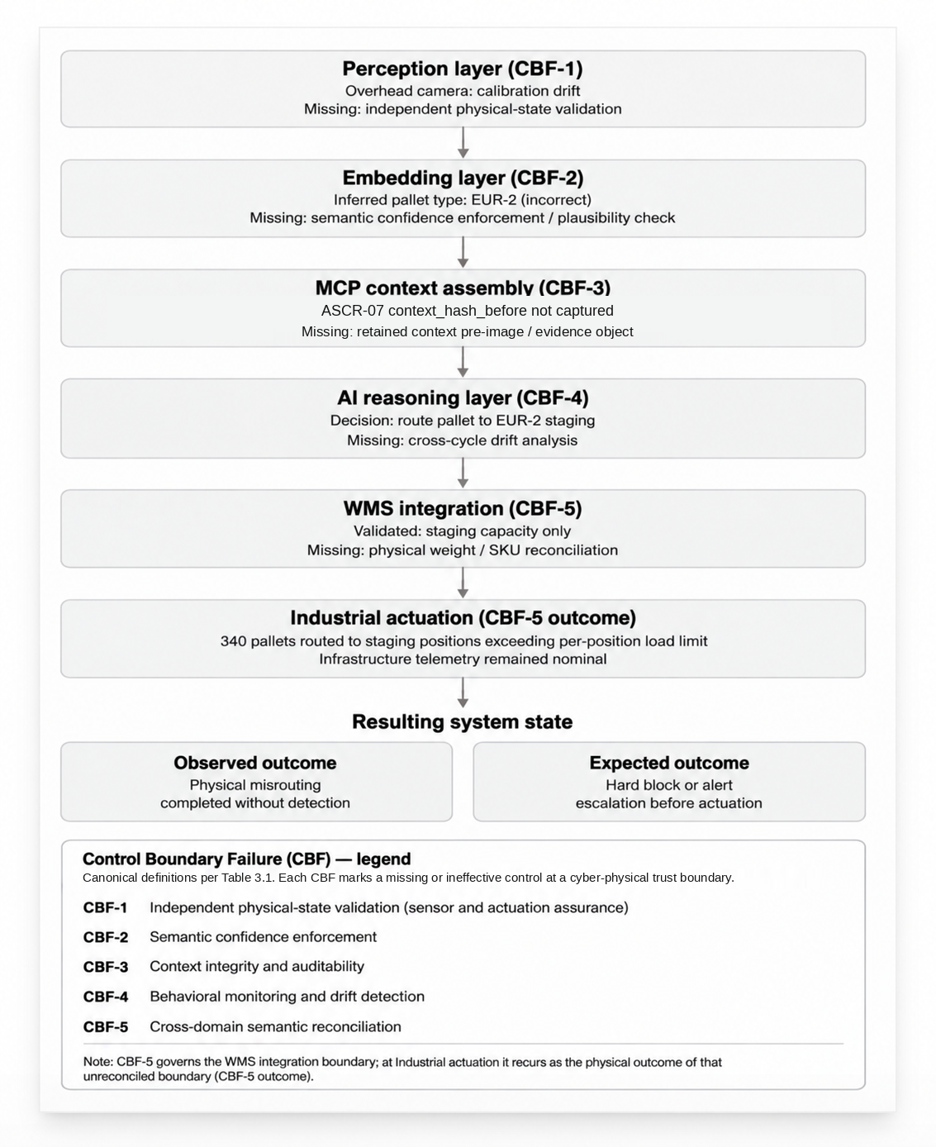
Figure ASCR-14A: Semantic Failure Propagation Across the
Vision-Language-Action Operational Pipeline

Figure ASCR-14A traces the lifecycle of a corrupted semantic state from initial sensor observation through industrial actuation.
Several characteristics of the propagation path are significant:
First, the initiating event is not a software defect or infrastructure compromise. The semantic error originates from an environmental calibration drift that alters the model's perception of physical reality while leaving the underlying computing infrastructure fully operational.
Second, each downstream component behaves consistently with its design assumptions. The embedding layer generates a plausible semantic representation, the reasoning layer produces a valid action token, the MCP orchestration successfully invokes operational services, the WMS validates staging capacity, and the conveyor control system executes the requested command. No individual subsystem experiences an execution failure.
Third, every transition between layers represents an opportunity for independent verification. Cross-sensor validation, semantic confidence enforcement, tamper-evident context-state evidence preservation, cross-cycle behavioral monitoring, and reconciliation against authoritative SKU records provide complementary means to detect, challenge, or reconstruct the evolving semantic inconsistency. Because each of these controls is absent, the corrupted semantic state is accepted as operationally trustworthy at every successive stage.
Finally, the operational outcome illustrates a defining characteristic of Physical AI security incidents: infrastructure health does not imply semantic correctness. Network connectivity, API availability, system performance, and application telemetry remain nominal throughout execution, even as the system progressively diverges from physical reality. The unsafe condition becomes visible only after industrial actuation has already occurred.
For engineering review and forensic reconstruction, however, a propagation model alone is insufficient. Investigators must also determine the specific technical observation at each stage, the missing control responsible for the Control Boundary Failure, and the operational or forensic consequences that resulted.

3.2 Control boundary analysis
To support forensic reconstruction, incident responders, security architects, and system owners must identify the specific technical condition observed at each stage, the independent control that should have interrupted the progression, and the operational consequence of allowing the corrupted semantic state to continue downstream.
Traditional infrastructure telemetry remains nominal throughout the sequence:
- network connectivity remains healthy,
- APIs return successful responses,
- WMS validations pass,
- and conveyor actuation executes normally.
The unsafe condition is therefore visible only at the semantic and physical-operation layers, not at the infrastructure layer where most conventional monitoring systems operate.
Layer | Component | Technical State / Observation | Control Boundary Failure | Operational or Forensic Consequence
Perception | Overhead Cameras | Drifted calibration produced parallax distortion in pallet dimension estimation | CBF-1 — Absence of cross-sensor consistency validation and physics plausibility enforcement | Sensor disagreement propagated into semantic inference without containment
Perception | Weight Sensors | Weight telemetry not integrated into inference pipeline | CBF-1 — Missing independent physical-state verification input | No secondary validation path existed to challenge incorrect dimension inference
Embedding | Vision Encoder (OpenVLA 7B) | Inference output classified pallet as EUR-2 despite low-confidence barcode read | CBF-2 — Absence of semantic confidence enforcement and physical consistency validation | Incorrect semantic state entered downstream reasoning pipeline
MCP Context | Context Assembly | context_hash_before not logged prior to reasoning execution | CBF-3 — Missing context integrity logging and audit telemetry preservation | No ASCR-07 context_hash_before commitment or corresponding retained context pre-image is available to verify and inspect the pre-reasoning context state or correlate it with downstream decision and actuation evidence
Reasoning | OpenVLA Core | Action token generated to route pallet to EUR-2 staging | CBF-4 — No cross-cycle action-token drift-gradient analysis deployed | Progressive semantic drift accumulated without alert generation
Integration | WMS API | Validation performed against staging capacity only; no reconciliation against authoritative SKU weight records | CBF-5 — Missing cross-domain semantic reconciliation control | Semantic inference traversed into operational execution domain unchecked
Actuation | Conveyor System | Approximately 340 pallets routed to staging positions whose scenario-defined per-position load limit was exceeded | CBF-5 — Unsafe conduit traversal into physical actuation domain | Physical operational impact occurred without interdiction or escalation
Result State | Cross-Layer Outcome | No alert generated at network, API, WMS, or actuation layers | Systemic control-boundary failure across perception-to-actuation trust chain | Unsafe operational state persisted while infrastructure telemetry remained nominal
Table 3.2. VLA Control Boundary Failure and Forensic Consequence Mapping - Layer-Level Audit Trace
Table 3.2 converts the propagation model into an audit-readable layer-and-component analysis. It retains separate evidence for overhead cameras and weight sensors and closes with the cross-layer Result State. For each layer and component, the table records the observed technical state, the applicable Control Boundary Failure, and the resulting operational or forensic consequence.

3.3 Analytical extensions: trust boundaries and governance exposure
Figure ASCR-14A reconstructed the operational progression of the incident by tracing how a corrupted semantic state propagated from perception through reasoning, operational integration, and industrial actuation. While this explains where the failure moved, it does not explain why the surrounding security architecture failed to stop it.
Industrial control system security frameworks evaluate not only failure propagation but also whether architectural trust boundaries successfully contain failures before they enter higher-consequence operational domains. Accordingly, the analysis now shifts from operational workflow to security architecture.
Figure ASCR-14B applies IEC 62443 zone-and-conduit concepts to the same incident and overlays ASCR-14's exercise-local Control Boundary Failure annotations. IEC 62443-3-2 uses zones, conduits, risk assessment, and target Security Levels (SL-T); the figure's operational criticality progression is not an IEC 62443 Security Level assignment. Rather than following the chronological execution sequence, the figure evaluates each transition between security zones to determine whether appropriate architectural controls existed to prevent unsafe semantic state from crossing into the next trust domain.
Figure ASCR-14B answers the complementary architectural question:
"Which trust boundary failed to contain the failure?"
This distinction is fundamental for cyber-physical incident analysis. The first figure reconstructs the failure path through the operational pipeline; the second evaluates whether the system's security architecture provided sufficient containment as that failure crossed enterprise, AI, operational technology, and industrial control domains.
The end-to-end execution path from enterprise planning to industrial actuation traverses multiple security zones with progressively higher trust requirements. Figure ASCR-14B illustrates this cross-domain architecture, highlighting the operational conduits between security zones and identifying the Control Boundary Failures (CBF-1 through CBF-5) that allowed an unsafe semantic state to traverse successive trust boundaries without containment.
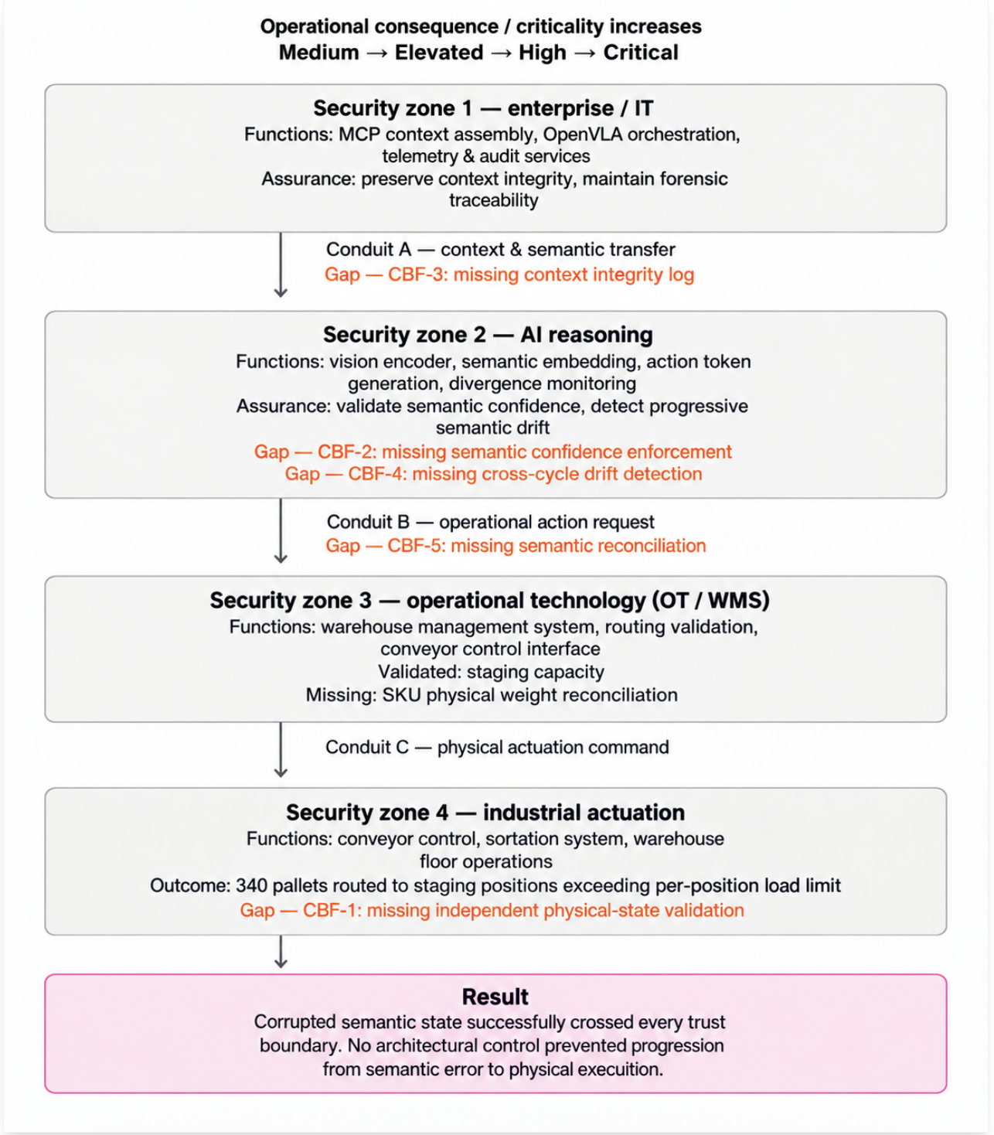
Figure ASCR-14B: Trust-Zone Segmentation and
Control Boundary Failure Across the VLA Operational Architecture
Viewed from an architectural perspective, the incident is no longer defined by an incorrect model prediction. Instead, it becomes a failure of layered trust management.
Each security zone fulfills a distinct operational responsibility while assuming that the semantic state received from the preceding zone remains trustworthy. Enterprise systems assume that contextual information is complete and auditable. The AI reasoning layer assumes that the perceived physical environment accurately reflects reality. Operational technology systems assume that AI-generated decisions are consistent with authoritative enterprise records. Finally, industrial control systems assume that commands arriving from upstream operational systems have already undergone sufficient validation.
These assumptions are reasonable only when independent assurance mechanisms exist at every trust boundary. In this scenario, each boundary forwards the corrupted semantic state without requiring additional evidence, allowing uncertainty introduced during perception to accumulate as operational certainty by the time industrial actuation occurs.
The absence of context integrity logging, semantic confidence enforcement, cross-cycle monitoring, cross-domain reconciliation, and independent physical-state validation collectively eliminates the layered defenses expected within a segmented industrial control architecture. The resulting unsafe physical outcome therefore represents the failure of multiple architectural assurance mechanisms rather than a single inference error.
Figures ASCR-14A and ASCR-14B together establish both the operational and architectural dimensions of the incident. The first explains how the semantic failure propagated through the perception-to-actuation pipeline; the second explains why the surrounding trust architecture failed to contain that propagation.
While Figure ASCR-14B identifies the architectural trust boundaries that failed, executive stakeholders require an assessment of the organizational significance of those failures. Table 3.3 translates each exercise-local Control Boundary Failure into operational severity, regulatory exposure, and recommended escalation priority.
Table 3.3 provides that perspective by mapping each Control Boundary Failure to its operational severity, regulatory implications, and recommended escalation level. Rather than describing system behavior, the table supports executive decision-making by identifying which architectural deficiencies present material organizational risk and therefore warrant immediate remediation or governance oversight.
Risk-rating calibration. The ratings in this table are synthetic exercise calibration, not legal conclusions. Regulatory Exposure must be localized against the operator's actual sector, entity status, jurisdiction, national implementation, and incident facts. A CRITICAL NIS2 or safety-reporting rating applies only after both regulatory applicability and the relevant reporting trigger have been confirmed.
CBF | Control Boundary  Failure | Operational  Severity | Regulatory  Exposure | Escalation  Level | Executive  Interpretation
CBF-1 | Cross-sensor validation absent | HIGH | MEDIUM | HIGH | Physical-state validation controls are ineffective, allowing erroneous sensor fusion to propagate
CBF-2 | Semantic confidence enforcement absent | HIGH | HIGH | HIGH | AI reasoning outputs are insufficiently bounded, allowing low-confidence inference to become executable action
CBF-3 | Context integrity logging absent | MEDIUM | HIGH | HIGH | Forensic reconstruction capability is degraded due to missing pre-reasoning state traceability
CBF-4 | Action-token drift-gradient monitoring absent | HIGH | MEDIUM | HIGH | Progressive semantic drift is not detected across cycles, allowing accumulation of latent error
CBF-5 | Cross-domain semantic reconciliation absent | CRITICAL | CRITICAL* | CRITICAL | Unsafe semantic state traverses into OT actuation layer without containment or interdiction
Table 3.3. Executive risk translation of Control Boundary Failure identifiers (CBF-1 through CBF-5) within a Vision-Language-Action cyber-physical system
*Scenario calibration only. Confirm the applicable regulatory regime and reporting trigger before treating a CRITICAL regulatory rating as an actual reporting or governance determination.
The table maps each exercise-local CBF class to operational risk severity, regulatory exposure, required escalation level, and executive interpretation. It serves as the governance layer of the ASCR-14 walkthrough, translating technical control failures into decision-relevant risk indicators for leadership, audit, and regulatory review.
Table 3.4. Rating Scale Used in Table 3.3
Operational Severity | LOW = Localized operational effect  MEDIUM = Workflow degradation  HIGH = Unsafe operational condition possible  CRITICAL = Direct physical-impact exposure
Regulatory Exposure | LOW = Internal governance issue  MEDIUM = Audit finding likely  HIGH = Potential reportable control deficiency  CRITICAL = Potential NIS2 / safety-reporting exposure
Escalation Level | LOW = Team-level tracking  MEDIUM = Security/operations management review  HIGH = Executive review required  CRITICAL = Immediate board-level escalation required

Where Figures ASCR-14A and ASCR-14B explain how the failure propagated and why segmentation controls failed to contain it, Table 3.3 translates those failures into operational severity, regulatory exposure, escalation level, and executive interpretation.

4. Exercise timeline
Pre-scenario: Overnight automated operation has been nominal by all available telemetry.
S+0:00: First misclassification occurs. EUR-1 pallet routed to EUR-2 staging location. No alert generated.
S+6:00: Approximately 180 pallets have been misrouted across approximately 72 planning cycles, each approximately 5 minutes in duration. The action-token drift score computed at the end of each individual cycle remains within acceptable threshold. No monitoring computes the gradient of action-token drift scores across cycles; the slow upward trend that would have been visible across the six-hour window is not instrumented.
S+11:00: Morning shift changeover. Floor supervisor observes physical congestion in staging area inconsistent with WMS allocation display.
S+11:14: Incident formally declared. Forensic reconstruction begins with no context_hash_before records and no cross-layer correlation identifiers available.
S+25:14: 14 hours of analyst time later, the perception→misclassification→routing chain is established through manual correlation of WMS routing logs, camera timestamp records, model confidence logs, and weight-sensor telemetry that were present but not integrated into any security monitoring pipeline.

4.1 Inject 1 — detection (deliver at E+10; scenario state S+0:00)
SITUATION: Overnight automated operation is running. Your NOC receives no alerts. Your SOC receives no alerts. Your WMS dashboard shows normal operation. No floor supervisor is present during the first 11 scenario hours.
INJECT: Your VLA model is currently misclassifying EUR-1 pallets as EUR-2 at a rate of approximately 31 pallets per hour.
FACILITATOR CALIBRATION NOTE: Before scoring detectability, record the scenario facility's total pallet-routing throughput for the same operating window and calculate 31 affected pallets per hour as a percentage of total routing events. If throughput has not been localized, treat 31 pallets per hour only as scenario load and do not infer whether routine WMS throughput or exception KPIs should have detected the condition.
Your weight sensors are recording gross pallet weights in the 850–940 kg range for the affected pallets. Your SKU database records show that the product loaded on these pallets has a unit weight profile consistent with EUR-1 floor loading; the synthetic scenario defines a maximum gross load of 600 kg per pallet position in the affected EUR-2 staging zone. This is a per-position operational limit, not an areal floor-load rating. The weight sensor telemetry directly contradicts the VLA's routing decision, but it feeds no validation gate. ASCR-07 context_hash_before capture and retention of the corresponding context pre-image or governed evidence object are not deployed.
DECISION POINT FOR CISO: What is your current Mean Time to Detection for a failure of this class — one that generates no network alert, no authentication failure, no syntactic API error, and no single-cycle anomaly? Is that MTTD documented anywhere in your incident response runbooks?
DECISION POINT FOR OT SECURITY MANAGER: Which non-visual telemetry sources — weight sensors, LiDAR, ultrasonic sensors, RFID readers — are currently integrated into your VLA decision pipeline? Which are available but not integrated? What is the documented reason for each gap?
DECISION POINT FOR CYBER ARCHITECT: Your action_token_drift_score monitoring triggers on per-cycle anomalies. Gradient analysis across cycles is not deployed. At what point in this failure timeline would your current monitoring have produced an alert?

4.2 Inject 2 — escalation (deliver at E+30; scenario state S+11:00)
SITUATION: The floor supervisor has declared an incident. 340 pallets have been misrouted. Your forensic team has WMS routing logs, camera timestamp records, model confidence logs, and weight-sensor telemetry, but no context_hash_before records, no corresponding retained context pre-images or governed evidence objects, and no cross-layer correlation identifiers. The evidence resides across multiple separate systems with no shared trace ID.
INJECT: Your CISO is asking two questions simultaneously: Is this an environmental failure or an adversarial attack? And how long has it been occurring?
DECISION POINT FOR SOC LEAD: What specific data points — available in your current logging architecture — would allow you to distinguish between thermal calibration drift and deliberate adversarial sensor manipulation within the first hour of investigation? If you cannot distinguish them, what is your default incident response posture?
DECISION POINT FOR CYBER ARCHITECT: Manual forensic reconstruction is estimated at 14 hours given current logging. If the full MCP context payload — including prompt, retrieved inventory state, and tool call parameters — had been serialized and hashed at each planning cycle, and if that payload had been retained alongside its hash, what would the reconstruction timeline be? Walk through which steps in the current 14-hour manual process become automated lookups versus which still require analyst judgment.
DECISION POINT FOR WMS INTEGRATION OWNER: Your WMS accepted 340 syntactically valid routing commands that contradicted physical reality. Does your current WMS integration have circuit-breaker logic that pauses actuation when inferred pallet type conflicts with SKU weight records in the product database? If not, what would implementing that cross-reference validation require?

DECISION POINT FOR SOC LEAD / CISO: Using the current ASCR-08 response framework, state the preliminary incident classification you would assign at this point, the containment or escalation path you would initiate, and the evidence that must be preserved before remediation changes the affected system state. Identify any fact still missing that prevents a defensible classification.

4.3 Inject 3 — strategic control (deliver at E+55; scenario state S+25:14)
SITUATION: The incident is contained. Physical inspection identifies progressive mounting-bracket/fastener shift on the affected cameras, and controlled recalibration eliminates the misclassification. The retained digital telemetry alone did not distinguish environmental drift from deliberate sensor manipulation before that physical examination. For this synthetic scenario, root cause is therefore attributed to non-adversarial calibration drift. Your board wants assurance this cannot happen again and cannot be exploited deliberately. Your regulator is asking how the organization will demonstrate the applicable EU AI Act Article 15(5) cybersecurity and adversarial-resilience requirements by the relevant application date.
INJECT: Your VLA model is provided by a third-party vendor. The model fine-tuning pipeline, the uncertainty estimation configuration, and the action token weighting logic are not directly accessible to your security team.
DECISION POINT FOR CISO: Environmental drift and adversarial sensor spoofing are functionally indistinguishable at the telemetry layer when cross-layer observability is absent. How does your current risk register treat this equivalence? Is adversarial sensor manipulation modeled in your deployment's threat analysis / risk assessment (TARA), or in its equivalent threat model and risk assessment?
DECISION POINT FOR CYBER ARCHITECT: Implementing ASCR-07 context_hash_before capture at the MCP context boundary, together with retention of the corresponding context pre-image or governed evidence object in the ASCR-07 companion evidence store, would improve forensic reconstruction of the pre-reasoning context state. Physics-based cross-sensor consistency checking at the perception layer could have reduced the detection window from 11 hours to approximately one planning cycle, approximately 5 minutes at this facility's scenario cycle rate. What is the implementation timeline and resource requirement for each control in your current architecture?
DECISION POINT FOR SAFETY ENGINEER: Does the proposed pre-actuation validation change alter a safety-relevant actuation path or operational safe-state assumption? What management-of-change, hazard-analysis, validation, and approval steps are required before it becomes blocking?
DECISION POINT FOR COMPLIANCE OFFICER: What exercise record, technical evidence, applicability determination, and remediation record must be retained to support the organization's applicable risk-management, quality-management, and incident-reporting obligations?
DECISION POINT FOR VLA SYSTEM OWNER: What Service Level Objectives exist in your vendor contract for model accuracy under degraded hardware conditions — specifically, sensor calibration drift beyond a defined tolerance? If none exist, what is the process for adding them at contract renewal?
DECISION POINT FOR CISO - EU AI Act: Article 15(5) addresses resilience of high-risk AI systems against attempts by unauthorized parties to alter their use, outputs, or performance through exploitation of system vulnerabilities. For VLA systems whose outputs are physical actuation commands, the attack surface includes the perception layer: an adversary who can manipulate what the vision encoder sees can alter actuation without touching the network or the API. A conformity assessment that excludes physical-world perception testing leaves a material attack vector unevaluated. This is an interpretive position; organizations should validate scope with their notified body or legal counsel. Where Article 15(5) applies to this deployment, does your current lifecycle or conformity-assessment process include physical-world adversarial testing of the VLA perception layer? If not, what evidence supports the current robustness determination and what is the gap-closure timeline?

5. Tabletop exercise (TTX) debrief framework
Following all three injects, the facilitator should guide the group through five closing questions before scoring:
- On detection: What is your actual MTTD for semantic failure classes that generate no infrastructure-layer alerts — and is that number documented, tested, and acceptable given the operational consequence profile of your VLA deployment?
- On forensics: Can your current logging architecture reconstruct the perception→reasoning→actuation chain for any given actuation event without manual cross-system correlation? If not, which specific logging gap is the highest priority to close?
- On incident response: Did the team use the ASCR-08 classification and response framework to distinguish detection of the semantic failure from the decisions required for containment, evidence preservation, escalation, and eventual recovery? Which evidence was necessary before those decisions could be made defensibly?
- On adversarial equivalence: Given that environmental drift and adversarial manipulation are forensically indistinguishable without cross-layer observability, does your security program treat sensor integrity as a security control or solely as an operational maintenance requirement?
- On regulatory posture: If this VLA deployment is classified as high-risk under the applicable EU AI Act Article 6 route, is the applicable Article 15(5) cybersecurity and adversarial-resilience evaluation documented, current, and scoped to the physical-world perception attack surface relevant to the deployment?
Use the closing questions above to structure the debrief discussion. Do not calculate a separate three-axis maturity score. The Facilitator's Scorecard below is the sole scored instrument for ASCR-14.

6. Facilitator expected patterns - do not distribute before the exercise
Organizations that have not deployed cross-layer observability commonly find that their MTTD for this failure class is bounded by human observation (e.g., shift changeover, physical inspection, customer complaint) rather than by instrumented detection. The 11-hour window in this scenario is not the worst case. It is the predictable output of a monitoring stack that starts at the API layer and treats the sensor as out of scope. This exercise surfaces that gap. An operational incident surfaces it with 340 misrouted pallets and a 14-hour reconstruction timeline.

7. Maturity check: the high-maturity response
A high-maturity security organization will demonstrate the following capabilities during the debrief. If these were not identified during the exercise, they should be prioritized as immediate remediation targets:
- Automated Circuit Breaking: The organization would have flagged the first misclassification at S+0:00 because a pre-actuation "gate" compares VLA inference (EUR-2) against independent physical telemetry (Weight Sensor) and SKU ground truth.
- Semantic Traceability: The SOC can provide a single Trace ID that links the raw camera frame, the retained pre-reasoning context evidence verified against ASCR-07 context_hash_before, and the WMS API call.
- Drift Analytics: The monitoring stack utilizes gradient analysis over a sliding window of planning cycles to detect the slow-burn of progressive calibration drift before it leads to physical staging congestion.
- Adversarial Sensor Testing: The CISO can produce a recent Adversarial Robustness Evaluation that specifically tests the vision encoder's resilience to parallax, occlusion, and lighting shifts as relevant to the applicable EU AI Act Article 15(5) cybersecurity and adversarial-resilience evaluation.

8. Facilitator’s scorecard: VLA semantic resilience
This Facilitator’s Scorecard is designed to provide a structured, objective assessment of participant responses during the VLA Semantic Failure Tabletop Exercise. It enables the facilitator to move beyond qualitative discussion and generate a "Maturity Profile" for the organization’s VLA security posture.

8.1 Scoring rubric
- Level 1 (Reactive): Detection relies on human observation; no cross-layer logging; forensic process is manual.
- Level 2 (Inconsistent): Basic telemetry exists but is siloed; logic lacks cross-reference validation.
- Level 3 (Defined): Integrated logging and basic anomaly thresholds; formal incident response for AI/ML is documented. Telemetry from at least two pipeline layers (e.g., perception and WMS) is correlated in a single monitoring view. A documented incident response procedure specific to AI/ML system failures exists and has been reviewed within the deployment-defined incident-response procedure review interval.
- Level 4 (Quantifiable): Cross-layer observability enabled; per-cycle action-token drift scores active; trace IDs across MCP/WMS layers.
- Level 5 (Optimized): Real-time physics-based validation; tamper-evident ASCR-07 decision-lineage evidence with cross-layer Trace IDs; automated circuit breakers based on semantic divergence.
Criterion | Level 1 observable state | Level 3 observable state | Level 5 observable state
MTTD Accuracy | Detection depends on human observation; no defensible MTTD | MTTD documented from available telemetry and reviewed | MTTD tested using instrumented evidence and repeatable measurement
Telemetry Fusion | Independent sensors not used in decision assurance | Independent telemetry correlated or displayed but non-blocking | Independent physical telemetry participates in validated pre-actuation enforcement
Gradient Analysis | No multi-cycle analysis | Documented multi-cycle threshold with alerting | Validated multi-cycle trend analytics integrated with governed response
Traceability | Manual multi-system correlation required | Shared identifier across at least two pipeline layers | Single trace links perception evidence, context state, decision, and actuation
Attribution Speed | No documented attribution path | Documented process uses preserved evidence | Tested process demonstrates timely environmental/adversarial differentiation or a justified Indeterminate classification
Evidence Integrity | Mutable or siloed logs | Centralized timestamped evidence with controlled access | Tamper-evident ASCR-07 evidence chain for relevant decision state
Semantic Validation | No independent reconciliation | Non-blocking independent cross-check with alerting | Governed blocking or safe-state validation in the pre-actuation path
Adversarial Modeling | Sensor manipulation absent from threat model | Physical perception manipulation included | Threat model is exercised and mitigations are tracked and tested
Vendor Governance | No degraded-condition SLO | Measurable degraded-condition behavior defined | SLO is testable, audited, and linked to remediation or escalation rights
Applicable Article 15(5) Posture | No applicability or evaluation record | Applicability and evaluation plan documented | Current evidenced evaluation with documented applicability review
Conformity Evidence | No relevant physical-world evidence | Representative physical-world test evidence retained | Repeatable physical-world test evidence linked to applicable lifecycle or conformity documentation

Levels 2 and 4 may be used only when the available evidence falls demonstrably between the
adjacent observable anchors.

A note for the facilitators: The tables below constitute the in-document Facilitator's Scorecard. If a controlled fillable worksheet is delivered with the ASCR-14 artifact set, use it for data entry; otherwise use these tables directly. Do not assume a companion worksheet exists unless it is present in the delivered set. The tables below define the assessment criteria and target maturity for pre-exercise calibration.

8.2 Phase 1: detection & observability
Assessment Criteria | Target Maturity | Assessed Level (1-5) | Key Observations / Gaps
MTTD Accuracy: Ability to define and defend a specific Mean Time to Detection for silent semantic failures. | Level 4
Telemetry Fusion: Integration of non-visual sensors (weight/LiDAR) into the VLA decision pipeline. | Level 5
Gradient Analysis: Deployment of monitoring that detects systematic drift across cycles rather than single-event spikes. | Level 4

8.3 Phase 2: forensic readiness & attribution
Assessment Criteria | Target Maturity | Assessed Level (1-5) | Key Observations / Gaps
Traceability: Use of a shared cross-layer Trace ID linking Perception, Reasoning, and Actuation evidence, with ASCR-07 context_hash_before and the corresponding retained context pre-image or evidence object available to verify and inspect the pre-reasoning context state. | Level 5
Attribution Speed: Capability to distinguish between environmental drift and adversarial injection within the deployment-defined attribution-time objective, or to reach and document a justified Indeterminate classification within that objective. | Level 4
Evidence Integrity: Presence of tamper-evident ASCR-07 decision-lineage records together with the retained context pre-image or evidence object and execution evidence required to verify and reconstruct the relevant MCP tool-calling event. | Level 5

8.4 Phase 3: architectural integrity & control
Assessment Criteria | Target Maturity | Assessed Level (1-5) | Key Observations / Gaps
Semantic Validation: Existence of a "circuit breaker" that compares VLA inference against ground-truth SKU databases. | Level 5
Adversarial Modeling: Inclusion of physical-world perception attacks in the current threat analysis / risk assessment (TARA), or equivalent threat model. | Level 4
Vendor Governance: Defined SLOs for model performance under degraded sensor conditions or high-uncertainty environments. | Level 3

8.5 Phase 4: regulatory & compliance (EU AI Act focus)
Assessment Criteria | Target Maturity | Assessed Level (1-5) | Key Observations / Gaps
Applicable Article 15(5) Posture: Documented cybersecurity and adversarial-resilience evaluation for VLA components where the applicable high-risk classification route makes Article 15(5) relevant. | Level 4
Conformity Evidence: Evidence of physical-world testing retained in the applicable AI system lifecycle or conformity-assessment documentation. | Level 4

8.6 Scoring interpretation
Record one facilitator-assessed level for each criterion using the criterion-specific evidence anchors above. Do not average maturity levels into a composite arithmetic score. Report the full eleven-criterion profile, the number of criteria below their calibrated target, and the number assessed at Level 1 or Level 2. Any individual criterion below Level 3 is a critical gap for remediation tracking. The Critical Fail Condition in the Facilitator Summary takes precedence over all summary reporting.

9. Facilitator summary & post-exercise actions

9.1 Critical fail condition
If the organization scores Level 1 or Level 2 in both Telemetry Fusion and Traceability, no combination of high scores elsewhere compensates. A facility in this state has no instrumented mechanism to detect a semantic failure before it manifests as a physical event. Treat this condition as a priority remediation finding regardless of stronger scores elsewhere.

9.2 Hotwash and after-action
Conduct a 15-minute hotwash immediately after scoring. The exercise record must capture participants and roles, actual inject-delivery times, material decisions, evidence cited, and every identified gap. Score each finding using the applicable ASCR-01 risk methodology, assign an accountable owner using the applicable ASCR-13 role definitions, and record a target remediation date. Transfer open findings into the applicable ASCR-12 tracking process and retain the exercise record under the applicable ASCR-07 evidence-retention and integrity requirements. A gap without a named owner and target date remains an observation rather than a closed remediation finding.

9.3 High-priority recommendations
- Immediate remediation: Within the deployment-defined immediate-remediation target, implement the ASCR-07 planning-cycle decision record for this path, including context_hash_before, the corresponding retained context pre-image or evidence object required by ASCR-07, and the required chain-integrity and Merkle-notarization mechanisms, so the pre-reasoning context can be verified and inspected and the downstream decision chain can be reconstructed. Do not treat a hash value without its required retained evidence, an application-layer payload hash, or a generic append-only log as a substitute for the ASCR-07 evidence specification.
- Short-term remediation: Within the deployment-defined short-term-remediation target, add independent weight-sensor and authoritative SKU ground truth to the deployment-specific hard-constraint evaluation in the ASCR-06 pre-actuation path invoked through ASCR-04 Layer 6. Before blocking enforcement is commissioned, define the tolerance band, sensor-unavailable behavior, breach disposition, and Safe-State consequence; validate false-hold behavior in governed shadow mode; and complete applicable safety and management-of-change review.
- Strategic, at next contract renewal: Update third-party VLA vendor contracts to include explicit, measurable performance tolerances for degraded sensor conditions, including calibration drift beyond the deployment-defined tolerance. Where EU AI Act Article 15(5) applies, require vendor participation in the documented cybersecurity and adversarial-resilience evaluation relevant to physical-world perception attacks.
The phase maturity criteria in this scorecard map to the Measure and Manage functions of the NIST AI Risk Management Framework (AI RMF 1.0) and to the risk-management, accuracy, robustness and cybersecurity, and quality-management requirements reflected in EU AI Act Articles 9, 15, and 17, respectively.

