1
Introduction to Clustering
Learning Objectives
By the end of this chapter, you will be able to distinguish between supervised learning and unsupervised learning. You will learn about clustering and, using this knowledge, you will be able to implement k-means clustering algorithms using built-in Python packages and calculate the Silhouette Score.
Introduction
Have you ever been asked to take a look at some data and come up empty handed? Maybe you were not familiar with the dataset, or maybe you didn't even know where to start. This may have been extremely frustrating, and even embarrassing, depending on who asked you to take care of the task.
You are not alone, and, interestingly enough, there are many times the data itself is simply too confusing to be made sense of. As you try and figure out what all those numbers in your spreadsheet mean, you're most likely mimicking what many unsupervised algorithms do when they try to find meaning in data. The reality is that many datasets in the real world don't have any rhyme or reason to them. One example to consider is the fact that these days, individuals generate massive amounts of granular data on a daily basis – whether it’s their actions on a website, their purchase history, or what apps they use on their phone. If you were to look at this information on the surface it would be big, unorganized mess with no hope of clarity. Don’t fret, however; this book will prepare you for such tall tasks so that you'll never be frustrated again when dealing with data exploration tasks no matter how large.
For this book, we have developed some best-in-class content to help you understand how unsupervised algorithms work and where to use them. We'll cover some of the foundations of finding clusters in your data, how to reduce the size of your data so it's easier to understand, and how each of these sides of unsupervised learning can be applied in the real world. We hope you will come away from this book with a strong real-world understanding of unsupervised learning, the problems that it can solve, and those it cannot.
Unsupervised Learning versus Supervised Learning
Unsupervised learning is the field of practice that helps find patterns in cluttered data and is one of the most exciting areas of development in machine learning today. If you have explored machine learning bookwork before, you are probably familiar with the common breakout of problems in either supervised or unsupervised learning. Supervised learning encompasses the problem set of having a labeled dataset that can be used to either classify data (for example, predicting smokers and non-smokers, if you're looking at a lung health dataset) or finding a pattern in clearly defined data (for example, predicting the sale price of a home based on how many bedrooms it has). This model most closely mirrors an intuitive human approach to learning.
For example, if you wanted to learn how to not burn your food with a basic understanding of cooking, you could build a dataset by putting your food on the burner and seeing how long it takes (input) for your food to burn (output). Eventually, as you continue to burn your food, you will build a mental model of when burning will occur and avoid it in the future. Development in supervised learning was once fast-paced and valuable, but it has since simmered down in recent years. Many of the obstacles to knowing your data have already been tackled and are listed in the following figure:
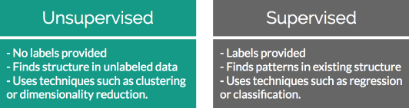
Figure 1.1: Differences between unsupervised and supervised learning
Conversely, unsupervised learning encompasses the problem set of having a tremendous amount of data that is unlabeled. Labeled data, in this case, would be data that has a supplied "target" outcome that you are trying to find the correlation to with supplied data. For instance, in the preceding example, you know that your “target outcome” is whether your food was burned; this is an example of labeled data. Unlabeled data is when you do not know what the "target" outcome is, and you only have supplied input data.
Building upon the previous example, imagine you were just dropped on planet Earth with zero knowledge of how cooking works. You are given 100 days, a stove, and a fridge full of food without any instructions on what to do. Your initial exploration of a kitchen could go in infinite directions. On day 10, you may finally learn how to open the fridge; on day 30, you may learn that food can go on the stove; and after many more days, you may unwittingly make an edible meal. As you can see, trying to find meaning in a kitchen devoid of adequate informational structure leads to very noisy data that is completely irrelevant to actually preparing a meal.
Unsupervised learning can be an answer to this problem. By looking back at your 100 days of data, you can use clustering to find patterns of similar days where a meal was produced, and you can easily review what you did on those days. However, unsupervised learning isn't a magical answer. Simply finding clusters can be just as likely to help you to find pockets of similar yet ultimately useless data. Expanding on the cooking example, we can illustrate this shortcoming with the concept of the “third variable.” Just because you have a cluster of really great recipes doesn’t mean they are infallible. During your research you may have found a unifying factor that all good meals were cooked on a stove. This does not mean that every meal cooked on a stove will be good, and you cannot easily jump to that conclusion for all future scenarios.
This challenge is what makes unsupervised learning so exciting. How can we find smarter techniques to speed up the process of finding clusters of information that are beneficial to our end goals?
Clustering
Being able to find groups of similar data that exist in your dataset can be extremely valuable if you are trying to find its underlying meaning. If you were a store owner and you wanted to understand which customers are more valuable without a set idea of what valuable is, clustering would be a great place to start to find patterns in your data. You may have a few high-level ideas of what denotes a valuable customer, but you aren't entirely sure in the face of a large mountain of available data. Through clustering, you can find commonalities among similar groups in your data. If you look more deeply at a cluster of similar people, you may learn that everyone in that group visits your website for longer periods of time than others. This can show you what the value is and also provide a clean sample size for future supervised learning experiments.
Identifying Clusters
The following figure shows two scatterplots:
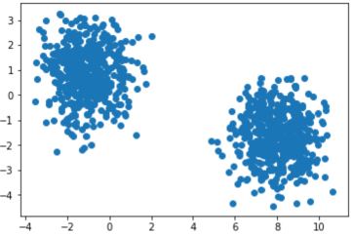
Figures 1.2: Two distinct scatterplots
The following figure separates the scatterplots into two distinct clusters:
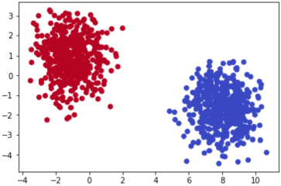
Figure 1.3: Scatterplots clearly showing clusters that exist in a provided dataset
Both figures display randomly generated number pairs (x,y coordinates) pulled from a Gaussian distribution. Simply by glancing at Figure 1.2, it should be plainly obvious where the clusters exist in your data; in real life, it will never be this easy. Now that you know that the data can be clearly separated into two clusters, you can start to understand what differences exist between the two groups.
Rewinding a bit from where unsupervised learning fits into the larger machine learning environment, let's begin by understanding the building blocks of clustering. The most basic definition finds clusters simply as groupings of similar data as subsets of a larger dataset. As an example, imagine that you had a room with 10 people in it and each person had a job either in finance or as a scientist. If you told all of the financial workers to stand together and all the scientists to do the same, you would have effectively formed two clusters based on job types. Finding clusters can be immensely valuable in identifying items that are more similar, and on the other end of the scale, quite different from each other.
Two-Dimensional Data
To understand this, imagine that you were given a simple 1,000-row dataset by your employer that had two columns of numerical data as follows:
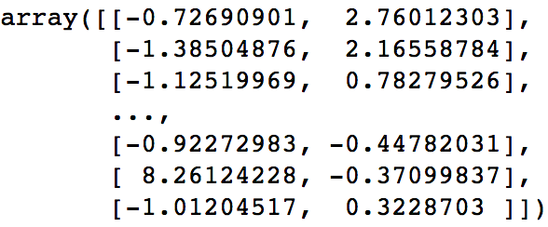
Figures 1.4: Two-dimensional raw data in an array
At first glance, this dataset provides no real structure or understanding.
A dimension in a dataset is another way of simply counting the number of features available. In most organized data tables, you can view the number of features as the number of columns. So, using the 1,000-row dataset example of size (1,000 x 2), you will have 1,000 observations across two dimensions:
You begin by plotting the first column against the second column to get a better idea of what the data structure looks like. There will be plenty of times where the cause of differences between groups will prove to be underwhelming, however the cases that have differences that you can take action on are extremely rewarding.
Exercise 1.01: Identifying Clusters in Data
You are given two-dimensional plots. Please look at the provided two-dimensional graphs and identify the clusters to drive the point home that machine learning is important. Without using any algorithmic approaches, identify where the clusters exist in the data.
This exercise will help start to build your intuition of how we identify clusters using our own eyes and thought processes. As you complete the exercises, think of the rationale of why a group of data points should be considered a cluster versus a group that should not be considered a cluster:
- Identify the clusters in the following scatterplot:
- 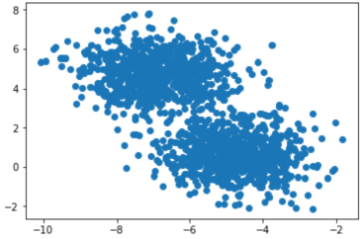
Figure1.5 Two-dimensional scatterplot
- The clusters are as follows:
- 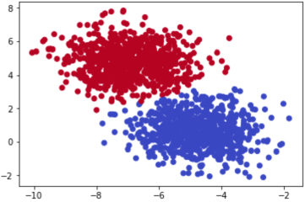
Figure 1.6: Clusters in the scatterplot
- Identify the clusters in the scatterplot:
- 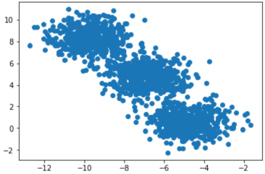
Figure1.7: Two-dimensional scatterplot
- The clusters are as follows:
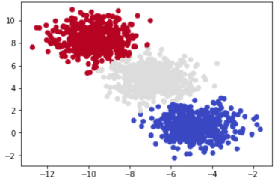
Figure 1.8: Clusters in the scatterplot
- Identify the clusters in the scatterplot:
- 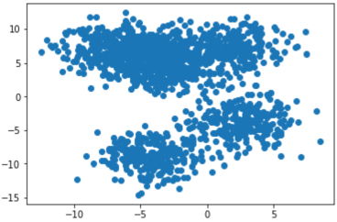
Figure1.9: Two-dimensional scatterplot
- The clusters are as follows:
- 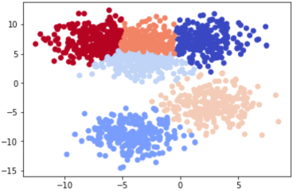
Figure 1.10: Clusters in the scatterplot
- Most of these examples were likely quite easy for you to understand, and that's the point. The human brain and eyes are incredible at finding patterns in the real world. Within milliseconds of viewing each plot, you could tell what fitted together and what didn't. While it is easy for you, a computer does not have the ability to see and process plots in the same manner that we do. However, this is not always a bad thing. Look back at Figure 1.10. Were you able to find the six discrete clusters in the data just by looking at the plot? You probably found only three to four clusters in this figure, while a computer is able to see all six. The human brain is magnificent, but it also lacks the nuances that come within a strictly logic-based approach. Through algorithmic clustering, you will learn how to build a model that works even better than a human at these tasks.
Let's look at the algorithm in the next section.
Introduction to k-means Clustering
Hopefully, by now, you can see that finding clusters is extremely valuable in a machine learning workflow. But, how can you actually find these clusters? One of the most basic yet popular approaches is by using a cluster analysis called k-means clustering. k-means works by searching for K clusters in your data and the workflow is actually quite intuitive. We will start with the no-math introduction to k-means, followed by an implementation in Python.
No-Math k-means Walkthrough
The no-math algorithm for k-means clustering is pretty simple:
- 1. First, pick ‘K’ centroids where ‘K’ would be the expected distinct number of clusters.
- 2. Then place the number of ‘K’ centroids you chose anywhere amongst your existing training data.
- 3. Calculate the distance from each centroid to all the points in your training data. We will go into detail on distance functions shortly, but for now just consider it as how far away points are from each other.
- Group all your training points in with their nearest centroid.
- Once you have all your groups surrounding centroids, calculate the mean data point in the group and move your centroid to that location.
- Repeat this process until convergence, or when the membership in each group no longer changes.
And that's it. Here is the process laid out step-by-step with a simple cluster example:
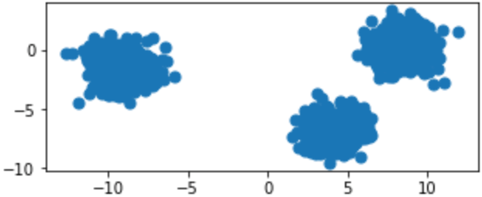
Figure 1.11: Original raw data charted on x,y coordinates
Provided with the original data in Figure 1.11, we can show the iterative process of k-means by showing the predicted clusters in each step:
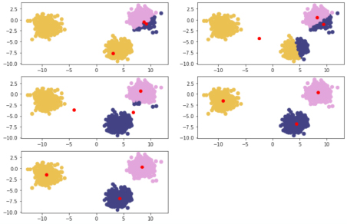
Figure 1.12: Reading from left to right; red points are randomly initialized centroids, and the closest data points are assigned to groupings of each centroid
k-means Clustering In-Depth Walkthrough
To understand k-means at a deeper level, let's walk through the example given in the introductory section again with some of the math that supports k-means. The most important math that underpins this algorithm is the distance function. A distance function is basically any formula that allows you to quantitatively understand how far one object is from another, with the most popular one being the Euclidean distance formula. This formula works by subtracting the components of each point and squaring to remove negatives, followed by adding the resulting distances and square rooting them:
Figure 1.13: Euclidean distance formula
Centroids are randomly set at the beginning as points in your n-dimensional space. Each of these centers is fed into the preceding formula as (a, b), and a point in your space is fed in as (x, y). Distances are calculated between each point and the coordinates of every centroid, with the centroid the shortest distance away chosen as the point's group.
As an example, let's pick three random centroids, an arbitrary point, and, using the Euclidean distance formula, calculate the distance from each point to the centroid:
- 1. Random Centroids: [ (2,5) , (8,3) , (4, 5) ]
- 2. Arbitrary point x: (0, 8)
- 3. Distance from point to each centroid: [ 3.61, 9.43, 5.00 ]
- Since the arbitrary point x is closest to the first centroid, it will be assigned to the first centroid.
Alternative Distance Metric: Manhattan Distance
Euclidean distance is the most common distance metric for many machine learning applications and is often known colloquially as the distance metric; however, it is not the only, or even the best, distance metric for every situation. Another popular distance metric in use for clustering is Manhattan distance.
Manhattan distance is called as such because it mirrors the concept of traveling through a metropolis (such as New York City) that has many square blocks. Euclidean distance relies on diagonals due to its basis in Pythagorean theorem, while Manhattan distance constrains distance to only right angles. The formula for Manhattan distance is as follows:
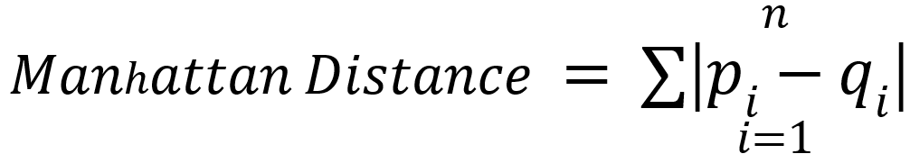
Figure 1.14: Manhattan distance formula
Here, p_{i} and q_{i} are x and y values of individual points as in Euclidean distance. Building upon our examples of Euclidean distance, where we want to find the distance between two points, if our two points were (1,2) and (2,3), then the Manhattan distance would equal |1-2| + |2-3|. This functionality scales to any number of dimensions. In practice, Manhattan distance may outperform Euclidean distance when it comes to higher dimensional data.
Deeper Dimensions
The preceding examples are clear to visualize when your data is only two-dimensional. This is for convenience, to help drive the point home of how k-means works and could lead you into a false understanding of how easy clustering is. In many of your own applications, your data will likely be orders of magnitude larger to the point that it cannot be perceived by visualization (anything beyond three dimensions will be unperceivable to humans). In the previous examples, you could mentally work out a few two-dimensional lines to separate the data into its own groups. At higher dimensions, you will need to be aided by a computer to find an n-dimensional hyperplane that adequately separates the dataset. In practice, this is where clustering methods such as k-means provide significant value.
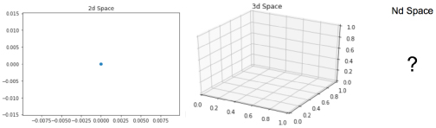
Figure 1.15: Two-dimensional, three-dimensional, and n-dimensional plots
In the next exercise, we will calculate Euclidean distance. We’ll build our set of tools here by using the Python packages NumPy and Math. NumPy is a scientific computing package for Python that pre-packages common mathematical functions in highly-optimized formats. As the name implies, the Math package is a basic library that makes implementing foundational math building blocks such as exponentials and square roots much easier. By using a package such as NumPy or Math, we help cut down the time spent creating custom math functions from scratch and instead focus on developing our solutions. You will see how each of these packages is used in practice with the following exercise.
Exercise 1.02: Calculating Euclidean Distance in Python
In this exercise, we will create an example point along with three sample centroids to help illustrate how Euclidean distance works. Understanding this distance formula is foundational to the rest of our work in clustering.
Perform the following steps to complete this exercise:
- Open a Jupyter notebook and create a naïve formula that captures the direct math of Euclidean distance, as follows:
import math
import numpy as np
def dist(a, b):
return math.sqrt(math.pow(a[0]-b[0],2) + math.pow(a[1]-b[1],2))
- This approach is considered naïve because it performs element-wise calculations on your data points (slow) compared to a more real-world implementation using vectors and matrix math to achieve significant performance increases.
- Create the data points in Python as follows:
centroids = [ (2, 5), (8, 3), (4,5) ]
x = (0, 8)
- Use the formula you created to calculate the Euclidean distance in Step 1:
centroid_distances =[]
for centroid in centroids:
centroid_distances.append(dist(x,centroid))
print(centroid_distances)
print(np.argmin(centroid_distances))
- The output is as follows:
[3.605551275463989, 9.433981132056603, 5.0]
0
- Since Python is zero-indexed, a position of zero as the minimum in our list of centroid distances signals to us that the example point, x, will be assigned to the number one centroid of three.
In this example, our formula was used on a single point, x (0, 8). Beyond this single point, the same process will be repeated for every remaining point in your dataset until each point is assigned to a cluster. After each point is assigned, the mean point is calculated among all of the points within each cluster. The calculation of the mean among these points is the same as calculating a mean between single integers.
While there was only one point in the example above, by completing the process you have effectively assigned a point to its first cluster using Euclidean distance. Let’s build upon this approach with more than one point in the following exercise.
Exercise 1.03: Forming Clusters with the Notion of Distance
It is very intuitive for our human minds to see groups of dots on a plot and determine which dots belong to discrete clusters. However, how do we ask a naïve computer to repeat this same task? In this exercise, you help teach a computer an approach to forming clusters of its own with the notion of distance. We will build upon how we use these distance metrics in the next exercise:
- 1. Create a list of points, [ (0,8), (3,8), (3,4) ], that are assigned to cluster one:
cluster_1_points =[ (0,8), (3,8), (3,4) ]
- 2. To find the new centroid amongst your list of points, calculate the mean point between all of the points to find the new centroid. In the case of having multi-dimensional points, this is achieved by adding the integers at from each respective place in the point and dividing by number of points:
mean =[ (0+3+3)/3, (8+8+4)/3 ]
print(mean)
- The output is as follows:
[2.0, 6.666666666666667]
- 3. After a new centroid is calculated, repeat the cluster membership calculation seen in Exercise 2, Calculating Euclidean Distance in Python, and then the previous two steps to find the new cluster centroid. Eventually, the new cluster centroid will be the same as the one you had entering the problem, and the exercise will be complete. How many times this repeats depends on the data you are clustering.
Once you have moved the centroid location to the new mean point of (2, 6.67), you can compare it to the initial list of centroids you entered the problem with. If the new mean point is different than the centroid that is currently in your list, you will have to go through another iteration of the preceding two exercises. Once the new mean point you calculate is the same as the centroid you started the problem with, you have completed a run of k-means and reached a point called convergence.
In the next exercise, we will implement k-means from scratch. To do this we will start employing common packages from the Python ecosystem that will serve as building blocks for the rest of your career. One of the most popular machine learning libraries is scikit-learn, which has many built in algorithms and functions to support your understanding of how the algorithms work. In the next exercise we will be using a generative function to create dummy data that will be clustered using your custom coded k-means algorithm. We will also be using functions from SciPy, which is a package much like NumPy from before that abstracts away basic scientific math functions that allow for more efficient deployment. Finally, the next exercise will introduce matplotlib, which is a plotting library that creates graphical representations of the data you are working with. By incorporating plots into your research you not only make your work easier to understand during the process, but also have easier to digest outputs for non-technical audiences.
Exercise 1.04: Implementing k-means from Scratch
In this exercise, we will have a look at the implementation of k-means from scratch. This exercise relies on scikit-learn, an open-source Python package that enables the fast prototyping of popular machine learning models. Within scikit-learn, we will be using the datasets functionality to create a synthetic blob dataset. In addition to harnessing the power of scikit-learn, we will also rely on Matplotlib, a popular plotting library for Python that makes it easy for us to visualize our data. To do this, perform the following steps:
- Import the necessary libraries:
from sklearn.datasets import make_blobs
import matplotlib.pyplot as plt
import numpy as np
import math
%matplotlib inline
- Generate a random cluster dataset to experiment on X = coordinate points, y = cluster labels, and define random centroids. We will achieve this with the make_blobs function that we imported from sklearn.datasets, which as the name implies, generates blobs of data points. Please review the sklearn documentation to learn how to tweak the parameters provided below:
X, y = make_blobs(n_samples=1500, centers=3,
n_features=2, random_state=800)
centroids = [[-6,2],[3,-4],[-5,10]]
- Print the data:
X
- The output is as follows:
array([[-3.83458347, 6.09210705],
[-4.62571831, 5.54296865],
[-2.87807159, -7.48754592],
...,
[-3.709726 , -7.77993633],
[-8.44553266, -1.83519866],
[-4.68308431, 6.91780744]])
- Plot the coordinate points using the scatterplot functionality we imported from matplotlib.pyplot. This function takes input lists of points and presents them graphically for easier understanding. Please review the matplotlib documentation if you want to explore the provided parameters at a deeper level:
plt.scatter(X[:, 0], X[:, 1], s=50, cmap='tab20b')
plt.show()
- The plot looks as follows:
- 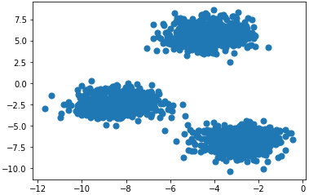
Figure 1.16: Plot of the coordinates
- Print the array of y:
y
- The output is as follows:
array([2, 2, 1, ..., 1, 0, 2])
- Plot the coordinate points with the correct cluster labels:
plt.scatter(X[:, 0], X[:, 1], c=y,s=50, cmap='tab20b')
plt.show()
- The plot looks as follows:
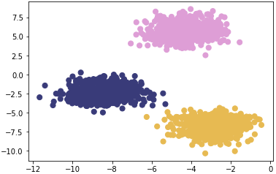
Figure 1.17: Plot of the coordinates with correct cluster labels
After completing the above exercise you will have implemented k-means from scratch on a dataset generated from scikit-learn. Not only are you now more familiar with the code and math that goes into the clustering algorithm, you’ve also learned how to present your findings in a clear manner that allows understanding from other stakeholders. In the next exercise we will continue to build your unsupervised learning toolset by introducing an optimized version of the Euclidean distance function from the SciPy package, cdist. You will compare a non-vectorized, clearly understandable version of the approach with cdist, wich has been specially tweaked for maximum performance.
Exercise 5: Implementing k-means with Optimization
Let's recreate these results on our own. We will go over an example implementing this with some optimizations. This exercise is built on top of the previous exercise and should be performed in the same Jupyter notebook. For this exercise, we will rely on SciPy, a Python package that allows easy access to highly optimized versions of scientific calculations. In particular, we will be implementing Euclidean distance with cdist, the functionally of which replicates the barebones implementation of our distance metric in a much more efficient manner:
- The basis of this exercise will be comparing basic implementation of Euclidean distance with an optimized version provided in SciPy. First import the optimized Euclidean distance, followed by creating the function on your own: The non-vectorized implementation of Euclidean distance is as follows:
from scipy.spatial.distance import cdist

def dist(a, b):
return math.sqrt(math.pow(a[0]-b[0],2) + math.pow(a[1]-b[1],2))

- Identify a subset of X you want to explore. For the example below we are only selecting 5 points to make the lesson clearer, however this approach scales to any number of points. We chose points 105-109, inclusive:
X[105:110]
- The output is as follows:
array([[-3.09897933, 4.79407445],
[-3.37295914, -7.36901393],
[-3.372895 , 5.10433846],
[-5.90267987, -3.28352194],
[-3.52067739, 7.7841276 ]])
- Calculate the distances and choose the index of the shortest distance as a cluster:
for x in X[105:110]:
calcs = []
for c in centroids:
calcs.append(dist(x, c))
print(calcs, "Cluster Membership: ", np.argmin(calcs, axis=0))
- Define the k_means function as follows and initialize k-centroids randomly. Repeat the process until the difference between new/old centroids equal 0, using the while loop:
def k_means(X, K):
# Keep track of history so you can see k-means in action
centroids_history = []
labels_history = []
rand_index = np.random.choice(X.shape[0], K)
centroids = X[rand_index]
centroids_history.append(centroids)
while True:

# Euclidean distances are calculated for each point relative to
# centroids, and then np.argmin returns the index location of the
# minimal distance - to which a cluster point is assigned

labels = np.argmin(cdist(X, centroids), axis=1)
labels_history.append(labels)

# Take mean of points within clusters to find new centroids

new_centroids = np.array([X[labels == i].mean(axis=0)
for i in range(K)])
centroids_history.append(new_centroids)

# If old centroids and new centroids no longer change, k-means is
# complete and the algorithm ends. Otherwise continue

if np.all(centroids == new_centroids):
break
centroids = new_centroids

return centroids, labels, centroids_history, labels_history

centers, labels, centers_hist, labels_hist = k_means(X, 3)
Note
Do not break this code, as it might lead to an error.
- Zip together the historical steps of centers and their labels:
for x, y in history:
plt.figure(figsize=(4,3))
plt.scatter(X[:, 0], X[:, 1], c=y, s=50, cmap='tab20b');
plt.scatter(x[:, 0], x[:, 1], c='red')
plt.show()
- The first plot is as follows:
- 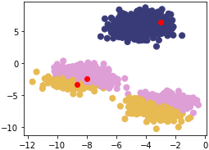
Figure 1.18: First scatterplot
- The second plot is as follows:
- 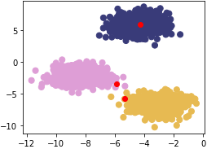
Figure 1.19: Second scatterplot
- The third plot is as follows:
- 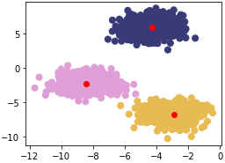
Figure 1.20: Third scatterplot
As you can see in the figures above, k-means takes an iterative approach to refining optimal clusters based on distance. The algorithm starts with random initialization and, depending on the complexity of the data, quickly finds the separations that make the most sense.
Clustering Performance: Silhouette Score
Understanding the performance of unsupervised learning methods is inherently much more difficult than supervised learning methods because there is often no clear-cut "best" solution. For supervised learning, there are many robust performance metrics—the most straightforward of these being accuracy in the form of comparing model-predicted labels to actual labels and seeing how many the model got correct. Unfortunately, for clustering, we do not have labels to rely on and need to build an understanding of how "different" our clusters are. We achieve this with the Silhouette Score metric. We can also use Silhouette Scores to find optimal "K" numbers of clusters for our unsupervised learning methods.
The Silhouette metric works by analyzing how well a point fits within its cluster. The metric ranges from -1 to 1. If the average silhouette score across your clustering is one, then you will have achieved perfect clusters and there will be minimal confusion about which point belongs where. For the plots in our last exercise, the Silhouette score will be much closer to one, since the blobs are tightly condensed and there is a fair amount of distance between each blob. This is very rare, though; the Silhouette Score should be treated as an attempt at doing the best you can, since hitting one is highly unlikely.
Mathematically, the Silhouette Score calculation is quite straightforward via the Simplified Silhouette Index (SSI), as SSIi = bi - ai/ max(ai, bi) where ai is the distance from point i to its own cluster centroid and bi is the distance from point i to the nearest cluster centroid.
The intuition captured here is that ai represents how cohesive point i's cluster is as a clear cluster, and bi represents how far apart the clusters lie. We will use the optimized implementation of silhouette_score in scikit-learn for Activity 1, Implementing k-means Clustering. Using it is simple and only requires you to pass in the feature array and the predicted cluster labels from your k-means clustering method.
In the next exercise, we will use the pandas library to read a CSV. Pandas is a Python library that makes data wrangling easier through the use of DataFrames. If you look back on the arrays you’ve built with NumPy, you probably noticed the resulting data structures are quite unwieldly. To extract subsets from the data you had had to index using brackets and specific numbers of rows. Instead of this approach, Pandas allows an easier to understand approach to moving data around and getting it into the format necessary for unsupervised learning and other machine learning techniques. To read data in Python, you will use variable_name = pd.read_csv('file_name.csv', header=None).
Exercise 6: Calculating the Silhouette Score
In this exercise, we're going to learn how to calculate the Silhouette Score of a dataset with a fixed number of clusters. For this, we will use the Seeds dataset, which is available at https://github.com/TrainingByPackt/Unsupervised-Learning-with-Python/tree/master/Lesson01/Exercise06.
Note
This dataset was downloaded from https://archive.ics.uci.edu/ml/datasets/seeds. It can be accessed at https://github.com/TrainingByPackt/Unsupervised-Learning-with-Python/tree/master/Lesson01/Exercise06.
- Load the Seeds data file using pandas, a package that makes data wrangling much easier through the use of DataFrames:
import pandas as pd
import numpy as np
import matplotlib.pyplot as plt
from sklearn.metrics import silhouette_score
from scipy.spatial.distance import cdist

seeds = pd.read_csv('Seed_Data.csv')

- Separate the X features, since we want to treat this as an unsupervised learning problem:
X = seeds[['A','P','C','LK','WK','A_Coef','LKG']]
- Bring back the k_means function we made earlier for reference:
def k_means(X, K):
#Keep track of history so you can see k-means in action
centroids_history = []
labels_history = []
rand_index = np.random.choice(X.shape[0], K)
centroids = X[rand_index]
centroids_history.append(centroids)
while True:
# Euclidean distances are calculated for each point relative to
# centroids, #and then np.argmin returns
# the index location of the minimal distance - which cluster a point
# is #assigned to
labels = np.argmin(cdist(X, centroids), axis=1)
labels_history.append(labels)
#Take mean of points within clusters to find new centroids:
new_centroids = np.array([X[labels == i].mean(axis=0)
for i in range(K)])
centroids_history.append(new_centroids)

# If old centroids and new centroids no longer change, k-means is
# complete and end. Otherwise continue
if np.all(centroids == new_centroids):
break
centroids = new_centroids

return centroids, labels, centroids_history, labels_history

- Convert our Seeds X feature DataFrame to a NumPy matrix:
X_mat = X.values
- Run our k_means function on the Seeds matrix:
centroids, labels, centroids_history, labels_history = k_means(X_mat, 3)
- Calculate the Silhouette Score for the Area (‘A’) and Length of Kernel (‘LK’) columns:
silhouette_score(X[['A','LK']], labels)
- The output is similar to:
0.5875704550892767
In this exercise, we calculated the Silhouette Score for the Area (‘A’) and Length of Kernel (‘LK’) columns of the Seeds dataset.
Activity 1.01: Implementing k-means Clustering
Scenario: You are asked in an interview to implement a k-means clustering algorithm from scratch to prove that you understand how it works. We will be using the Seeds dataset provided by the UCI ML repository. The Seeds dataset is a classic in the data science world and has features of wheat kernels that are used to predict 3 different types of wheat species. The download location can be found later in this activity.
For this activity, you are able to use Matplotlib, NumPy, scikit-learn metrics, and pandas.
By loading and reshaping data easily, you can focus more on learning k-means instead of writing dataloader functionality.
Seeds data columns are provided as follows for reference:
1. area (A),
2. perimeter (P)
3. compactness (C)
4. length of kernel (LK)
5. width of kernel (WK)
6. asymmetry coefficient (A_Coef)
7. length of kernel groove (LKG)

Aim: To truly understand how something works, you need to build it from scratch. Take what you have learned in the previous sections and implement k-means from scratch in Python.
Please open your favorite editing platform and try the following:
- Using NumPy or the math package and the Euclidean distance formula and write a function that calculates the distance between two coordinates.
- Write a function that calculates the distance from centroids to each of the points in your dataset and returns the cluster membership.
- Write a k-means function that takes in a dataset and the number of clusters (K) and returns the final cluster centroids, as well as the data points that make up that cluster's membership. After implementing k-means from scratch, apply your custom algorithm to the Seeds dataset, located here: https://github.com/TrainingByPackt/Unsupervised-Learning-with-Python/tree/master/Lesson01/Activity01.
Note
This dataset was downloaded from https://archive.ics.uci.edu/ml/datasets/seeds. It can be accessed at https://github.com/TrainingByPackt/Unsupervised-Learning-with-Python/tree/master/Lesson01/Activity01.
UCI Machine Learning Repository [http://archive.ics.uci.edu/ml]. Irvine, CA: University of California, School of Information and Computer Science.
- Remove the classes supplied in this dataset and see if your k-means algorithm can group the different wheat species into their proper groups just based on plant characteristics!
- Calculate the Silhouette Score using the scikit-learn implementation.
Outcome: By completing this exercise, you will gain hands-on experience of tuning a k-means clustering algorithm for a real-world dataset. The Seeds dataset is seen as a classic "hello world" type problem in the data science space and is helpful for testing foundational techniques. Your final clustering algorithm should do a decent job of finding the three clusters of wheat species types that exist in the data, as follows:

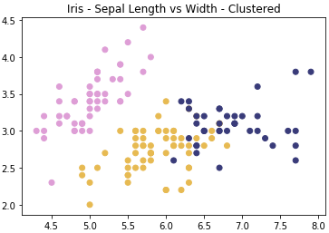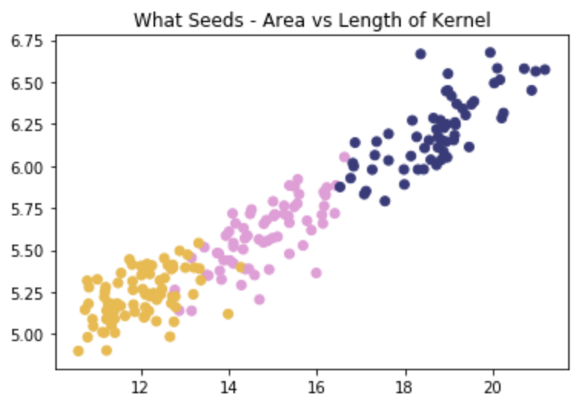
Figure 1.21: Expected plot of three clusters of wheat species
Note
The solution for this activity can be found on page XX.
Summary
In this chapter, we have explored what clustering is and why it is important in a variety of data challenges. Building upon this foundation of clustering knowledge, you implemented k-means, which is one of the simplest yet most popular methods of unsupervised learning. If you have reached this summary and can repeat what k-means does step-by-step to a friend, then you’re ready to move onto more complex forms of clustering.
From here, we will be moving on to hierarchical clustering, which, in one configuration, reuses the centroid learning approach that we used in k-means. We will build upon this approach by outlining additional clustering methodologies and approaches in the next chapter.

