SOFTWARE ENGINEERING LAB

Vehicle Monitoring System

21MCME16, 21MCME26

**Problem Statement:**

By utilizing the CCTV cameras already in place, the vehicle management system seeks to simplify security protocols on campus. If a registered car is captured by the cameras and cross-referenced with the database, it can be admitted. To expedite visitor acceptance without human checks, professors can submit visitor forms with vehicle numbers. Instructors and students may register their cars online, but administrative clearance is needed. Effective tracking is made possible by the system's maintenance of vehicle records that are available to administrators and users. All in all, the system increases efficiency in vehicle management, lowers the need for manual checks, and strengthens security.

**SOFTWARE REQUIREMENTS SPECIFICATION(SRS)**

**1.Introduction**

1.1 Purpose

1.2 Scope

1.3 Definitions, Acronyms, Abbreviations

1.4 References

1.5 Overall Description

**2.Overall Descriptions**

2.1 Product Perspective

2.2 Product Functions

2.3 User Characteristics

2.4 User Constraints

2.4 Assumptions & Dependencies

**3. Specific Requirements**

**3.1 Interface Requirements**

3.1.1 External Interface

3.1.2 Hardware Interface

3.1.3 Software Interface

3.1.4 Communication Interface

**3.2 Functional Requirements**

3.2.1 Use Case Model/ Information Flows

3.2.2 Use Case Specifications /Process Description

3.2.3 Analysis Classes/Data Dictionary

**3.3 Performance Requirements**

**3.4 Logical Database**

**3.5 Design Constraints**

**3.6 Software System Attributes**

3.6.1 Reliability

3.6.2 Availability

3.6.3 Security

3.6.4 Maintainability

3.6.5 Portability

**4.Supporting Information**

**1.Introduction**

**1.1 Purpose**

The goal of this project is to create an efficient vehicle management system for a university campus that will handle vehicle admission and streamline security protocols for registered, unregistered and visitor vehicles.

**1.2 Scope**

The system will have functions for tracking vehicle movement, vehicle registration, and visitor management. By allowing professors to submit visitor forms with car details and eliminating human inspections, it will expedite the visitor approval process. Teachers can also register their cars, so only registered cars are allowed. Additionally, the system will track car movements, giving useful information for improving campus transportation services. These features are intended to increase campus administration efficiency overall, lessen traffic, and improve security with digital vehicle records.

**1.3 Definitions, Acronyms, Abbreviations**

**Definitions:**

A vehicle management system is a piece of software used to monitor and control the movement of vehicles into and out of a designated area, like a campus of a university.

CCTV: stands for closed-circuit television, a system of security cameras that sends signals to a designated group of monitors.

Admin: The administrator is a user with high-level access who is in charge of running the car management system.

**1.4 References**

flask tutorial : <https://www.youtube.com/watch?v=dam0GPOAvVI&pp=ygUOZmxhc2sgdHV0b3JpYWw%3D>

opencv :

[https:// www.youtube.com/watch?v=oXlwWbU8l2o](https://www.youtube.com/watch?v=dam0GPOAvVI&pp=ygUOZmxhc2sgdHV0b3JpYWw%3D)

**2Overall Description**

**2.1 Product Perspective**

Users and administrators can easily engage with the system's such as reviewing vehicle records and diffenret forms for registration and visitor arrival. It combines with the campus's current CCTV cameras to provide real-time tracking and recording of vehicle activity. By combining these elements, security and monitoring are improved, resulting in efficient resource management on campus and safety precautions.

**2.2 Product Functions**

The system makes it easier for admin, security, users to document temporary vehicles, view vehicle records, register cars, and submit visitor forms. Entry procedures are streamlined by users' ease of registration of their vehicles and completion of visitor forms. They can also consult their own vehicle records for further information, and security guards can effectively record temporary vehicle information as needed. These elements improve campus operations and overall security. Admin has access to every vehicle record. Users have access to their own vehicle records. Admin has to approve or deny the registrations according to the documentation provided by the user. Then, the user’s vehicle gets registered. User can submit visitor form and select can select their availability.

**2.3 User Characteristics**

Professors, security guards, and administrators.

**2.4 User Constraints**

For some features, users must be able to access the application and have the appropriate authorization.

admin has access to every vehicle record.

Users have access to their own vehicle records.

**2.5 Assumptions & Dependencies**

Assumes network connectivity and the presence of CCTV cameras.

**3.Specific Requirements**

**3.1.1 User Interface:**

**user:**

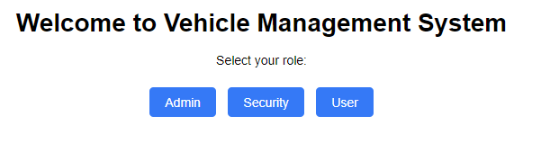

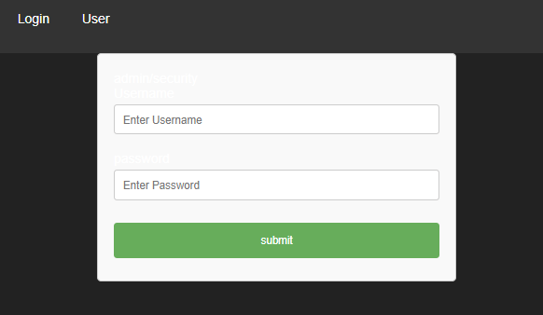

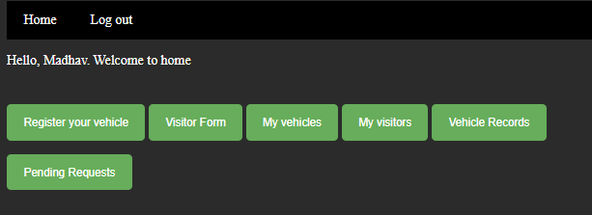

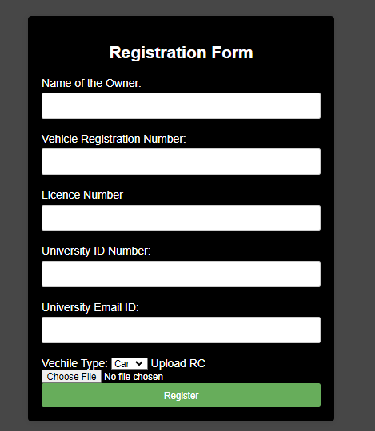

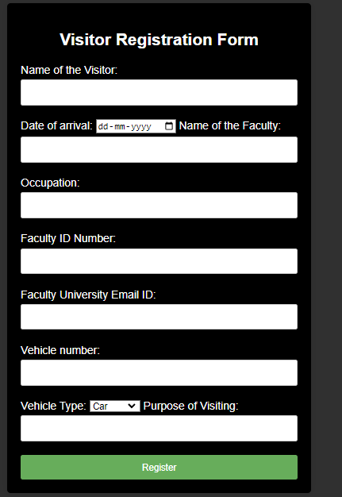

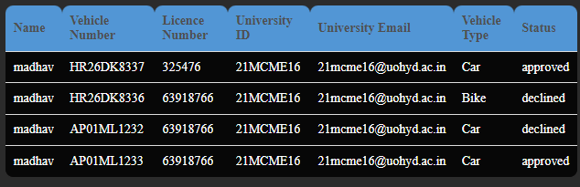

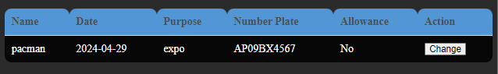

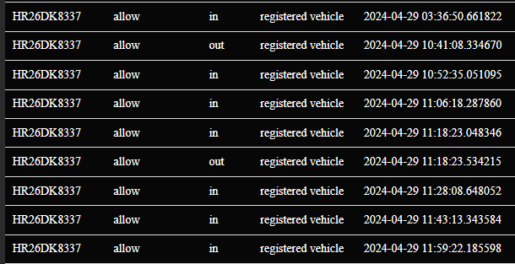

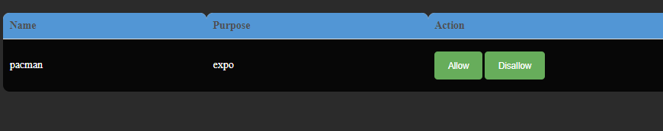

**security:**

**registered user:**

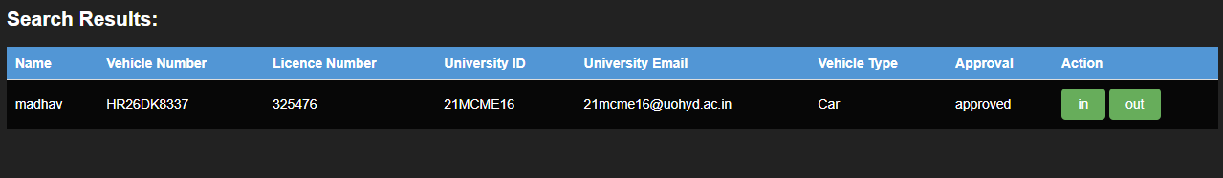

**unregistered user:**

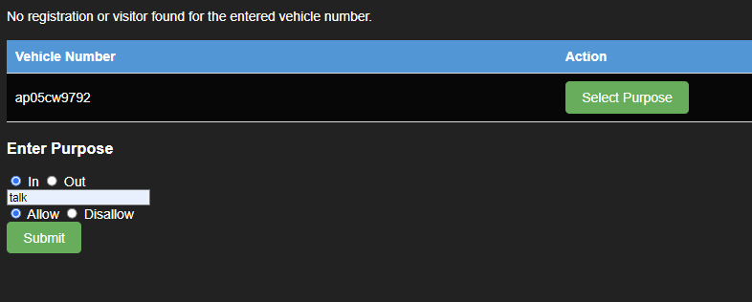

**visitor:**

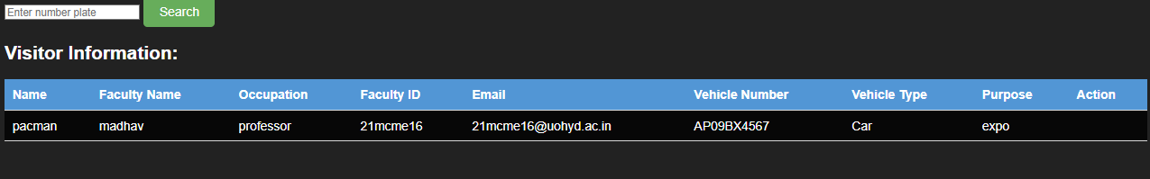

**admin:**

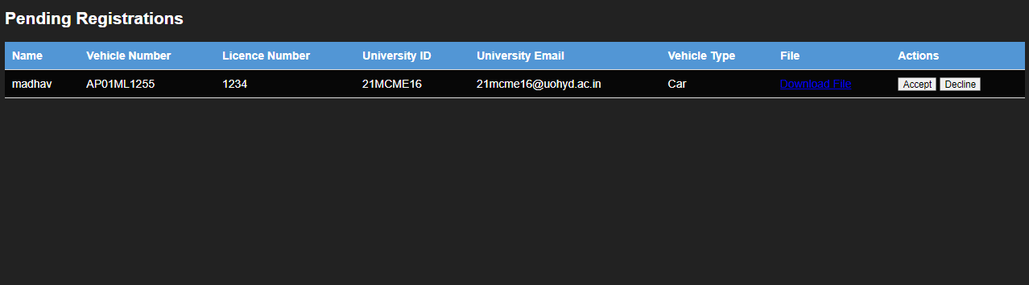

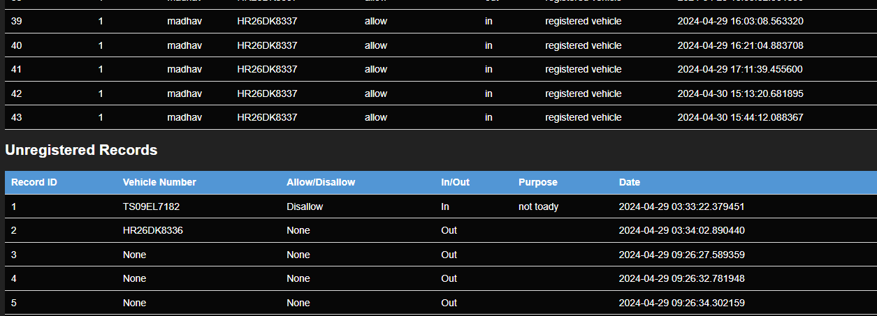

**3.1.2 Hardware Interface**

Integration with the CCTV systems currently in place.

**3.1.3 Software Interface**

The points of interaction between the vehicle management system and other software systems or components are referred to as the software interface. This covers the data interchange formats, communication protocols, and integration techniques required to link the system to outside components such databases, user interfaces, and CCTV cameras. The system's functionality and data flow are guaranteed by the software interface, which facilitates smooth communication between various software components. Also, an open cv model has been used to recognize the number plate of the vehicle. It also makes it easier for the vehicle management system to be integrated with other software programs or services, which improves its functionality and compatibility.

**3.1.4 Communication Interface**

Effective data interchange and coordination are made possible by the system's smooth communication between CCTV systems and applications. By providing real-time monitoring and recording of campus activities, this integration improves surveillance capabilities. Through communication enhancement between CCTV systems and applications, the system improves campus management in general and security measures in particular.

**3.2 Function Requirements**

**3.2.1 Use Case Model/ Information Flows:**

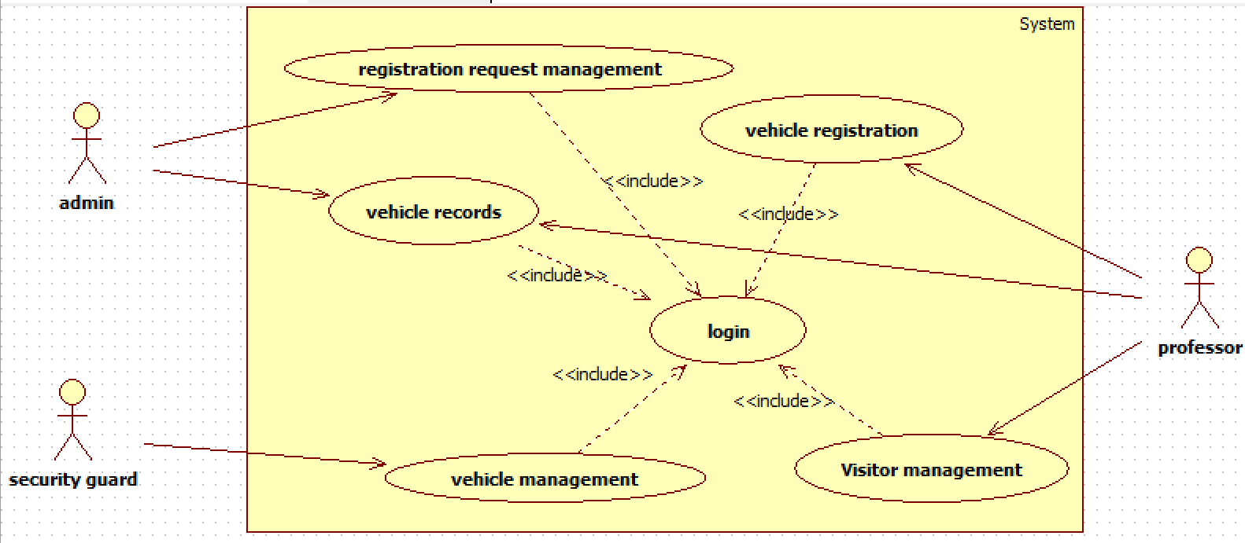

Vehicle Registration:

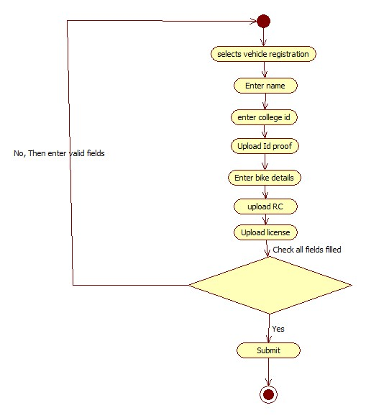

Registration request management:

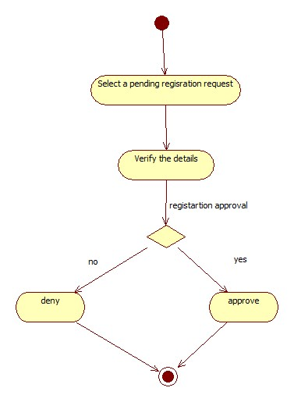

Vehicle records:

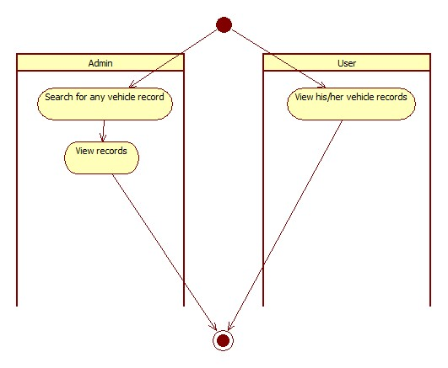

Vehicle management:

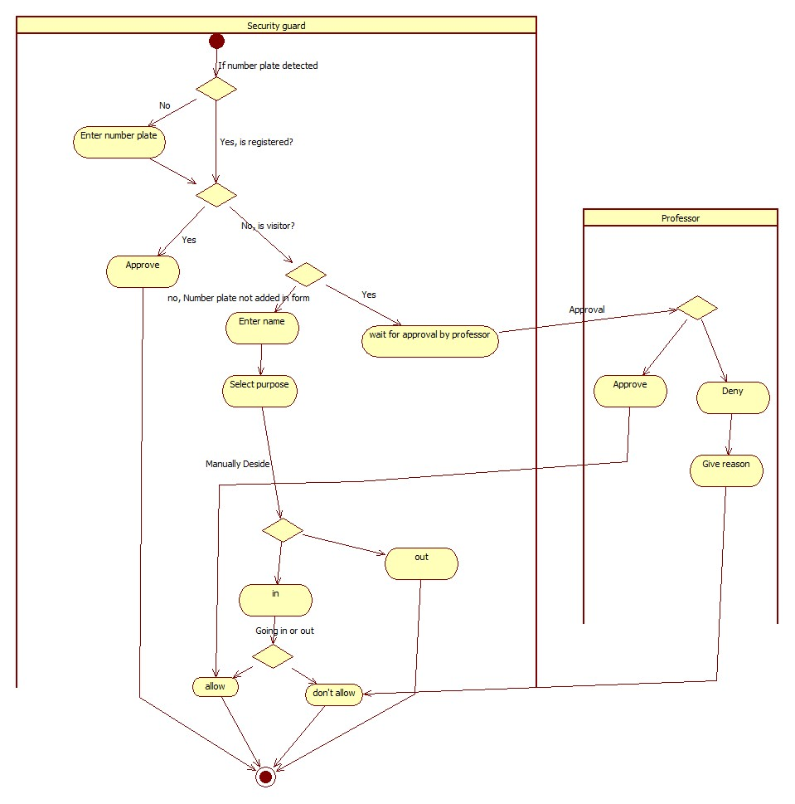

**Visitor management:**

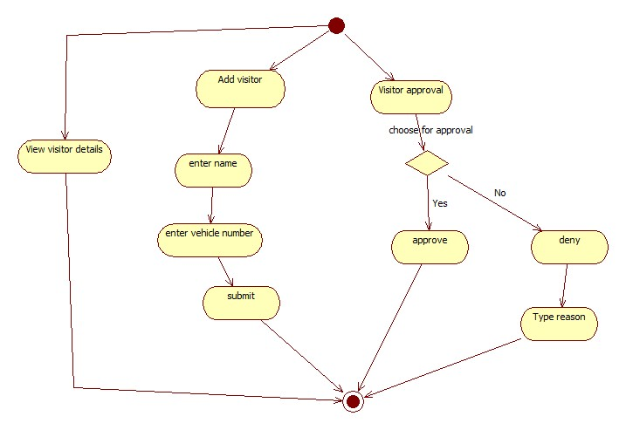

**Login:**

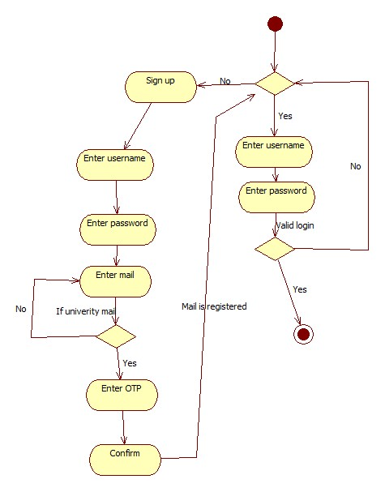

**3.2.2 Use Case Specifications / Process Description:**

|  |  |  |  |
| --- | --- | --- | --- |
| Use Case ID: | 1 | | |
| Use Case Name: | Vehicle Registration | | |
| Created By: | G. Lokesh Varma | Last Updated By: | G. Lokesh Varma |
| Date Created: | 17-02-2024 | Date Last Updated: | 04-04-24 |

|  |  |
| --- | --- |
| Actors: | Admin |
| Description: | This use case involves the registration of vehicles by professors. |
| Preconditions: | Professor must be logged in.  Professor privileges are required for vehicle registration. |
| Post conditions: | Registration request is passed. |
| **Normal Flow:** | * I. Professor selects the "vehicle registration" option. * II. Professor enters vehicle details such as: * - Name * - Vehicle number * - Licence number * - University ID, mail ID * - Vehicle type * - RC copy of vehicle. * IV. After submitting the form, it goes to the registration request section. |
| **Alternative Flows:** | I. If the user provides an invalid or empty fields:  2.1. The system notifies the user about the invalid fields.  2.2. Resume normal flow from step IV. |
| Exceptions: | Incomplete information provided during registration.  Incorrect vehicle details. |
| Includes: |  |
| Priority: | High |
| Frequency of Use: | Rare |
| Business Rules: | Only professors can initiate vehicle registration.  A vehicle can only be registered once. |
| Assumptions: | The professor has valid login credentials. |

USE CASE TEMPLATE

|  |  |  |  |
| --- | --- | --- | --- |
| Use Case ID: | 2 | | |
| Use Case Name: | Registration request management | | |
| Created By: | V. Madhava Babu | Last Updated By: | G. Lokesh Varma |
| Date Created: | 17-02-2024 | Date Last Updated: | 04-04-24 |

|  |  |
| --- | --- |
| Actors: | Admin |
| Description: | This use case involves the admin managing vehicle registration requests, reviewing and either approving or denying them, with corresponding notifications sent to the users. |
| Preconditions: | Admin must be logged into the system.  Vehicle registration requests should be pending. |
| Post conditions: | Vehicle registration is either approved or denied, and users receive notifications. |
| **Normal Flow:** | * I. Admin selects the "Registration Request Management" option. * II. System displays a list of pending vehicle registration requests. * III. Admin selects a specific request to review. * IV. Admin reviews the details provided in the registration request. * V. Admin approves or denies the registration request. |
| **Alternative Flows:** | None |
| Exceptions: |  |
| Includes: | Vehicle Registration (for users to initiate registration requests). |
| Priority: | High |
| Frequency of Use: | Frequent |
| Business Rules: | Only admins can manage and approve/deny registration requests. |
| Assumptions: | The user has valid login credentials |

USE CASE TEMPLATE

|  |  |  |  |
| --- | --- | --- | --- |
| Use Case ID: | 3 | | |
| Use Case Name: | Vehicle records | | |
| Created By: | G. Lokesh Varma | Last Updated By: | G. Lokesh Varma |
| Date Created: | 17-02-2024 | Date Last Updated: | 04-04-24 |

|  |  |
| --- | --- |
| Actors: | Admin, Professor |
| Description: | This use case involves accessing vehicle records for both users and admins |
| Preconditions: | User must be logged into the system. |
| Post conditions: | Vehicle records are viewed |
| **Normal Flow:** | * I. User selects the "Vehicle Records" option. * II. Admin can enter vehicle details or searches for specific records such as ID. * III. Admins can access records of any vehicle. * IV. Professors can access their own vehicle records. * V. Professors can also see their respective visitor vehicle records |
| **Alternative Flows:** | I. If no vehicle records are found for the specified criteria:  1.1. The system notifies the user about the absence of records.  1.2. User is prompted to refine the search criteria.  1.3. Resume normal flow from step II. |
| Exceptions: | No vehicle records found for the specified criteria. |
| Includes: |  |
| Priority: | Medium |
| Frequency of Use: | Regular |
| Business Rules: | Admins can access any vehicle record.  Professors can only access their own vehicle records. |
| Assumptions: | The user has valid login credentials |

USE CASE TEMPLATE

|  |  |  |  |
| --- | --- | --- | --- |
| Use Case ID: | 4 | | |
| Use Case Name: | Vehicle management | | |
| Created By: | V. Madhava Babu | Last Updated By: | G. Lokesh Varma |
| Date Created: | 17-02-2024 | Date Last Updated: | 04-04-24 |

|  |  |
| --- | --- |
| Actors: | Security Guard |
| Description: | This use case involves the security guard managing the entry of detected vehicles, allowing access for registered vehicles, and collecting information for unregistered ones, with number plate detection performed by technology like YOLO (You Only Look Once). |
| Preconditions: | Security guard must be logged into the system.  Vehicle number must be detected before managing the Vehicles.  Visitor form is submitted. |
| Post conditions: | Access is granted for registered vehicles, and information is collected for unregistered ones. |
| **Normal Flow:** | * I. After Security guard logged in to the system. * II. The system, using technology like YOLO, detects the number plate of the approaching vehicle. * III. If the vehicle is registered, the system shows it is registered you can choose in or out. * IV. If the vehicle is not registered, the system prompts the security guard to enter the visitor's name and purpose allowed or not allowed and in or out. * V. If the vehicle is not registered and it is a visitor given by visitor form, the system shows he is a visitor allow wait for professor’s approval. * VI. Security guard enters visitor information. * VII. System logs entry details for the unregistered vehicle. |
| **Alternative Flows:** | If the number plate detection fails or is inaccurate, the security guard may manually enter the vehicle details. |
| Exceptions: | Invalid or unreadable number plate.  Information entered is incomplete. |
| Includes: | None |
| Priority: | High |
| Frequency of Use: | Frequent |
| Business Rules: | Security guards are responsible for managing vehicle entry.  Unregistered vehicles may require manual entry of visitor information if the automated number plate detection fails. |
| Assumptions: | The number plate detection technology (e.g., YOLO) is functional.  Security guards are trained to handle the manual entry process if needed. |

USE CASE TEMPLATE

|  |  |  |  |
| --- | --- | --- | --- |
| Use Case ID: | 5 | | |
| Use Case Name: | Visitor management | | |
| Created By: | V. Madhava Babu | Last Updated By: | G. Lokesh Varma |
| Date Created: | 17-02-2024 | Date Last Updated: | 04-04-24 |

|  |  |
| --- | --- |
| Actors: | Professor |
| Description: | This use case involves professors submitting visitor forms to streamline visitor entry. |
| Preconditions: | Professor must be logged into the system. |
| Post conditions: | Visitor details are uploaded.  System notifies for approval if visitor comes.  System notifies if the visitor enters or leaves. |
| **Normal Flow:** | * Professor selects the "Visitor Form" option. * Professor enters visitor details including the vehicle number. * If visitor is arrived, System notifies the intended professor for visitor approval. |
| **Alternative Flows:** | I. Incomplete Information Provided:  1.1 If the professor submits the visitor form with incomplete information, the system prompts the professor to provide the missing details.  1.2 The professor revises the visitor form, filling in the necessary information.  1.3 After completing the form, the professor submits it again.  1.4 The system validates the form and proceeds with the normal flow, notifying the intended professor if the visitor arrives. |
| Exceptions: | Incomplete information provided in the visitor form. |
| Includes: |  |
| Priority: | Medium |
| Frequency of Use: | Occasional |
| Business Rules: | Professors are responsible for submitting visitor forms. |
| Assumptions: |  |

USE CASE TEMPLATE

|  |  |  |  |
| --- | --- | --- | --- |
| Use Case ID: | 6 | | |
| Use Case Name: | Login | | |
| Created By: | G. Lokesh Varma | Last Updated By: | G. Lokesh Varma |
| Date Created: | 17-02-2024 | Date Last Updated: | 04-04-24 |

|  |  |
| --- | --- |
| Actors: | Admin, Professor, Security Guard |
| Description: | This use case involves logging into the Vehicle Management System. |
| Preconditions: | User must have valid login credentials. |
| Post conditions: | User is successfully logged into the system. |
| **Normal Flow:** | * I. User enters username and password. * II. If the user doesn't have login credentials, they must register. * III. Admin and security have their own private passwords. * IV. System verifies the credentials. * V. If valid, user is granted access to the system. |
| **Alternative Flows:** | 1. Forgot password functionality is used for password recovery. |
| Exceptions: | Invalid username or password. |
| Includes: | All other use cases |
| Priority: | High |
| Frequency of Use: | Every use of the system |
| Business Rules: | Only registered users can log in. |
| Assumptions: | Users have valid login credentials. |

**3.2.3 Analysis Classes/ Data Dictionary**

"Registration": ["id", "name", "vehicleNumber", "licenceNumber", "universityId", "universityEmail", "vehicleType", "approval", "filename", "data", "user_id"],

"Visitor": ["id", "name", "faculty_name", "occupation", "faculty_id", "email", "vehicle_number", "vehicle_type", "purpose", "date", "allowance", "user_id"],

"Pending": ["id", "user_id", "name", "action", "reason"],

"User": ["id", "email", "password", "first_name", "role"],

"Admin": ["id", "username", "password", "role"],

"Security": ["id", "username", "password", "role"],

"RegRecords": ["id", "user_id", "name", "vehicleNumber", "allowDisallow", "inOut", "purpose", "date"],

"UnRegRecords": ["id", "vehicleNumber", "allowDisallow", "inOut", "purpose", "date"]

**3.3 Performance Requirements**

Real-time processing of visitor forms and vehicle registrations by the system guarantees quick approval and admission processes. Users can also easily retrieve vehicle records for purposes of reference and confirmation. This real-time processing and simple access to vehicle records improve productivity and simplify system operations.

**3.4 Logical Database Requirements**

To effectively record and handle the details of visitors and cars, the system makes use of a structured database. Comprehensive tracking of visitor data, such as names, car numbers, and entry times, is made possible by this database structure. Likewise, it keeps track of car information such license plates, owner names, and related departments. The system's data organization helps to improve security and operational efficiency by guaranteeing accurate record-keeping and simple information retrieval.

**3.5 Design Constraints**

The system has an intuitive user interface that is made to be simple to use and seamlessly integrate with current CCTV systems. Through this interface, users can easily traverse the system and access functions like vehicle management and visitor registration with little effort. Furthermore, the interface easily connects with existing CCTV systems, giving users quick access to recorded and live feeds for improved monitoring and surveillance. The system's efficacy in improving campus security and management is maximized and seamless operation is ensured by its user-centric design.

**3.6 Software System Attributes:**

**3.6.1 Reliability**

The system offers a strong foundation for keeping correct records by guaranteeing the trustworthy recording and administration of visitor and vehicle data. To reduce the possibility of data loss or corruption, it uses strong data management techniques to safely store and arrange car and visitor information. The system's emphasis on data integrity and reliability fosters trust and confidence in its capabilities, which in turn improves campus security and operational efficiency.

**3.6.2 Availability**

The system is intended to be available when required most, being useable and accessible during typical university business hours. Reliability is a primary concern, since the system continues to function during peak hours, enabling smooth administration of visitor and vehicle activity on campus. This guarantees that users may depend on the system's usability and accessibility to efficiently support their daily operations.

**3.6.3 Security**

The system takes strong precautions to protect sensitive data, ensuring the security and privacy of user information. The system guarantees that user data is safe from breaches or unauthorized access by following strict security protocols. The system places a high priority on maintaining the confidentiality and integrity of user data while emphasizing privacy compliance, giving users peace of mind about the security of their data. This dedication to data security builds the system's credibility and confidence, promoting a safe atmosphere for controlling visitor and vehicle activity on university property.

**3.6.4 Maintainability**

The system is made to be easily updated and maintained, which makes administration and maintenance chores easier. Administrators can execute changes more effectively because updating the system is simple and comes with intuitive procedures and user-friendly interfaces. Furthermore, integrated maintenance functions simplify regular duties, guaranteeing the system stays in top shape with the least amount of work. The system's longevity and dependability are increased by how easy it is to update and maintain, guaranteeing that car and visitor activities on the university campus will continue to be supported.

**3.6.5 Portability**

The software is designed to work on a wide variety of hardware configurations and operating systems, making it accessible on a broad spectrum of platforms. Because of this compatibility, users can access the system with ease from desktop, laptop, tablet, and smartphone devices. The system optimizes its usability and reach by giving priority to cross-platform compatibility, enabling users to engage with the program on their preferred device or platform. This adaptability makes it easier to handle visitor and vehicle activity on campus more effectively and adds to a smooth user experience.

**4.Supporting Information**

**Future enhancements:**

More enhancements can be taken for better vehicle recognition by more training of the model. Installation of cctv cams at every center can track the vehicle’s last record.