Assignment 4 Facade Pattern
Option B: Online Order Processing Facade

1. Introduction
This project implements the Facade structural design pattern for a online store. Processing an order involves several services: checking and reserving inventory, charging the customer, arranging shipment and sending a notification.

2. UML Class Diagram
Main.java is the client in src/. OrderFacade.java is located in src/facade/. The four subsystem services and the data types Cart, Customer, and Order are separate Java files in src/subsystem/.
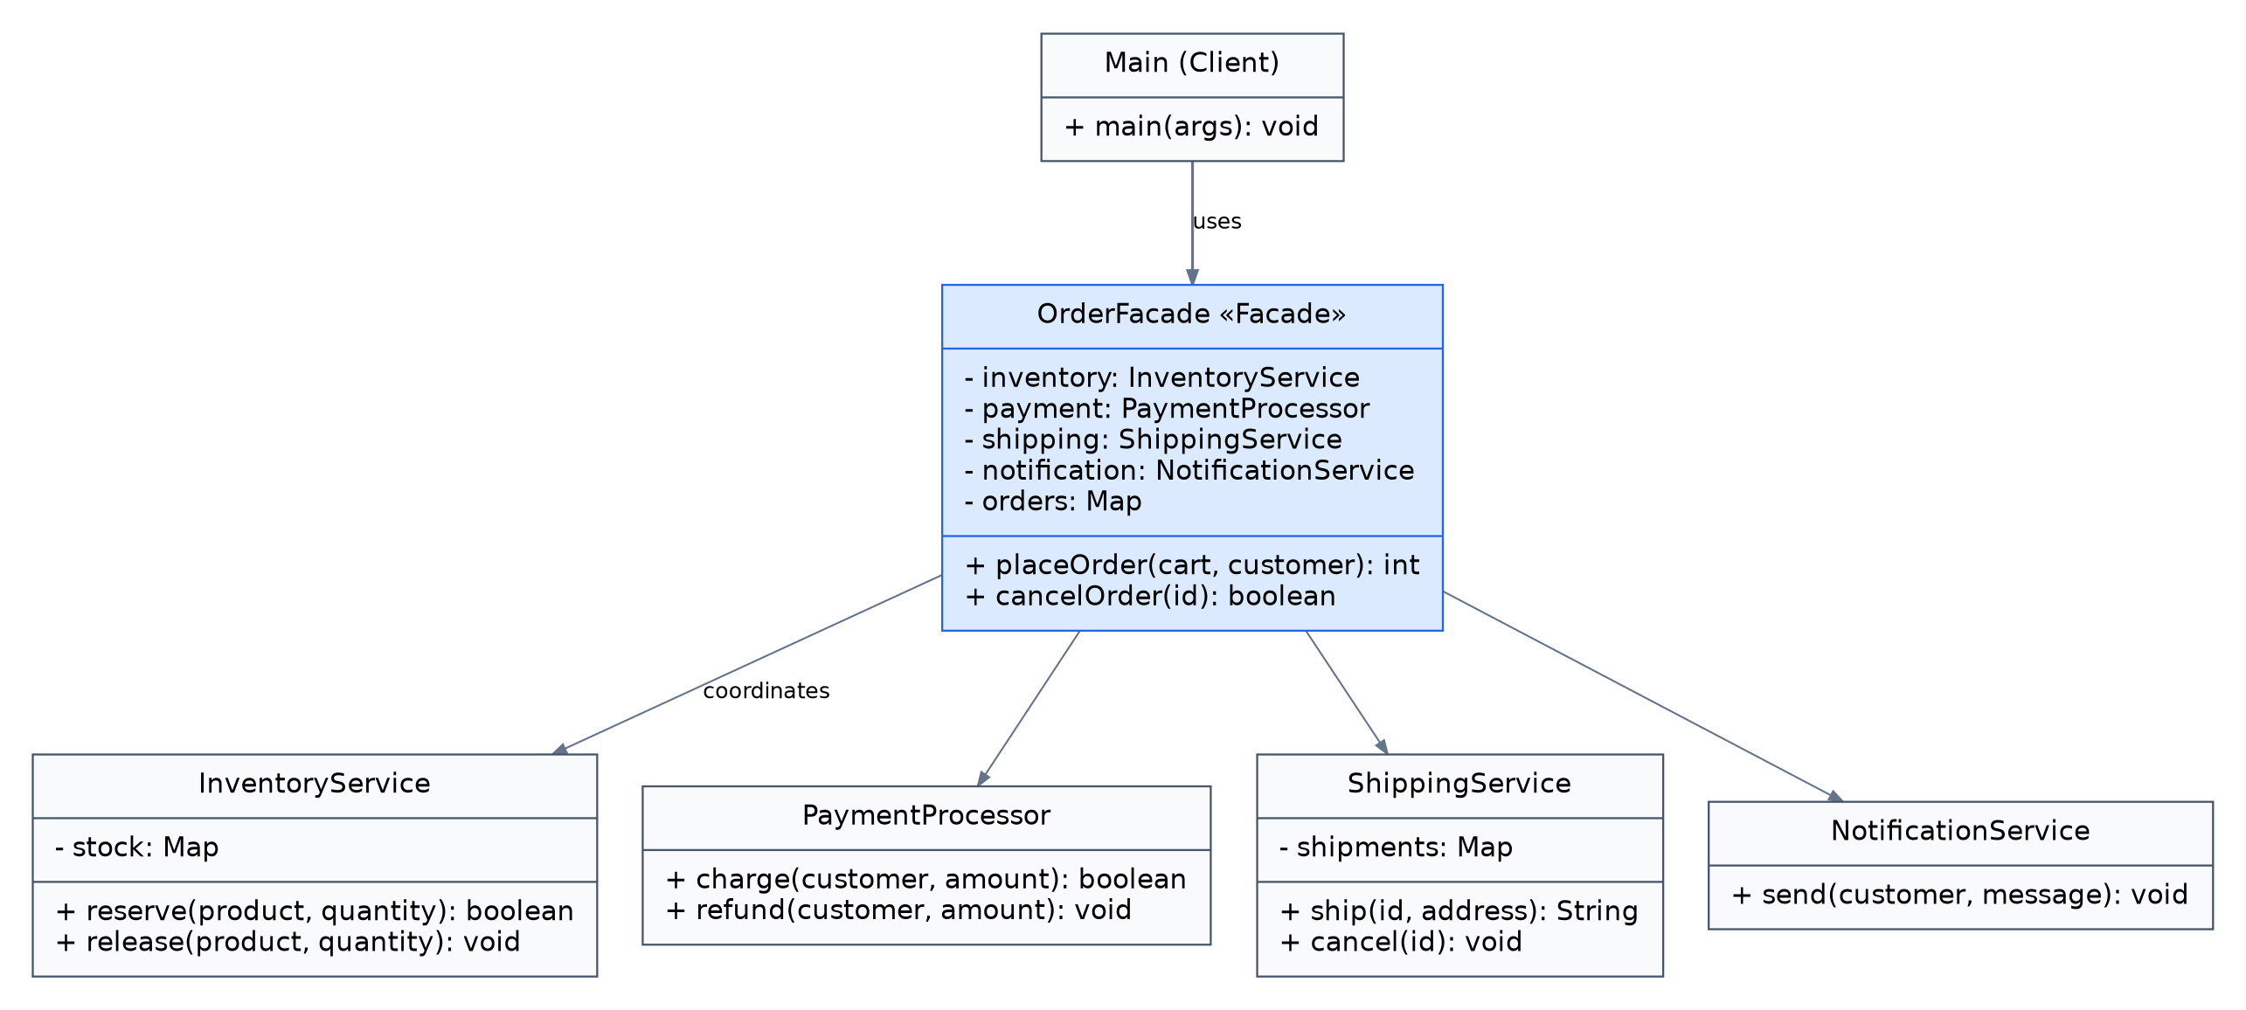
Client dependency: Main -> OrderFacade. Facade dependencies: OrderFacade -> InventoryService, PaymentProcessor, ShippingService, NotificationService. Cart, Customer, and Order are supporting data types.

3. Clean Code Principles
The short excerpts below come from src/Main.java, src/facade/OrderFacade.java, and the Java classes in src/subsystem/.
1) Meaningful names
int placeOrder(Cart cart,Customer customer)
boolean cancelOrder(int id)
2) Single Responsibility Principle
boolean charge(Customer customer,int amount) {
if(amount<=0||customer.balance<amount) return false;
customer.balance-=amount;
return true;
}
PaymentProcessor handles payment rules. OrderFacade calls the service and not duplicate its balance-changing logic.
3) Encapsulation
OrderFacade facade=new OrderFacade();
int orderId=facade.placeOrder(new Cart("Laptop",2,500),amanda);
Main creates the Facade and passes ordinary data objects.
4) Small subsystem classes
boolean reserve(String product,int quantity) {
if(quantity<=0||stock.getOrDefault(product,0)<quantity) return false;
stock.put(product,stock.get(product)-quantity);
return true;
}
5) Error handling and rollback
if(!payment.charge(customer,amount)) {
inventory.release(cart.product(),cart.quantity());
notification.send(customer.name,"Payment declined");
return -1;
}
If payment fails after stock was reserved the Facade restores the stock and returns a failure value.

4. Conclusion
The Facade hides the correct execution order, temporary inventory reservations, failed-payment rollback, shipping coordination, notifications, and order storage.

5. GitHub Repository
Repository link: https://github.com/PactusOs/SE2528ASSIGN4SDP

