**📘 Project Documentation – Auto-Platform-Dashboard**

**📌 General Description  
Auto-Platform-Dashboard is a full-stack web application designed to manage a car sales platform for second-hand vehicles. The application provides an intuitive interface that allows the administrator to add, edit, delete, and view cars, while users can search for vehicles based on criteria such as make, model, price, year of manufacture, and more.**

**🛠️ Technologies Used**

| **Component** | **Technology** |
| --- | --- |
| Frontend | HTML, CSS, JavaScript, Bootstrap |
| Backend | PHP, MySQL |
| Database | MySQL |
| Other Tools | AJAX, PhpMyAdmin, XAMPP |

**🖥️ Main Features**

**1. Homepage**

**The platform's homepage with banners, description, and a call-to-action towards the car search section.**

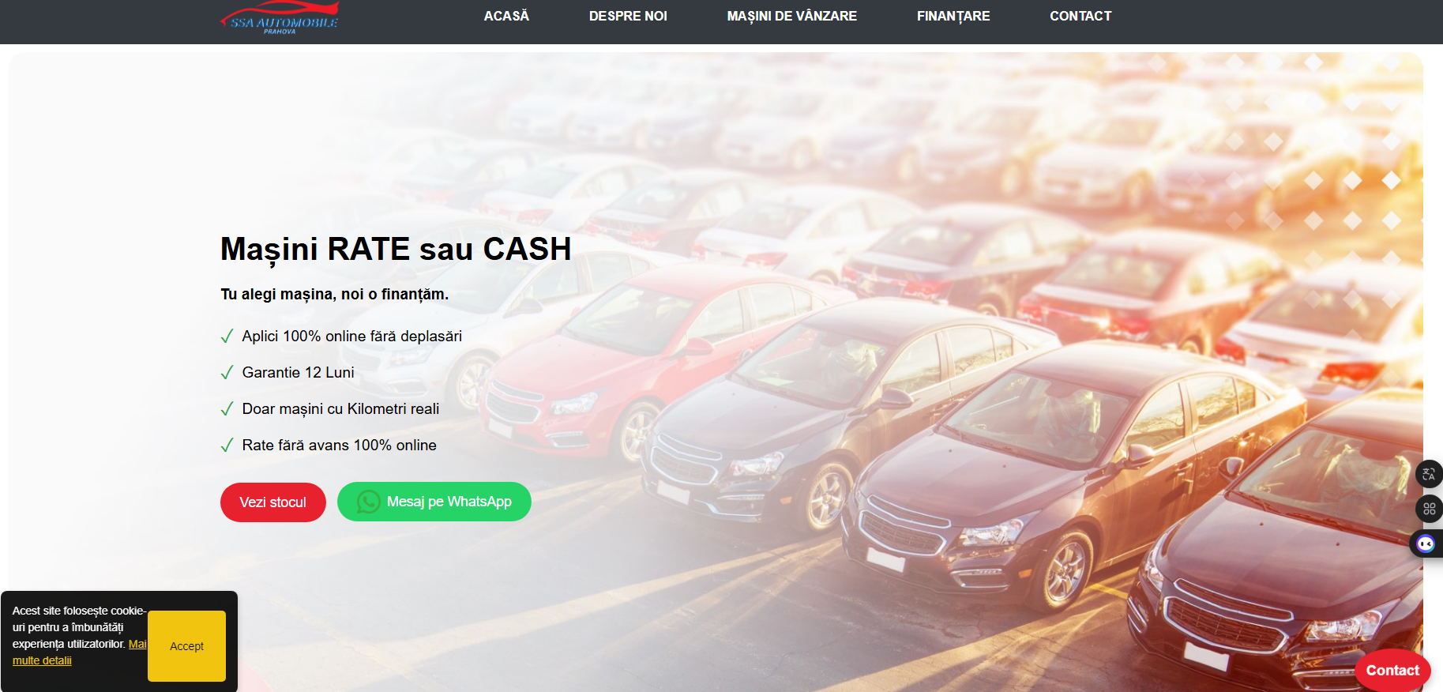

**2. Car Listings**

**Displaying cards with available cars retrieved from the database. The displayed information includes: make, model, year, price, mileage, engine, etc.**

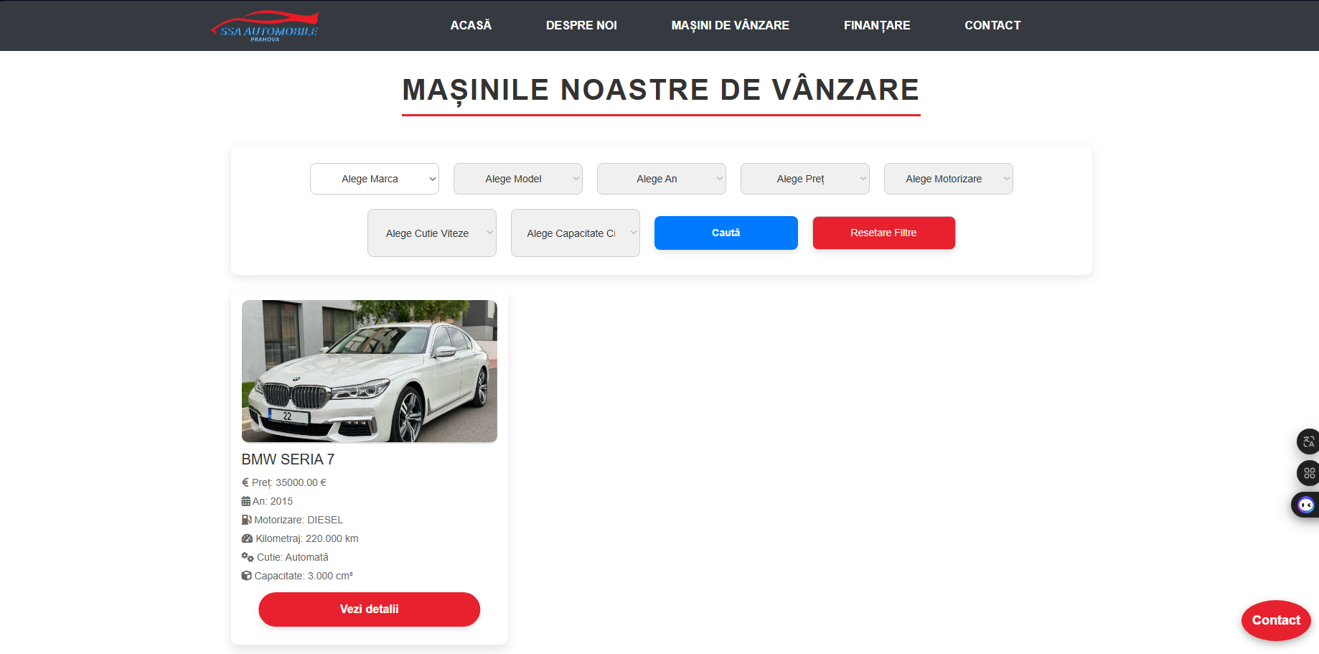

**3. Search Filter**

**Users can filter cars by: make, model, price, year, and mileage. Results are displayed dynamically.**

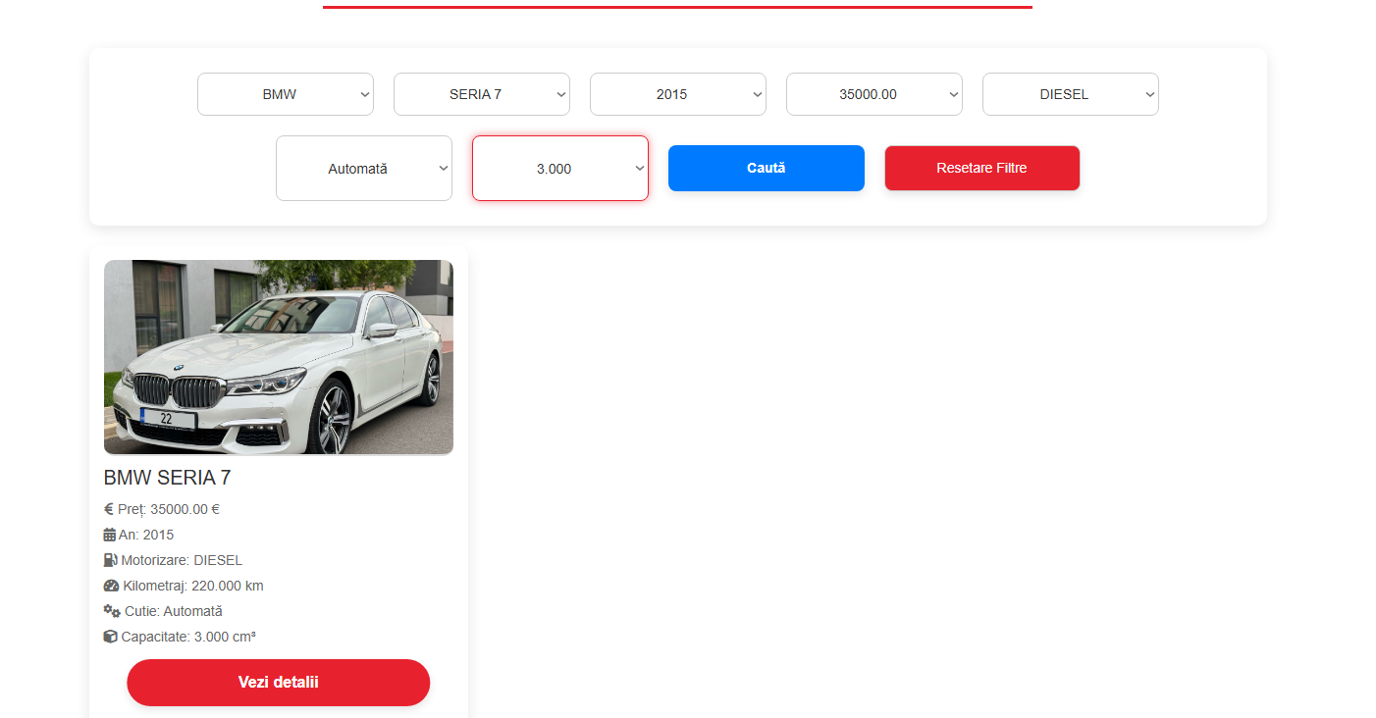

**4. Admin Dashboard (Login Required)**

**The administrator has access to a separate interface where they can:**

* **Add a new car**
* **Edit existing information**
* **Delete cars**
* **View all vehicles in tabular format**

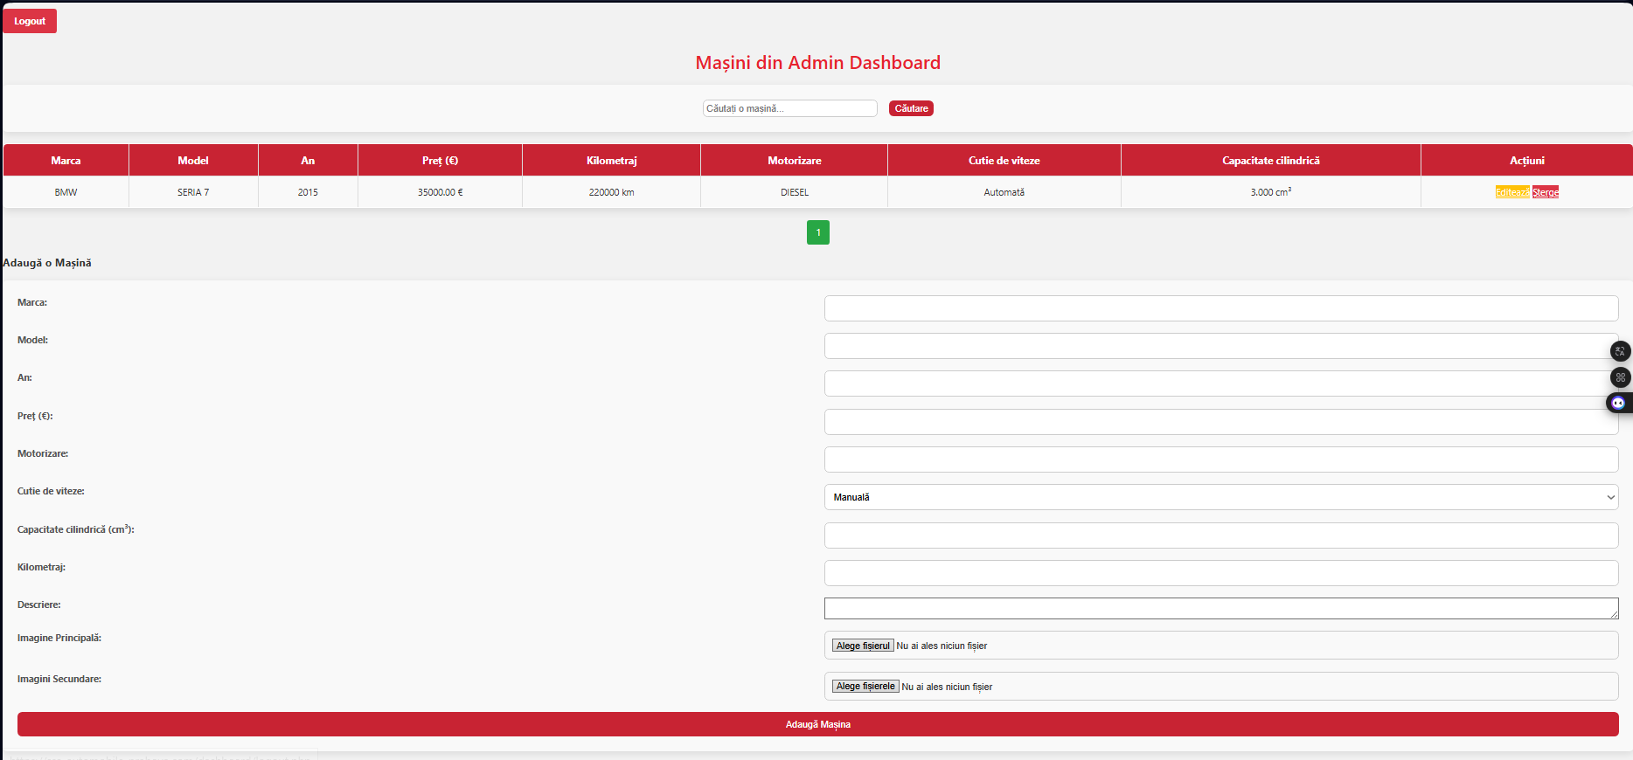

**5. Admin Authentication**

**Only authenticated users can access the dashboard. Authentication is done using credentials stored in the database.**

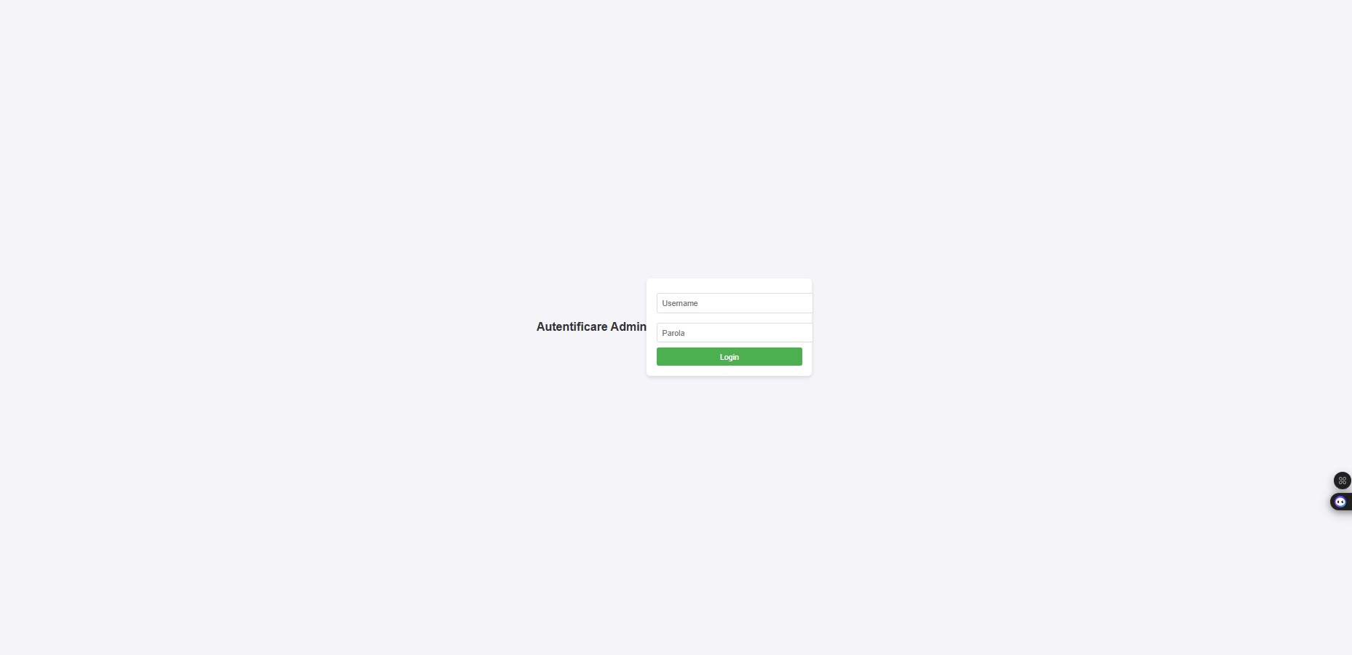

**🗃️ Database Structure (MySQL)**

**Table: cars**

* **id – INT, AUTO_INCREMENT**
* **make – VARCHAR**
* **model – VARCHAR**
* **year – INT**
* **price – DECIMAL**
* **mileage – INT**
* **fuel – VARCHAR**
* **transmission – VARCHAR**
* **image – VARCHAR (link to image)**

**Table: admin**

* **id – INT, AUTO_INCREMENT**
* **username – VARCHAR**
* **password – VARCHAR (encrypted)**

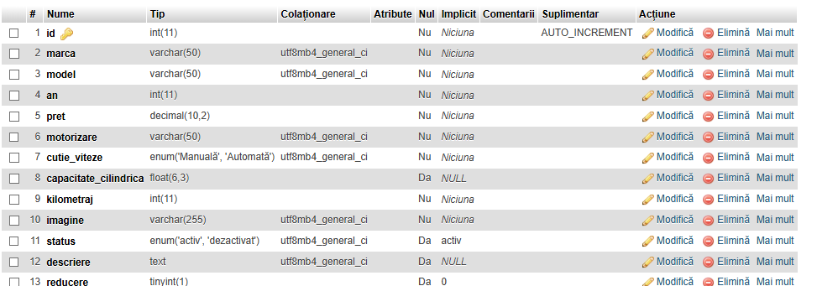

**✅ Conclusions and Possible Improvements**

* **The application fully supports the management and display of second-hand vehicles.**
* **Responsive design, optimized for both desktop and mobile devices.**

**The following features could be added:**

* **A detailed page for each vehicle**
* **Contact form for each vehicle**
* **Google Maps integration for vehicle location**
* **A “How to get financing” page with visual steps and conditions**