**📘 Project Documentation – Gym-Management-App**

**📌 General Description**

**Gym-Management-App is a full-stack application designed to manage members of a fitness center. It offers features such as:**

* **Registering new members**
* **Renewing memberships**
* **Viewing and managing data through an intuitive interface**
* **Managing personal information and subscription types**

**🛠️ Technologies Used**

| **Component** | **Technology** |
| --- | --- |
| **Frontend** | **HTML, CSS, JavaScript** |
| **Backend** | **PHP, MySQL** |
| **Database** | **MySQL** |
| **Other Tools** | **Bootstrap, XAMPP, PhpMyAdmin** |

**🖥️ Main Features**

**1. Main Dashboard**

**Displays an overview of the members, the number of active and expired subscriptions, etc.**

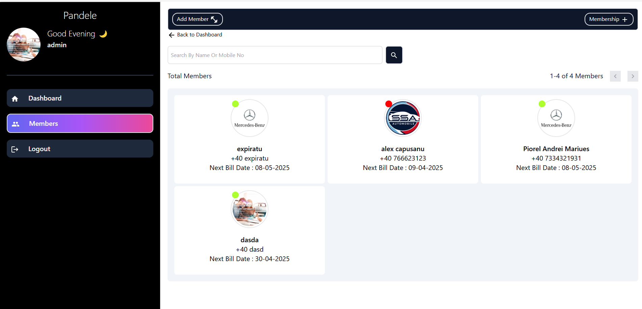

**2. New Member Registration**

**Form used by the administrator to register a new member, filling out details such as name, surname, email, phone number, membership type, start date, etc.**

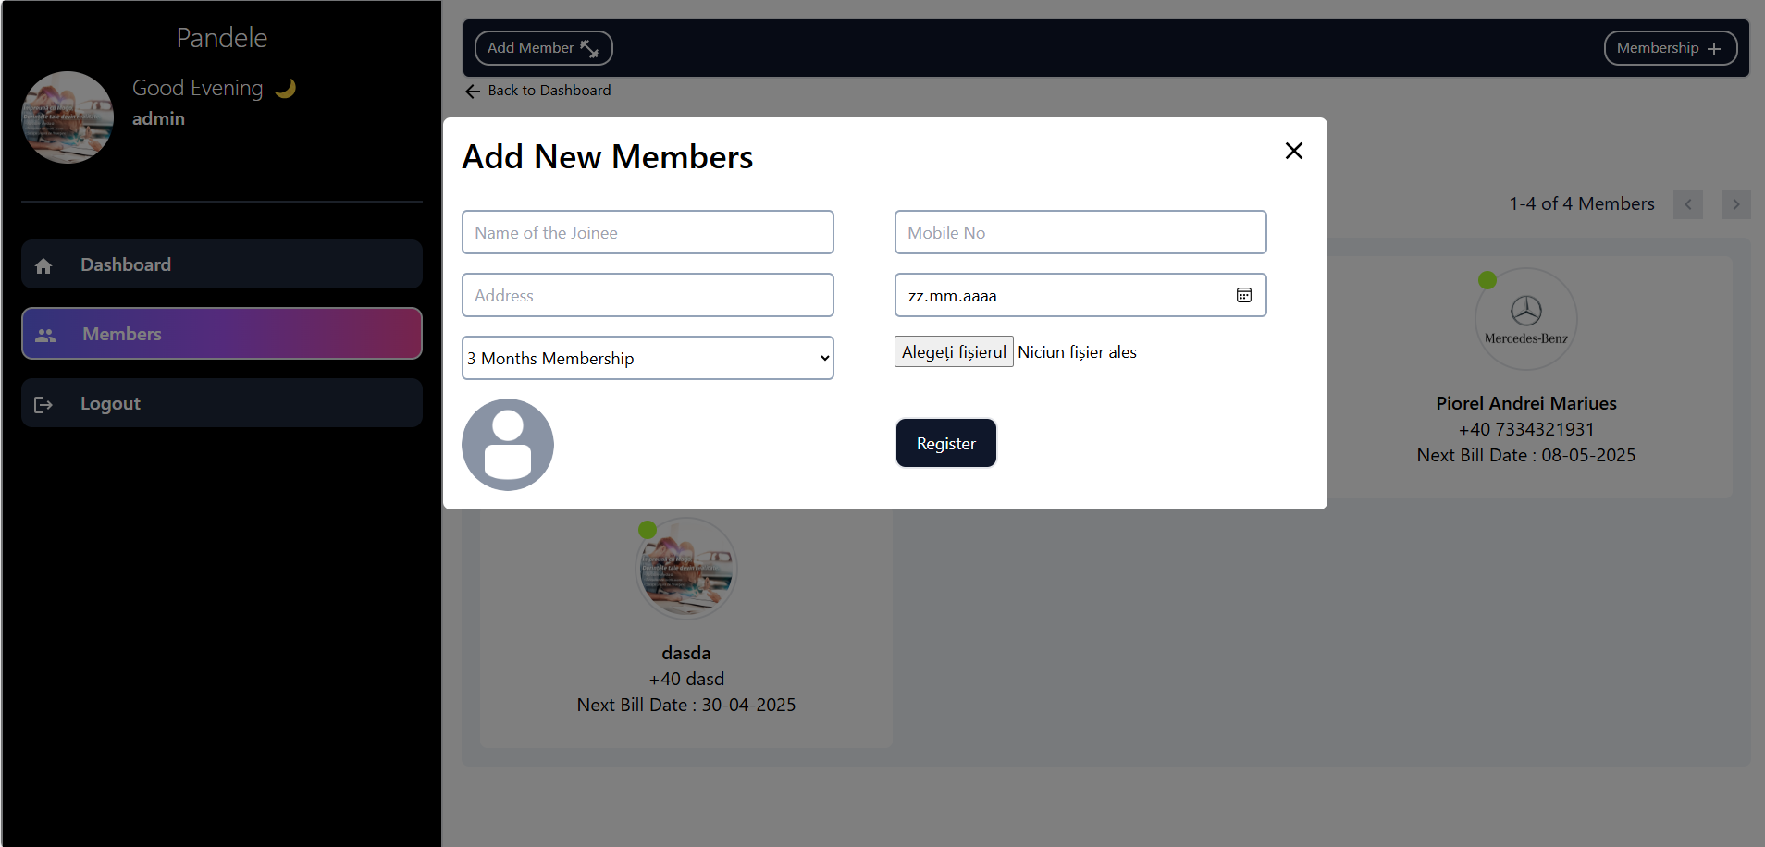

**3. Membership Renewal**

**Feature that allows the administrator to renew a member's subscription with a single click.**

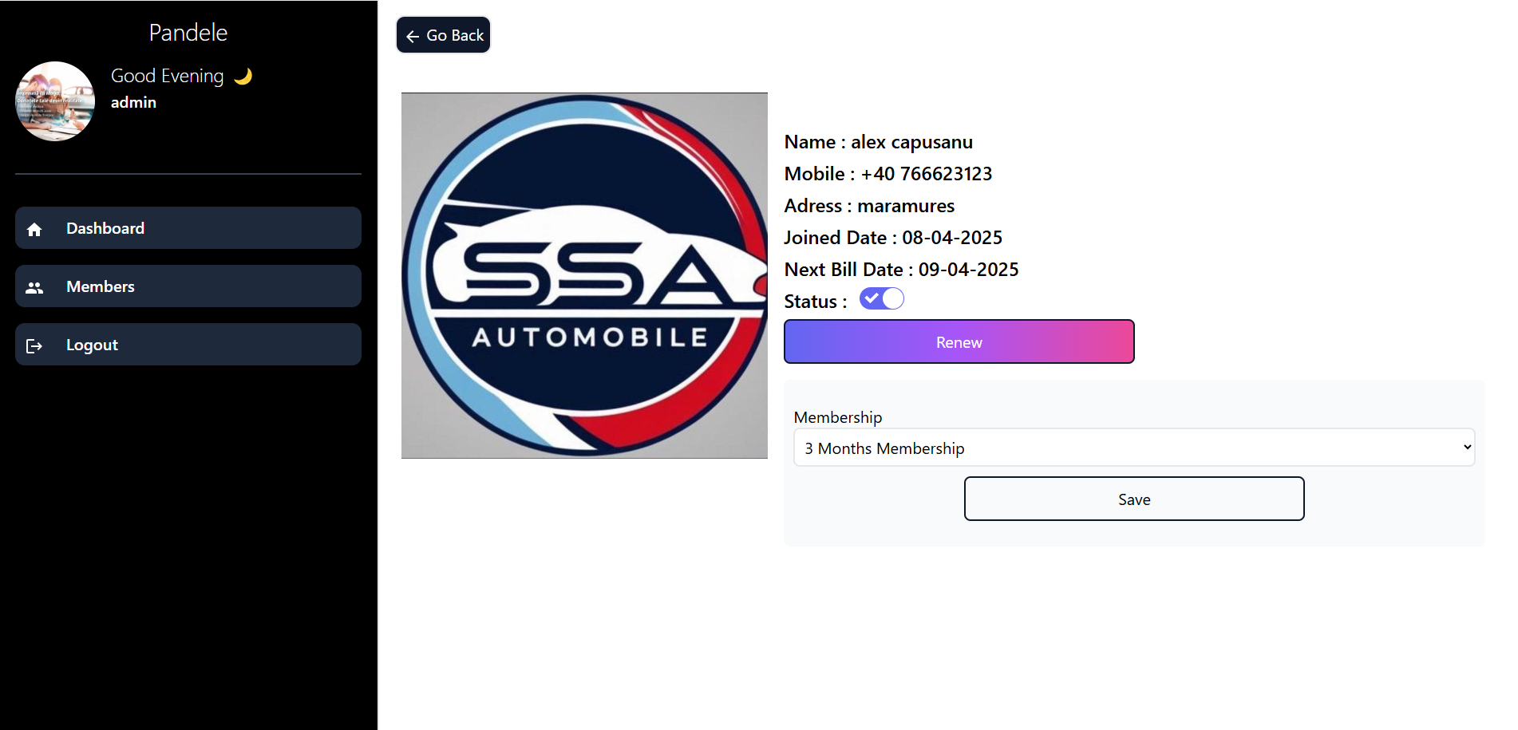

**4. Expired Membership Validation**

**Automatically checks the expiration date of the membership. Members with expired subscriptions are highlighted.**

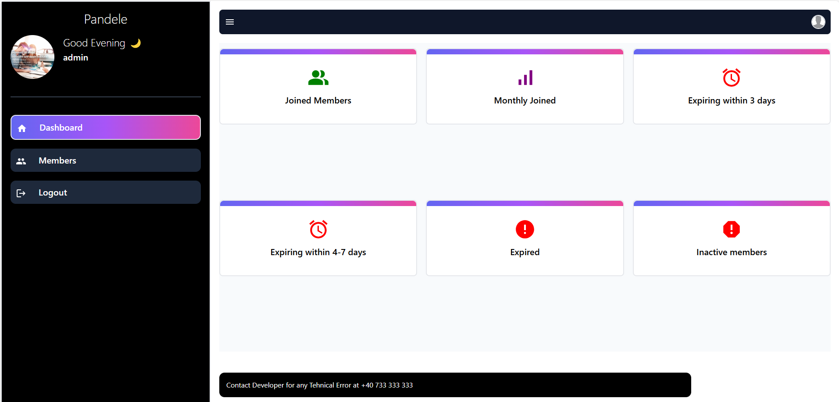

**5. Admin Authentication (Log In) + Admin Registration (Sign Up)**

**A login system that allows access to the dashboard only for authenticated users. The username and password are verified from the database.**

**If there are no existing admin accounts, the app allows registering a new one (e.g., on first run). The registration form includes name, email, username, and password – which is encrypted before storing in the database.**

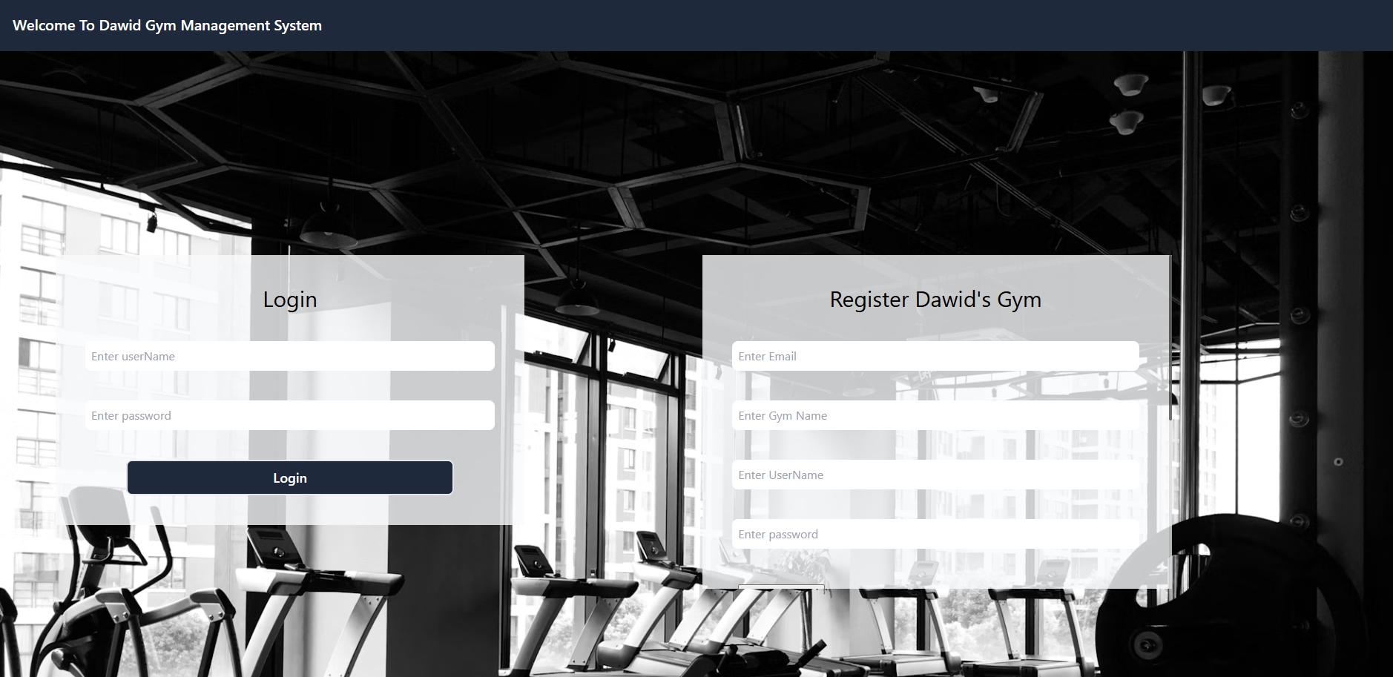

**6. Password Recovery (Forgot Password) + OTP**

**If an administrator forgets their password, the application provides a recovery option using an OTP (One-Time Password). The admin enters their registered email address, receives a temporary code, and can then reset the password. The new password is encrypted and updated in the database.**

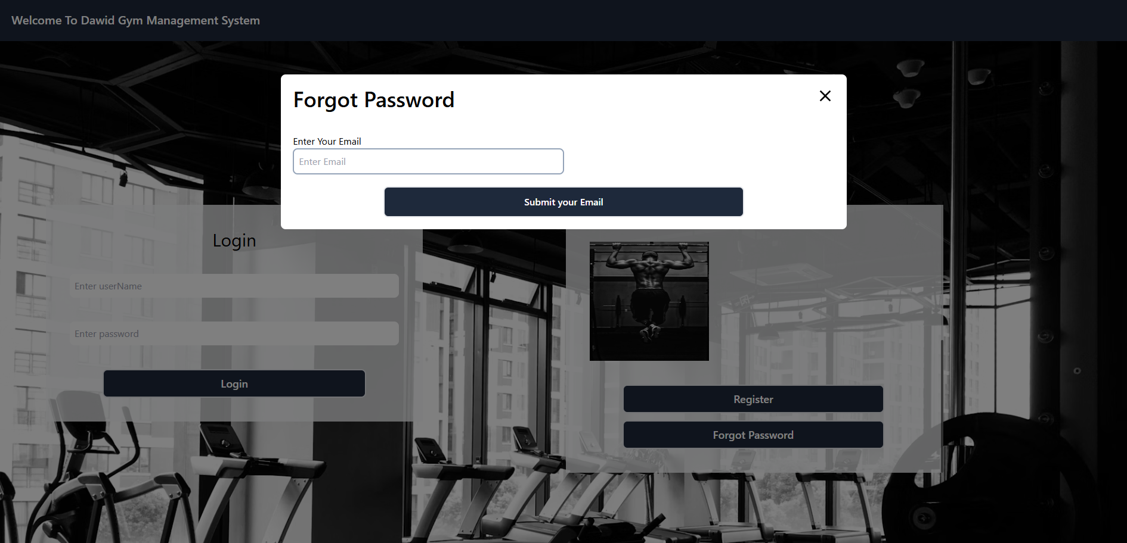

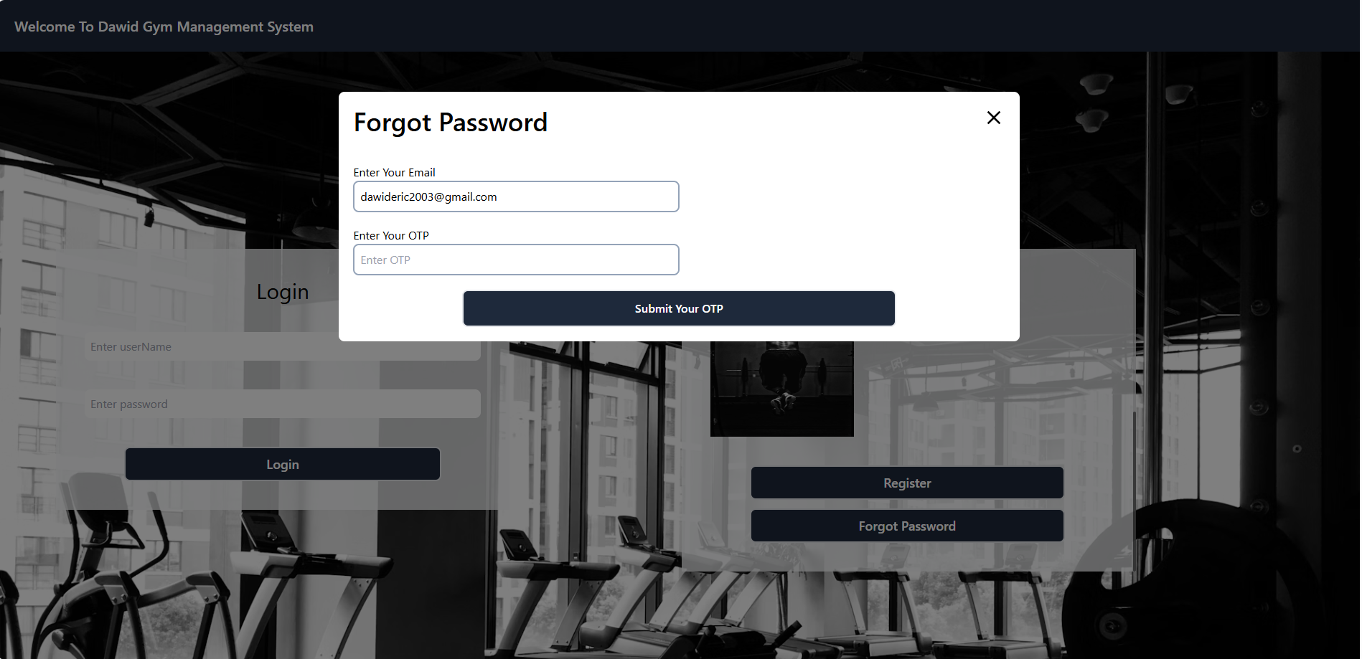

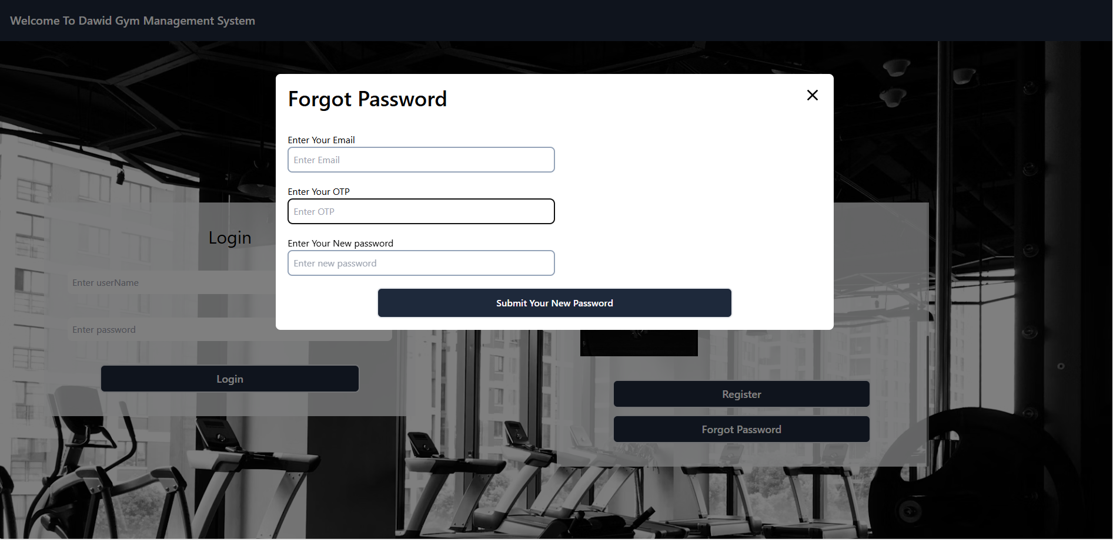

**✅ Conclusions and Possible Improvements**

* **The app covers all essential features for managing a fitness center**
* **A notification system for upcoming expirations could be added**
* **Possibility to generate monthly reports or export data to Excel**
* **Responsive design for mobile accessibility**