In Version 56.0.2924.0 (32-bits)

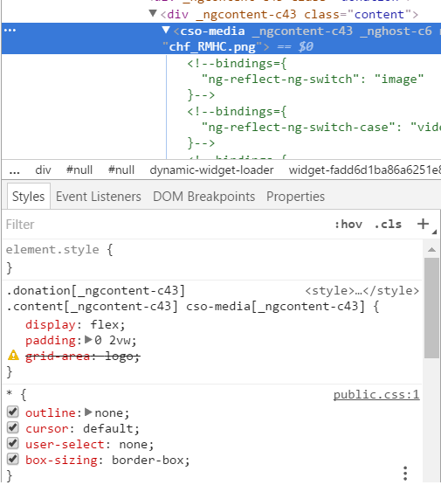

The exact same source in Version 61.0.3163.100 (Official Build) (64-bit) doesn’t give the “grid-area” “undefined property name” thing ..

What could cause that?