Project 2: Test Strategy

Software Quality

Name: Burhan Shibli | Daeseong Yu | Nick Turco | Sungmin Leem
Group 11
Course: Software Engineering Technology
Date of Submission: 8 December 2025

Mind Map
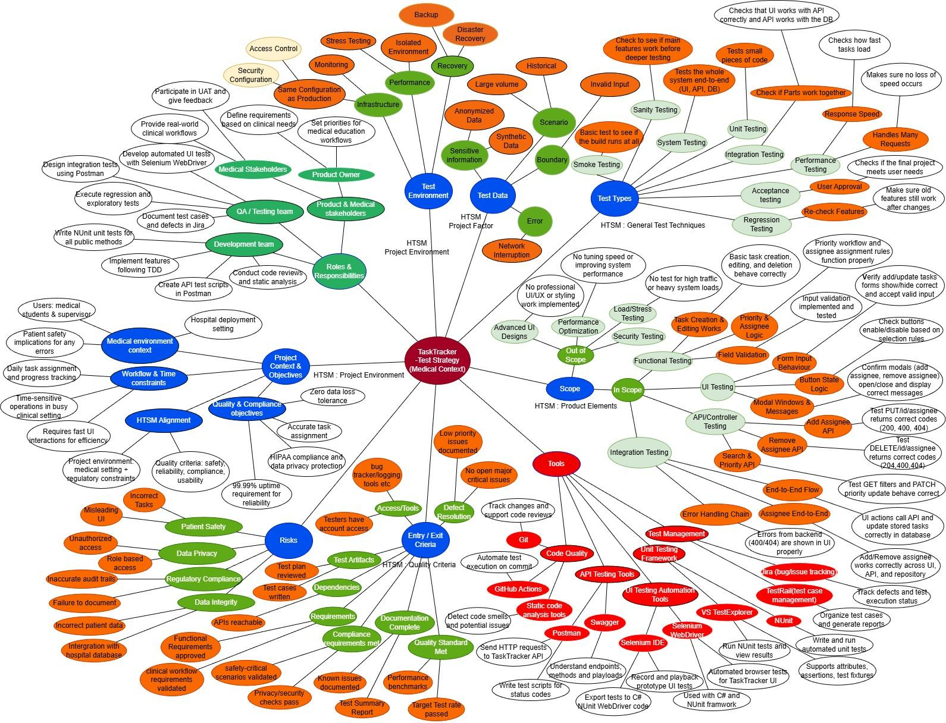

Team Approach and HTSM influence

We made a mind map for our TaskTracker test strategy. This app will be used in hospitals, so we need to be very careful. We divided the work; Burhan worked on TextTypes and Scope parts. Daeseong did Test Environments, and Test Data. Nick was responsible for Risks and Entry & exit criteria. Sungmin made Roles & Responsibilities, Tools and Project context & Objectives. We used draw.io to create the mind map together.
The HTSM framework helped us organize our mind map. We learned about this framework in our software quality class. For General Test Techniques, we put unit testing, API testing, and UI testing in our map. For Project Environment, we added hospital settings and medical stakeholders. For Product Elements, we included task creation and assignment features. For Quality Criteria, we focused on safety, reliability, and HIPAA compliance. Each team member used ideas from the course materials. For example, we used NUnit for unit testing, Postman for API tests, and Selenium WebDriver for UI automation as taught in the course while testing the Task Tracker. This mind map shows our whole test strategy for the medical app.

