

**Tribhuvan University**

**Faculty of Humanities and Social Science**

**Online Attendance System**

**A PROJECT REPORT**

**Submitted To:**

**Department of Computer Application**

**Nepal Mega College**

***In partial fulfillment of the requirements for the Bachelors in Computer Application***

Submitted By:

Padam Thapa Magar (6-2-266-14-2022)

Pemba Tamang Lama (6-2-266-19-2022)

Chaitra, 2081

Under the Supervision of

**Niraj Kumar Pokharel**



**Tribhuvan University**

**Faculty of Humanities and Social Science**

**Nepal Mega College**

**Supervisor’s Recommendation**

I hereby recommend that this project prepared under my supervision by Padam Thapa Magar and Pemba Tamang Lama entitled **“Online Attendance System (Hajir)”** in partial fulfillment of the requirements for the degree of Bachelor of Computer Application is recommended for the final evaluation.

**SIGNATURE**

**Niraj Kumar Pokharel**

BCA Department

Nepal Mega College



**Tribhuvan University**

**Faculty of Humanities and Social Science**

**Nepal Mega College**

# **LETTER OF APPROVAL**

This is to certify that this project prepared by Padam Thapa Magar and Pemba Tamang Lama entitled “**Online Attendance System (Hajir)”** in partial fulfillment of the requirements for the degree of Bachelor in Computer Application has been evaluated. In our opinion it is satisfactory in the scope and quality as a project for the required degree.

|  |  |
| --- | --- |
| **SIGNATURE of Supervisor**      Niraj Kumar Pokharel, Supervisor  Nepal Mega College  Babarmahal, Kathmandu | **SIGNATURE of Coordinator**      Dharma Raj Poudel, Coordinator  Nepal Mega College  Babarmahal, Kathmandu |
| **SIGNATURE of Internal Examiner** | **SIGNATURE of External Examiner** |

# **ABSTRACT**

In today's fast-paced world, managing attendance manually can be time-consuming and prone to errors. This project aims to develop an **Online Attendance System** designed to simplify and streamline the process of recording and tracking attendance for both students and employees. The system allows administrators to easily manage attendance records in real-time, offering a digital solution that eliminates the need for traditional paper-based methods. The front-end of the system is built using HTML, CSS, and JavaScript to provide an intuitive and user-friendly interface for both users and administrators. The back-end is powered by PHP and MySQL, which store and manage attendance data, ensuring secure and efficient record keeping.

The final version of the system consists of two main parts: a front-end for users to check and mark their attendance and a back-end for administrators to manage and track attendance records. This system also incorporates features such as real-time updates, report generation, and data analytics. In addition, the project includes comprehensive documentation covering various aspects such as system design decisions, user requirements, database structure, security measures, data privacy, and potential system integration. It also addresses the costs and benefits of the system, as well as the project schedule, providing a complete solution for efficient attendance management.

***Keywords: Intuitive, Real-time Updates, Comprehensive documentation, Potential System Integration.***

# **ACKNOWLEDGEMENT**

We would like to express my sincere gratitude to **Niraj Kumar Pokharel** and **Dharma Raj Poudel** for their invaluable guidance, support, and encouragement throughout this project. Their expertise and constructive feedback have been instrumental in shaping this work.

We also extend our appreciation to Nepal Mega College and the faculty members of the BCA Department for providing the necessary resources and knowledge that helped in the successful completion of this project.

A special thanks to my peers and friends for their insightful discussions and motivation during this journey. Lastly, We are grateful to our family for their constant support and encouragement.

**TABLE OF CONTENT**

LETTER OF APPROVAL II

ABSTRACT III

ACKNOWLEDGEMENT IV

LIST OF ABBREVIATIONS VI

LIST OF FIGURES VII

LIST OF TABLES VIII

Chapter 1: Introduction 1

1.1. Introduction 1

1.2. Problem Statement 1

1.3. Objectives 2

1.4. Scope and Limitation 2

1.5. Report Organization 3

Chapter 2: Background Study and Literature Review 4

2.2. Literature Review 4

Chapter 3: System Analysis and Design 6

3.1. System Analysis 6

3.1.1. Requirement Analysis 7

3.1.2. Feasibility Analysis 9

3.1.3. Data Modeling (ER-Diagram) 11

3.2. System Design 14

3.2.1 Architectural design 14

3.2.2. Database Schema Design 15

4.1. Implementation 18

4.1.1. Tools Used 18

4.1.2. Implementation Details of Modules 19

4.2. Testing 21

4.2.1. Test Cases for Unit Testing 21

4.2.2. Test Cases for System Testing 23

Chapter 5: Conclusion and Future Recommendations 24

5.1. Lesson Learnt 24

5.2. Conclusion 24

5.3. Future Recommendations 25

References 26

# **LIST OF ABBREVIATIONS**

|  |  |
| --- | --- |
| BCA | Bachelors in Computer Applications |
| CSS | Cascade Style Sheet |
| DFD | Data Flow Diagram |
| HTML | Hyper Text Markup Language |
| JS | Java Script |
| MySQL | My Structured Query Language |
| PHP | Hyper Text Preprocessor |
| UI | User Interface |

# **LIST OF FIGURES**

Figure 1: Waterfall Methodology of Online Attendance System 6

Figure 2: Use-Case Diagram of Online Attendance System 8

Figure 3 Gantt Chart of Online Attendance System 10

Figure 4:ER-Diagram of Online Attendance System 11

Figure 5: Process Modeling ( DFD Level 0) of Online Attendance System 12

Figure 6:DFD Level 1 of Online Attendance System 13

Figure 7: Architectural Design of Online Attendance System 14

Figure 8:Schema Design of Online Attendance System 15

Figure 9:Interface Design of Online Attendance System 16

Figure 10: Physical Design of Online Attendance System 17

Figure 11: Validation within authentication module of Online Attendance System 19

Figure 12:Attendance Management Module of Online Attendance System 20

# **LIST OF TABLES**

Table 1: Test Cases for Unit Testing 21

Table 2: Test Cases for System Testing 23

# **Chapter 1: Introduction**

## **Introduction**

Imagine a classroom where taking attendance is as simple as clicking a button—no more shuffling through papers or dealing with messy spreadsheets. That's where Hajir comes in. This online attendance system is designed with students in mind, making it easier than ever to record, track, and manage attendance digitally. Developed as a college assignment to showcase basic CRUD operations (create, read, update, delete), Hajir runs locally on XAMPP with Apache and MySQL, and it's built using HTML, CSS, and JavaScript.

Hajir was created to simplify the routine task of marking attendance, allowing teachers to focus on what really matters—teaching. By automating attendance, the system not only enhances data management and accuracy but also significantly reduces the administrative hassle of manual paperwork. Whether you're a student curious about digital systems or a teacher looking for a smoother way to manage class records, Hajir offers a friendly, efficient solution for tracking student attendance in real time.

Hajir is a system that:

* Streamlines attendance marking with just a click, eliminating the need for paper-based registers.
* Enhances data accuracy and ease of retrieval by storing attendance records in a centralized digital system.
* Minimizes manual paperwork, allowing educators to focus more on teaching rather than administrative tasks.

## **1.2. Problem Statement**

Imagine a teacher standing at the front of the class, flipping through a paper register to mark attendance by hand. This method not only takes up valuable time but also risks errors like missed names or messy handwriting. Sorting through piles of paper to find a specific day's record is frustrating, and if any of those sheets are lost or damaged, there's no backup.

* Manual entry can lead to mistakes like recording the wrong date, time, or name, causing inaccurate records.
* Collecting and entering attendance data by hand takes a lot of time, especially in large institutions.
* Since records are kept on paper, compiling daily, weekly, or monthly reports is a slow and tedious process.
* Manual systems don’t provide real-time updates, making it difficult for administrators to check current attendance instantly.
* Paper records can be easily lost, damaged, or destroyed by fire, water, or wear and tear over time.
* Manual systems lack tools to analyze attendance trends, making it harder to track patterns without transferring data to a digital system.

## **1.3. Objectives**

The objective of an online attendance system is to provide a **fast, accurate, and efficient** way to record and manage attendance digitally. Here are its key goals:

* To digitalize attendance by cutting paper records by 90% by the end of the trial period.
* To implement real-time tracking with 95% uptime in the first quarter.
* To integrate interactive dashboards (doughnut and line charts) and achieve 80% positive user feedback by the term's end.
* To ensure secure access for all educators and students by the end of the rollout.
* To reduce administrative time by 50% through a user-friendly platform by the end of the implementation phase.

## **1.4. Scope and Limitation**

While the Online Attendance System offers many benefits, there are some limitations to consider. One key limitation is the reliance on internet access and devices to access the system. Users who do not have access to a stable internet connection or the necessary devices (e.g., smartphones, computers) may face difficulties using the system. Additionally, while the system supports digital attendance management, it does not yet support biometric features such as fingerprint or facial recognition for more accurate and secure attendance tracking. Moreover, the system currently lacks features for automatic notifications or reminders for users who forget to mark their attendance. Finally, the system may need further customization to integrate with other institutional systems, which could require additional development.

## **1.5. Report Organization**

After completing our project development, we have recorded key milestones, and the final report has been structured into the following chapters. This report provides a comprehensive overview and presents the organized flow of information.

**Chapter 1:** **Introduction:** This chapter includes the introductory section, outlining the project's objectives, scope, and limitations.

**Chapter 2**: **Background Study and Literature Review:** This chapter covers the background research and literature review related to the project.

**Chapter 3:** **System Analysis and Design:** This chapter includes the requirement analysis and feasibility study, system design with architectural design, database design, activity design, and all relevant diagrams.

**Chapter 4:** **Implementation and Testing:** This chapter outlines the implementation and testing phases, including the development methodology, tools used, and the testing process applied throughout the development. It provides details on system testing and describes the techniques employed in both the front-end and back-end development. Additionally, it covers how the modules were developed and tested, along with the testing process for both individual modules and the overall system.

**Chapter 5**: **Conclusion and Future Recommendations:** This chapter presents the conclusions drawn from the project, along with potential future enhancements and improvements for the system.

**Chapter 6:** Appendices: This chapter contains screenshots of the entire implementation, along with their descriptions.

# **Chapter 2: Background Study and Literature Review**

Traditional attendance systems have long relied on manual methods such as paper registers or basic software. In these setups, teachers or administrators call out names and record attendance by hand. While simple and not dependent on advanced technology, this approach is slow and prone to human error, often making it difficult for students and employees to verify their records.

Many institutions have shifted to web-based attendance systems, which reduce the reliance on physical registers and simplify data retrieval. However, these digital solutions are not without flaws. Although they tend to be affordable and more accessible, they frequently lack essential features such as real-time tracking, automated reporting, and user-friendly interfaces, making them less effective for larger or more dynamic environments.

To overcome these challenges, the Online Attendance System was developed as an efficient, modern solution that blends the simplicity of traditional methods with advanced digital features. This system offers accurate, real-time attendance tracking and automated report generation, ensuring that records are easily accessible and reducing the risk of errors. As a result, it modernizes attendance management for both students and administrators, addressing the shortcomings of older and existing digital platforms.

## **2.2. Literature Review**

**Hajir** is an innovative Online Attendance System developed to address the challenges of manual attendance tracking in educational institutions and organizations across Nepal. The system is designed to simplify the process of recording, managing, and tracking attendance for students and employees. This allows institutions to easily monitor attendance in real-time, reducing administrative workload and eliminating human errors associated with traditional methods. With **Online Attendance System**, students and employees can mark their attendance through a user-friendly digital platform, ensuring accuracy and convenience. The system provides both front-end access for users and a back-end interface for administrators to manage and generate detailed reports.

**e-School** is a simple online attendance management tool for educational institutions and businesses in Nepal. It allows administrators to easily record and track attendance digitally, offering real-time updates and secure data storage. The system provides basic reporting features but is limited in customization and scalability compared to more advanced platforms. [1]

**eAttendance Nepal** is a digital attendance solution for schools and workplaces in Nepal. It features a user-friendly interface for marking and managing attendance, along with the ability to generate reports. The system also integrates with SMS and email notifications. However, it may lack advanced features and scalability, limiting its use for larger organizations. [2]

**Online Attendance System** is a web portal designed for taking and managing student's attendance in institutions by means of Smartphone as well as desktops. Till now the college uses paper records. The project use database to keep the track of attendance and is used to generate a report for individual student. The whole system is handled by admin about the faculties profile and student's data. [3]

**EduSmart Attendance** is designed specifically for schools in Nepal, offering real-time attendance tracking and easy report generation. It is accessible on mobile and desktop devices, making it convenient for both teachers and students. While user-friendly, it may not support advanced integrations or detailed analytics, making it less suitable for large institutions. [4]

Currently, many institutions still rely on outdated, paper-based attendance systems that are slow and prone to errors, but Online Attendance System offers a more efficient and scalable solution. By shifting to a digital attendance management system, Online Attendance System offers a modern approach to attendance tracking, making it easier for organizations to manage their records and improve overall efficiency.

# **Chapter 3: System Analysis and Design**

## **3.1. System Analysis**

System Analysis is a crucial phase in the software development process where we identify and evaluate the system’s objectives, requirements, and constraints. During this phase, we also assess any existing systems to ensure the new one addresses all necessary requirements and improvements. For Hajir, the System Analysis focuses on understanding user needs, defining the core functionality, and determining how the system will fulfill those needs.

The Hajir platform was developed using the Waterfall methodology, which follows a sequential approach where each phase (requirements, design, implementation, verification, and maintenance) cascades downward, ensuring a structured and organized development process.

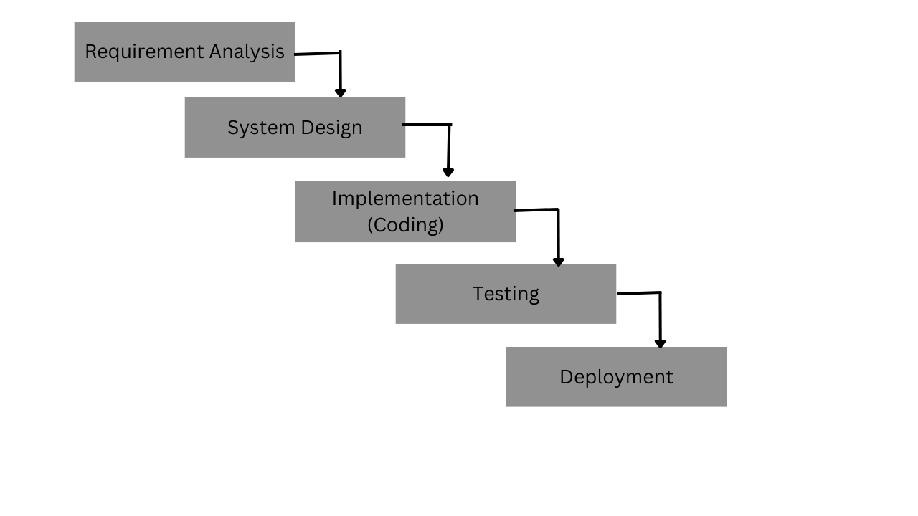

Figure 1: Waterfall Methodology of Online Attendance System

### **3.1.1. Requirement Analysis**

Requirements represent the user's expectations from the software product. These can range from obvious to hidden, known to unknown, and expected to unexpected from the client's perspective. It is essential to clearly communicate these requirements to the development team and stakeholders to ensure alignment and understanding throughout the development process.

#### **i. Functional Requirements**

The system must provide the following functionalities:

* User Authentication: The system must provide secure login and logout, verifying user credentials and managing sessions.
* User Registration: The system must allow new users (staff and students) to create accounts, storing and validating personal information.
* User Profile Management: The system must enable users to view and update their personal profiles.
* Class Management: The system must let authorized users add, edit, or remove classes, including class details like name, schedule, and assigned staff.
* Staff Management: The system must allow authorized personnel to add or modify staff details, assigning roles and permissions accordingly.
* Student Management: The system must enable authorized users to add or modify student details, maintaining an up-to-date list for each class.
* Attendance Marking: The system must allow authorized users (e.g., teachers) to mark attendance for each class session, recording present or absent status.
* Attendance Modification: The system must allow authorized users to update or correct attendance records, optionally keeping an audit trail.
* Attendance Reporting: The system must generate attendance reports (daily, weekly, monthly, or class-wise) for authorized users to view or download.
* Student List Management: The system must allow authorized users to add, remove, or update student lists for each class, ensuring accurate enrollment data.
* Security and Access Control: The system must enforce role-based access, ensuring that only authorized personnel can perform specific actions.

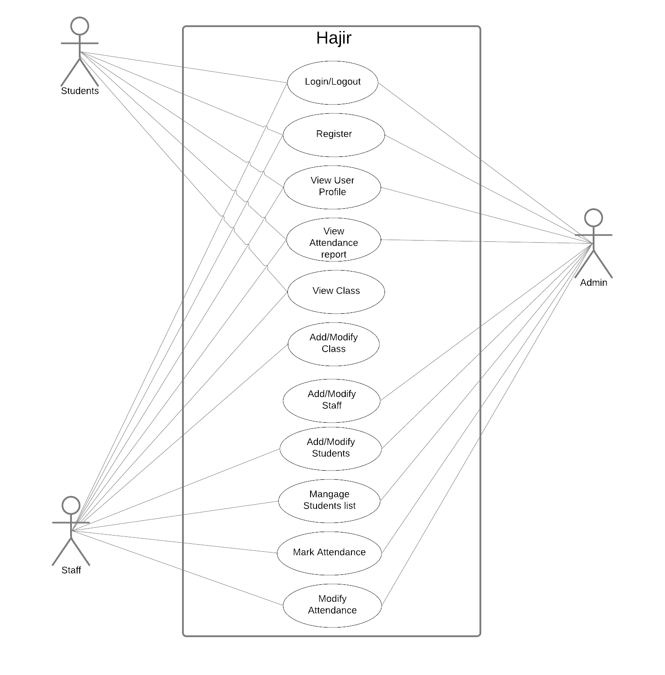

Figure 2: Use-Case Diagram of Online Attendance System

**ii. Non-Functional Requirements**

This system is:

* Performance: Optimized queries, AJAX interactions, and caching for smooth operation and fast response.
* Security: Uses prepared statements, session management, password hashing, role-based access, and encrypted data storage
* Usability: Intuitive, responsive interface with clear labels and minimal training required.
* Scalability: Designed to handle more users and data with future expansion support.

### **3.1.2. Feasibility Analysis**

A feasibility study evaluates the practicality of a proposed plan or solution. Our proposed solution is designed to meet all requirements and is flexible enough to accommodate future changes. It can be easily adapted to meet evolving needs. The main tasks completed during the feasibility study include assessing the system's workability, its impact on the organization, its ability to fulfill user needs, and the efficient use of resources.

#### **i. Technical Feasibility**

The system is technically feasible as it utilizes widely adopted technologies such as HTML, CSS, JavaScript, PHP, and MySQL. These open-source tools ensure easy development, scalability, and cost-effectiveness without requiring specialized hardware or software.

Its 3-tier architecture separates the presentation layer, business logic, and database, enhancing performance, security, and maintainability. As a web-based solution, it runs smoothly on any device with a browser, ensuring accessibility and ease of use. Given these factors, there are no major technological barriers to implementing the system efficiently.

#### **ii. Operational Feasibility**

The system is operationally feasible, reducing development costs while maintaining high quality. It is user-friendly, requiring no specialized training. The system delivers timely, accurate, and relevant information in an organized format, effectively addressing identified problems and leveraging opportunities. It meets all requirements established during the requirement analysis phase.

#### **iii. Economic Feasibility**

The system is designed using freeware software, and no external personnel are needed for its development. The entire system cycle will be operated by just two people, which helps reduce the overall expenses during the project development life cycle. There are no additional costs associated with this project, and the system will be available to all users free of charge. Therefore, it can be considered economically feasible.

#### **iv. Schedule Feasibility**

A Gantt chart was used for planning our project, providing a clear view of the work scheduled for specific days. It helped us visualize the start and end dates of the project in a simple format. The Gantt chart proved to be incredibly useful by breaking down complex tasks into an easy-to-follow plan and tracking the progress of each task. The following Gantt chart illustrates the timeline needed for project completion. However, due to unforeseen circumstances, the timeline may be adjusted and updated as necessary.

|  |  |  |  |  |  |  |  |  |  |  |  |  |  |  |  |  |  |  |  |  |
| --- | --- | --- | --- | --- | --- | --- | --- | --- | --- | --- | --- | --- | --- | --- | --- | --- | --- | --- | --- | --- |
| Month | Shrawan | | | | Bhadra | | | | Ashoj | | | | Kartik | | | | Mangsir | | | |
| Week | 1 | 2 | 3 | 4 | 1 | 2 | 3 | 4 | 1 | 2 | 3 | 4 | 1 | 2 | 3 | 4 | 1 | 2 | 3 | 4 |
| Planning |  |  |  |  |  |  |  |  |  |  |  |  |  |  |  |  |  |  |  |  |
| Analysis |  |  |  |  |  |  |  |  |  |  |  |  |  |  |  |  |  |  |  |  |
| Design |  |  |  |  |  |  |  |  |  |  |  |  |  |  |  |  |  |  |  |  |
| Coding |  |  |  |  |  |  |  |  |  |  |  |  |  |  |  |  |  |  |  |  |
| Testing |  |  |  |  |  |  |  |  |  |  |  |  |  |  |  |  |  |  |  |  |
| Documentation |  |  |  |  |  |  |  |  |  |  |  |  |  |  |  |  |  |  |  |  |

*Figure 3 Gantt Chart of Online Attendance System*

### **3.1.3. Data Modeling (ER-Diagram)**

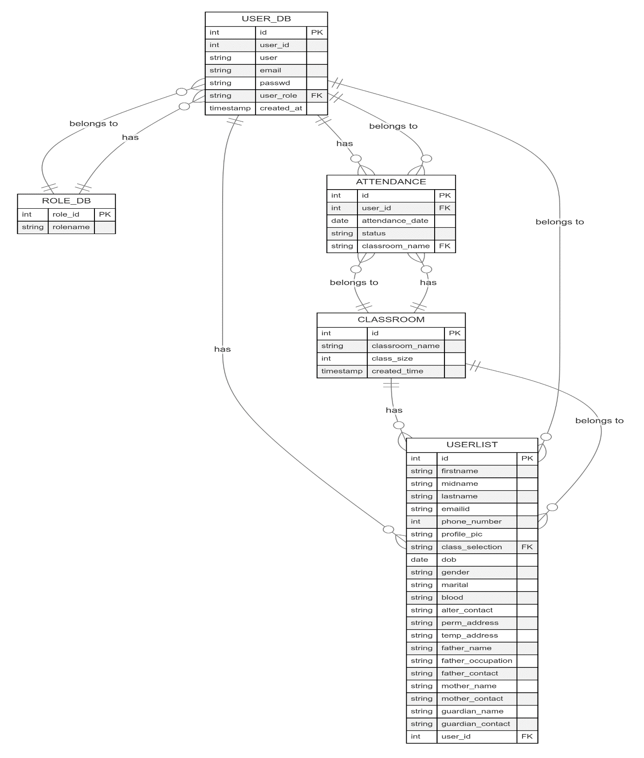

Figure 4:ER-Diagram of *Online Attendance System*

**3.1.4 Process Modeling (DFD)**

**Context Diagram**

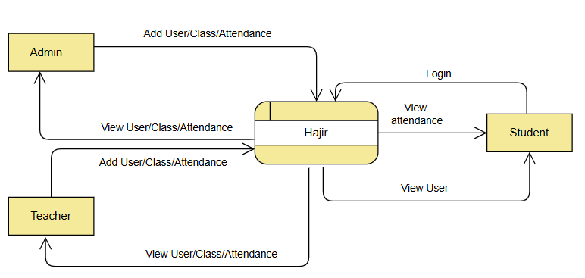

##### 

##### **Figure3: Context Diagram of Room Rental System**

Figure 5: Process Modeling ( DFD Level 0) of *Online Attendance System*

The context-level DFD for the Online Attendance System provides an overview of how the system interacts with its primary users: Admin, Teacher, and Student. The system serves as a central process that manages user requests and provides access based on roles. The Admin can add and view users, classes, and attendance records, while the Teacher has read-only access to class details and attendance records. The Student can only view their own attendance history. Each user must authenticate by submitting login credentials, which the system validates before granting access. The diagram focuses on these external interactions, without delving into internal processes, and sets the foundation for more detailed analysis in future DFD levels.

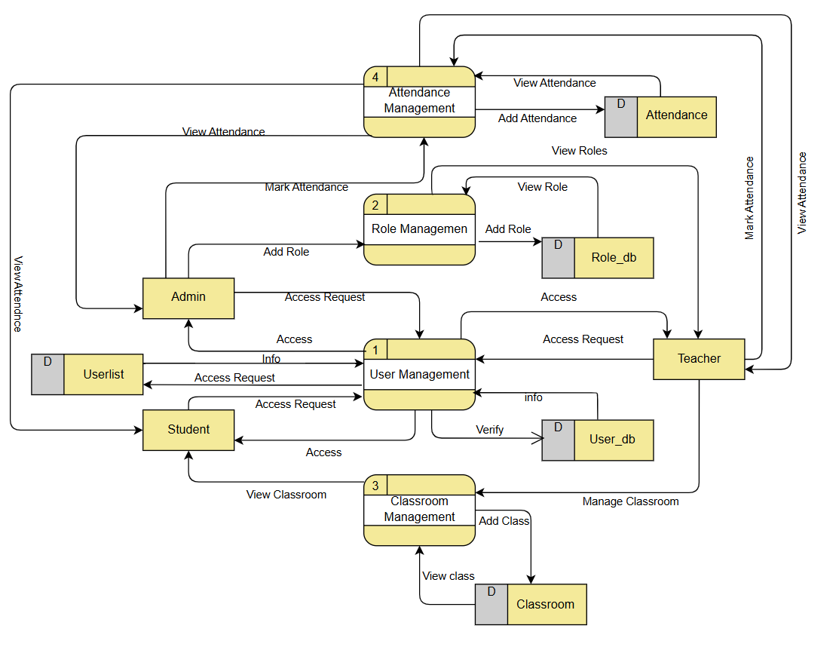**Data Flow Diagram**

Figure 6:DFD Level 1 of *Online Attendance System*

## **3.2. System Design**

The block diagrams below show a simple visual representation for describing actions of the complex system. The blocks are often referred as black boxes, which represent mathematical or logical operations that occur in sequence.

### **3.2.1 Architectural design**

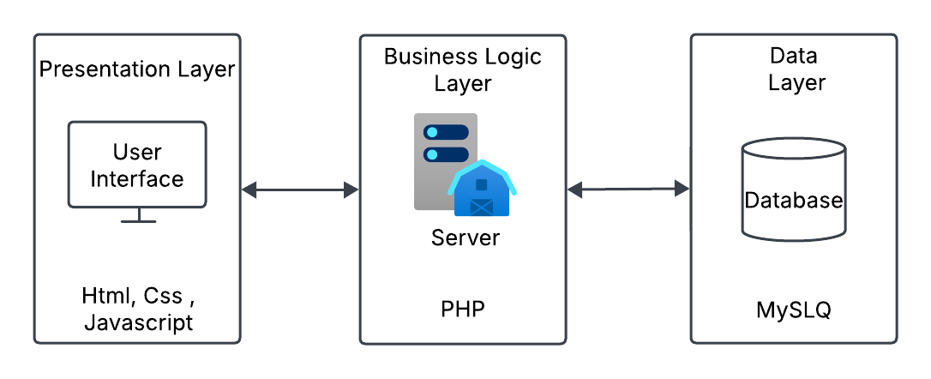

Figure 7: Architectural Design of *Online Attendance System*

### C:\Users\acer\AppData\Local\Microsoft\Windows\INetCache\IE\O7IDOL6F\HajirSchema[1].png**3.2.2. Database Schema Design**

Figure 8:Schema Design of *Online Attendance System*

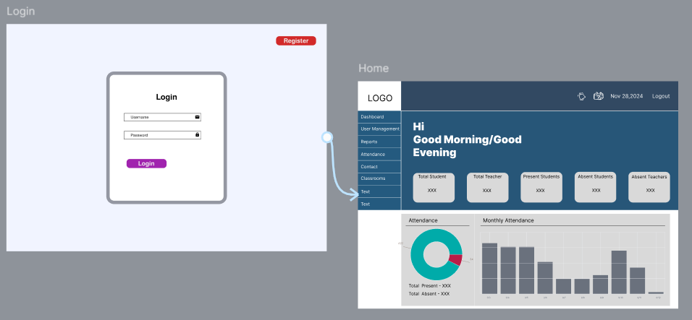**3.2.3. Interface design**

Figure 9:Interface Design of *Online Attendance System*

**3.2.4 Physical Design**

A Physical Data Flow Diagram (DFD) represents theactual implementation of the system’s data flow, depicting how data moves between different entities, databases, and external systems. It helps in understanding the real-world operation of the system

Figure 10: Physical Design of *Online Attendance System*

**Chapter 4: Implementation and Testing**

## **4.1. Implementation**

### **4.1.1. Tools Used**

**i. Front End Tool**: The front end of this application is designed using HTML, CSS, and JavaScript (JS). This Online Attendance System is built with a popular combination of web technologies. HTML and CSS are used for structuring and styling the content, while JavaScript enhances interactivity. This combination allows for the creation of responsive and dynamic web pages, ensuring a smooth user experience across different devices.

**ii. Back End and Database Tool**: The back end of this system is built using PHP, with MySQL managing the database. The system is hosted on an Apache server through XAMPP software. XAMPP stands for Cross-platform, Apache, MySQL, and PHP, allowing the system to run on a local web server on your computer. This setup provides an efficient environment for developing and testing the application before deployment.

**iii. Documentation Tool:** Microsoft Word (MS Word), a graphical word processing program, was used for documenting our Online Attendance System. For creating diagrams and figures, we used Draw.io, DBDiagram, and Visual Paradigm. Draw.io helped in creating simple system flowcharts, DBDiagram was used for designing and visualizing database schemas, and Visual Paradigm was utilized for overall system design and UML diagrams, providing a clear and structured representation of the system's architecture and processes.

**iv. Software Used:** For the development process, VS Code was used for writing the code, offering a powerful and efficient environment for coding. The application is hosted locally using the XAMPP server, which provides a platform for running Apache and MySQL services. Microsoft Edge was used for testing and running the web application, ensuring compatibility and smooth performance across different devices.

### **4.1.2. Implementation Details of Modules**

#### **Authentication Module**

This module manages user login and validation. It uses secure password hashing and session management allowing the authorized personal to login and access the system

* Checks if username and password fields are empty.
* 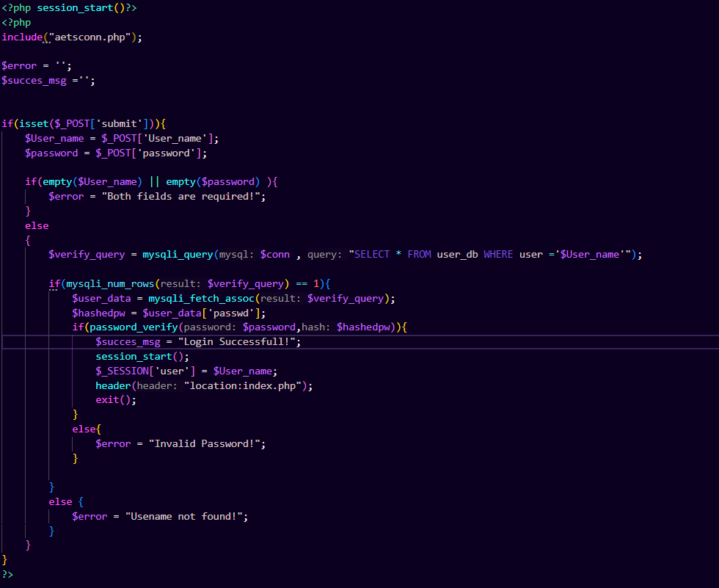Allow register user to login.

Figure 11: Validation within authentication module of *Online Attendance System*

**Attendance Management Module**

Authorized users (Admin or Teacher) can mark and edit student attendance based on their classroom. The system records attendance with the exact date and time in the database, ensuring accurate and time-stamped records.

* Authorized user can mark and edit attendance.
* Record exact data and time of marked attendance.

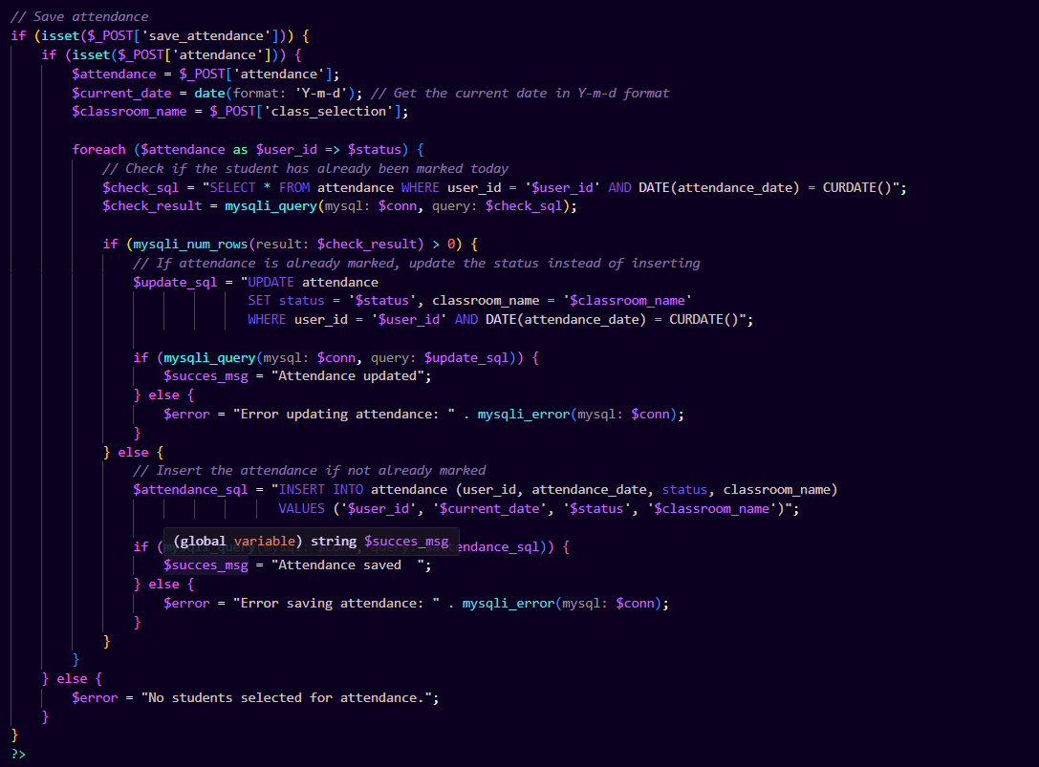

Figure 12:Attendance Management Module of *Online Attendance System*

## **4.2. Testing**

Unit testing and system testing were conducted after the system's implementation. The user module was thoroughly tested and confirmed to function as intended. Login functionality works only with registered user credentials. Since the system is focused solely on the user module, this module underwent both unit and system testing. The following test cases were performed during the testing process.

### **4.2.1. Test Cases for Unit Testing**

Table 1: Test Cases for Unit Testing

|  |  |  |  |  |  |  |
| --- | --- | --- | --- | --- | --- | --- |
| **S.N.** | **Objectives** | **Test description** | **Test Data** | **Expected Outcome** | **Result** | **Remarks** |
| 1 | Register User | Register user with valid details | Full Name: Padam Thapa Magar  Username: Padam  Email: padammgr567@gmail.com  Password: 12345  Registration Code: ADMIN123  (Click on submit) | User register successfully and user’s data stored in database successfully | Pass |  |
| 2 | User Login | Validate Login with correct data | Username: Padam  Password: 12345  (click on login) | You log in successfully into user panel | Pass |  |
| **3** | User login | Validate Login with incorrect data | Username: Padam  Password: 11111 | Login fail: error msg  “Incorrect password” | pass |  |
| 4 | Add classroom | Filling the form details in classroom details | Class Name = ‘One’ Size of classroom = ‘20’ | Classroom created | pass |  |
| 5 | To add attendance | Filling the following details in the Mark attendance form:  Then Save Attendance | Select classroom = ‘one’  Check the student in the status of attendance (present/absent) | Attendance Saved | pass |  |

### **4.2.2. Test Cases for System Testing**

This testing is done to ensure that the system meet the requirement. We have performed the system testing of our system and achieved the following result.

Table 2: Test Cases for System Testing

|  |  |  |  |  |  |  |
| --- | --- | --- | --- | --- | --- | --- |
| S.N. | Objectives | Test Description | Test Data | Expected Outcome | Result | Remark |
| 1 | End-to-end Authentication  for login |  | 1. Name : Padam 2. Password:12345 3. Name : Hari 4. Password:12345 | User are authenticate and redirect to their dashboard | Pass |  |

# **Chapter 5: Conclusion and Future Recommendations**

## **5.1. Lesson Learnt**

The development process was very informative. During the course of this system’s development, we found that several features of web development could be used to develop a system. Different technologies that we were unknown about have been brought in use. Time management was the main factor. This system is developed in a team and proper work division, resources management was the key. We learnt presentation ideas and skills.

Some important learning’s of this project are:

• **Effective Time Management**: Learning to allocate time properly to ensure the project stayed on track.

• **Exploring Web Development Models**: Gaining hands-on experience with various web development frameworks and techniques.

• **System Modeling and Diagramming**: Creating visual representations of the system to help organize and plan development.

• **Database Design**: Designing efficient database structures to ensure smooth data management.

• **Planning Development Activities**: Organizing and scheduling tasks to ensure that development progressed smoothly.

• **Team Management**: Collaborating effectively with teammates to distribute tasks and ensure a successful outcome.

## **5.2. Conclusion**

In conclusion, the Online Attendance System successfully addresses the challenges of manual attendance tracking in educational institutions. By automating the process, it has made attendance management more efficient, accurate, and accessible. The system ensures that both administrators and students can easily track and manage attendance records in real-time, eliminating errors, reducing time spent on manual tasks, and improving data security.

Throughout the development of the system, we have gained valuable insights into web development, database management, and system design, which have enhanced our skills and knowledge. The system meets all the requirements set at the beginning of the project and offers a user-friendly interface that simplifies the attendance process.

As the system continues to evolve, future enhancements may include additional features like real-time notifications, analytics, and integration with other educational tools. Overall, Hajir provides an effective, reliable solution for attendance management that can be easily adapted for use in various educational settings.

## **5.3. Future Recommendations**

Due to time constraints, it was challenging to test and implement all the planned features. However, the system provides a solid foundation, and future improvements will be made based on feedback and reviews received from users. Regular updates and enhancements to the database will also be conducted to ensure optimal performance.

Future improvements may include:

* **Biometric Integration**: Adding biometric authentication, such as fingerprint or **face recognition**, to improve the accuracy and security of attendance marking, ensuring that only the authorized person is marked present.
* **Mobile App Integration**: Developing a mobile application to allow students and administrators to access and manage attendance data on the go.
* **SMS/Email Notifications**: Implementing SMS or email notifications for students and administrators to keep them informed of attendance-related events, such as absences or tardiness.
* **Multi-Language Support**: Offering multi-language support to cater to users from different linguistic backgrounds, making the system more accessible.
* **Customizable Reports**: Providing more flexibility with customizable attendance reports, allowing users to generate reports tailored to specific needs or preferences.
* **Leave Management Integration**: Adding leave management features to allow students and employees to request, track, and manage their leave, further streamlining attendance management.
* **API Integration**: Integrating APIs to allow the system to interface with other institutional systems, enabling seamless data exchange and better overall management.

These enhancements will ensure that the Hajir Online Attendance System remains adaptable, user-friendly, and capable of meeting the needs of evolving educational institutions.

# **References**

|  |  |
| --- | --- |
| [1] | "e-School," e-Zone International Pvt Ltd, [Online]. Available: https://eschool.ezone.com.np/attendance. [Accessed Monday February 2025]. |
| [2] | "Edu Smart," Edu Smart, [Online]. Available: https://www.edusmart.app/. [Accessed 28 January 2025]. |
| [3] | S. M. ,. W. K. K. ASHISH MAHALLE, "IRE Journals," *Online Attendance System,* vol. 2, no. 4, p. 3, 2018. |
| [4] | "Edu Smart," Edu Smart, [Online]. Available: https://www.edusmart.app/. [Accessed Tuesday January 2025]. |

# 

**Appendices**

The appendices contain supporting materials such as screenshots of the **final implemented system**, source code snippets, and supervisor logs.

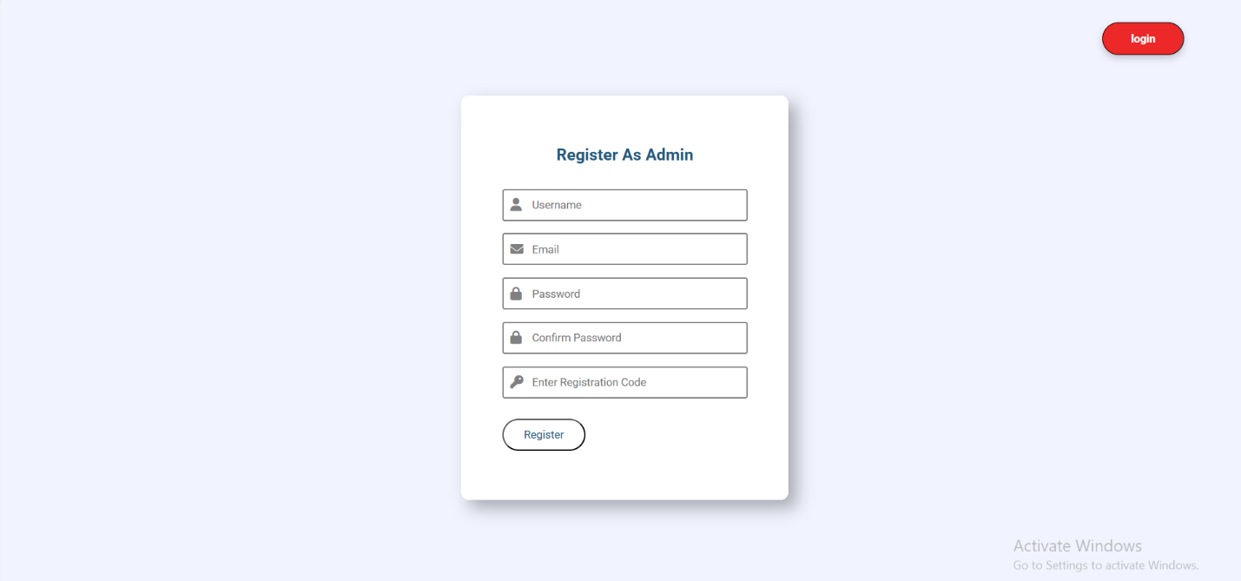**Registration Page**

**Login Page**

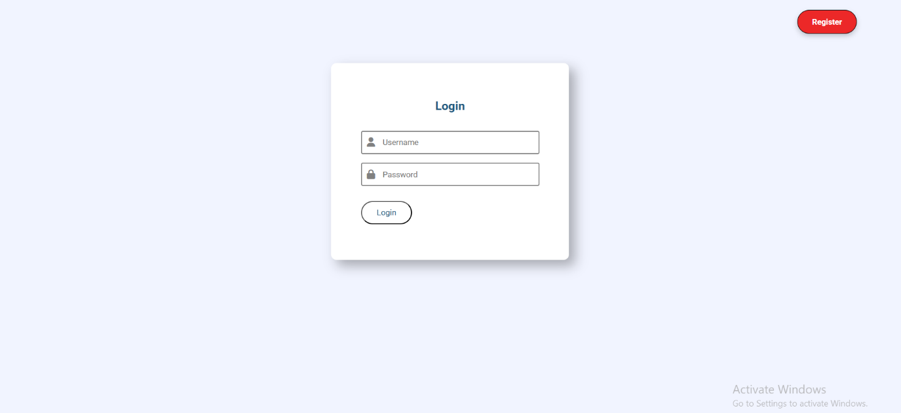

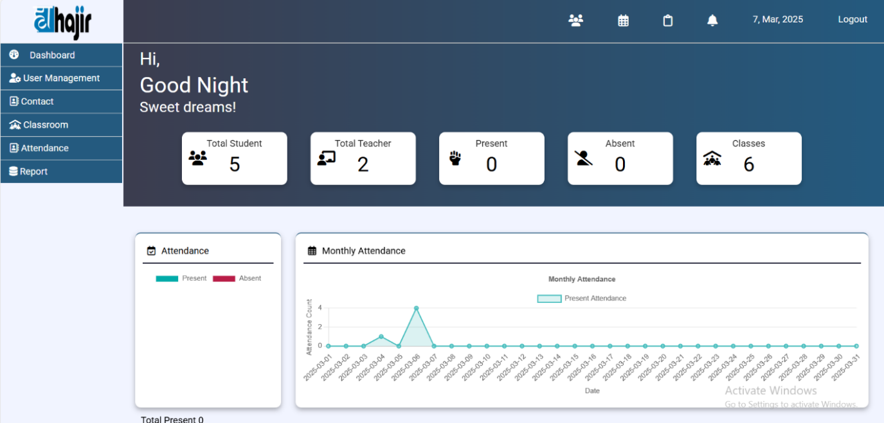**Dashboard**

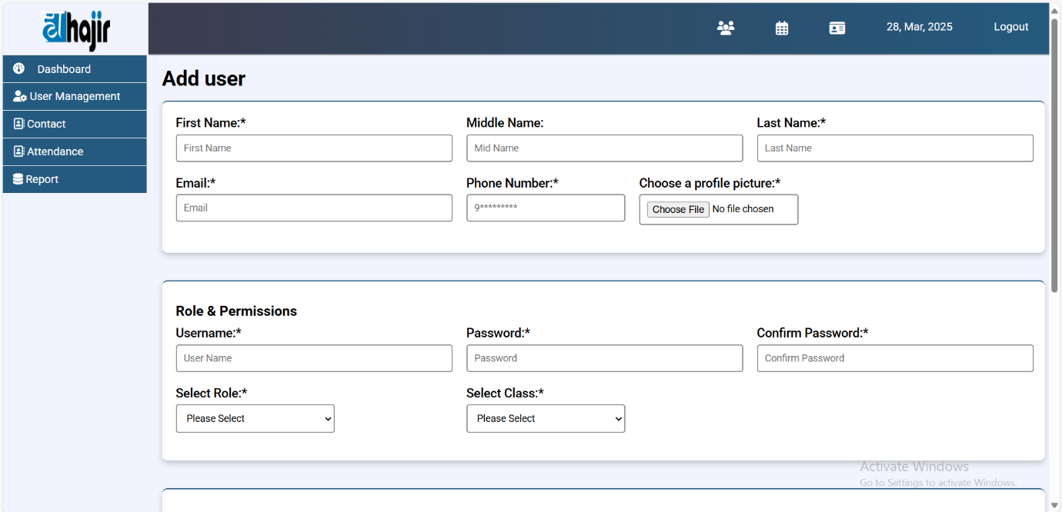**Add User**

**Edit User**

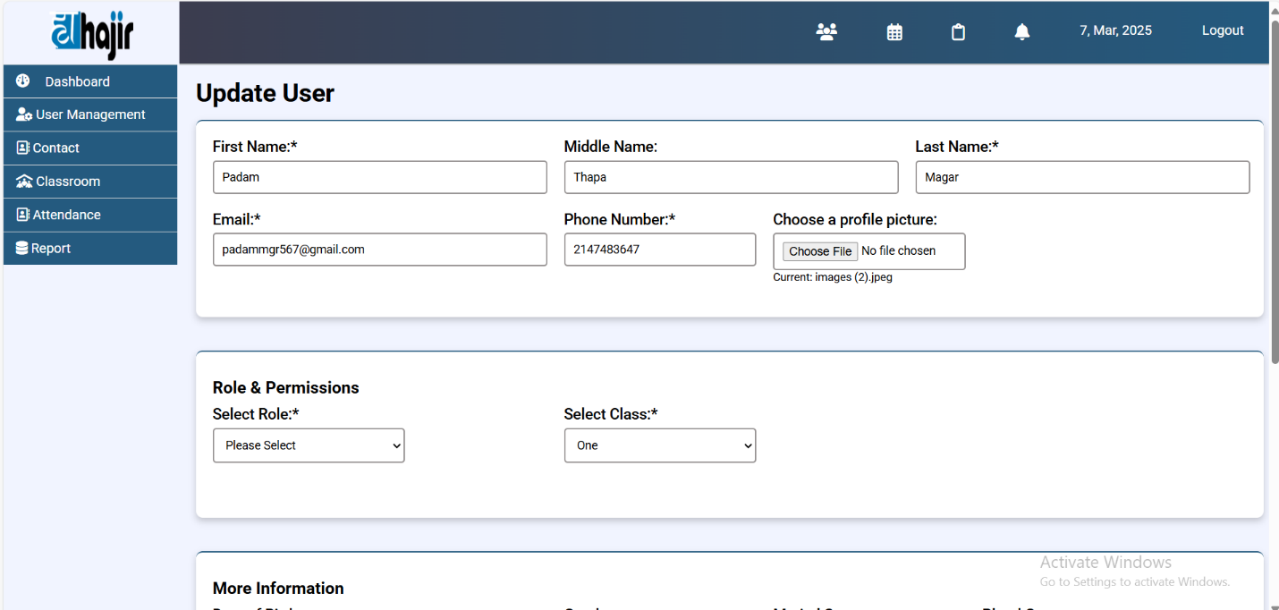

**Mark Attendance**

**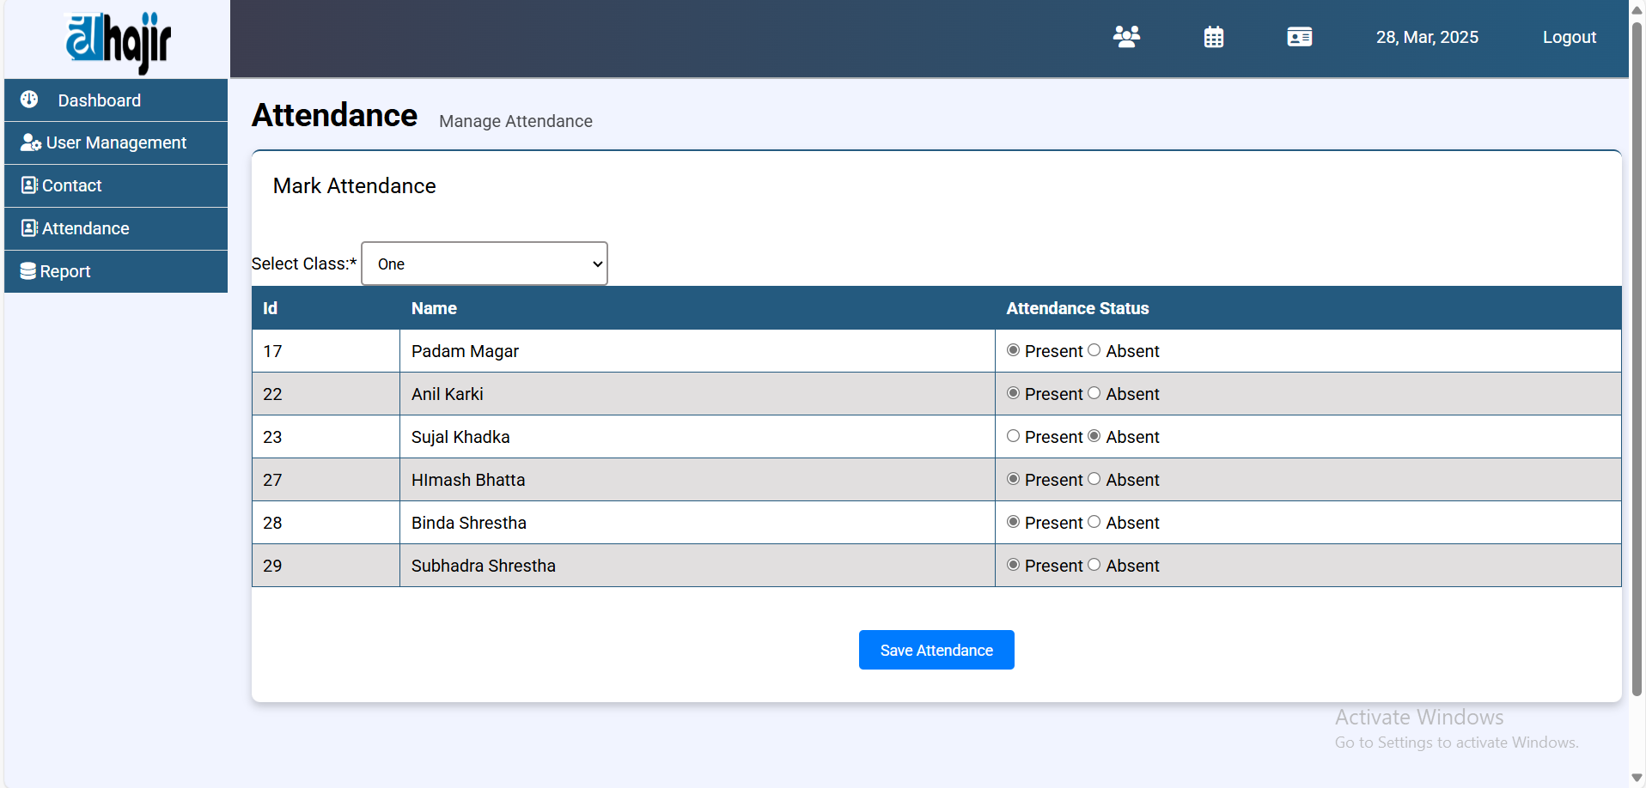  
  
View Report**

