Myo Fantasy I

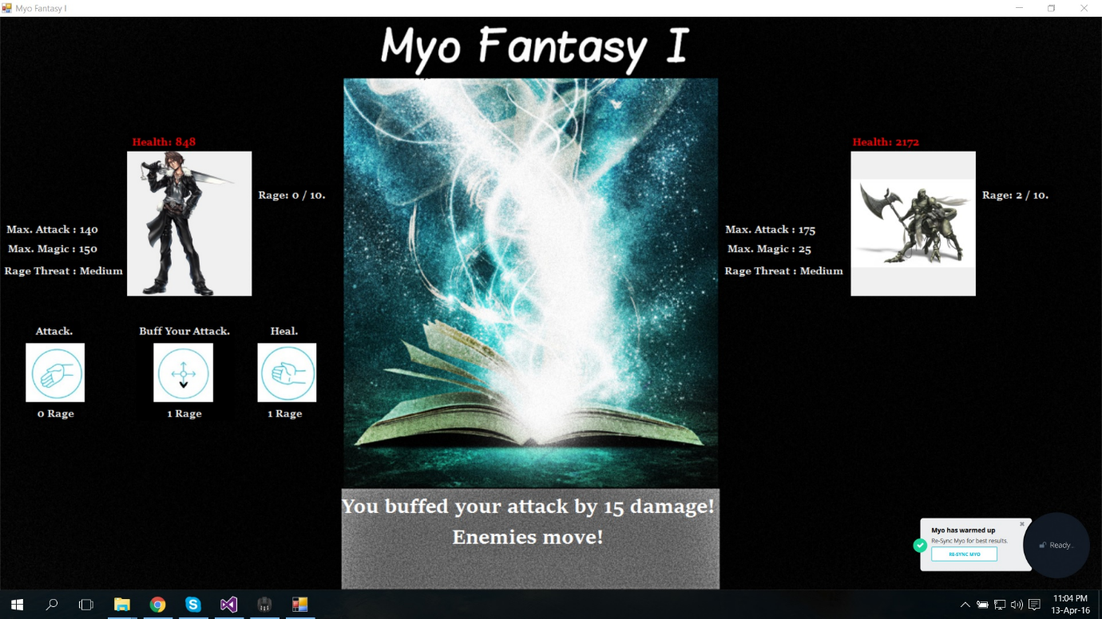**Purpose of the application** – The purpose of this application was to create a game on the basis of very popular game "Final Fantasy". Where I developed basic user interface which is easy to follow. This is a turn based game, there is a 30 second timer that ticks every 2 seconds. User has the first move, then it is the enemies move (there are 3 different enemies that the game generates) and then back to the user, and so on until either user or enemy wins. There are 4 abilities that the user can use, attack, buffing your attack, healing and using rage ability. Each of these abilities (except attack) require rage to be used – rage is generated when you take a hit from the enemy. Likewise, enemies rage is generated when you hit your enemy. The enemy doesn't have the ability to buff their attack. Down below is a screenshot showing the basic user interface that I created.

**Gestures identified as appropriate for this application** – Each of the abilities that user can use, require to perform certain gestures using the Myo Armband. There are different gestures that I used for my application, as well as gesture sequence and myo armband orientation data. Doing so helped me design a creative way that the user can interact with the game and the armband. Below is the list of gestures I used to certain abilities:

* Start the game – FIST gesture
* Attack ability – WAVE-IN gesture
* Buff your attack ability – Putting your arm down (Using myo orientation data)
* Healing ability – WAVE-OUT gesture
* Rage ability – Gesture sequence of (FIST and then FINGER SPREAD). (The sequence was double tap, fist and then finger spread but it was hard for the new users to follow)

**Hardware used in creating the application** – The only hardware I have used except of my laptop was the myo armband as I have came to the conclusion that it would suit best for the idea of my application. I have tried connecting Kinect but I couldn't quite get it to work properly and didn't really see how exactly it could be used for my game. Using myo armband helped me to achieve what I wanted to.

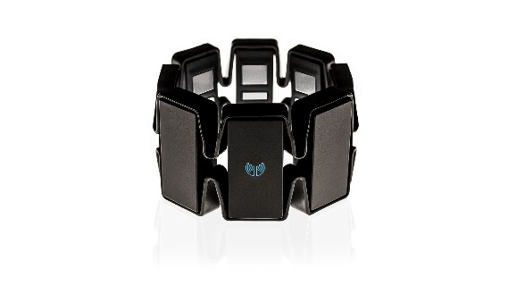**Architecture for the solution**



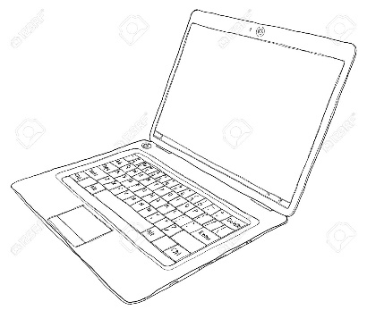

**Conclusions & Recommendation** – I have learned a lot from this project, from installing and downloading proper SDKs and software for the myo armband to work properly, to doing a research on how to use the myo armband API properly, and then to actual coding it and testing it which was a lot of fun. This has helped me to be more confident in new challenges and new technology that I have never used before. If I was doing this project again I would definitely work on a better user interface to make it more professional, I would also include some background music while the game is being played so it would be more enjoyable for the user. One of the other things that I would add to my game is to allow the user to choose the character that they want to play. Last but not least, if I had more time with the myo armband (There wasn't enough for the whole class so we had to take turns) I would definitely would like to try and develop this game in unity, to create a proper 3D game that who knows, might be even submitted to the myo market.