FIFA Report Analysis

by
Adam Aboud
Gabriel Dubé
John Arun
Cameron Turner

Foundations of Data Science

Ontario, Canada
12 of December, 2022

Objective

The main objective of this analysis is to understand and find what are the attributes of the most valuable soccer players in the world.

To achieve this, we will be using a Sports Data analysis data set containing information on various soccer players and their professional attributes such as income, age, preferred foot, etc. Since we are trying to understand what attributes are the most valuable, we will have to define “Value”. A multitude of analysis will be performed to view what high performing players look like and what high performing look like.

Our hypothesis is that the highest performing athletes will be the ones that are also paid the most. Usually high performance means high value but in this case, it would be interesting to see if we have any high performing athletes that are not necessarily paid highly.

The strategy to obtain the answer to our hypothesis will be to first dissect and analyse the data. Then we will input our data within a Linear regression model to complete our visual overview.

Data Preparation

Data Source

The data source for this analysis was the "Sports Data Analysis" dataset on Kaggle:
https://www.kaggle.com/datasets/mukeshmanral/fifa-data-for-eda-and-stats?resource=download

This dataset, compiled by Mukesh Manral, is licensed for use under the GNU Lesser General Public Licence. The data is free to download after creating an account on Kaggle.

This dataset contains information on professional soccer players that play in FIFA (Fédération internationale de Football Association) clubs around the world. The dataset contains 57 columns including general data such as name, country, height, weight and salary; as well as performance data on various aspects of a player's skill such as crossing, finishing, dribbling and ball control. There are 18,208 players in the dataset.

Data Quality and Cleaning

The quality of the dataset, overall, is excellent. There are several columns with missing data. However, the four columns that are missing the most data (e.g., Loaned From, Release Clause, Joined, Contract Valid Until) are all irrelevant to the objective of this data analysis. Therefore, these columns can easily be purged from the dataset. For the remaining columns that contain missing data, only 0.33% of the entire dataset is affected. These values could have been imputed with their respective column means; however, as they represent such a small percentage of the dataset, these rows were simply deleted from the analysis.

To assist in data preparation, the following data cleaning / preparation techniques were used:

Country Mapping: the dataset contains a column indicating the player's country. As there over 180 countries, this data range is impractical for location analysis. Instead, the player’s countries were mapped to continents so that player location analysis can be easier applied.

Age Binning: the dataset contains a column for the player's age. As the data range for age is approximately 30 years, this range would make it impractical for age-based analysis. The players’ ages were therefore binned into eight categories from Teenager to Forties and older.

Overall Skill Level Binning: the dataset contains a column for the player's overall skill level. This integer data has a range of 0 - 100. Due to the difficulty of evaluating a wide range of data values, these values were binned into six categories from Mediocre to Elite to provide an initial player classification.

Value and Wage Data Extraction: the dataset contains columns for the player's value and salary. These are String data types containing the Euro symbol and "K" (1,000). Therefore, these fields were split out into another column, Salary, which was typecast from a String to an int for easier analysis.

To assist in faster data exploration, familiarization and evaluation, a Python class was created in the Jupyter notebook to contain several generic methods. These methods created Pivot Tables, Groupings and various visualization charts based on supplied parameters. This permitted the analysts to rapidly evaluate various columns within the dataset to determine relevance to the objective.

Data Analysis

Exploring the Dataset

One of the first steps when presented with a new data source is to analyze it in order for the data analysts to familiarize themselves with the data to help direct future data analysis.
After applying the bins on Continent, Age Group and Overall Skill, the following data exploration analyses were conducted using groupings and pivot tables:
- Counting Players by Age Group
- Counting Players by Continent
- Counting Players by Overall Skill
- Counting Players by Overall Skill and Continent
These data bins were also applied, along with the Salary data preparation, to conduct the following data exploration analyses using pivot tables:
- Determining Maximum Salary based on Overall Skill and Continent
- Determining Maximum Salary based on Age and Continent
As one of the fields also included a Potential rating, a box plot was used to analyze players potential based on their Overall Skill grouping.
The results of these data explorations are noted in the Jupyter notebook.

Reducing the Dataset

As noted earlier, the FIFA dataset contains 57 columns and of these, 34 fields pertain to performance attributes (e.g., Ball Control, Crossing, Dribbling). After performing some exploratory data analysis on other data in the dataset, the performance attributes were analyzed to determine which ones were more significant to a player’s overall performance.
These performance attributes were triaged individually against the Overall Skill classification of the players to determine their impact. Using a rule-of-thumb of at least a 30% difference in mean scores between Elite players at the top and Mediocre players at the bottom, the number of significant performance attributes were reduced to 15. Two examples are provided in the Jupyter notebook. The following table outlines the delta between Elite players and Mediocre players of those performance attributes that met the 30% threshold.

Performance Attribute | Delta Between Elite and Mediocre Players
Composure | 45%
Reactions | 45%
Ball Control | 42%
Long Shots | 42%
Finishing | 40%
Curve | 40%
Freek Kick Accuracy | 40%
Vision | 40%
Positioning | 39%
Crossing | 37%
Long Passing | 37%
Short Passing | 37%
Dribbling | 36%
Shot Power | 35%
Penalties | 35%

Calculating a New Overall Performance

Based on this new subset of performance attributes that were more likely to impact a player’s overall performance, a new overall performance score was calculated by taking the mean of these performance attributes for each player.
The performance attribute subset was then graphed into a scatter matrix and validated through a performance heat map to determine positive correlation. The belief being that the subset of significant performance attributes should all have a positive correlation on each other and none should have a negative correlation.
After visualizing the data in the scatter matrix and heat map, all of the performance attributes indicated positive correlations with a majority of these showing medium to strong correlations.
A final side bar graph was then created to view the difference between the original Overall Skill level with the new Overall Skill level. The results showed that in each category, the new Overall Skill levels dropped slightly. However, as this drop is proportional between categories, it won’t affect an effect on the player’s relative Overall Skill category.

Evaluating the Model

To explore and analyze our data set, a Linear Regression model was applied on it.

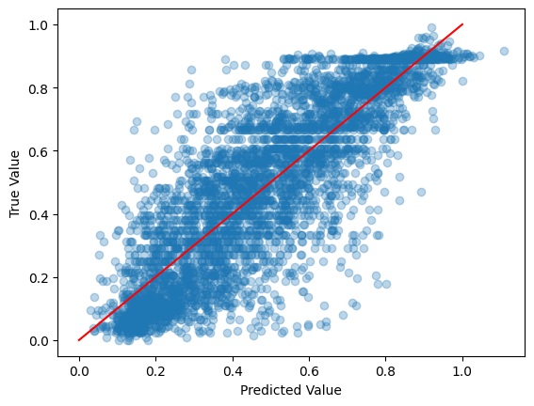
The figure above is a representation of our model outputs (X axis) against the ground truth (Y axis). A perfectly accurate prediction will lie on top of the red line, indicating parity between the model output and the ground truth

In order for us to have a general idea of the effectiveness of our model, we used the Mean Squared Error (MSE) & R2 score metrics. Based on the model above, we obtained a MSE of 0.02 and a R2 Score of 0.71. Considering that a low MSE & a high R2 Score results in an accurate model, we can assume that our model is providing us with a mostly correct prediction.

Within the realm of machine learning analysis, there is also a need to validate if we would obtain similar results if we used a different train / test split distribution. To complete the cross validation, a KFolding model was used to confirm that the model did not have any bias from the train/test distribution.

The R2 Scoring was evaluated repeatedly on 5 different splits 5 times giving us a total of 25 different scoring.
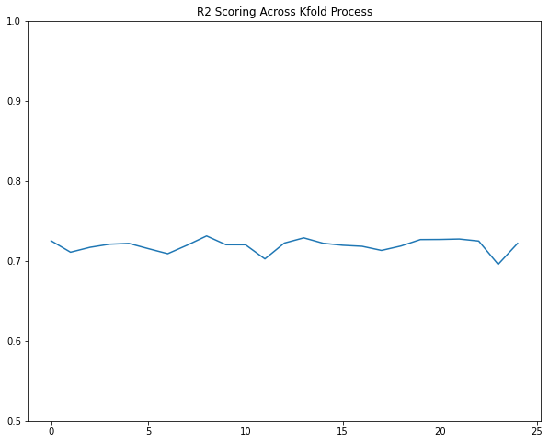

The variation is very minimal, staying within the same 0.07 range confirming that our model is not depending on the train/test distribution to provide its accurate prediction.

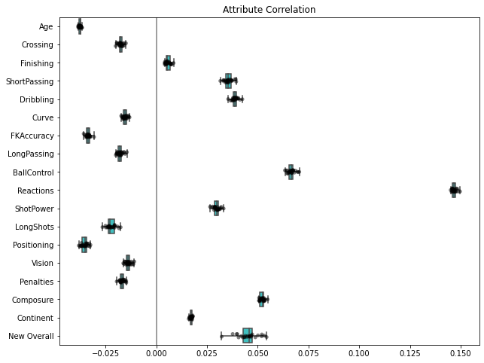

The above figure is a depiction of the correlation of each attribute toward the model output normalized by the standard deviation of the inputs. In other words, the relationship between an athlete and their overall value. For instance, the age attribute has a value of approximately -0.05 which means that younger players are likely to have higher valuations.

