FALL SEMESTER 2026–2027
BACSE202 – DATABASE MANAGEMENT SYSTEMS
CYBERSHIELD SOC
A Database-Driven Security Operations and Incident Management Platform
Submission Detail | Information
Course | BACSE202 – Database Management Systems
Faculty | Dr. S. Geetha
Semester | Fall 2026–2027
Slot / Class | D1 + TD1 / CH202670101707
Project Title | CyberShield SOC
Team Members | Srivikasni S. – 25BCE1435  Shrinithi N.M – 25BCE5742  J. Padhmavathi – 25BCE1510
Submitted to Dr. S. Geetha

Abstract
CyberShield SOC is a database-driven Security Operations Center application designed to organize the handling of security events, alerts, incidents and digital forensic evidence. The system provides a traceable workflow beginning with simulated security-event ingestion and rule-based alert generation, followed by incident creation, investigator assignment, service-level agreement (SLA) tracking, evidence registration, chain-of-custody recording, forensic analysis, response actions and resolution. The application uses Python Flask for server-side logic and Oracle Database for persistent relational storage and PL/SQL workflow operations. Role-based access distinguishes administrators, managers, analysts and read-only auditors. Relational constraints, stored procedures, triggers, views and indexes support data integrity, controlled state transitions, reporting and auditability. The system is intended for controlled academic demonstration using synthetic security data; it does not perform live network interception, malware execution or automatic blocking of real attacks.
Keywords: Security Operations Center, Oracle Database, Flask, PL/SQL, Incident Management, Role-Based Access Control, Digital Forensics, Chain of Custody, SLA, Audit Logging.

1. Introduction

1.1 Background
Organizations generate security-related records from servers, applications, network devices and other infrastructure. When these records are stored in disconnected tools or handled through informal processes, it becomes difficult to connect an event to an alert, an incident, the investigator responsible, the evidence collected and the final resolution. A Security Operations Center (SOC) requires a consistent process for recording and investigating these activities.
CyberShield SOC applies database management concepts to this problem. It uses a relational database to connect operational records and preserve the history of incident handling. The project demonstrates entity relationships, keys, integrity constraints, normalization, SQL queries, PL/SQL procedures, triggers, views, transactions and application–database connectivity.

1.2 Problem Statement
The project addresses the problem of maintaining a reliable and auditable record of simulated cybersecurity events and their investigation lifecycle. The system must prevent disconnected or inconsistent records, support controlled assignment and status changes, preserve forensic evidence handling history, and provide useful operational reports.

1.3 Objectives
- Record simulated security events with source server, source IP address, attack type, timestamp and severity score.
- Generate and triage alerts using a configurable severity threshold.
- Create incidents and link relevant alerts and optional campaign information.
- Assign investigators and preserve assignment history across investigation cycles.
- Track response and resolution deadlines and record SLA escalation.
- Register evidence using SHA-256 metadata and maintain a chain-of-custody history.
- Record forensic analysis, response actions, resolution details and audit events.
- Provide role-based access and reporting views for operational monitoring.

1.4 Scope
The project scope includes a Flask web application connected to Oracle Database, synthetic event simulation, incident and investigation workflows, evidence metadata and custody records, role-based access, and database-backed reports. The system is not a live intrusion-detection sensor, packet-capture platform, malware sandbox or automated network-blocking product. Threat-actor attribution is treated as unverified unless supported by evidence.

1.5 Intended Users
Role | Main responsibilities
ADMIN | Manage users and reference data; perform authorized operational actions; inspect audit records.
MANAGER | View operational information, assign investigators, monitor SLA, escalate and reopen cases where permitted.
ANALYST | Work on assigned incidents; triage alerts; register evidence; add findings and response actions; resolve cases.
AUDITOR | Read permitted incident histories, custody trails and audit metadata without modifying records or downloading evidence.

2. Existing Systems and Proposed System

2.1 Existing Approaches
SOC teams commonly use SIEM platforms, ticketing systems, asset inventories and digital-forensics tools. These systems may provide event collection, correlation, case management or evidence tracking. The comparison below is functional and is not a benchmark of commercial products.
Approach | Typical capability | Gap addressed by CyberShield SOC
Spreadsheet/manual tracking | Basic lists of events, owners and status. | Relational links, validation, role checks and structured history.
Standalone alert dashboard | Displays alerts and severity. | Connects alerts to incidents, investigators, evidence and resolution.
General ticketing system | Tracks work items and assignments. | Adds security-event relationships, SLA cycles and forensic custody records.
Separate evidence register | Stores evidence metadata. | Links evidence to incidents and records custody transfers and analysis.

Examples for background reading include
Splunk Enterprise Security (https://www.splunk.com/en_us/products/enterprise-security.html),
IBM QRadar (https://www.ibm.com/products/qradar-siem),
and the NIST Computer Security Incident Handling Guide (https://csrc.nist.gov/pubs/sp/800/61/r2/final).
These are references only; they are not integrated into this project.

2.2 Proposed System
The proposed system maintains a single relational record of the event-to-resolution workflow. It uses Oracle tables and constraints for persistent data, PL/SQL procedures for critical workflows, views for reporting, and Flask routes/templates for user interaction. Application requests use parameterized database operations and server-side authorization. Synthetic data is used for demonstration.

3. Requirements and System Architecture

3.1 Functional Requirements
ID | Requirement
FR01 | User authentication, logout, session expiry and role-based authorization.
FR02 | Server inventory with hostname, operating system, department, criticality and IP history.
FR03 | Simulated event ingestion with a unique source event key and event metadata.
FR04 | Alert generation from a configurable score threshold, with triage and escalation.
FR05 | Threat actors, historical intelligence, campaigns and campaign-event relationships.
FR06 | Incident creation, linked alerts, controlled statuses and investigation cycles.
FR07 | Investigator assignment with primary/support roles and assignment history.
FR08 | Response/resolution SLA deadlines, acknowledgement and escalation.
FR09–11 | Evidence registration, chain of custody and append-preserving forensic analysis.
FR12 | Response actions, resolution, closure and authorized reopening.
FR13–15 | Operational reporting, audit history, filtering, pagination and authorized exports.
FR16 | Clearly labelled simulation; no real attack interception or external blocking.

3.2 Non-Functional Requirements
- Integrity: primary keys, foreign keys, unique constraints and check constraints validate stored data.
- Security: role checks are enforced on the server and in critical database workflows; passwords are stored as hashes.
- Auditability: protected changes record actor, action, entity and timestamp; sensitive values are redacted.
- Reliability: multi-step write operations are committed as one application transaction or rolled back on failure.
- Maintainability: schema changes are organized into ordered SQL migration scripts.
- Usability: pages provide validation feedback and readable operational summaries.

3.3 Architecture
Layer | Technology / responsibility
Presentation | HTML, Jinja templates, CSS and browser-side presentation.
Application | Python Flask routes, sessions, role checks, validation and request handling.
Database access | python-oracledb, parameter binding, connection management and PL/SQL calls.
Database | Oracle Database; relational tables, constraints, indexes, views, procedures and triggers.
Evidence storage | Controlled file storage outside publicly served static assets; database stores metadata and storage key.

Typical write flow: user submits a validated form → Flask verifies session and role → the application obtains an Oracle connection → a parameterized statement or stored procedure executes → related changes commit together if successful, otherwise the request rolls back → the application redirects or displays a validation/error message.
Figure 1. Insert a screenshot or diagram of the actual Flask–Oracle architecture here.

3.4 Technology Stack
Component | Technology
Backend | Python and Flask
Database | Oracle Database (Oracle Free / XE / compatible university instance)
Driver | python-oracledb
Database programming | SQL and PL/SQL
Frontend | HTML, Jinja2, CSS; JavaScript for presentation where used
Testing | pytest, SQL integrity/transaction checks and manual browser verification

4. ER Model and Relational Schema

4.1 Main Entities
The database guide for the root Oracle + Flask application identifies 26 tables, grouped below by responsibility.
Group | Tables
Identity and access | app_user, investigator
Assets and network references | server, ip_address, server_ip_address, attack_type
Threat intelligence | threat_actor, historical_threat_intelligence, attack_campaign, campaign_event
Event and alert processing | soc_policy, security_event, alert
Incident lifecycle | incident, incident_alert, investigation_cycle, incident_assignment, sla, incident_status_history
Forensics and response | evidence, chain_of_custody, forensic_analysis, response_action, resolution
Governance | audit_log, schema_migration

4.2 Relationship Summary
- One app_user may have one investigator profile; an investigator profile references its application account.
- A server may have multiple IP addresses over time through server_ip_address; an IP address may be associated with multiple servers over time.
- Each security_event references one server, one source IP address and one attack type. An event may produce one alert.
- Campaigns and security events have a many-to-many relationship through campaign_event.
- An incident may be linked to multiple alerts through incident_alert; an alert is linked to at most one incident in the defined design.
- An incident has one or more investigation cycles over its lifetime. Each cycle has assignments, an SLA, status history, response actions and a resolution record where resolved.
- An incident may contain multiple evidence records. Each evidence record can have custody-transfer records and forensic-analysis records.
- Audit records identify the actor and the entity/action associated with a protected change.
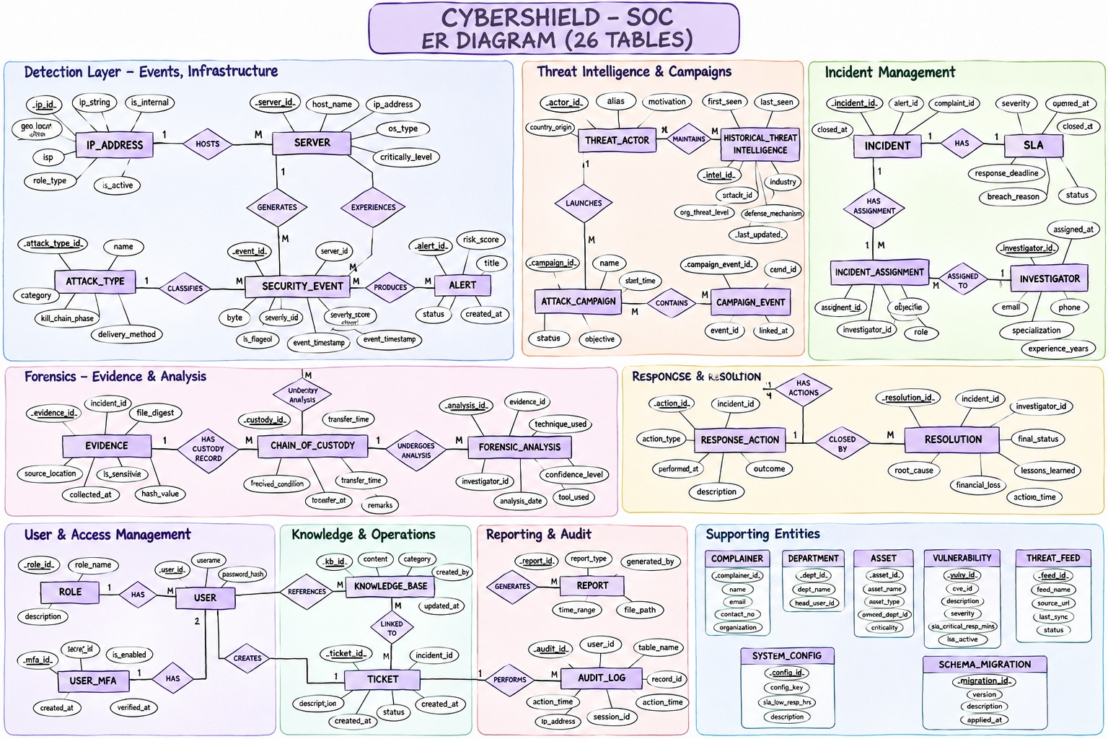
Figure 2. CyberShield SOC Entity–Relationship Diagram

4.3 Relational Schema and Key Examples
Relation | Primary key | Important foreign/unique keys
app_user | user_id | email UNIQUE
investigator | investigator_id | user_id → app_user; user_id UNIQUE
security_event | event_id | source_event_key UNIQUE; server_id, source_ip_id, attack_type_id FKs
alert | alert_id | event_id UNIQUE FK → security_event
incident | incident_id | created_by FK → app_user; campaign_id FK → attack_campaign (optional)
incident_alert | (incident_id, alert_id) | both columns FKs; alert_id unique in the design
campaign_event | (campaign_id, event_id) | both columns are FKs
investigation_cycle | cycle_id | (incident_id, cycle_no) UNIQUE
incident_assignment | assignment_id | cycle_id, investigator_id, assigned_by FKs
sla | sla_id | cycle_id UNIQUE FK → investigation_cycle
evidence | evidence_id | incident_id, collected_by, current_custodian_id FKs
chain_of_custody | custody_id | evidence_id, from/to investigator and performed_by FKs
forensic_analysis | analysis_id | evidence_id, investigator_id; supersedes_analysis_id self-FK
resolution | resolution_id | cycle_id UNIQUE FK → investigation_cycle
audit_log | audit_id | actor_user_id FK → app_user (nullable)

Identity-style numeric primary keys use Oracle NUMBER(10) identity columns in the database reference. Bridge tables use composite primary keys where appropriate. The exact deployed DDL remains authoritative for constraint names and implementation-specific differences.

5. Keys, Constraints, Functional Dependencies and Normalization

5.1 Key Types
A primary key uniquely identifies each row and cannot be null. Foreign keys preserve valid references between related tables. Candidate keys are minimal attributes or attribute sets that can uniquely identify a row; the selected candidate key becomes the primary key. Unique constraints enforce additional candidate keys, such as app_user.email, server.hostname, ip_address.ip_text and security_event.source_event_key. Composite keys are used in bridge relations such as campaign_event(campaign_id, event_id) and incident_alert(incident_id, alert_id).

5.2 Integrity Constraints
- NOT NULL: required attributes such as incident title, severity and event timestamp must be supplied.
- UNIQUE: prevents duplicate emails, hostnames, IP text, source event keys and other designated unique values.
- FOREIGN KEY: prevents references to missing parent records and blocks deletion where operational history depends on the parent.
- CHECK: validates enumerated roles/statuses, severity ranges, non-negative traffic counts, flags and date/amount rules.
- Workflow rules: procedures validate role, assignment eligibility, status transitions, custody chronology and incident-cycle rules.
- Append-only protection: triggers reject ordinary UPDATE/DELETE operations on protected history, custody, audit, analysis and resolution records.

5.3 Functional Dependencies
Functional dependencies are derived from the key definitions and business meaning of the relations. Representative examples are:
Relation | Representative functional dependency
app_user | user_id → email, password_hash, full_name, role_code, is_active, created_at; email → user_id (unique)
server | server_id → hostname, os_name, department, criticality, is_active; hostname → server_id (unique)
ip_address | ip_id → ip_text, country_code, is_simulated; ip_text → ip_id (unique)
security_event | event_id → source_event_key, server_id, source_ip_id, attack_type_id, event_at, protocol, counts, score; source_event_key → event_id
alert | alert_id → event_id, severity, status, created_at, triage fields; event_id → alert_id (unique)
investigation_cycle | cycle_id → incident_id, cycle_no, started_at, ended_at; (incident_id, cycle_no) → cycle_id
sla | sla_id → cycle_id, deadlines and escalation fields; cycle_id → sla_id (unique)

5.4 Normalization to 3NF
Normalization reduces repeated facts and update anomalies. The following is an illustrative decomposition of a combined incident-investigation worksheet, using the project’s business attributes.
Initial combined relation: INCIDENT_WORK(incident_id, title, severity, status, created_by, creator_email, cycle_no, cycle_started_at, investigator_id, investigator_name, assignment_role, response_due_at, evidence_id, evidence_hash). One incident can have multiple cycles, assignments and evidence records, so a single combined relation creates repeating groups and duplicated facts.
Representative dependencies: incident_id → title, severity, status, created_by; created_by → creator_email; (incident_id, cycle_no) → cycle_started_at; investigator_id → investigator_name; evidence_id → incident_id, evidence_hash.
Stage | Decomposition / reason
1NF | Store each attribute atomically and move repeating sets of investigators/evidence into separate rows rather than list-valued columns.
2NF | Separate attributes that depend on only part of a composite key. Incident facts belong to INCIDENT; investigator name belongs to INVESTIGATOR; cycle facts belong to INVESTIGATION_CYCLE.
3NF | Remove transitive dependencies. creator_email depends on created_by, not directly on incident_id, so account details remain in APP_USER and INCIDENT stores created_by as an FK.

Resulting relations include INCIDENT(incident_id, title, severity, status, created_by, campaign_id, opened_at, closed_at), APP_USER(user_id, email, password_hash, full_name, role_code, ...), INVESTIGATION_CYCLE(cycle_id, incident_id, cycle_no, ...), INVESTIGATOR(investigator_id, user_id, ...), INCIDENT_ASSIGNMENT(assignment_id, cycle_id, investigator_id, ...), SLA(sla_id, cycle_id, ...), and EVIDENCE(evidence_id, incident_id, sha256, ...). Each non-key attribute is stored with the entity or relationship it describes.
The design separates event, alert, incident, cycle, assignment, evidence, custody and analysis facts into distinct relations. This supports 3NF-style separation and avoids repeating multi-valued facts in incident rows. Formal certification of every deployed relation requires checking the final DDL and complete dependency set; this report does not claim a mathematically proven BCNF decomposition for every table.

5.5 Deliberate Design Choices
server_ip_address preserves IP assignment history rather than overwriting a server’s previous address. campaign_event and incident_alert represent many-to-many associations. investigation_cycle preserves a new investigation round when a resolved case is reopened. These are relationship/history structures rather than denormalized copies.

6. Database and Application Implementation

6.1 Oracle Database
Oracle is used as the persistent relational database. Numeric identifiers use identity columns, timestamps use TIMESTAMP WITH TIME ZONE, longer descriptions/findings use CLOB where required, and hashes use fixed-length SHA-256 text. SQL scripts are organized as ordered migrations. The project database guide identifies V001–V007 for schema, security helpers, workflow procedures, audit and views; V008 for runtime grants; V009 for synthetic demo data; and V010 plus grants_asset_admin.sql for asset administration.

6.2 Flask Connectivity
The Flask application communicates with Oracle through python-oracledb. User-supplied values are passed as bind parameters rather than concatenated into SQL. For a write request, the application uses a single connection/transaction boundary, invokes the relevant procedure or SQL operation, commits after successful completion and rolls back on exceptions. Connection and authenticated-actor context must be released/cleared after the request.

6.3 Security Controls
- Role-based authorization for ADMIN, MANAGER, ANALYST and AUDITOR.
- Adaptive password hashing; plaintext passwords are not stored.
- CSRF protection for form submissions and server-side session handling.
- Evidence file storage outside public static directories, with generated storage keys and authorized access.
- SHA-256 hash metadata for evidence integrity checking.
- Append-oriented custody and audit history; password/session secrets are excluded from audit payloads.
- Separate owner and runtime database accounts with limited runtime grants.

6.4 Incident Lifecycle
The defined lifecycle is OPEN → TRIAGED → INVESTIGATING → CONTAINED → RESOLVED → CLOSED. Resolution is a dedicated operation and closure requires a resolution. Reopening is restricted to ADMIN or MANAGER from RESOLVED/CLOSED, creates a new investigation cycle and SLA, and preserves the earlier cycle’s assignments and resolution history.

6.5 SLA Policy
Severity | Response target | Resolution target
LOW | 8 hours | 72 hours
MEDIUM | 4 hours | 48 hours
HIGH | 1 hour | 24 hours
CRITICAL | 15 minutes | 4 hours

These are the project’s defined SLA targets. Actual breach status is determined from recorded acknowledgement/resolution timestamps and deadlines.

7. SQL Operations and Database Features

7.1 Data Manipulation
The application and SQL scripts use INSERT to create reference, event, incident and evidence records; UPDATE for permitted mutable catalogue or workflow state; DELETE only where permitted for non-historical data; and SELECT for lists, detail pages, dashboards and reports. Protected operational history is not treated as freely editable data.

7.2 Joins and Aggregation
Reporting combines related tables to calculate event counts by date, severity distribution, top servers, attack-type frequency, repeat source IP addresses, incident status counts, investigator workload and SLA breaches. GROUP BY and aggregate functions such as COUNT, SUM and AVG support summaries; HAVING filters grouped results.

7.3 Subqueries and Analytical SQL
The reporting query set includes subqueries and correlated comparisons for repeat IPs and alerts without incidents. Common table expressions (WITH), ranking functions such as ROW_NUMBER and DENSE_RANK, and timestamp-based calculations support top-N reports, MTTA and MTTR metrics.

7.4 Views
View | Purpose
vw_open_incidents | Open incident and active-cycle summary, lead and SLA deadlines.
vw_critical_alerts | Critical alerts with event, host and incident context.
vw_investigator_workload | Investigator availability and active/lead case counts.
vw_sla_status | Response and resolution deadline/breach indicators.
vw_custody_history | Evidence custody transfer history.
vw_dashboard_summary | Overall counts for servers, events, alerts, incidents, investigators and SLA breaches.

7.5 Stored Procedures and Packages
Procedure / package | Purpose
sp_ingest_event | Insert an event and create an alert when policy/score conditions are met.
sp_create_incident | Create incident, initial cycle, SLA and status history; optionally link an alert.
sp_assign_investigator | Assign an investigator to the active investigation cycle.
sp_change_status | Validate and record an incident status transition.
sp_link_alert / sp_triage_alert | Link an alert to an incident and update triage status.
sp_resolve_incident / sp_reopen_incident | Record resolution or create a new investigation cycle.
sp_escalate_sla | Record SLA escalation.
sp_register_evidence / sp_transfer_evidence | Register evidence and record custody transfer.
sp_add_analysis / sp_record_action | Record forensic findings and response actions.
sp_save_server / sp_save_ip | Authorized asset/IP administration.
CS_SECURITY / CS_AUDIT | Security actor/permission helpers and audit recording/redaction.

7.6 Indexes and Transactions
Indexes support common filters and joins, including event timestamps, server/time, source-IP/time, alert status/severity, incident status/opened time, assignment investigator/end time, evidence incident, custody evidence/time and response-action cycle. Primary-key and unique constraints also create supporting indexes where required. Transactions protect multi-step operations such as event ingestion, incident creation and custody transfer so partial workflow changes are not retained after a failure.

8. Implemented Features and End-to-End Workflow
- Authentication and role-based navigation: users sign in and receive access according to their role.
- Asset and reference management: servers, IP addresses and attack types provide reference data for event records.
- Event simulation and alert creation: a synthetic event is stored and checked against the configured alert threshold.
- Incident handling: an alert can be associated with an incident; the incident moves through controlled lifecycle states.
- Investigator assignment and SLA monitoring: investigators are assigned to a cycle and response/resolution deadlines are tracked.
- Evidence and custody: evidence metadata and SHA-256 hash are recorded, and custody transfers append to custody history.
- Forensic analysis and response: investigators record techniques, findings, indicators and response outcomes.
- Resolution, reopening and audit: resolution is stored per cycle; authorized reopening creates a new cycle; protected changes are audited.
- Reporting: database views and SQL reports summarize incidents, alerts, workload, custody and SLA status.
Demonstration workflow: create/select synthetic server, IP and attack-type records → ingest a synthetic security event → verify alert generation → create an incident from the alert → assign an investigator → triage and update status → register evidence → transfer custody if required → add analysis and response action → resolve/close the incident → inspect dashboard, SLA and audit reports.
Figure 3. Insert screenshots of login/dashboard, event and alert page, incident detail, assignment/SLA page, evidence/custody page and Oracle query results. Use screenshots from the actual running application.

9. Testing, Results and Discussion

9.1 Testing Approach
Testing should cover database integrity, workflow procedures, application routes, authorization, transaction rollback, duplicate handling and the browser demonstration. Test data should be synthetic. Expected and actual outcomes should be recorded with screenshots or query output.
Test | Expected outcome | Actual result / evidence
Oracle connectivity / health | Application reports healthy database connectivity without exposing credentials. | Previously reported successful; attach current /health screenshot.
Valid login | Authorized user receives a session and role-appropriate pages. | [Record final result and screenshot.]
Invalid login | Login is rejected and no authenticated session is created. | [Record final result.]
Duplicate source event key | Unique constraint/procedure prevents duplicate event ingestion. | [Record final result.]
Event above configured threshold | Event is stored and alert is generated once. | [Record final result and query output.]
Incident status transition | Only allowed transitions are accepted and status history is recorded. | [Record final result.]
Unauthorized role action | Request is denied and no protected data is changed. | [Record final result.]
Evidence custody transfer | Custodian changes and transfer history is recorded atomically. | [Record final result.]
Invalid custody/assignment | Operation fails and transaction is rolled back. | [Record final result.]
SLA/report query | View/query returns values consistent with stored records. | [Record final result and screenshot.]

9.2 Verification Notes
Earlier project verification notes recorded that the root Flask application was running at http://127.0.0.1:5000, the Oracle health endpoint returned a healthy result, and 64 focused pytest tests passed. These are historical verification statements and should be re-run against the exact version submitted. Include the latest test command/output and browser screenshots in the final repository and submission document.
The database guide notes that schema_migration is not populated consistently by every older migration script, and that some logical relationships may not be enforced by a database foreign-key constraint. Treat these as known implementation limitations unless corrected and re-verified.

9.3 Results and Discussion
The database structure supports a traceable chain from event and alert records to incidents, investigation cycles, assignments, evidence and resolution. Separate history relations reduce overwriting of important forensic and operational information. Stored procedures centralize critical workflow validation, while views and reporting queries reduce repeated reporting logic. The quality of the final demonstration depends on the deployed Oracle schema, application version, role permissions, synthetic seed data and reproducible setup instructions.

10. Limitations and Future Enhancements

10.1 Limitations
- Security events are simulated; the application does not collect live network telemetry.
- The system does not execute malware, intercept real attacks or automatically block external traffic.
- Threat-actor attribution is not proof of identity and must remain marked unverified unless independently validated.
- Evidence integrity metadata and application-level custody controls do not make the database immune to privileged DBA modification.
- The migration ledger requires consistent population and validation across all migration scripts.
- The test table must be updated with current run results and screenshots before submission.

10.2 Future Enhancements
- Integrate authorized log sources or a controlled telemetry collector.
- Add stronger alert correlation and configurable detection rules.
- Add richer dashboards and scheduled reports for MTTA, MTTR and SLA trends.
- Improve evidence retention, secure storage, access review and integrity re-verification.
- Add automated migration validation and repeatable clean-environment deployment tests.
- Integrate threat-intelligence feeds with source attribution and confidence tracking.

11. Conclusion
CyberShield SOC demonstrates how database management concepts can support a security incident-management workflow. The project connects simulated events, alerts, incidents, investigation cycles, assignments, SLA records, evidence, custody transfers, forensic analysis and resolution through a relational Oracle database and a Flask application. Keys, constraints, normalized relations, PL/SQL procedures, triggers, views, indexes and transactions provide a foundation for integrity, controlled operations and reporting. The project is an academic simulation and should be evaluated using the exact submitted source code, Oracle schema, test outputs and demonstration video.

12. References
[1] Dr. S. Geetha, “BACSE202 – Database Management Systems: Digital Assignment,” Fall Semester 2026–2027, 26 Oct. 2026.
[2] CyberShield SOC Team, “CyberShield SOC Product Requirements Document, Version 1.1,” 28 Oct. 2026. Internal project specification.
[3] CyberShield SOC Team, “CyberShield SOC — Oracle Database & PL/SQL Reference,” project database guide, 29 Oct. 2026.
[4] Oracle, “Oracle Database SQL Language Reference,” Oracle Documentation. [Online]. Available: https://docs.oracle.com/en/database/
[5] Oracle, “PL/SQL Language Reference,” Oracle Documentation. [Online]. Available: https://docs.oracle.com/en/database/oracle/oracle-database/
[6] Pallets Projects, “Flask Documentation.” [Online]. Available: https://flask.palletsprojects.com/
[7] Python Software Foundation, “python-oracledb Documentation.” [Online]. Available: https://python-oracledb.readthedocs.io/
[8] P. Cichonski, T. Millar, T. Grance, and K. Scarfone, “Computer Security Incident Handling Guide,” NIST SP 800-61 Rev. 2, Aug. 2012. [Online]. Available: https://csrc.nist.gov/pubs/sp/800/61/r2/final
[9] Splunk Inc., “Splunk Enterprise Security.” [Online]. Available: https://www.splunk.com/en_us/products/enterprise-security.html
[10] IBM, “IBM QRadar SIEM.” [Online]. Available: https://www.ibm.com/products/qradar-siem

Appendix A. Website Screenshots by Login Role
The following screenshots document the implemented CyberShield SOC website pages and role-specific views. Each figure is labelled with the login role visible in the application header or user panel and a brief description of the function demonstrated. The screenshots show the application connected to the Oracle-backed workspace.

A.1 ADMIN Login
Figure A1. SOC overview dashboard
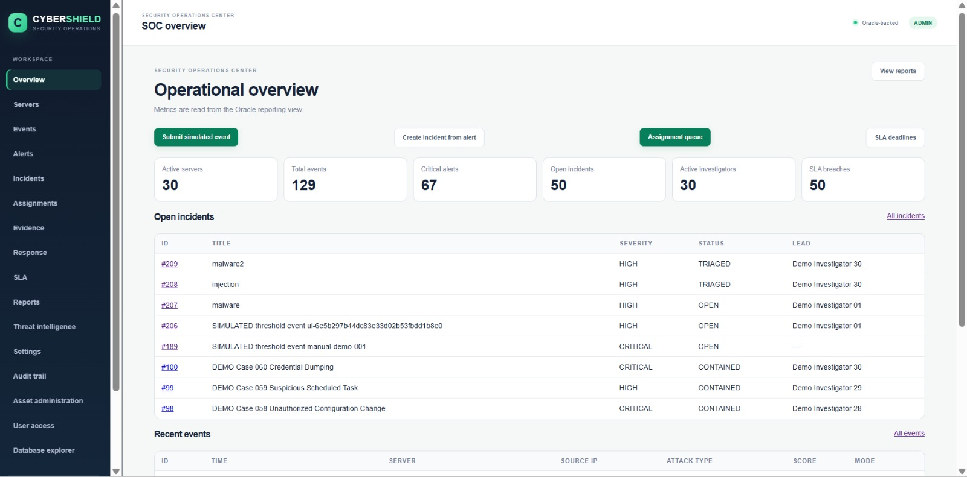
Login: ADMIN — The ADMIN dashboard summarizes active servers, event volume, critical alerts, open incidents, investigators, SLA breaches, and recent operational records.
Figure A2. SOC overview – recent activity
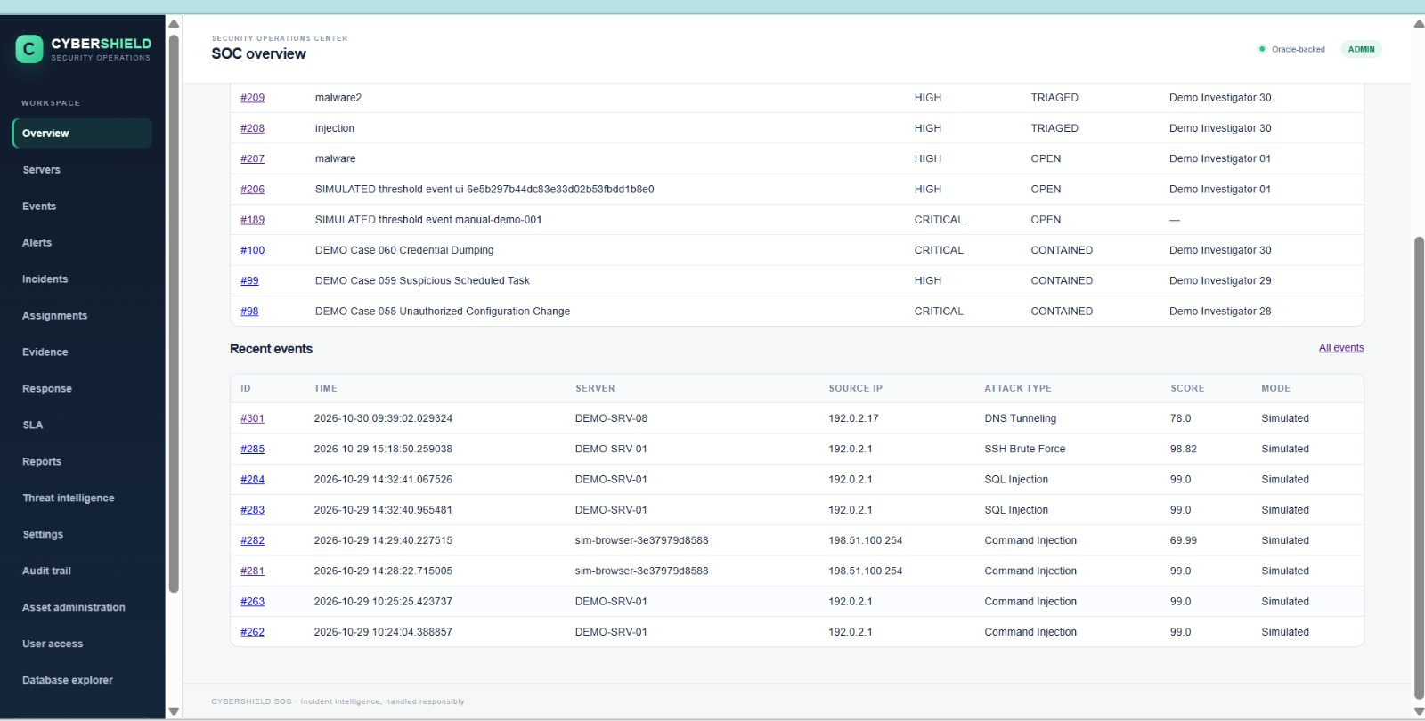
Login: ADMIN — The ADMIN overview displays the open-incident list and recent security events with their server, source IP, attack type, score, and simulation mode.

Figure A3. Server inventory
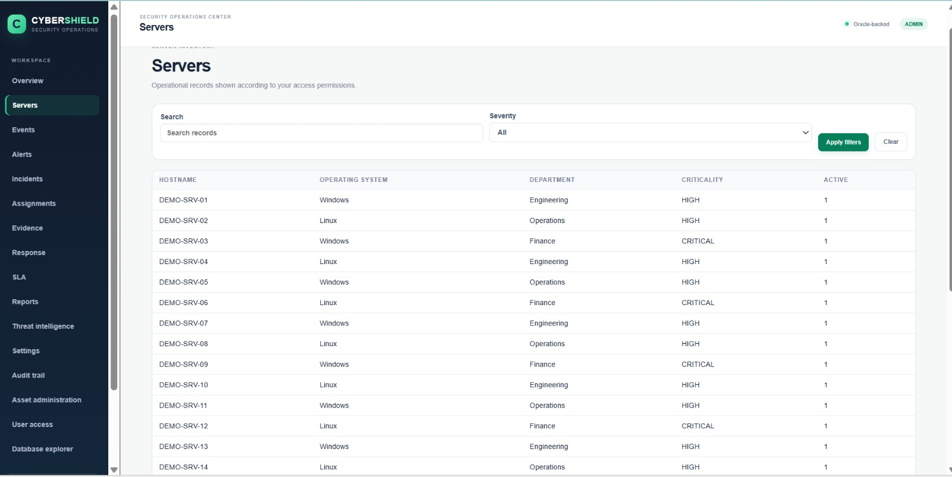
Login: ADMIN — The ADMIN can review registered servers, including hostname, operating system, department, criticality, and active status.

Figure A4. Security events
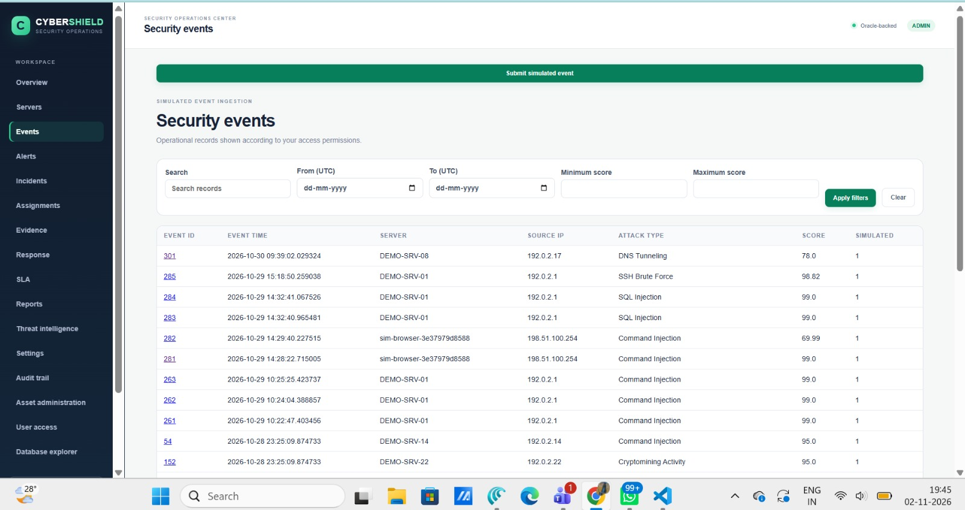
Login: ADMIN — The ADMIN can inspect ingested or simulated security events and filter them by date, score, server, source IP, and attack type.
Figure A5. Alert triage queue
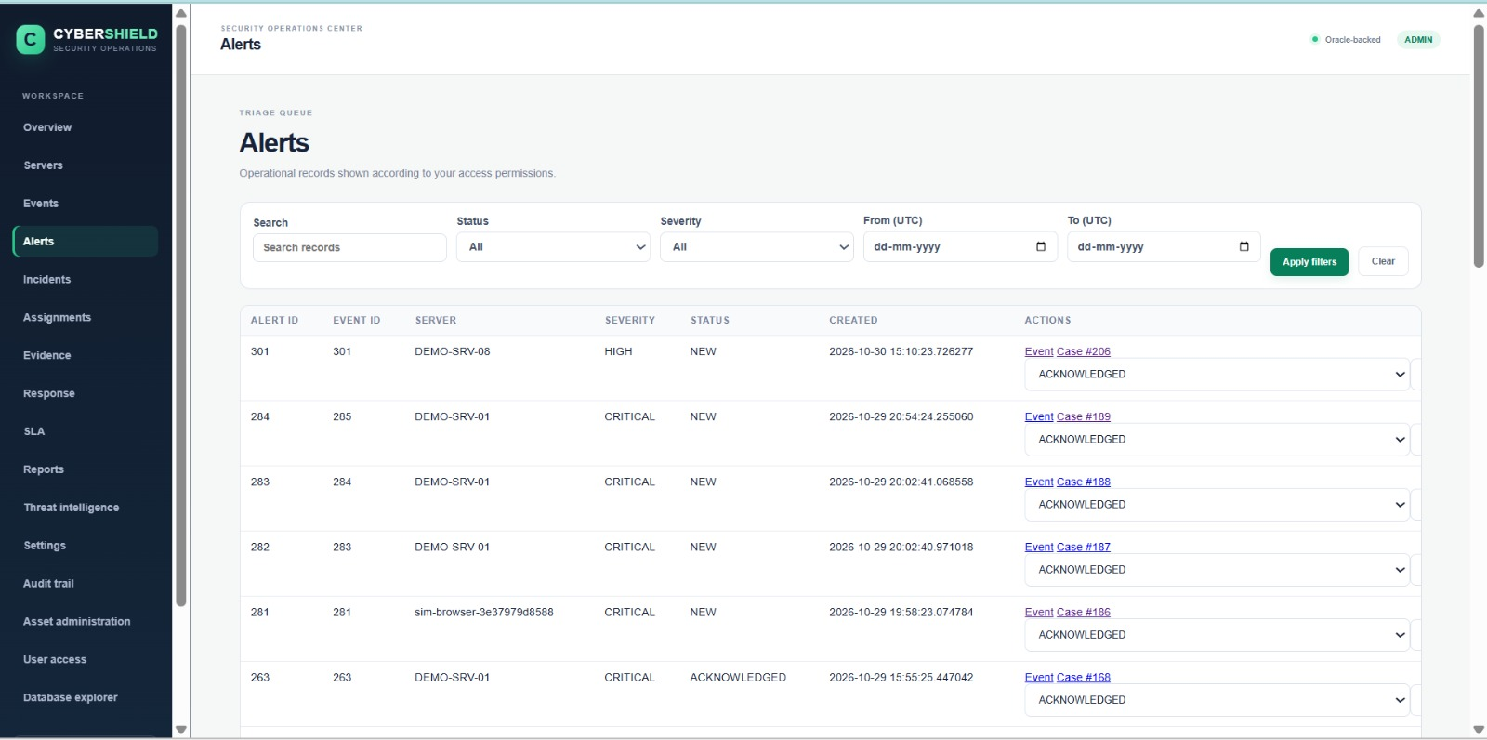
Login: ADMIN — The ADMIN alert queue displays event-linked alerts, severity, status, creation time, and the available acknowledgement workflow.

Figure A6. Incident management
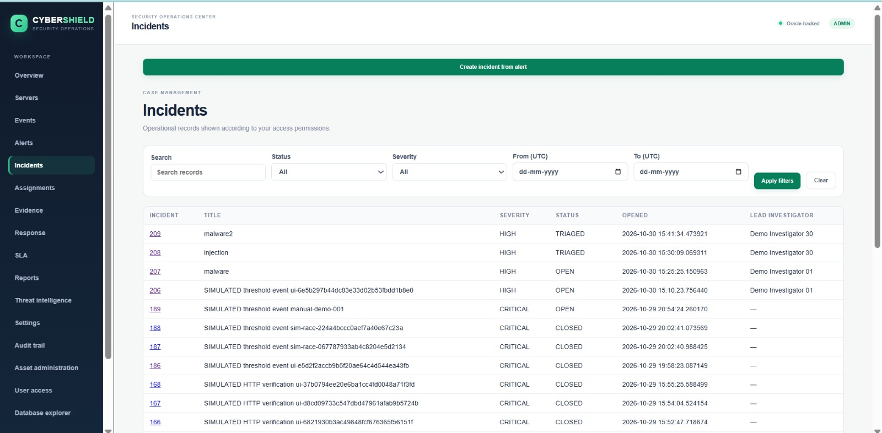
Login: ADMIN — The ADMIN can review incidents by status and severity and open the workflow for creating an incident from an alert.

Figure A7. Investigator assignments
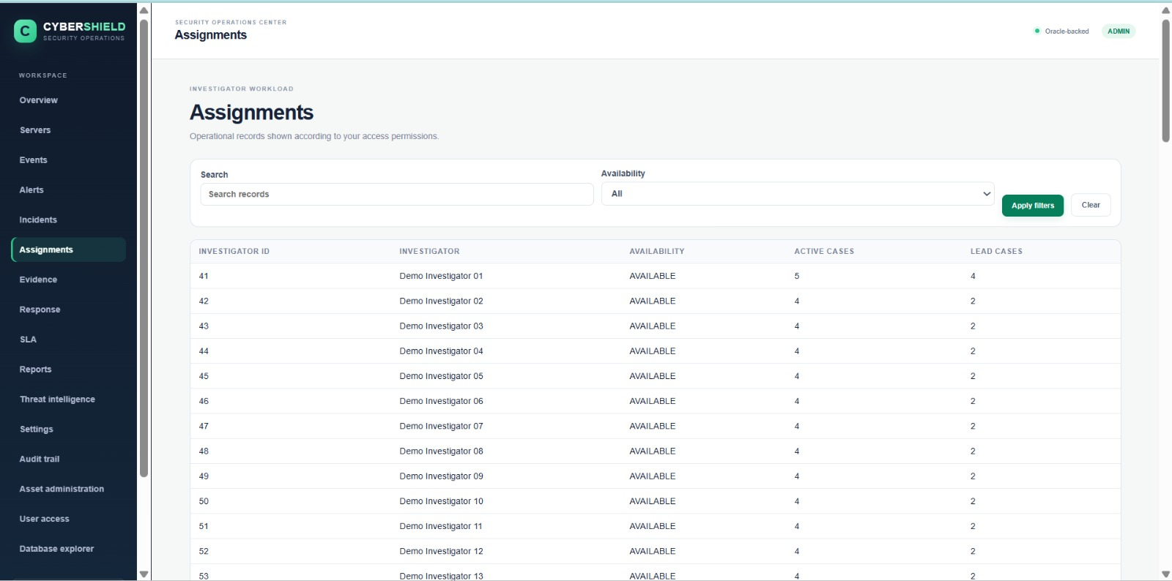
Login: ADMIN — The ADMIN can monitor investigator availability and workload, including active cases and lead-case counts.

Figure A8. Evidence register
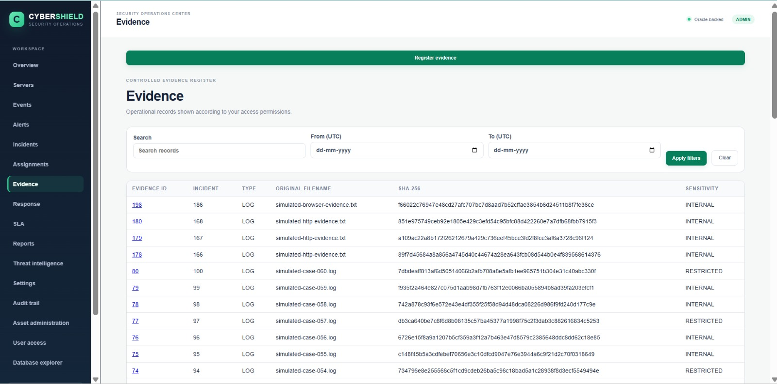
Login: ADMIN — The ADMIN evidence register lists incident-linked evidence with its type, filename, SHA-256 hash, and sensitivity classification.

Figure A9. Response actions
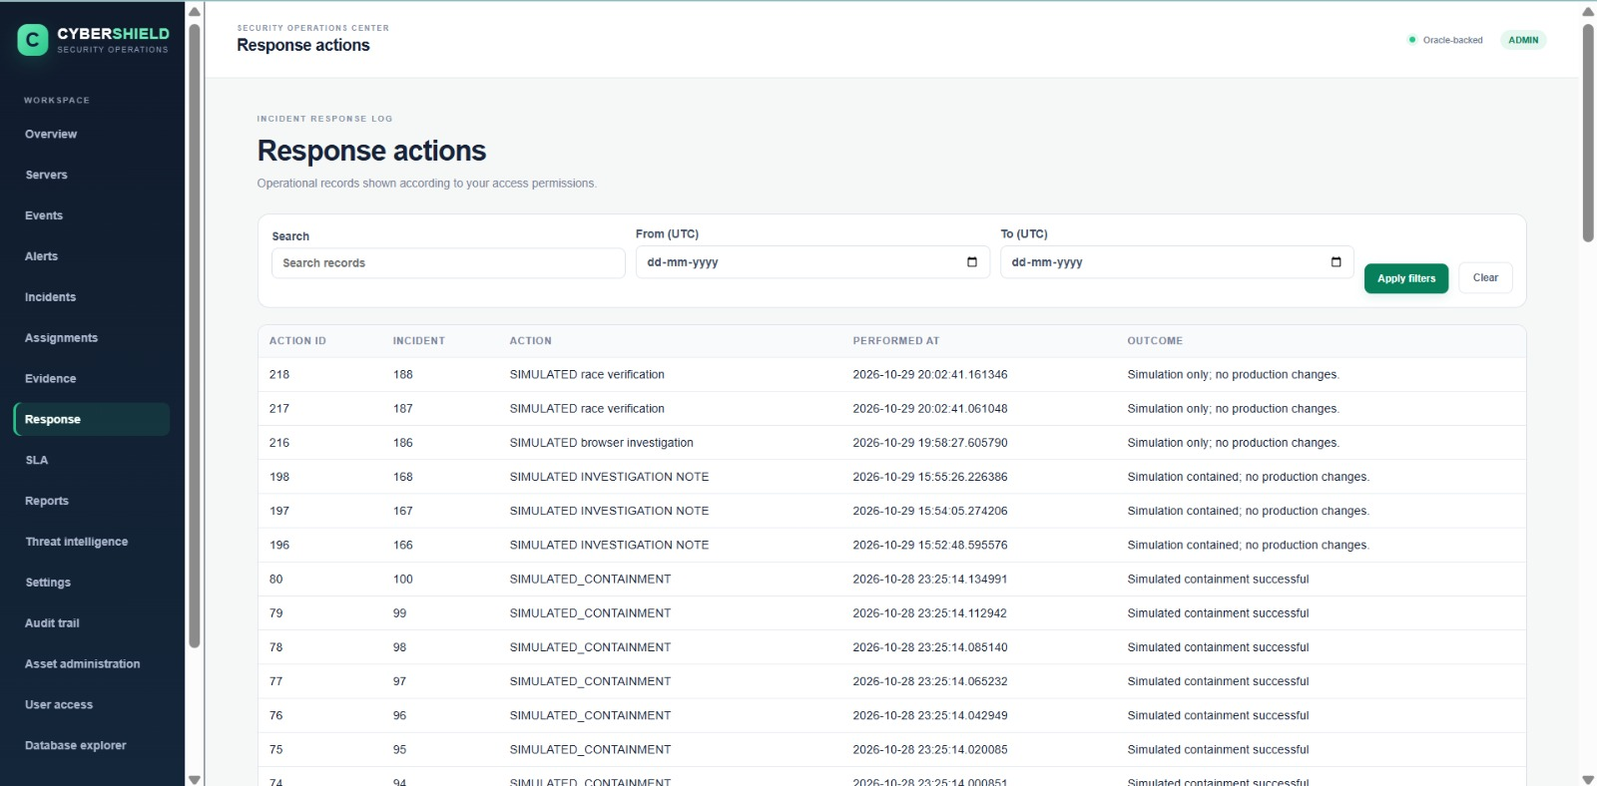
Login: ADMIN — The ADMIN can review recorded incident-response actions, timestamps, and outcomes, including actions marked as simulation-only.

Figure A10. SLA monitoring
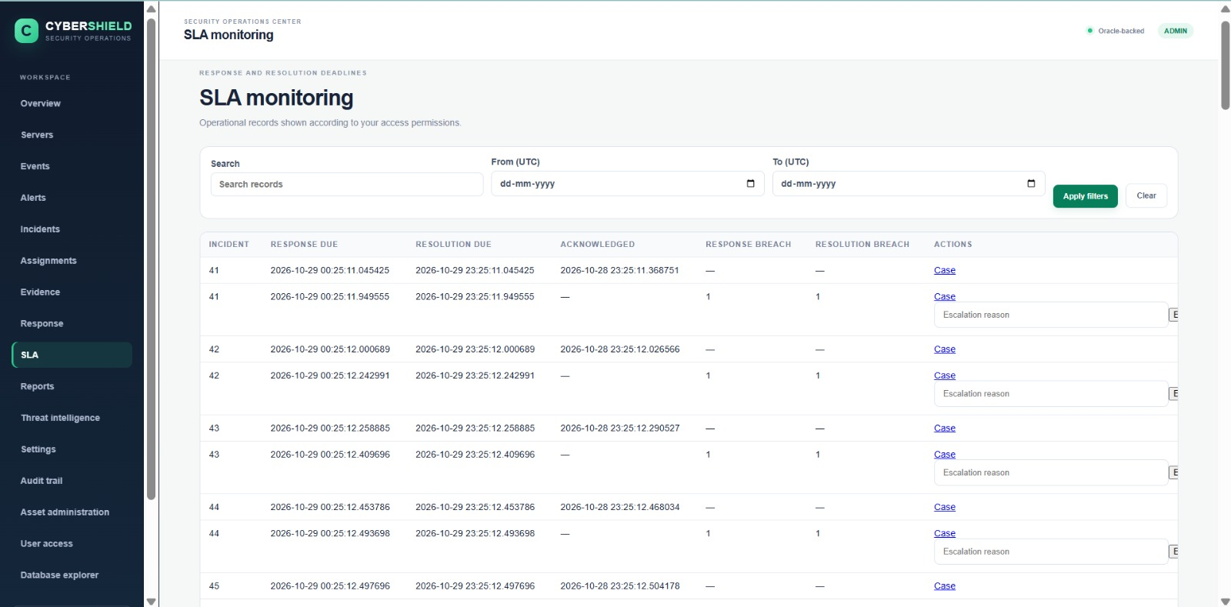
Login: ADMIN — The ADMIN can monitor response and resolution deadlines, acknowledgement times, breach indicators, and escalation actions.

Figure A11. Reports and metrics
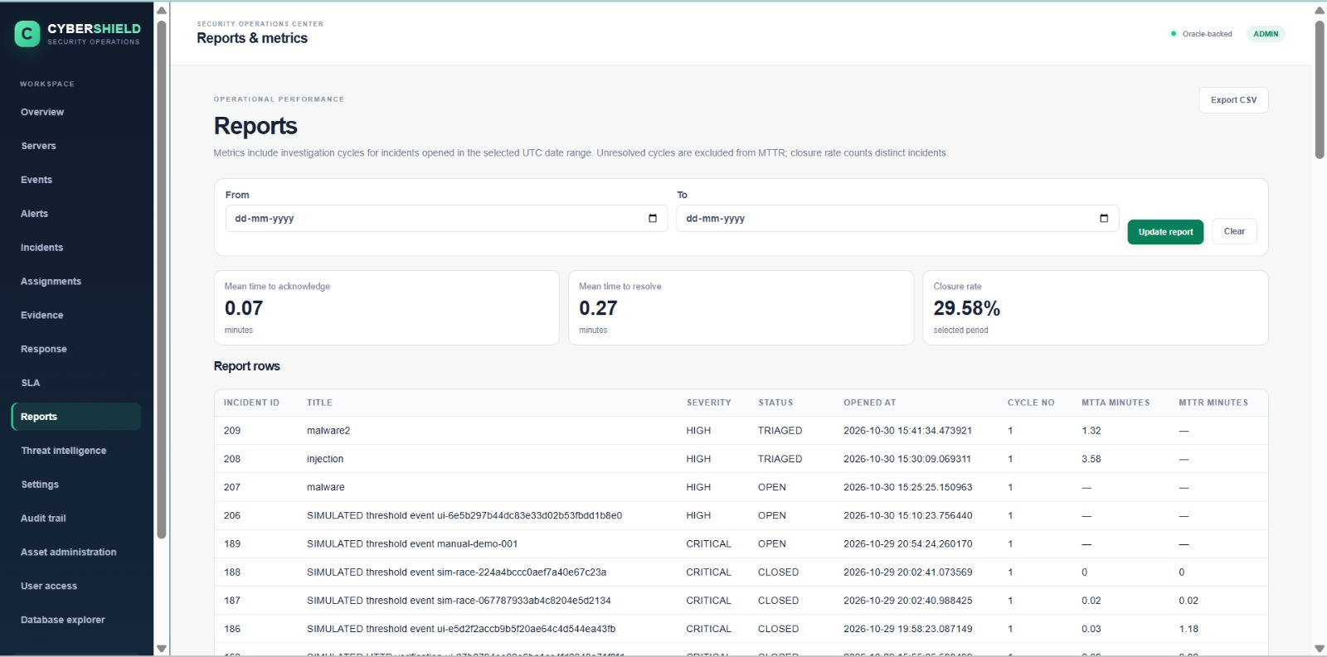
Login: ADMIN — The ADMIN reports page presents mean time to acknowledge, mean time to resolve, closure rate, and incident-level performance rows.

Figure A12. Threat intelligence
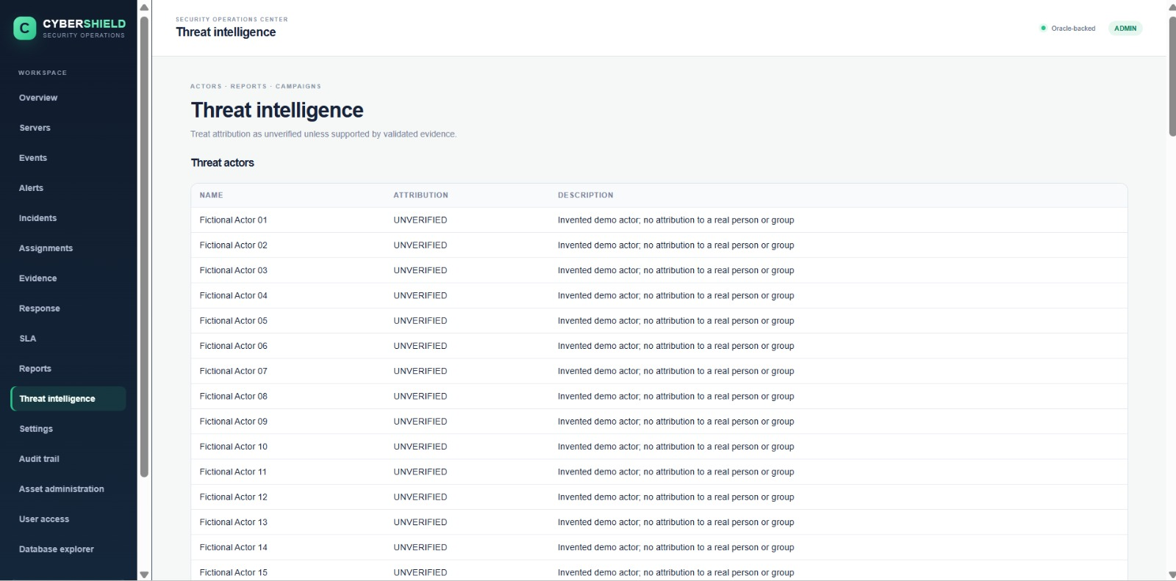
Login: ADMIN — The ADMIN can review threat-actor records and attribution notes, with demo actors explicitly identified as fictional and unverified.

Figure A13. Administration settings
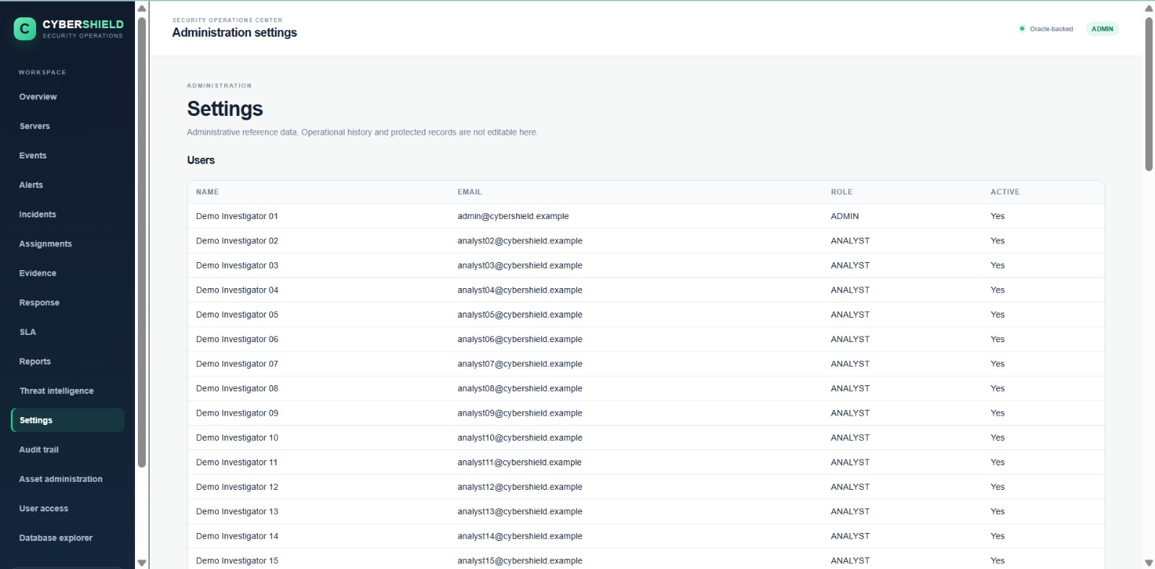
Login: ADMIN — The ADMIN settings page provides a read-only view of configured users, their roles, email identifiers, and active status.

Figure A14. Audit trail
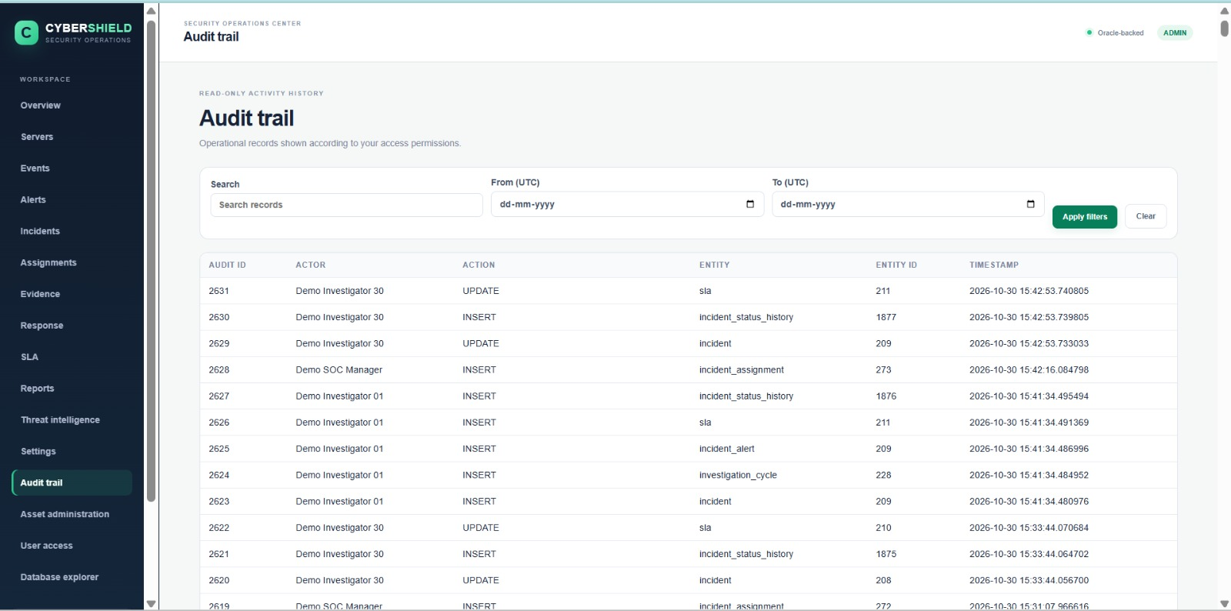
Login: ADMIN — The ADMIN audit trail records actor, action, affected entity, entity identifier, and timestamp, with search and date filters.

Figure A15. Asset administration
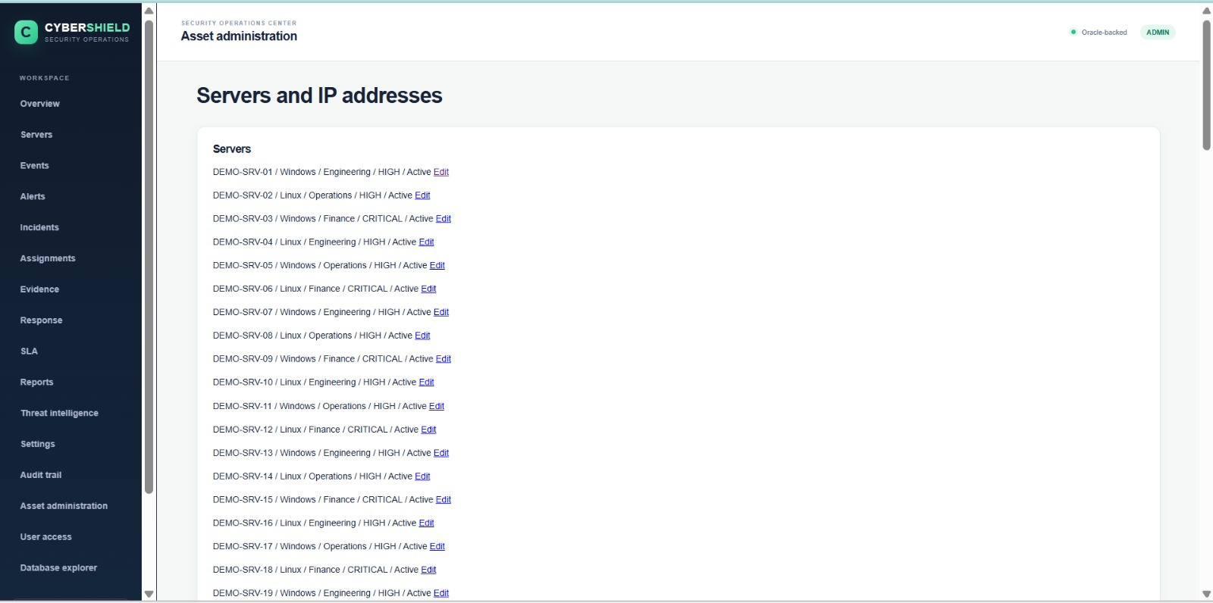
Login: ADMIN — The ADMIN can review and edit registered server and IP-address asset information through the asset-administration area.

Figure A16. Oracle user access
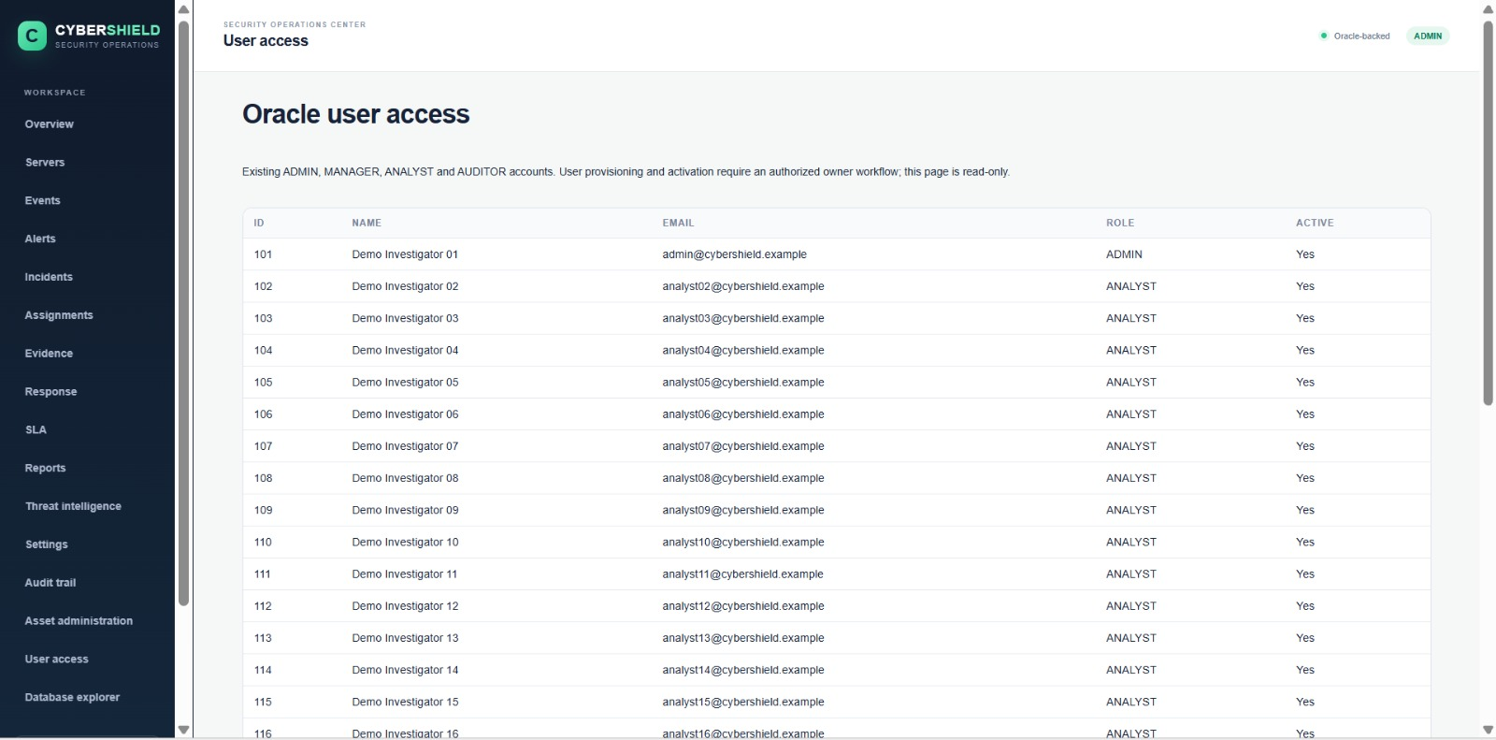
Login: ADMIN — The ADMIN user-access page displays existing accounts, assigned roles, and account activation status; provisioning is restricted to the authorized owner workflow.

Figure A17. Database explorer
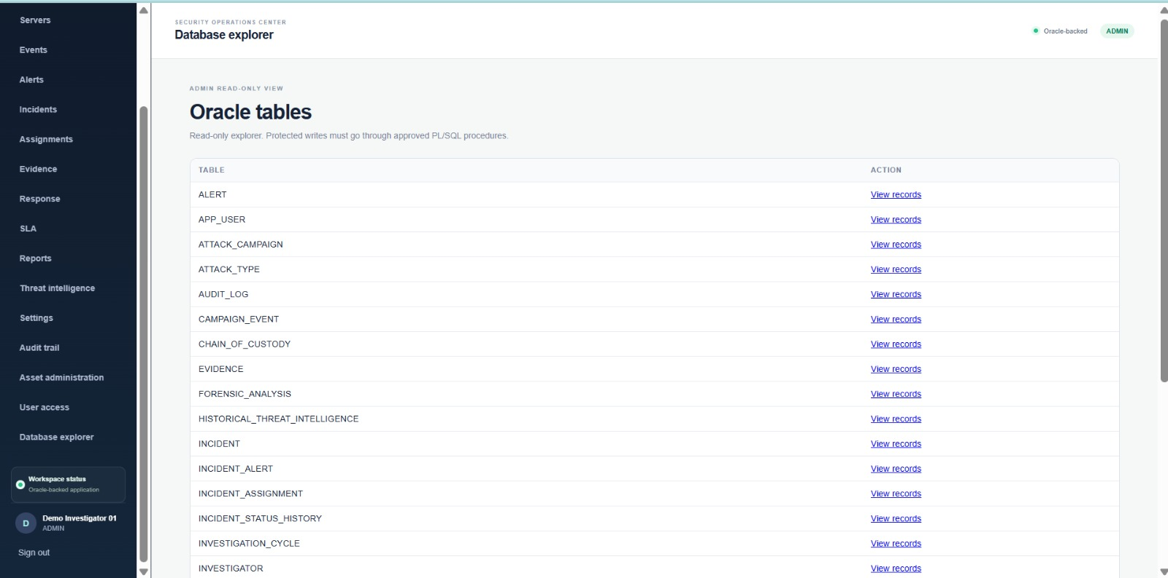
Login: ADMIN — The ADMIN read-only database explorer lists Oracle tables and provides links to inspect their records while protected writes remain procedure-controlled.

Figure A18. Submit simulated event
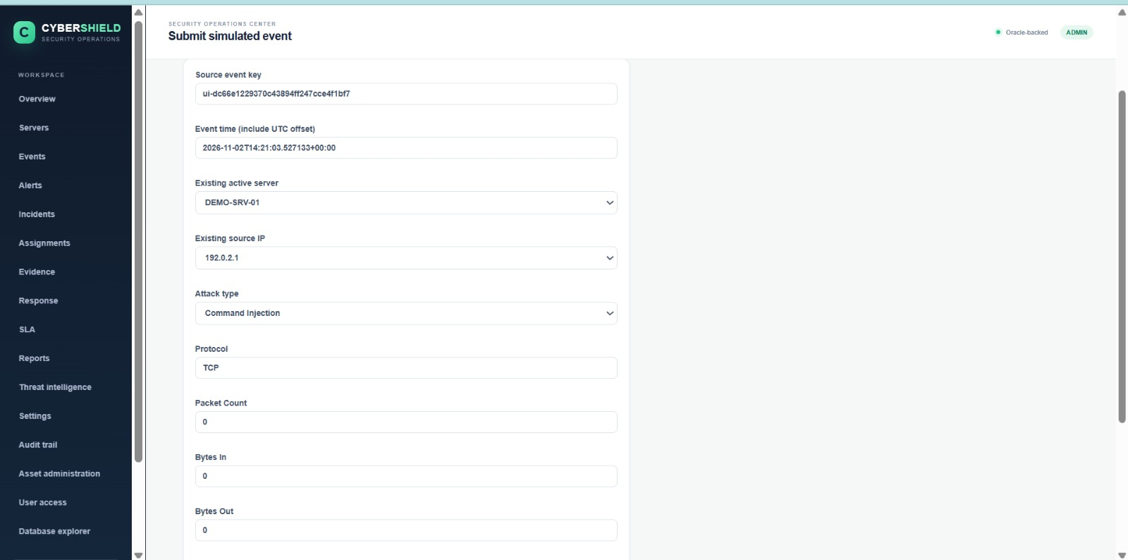
Login: ADMIN — The ADMIN event-submission form accepts a source event key, event time, server, source IP, attack type, protocol, and traffic metrics for controlled event simulation.

A.2 MANAGER Login

Figure A19. Reports and metrics
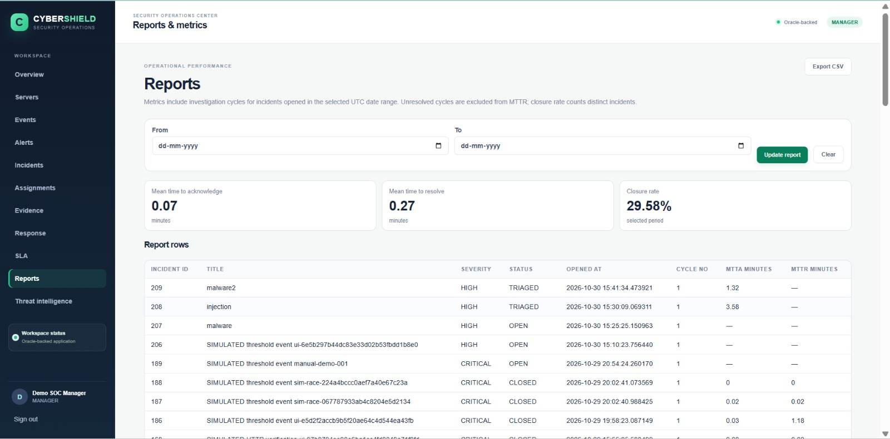
Login: MANAGER — The MANAGER can review operational performance metrics and incident-level report rows, including acknowledgement time, resolution time, and closure rate.

Figure A20. SLA monitoring – escalation controls
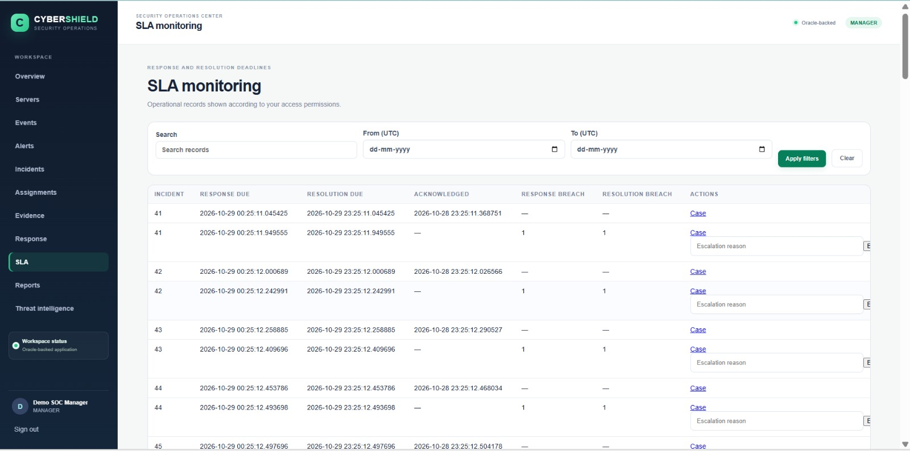
Login: MANAGER — The MANAGER SLA view exposes overdue-case escalation controls, including an escalation-reason field and an action to escalate an overdue SLA.

Figure A21. SLA monitoring – deadline and breach records
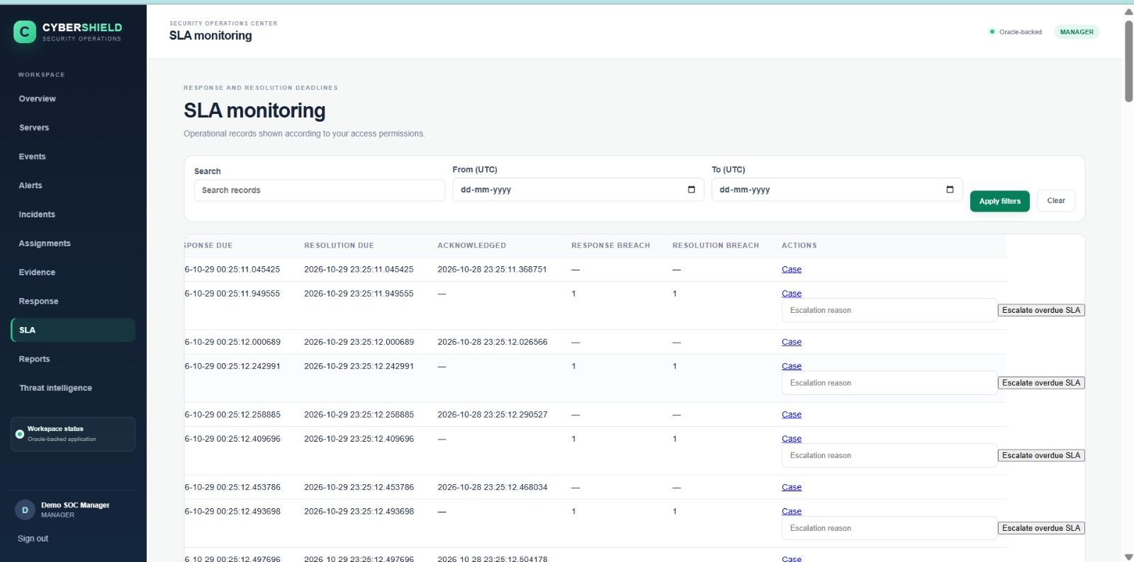
Login: MANAGER — The MANAGER can inspect incident response and resolution due times, acknowledgement timestamps, and response or resolution breach indicators.

Figure A22. Assign investigator
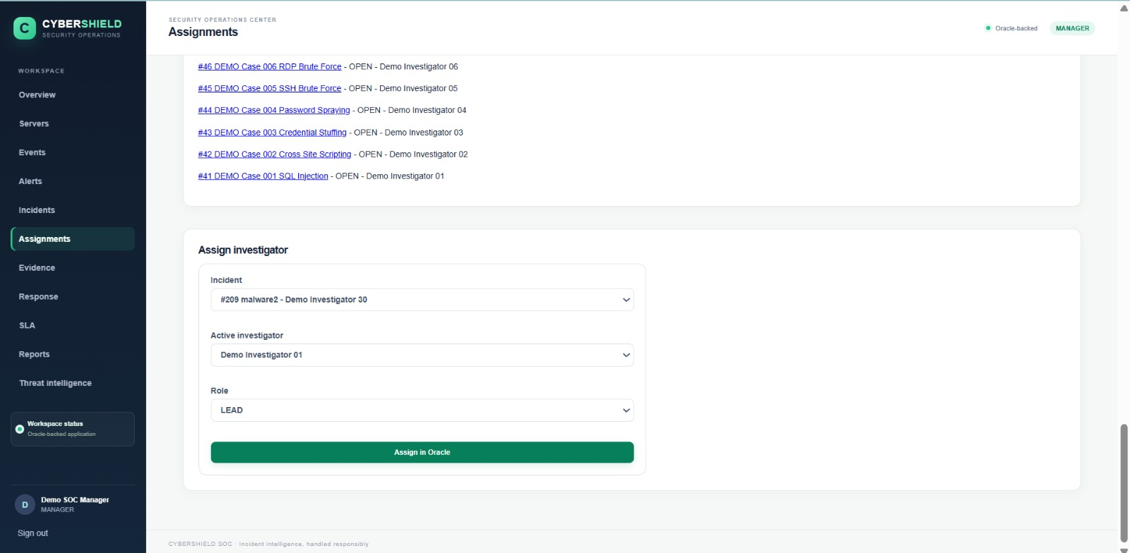
Login: MANAGER — The MANAGER assignment workflow allows an incident, active investigator, and assignment role such as LEAD to be selected before assigning the case in Oracle.

A.3 ANALYST Login

Figure A23. Register evidence
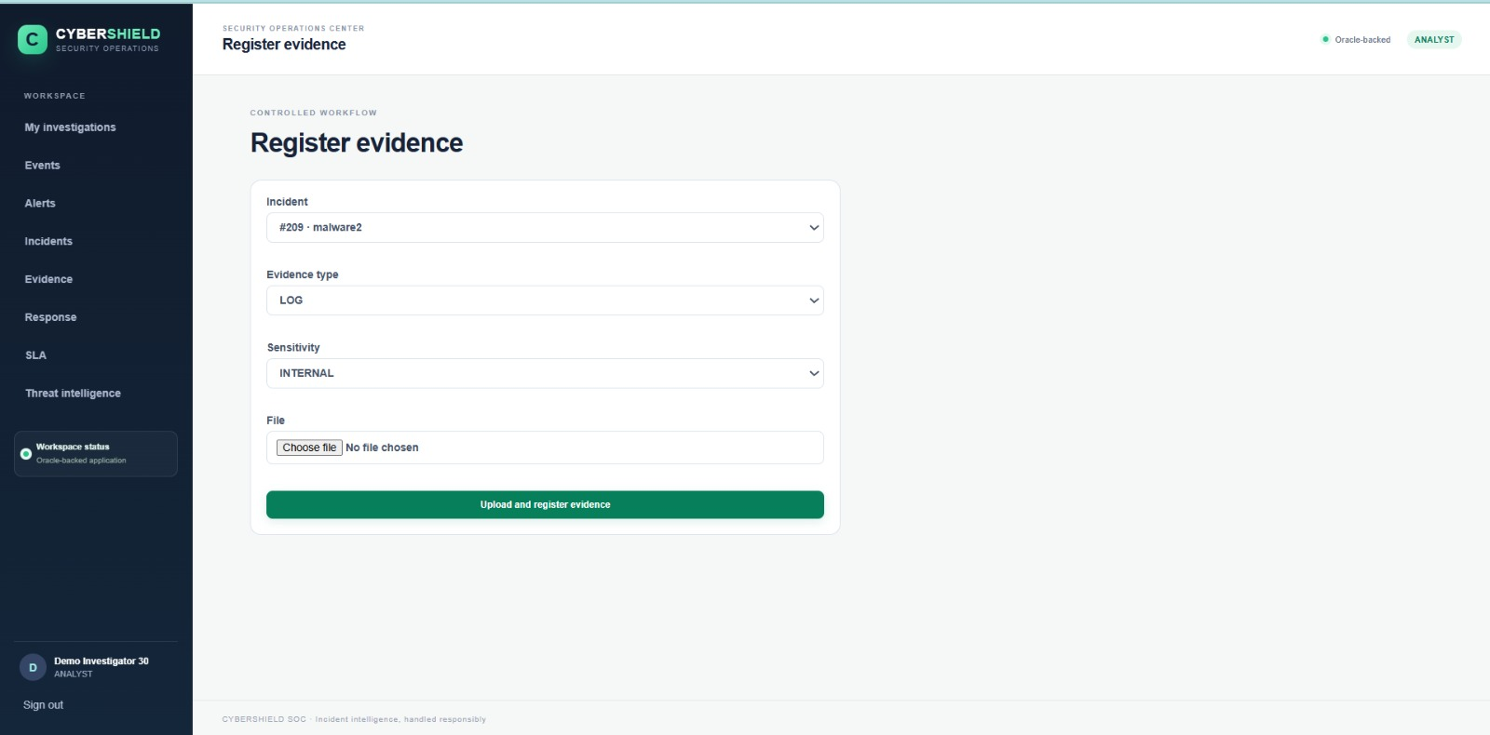
Login: ANALYST — The ANALYST can register evidence against an incident by selecting its type and sensitivity and uploading the associated file.

Figure A24. My investigations
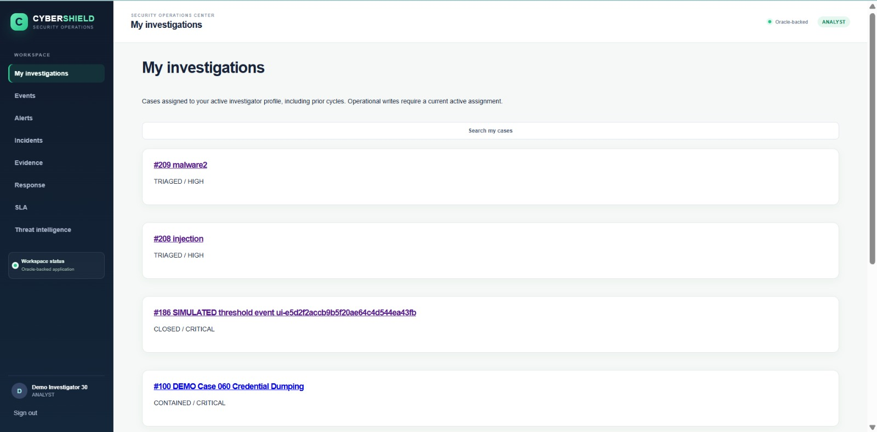
Login: ANALYST — The ANALYST can view cases assigned to the active investigator profile, including incident identifiers, titles, statuses, and severity levels.

A.4 Login and AUDITOR Login Screenshots

Figure A25. CyberShield sign-in page
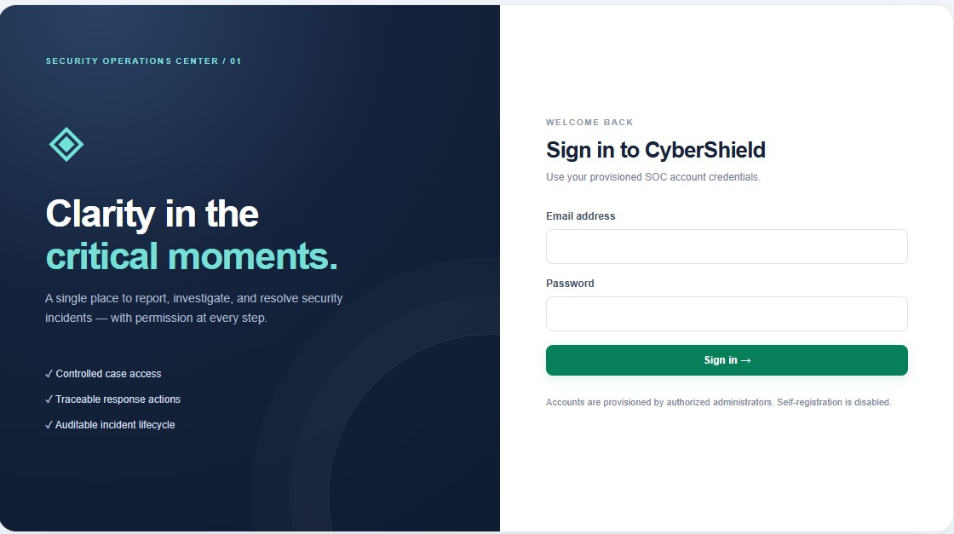
The sign-in page accepts the email address and password of an account provisioned by an authorized administrator. Self-registration is disabled.
Figure A26. AUDITOR read-only SOC overview
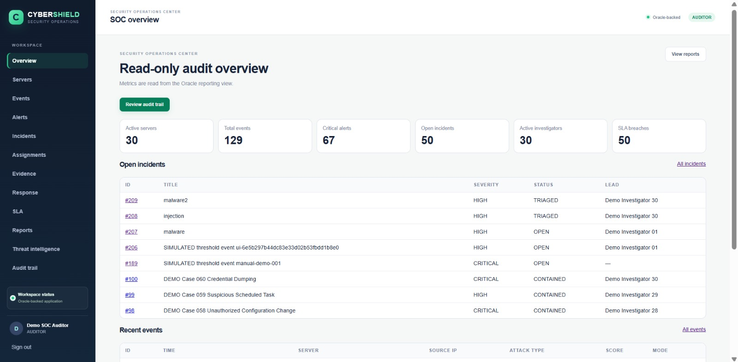
Login: AUDITOR — The auditor dashboard presents read-only operational metrics and incident/event summaries from Oracle reporting views. The page provides access to audit review and reports without presenting operational write controls.

