HIYAGHAR
Admin Panel Workflow Report
Flowcharts, modules, order lifecycle and daily operations
Website: HiyaGhar e-commerce store (admin area at /admin)
Document date: 2 November 2026
Version: 1.0
Based on: the current application code (main branch)

Contents
1. Purpose and scope 2
2. Signing in to the admin panel 2
3. Roles and permissions 3
4. Admin panel at a glance 5
5. Module guide 6
5.1 Catalog & Inventory 6
5.2 Orders & Logistics 6
5.3 Customers & Inquiries 6
5.4 Marketing & Promotions 7
5.5 Website & Content 7
5.6 System & Security 7
6. Order lifecycle 8
6.1 Status rules 8
6.2 Payment status 9
7. Store setup and daily routine 10
7.1 Why the setup order matters 10
8. Key settings and default values 10
9. Points to note 11

If the contents list is empty, right-click it in Word and choose "Update Field".

1. Purpose and scope
This report explains how the HiyaGhar admin panel works: how staff sign in, what each role can see, which modules exist, how an order moves from "Placed" to "Delivered", and what a typical day of store administration looks like.
It is written for the store owner, managers and admin staff. It describes the panel as it is built today, based on the application code. Values marked as defaults are starting values in the system; the live values can be changed from the admin panel.
The report contains four flowcharts:
- Figure 1: Admin login and access control
- Figure 2: Admin panel module map
- Figure 3: Order lifecycle
- Figure 4: Store setup and daily admin routine
The same flowcharts are also provided as separate PNG and SVG image files in the Flowcharts folder next to this report.

2. Signing in to the admin panel
The admin panel is opened at /admin on the website. If the person is not signed in, the Admin Login page is shown.
- Enter the admin email and password. Tick Remember me to have the email filled in next time.
- If the details are wrong, an error message is shown and the person can try again.
- If the details are correct, the system saves a secure login token and loads the person's roles and permissions.
- The Dashboard opens. The sidebar shows only the modules this person is allowed to view.
- When a module is opened, the system checks the View permission again. Without it, an Access Denied page is shown with a button back to the Dashboard.
- Inside a module, the Add, Edit, Delete and Export buttons appear only when the role allows that action.
- Logout (top bar) ends the session and returns to the login page.
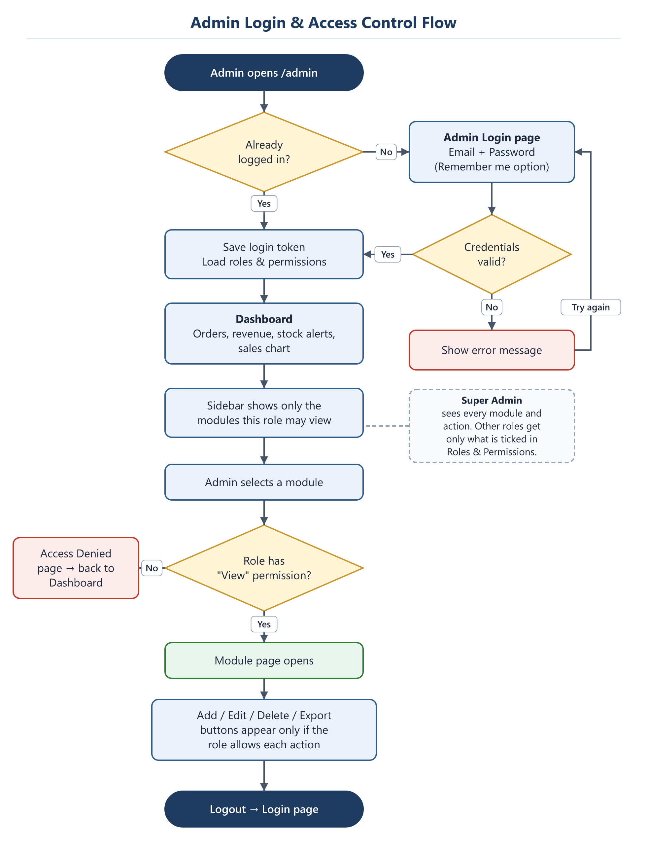
Figure 1: Admin login and access control flow

3. Roles and permissions
Access is controlled per module through Roles & Permissions (System & Security group). Each role has five tick-boxes for every module:
Permission | What it allows
View | See the module in the sidebar and open it.
Add | Create new records (for example a new product or coupon).
Edit | Change existing records, including status changes.
Delete | Remove records.
Export | Download lists from the module.

- Super Admin automatically sees every module and every action.
- Staff accounts are created in Users and given one or more roles.
- Menu Registry holds the list of modules (menu keys) that permissions are attached to. A new module must be registered here before it can be given to a role.
- Permissions are checked both in the sidebar and when a page is opened directly by its web address, so typing a URL does not bypass access control.

4. Admin panel at a glance
The sidebar is organised into the Dashboard plus six groups. Only one group is expanded at a time, and groups the person has no access to are hidden completely.
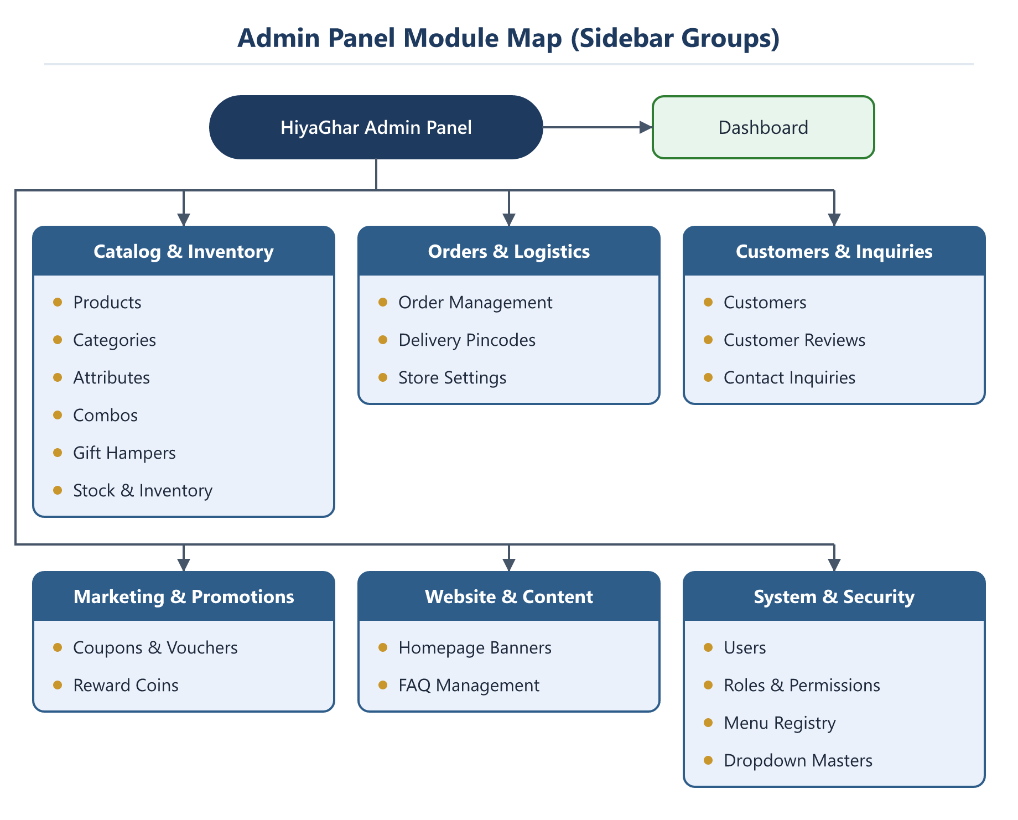
Figure 2: Admin panel module map (sidebar groups)
Sidebar group | Contains
Dashboard | Daily overview: total orders, pending orders, revenue (cancelled orders excluded), low-stock and out-of-stock counts, and a sales chart for the last 7, 14 or 30 days or a custom range.
Catalog & Inventory | Products, Categories, Attributes, Combos, Gift Hampers, Stock & Inventory.
Orders & Logistics | Order Management, Delivery Pincodes, Store Settings.
Customers & Inquiries | Customers, Customer Reviews, Contact Inquiries.
Marketing & Promotions | Coupons & Vouchers, Reward Coins.
Website & Content | Homepage Banners, FAQ Management.
System & Security | Users, Roles & Permissions, Menu Registry, Dropdown Masters.

5. Module guide
What the admin does in each module.

5.1 Catalog & Inventory
Module | What the admin does
Products | Create and edit products, their variants (for example size or weight), prices, images and attributes.
Categories | Manage store categories such as Mukhwas, Tea Masala, Hair Oil and Handmade Soap.
Attributes | Maintain product attributes (for example flavour or size) and the order they are shown in.
Combos | Build combo packs from existing products.
Gift Hampers | Build and price gift hampers.
Stock & Inventory | Three tabs: Stock Overview (current, reserved and sellable stock), Stock History (audited record of every stock change) and Reservations (stock held for customers who are checking out).

5.2 Orders & Logistics
Module | What the admin does
Order Management | View all orders (customer and guest), move orders through their statuses, add courier and tracking details, record cancellations and returns with a reason, and update payment status. See section 6.
Delivery Pincodes | Maintain the list of pincodes the store delivers to.
Store Settings | Shipping charges and free-shipping limit, express delivery, delivery-time text, GST display, FSSAI licence number and the store contact details shown on the website.

5.3 Customers & Inquiries
Module | What the admin does
Customers | View and manage registered customer accounts.
Customer Reviews | Show or hide product reviews with an on/off status toggle, or delete them.
Contact Inquiries | Read messages sent from the Contact Us page, filter them by status, and move each one through Pending → In Progress → Resolved → Closed with internal admin notes.

5.4 Marketing & Promotions
Module | What the admin does
Coupons & Vouchers | Create coupon codes with a percentage or flat discount, maximum discount, minimum order value, start and end dates, total and per-customer usage limits, and a first-order-only option.
Reward Coins | Three tabs: Settings (coins for sign-up, login and referrals, coin-to-rupee rate, maximum share of an order payable by coins), Slabs (coins earned per order-value range) and Ledger (every coin credit and debit).

5.5 Website & Content
Module | What the admin does
Homepage Banners | Manage the hero banners and other sections shown on the home page.
FAQ Management | Add, edit and order the questions shown on the FAQ page.

5.6 System & Security
Module | What the admin does
Users | Create staff login accounts and assign roles.
Roles & Permissions | Create roles and tick View, Add, Edit, Delete and Export for each module.
Menu Registry | Register the modules (menu keys) that permissions are attached to.
Dropdown Masters | Maintain dropdown lists and display labels used across the site, such as the order status names customers see.

6. Order lifecycle
Every order starts as Placed. The admin moves it forward from Order Management. The system blocks any move that is not allowed, for example moving an order backwards.
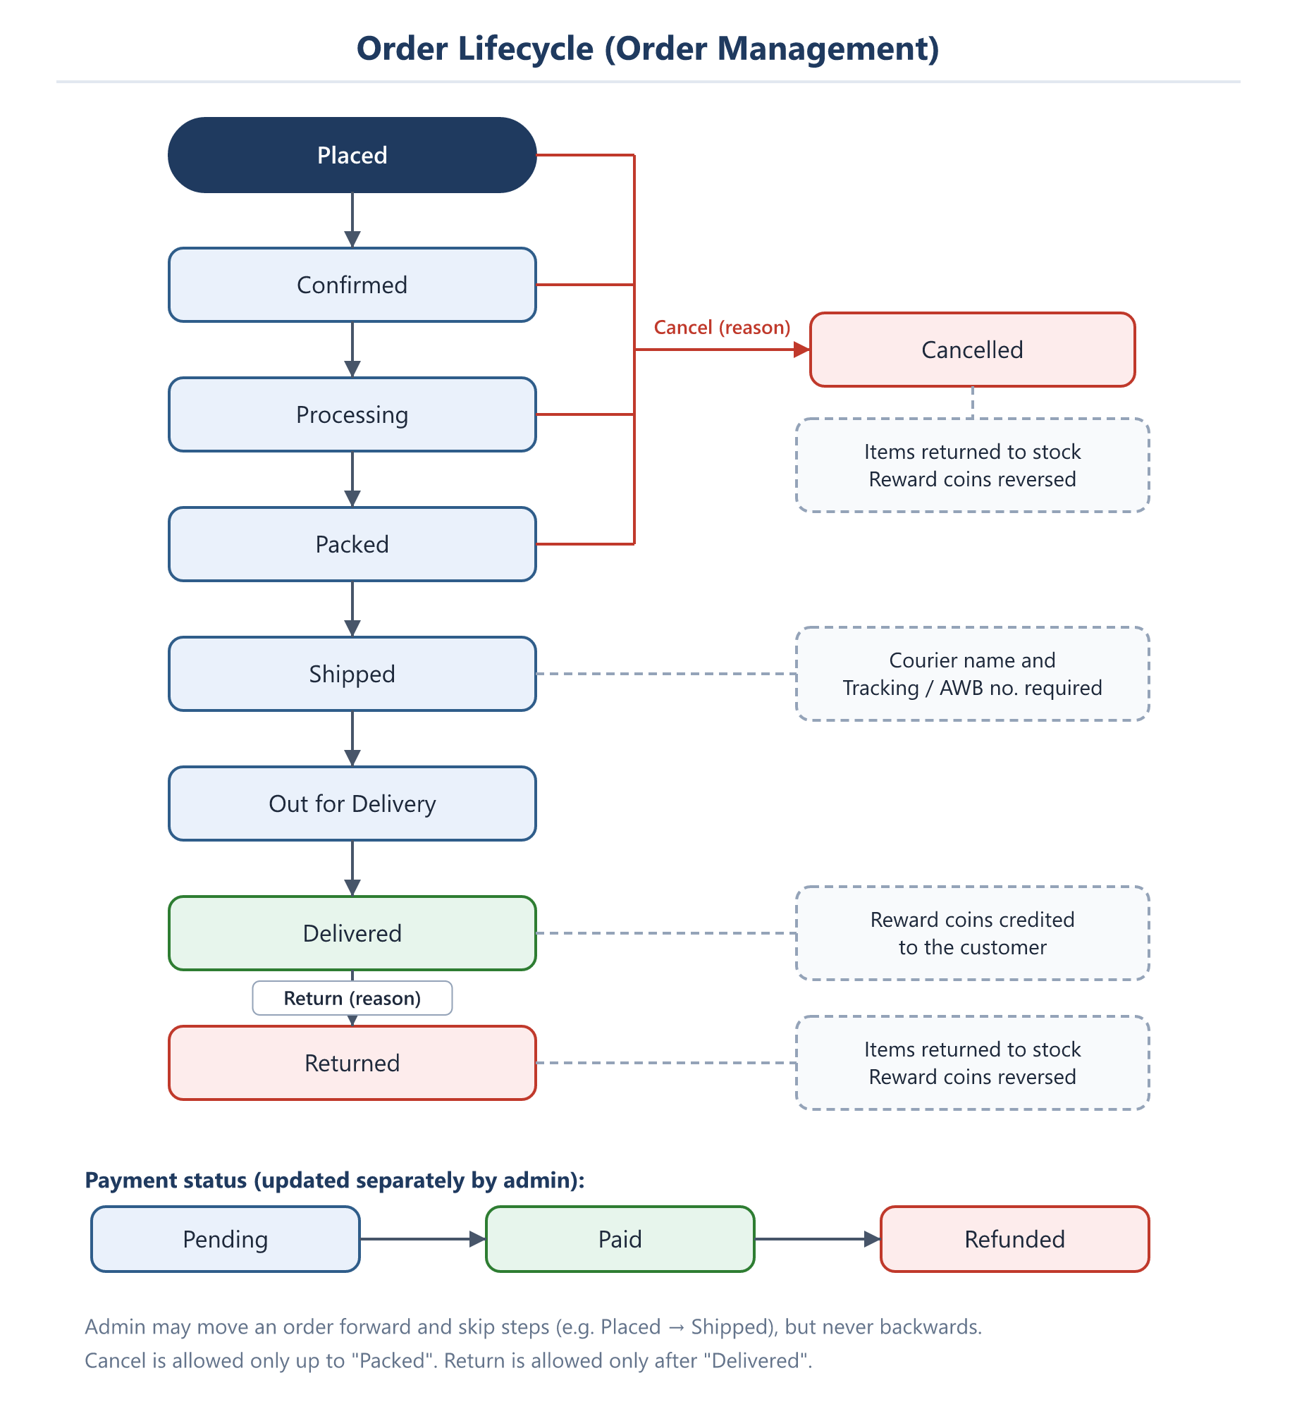
Figure 3: Order lifecycle and payment status

6.1 Status rules
Status | Can move to | What happens automatically
Placed | Confirmed, Processing, Packed, Shipped, Out for Delivery, Delivered, Cancelled | -
Confirmed | Processing, Packed, Shipped, Out for Delivery, Delivered, Cancelled | -
Processing | Packed, Shipped, Out for Delivery, Delivered, Cancelled | -
Packed | Shipped, Out for Delivery, Delivered, Cancelled | -
Shipped | Out for Delivery, Delivered | Courier name and tracking/AWB number must be entered.
Out for Delivery | Delivered | -
Delivered | Returned | Reward coins are credited to the customer.
Cancelled | (final) | Reason required. Items go back into stock. Reward coins are reversed.
Returned | (final) | Reason required. Items go back into stock. Reward coins are reversed.

6.2 Payment status
Payment status is updated separately from the order status and has three values: Pending, Paid and Refunded.

7. Store setup and daily routine
Figure 4 shows the recommended order for setting up the store for the first time, and the routine an admin follows each day.
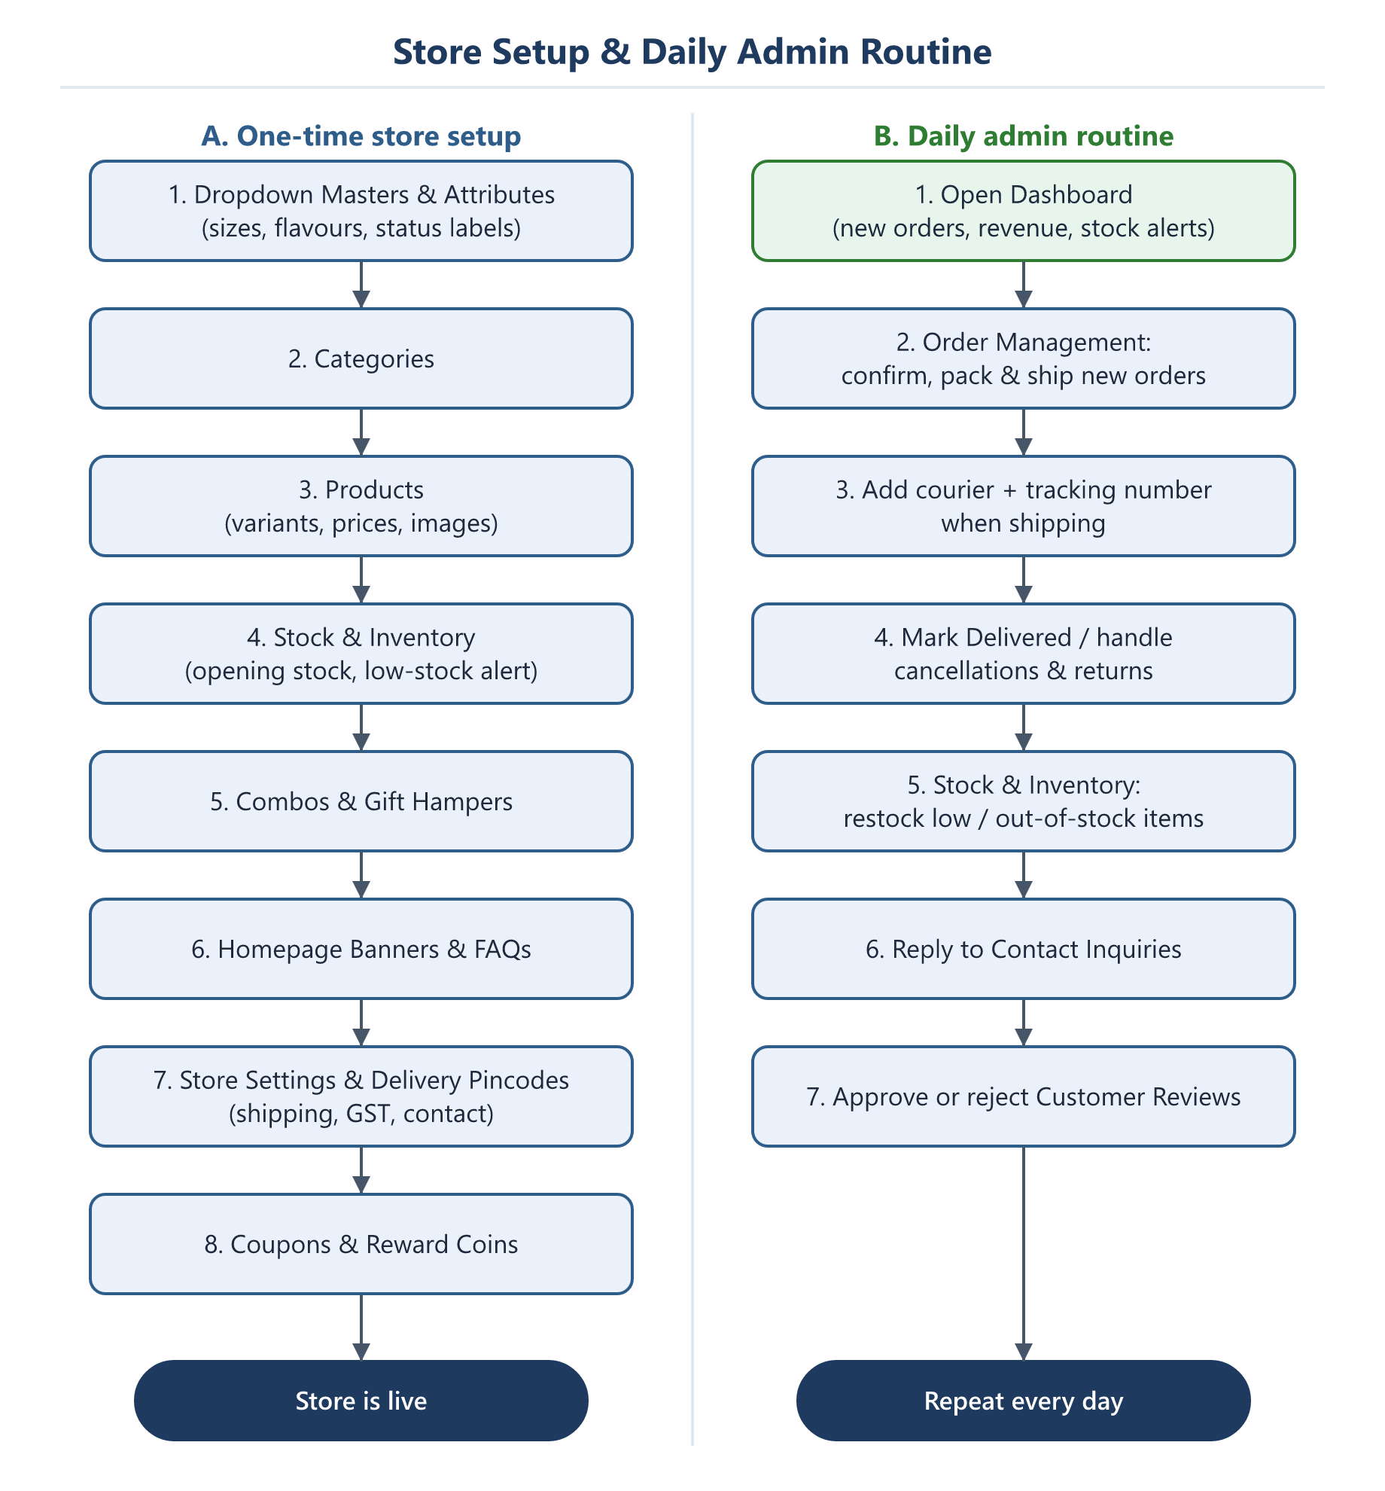
Figure 4: One-time store setup and daily admin routine

7.1 Why the setup order matters
- Attributes and dropdown values must exist before products can use them.
- Categories must exist before products are assigned to them.
- Products must exist before stock, combos and gift hampers can be created.
- Store settings, delivery pincodes, coupons and reward coins should be checked before the store takes orders.

8. Key settings and default values
These are the starting values in the system. Change them from the admin panel as needed.
Setting | Where | Default
Free shipping above | Store Settings | ₹500
Standard shipping charge | Store Settings | ₹49 (3–5 business days)
Express shipping charge | Store Settings | ₹99 (1–2 business days)
GST shown at checkout | Store Settings | 5% (included in price)
Deliver only within Ahmedabad | Store Settings | On
Low-stock alert level | Stock settings | Set by admin
Checkout stock hold time | Stock settings | Set by admin (minutes)
Coin-to-rupee rate | Reward Coins › Settings | 1 coin = ₹1
Maximum coins per order | Reward Coins › Settings | 10% of order value

9. Points to note
- Order status emails are switched off. Customers and admins do not currently receive an email when an order's status changes. This was disabled on purpose in the code and can be turned back on if needed.
- Delivery is limited to Ahmedabad by default. Check the "Only Ahmedabad delivery" option and the Delivery Pincodes list before expanding to new areas.
- A "Test Menu" module exists. It is only visible to roles that have been given permission to it. It can be removed from Menu Registry if it is not needed in production.
- Unknown admin addresses are protected. Any /admin/... address that does not match a known module still goes through the permission check, so unregistered pages are not exposed.

