**Lorann Project**

**TEAM PRESENTATION :**

**Raphaël Bensimon**…………………………………………....**Software engineer**

**Kevin Bourdeau**……………………………………………….**Software engineer**

**Clément Perin**………………………………………………….**Software engineer**

**Aymeric Bouguéon**………………………………………….…**Project Manager**

**Plan :**

1. **Project implementation and group reflection**
2. How to design this project and with which tools
3. Setting up the project on our computer
4. **Organization of the project**
5. WBS
6. Gantt
7. Trello
8. Pert
9. **Database**
10. Maps creation
11. Stored procedures

**Deliverables**:

- Full JavaDoc of your project (tests included)

- Full JXR of your project (tests included)

- SureFire report of your project

- Component diagram

- Package Diagram

- Class diagram (one per package)

- Sequence diagram (as much as you will find it useful to understand and explain the

operation of your program)

- A GIT report to identify the production of each member of the team.

- Any other documents you deem necessary (CDM, stored procedures, other

diagrams, comments, ...)

**Constraints :**

The use of Java(Popular waltz), Maven, GitHub and Junit is compulsory.

No graphical framework other than Swing is allowed.

Start of the project: Monday, May 28th. End of the project: Wednesday, June 6th.

The team of development will be constituted by 4 members maximum.

A project manager will be appointed. It will be responsible :

-the proper distribution of the load between the team members

- the deliverables (time and content)

- the making of optional appointments (but recommended) with your tutor

No SQL request must be present in the Java code. All calls must be via stored procedures.

1. **Project implementation and group reflection**

At the beginning of the project, we chose Aymeric as the project manager. Then we read the subject and we divides the tasks between us. To make a good project we thought that it was better to have a GIT for each members a group, to have a functional Maven project so thanks to the basic architecture offered on resources.

Furthermore, to manage the project, we have done a GANTT and a PERTT.

First, we made diagrams class, package and component to have a good representation of our project. Then we took over the basic architecture and created our own git to touch our part that had been assigned to us. And at the end we gather everything in one git.

1. **Organization of the project** :

**WBS** :

To simplify the project, we have made a WBS. This diagram was divided in 3 main branches UML diagrams, Organization and Code.

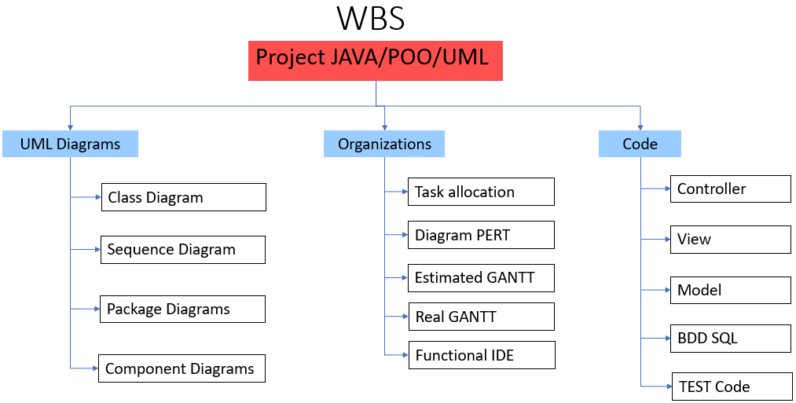

**Gantt** :

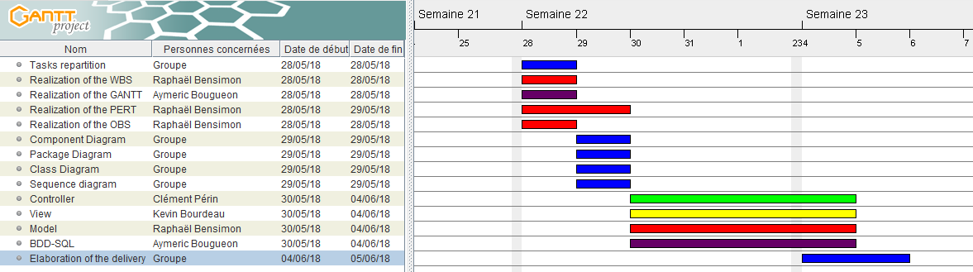Then we have made a Gantt to see the distribution of the task and their times per person.

**Trello** :

Thanks to Trello we were able to interact in real time with our mates to complete our progress.

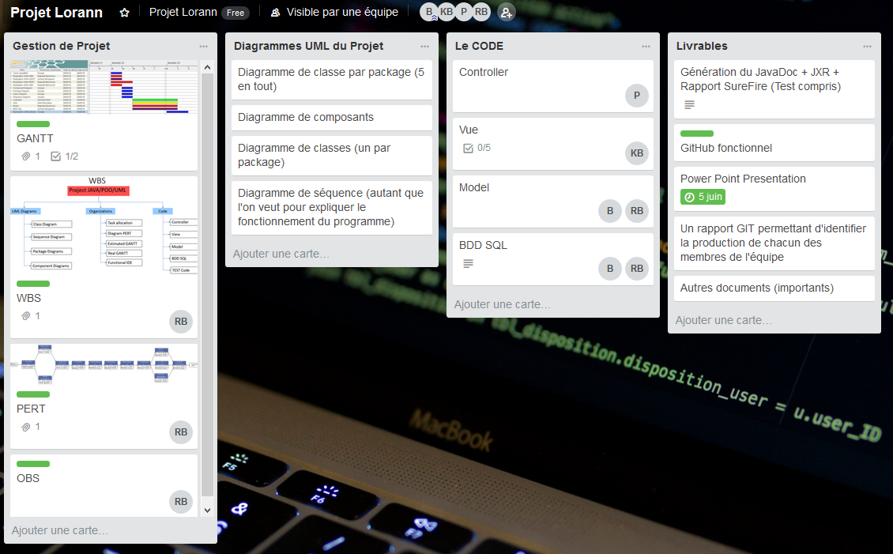

**PERT** :

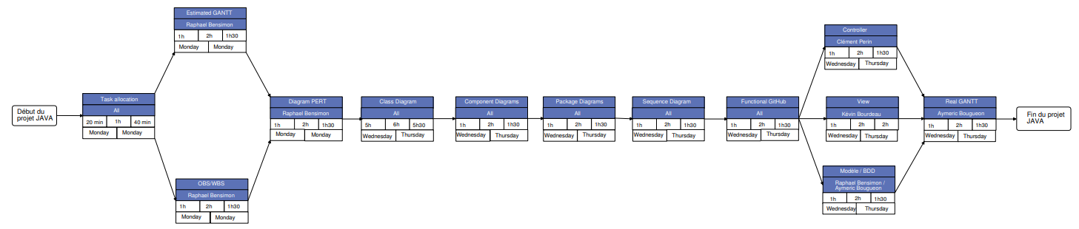Then we established a PERT diagram to see the dependencies between different tasks. So, we could check our progress during the project.

1. **Database :**
2. **Stored procedures**

A stored procedure is an SQL query that will perform a specific task. In first we choose which database we wanted to store them. In this database, we create the requests of the procedures and we called the different procedures to show the different maps.

1. **Maps creation :**

To create the database, we used the Workbench software. In the database we have created a table that will allow us to store our data in the form of table. In the table we have created 2 columns : an ID column, and mp column (with one map per row)

**Rex** :

**Raphaël Bensimon** :

This project was very interesting, make code in group interest me a lot.

With this project, I can use my knowledge learned during the prosit.

I lighten some point that I haven’t understand thanks to the practice.

I don’t see the SQL part and the View.

I succeed to make model and diagram and some deliverable.

**Clément Perin:**

Really bad experience, I had many issues to manage my work with others. Theme of the project was cool but a little bit hard after all we done in Java. I had not real problem in the way of making how work the game but . . . My group wasn't really helping because they had their own issues.

**Kevin Bourdeau:**

Overall of the project, we have a good group work. Our project manager was Aymeric and was very good in his role.

My part was to display the view of the game. It was difficult to create the view because I didn't use the proposed showboard. The view took me a lot of time because I created my own view without showboard because I didn’t understand the showboard.

Otherwise, I think I should not have spent too much time on the view since I did nothing else except the class, package and component diagram of my view.

To conclude, it was a good project but there were things that took me longer than others.

**Aymeric Bouguéon:**

In this project I took care of the database. The connectivity between MySQL and the Java project. I had problem with the string size in my database, but I resolved it by formatting it into array char.