**Fine Tuning**

Input

Dropout 0.2

Batch Normalization

Global Average Pooling 2D

Dropout 0.5

Dense Layer (64)

DenseNet201

Softmax

(64)

Category of Breast Cancer

Dense Layer

(2)

(7, 7, 1920)

(224, 224, 3)

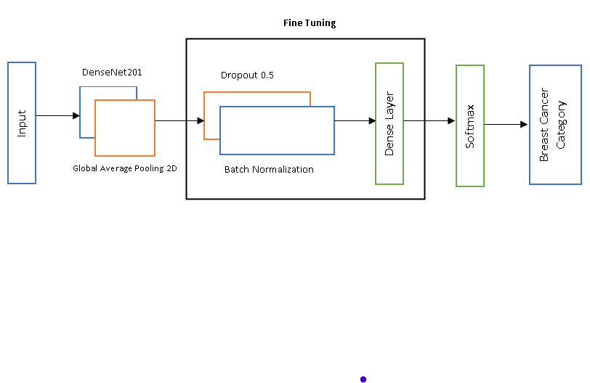

|  |  |  |  |
| --- | --- | --- | --- |
| **Reference** | **Number of images** | **Segmentation algorithms used** | **Quantitative results** |
| Rajyalakshmi et al. [7] | 96 images for training and 24 images for testing | Modified Marker-Controlled Watershed Approach | Normal: Se=93.74%, Sp=96.27%, Acc=95.79%  Invasive: Se=94.70%, Sp=87.25%, Acc=95.56% |
| Wenzhong Liu et al.[12] | 7909 breasr cancer biopsy images | Deep Convolutional Neural Network  (Inception, ResNet, AlexNet) | Acc=96.43%, F1-Score=97.38% |
| Zhang et al. [16] | 215866 images | Multi Scale Residual Convolutional Neural Netwok and SVM. | Acc=87.45±0.81%, BaAcc=85.7±0.95%, F1=79.89±1.11% |
| Alzubaidi et al. [17] | 400 histology | Hybrid Deep Convolutional Neural network | Patchwise-Acc=90.5%, Imagewise-Acc=97.4% |
| Teresa et al. [18] | Training set-249 imgaes, Testing set-20 images | Convolutional Neural Netwok and SVM. | Patchwise-Acc=76.9%%, Imagewise-Acc=83.3% |
| Qiwen Xu et al, [22] | 1260 2D gray scale images | CNN using Diffuse Optical Tomography | Se=0.88, Sp=0.96, Acc=93.3% AUC=0.95 |
| He Ma et al. [23] | 1052 Images | CNN (Fus2Net) | Se=95.65%, Sp=88.89%, Acc=0.92, AUC=0.97 |
| Alom et al. [25] | 7909 Samples | Inception Recurrent Residual Convolutional Neural Network. | Testing Acc =99.05% (binary), 98.59%(multi-class) |
| Burcak et al. [27] | 9109 microscopic images | Hybrid Deep Convolutional Neural network (GooogLeNet) | Acc=99.05% |