**NAME**:V Padmasree  
**Branch**: Bio Medical Engineering  
**Year**:IIIrd year  
**Register Number**:112021121010  
**Course Name**:Artificial Intelligence

Abstract:

In this document, includes a dataset of diabetes prediction such as glucose levels, blood pressure, BMI, etc., by using Machine Learning along with the information of an individual has diabetes or not.

DataSets:

* Pregnancies: Number of times pregnant
* Glucose: Plasma glucose concentration a 2 hours in an oral glucose tolerance test
* Blood Pressure: Diastolic blood pressure (mm Hg)
* Skin Thickness: Triceps skin fold thickness (mm)
* Insulin: 2-Hour serum insulin (mu U/ml)
* BMI: Body mass index (weight in kg/(height in m)^2)
* Diabetes Pedigree Function: Diabetes pedigree function
* Age: Age (years)
* Outcome: Class variable (0 or 1)

Link:

[kaggle datasets download -d mathchi/diabetes-data-set](AI_Phase5.docx)

In the above link the datasets can be recovered

#STEP 1: Importing library

import pandas as pd

import numpy as np

import matplotlib.pyplot as plt

import seaborn as sns

from sklearn.model_selection import train_test_split

from sklearn.linear_model import LogisticRegression

from sklearn import metrics

from sklearn.metrics import classification_report,confusion_matrix

from pandas_profiling import ProfileReport

*# Step 2: Load the dataset*

df = pd.read_csv('/kaggle/input/diabetes-data-set/diabetes.csv')

*# Step 3: Data Cleaning*

*# Check for Missing Values*

missing_values = df.isnull().sum()

print("Missing Values:")

print(missing_values)

*# Handle missing values (if any)*

*# For example, fill missing values with the mean of the column*

mean_fill = df.mean()

df.fillna(mean_fill, inplace=True)

*# Check for Duplicate Rows*

duplicate_rows = df[df.duplicated()]

print("**\n**Duplicate Rows:")

print(duplicate_rows)

*# Handle duplicate rows (if any)*

*# For example, drop duplicate rows*

df.drop_duplicates(inplace=True)

*#Step 4: Data Analysis*

*# Summary Statistics*

summary_stats = df.describe()

print("**\n**Summary Statistics:")

print(summary_stats)

*# Class Distribution (for binary classification problems)*

class_distribution = df['Outcome'].value_counts()

print("**\n**Class Distribution:")

print(class_distribution)

*# Step 5: Data Visualization*

sns.pairplot(df, hue='Outcome')

plt.show()

*# Step 6: Support Vector Machine (SVM) Modeling*

*# Separate features and target variable*

X = df.drop('Outcome', axis=1)

y = df['Outcome']

*# Split the dataset into a training and testing set*

X_train, X_test, y_train, y_test = train_test_split(X, y, test_size=0.2, random_state=42)

*# Standardize features*

scaler = StandardScaler()

X_train = scaler.fit_transform(X_train)

X_test = scaler.transform(X_test)

*# Initialize and train the SVM model*

model = SVC(kernel='linear', random_state=42)

model.fit(X_train, y_train)

*# Make predictions*

y_pred = model.predict(X_test)

*#Evaluate the model*

accuracy = accuracy_score(y_test, y_pred)

print(f'Accuracy: **{**accuracy**:**.2f**}**')

*# Classification report and confusion matrix*

print(classification_report(y_test, y_pred))

cm = confusion_matrix(y_test, y_pred)

sns.heatmap(cm, annot=True, fmt='d')

plt.show()

Missing Values:

Pregnancies 0

Glucose 0

BloodPressure 0

SkinThickness 0

Insulin 0

BMI 0

DiabetesPedigreeFunction 0

Age 0

Outcome 0

dtype: int64

Duplicate Rows:

Empty DataFrame

Columns: [Pregnancies, Glucose, BloodPressure, SkinThickness, Insulin, BMI, DiabetesPedigreeFunction, Age, Outcome]

Index: []

Summary Statistics:

Pregnancies Glucose BloodPressure SkinThickness Insulin \

count 768.000000 768.000000 768.000000 768.000000 768.000000

mean 3.845052 120.894531 69.105469 20.536458 79.799479

std 3.369578 31.972618 19.355807 15.952218 115.244002

min 0.000000 0.000000 0.000000 0.000000 0.000000

25% 1.000000 99.000000 62.000000 0.000000 0.000000

50% 3.000000 117.000000 72.000000 23.000000 30.500000

75% 6.000000 140.250000 80.000000 32.000000 127.250000

max 17.000000 199.000000 122.000000 99.000000 846.000000

BMI DiabetesPedigreeFunction Age Outcome

Count 768.000000 768.000000 768.000000 768.000000

mean 31.992578 0.471876 33.240885 0.348958

std 7.884160 0.331329 11.760232 0.476951

min 0.000000 0.078000 21.000000 0.000000

25% 27.300000 0.243750 24.000000 0.000000

50% 32.000000 0.372500 29.000000 0.000000

75% 36.600000 0.626250 41.000000 1.000000

max 67.100000 2.420000 81.000000 1.000000

Class Distribution:

Outcome

0 500

1 268

Name: count, dtype: int64

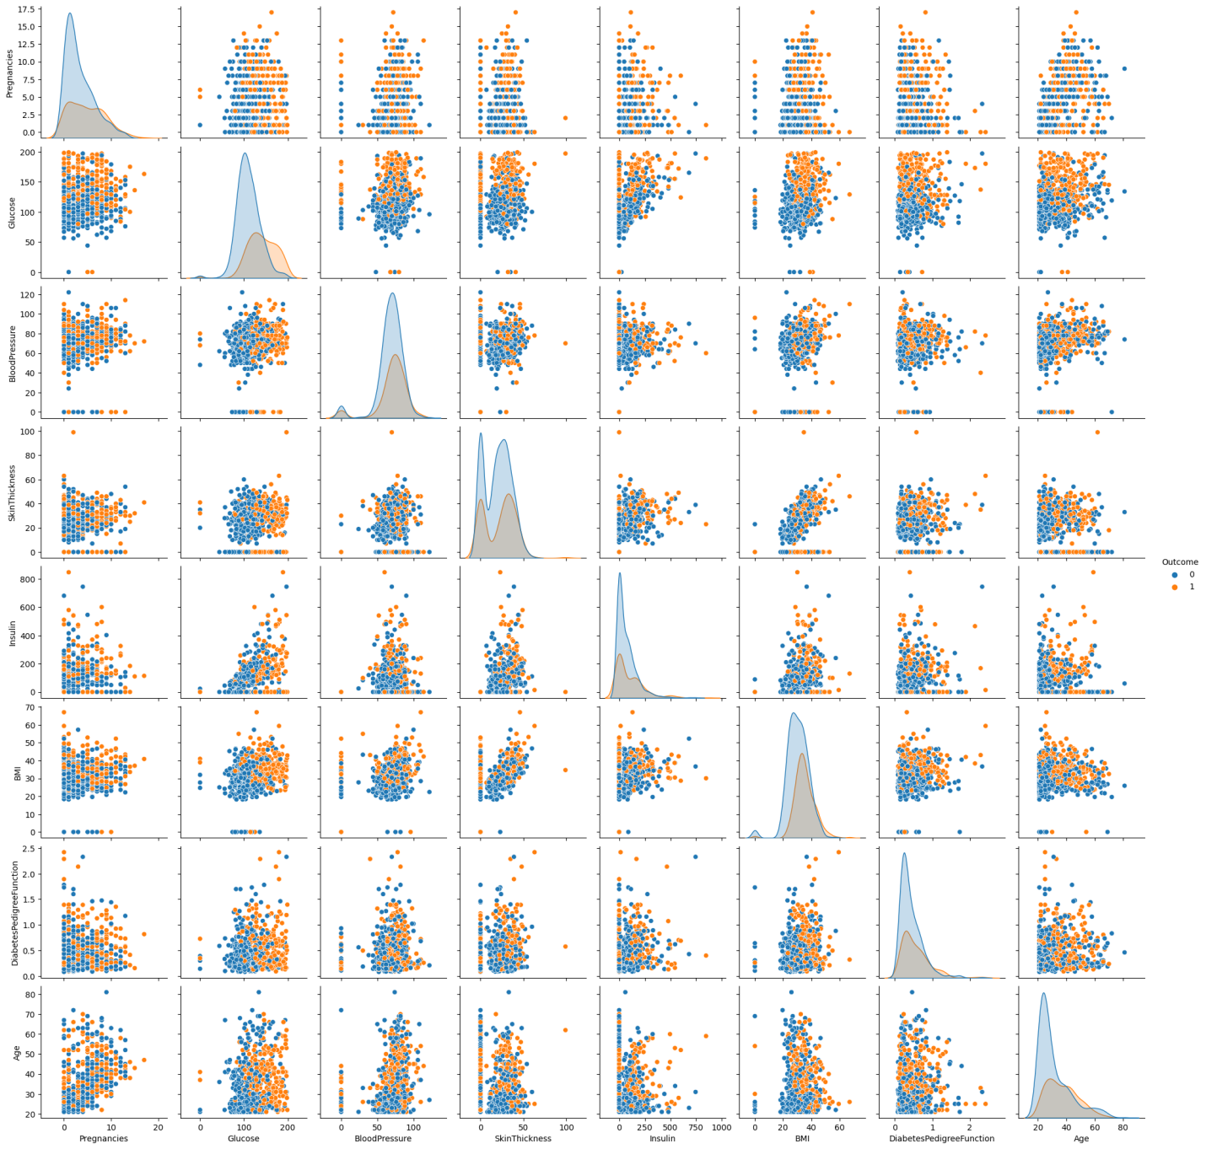

Accuracy: 0.76

precision recall f1-score support

0 0.81 0.82 0.81 99

1 0.67 0.65 0.66 55

accuracy 0.76 154

macro avg 0.74 0.74 0.74 154

weighted avg 0.76 0.76 0.76 154

