**Test circuit**

**Test circuit design code:**

In vivado software, I have created Verilog file for test circuit and written the code in it.

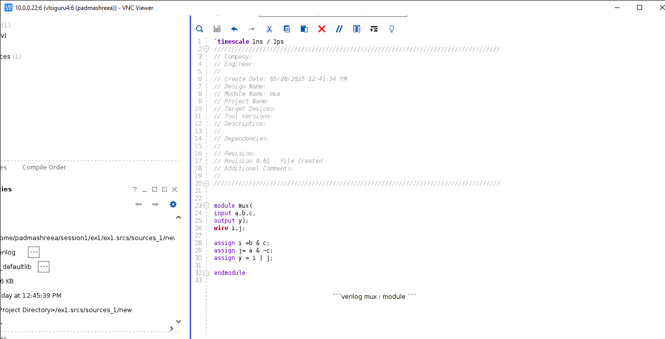

**Test circuit truth table**

From synthesis we got the truth table as it shown in bellow

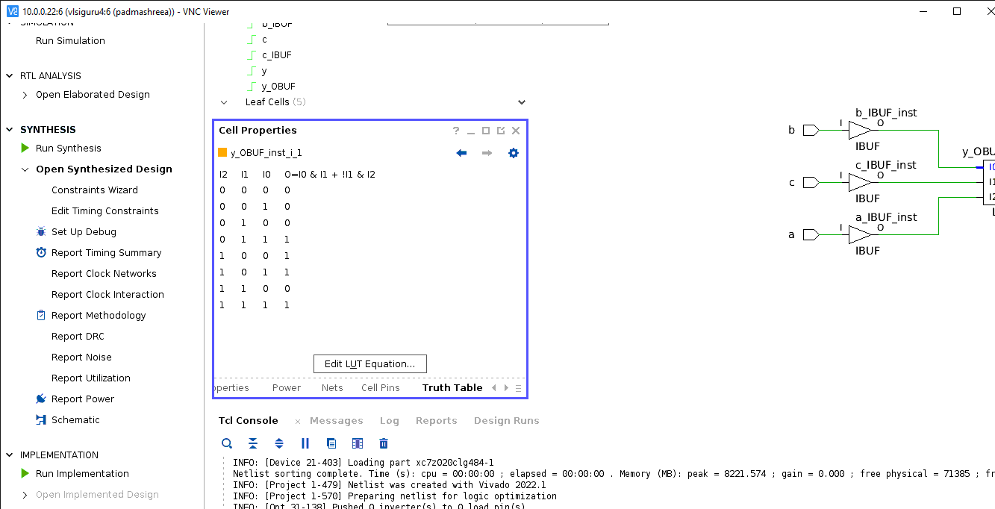

**Test circuit schematic diagram**

From synthesis we got schematic diagram as below.

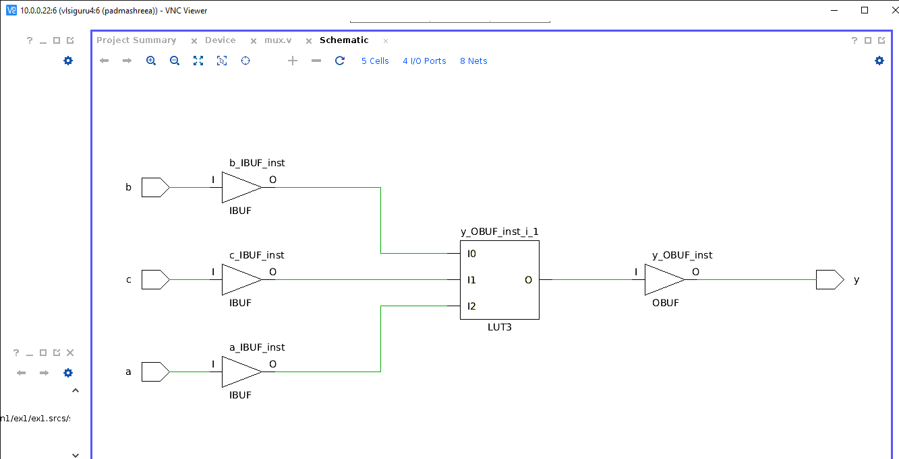

**Test circuit Elaborated design**

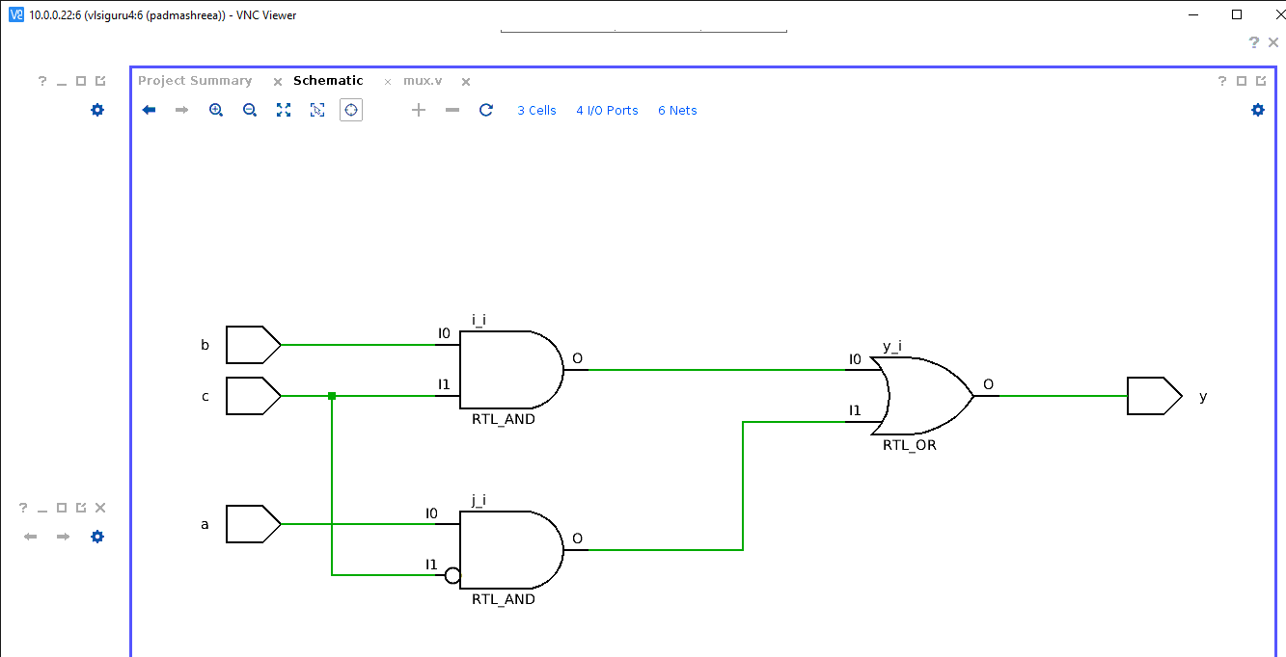

**Full Adder**

**RTL/Verilog code**

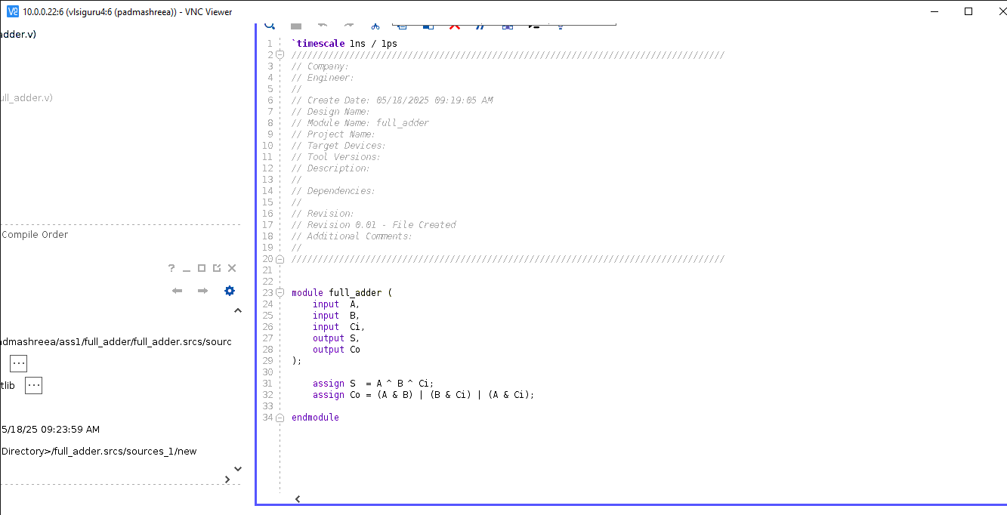

**Schematic diagram**

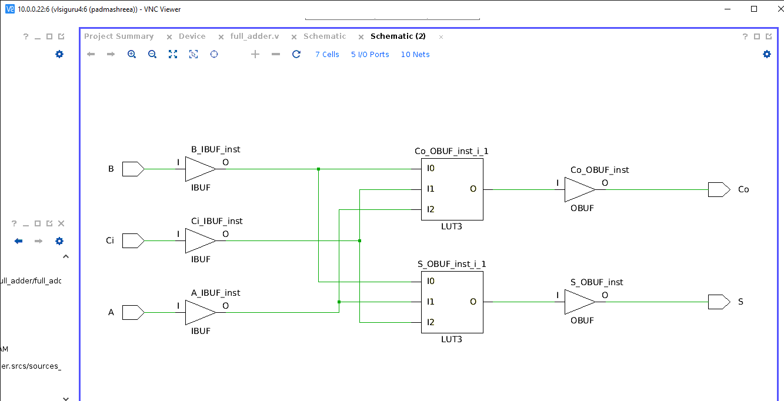

**Truth table for Sum**

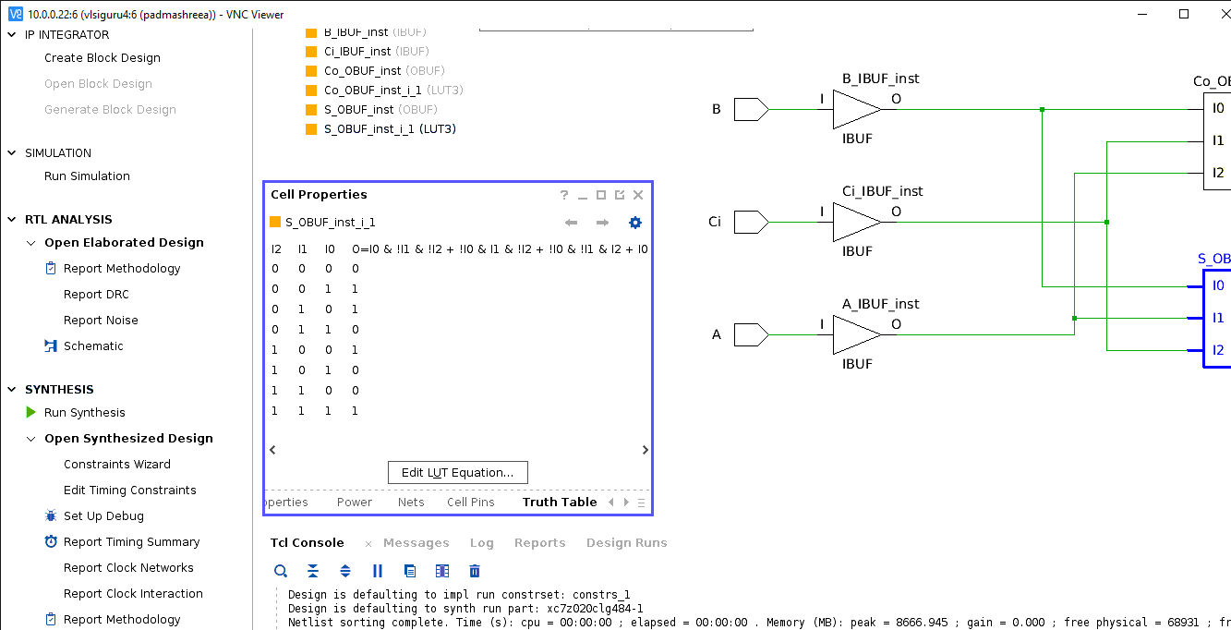

**Truth table for carry**

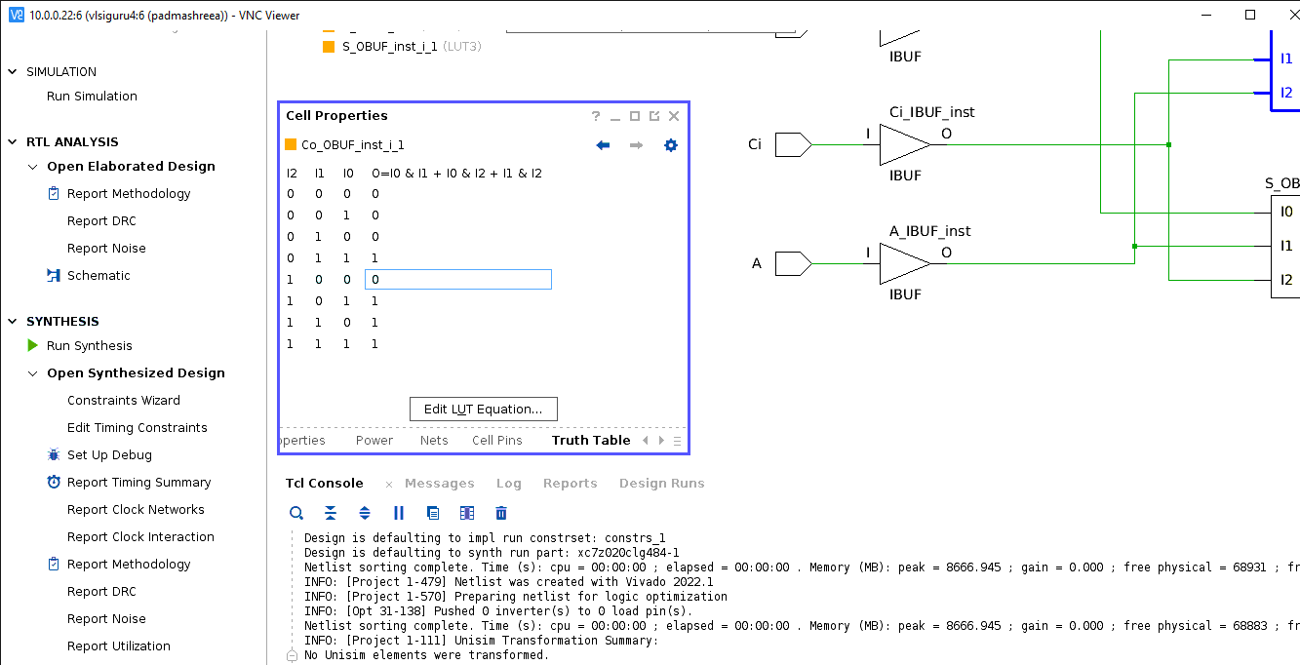

**Elaborated diagram**

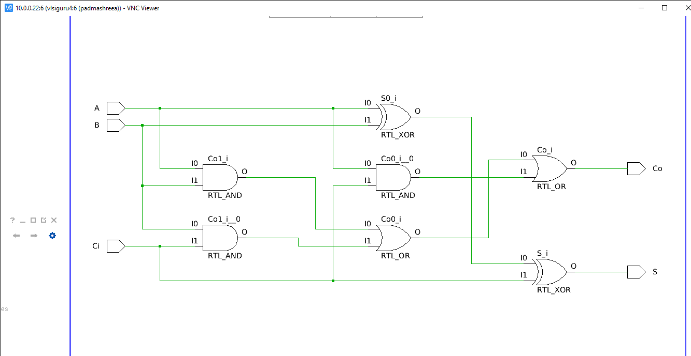

**2:1 Mux**

**RTL/Verilog code**

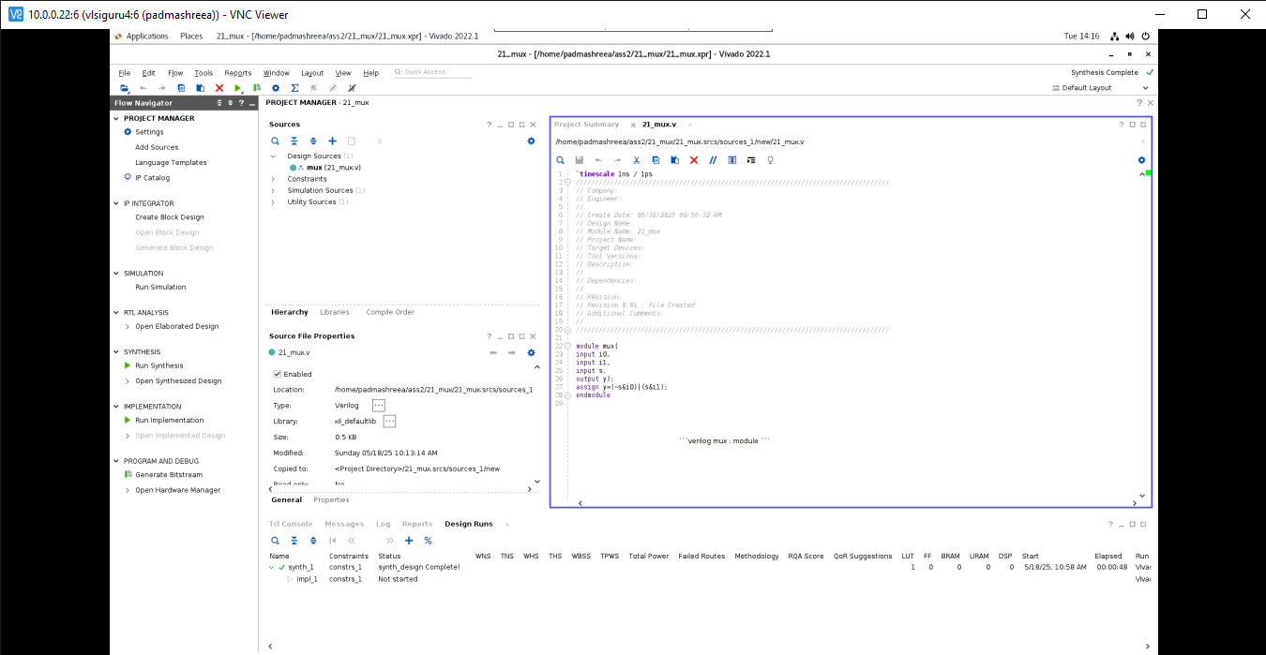

**Schematic diagram**

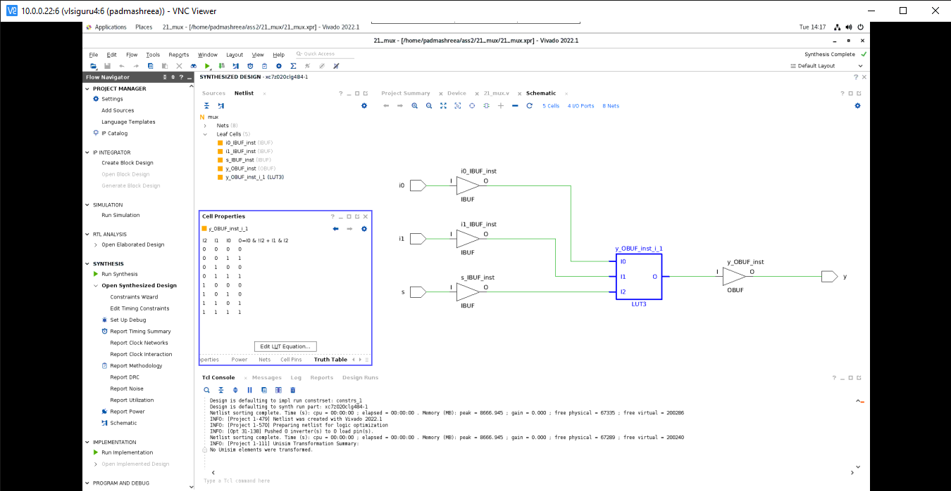

**Truth table**



**Elaborated diagram**

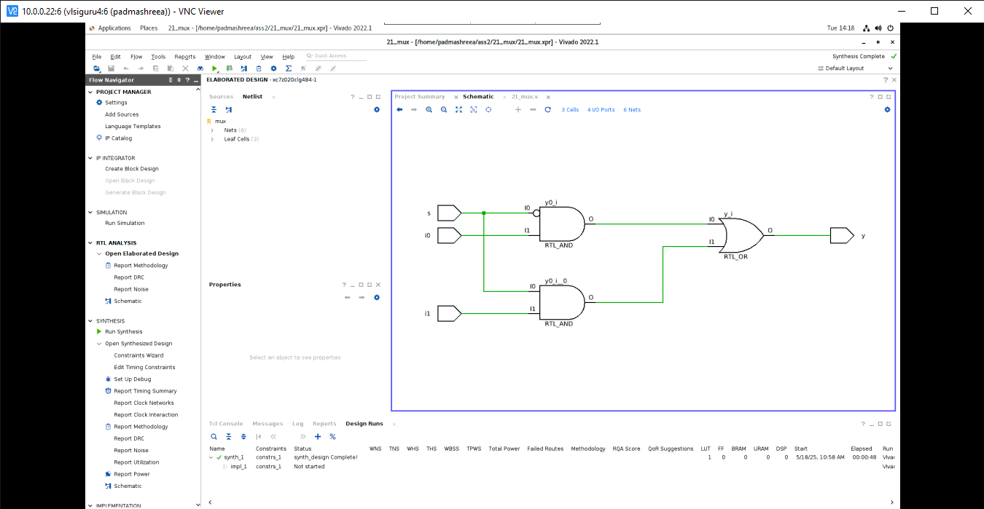

**Priority Encoder**

**RTL/Verilog code**

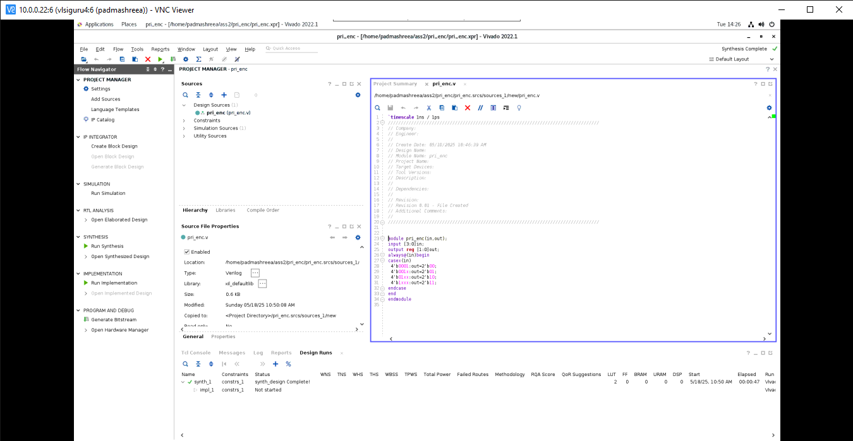

**Schematic diagram**

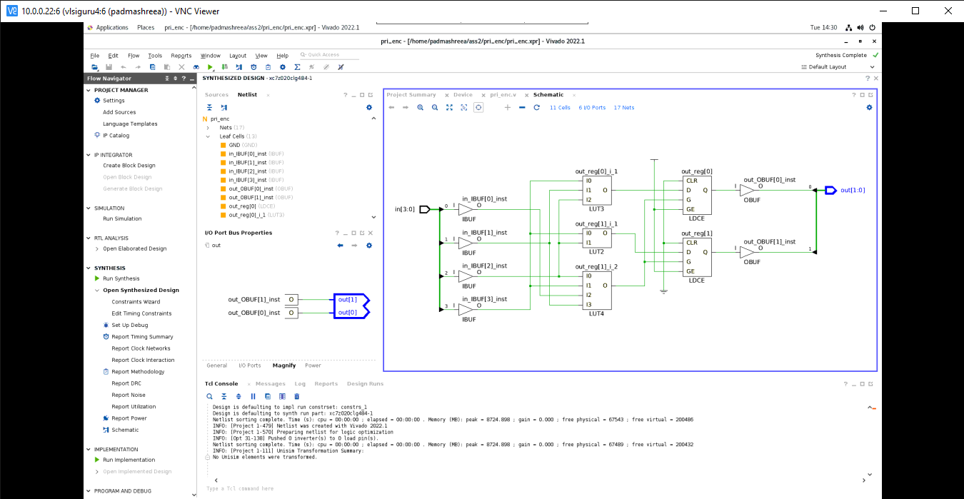

**Elaborated circuit**

