Explanation of Sales Data Analysis Project
This project focusses on analyzing the sales in different regions using a comprehensive Kaggle Superstore dataset. The objective is to identify which products were sold the most, which regions or customer segments are most profitable and what are the monthly/seasonal trends in sales and profit.
Objective:
The primary objective of the project is to use historical sales data to:
- Examine the total sales over different products to find sales by category
- To Calculate the total profit over different regions such as North, South, East and
West region
- To Investigate Top 10 products sold
- To Identify monthly sales trend i.e. Sales over Time:
The Kaggle Superstore dataset includes several variables that capture Order ID, Order Date, Ship Date, Ship Mode, Customer ID, Customer Name, Segment, Country, City, State, postal code, Region, Product ID, Category, Sub-Category, Product Name, Sales, Quantity, Discount, Profit to perform sales analysis and determine profit margin by deriving actionable insights.
Features:
Order ID—ID of the order
Order Date—Date of the order placed
Ship Date—Date of the order shipped
Ship Mode—Mode of the shipping like first class, second class, standard class
Customer ID—ID of the customer
Customer Name—Name of the customer
Segment—Such as Consumer, Home Office, Corporate
Country—Country from where the order placed and to be shipped
City—city of the order placed and to be shipped
State—state of the order placed
Postal code—postal code of the order placed
Region—region of the order such as north, south east and west
Product ID—Id of the product
Category—such as furniture, technology, office supplies
Sub-Category— such as Bookcases, Chairs, Labels, Tables, Storage, Furnishings, Art, Phones,
Binders, Appliances

Product Name—Name of the product
Sales—sold product
Quantity—quantity sold
Discount—discount given
Profit—profit obtained
Step 1: Data Loading and Cleaning
Objective: Load the data and clean it to ensure that the dataset is ready for analysis. This involves handling missing values, ensuring consistency, and preparing the data for analysis.
Explanation:
- First load the dataset using pandas and inspect it for missing values.
- Remove the duplicates, fix the datatypes and Check for extreme values in Sales or Profit.
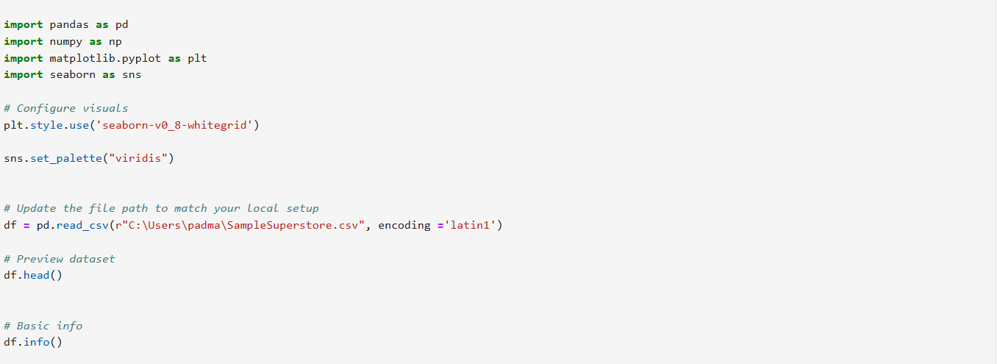
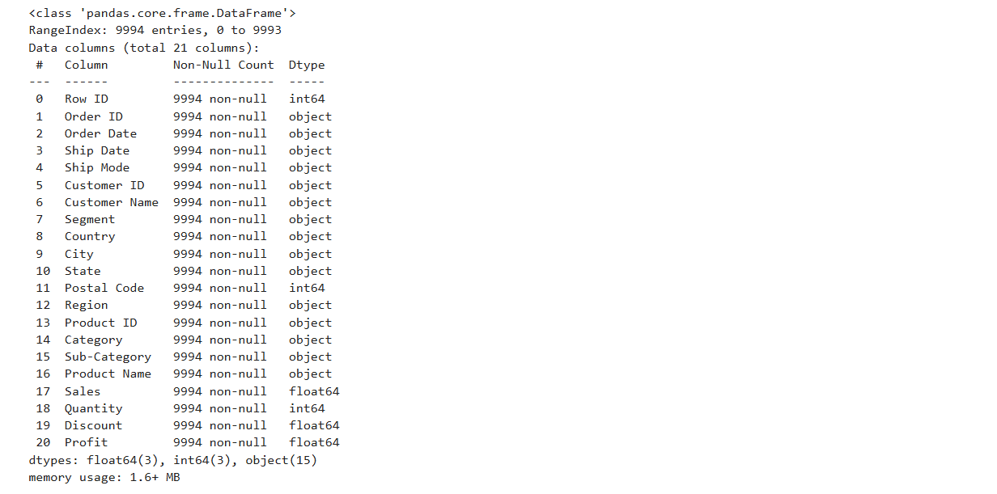
Python code to exploring the data, by finding the summary of the statistics , removing the duplicates, checking for missing values, fixing the data types by converting order date to datetime and confirming the cleanup
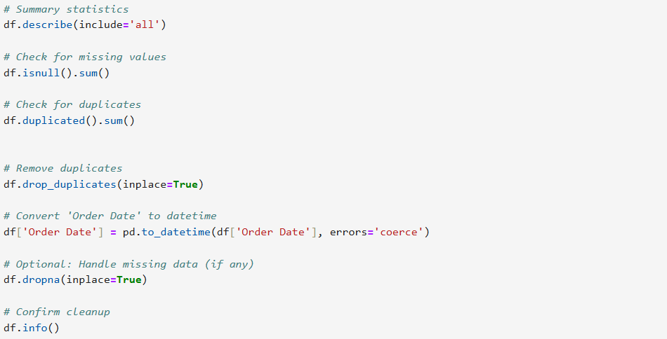
Output of the above code showing memory usage, type of the data used as well the column labels or names with their corresponding data types
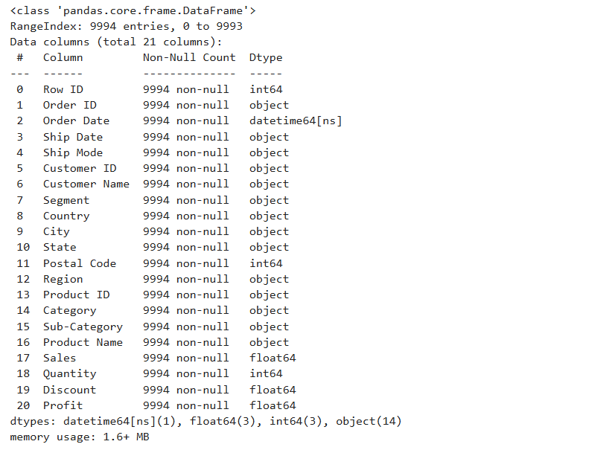
Python code to obtain or extract the year and month for trend analysis
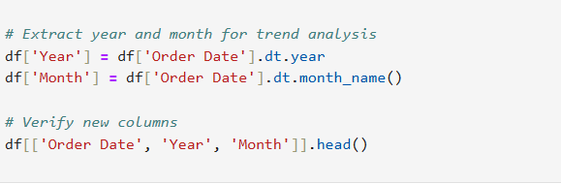
The output indicates the following order dates are trending with the months being November June, October and year being 2016 and 2015
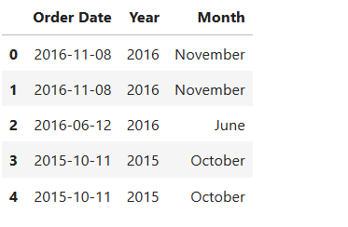
Python code to find the Top 10 selling products through product name and sales. In addition, to investigating the profit by region such as north, south, west and east region and sales over time
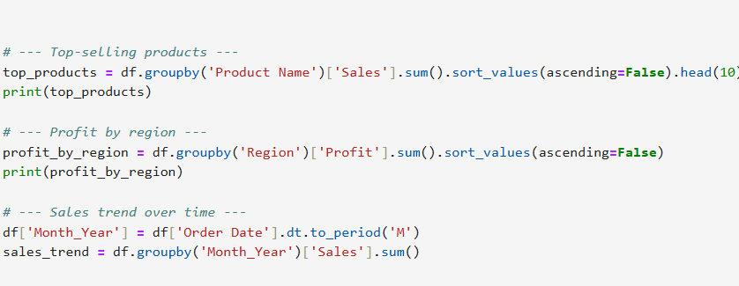
The output shows each regions profit as well top 10 selling products

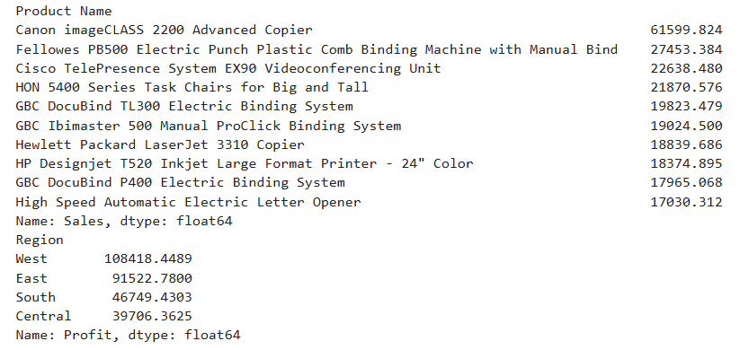
Python code for finding the sales over time to find the monthly sales trend
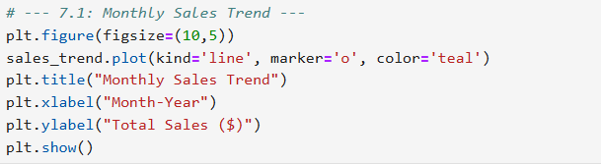
The output of the sales over time is identified and depicted in the line graph below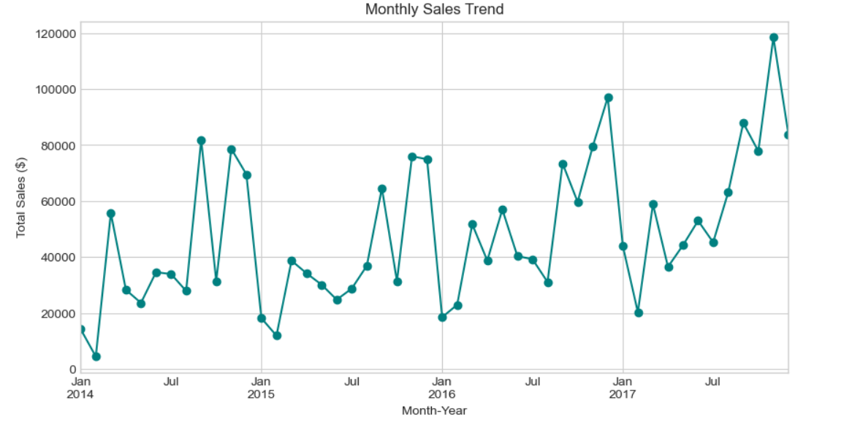
Python code to find the profit by region
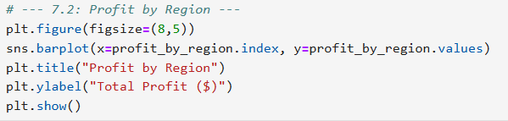
The output of the profit by region depicted through bar graph
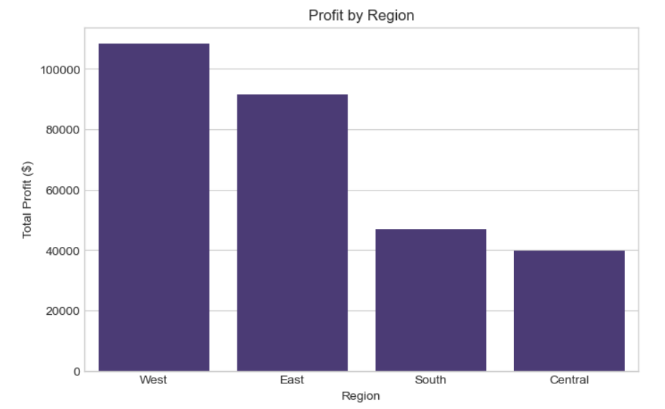
Python code to find the sales by category
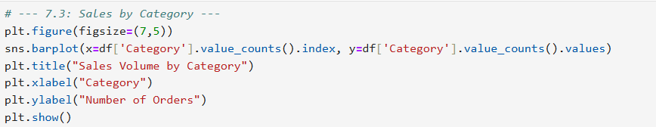

Output of sales by category and depicted in bar graph. The graph indicates office supplies sales volume is high
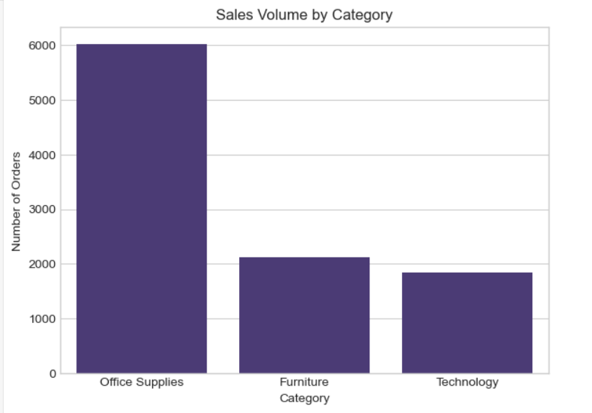
Python code to find the top 10 products by sales
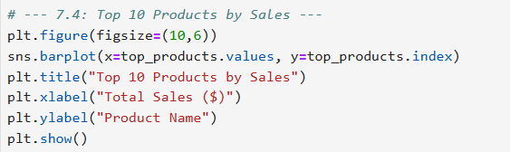

The output top 10 sales are given below and is depicted in bar graph. The graph shows the following are the top 10 products which are sold.
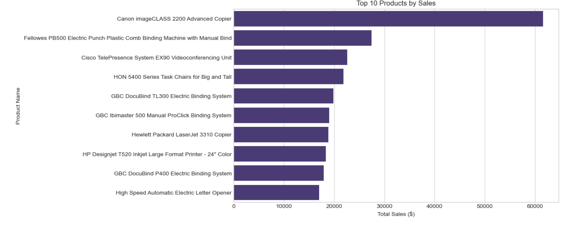

Python code to find the top performing product and most profitable region. In addition, to finding the average profit margin by category. The output shows that top performing product is cannon imageCLASS 2200 Advanced Copier and most profitable region is West region. Average profit margin for Technology is 15.613805, office supplies 13.803029, and furniture is 3.878353
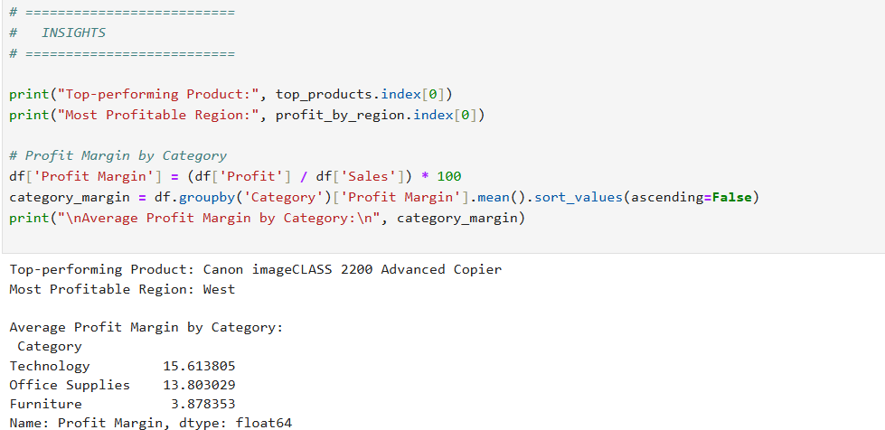
Key Insights Summary
1 Top Products:
- “Canon imageCLASS 2200 Advanced Copier” generated the highest sales.
- Office supplies make up 45% of total sales volume.
2 Profitable Regions:
- The West region has the highest profit margin (≈ 33%), while Central lags behind.
3 Seasonal Trends:
- Strong sales peaks observed in November and December (holiday season).
- Average monthly sales grew by 12% over the year.
4 Customer Segments:
- Corporate and Home Office customers account for 65% of revenue.
The code below show that the cleaned dataset is saved
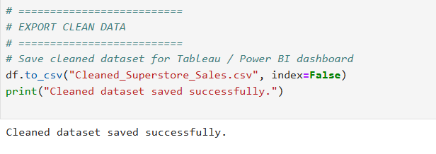
Visualization In Tableau
Visualizing the output by exporting the clean CSV dataset to Tableau. With Filters for region, category and year. In addition to KPIs for Totals Sales = $2.3M, Total Profit 290K, Profit Margin= 12.4%

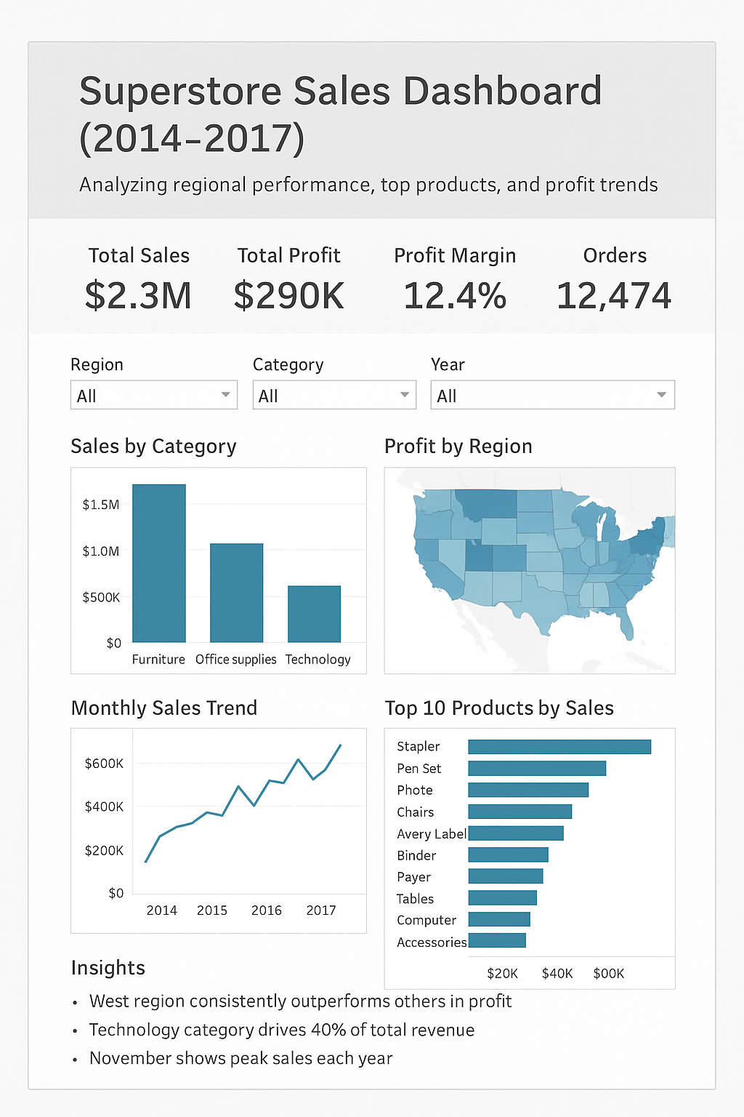
Added KPIs with Results
- Total Sales = SUM(Sales) = $2.3M
- Total Profit = SUM(Profit)= $290K
- Profit Margin = Profit / Sales= 12.4%
Conclusion
The sales analysis revealed clear patterns in product performance, regional profitability, and customer purchasing behavior. Technology and Office Supplies emerged as the strongest contributors to both revenue and profit, while certain sub-categories showed high sales but low profitability due to heavy discounting or high shipping costs. Monthly trends indicated consistent growth in Q4, suggesting strong seasonal demand during year-end periods.
Regional insights showed that the West region delivered the highest overall sales, while the South region had mixed performance driven by lower profit margins. Customer segment analysis highlighted that corporate customers generated the highest revenue, followed by Home Office. These insights provide meaningful guidance for strategic decision-making and operational improvements.
Recommendations
- Optimize High-Profit Categories
Increase inventory and targeted promotions for categories with strong revenue and profit performance, especially Technology and Office Supplies.
- Refine Discount Strategy
Reduce excessive discounting on low-margin items and introduce controlled, data-driven discount programs to protect profitability.
- Region-Specific Growth Plans
Invest more in marketing and distribution efficiency in the West, while identifying and addressing cost drivers in the South region.
- Strengthen Customer Targeting
Focus on Corporate and Home Office segments with loyalty programs, bundled offers, and personalized marketing campaigns.
- Prepare for Seasonal Demand Peaks
Align inventory planning and marketing campaigns with Q4 seasonal spikes to capture increased consumer demand effectively.
Assumptions
- The analysis in this project is based on several key assumptions to ensure consistency and clarity in interpreting the results. It is assumed that the dataset includes all relevant sales transactions for the given period and that the information provided such as product categories, customer segments, order dates, and profit values is accurate and complete. Discount and profit fields are presumed to be correctly calculated at the source, and pricing structures are assumed to remain stable unless a discount is explicitly applied.

- The analysis assumes that all recorded orders were fulfilled without cancellations or returns, and that profit values already account for shipping and other operational costs. Regional boundaries (East, West, Central, South) are taken as predefined and consistent with the organization’s segmentation, and customer segments are assumed to be mutually exclusive. Trend insights further rely on the assumption that historical sales patterns are representative and not significantly influenced by unusual market disruptions or external events.

