**Padmalochan Mahakud**

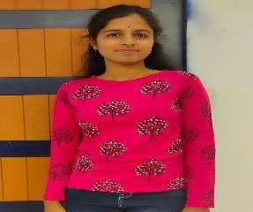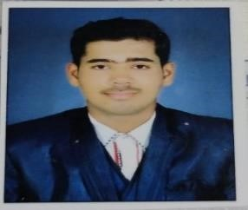

**Email – padmalochan13598@gmail.com**

**Address – Sahajapad,markona,Balasore (Odisha)**

**Contact - 6370227059**

# PROFESSIONAL SUMMARY

Highly skilled and dependable Java developer seeking a position at a top-tier software company. My extensive experience includes a deep understanding of Core Java. I aim to leverage my technical expertise and analytical abilities for professional growth. Technically adept and an analytical problem solver with a composed and focused attitude.

# TECHNICAL SKILLS

•

**JAVA**

Good in OOPS Concepts, Good in Array and String, Exception handling,File handling, Interface Good in

Collection and Multithreading,java 8 fetures,J2EE module,JDBC,Servlet & JSP.

Basic knowledge in Framework like SpringBoot .

## • HTML

HTML basic knowledge and how to make table & chat and semantic markup using various tags.

## • CSS

## Experience optimizing layouts for cross-browser compatibility and performance. Align and distribute items

## within container using flex properties.

## • Databases

## ORACLE ( SQL language ) CURD operation

# EDUCATION

**BPUT -** Master in Computer Application with 70%

**FM UNIVERSITY –** BSc. Physics with 72%

**Simulia junior college-** Intermediat**e** with 60%

# SKILLS

* Engaged listening
* Guidance
* Collaboration
* Interpersonal communication
* Critical thinking
* Leadership

# PERSONAL DETAILS -

D.O.B. : 13/05/1998

Gender : Male

Language :English,Hindi,odia