Project Objective
The objective of this project is to analyze an e-commerce product dataset to:
- Understand product popularity, pricing, and value-for-money patterns
- Identify top-performing brands, categories, and product series
- Build a machine learning model to predict whether a product is popular based on its attributes
- Present insights through an interactive Power BI dashboard for business decision-making

Data Collection Method
- Data of category laptops was scraped from an open and scraping-friendly e-commerce test website (webscraper.io)
- Python libraries used:
  - requests and BeautifulSoup for data extraction
  - pandas for data storage and manipulation
- Extracted fields include:
  - Product name
  - Price
  - Rating
  - Number of reviews
The scraped data was stored in a pandas DataFrame and later exported as CSV for dashboarding after performing the Exploratory Data Analysis in python.

Data Cleaning & Feature Engineering
Several cleaning and preprocessing steps were performed to make the data analysis-ready:
🔹 Cleaning Steps
- Removed duplicate rows, special characters and inconsistent formatting from product names
- Parsed product names to extract:
  - Brand
  - Series
- Handled missing and inconsistent category labels
- Standardized category names (Consumer, Business, Gaming, Premium, Convertible)
🔹 Feature Engineering
- Popularity (Target Variable):
  - Defined using review count (products with higher reviews classified as popular)
- Value Score:
- value_score = rating / price
- Scaled Value Score:
  - Applied MinMaxScaler for better interpretability and modeling
- Created derived fields such as:
  - Product category
  - Brand-series grouping

Exploratory Data Analysis (EDA) – Key Findings
- Category Insights
- Consumer laptops dominate the platform
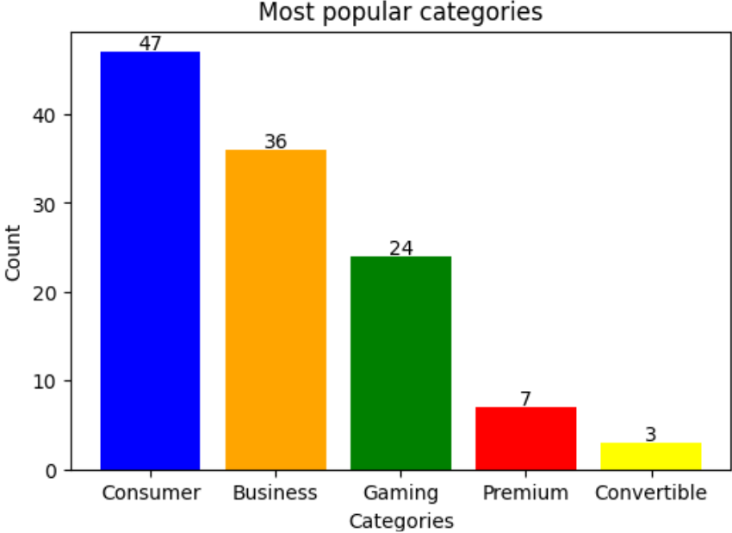
- Gaming and Premium categories have fewer listings but higher prices
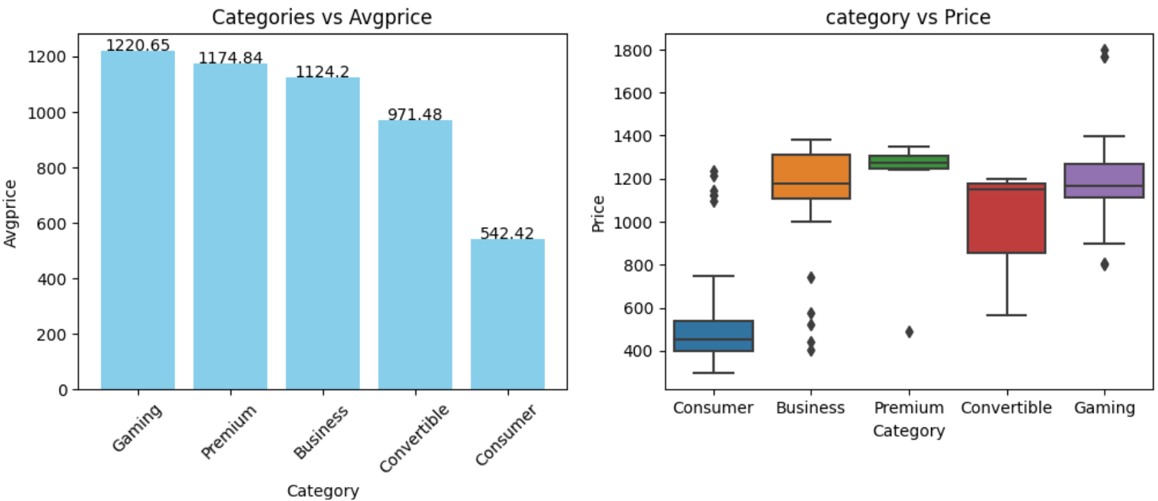
- Despite similar average ratings across categories, the box plot reveals that Convertible products have the tightest and most consistent customer satisfaction range.
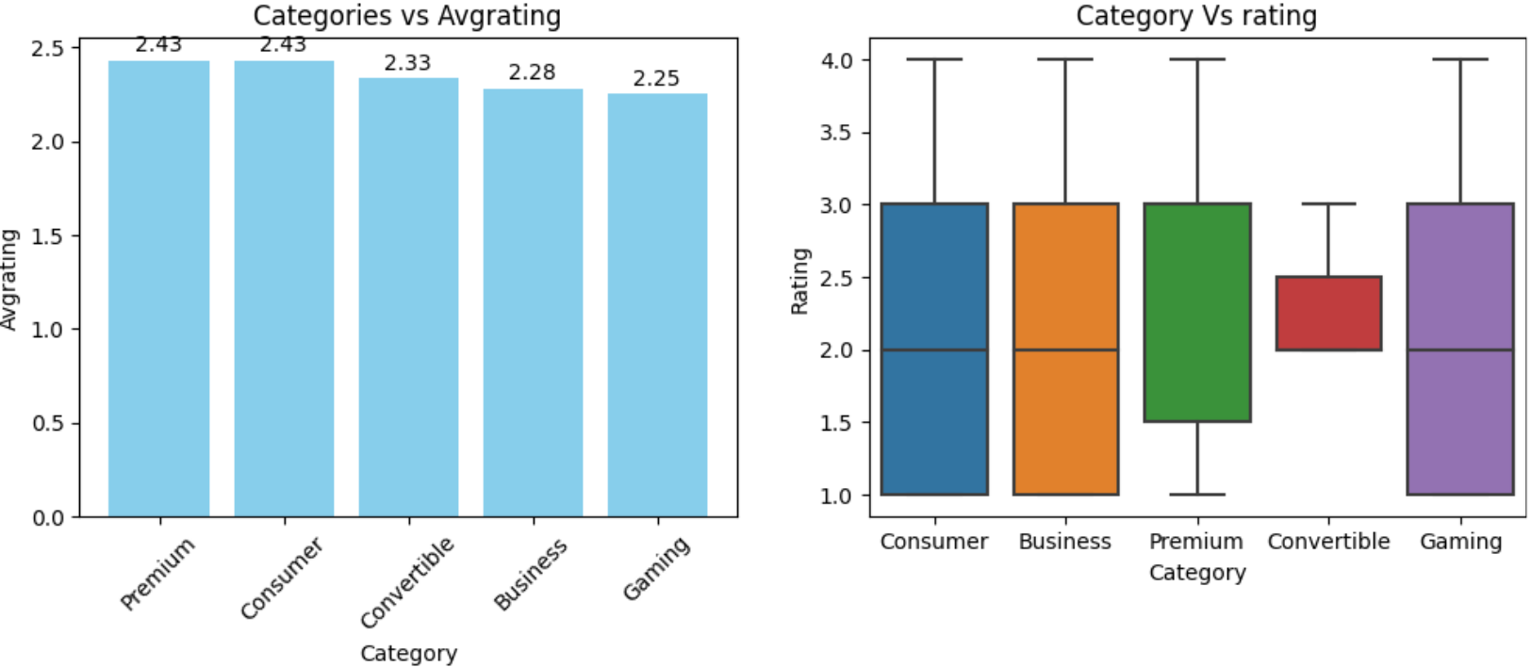
- Consumer segment has got highest engagement. Box plot suggests that Business laptops demonstrate high and consistent customer engagement, rivaling Gaming in median reviews but outperforming it in reliability and spread.
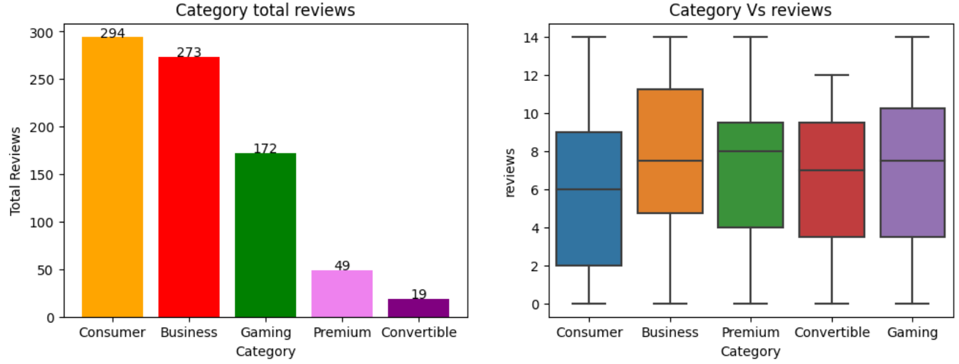
- Consumer category shows strong value-for-money positioning.
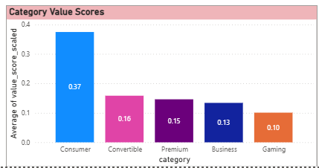
- Brand Insights
- Acer, Lenovo, and Dell have the highest product presence
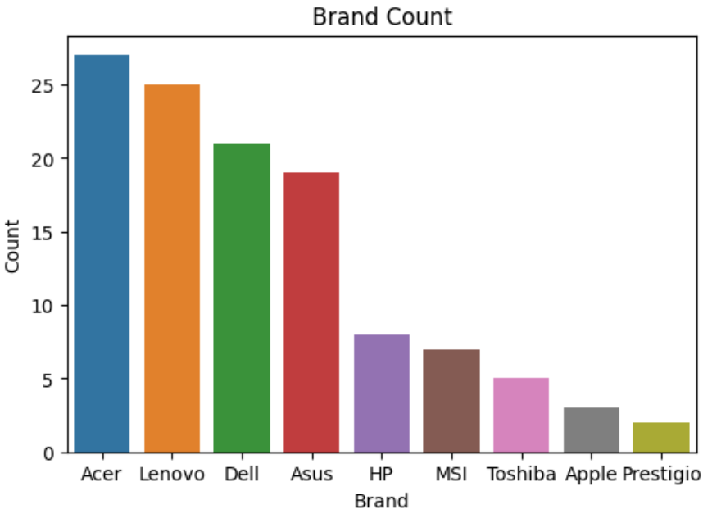
- Apple stands out with the highest median price around 1300 indicating a premium pricing strategy and consistent high-end positioning. Prestigio has the lowest price range centered around 400 making it the most affordable brand in the comparison. Asus spans from 400 to $1800 suggesting a diverse product lineup—from entry-level to high-performance models.
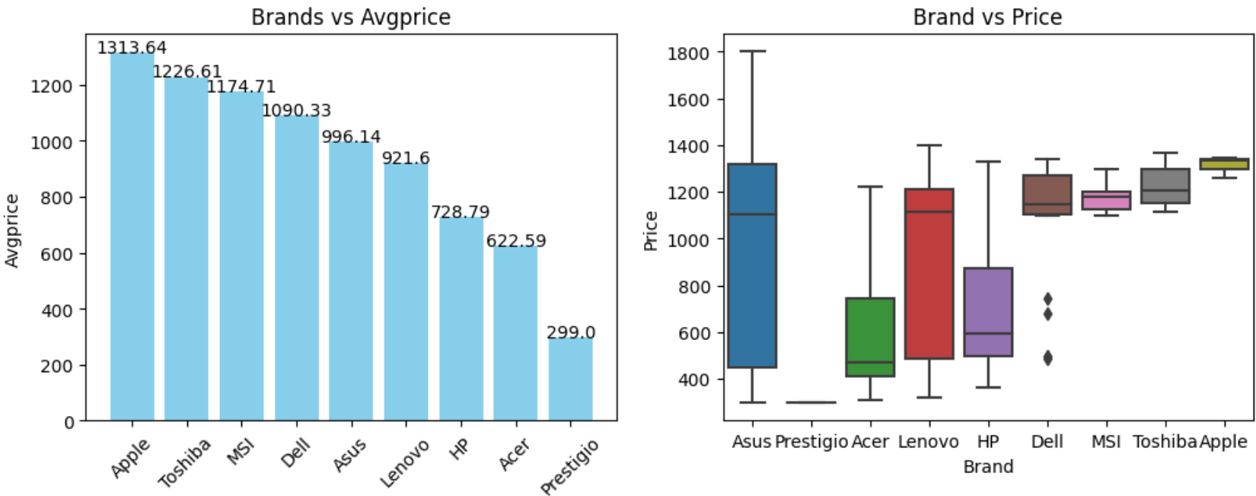
- Prestigio Leads in Customer Satisfaction Despite Low Pricing. It shows the highest median rating among all brands, even though it typically operates in the lowest price segment. This suggests that affordability doesn't compromise perceived quality — users are highly satisfied with Prestigio products relative to their cost.
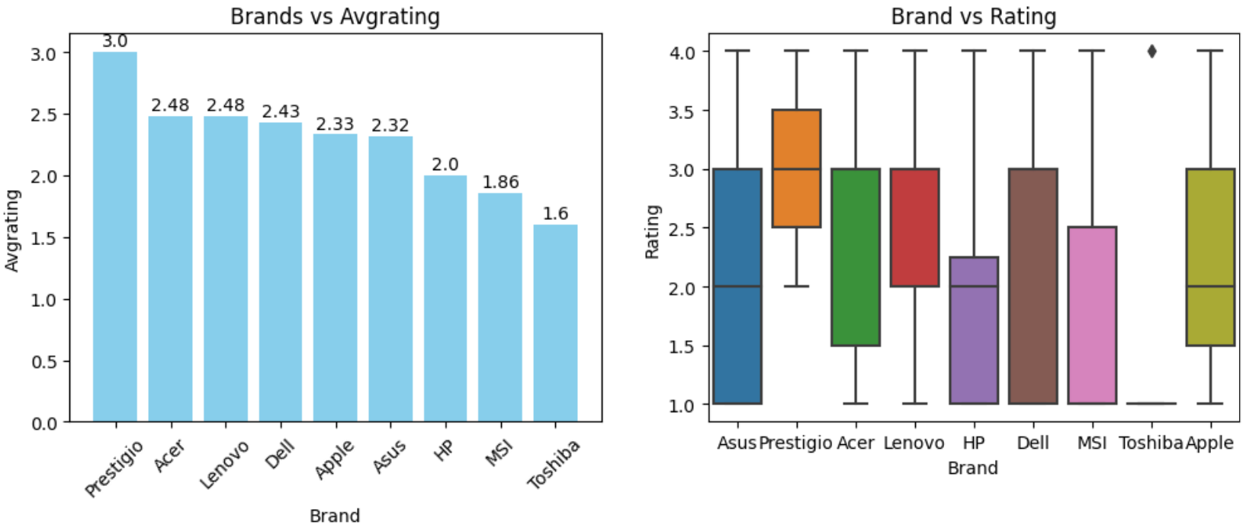
- Lenovo leads in total reviews, indicating strong engagement. Boxplot suggests Prestigio has a high median review count with a tight interquartile range, meaning most of its products consistently receive more reviews than other brands.
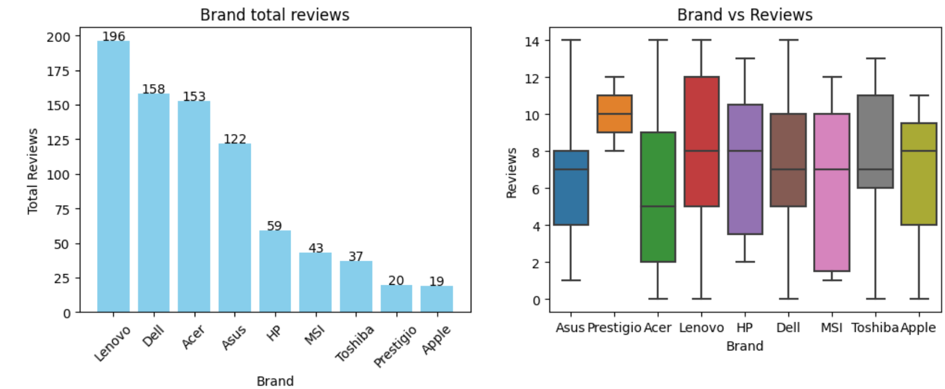
- Prestigio shows strong value-for-money positioning
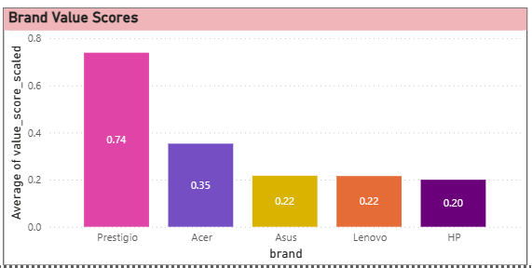

- Price, Rating & Reviews
- Higher-priced products do not always receive higher ratings
- Popularity is more strongly linked to review volume than rating alone
- Value_score varies significantly across brands and categories
- Correlation Analysis
- Weak correlation between price and rating
- Weak correlation between price and reviews
- Moderate relationship between reviews and popularity

Model Performance
- Problem Type
- Binary Classification: Predict whether a product is popular or not popular
- Models Evaluated
- Logistic Regression
- Decision Tree
- Random Forest
- Gradient Boosting
- Evaluation Strategy
- Initial Train–Test split
- Improved using Stratified K-Fold Cross-Validation (5 folds)
- Metric used: F1 Score (balanced precision and recall)
- Optimization Process
- GridSearchCV with 5-fold stratified cross-validation was applied to the Random Forest classifier to explore optimal hyperparameter combinations.
- The tuned model achieved comparable F1 performance to the baseline model but did not result in a significant improvement, indicating that the original configuration was already well-generalized.
- This outcome highlights the stability of the baseline model and confirms that additional model complexity did not yield meaningful performance gains for the given dataset and target formulation.

- Final Cross-Validated Results
Model | Mean F1 Score
Decision Tree | 0.65
Random Forest | 0.60
Gradient Boosting | 0.59
Logistic Regression | 0.57
- Interpretation
- Moderate performance is expected due to:
  - Small dataset size
  - Popularity being derived from reviews (limited signal)
- Cross-validation provided a more reliable estimate than a single train-test split

Key Business Insights
- High product count does not guarantee popularity
- Brands with competitive pricing often achieve:
  - Higher value_score
  - Better popularity
- Popularity is influenced more by:
  - Product visibility and engagement
  - Price accessibility
- Premium-priced products require strong branding or differentiation to succeed

Recommendations
- For Business Teams
- Focus on value-for-money positioning rather than price alone
- Increase visibility for mid-priced, high-rating products
- Optimize pricing strategies by category
- For Data & Product Teams
- Collect additional features such as:
  - Specifications
  - Discounts
  - Seller ratings
- Use larger datasets for improved model performance
- Consider regression models for price optimization in future work

WebScraping Code
url = "https://webscraper.io/test-sites/e-commerce/static/computers/laptops"
response = requests.get(url)
soup = BeautifulSoup(response.text, "html.parser") # converting raw html data into structured format
products = soup.find_all("div", class_="thumbnail")
base_url = "https://webscraper.io/test-sites/e-commerce/static/computers/laptops?page="

data = []

for page in range(1,21):
url = base_url + str(page)
response = requests.get(url)
soup = BeautifulSoup(response.text, "html.parser") # converting raw html data into structured format
products = soup.find_all("div", class_="thumbnail")

if not products:
break

for product in products:
# extracting product name
#name = product.find("a", class_="title").text.strip()
product_tag = product.find("a", class_="title")
name = product_tag["title"].strip()

#extracting product price
price = product.find("span", itemprop="price").text.strip().replace("$", "")

#extracting rating
rating_tag = product.find("p", attrs={"data-rating": True})
rating = int(rating_tag["data-rating"]) if rating_tag else 0

#extracting product reviews
reviews = product.find("span", itemprop="reviewCount").text.strip()

data.append([name, float(price), rating, int(reviews), "Laptop"])

df = pd.DataFrame(data, columns=["product_name", "price", "rating", "reviews", "category"])

Dashboard Screenshots
- KPIS & Bookmark Links
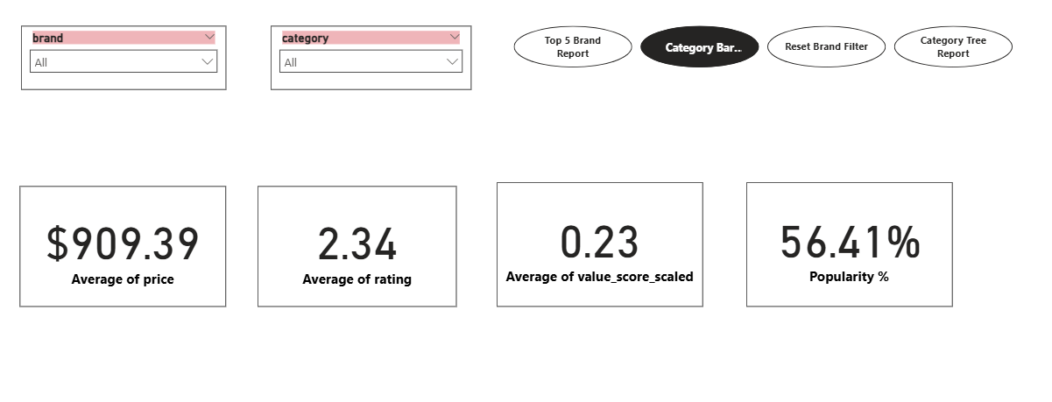
- Brand Report
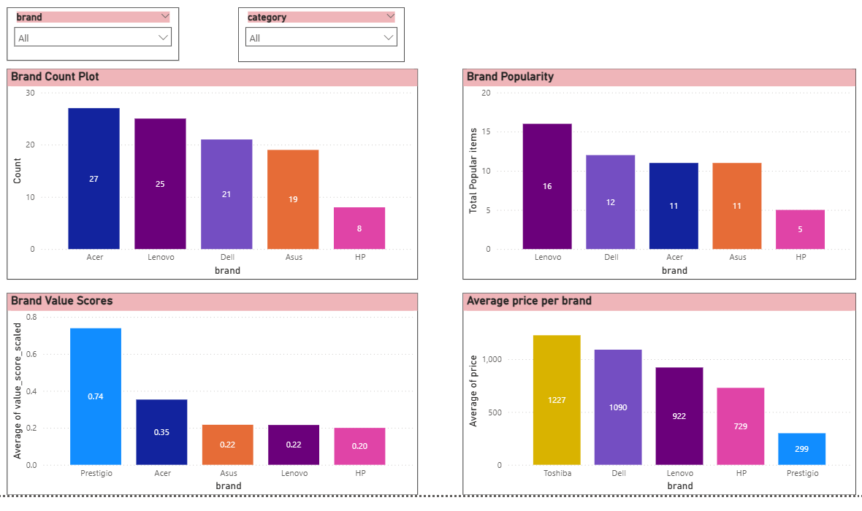
- Brand Takeaways
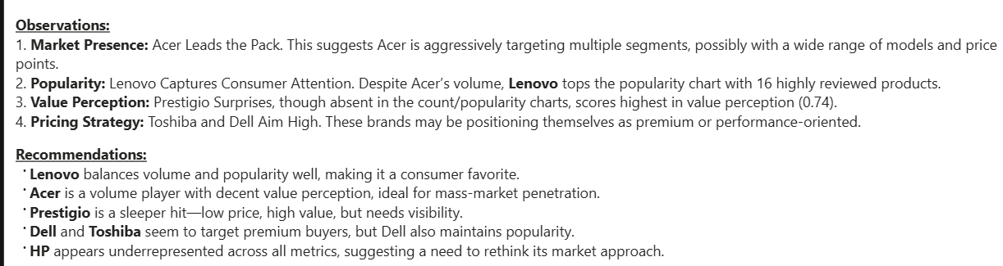

- Category Report:
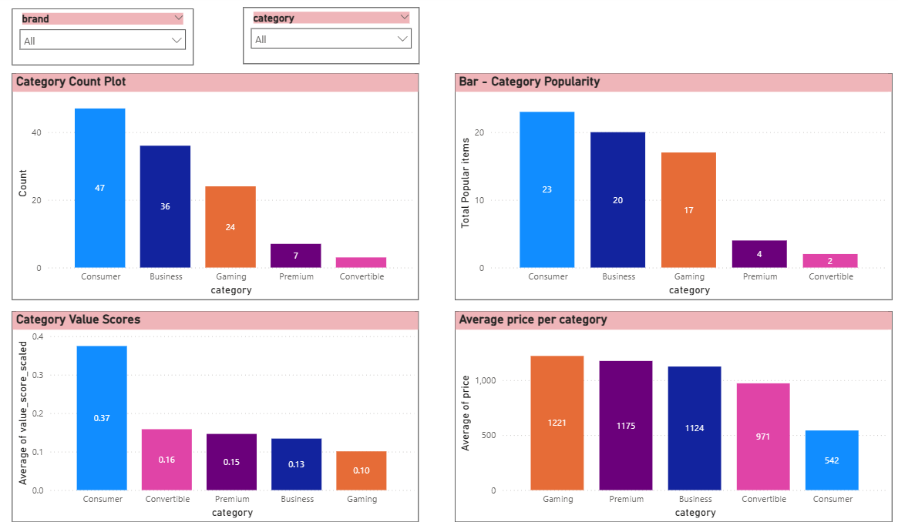

- Category Takeaway:
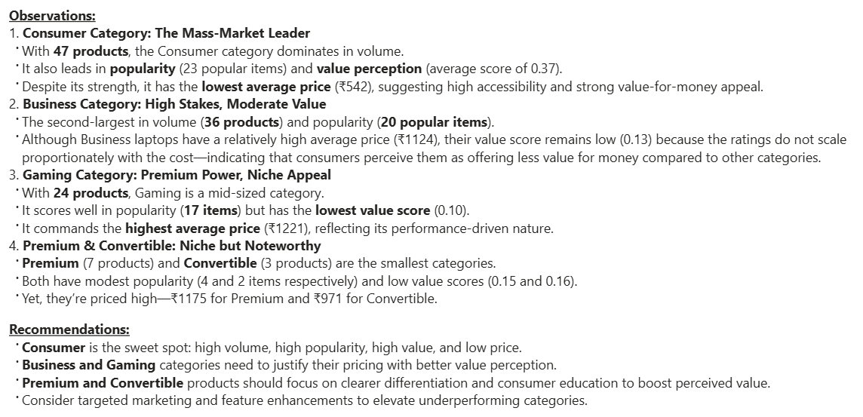

- Correlation Plots:
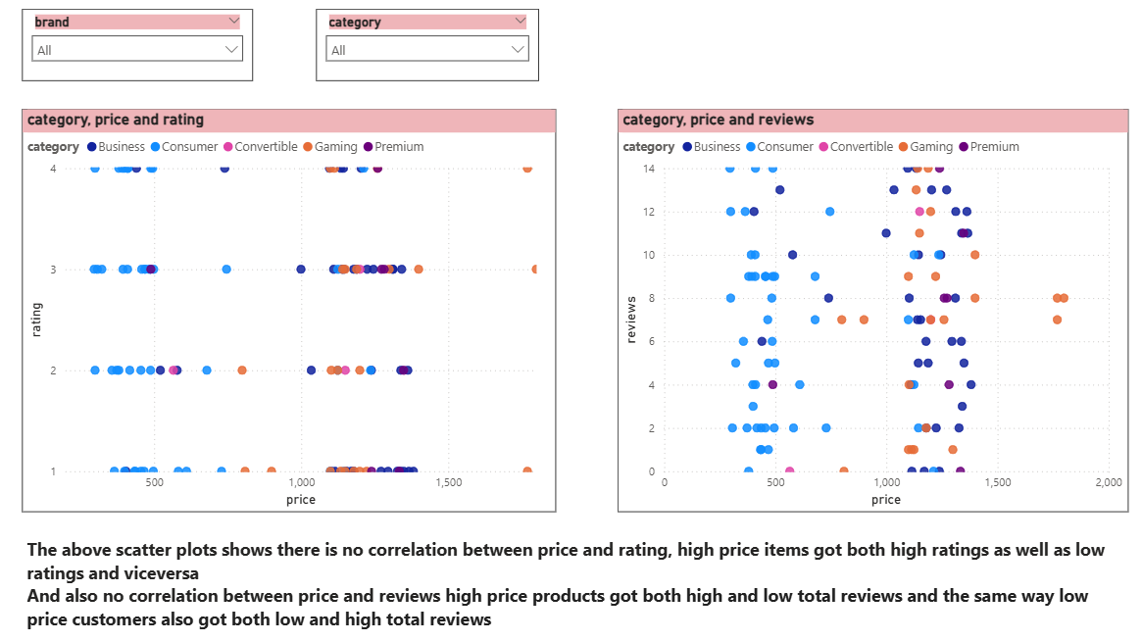
- Clustered Column Chart:
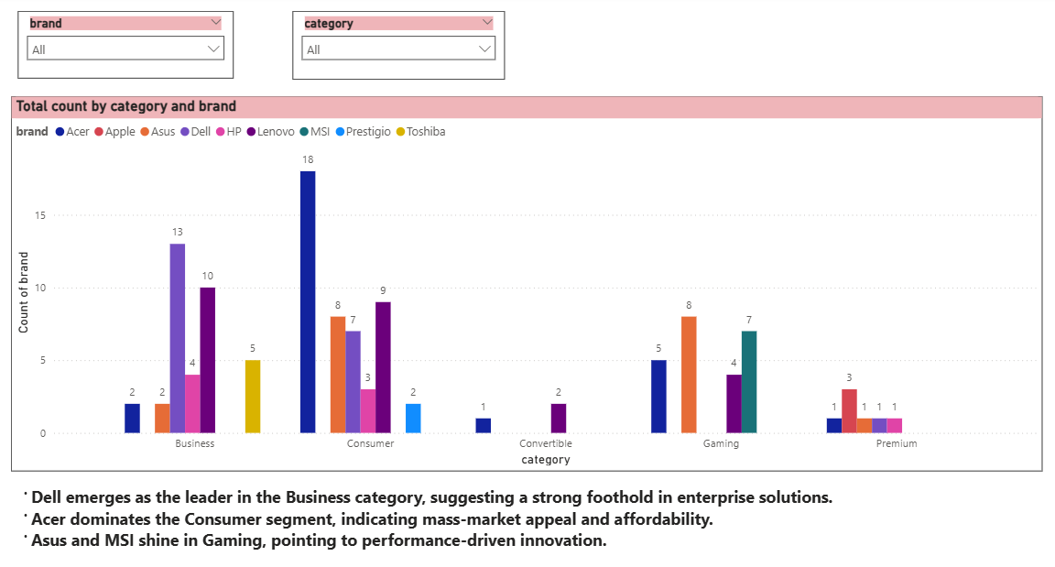
- KeyInfluencer AI Visual:
In this chart I have tried to analyze popularity based on the following fields
- Price
- Rating
- Value_Score
- Reviews
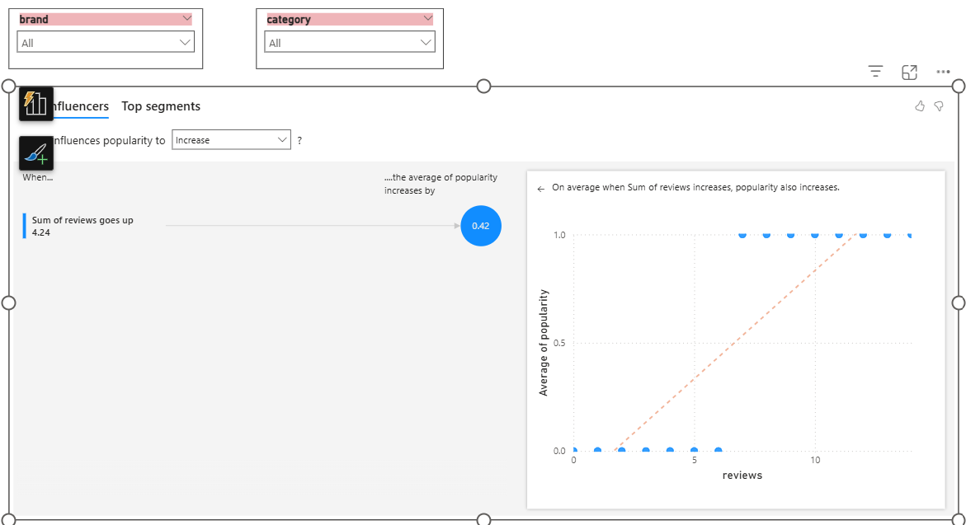
Among all the analyzed fields — Price, Rating, Value_Score, and Reviews — only Reviews show a meaningful relationship with Popularity. Specifically, when the sum of reviews increases by 4.24, the average popularity rises by 0.42. This suggests that higher customer engagement through reviews tends to boost perceived popularity.
- Decomposition Tree AI Visual:
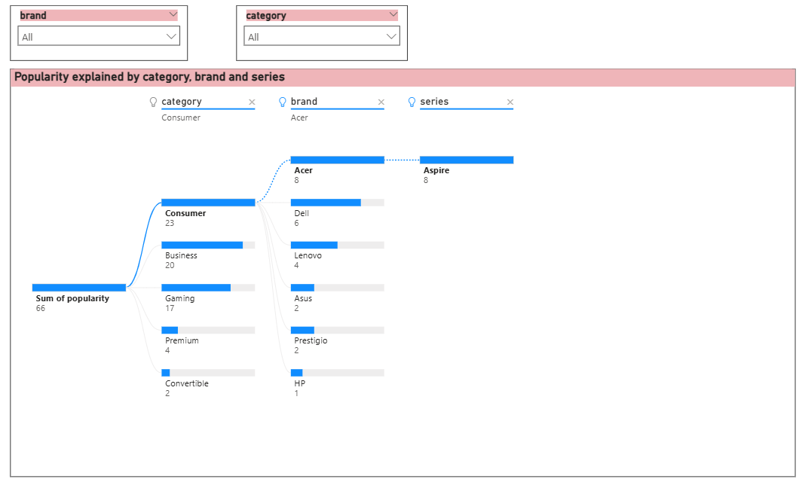

- Bar Chart (ML Problem Chart)
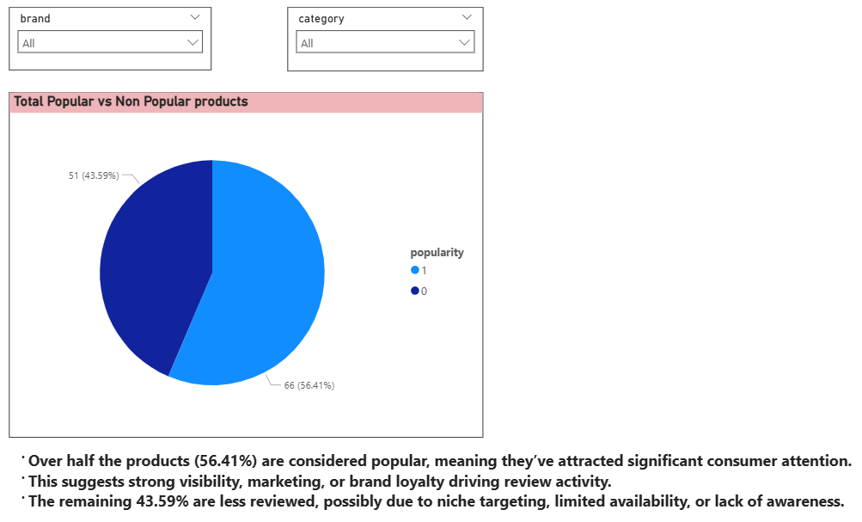
- Drill Through Page:
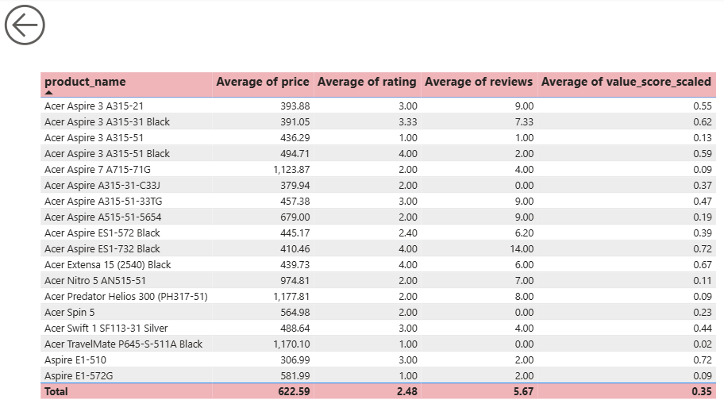
- Role Manager:
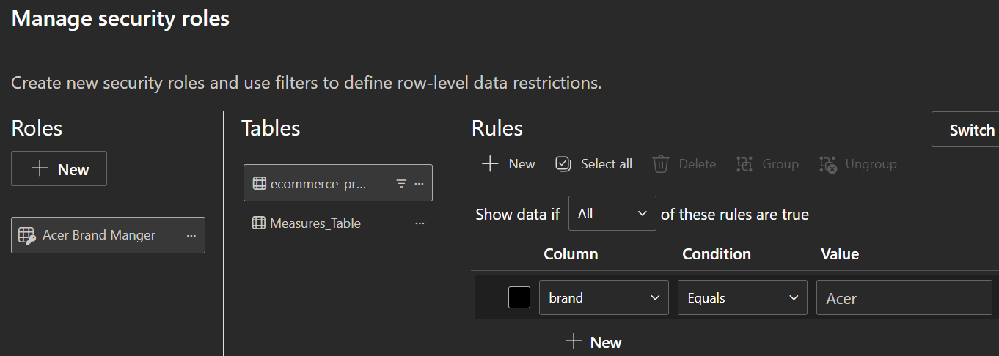
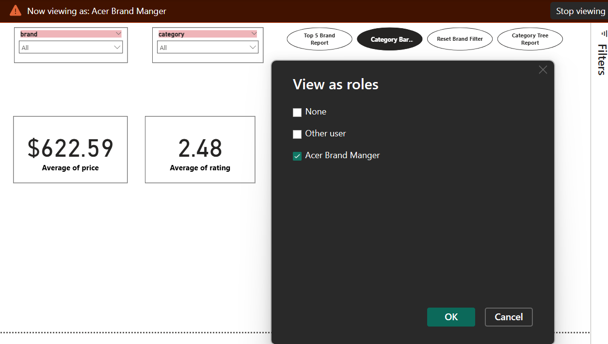

Project Video Link
- Webscraping and EDA (Video Part 1):
https://www.loom.com/share/702ebfaa0b1348afb1467b819bcbe6e2
- Modeling, Interactive Dashboard and Project report (Video Part 2):
https://www.loom.com/share/a7025b95781b489d86d123e09cfd1c5b

