**CSE 5351 Parallel Processing – Lab1- Summer 2018**

Padmavati H. Channal Student id: 1001398166

Hi Professor,

The zipped folder consists of three files:

* Tree-based-add.c
* Matrix_strip.c
* Data.txt

**Solution 1**: For problem 1 in <http://ranger.uta.edu/~sjiang/CSE4351-5351-summer/lab1.pdf>

🡪 **compiles and executes properly**

🡪 Gives right data irrespective of any no. of processes

🡪 Solution is sum of the sums displayed.

Ex: When you execute with 4 processes: result is like below. Answer is 3 +3. I have just displayed all Process’s sum.

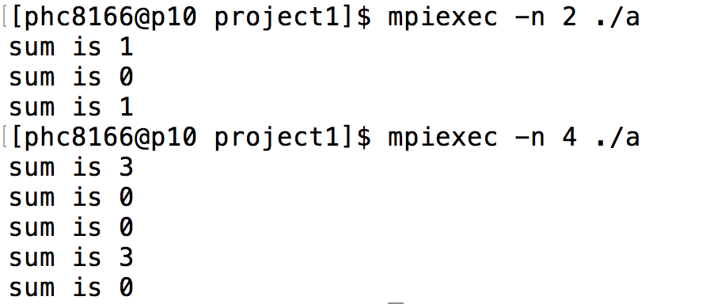

**Solution 2**: For problem 1 in <http://ranger.uta.edu/~sjiang/CSE4351-5351-summer/lab1.pdf>

**🡪compiles and executes properly**

**🡪** I have displayed the result on screen

🡪 As I had asked question to you with respect to output file & clarified with you: I am displaying result on screen instead of writing it in file matrix_result.txt