**Eidiko Systems Integrators – CONFIDENTIAL **

APP Connect Enterprise – Activity Log Enhancements

### Activity Log Enhancements

**Purpose:**

IBM App Connect Enterprise (ACE) 12 was the latest version available. Enhancements to activity logging in ACE 12 primarily focus on providing improved visibility, traceability, and monitoring capabilities for integration flows running on the platform.

You can configure the destination of activity log output and apply filtering to the entries that are written in 2 ways.

1. By deploying an Activity Log policy.
2. By setting properties in the ActivityLog section of the server.conf.yaml file.
3. **Activity Log policy:**

Activity Log policy is used to control the data that is written to the activity logs, and to control how the logs are written to a file.Activity logs contain information about message flows and how they interact with external resources.

They can be generated for a message flow or a resource type. The data in your activity logs is organized into columns, and you can use tags to filter data and to provide additional information. You can use an Activity Log policy to control, at run time, where you write your activity logs, what data you write to them, and whether the logs are formatted.

You can change the activity log by redeploying the policy. If you redeploy an Activity Log policy that changes the value of the **File name** property, the existing activity log is deleted and a new activity log is created.

Properties of the Activity log policy is shown in below.

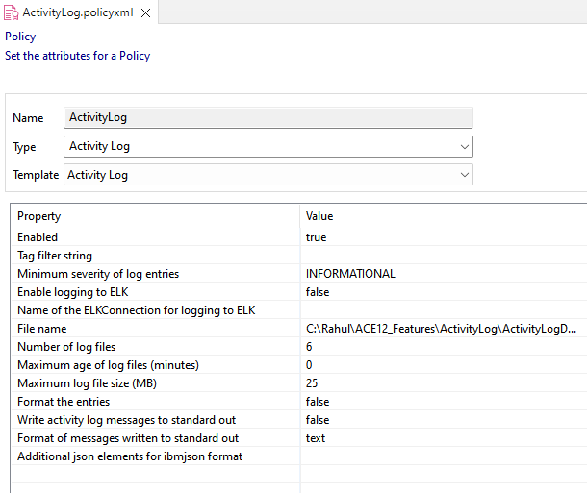

In this policy, mention the file name with path in **File name** property. After that deploy the policy and application. The Activity logs are stored in file like as shown in below.

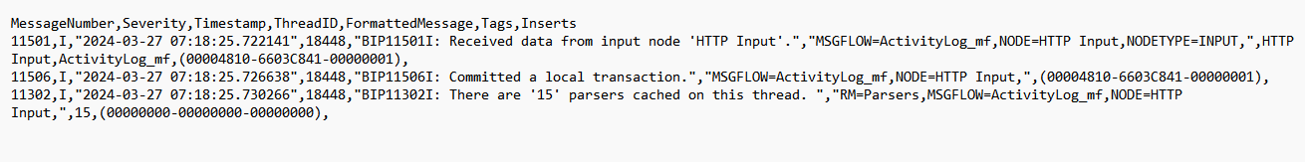

# **Configuring activity log output:**

Configure the output of an activity log by setting properties in the Activity Log section of a node.conf.yaml or server.conf.yaml configuration file.

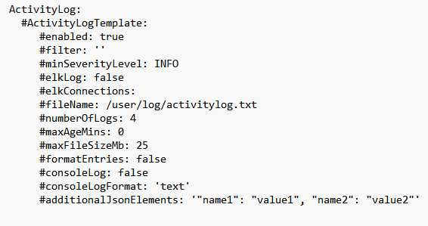

Enable the properties in server.conf.yaml file with the help of **Activity Log Policy.** After enable the properties, the server.conf.yaml file is shown in below.

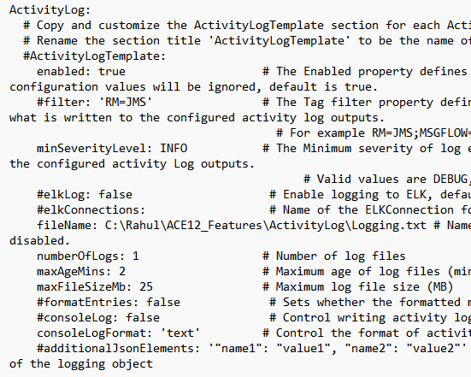

After that restart the integration node and deploy the application. The Activity logs are stored in file like as shown in below.



For more Reference,

https://www.ibm.com/docs/en/app-connect/12.0?topic=wniv1-new-function-added-in-version-120-modification-packs-fix-packs#v120110__log_node

**Prepared By,**

**Shaik Rahul**