**Eidiko Systems Integrators – CONFIDENTIAL **

APP Connect Enterprise – Scheduler Node

**Scheduler Node**

Purpose:

Scheduler node is used to configure a message flow to run at specified intervals of time, or at specified times on specified days.



Terminals:

1. Failure
2. Out
3. Catch

Properties:

The Scheduler node has two different modes of operation that you can choose by selecting the appropriate options in the Basic tab. The available modes of operation are

1. Repeat interval
2. Calendar
3. Repeat interval:

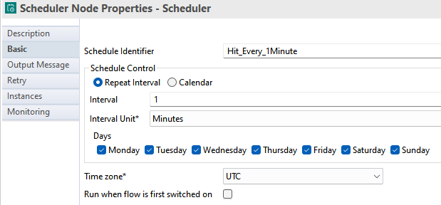

1. Calendar:

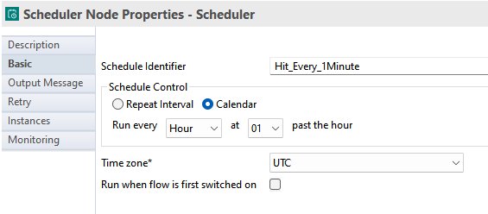

Output Message Property:

Output Message property is controls which message format is propagated to the flow. The options are

* Scheduler format
* Timeout notification node format
* Message Assembly file

Message Assembly File:

In message assembly file, type in the full path name for a file, or click to either select a message assembly file from your local file system, or click the link to create a new message assembly file.

Flow Behaviour:

Create an application and create a messageflow for scheduler node and give the properties as like shown below.

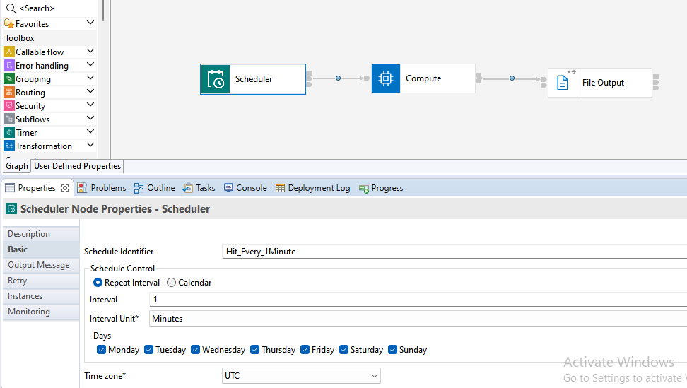

In this task, the flow is trig for every one minute. Its works same like Timer Notification Node. But in scheduler node, some features are added like type of mode and mention the days. In case don’t mention the days by default every day flow will trig.

**Prepared By,**

**Shaik Rahul**