**Unit Test Cases**

You can use the IBM App Connect Enterprise Toolkit to create a test case for a message flow node, either from a recorded message flow or by using XML or JSON files to generate input or output message assembly files.

Take a simple HTTP Flow to perform Unit Testing.

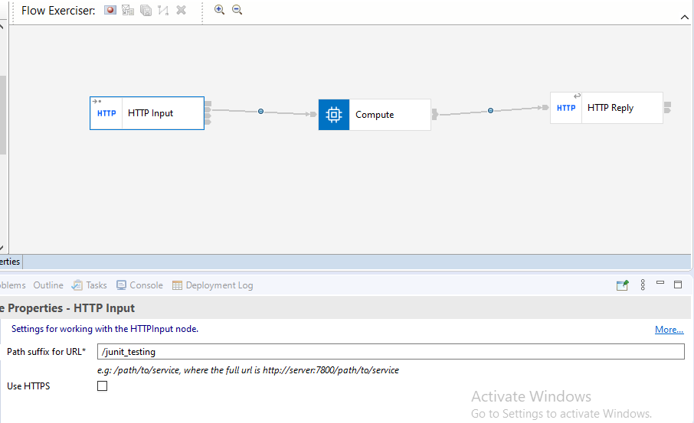

Here we are giving the XML message as input.

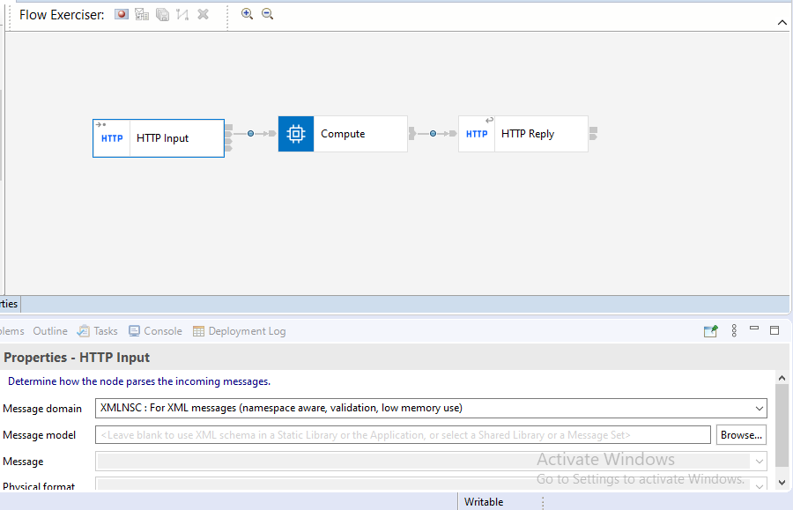

In this Compute Node transforming the XML message JSON message.

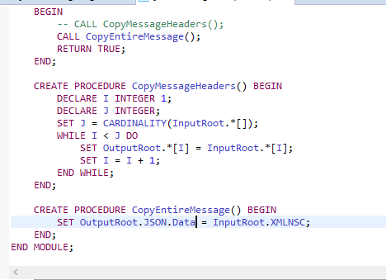

Start the **Flow Exerciser** and **deploy** the Application.

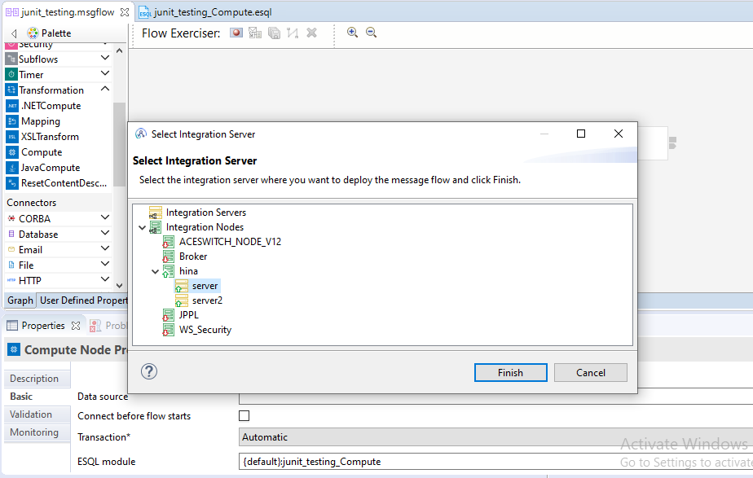

Right click on **Recording** and **send the input message.**

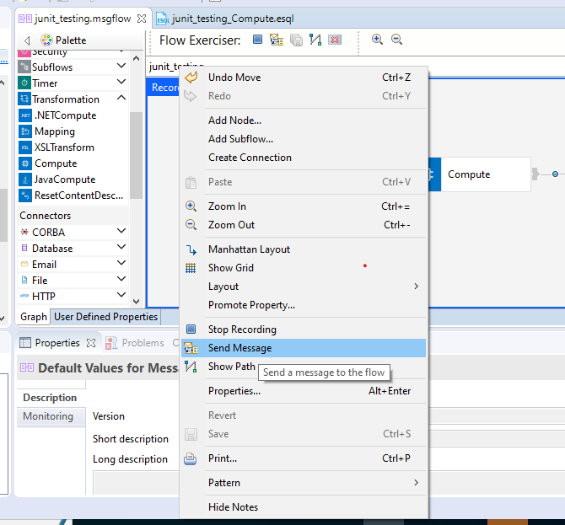

Select the **Input message** and add **new** message.

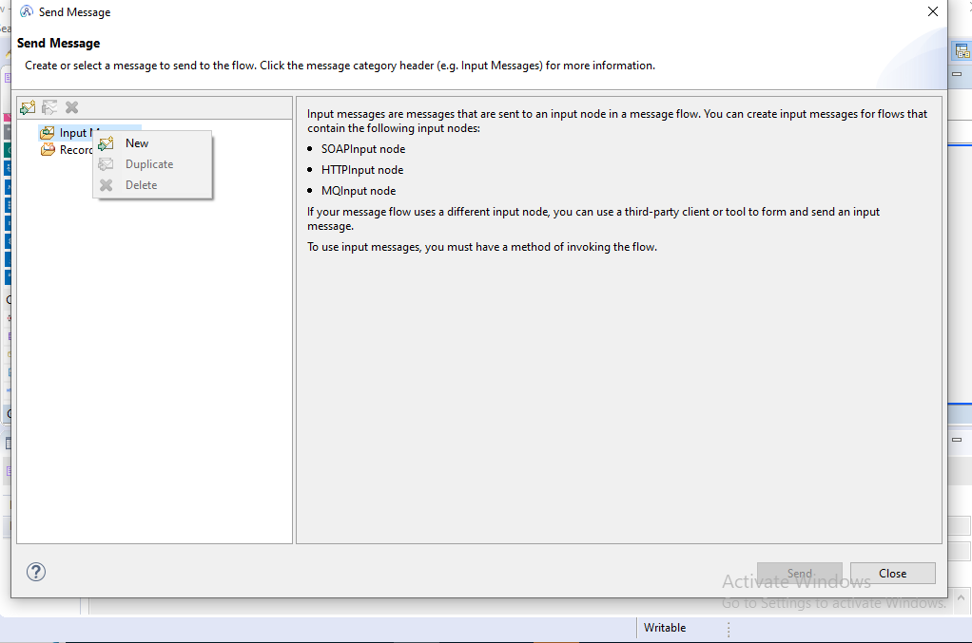

Give the Input as XML message. And click on **send** option.

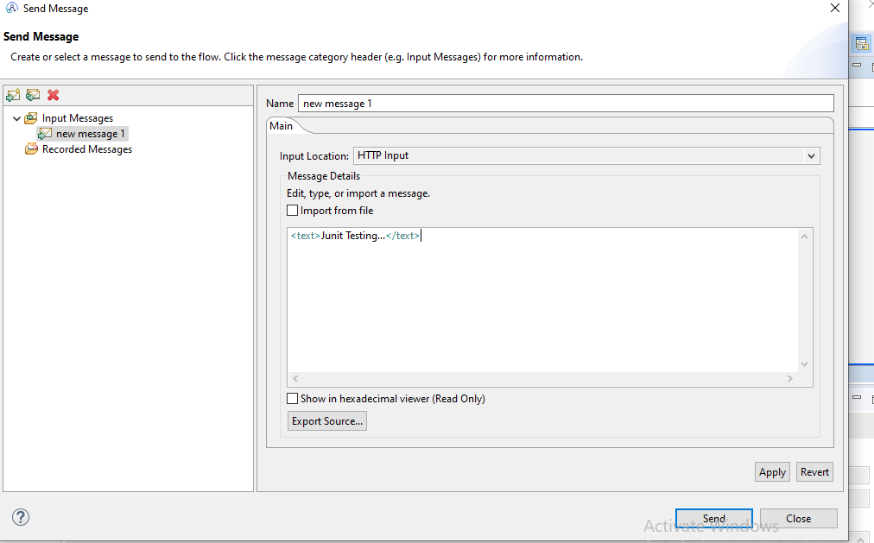

In below step copy the **Input message** in a separate file.

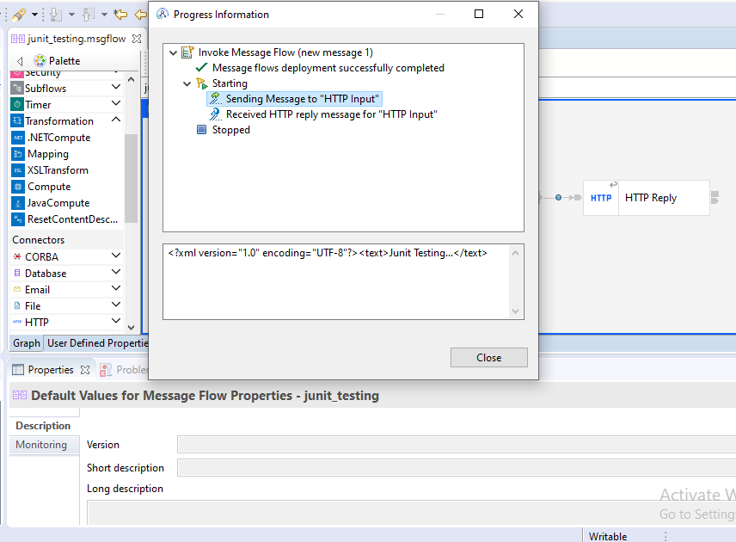

In below step copy the **Output message** in a separate file.

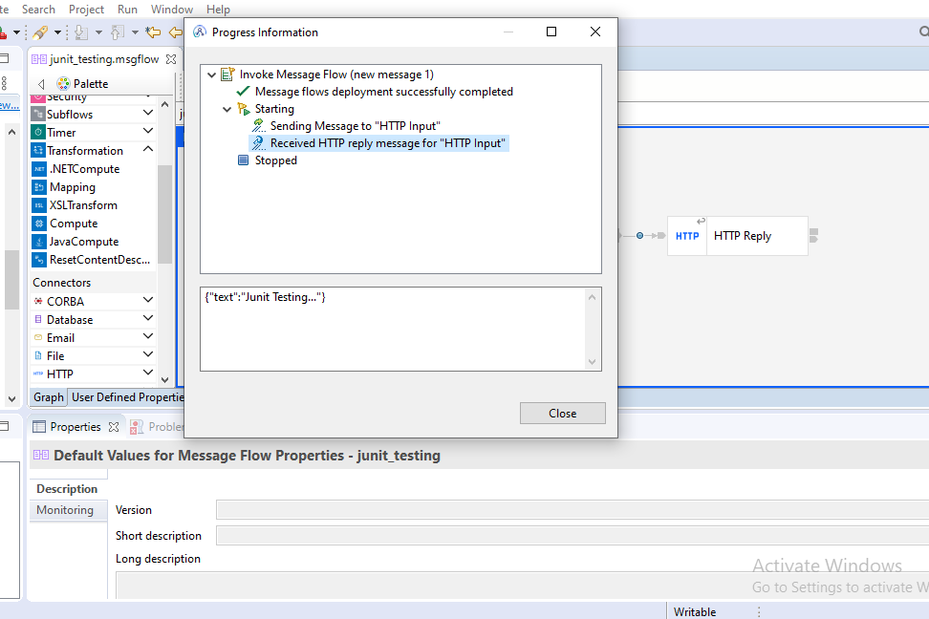

Stop the Recording in **flow exerciser.**

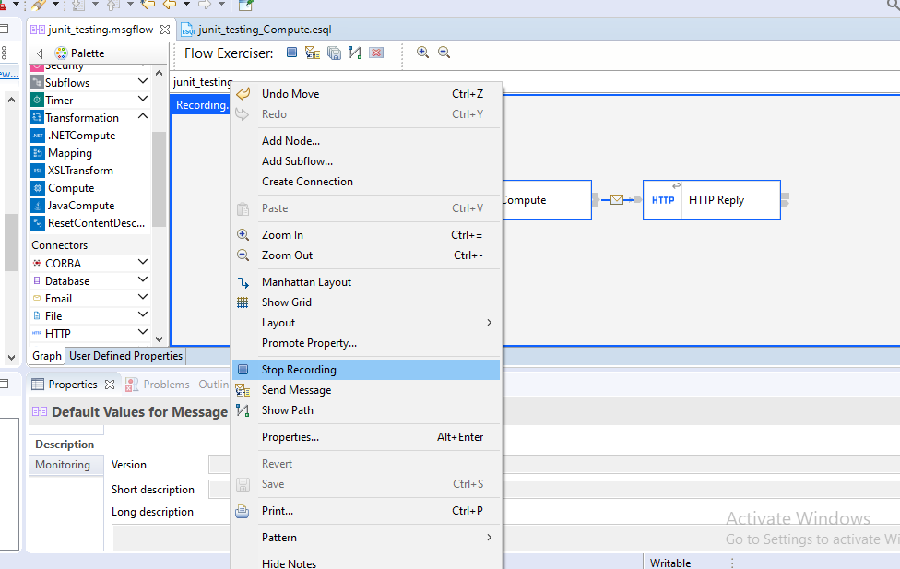

Right click on Compute Node and select **Create Test Case.**

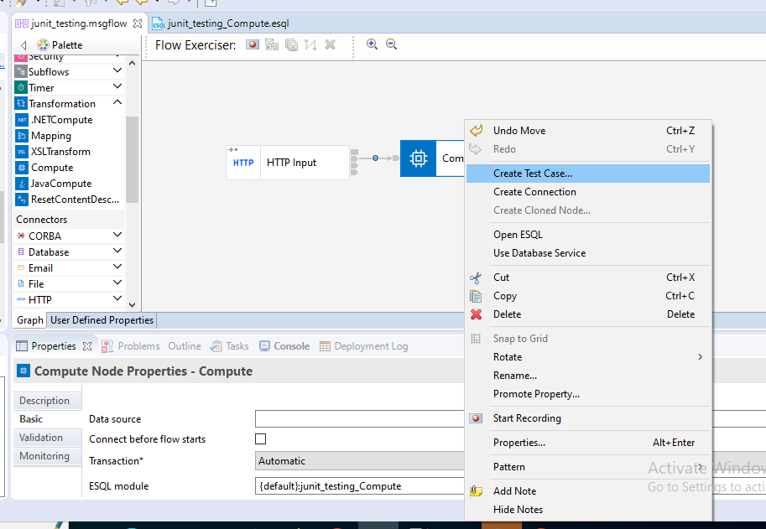

It will generate the below test case.

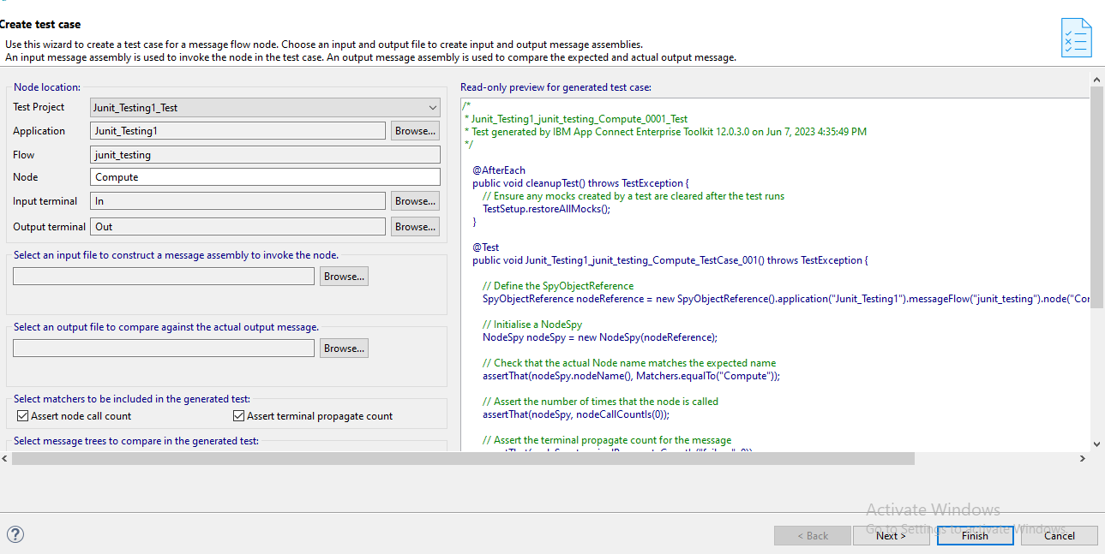

In this step browse the Input and Output files , Which we have already saved in the above step.

And click on **Finish**.

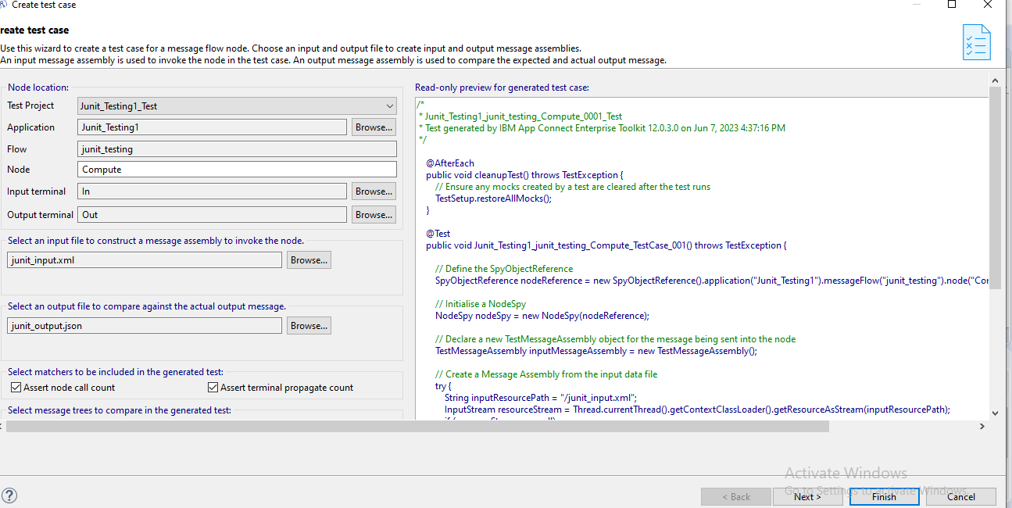

It will generate the one java file , message-flow name with .java extension. And right click on that java project and select **Run as Java Project.**

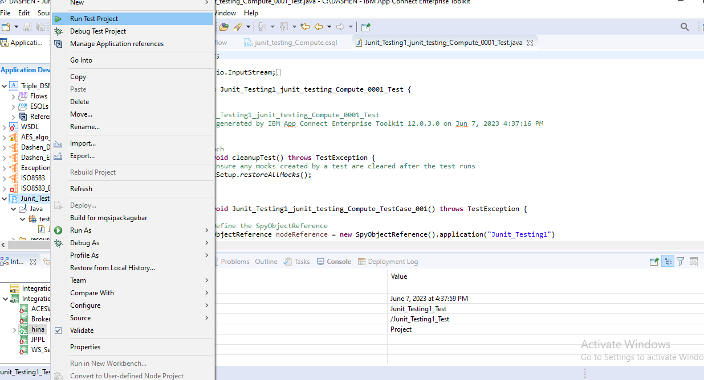

Here we are testing for the success scenario.

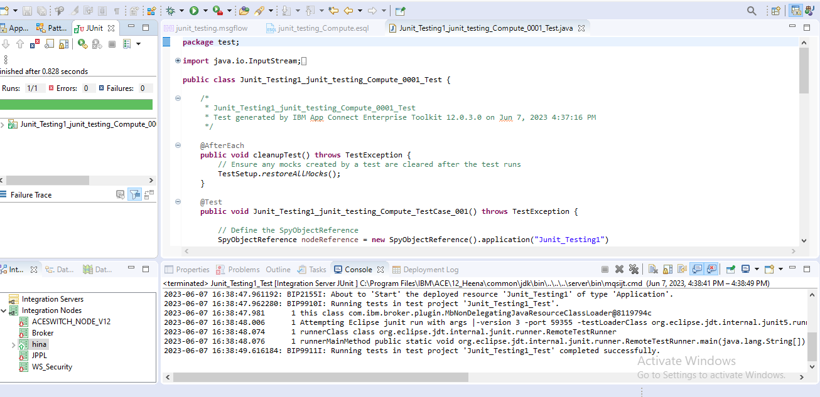

For testing failure case we removed json in the esql code.

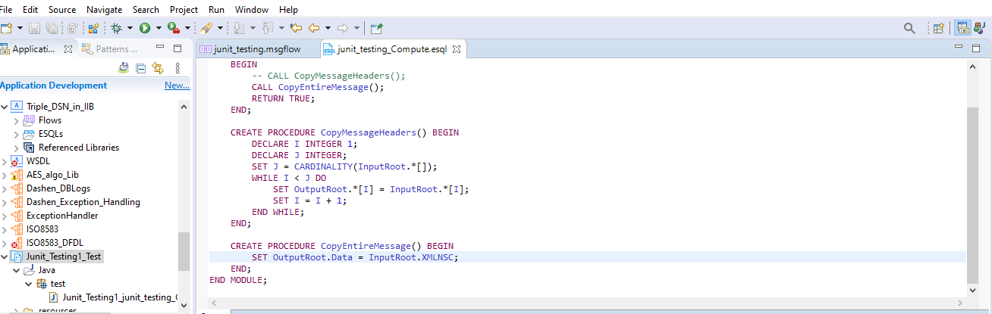

And right click on that java project and select **Run as Java Project.**

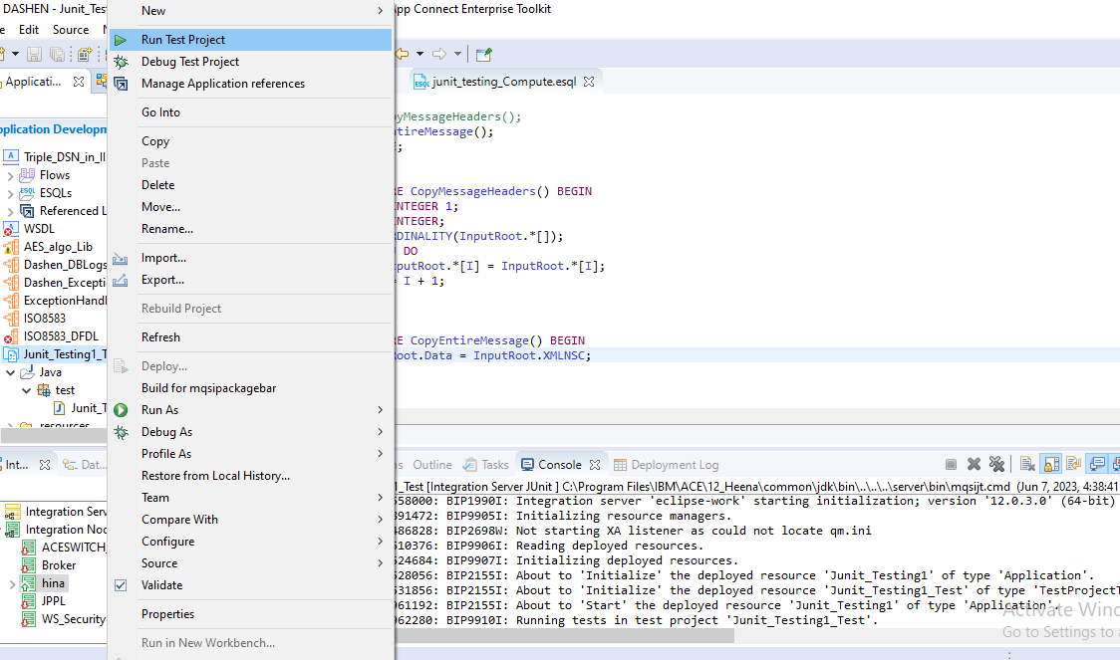

We got the response as failure.

