

unit tests cases

* We can create and run unit tests while you are developing your message flows and nodes, or you can create and run tests for flows that have already been deployed, by generating tests in bulk from messages that were recorded as they passed through a message flow.

## Procedure :-

following steps to create a test case for a message flow node by using messages in a recorded message flow:

* Create the  simple message flow consisting of HTTP input and reply nodes, and a Compute node.
* using the Flow Exerciser to record the flow of messages through the

message flow.

* When messages have been sent through the flow, you can create a test case using the messages that were recorded by the Flow Exerciser.

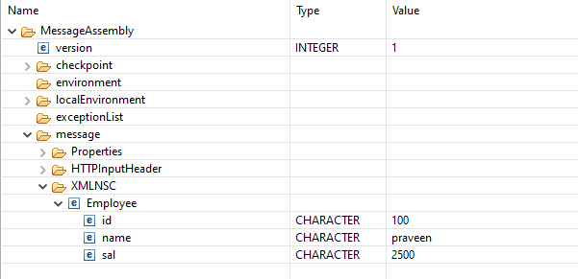

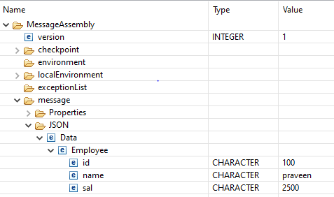

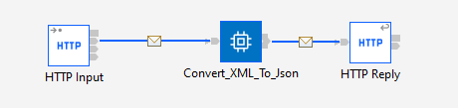

* After that right-click the Compute node in the message flow and click **Create Test Case**

.

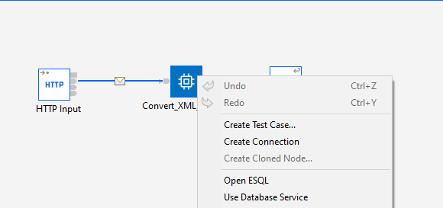

* The **Create Test Case** dialog is displayed, containing information about the selected message flow node, the names of the files to be used for the input and output messages.
* It will automatically create java code for the whatever we mentioned in the paths.

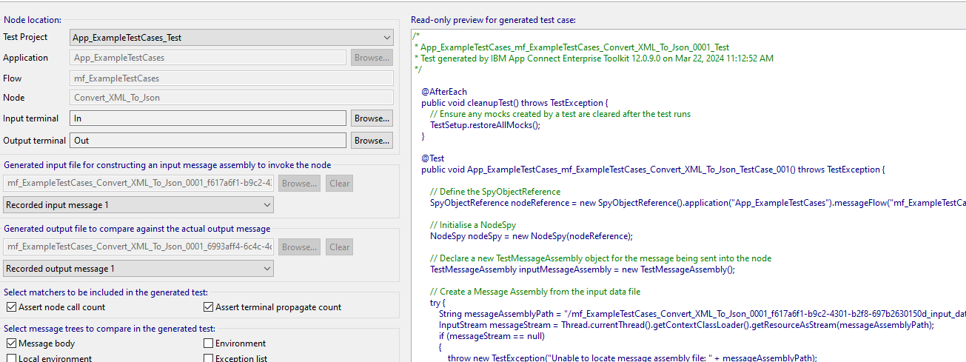

* we can choose which message trees in the message assembly are to be compared in the generated test, by selecting one or more of the following options:

Message body

Local environment

Environment

Exception list

* After click finish It will be created test project.

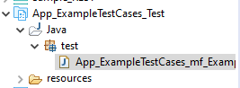

* You can run the test by right-clicking the test project XMLtoJSON_App_Test and then clicking **Run Test Project**.
* 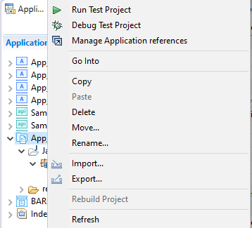
* View the test result by opening the JUnit view in the Toolkit

