**Contents**

**1.** **Introduction** 3

**2.** **Channels** 3

**1.** **Mobile Banking** 3

**1. Bank Account Balance Enquiry** 3

**2. Internal Transfer [ETB to ETB, Dollar to ETB within the Bank]** 3

**3. Bank Account Details** 3

**4. Mini Statement** 4

**5. Wallet to Bank Transfer** 5

**6. Bank to Wallet Transfer** 6

**7. Internal Transfer [ETB to ETB other bank]** 7

**8. Bill Payment using Bank Account** 8

**9. Reversal Process** 11

**2.** **Internet Banking** 11

**1. Bank Account Balance Enquiry** 12

**2. Internal Transfer [ETB to ETB, Dollar to ETB within the Bank]** 12

**3. Batch Upload [corporate customers]** 12

**4. Account Details Bank** 12

**5. Mini Statement** 13

**6. Full Statement** 13

**7. Internal Transfer [ETB to ETB other bank]** 13

**8. Wallet to Bank Transfer** 15

**9. Bank to Wallet Transfer** 16

**10. Bill Payment Using Bank Account** 17

**11. Reversal Process** 19

**3.** **USSD** 20

**1.** **Bank Account Balance Enquiry** 21

**2.** **Internal Transfer [ETB to ETB, Dollar to ETB within the Bank]** 21

**3.** **Wallet to Bank Transfer** 22

**4.** **Bank to wallet Transfer** 23

**5.** **Bill Payment using Bank Account** 24

**6.** **Reversal Process** 27

**5.** **Social Banking** 28

**1.** **Content Shelf** 28

**2.** **Bill Payment from wallet** 28

**6.** **Agent MPOS** 29

**1.** **Deposit Wallet -Walk-in customers.** 29

**2.** **Bill Payment from wallet.** 29

**3.** **With drawal Wallet -walk-in customers.** 29

**4.** **Bill payment at Merchant site.** 29

**5.** **Content shelf** 29

**7.** **ATM** 29

**1.** **Account Balance Enquiry** 30

**2.** **Mini Statement** 30

**3.** **Cash Withdrawal** 30

**8.** **Merchant POS** 30

**1.** **Account Balance Enquiry** 30

**2.** **Purchase** 30

**3.** **Refund** 30

**4.** **Reversal** 30

**5.** **Manual Card Entry** 30

**6.** **Purchase [Remote On us]** 32

**9.** **Branch POS** 32

**1.** **Account Balance Enquiry.** 32

**2.** **Reversal.** 32

**3.** **Cash advance.** 32

**10.** **Cheque Point** 33

**1.** **Cheque Point Traffic.** 33

**2.** **Cheque Point Tax.** 41

**3.** **Check application with NBE** 47

**4.** **Incoming Check application with NBE :** 50

**5.** **Liquidate Transaction [NBE CPO txn] :** 51

**6.** **Fund Transfer [NBE cheque txn]:** 52

**7.** **Bulk Fund Transfer [NBE Account to account]:** 53

**11.** **ECX** 53

**1.** **Bulk Fund Transfer** 53

# **Introduction**

This document will make you understand the flow between the systems

# **Channels**

# **Mobile Banking**

The below services are under Mobile Banking

### **Bank Account Balance Enquiry**

### **Internal Transfer [ETB to ETB, Dollar to ETB within the Bank]**

### **Bank Account Details**

### **Bank Account Summary**

Note: Below sequence Diagram represents all above 3 services

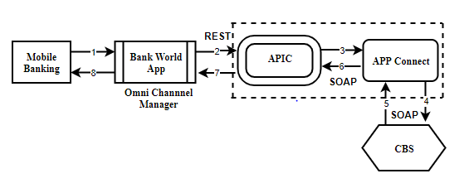

**Sequence of steps:**

1. User Initiate the request to Bank World App.
2. Bank World App sent the user request to APIC Via REST Web-service call.
3. APIC will Send the request to APP Connect via SOAP Web-service call.
4. App Connect will send the valid request to Bank Core Banking System via SOAP Web-service call.
5. Core Banking System will Respond bank to App connect with valid response Via SOAP Web-service call.
6. App Connect will send response back to APIC with valid response Via SOAP Web-service call.
7. APIC will send response back to Bank World App via REST Web-service call.
8. Bank World App will send response back to the End User.

### **Mini Statement**

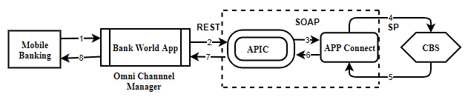

**Sequence of steps:**

1. User Initiate the request to Bank World App.
2. Bank World App sent the user request to APIC Via REST Web-service call.
3. APIC will Send the request to APP Connect via SOAP Web-service call.
4. App Connect will send the valid request to Bank Core Banking System via Stored procedure.
5. Core Banking System will Respond bank to App connect with valid response Via Stored procedure.
6. App Connect will send response back to APIC with valid response Via SOAP Web-service call.
7. APIC will send response back to Bank World App via REST Web-service call.
8. Bank World App will send response back to the End User.

### **Wallet to Bank Transfer**

**Note: Below sequence Diagram represents service**

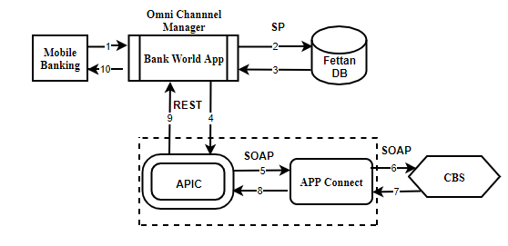

**Sequence of steps:**

1. User Initiate the request to Bank World App.
2. Bank World App sent the user request to Fettan DB to debit the user wallet and credit the GL wallet.
3. After successful debit and credit operation Fettan DB respond back to Bank World APP via Database Stored procedure.
4. Bank world App will initiate Account credit request to APIC via REST web-service call.
5. APIC will send the same request to APP Connect via SOAP web-service call.
6. App connect will send the request to Core banking system via SOAP web-service call.
7. Core Banking System will credit the customer account and debit the bank pool account and send the response to App Connect via SOAP web-service call.
8. App Connect will send response to APIC via SOAP web-service call.
9. After receiving successful response from APP Connect the same will send to Bank World App via REST web-service call.
10. Bank World App will send final response to User.

### **Bank to Wallet Transfer**

**Note: Below sequence Diagram represents service**

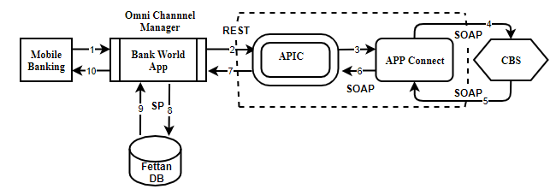

**Sequence of steps:**

1. User Initiate the request to Bank World App.
2. Bank World App sent the user request to APIC debit the user Account and credit the GL Account via REST web-service call.
3. APIC will pass the request to App Connect via Soap Web-service call.
4. App connect will send the request to Core banking system Via Soap Web-service call.
5. Once Core banking system receive the request will debit the customer bank account and credit the GL Account and send the response back to App connect.
6. App connect will send the response bank to APIC via SOAP web-service call.
7. After receiving successful response from APP Connect the same will send to World Bank App via REST web-service call.
8. Bank world App will send request to Fettan DB to credit the customer wallet Via Database stored procedure.
9. After receiving the request from Bank world App Fettan DB will credit the customer wallet and debit the GL wallet and send the response back to Bank world App via Database stored procedure.
10. Bank World app will send the final response to user.

### **Internal Transfer [ETB to ETB other bank]**

**Note: Below sequence Diagram represents service**

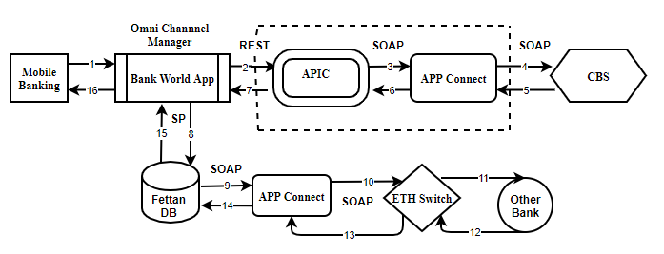

**CBS will debit the customer bank Account and credit the other bank pool account.**

**Sequence of steps:**

1. User Initiate the request to Bank World App.
2. Bank World App sent the user request to APIC to debit the user Account and credit the other bank pool Account via REST web-service call.
3. APIC will pass the request to App Connect via Soap Web-service call.
4. App connect will send the request to Core banking system Via Soap Web-service call.
5. Once Core banking system receive the request will debit the customer bank account and credit the Other Bank Account and send the response back to App connect.
6. App connect will send the response bank to APIC via SOAP web-service call.
7. After receiving successful response from APP Connect will send the same to Bank World App via REST web-service call.
8. After receiving the response from APIC the Bank world App will send request to Fettan DB to credit the other bank customer bank account Via Database stored procedure.
9. After receiving the request from Bank world App Fettan DB will send the other bank Credit request to App Connect via SOAP web-service call.
10. App Connect will send the same request to ETH Switch via SOAP web-service call.
11. ETH Switch will send the other bank customer credit request to other bank.
12. Other bank will credit the exact customer bank account and respond back to ETH Switch.
13. ETH Switch will respond back to App connect with valid response via SOAP web-service call.
14. App will send response back to Fettan DB via SOAP web-service call.
15. Fettan DB send the response back to Bank World App.
16. Bank World app will send the final response to user.

### **Bill Payment using Bank Account**

In the process of bill payment using Bank Account the following steps are involved.

1. **Bill Enquiry**.

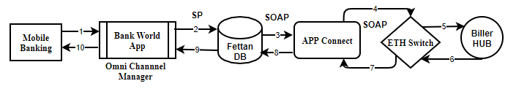

This service helps the customer to know his bill amount to be paid.

**Sequence of steps:**

1. User Initiate the request from Mobile Banking to Bank World App.
2. Bank World App sent the user request to Fettan DB via Database Stored Procedure.
3. Fettan DB in-turn send the Bill enquiry request to App Connect via SOAP web-service call.
4. APP Connect will send the request to Eth Switch via SOAP web-service call.
5. ETH Switch send the request back to exact Biller to get the details of bill due details.
6. Biller Hub Respond back to ETH switch which indeed has due amount to be paid by the customer.
7. ETH switch send the response to App Connect via SOAP web-service call.
8. APP Connect will send the response to Fettan DB via SOAP web-service call.
9. Fettan DB send the Bill amount due details to Bank World App.
10. Bank world App send the exact bill amount due details back to the end user.
11. **Bill Payment Using Bank Account** 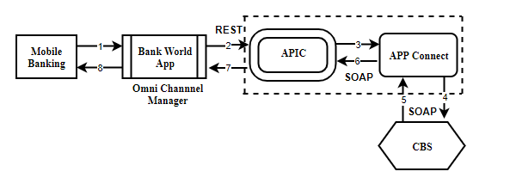

This service helps the customer to pay his bill amount.

**Sequence of steps:**

1. User Initiate the request from Mobile Banking to Bank World App.
2. Bank World App sent the user request to APIC Via SOAP/REST web-service call.
3. APIC in-turn send the Bill payment request to APP connect Via REST web-service call.
4. APP connect send the request back to Core Banking System (CBS) Via SOAP/REST web-service call.
5. Core Banking System (CBS) based on the available funds in the customer account will debit the customer Account and credit the biller pool account. In case of insufficient funds a valid response is sent by Core Banking System (CBS) to App connect Via SOAP web-service call.
6. App connect will send the response back to APIC Via REST web-service call.
7. APIC will send the response to Bank World App.
8. Bank world App send the response back to the end user.
9. **Acknowledgement to the Biller.**



This service will update Biller after successful bill amount is paid.

**Sequence of steps:**

1. User Initiate the request from Mobile Banking to Bank World App.
2. Bank World App sent the user request to Fettan DB via Database Stored Procedure.
3. Fettan DB in-turn send the Bill payment ACK to App Connect via SOAP web-service call.
4. APP Connect will send the request to Eth Switch via SOAP web-service call.
5. ETH Switch send the request back to exact Biller to get the details of bill due details.
6. Biller Hub Respond back to ETH switch with successful response.
7. ETH switch send the response to App Connect via SOAP web-service call.
8. APP Connect will send the response to Fettan DB via SOAP web-service call.
9. Fettan DB send the Bill payment ACK to Bank World App.
10. Bank world App send the bill ACK back to the end user.

### **Reversal Process**

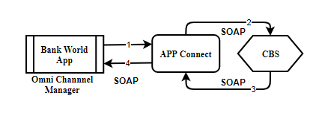

This service will be initiated whenever a fund transfer gets failed in order to credit the funds back to customer account.

**Sequence of steps:**

1. Bank World App Initiate the reversal request to APP Connect via SOAP Web-service call.
2. App Connect will send the valid request to Bank Core Banking System via SOAP Web-service call.
3. Core Banking System will Respond bank to App connect with valid response by debiting the pool Account and credit the customer Account via SOAP Web-service call.
4. App Connect will send response back to Bank World App with valid response Via SOAP Web-service call.

# **Internet Banking**

### **Bank Account Balance Enquiry**

### **Internal Transfer [ETB to ETB, Dollar to ETB within the Bank]**

### **Batch Upload [corporate customers]**

### **Account Details Bank**

### **Bank Account Summary**

**Note: Below sequence Diagram represents all above 3 services**

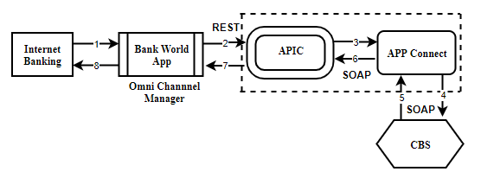

**Sequence of steps:**

1. User Initiate the request to Bank World App.
2. Bank World App sent the user request to APIC Via REST Web-service call.
3. APIC will Send the request to APP Connect via SOAP Web-service call.
4. App Connect will send the valid request to Bank Core Banking System via SOAP Web-service call.
5. Core Banking System will Respond bank to App connect with valid response Via SOAP Web-service call.
6. App Connect will send response back to APIC with valid response Via SOAP Web-service call.
7. APIC will send response back to Bank World App via REST Web-service call.
8. Bank World App will send response back to the End User.

### **Mini Statement**

### **Full Statement**



**Sequence of steps:**

1. User Initiate the request to Bank World App.
2. Bank World App sent the user request to APIC Via REST Web-service call.
3. APIC will Send the request to APP Connect via SOAP Web-service call.
4. App Connect will send the valid request to Bank Core Banking System via Stored procedure.
5. Core Banking System will Respond bank to App connect with valid response Via Stored procedure.
6. App Connect will send response back to APIC with valid response Via SOAP Web-service call.
7. APIC will send response back to Bank World App via REST Web-service call.
8. Bank World App will send response back to the End User.

### **Internal Transfer [ETB to ETB other bank]**

**Note: Below sequence Diagram represents service**

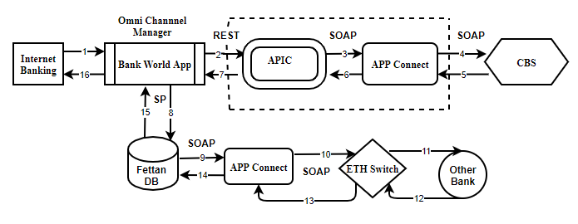

**CBS will debit the customer Dashen bank Account and credit the other bank pool account.**

1. User Initiate the request to Bank World App.
2. Bank World App sent the user request to APIC to debit the user Account and credit the other bank pool Account via REST web-service call.
3. APIC will pass the request to App Connect via Soap Web-service call.
4. App connect will send the request to Core banking system Via Soap Web-service call.
5. Once Core banking system receive the request will debit the customer bank account and credit the Other Bank Account and send the response back to App connect.
6. App connect will send the response bank to APIC via SOAP web-service call.
7. After receiving successful response from APP Connect the same will send to Bank World App via REST web-service call.
8. After receiving the response from APIC the Bank world App will send request to Fettan DB to credit the other bank customer bank account Via Database stored procedure.
9. After receiving the request from Bank world App Fettan DB will send the other bank Credit request to App Connect via SOAP web-service call.
10. App Connect will send the same request to ETH Switch via SOAP web-service call.
11. ETH Switch will send the other bank customer credit request to other bank.
12. Other bank will credit the exact customer bank account and respond back to ETH Switch.
13. ETH Switch will respond back to App connect with valid response via SOAP web-service call.
14. App will send response back to Fettan DB via SOAP web-service call.
15. Fettan DB send the response back to Bank World App.
16. Bank World app will send the final response to user.

### **Wallet to Bank Transfer**

**Note: Below sequence Diagram represents service**

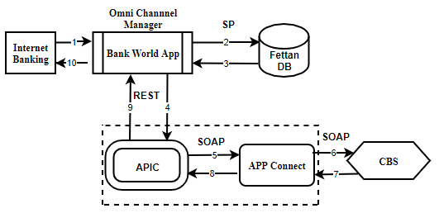

**Sequence of steps:**

1. User Initiate the request to Bank World App.
2. Bank World App sent the user request to Fettan DB to debit the user wallet and credit the GL wallet.
3. After successful debit and credit operation Fettan DB respond back to Bank World APP via Database Stored procedure.
4. Bank world App will initiate Account credit request to APIC via REST web-service call.
5. APIC will send the same request to APP Connect via SOAP web-service call.
6. App connect will send the request to Core banking system via SOAP web-service call.
7. Core Banking System will credit the customer account and debit the bank pool account and send the response to App Connect via SOAP web-service call.
8. App Connect will send response to APIC via SOAP web-service call.
9. After receiving successful response from APP Connect the same will send to World Bank App via REST web-service call.
10. Bank World App will send final response to User.

### **Bank to Wallet Transfer**

**Note: Below sequence Diagram represents service**

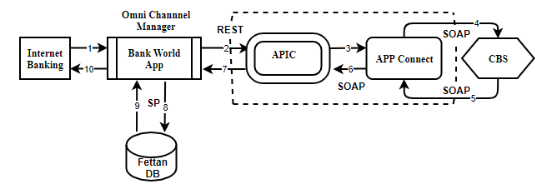

**Sequence of steps:**

1. User Initiate the request to Bank World App.
2. Bank World App sent the user request to APIC debit the user Account and credit the GL Account via REST web-service call.
3. APIC will pass the request to App Connect via Soap Web-service call.
4. App connect will send the request to Core banking system Via Soap Web-service call.
5. Once Core banking system receive the request will debit the customer bank account and credit the GL Account and send the response back to App connect.
6. App connect will send the response bank to APIC via SOAP web-service call.
7. After receiving successful response from APP Connect the same will send the response to World Bank App via REST web-service call.
8. Bank world App will send request to Fettan DB to credit the customer wallet Via Database stored procedure.
9. After receiving the request from Bank world App Fettan DB will credit the customer wallet and debit the GL wallet and send response back to Bank world App via Database stored procedure.
10. Bank World app will send the final response to user.

### **Bill Payment Using Bank Account**

**Note: Below sequence Diagram represents service**

In the process of bill payment using Bank Account the following steps are involved.

1. **Bill Enquiry**.

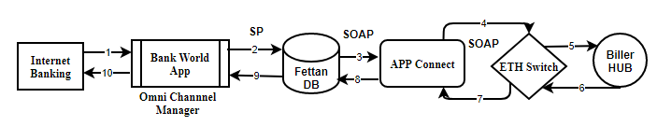

This service helps the customer to know his bill amount to be paid.

**Sequence of steps:**

1. User Initiate the request from Mobile Banking to Bank World App.
2. Bank World App sent the user request to Fettan DB via Database Stored Procedure.
3. Fettan DB in-turn send the Bill enquiry request to App Connect via SOAP web-service call.
4. APP Connect will send the request to Eth Switch via SOAP web-service call.
5. ETH Switch send the request back to exact Biller to get the details of bill due details.
6. Biller Hub Respond back to ETH switch which indeed has due amount to be paid by the customer.
7. ETH switch send the response to App Connect via SOAP web-service call.
8. APP Connect will send the response to Fettan DB via SOAP web-service call.
9. Fettan DB send the Bill amount due details to Bank World App.
10. Bank world App send the exact bill amount due details back to the end user.
11. **Bill Payment Using Bank Account**

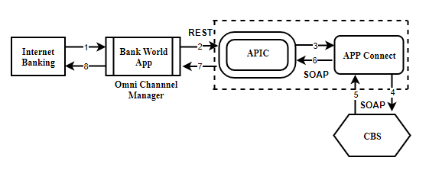

This service helps the customer to pay his bill amount.

**Sequence of steps:**

1. User Initiate the request from Internet Banking to Bank World App.
2. Bank World App sent the user request to APIC Via REST web-service call.
3. APIC in-turn send the Bill payment request to APP connect Via SOAP web-service call.
4. APP connect send the request back to Core Banking System (CBS) Via SOAP web-service call.
5. Core Banking System (CBS) based on the available funds in the customer account will debit the customer Account and credit the biller pool account. In case of insufficient funds a valid response is sent by Core Banking System (CBS) to App connect Via SOAP web-service call.
6. App connect send the response back to APIC Via SOAP web-service call.
7. APIC will send the response to Bank World App.
8. Bank world App send the response back to the end user.
9. **Acknowledgement to the Biller.**



This service will update Biller after successful bill amount is paid.

**Sequence of steps:**

1. User Initiate the request from Mobile Banking to Bank World App.
2. Bank World App sent the user request to Fettan DB via Database Stored Procedure.
3. Fettan DB in-turn send the Bill payment ACK to App Connect via SOAP web-service call.
4. APP Connect will send the request to Eth Switch via SOAP web-service call.
5. ETH Switch send the request back to exact Biller to get the details of bill due details.
6. Biller Hub Respond back to ETH switch with successful response.
7. ETH switch send the response to App Connect via SOAP web-service call.
8. APP Connect will send the response to Fettan DB via SOAP web-service call.
9. Fettan DB send the Bill payment ACK to Bank World App.
10. Bank world App send the bill ACK back to the end user.

### **Reversal Process**

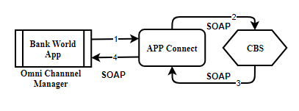

This service will be initiated whenever a fund transfer gets failed in order to credit the funds back to customer account.

**Sequence of steps:**

1. Bank World App Initiate the reversal request to APP Connect via SOAP Web-service call.
2. App Connect will send the valid request to Bank Core Banking System via SOAP Web-service call.
3. Core Banking System will Respond bank to App connect with valid response by debiting the pool Account and credit the customer Account via SOAP Web-service call.
4. App Connect will send response back to Bank World App with valid response Via SOAP Web-service call.

# **USSD**

Initially when a customer hits the service the following process take place.

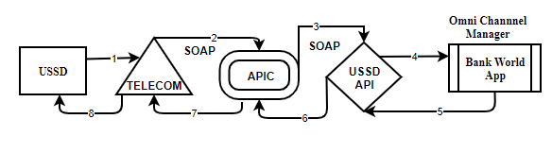

**Sequence of steps:**

1. When a user/Customer initiate the request with USSD Code this will be sent to the exact telecom provider. (#996#)
2. After receiving the request from the user the telecom provider send the request to APIC via SOAP web-service call.
3. APIC will send the request to USSD API via SOAP web-service call.
4. The USSD API will send the user request to Channel Manager.
5. Once request received at the channel manager tries to send the available options or menu as a response to the USSD API.
6. After receiving the available options as response from bank world App the same response is sent to APIC via SOAP web-service.
7. The Telecom provider will receive the response from APIC.
8. The available options are displayed to end user.

### **Bank Account Balance Enquiry**

### **Internal Transfer [ETB to ETB, Dollar to ETB within the Bank]**

### **Bank Account Summary**

**Note: Below sequence Diagram represents service**

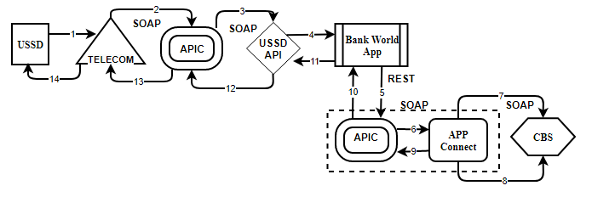

**Sequence of steps:**

1. User Initiate the request to Telecom Provider with valid option.
2. Telecom Provider send the request to APIC via Soap web-service call.
3. APIC send the request to USSD API via SOAP web-service call.
4. USSD API Send the user request to Channel Manager (Bank World App).
5. Bank world App send the request to APIC via REST web-service call.
6. APIC sent the user request to APP Connect via SOAP Web-service call.
7. App Connect will send the valid request to Bank Core Banking System via SOAP Web-service call.
8. Core Banking System will Respond bank to App connect with valid response via SOAP Web-service call.
9. App Connect will send response back to APIC with valid response via SOAP Web-service call.
10. APIC will send the response to bank world app via REST Web-service call
11. Bank World App will respond back to USSD API with valid response.
12. USSD API send the response back to APIC via SOAP web-service call.
13. APIC will send the response to Telecom provider via SOAP web-service call.
14. Telecom provider will send response back to the End User.

### **Wallet to Bank Transfer**

**Note: Below sequence Diagram represents service**

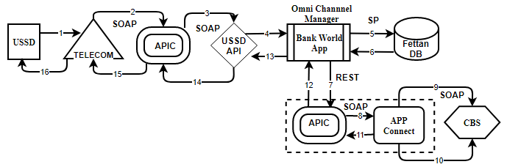

**Sequence of steps:**

1. User Initiate the request to Telecom Provider.
2. Telecom Provider send the request to APIC via SOAP web-service call.
3. APIC will send the user request to USSD API via SOAP web-service call.
4. USSD API will send the request to Bank world App (Channel Manager).
5. Bank World App sent the user request to Fettan DB to debit the user wallet and credit the GL wallet.
6. After successful debit and credit operation Fettan DB respond back to Bank World APP via Database Stored procedure.
7. Bank world App will initiate Account credit request to APIC via REST web-service call.
8. APIC will send the request to APP Connect via SOAP Web-service call.
9. App connect will send the request to Core banking system via SOAP web-service call.
10. Core Banking System will credit the customer account and debit the bank pool account and send the response to App Connect via SOAP web-service call.
11. App Connect will send the response to APIC via SOAP Web-service call.
12. APIC will send response to Bank World App via REST web-service call.
13. Bank World App will send response to USSD API.
14. USSD API will send the response back to APIC via SOAP web-service call.
15. APIC will send Wallet to bank account corresponding response back to Telecom Provider.
16. Telecom provider will send response back to the End User.

### **Bank to wallet Transfer**

**Note: Below sequence Diagram represents service**

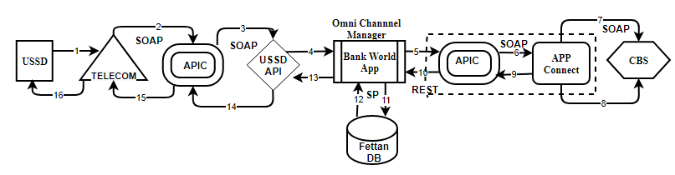

**Sequence of steps:**

1. User Initiate the request to Telecom Provider.
2. Telecom Provider send the request to APIC via SOAP web-service call.
3. APIC will send the user request to USSD API via SOAP web-service call.
4. USSD API will send the user request to Channel Manager (Bank world App).
5. Bank World App sent the user request to APIC to debit the user Account and credit the GL Account via REST web-service call.
6. APIC will send the request to APP Connect via SOAP Web-service call
7. App connect will send the request to Core banking system Via Soap Web-service call.
8. Once Core banking system receive the request will debit the customer bank account and credit the GL Account and send the response back to App connect.
9. App connect will send the response bank to APIC via SOAP web-service call.
10. APIC will send the response to Bank world APP via REST web-service call.
11. Bank world App will send request to Fettan DB to credit the customer wallet via Database stored procedure.
12. After receiving the request from Bank world App Fettan DB will credit the customer wallet and debit the GL wallet and send response back to Bank world App via Database stored procedure.
13. Bank World app will send the final response to USSD API.
14. USSD API will send the response back to APIC via SOAP web-service call.
15. APIC will sends the Bank to wallet response to Telecom service provider via SOAP web-service call.
16. Telecom provider will send response back to the End User.

### **Bill Payment using Bank Account**

In the process of bill payment using Bank Account the following steps are involved.

1. **Bill Enquiry**

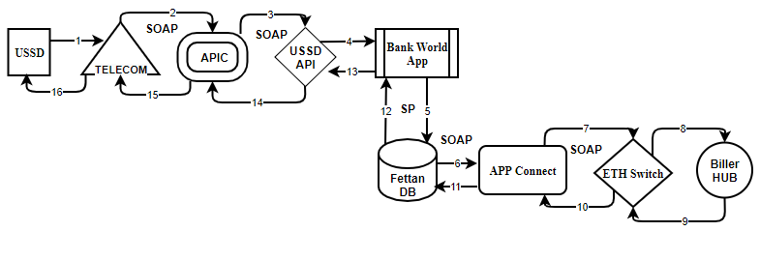

This service helps the customer to know his bill amount to be paid.

**Sequence of steps:**

1. User Initiate the request from USSD to Telecom Provider.
2. Telecom Provider send the request to APIC via SOAP web-service call.
3. APIC will send the request to USSD APP via SOAP web-service call.
4. USSD API will send the user request to Channel Manager (Bank world App).
5. Bank World App sent the user request to Fettan DB via Database Stored Procedure.
6. Fettan DB in-turn send the Bill enquiry request to APP Connect via SOAP web-service call.
7. APP Connect will send the bill enquiry request to ETH switch via SOAP web-service call.
8. ETH Switch send the request back to exact Biller to get the details of bill due details.
9. Biller Hub Respond back to ETH switch which indeed has due amount to be paid by the customer.
10. Eth switch send the bill due details to APP connect via SOAP web-service call.
11. APP connect send the response to Fettan DB.
12. Fettan DB send the Bill amount due details to Bank World App.
13. Bank world App send the exact bill amount due details back to the USSD API.
14. USSD API will send the response back to APIC via SOAP web-service.
15. APIC will send bill due details back to telecom Service provider via SOAP web-service call.
16. Telecom provider will send response back to the End User.
17. **Bill Payment Using Bank Account**

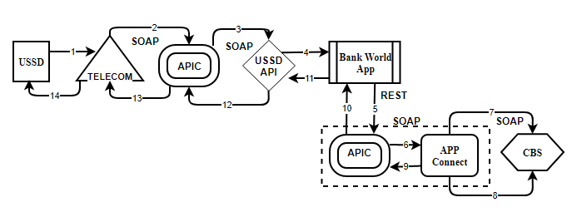This service helps the customer to pay his bill amount.

**Sequence of steps:**

1. User Initiate the request from USSD to Telecom Provider.
2. Telecom Provider send the request to APIC via SOAP web-service call.
3. APIC will send bill payment request to USSD API via SOAP web-service call.
4. USSD API will send the user request to Channel Manager (Bank world App).
5. Bank World App sent the user request to APIC via REST web-service call.
6. APIC will send request to APP Connect via SOAP web-service call.
7. APP connect send the request back to Core Banking System (CBS) Via SOAP web-service call.
8. Core Banking System (CBS) based on the available funds in the customer account will debit the customer Account and credit the biller pool account. In case of insufficient funds a valid response is sent by Core Banking System (CBS) to App connect Via SOAP/REST web-service call.
9. App connect send the response back to Bank world APIC via SOAP web-service call.
10. APIC will send the response to Bank world App via REST web-service call.
11. Bank world App send the response back to the USSD API.
12. USSD API will send the response back to APIC via SOAP web-service call.
13. APIC will send the response to Telecom Service provider via SOAP web-service call.
14. Telecom provider will send response back to the End User.
15. **Acknowledgement to the Biller.**



This service will update Biller after successful bill amount is paid.

**Sequence of steps:**

1. User Initiate the request from USSD to Telecom Provider.
2. Telecom Provider send the request to APIC via SOAP web-service call.
3. APIC will send the request to USSD APP via SOAP web-service call.
4. USSD API will send the user request to Channel Manager (Bank world App).
5. Bank World App sent the user request to Fettan DB via Database Stored Procedure.
6. Fettan DB in-turn send the Bill payment ACK to APP Connect via SOAP web-service call.
7. APP Connect will send the bill payment ACK to ETH switch via SOAP web-service call.
8. ETH Switch send the request back to exact Biller to update the bill.
9. Biller Hub Respond back to ETH switch which ack amount paid by the customer.
10. Eth switch send the response to APP connect via SOAP web-service call.
11. APP connect send the response to Fettan DB via SOAP web-service call.
12. Fettan DB send the Bill Acknowledgement to Bank World App.
13. Bank world App send the Bill Acknowledgement back to the USSD API.
14. USSD API will send the response back to APIC via SOAP web-service.
15. APIC will send Bill Acknowledgement back to telecom Service provider via SOAP web-service call.
16. Telecom provider will send response back to the End User.

### **Reversal Process**



This service will be initiated whenever a fund transfer gets failed in order to credit the funds back to customer account.

**Sequence of steps:**

1. Bank World App Initiate the reversal request to APP Connect via SOAP Web-service call.
2. App Connect will send the valid request to Bank Core Banking System via SOAP Web-service call.
3. Core Banking System will Respond bank to App connect with valid response by debiting the pool Account and credit the customer Account via SOAP Web-service call.
4. App Connect will send response back to Bank World App with valid response Via SOAP Web-service call.

# **Social Banking**

### **Content Shelf**

### **Bill Payment from wallet**

**Note: Below sequence Diagram represents all above 2 services**

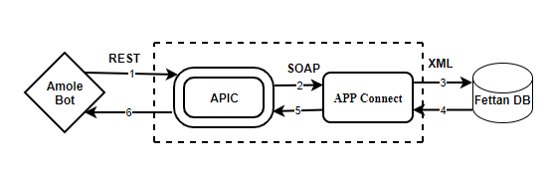

**Sequence of steps:**

1. User Initiate the request from Amole Bot request is send to APIC Via REST format.
2. APIC sent the user request to APP Connect via SOAP format.
3. APP Connect will pass the request to Fettan DB to debit customer wallet and credit merchant wallet request Via XML format.
4. Fettan DB will debit customer wallet and credit merchant wallet and send back the valid response to APP Connect via XML format.
5. Once APP Connect receive the response send back to the APIC SOAP format.
6. APIC will respond back to Amole Bot via REST format.

# **Agent MPOS**

**Under Agent Mpos there are 5 types’ transactions.**

### **Deposit Wallet -Walk-in customers.**

### **Bill Payment from wallet.**

### **With drawal Wallet -walk-in customers.**

### **Bill payment at Merchant site.**

### **Content shelf**

**Note: Below sequence Diagram represents all above 5 services**

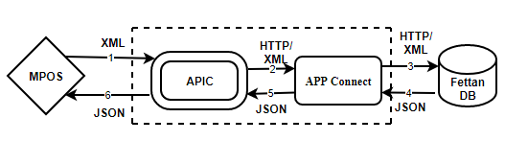

**Sequence of steps:**

1. User Initiate the request to APIC Via XML format.
2. APIC sent the user request to APP Connect via XML format.
3. APP Connect will pass the request to Fettan DB via JSON format.
4. Fettan DB will send back the valid response to APP Connect via JSON format.
5. Once APP Connect receive the response send back to the APIC JSON format.
6. APIC will respond back to user via JSON format.

# **ATM**

**Under ATM there are three types’ transactions**

### **Account Balance Enquiry**

### **Mini Statement**

### **Cash Withdrawal**

**Note: Below sequence Diagram represents all above 3 services**

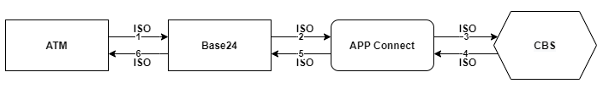

**Sequence of steps:**

1. User Initiate the request to BASE24 via TCP/ISO format.
2. BASE24 sent the user request to APP Connect via TCP/ISO format.
3. APP Connect will pass the request to Core Banking System via TCP/ISO format.
4. Core Banking System will send back the valid response to APP Connect via TCP/ISO format.
5. Once APP Connect receive the response send back to the BASE24 TCP/ISO format.
6. BASE24 will respond back to user via TCP/ISO format.

# **Merchant POS**

**Under Merchant Pos there are five types’ transactions.**

### **Account Balance Enquiry**

### **Purchase**

### **Refund**

### **Reversal**

### **Manual Card Entry**

**Note: Below sequence Diagram represents all above 5 services**

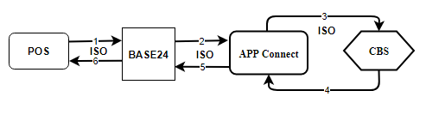

**In Case of on-us Transaction: (Dashen pos and Dashen Bank Card)**

**Purchase:**

When a customer do purchase using Dashen bank card using purchase service customer account will be debit and merchant pool account will be credit.

**Sequence of steps:**

1. User Initiate the request to BASE24 via TCP/ISO format.
2. BASE24 sent the user request to APP Connect via TCP/ISO format.
3. APP Connect will pass the request to Core Banking System via TCP/ISO format.
4. Core Banking System will send back the valid response to APP Connect via TCP/ISO format.
5. Once APP Connect receive the response send back to the BASE24 TCP/ISO format.
6. BASE24 will respond back to user via TCP/ISO format.

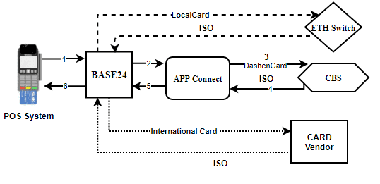

**In the Case of off us transactions**

**Case 1: Local card (Other Bank card)**

Base 24 directly send the request to Eth Switch.

**Case 2: International Card Transaction**

Base 24 directly send the request to International Card Vendor.

### **Purchase [Remote On us]**

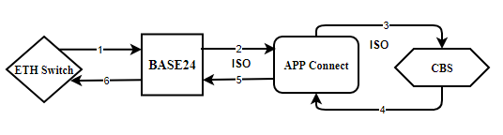

**Sequence of steps:**

1. User Initiate the request from other bank pos to BASE24 via TCP/ISO format.
2. BASE24 sent the user request to APP Connect via TCP/ISO format.
3. APP Connect will pass the request to Core Banking System via TCP/ISO format.
4. Core Banking System will send back the valid response to APP Connect by doing debit in customer account and credit the other bank pool account via TCP/ISO format.
5. Once APP Connect receive the response send back to the BASE24 TCP/ISO format.
6. BASE24 will respond back to user via TCP/ISO format.

# **Branch POS**

**Under Branch Pos there are four types’ transactions.**

### **Account Balance Enquiry.**

### **Reversal.**

### **Cash advance.**

**Note: Below sequence Diagram represents all above 3 services**

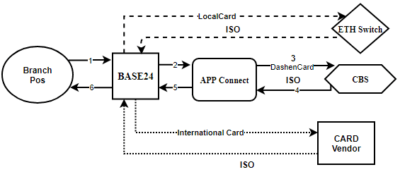

**Sequence of steps:**

1. User Initiate the request to BASE24 via TCP/ISO format.
2. BASE24 sent the user request to APP Connect via TCP/ISO format.
3. APP Connect will pass the request to Core Banking System via TCP/ISO format.
4. Core Banking System will send back the valid response to APP Connect via TCP/ISO format.
5. Once APP Connect receive the response send back to the BASE24 TCP/ISO format.
6. BASE24 will respond back to user via TCP/ISO format.

# **Cheque Point**

**Under Cheque Point there are 3 types’ transactions.**

### **Cheque Point Traffic.**

Customer can pay the traffic due by using the Cheque point Traffic system.

The following steps are involved for doing this process.

**Step 1:** **Get AuthToken.**

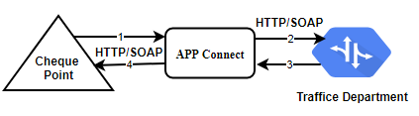

This token will be used for all the steps involved in traffic payment. It will acts unique for the process.

**Sequence of Steps:**

1. Cheque Point Application Initiate the request to App Connect Provider ID as parameters via HTTP/SOAP format.
2. APP Connect will the same request to Traffic Management System via HTTP/SOAP format.
3. Traffic Management System respond back to the APP Connect with Token as response via HTTP/SOAP format.
4. APP Connect will send the details of the person to Cheque point application via HTTP/SOAP format.

**Step 2:** **Driver Lookup.**



**Sequence of Steps:**

1. Cheque Point Application Initiate the request to App Connect to get the traffic Due details by passing License number as parameter via HTTP/SOAP format.
2. APP Connect will the same request to Traffic Management System via HTTP/SOAP format.
3. Traffic Management System respond back to the APP Connect with details of the person via HTTP/SOAP format.
4. APP Connect will send the details of the person to Cheque point application via HTTP/SOAP format.

**Step 3:** **Register Diver.**

Driver has to register in the traffic system before paying his due details. This API used for register purposes.



**Sequence of Steps:**

1. Cheque Point Application Initiate the request to App Connect by passing Driver details as parameters via HTTP/SOAP format.
2. APP Connect will the same request to Traffic Management System via HTTP/SOAP format.
3. Traffic Management System respond back to the APP Connect with Success or failed response via HTTP/SOAP format.
4. APP Connect will send the details of the person to Cheque point application via HTTP/SOAP format.

**Step 4:** **Registration of the Penalty.**



**Sequence of Steps:**

1. Cheque Point Application Initiate the request to App Connect Violation Date, Ticket No number as parameters via HTTP/SOAP format.
2. APP Connect will the same request to Traffic Management System via HTTP/SOAP format.
3. Traffic Management System respond back to the APP Connect with Registration penalty response via HTTP/SOAP format.
4. APP Connect will send the details of the person to Cheque point application via HTTP/SOAP format.

**Step 5:** **Check the Balance using balance Enquiry Service.**

**Note: Below sequence Diagram.**

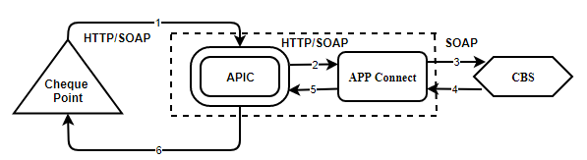

**Sequence of Steps:**

**After successful get due details**

1. Cheque Point Application initiate a request to APIC to get the available funds in the customer via HTTP/SOAP format.
2. APIC will send the request to APP connect via SOAP Format.
3. APP Connect will send the request to Core Banking System (CBS) to get available funds in the customer account.
4. Core Banking System will respond back to App connect with available balance in the customer account via HTTP/SOAP Format.
5. APP Connect will send the response back to APIC via HTTP/SOAP Format.
6. APIC will send available funds in the customer account as a final response to the Cheque point application via SOAP format.

**Step 6: Fund Transfer.**

Based on the available funds using step 2, Cheque point will proceed for fund transfer.

**Note: Below sequence Diagram.**



**Credit—Traffic pool Account.**

**Debit-Dashen Bank Customer.**

**Wilkin Customer who doesn’t hold bank account.**

**Debit –GML pool Account.**

**Sequence of Steps:**

1. Cheque Point Application initiate a request to APIC via SOAP format.
2. APIC will send the request to APP connect via SOAP Format.
3. APP Connect will send the request to Core Banking System (CBS) to initiate FT request.
4. Core Banking System will respond back to App connect by doing debit in the customer account and credit the pool account via SOAP Format.
5. APP Connect will send the response back to APIC via SOAP Format.
6. APIC will send a final response to the Cheque point application via SOAP format.

**Step 7: Submit Payment to Traffic Management System.**

**Note: Below sequence Diagram.**

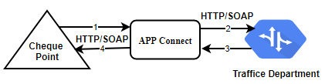

**Sequence of Steps:**

1. After successful fund transfer Cheque Point Application Initiate the Ack to APP Connect via HTTP/SOAP format.
2. APP Connect will send the ACK to Traffic Management System via HTTP/SOAP format.
3. Traffic Management System respond back to the APP Connect via HTTP/SOAP format.
4. APP Connect will send the response back to Cheque point application via HTTP/SOAP format.

**Step 8: Retrieve Penalty.**

**If the customer is already register then it will allow to use this Service.**

**Note: Below sequence Diagram.**



**Sequence of Steps:**

1. After successful fund transfer Cheque Point Application Initiate the Ack to APP Connect via HTTP/SOAP format.
2. APP Connect will send the ACK to Traffic Management System via HTTP/SOAP format.
3. Traffic Management System respond back to the APP Connect via HTTP/SOAP format.
4. APP Connect will send the response back to Cheque point application via HTTP/SOAP format.

**Step 9: Fetch Payment List.**

**Note: Below sequence Diagram.**



**Sequence of Steps:**

1. Cheque Point Application Initiate the request to App Connect Driver ID as parameters via HTTP/SOAP format.
2. APP Connect will the same request to Traffic Management System via HTTP/SOAP format.
3. Traffic Management System respond back to the APP Connect with Token as response via HTTP/SOAP format.
4. APP Connect will send the details of the person to Cheque point application via HTTP/SOAP format.

**Step 10: Fetch Penalty List.**

**Note: Below sequence Diagram.**



**Sequence of Steps:**

1. Cheque Point Application Initiate the request to App Connect Driver ID as parameters via HTTP/SOAP format.
2. APP Connect will the same request to Traffic Management System via HTTP/SOAP format.
3. Traffic Management System respond back to the APP Connect with Token as response via HTTP/SOAP format.
4. APP Connect will send the details of the person to Cheque point application via HTTP/SOAP format.

**Step 10: Void Payment.**

Customer can roll back the transaction

**Note: Below sequence Diagram.**



**Sequence of Steps:**

1. Cheque Point Application initiate a request to APIC via SOAP format.
2. APIC will send the request to APP connect via SOAP Format.
3. APP Connect will send the request to Core Banking System (CBS) to initiate FT request.
4. Core Banking System will respond back to App connect by doing credit the customer account and debit the pool account via SOAP Format.
5. APP Connect will send the response back to APIC via SOAP Format.
6. APIC will send a final response to the Cheque point application via SOAP format.

### **Cheque Point Tax.**

Customer can pay the tax due by using the Cheque point tax system.

The following steps are involved for doing this process.

**Step 1:** **Get the Due Details from Tax System.**

**Note: Below sequence Diagram.**

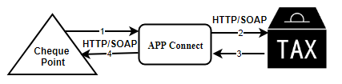

**Sequence of Steps:**

1. Cheque Point Application Initiate the request to APP Connect to get the tax Due details by passing PAN number as parameter via HTTP/SOAP format.
2. APP Connect will send the same request to Tax System via HTTP/SOAP format.
3. Tax System respond back to the APP Connect with exact due amount to be paid via HTTP/SOAP format.
4. APP Connect will send the tax due details back to Cheque point application via HTTP/SOAP format.

**Step 2:** **Bill Status from Tax System.**

**Note: Below sequence Diagram.**



**Sequence of Steps:**

1. Cheque Point Application Initiate the request to APP Connect to get the bill status by passing biller ID as parameter via HTTP/SOAP format.
2. APP Connect will send the same request to Tax System via HTTP/SOAP format.
3. Tax System respond back to the APP Connect with status of the bill via HTTP/SOAP format.
4. APP Connect will send the tax due details back to Cheque point application via HTTP/SOAP format.

**Step 3:** **Check the Balance using balance Enquiry Service.**

**Note: Below sequence Diagram.**



**Sequence of Steps:**

**After successful get due details**

1. Cheque Point Application initiate a request to APIC to get the available funds in the customer account via SOAP format.
2. APIC will send the request to APP connect via SOAP Format.
3. APP Connect will send the request to Core Banking System (CBS) to get available funds in the customer account.
4. Core Banking System will respond back to App connect with available balance in the customer account via SOAP Format.
5. APP Connect will send the response back to APIC via SOAP Format.
6. APIC will send available funds in the customer account as a final response to the Cheque point application via SOAP format.

**Step 4: Blocking the amount.**

**Note: Below sequence Diagram.**



**Sequence of Steps:**

1. Cheque Point Application initiate a request to APIC to block funds in the customer account via SOAP format.
2. APIC will send the request to APP connect via SOAP Format.
3. APP Connect will send the request to Core Banking System (CBS) to Block the funds in the customer account.
4. Core Banking System will respond back to App connect by blocking the funds if available balance is there in the customer account via SOAP Format.
5. APP Connect will send the response back to APIC via SOAP Format.
6. APIC will send response to the Cheque point application via SOAP format.

**Step 5: Make payment To Tax System.**

**Note: Below sequence Diagram.**



**Sequence of Steps:**

1. Cheque Point Application Initiate the request to APP Connect by passing biller ID and debit amount as parameter via HTTP/SOAP format.
2. APP Connect will send the same request to Tax System via HTTP/SOAP format.
3. Tax System respond back to the APP Connect with status of the bill via HTTP/SOAP format.
4. APP Connect will send the tax due details back to Cheque point application via HTTP/SOAP format.

**Step 6: Notification to Tax System.** (Need to Check)

**Note: Below sequence Diagram.**



**Sequence of Steps:**

1. Cheque Point Application Initiate the request to APP Connect by passing biller ID and debit amount as parameter via HTTP/SOAP format.
2. APP Connect will send the same request to Tax System via HTTP/SOAP format.
3. Tax System respond back to the APP Connect with status of the bill via HTTP/SOAP format.
4. APP Connect will send the tax due details back to Cheque point application via HTTP/SOAP format.

**Step 7:** **Get approval from NBE (National Bank of Ethiopia). (Need to Check)**

**Note: Below sequence Diagram.**

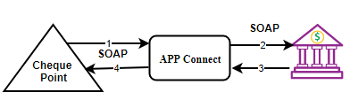

**Sequence of Steps:**

1. Cheque point Application send the approval request to APP Connect via SOAP format.
2. App Connect will send the Approval request to NBE (National Bank of Ethiopia) via SOAP Format.
3. NBE Respond back for the approval request to APP Connect via SOAP format.
4. APP Connect will send the response back to Cheque Point Application.

**Step 8: unblocking the amount.**

**Note: Below sequence Diagram.**



**Sequence of Steps:**

1. Cheque Point Application initiate a request to APIC to unblock funds in the customer account via SOAP format.
2. APIC will send the request to APP connect via SOAP Format.
3. APP Connect will send the request to Core Banking System (CBS) to unblock the funds in the customer account.
4. Core Banking System will respond back to App connect by unblocking the funds in the customer account via SOAP Format.
5. APP Connect will send the response back to APIC via SOAP Format.
6. APIC will send response to the Cheque point application via SOAP format.

**Step 9: Fund Transfer.**

Cheque point will proceed for fund transfer.

**Note: Below sequence Diagram.**



**Tax Due funds will be debit from customer account and credit the GL Pool Account.**

**Sequence of Steps:**

1. Cheque Point Application initiate a request to APIC via SOAP format.
2. APIC will send the request to APP connect via SOAP Format.
3. APP Connect will send the request to Core Banking System (CBS) to initiate FT request.
4. Core Banking System will respond back to App connect by doing debit in the customer account and credit the pool account via SOAP Format.
5. APP Connect will send the response back to APIC via SOAP Format.
6. APIC will send a final response to the Cheque point application via SOAP format.

**Step 10:** **Submit ACH Call**

**Note: Below sequence Diagram.**



**Once the Tax amount is paid an ack will be sent to Tax System.**

**Sequence of Steps:**

1. After successful fund transfer Cheque Point Application Initiate the Ack to APP Connect via SOAP format.
2. APP Connect will send the ACK to Tax System via SOAP format.
3. Tax System respond back to the APP Connect via SOAP format.
4. APP Connect will send the response back to Cheque point application via SOAP format.

### **Check application with NBE**

**Step 1:** **Check the Balance using balance Enquiry Service.**

**Note: Below sequence Diagram.**



**Sequence of Steps:**

1. Cheque Point Application initiate a request to APIC to get the available funds in the customer account via SOAP format.
2. APIC will send the request to APP connect via SOAP Format.
3. APP Connect will send the request to Core Banking System (CBS) to get available funds in the customer account.
4. Core Banking System will respond back to App connect with available balance in the customer account via SOAP Format.
5. APP Connect will send the response back to APIC via SOAP Format.
6. APIC will send available funds in the customer account as a final response to the Cheque point application via SOAP format.

**Step 2: Blocking the amount.**

**Note: Below sequence Diagram.**



**Sequence of Steps:**

1. Cheque Point Application initiate a request to APIC to block funds in the customer account via SOAP format.
2. APIC will send the request to APP connect via SOAP Format.
3. APP Connect will send the request to Core Banking System (CBS) to Block the funds in the customer account.
4. Core Banking System will respond back to App connect by blocking the funds if available balance is there in the customer account via SOAP Format.
5. APP Connect will send the response back to APIC via SOAP Format.
6. APIC will send response to the Cheque point application via SOAP format.

**Step 3:** **Get approval from NBE (National Bank of Ethiopia).**

**Note: Below sequence Diagram.**

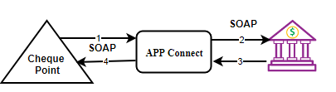

**Sequence of Steps:**

1. Cheque point Application send the approval request to APP Connect via SOAP format.
2. App Connect will send the Approval request to NBE (National Bank of Ethiopia) via SOAP Format.
3. NBE Respond back for the approval request to APP Connect via SOAP format.
4. APP Connect will send the response back to Cheque Point Application.

**Step 4: unblocking the amount.**

**Note: Below sequence Diagram.**



**Sequence of Steps:**

1. Cheque Point Application initiate a request to APIC to unblock funds in the customer account via SOAP format.
2. APIC will send the request to APP connect via SOAP Format.
3. APP Connect will send the request to Core Banking System (CBS) to unblock the funds in the customer account.
4. Core Banking System will respond back to App connect by unblocking the funds in the customer account via SOAP Format.
5. APP Connect will send the response back to APIC via SOAP Format.
6. APIC will send response to the Cheque point application via SOAP format.

**Step 5: Fund Transfer.**

Cheque point will proceed for fund transfer.

**Note: Below sequence Diagram.**



**Funds will be debit from customer account and credit the GL Pool Account.**

**Sequence of Steps:**

1. Cheque Point Application initiate a request to APIC via SOAP format.
2. APIC will send the request to APP connect via SOAP Format.
3. APP Connect will send the request to Core Banking System (CBS) to initiate FT request.
4. Core Banking System will respond back to App connect by doing debit in the customer account and credit the pool account via SOAP Format.
5. APP Connect will send the response back to APIC via SOAP Format.
6. APIC will send a final response to the Cheque point application via SOAP format.

### **Incoming Check application with NBE :**

Incoming RGTS message is deposited to Dashen Customer Account from other bank

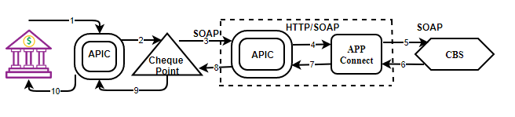

**Sequence of Steps:**

1. NBE initiate a request to APIC.
2. APIC will send the request to Cheque point
3. Cheque point will send the Dashen Bank credit request to APIC via SOAP Format.
4. APIC will send the credit request to APP Connect via SOAP format.
5. APP Connect will send the request to Core Banking System (CBS).
6. Core Banking System will respond back to App connect by Crediting in the customer account and Debit the pool account via SOAP Format.
7. APP Connect will send the response back to APIC via SOAP Format.
8. APIC will send a final response to the Cheque point via SOAP format.
9. Cheque point will send response back to APIC.
10. APIC will send response back to NBE.

### **Liquidate Transaction [NBE CPO txn] :**

**Note: Below sequence Diagram.**



**Funds will be debit from customer account and credit the GL Pool Account.**

**Sequence of Steps:**

1. Cheque Point Application initiate a request to APIC via SOAP format.
2. APIC will send the request to APP connect via SOAP Format.
3. APP Connect will send the request to Core Banking System (CBS) to initiate FT request.
4. Core Banking System will respond back to App connect by doing debit in the customer account and credit the pool account via SOAP Format.
5. APP Connect will send the response back to APIC via SOAP Format.
6. APIC will send a final response to the Cheque point application via SOAP format.

### **Fund Transfer [NBE cheque txn]:**

**Note: Below sequence Diagram.**



**Funds will be Credit from customer account and debit the NBE Pool Account.**

**Sequence of Steps:**

1. Cheque Point Application initiate a request to APIC via SOAP format.
2. APIC will send the request to APP connect via SOAP Format.
3. APP Connect will send the request to Core Banking System (CBS) to initiate FT request.
4. Core Banking System will respond back to App connect by doing credit in the customer account and debit the pool account via SOAP Format.
5. APP Connect will send the response back to APIC via SOAP Format.
6. APIC will send a final response to the Cheque point application via SOAP format.

### **Bulk Fund Transfer [NBE Account to account]:**

**Note: Below sequence Diagram.**



**Funds will be debit from customer account and Credit the NBE Pool Account/Other Bank Account.**

**Sequence of Steps:**

1. Cheque Point Application initiate a request to APIC via SOAP format.
2. APIC will send the request to APP connect via SOAP Format.
3. APP Connect will send the request to Core Banking System (CBS) to initiate FT request.
4. Core Banking System will respond back to App connect by doing credit in the customer account and debit the pool account via SOAP Format.
5. APP Connect will send the response back to APIC via SOAP Format.
6. APIC will send a final response to the Cheque point application via SOAP format.

# **ECX**

### **Bulk Fund Transfer**

**Step 1: Get Bulk Balance Enquiry**

**Note: Below sequence Diagram represents services**

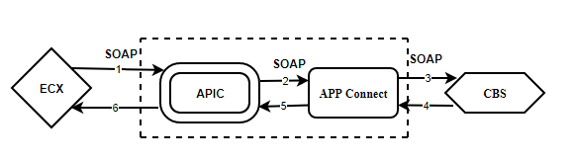

**Sequence of steps:**

1. ECX Application initiate a request to APIC via SOAP format.
2. APIC will send the request to APP connect via SOAP Format.
3. APP Connect will send the request to Core Banking System (CBS) to initiate FT request.
4. Core Banking System will respond back to App connect by doing debit in the ECX customer account and ECX authority account via SOAP Format.
5. APP Connect will send the response back to APIC via SOAP Format.
6. APIC will send a final response to the Cheque point application via SOAP format.

**Step 2: Authorization**

**Note: Below sequence Diagram represents services**

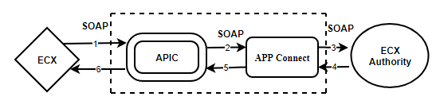

**Sequence of steps:**

1. ECX Application initiate a request to APIC via SOAP format.
2. APIC will send the request to APP connect via SOAP Format.
3. APP Connect will send the request to Ecx Authority.
4. Ecx will authorize the request and respond back to APP connect via SOAP web-service call.
5. APP Connect will send the response back to APIC via SOAP Format.
6. APIC will send a final response to ECX via SOAP format.