**Contents**

**1.** **Introduction** 4

**2.** **Channels** 4

**1.** **Mobile Banking** 4

**1. Bank Account Balance Enquiry** 4

**2. Internal Transfer [ETB to ETB, Dollar to ETB within the Bank]** 4

**3. Bank Account Details** 4

**4. Wallet to Bank Transfer** 5

**5. Bank to Wallet Transfer** 6

**6. Mini Statement** 7

**7. Internal Transfer [ETB to ETB other bank]** 7

**8. Bill Payment using Bank Account** 8

**9. Reversal Process** 10

**2.** **Internet Banking** 10

**1. Bank Account Balance Enquiry** 10

**2. Internal Transfer [ETB to ETB, Dollar to ETB within the Bank]** 10

**3. Batch Upload [corporate customers]** 10

**4. Account Details Bank** 10

**5. Mini Statement** 11

**6. Full Statement** 11

**7. Internal Transfer [ETB to ETB other bank]** 12

**8. Wallet to Bank Transfer** 12

**9. Bank to Wallet Transfer** 13

**10. Bill Payment Using Bank Account** 14

**11. Reversal Process** 16

**3.** **USSD** 18

**1.** **Bank Account Balance Enquiry** 18

**2.** **Internal Transfer [ETB to ETB, Dollar to ETB within the Bank]** 18

**3.** **Mini Statement** 20

**4.** **Wallet to Bank Transfer** 21

**5.** **Bank to wallet Transfer** 22

**6.** **Bill Payment using Bank Account** 23

**7.** **Reversal Process** 26

**4.** **Social Banking** 27

**1.** **Content Shelf** 27

**2.** **Bill Payment from wallet** 27

**5.** **Agent MPOS** 28

**1.** **Deposit Wallet -Walk-in customers.** 28

**2.** **Bill Payment from wallet.** 28

**3.** **With drawal Wallet -walk-in customers.** 28

**4.** **Bill payment at Merchant site.** 28

**5.** **Content shelf** 28

**6.** **ATM** 29

**1.** **Account Balance Enquiry** 29

**2.** **Mini Statement** 29

**3.** **Cash Withdrawal** 29

**7.** **Merchant Pos** 30

**1.** **Account Balance Enquiry** 30

**2.** **Purchase** 30

**3.** **Refund** 30

**4.** **Reversal** 30

**5.** **Manual Card Entry** 30

**6.** **Purchase [Remote On us]** 31

**8.** **Branch POS** 32

**1.** **Account Balance Enquiry.** 32

**2.** **Reversal.** 32

**3.** **Cash advance.** 32

**9.** **Cheque Point** 33

**1.** **Cheque Point Traffic.** 33

**2.** **Cheque Point Tax.** 35

**3.** **Check application with NBE** 40

**10.** **ECX** 44

**1.** **Bulk Fund Transfer** 44

# **Introduction**

This document will make you understand the flow between the systems

# **Channels**

# **Mobile Banking**

The below services are under Mobile Banking

### **Bank Account Balance Enquiry**

### **Internal Transfer [ETB to ETB, Dollar to ETB within the Bank]**

### **Bank Account Details**

Note: Below sequence Diagram represents all above 3 services

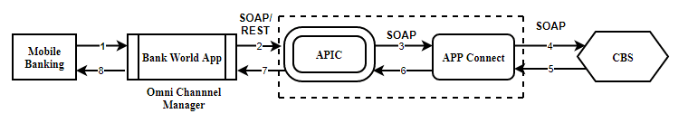

**Sequence of steps:**

1. User Initiate the request to Bank World App.
2. Bank World App sent the user request to APIC Via SOAP/REST Web-service call.
3. APIC will Send the request to APP Connect via SOAP Web-service call.
4. App Connect will send the valid request to Bank Core Banking System via SOAP Web-service call.
5. Core Banking System will Respond bank to App connect with valid response Via SOAP Web-service call.
6. App Connect will send response back to APIC with valid response Via SOAP Web-service call.
7. APIC will send response back to Bank World App via SOAP/REST Web-service call.
8. Bank World App will send response back to the End User.

### **Wallet to Bank Transfer**

**Note: Below sequence Diagram represents service**

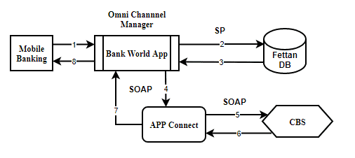

**Sequence of steps:**

1. User Initiate the request to Bank World App.
2. Bank World App sent the user request to Fettan DB to debit the user wallet and credit the GL wallet.
3. After successful debit and credit operation Fettan DB respond back to Bank World APP via Database Stored procedure.
4. Bank world App will initiate Account credit request to App connect via SOAP web-service call.
5. App connect will send the request to Core banking system via SOAP web-service call.
6. Core Banking System will credit the customer account and debit the bank pool account and send the response to App Connect via SOAP web-service call.
7. App Connect will send response to Bank World App via SOAP web-service call.
8. Bank World App will send final response to User.

### **Bank to Wallet Transfer**

**Note: Below sequence Diagram represents service**

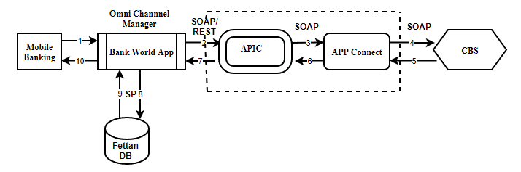

**Sequence of steps:**

1. User Initiate the request to Bank World App.
2. Bank World App sent the user request to APIC debit the user Account and credit the GL Account via SOAP/REST web-service call.
3. APIC will pass the request to App Connect via Soap Web-service call.
4. App connect will send the request to Core banking system Via Soap Web-service call.
5. Once Core banking system receive the request will debit the customer bank account and credit the GL Account and send the response back to App connect.
6. App connect will send the response bank to APIC via SOAP web-service call.
7. After receiving successful response from APP Connect the same will send the response to World Bank App via SOAP/REST web-service call.
8. Bank world App will send request to Fettan DB to credit the customer wallet Via Database stored procedure.
9. After receiving the request from Bank world App Fettan DB will credit the customer wallet and debit the GL wallet and send response back to Bank world App via Database stored procedure.
10. Bank World app will send the final response to user.

### **Mini Statement**

**Note: Below sequence Diagram represents service**

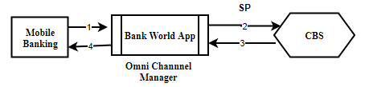

**Sequence of steps:**

1. User Initiate the request to Bank World App.
2. Bank World App sent the user request to Core Banking System via Database Stored Procedure.
3. Core Banking System respond back to Bank world App via Database Stored Procedure.
4. Bank World App respond back to user with valid response.

### **Internal Transfer [ETB to ETB other bank]**

**Note: Below sequence Diagram represents service**

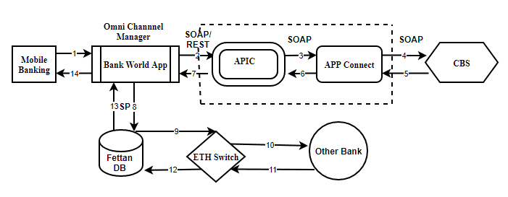

**CBS will debit the customer bank Account and credit the other bank pool account.**

### **Bill Payment using Bank Account**

In the process of bill payment using Bank Account the following steps are involved.

1. **Bill Enquiry**.

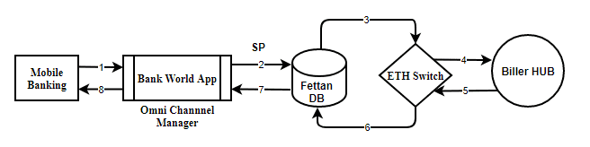

This service helps the customer to know his bill amount to be paid.

**Sequence of steps:**

1. User Initiate the request from Mobile Banking to Bank World App.
2. Bank World App sent the user request to Fettan DB via Database Stored Procedure.
3. Fettan DB in-turn send the Bill enquiry request to ETH Switch.
4. ETH Switch send the request back to exact Biller to get the details of bill due details.
5. Biller Hub Respond back to ETH switch which indeed has due amount to be paid by the customer.
6. ETH switch send the response to Fettan DB.
7. Fettan DB send the Bill amount due details to Bank World App.
8. Bank world App send the exact bill amount due details back to the end user.
9. **Bill Payment Using Bank Account**

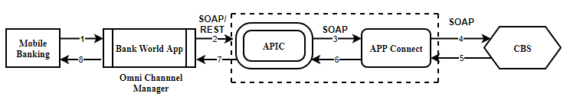

This service helps the customer to pay his bill amount.

**Sequence of steps:**

1. User Initiate the request from Mobile Banking to Bank World App.
2. Bank World App sent the user request to APIC Via SOAP/REST web-service call.
3. APIC in-turn send the Bill payment request to APP connect Via SOAP/REST web-service call.
4. APP connect send the request back to Core Banking System (CBS) Via SOAP/REST web-service call.
5. Core Banking System (CBS) based on the available funds in the customer account will debit the customer Account and credit the biller pool account. In case of insufficient funds a valid response is sent by Core Banking System (CBS) to App connect Via SOAP/REST web-service call.
6. App connect send the response back to APIC Via SOAP/REST web-service call.
7. APIC will send the response to Bank World App.
8. Bank world App send the response back to the end user.
9. **Acknowledgement to the Biller.**



This service will update Biller after successful bill amount is paid.

**Sequence of steps:**

1. User Initiate the request from Mobile Banking to Bank World App.
2. Bank World App sent the user request to Fettan DB via Database Stored Procedure.
3. Fettan DB in-turn send the Bill acknowledgement request to ETH Switch.
4. ETH Switch send the request back to exact Biller to update the bill details.
5. Biller Hub Respond back to ETH switch.
6. ETH switch send the response to Fettan DB.
7. Fettan DB send the acknowledgement response to Bank World App.
8. Bank world App send the acknowledgement response back to the end user.

### **Reversal Process**

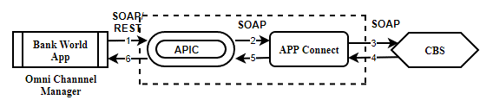

This service will be initiated whenever a fund transfer gets failed in order to credit the funds back to customer account.

**Sequence of steps:**

1. Bank World App Initiate the reversal request to APIC via REST/SOAP Web-service call.
2. APIC sent the reversal request to APP Connect via SOAP/REST Web-service call.
3. App Connect will send the valid request to Bank Core Banking System via SOAP Web-service call.
4. Core Banking System will Respond bank to App connect with valid response by debiting the pool Account and credit the customer Account via SOAP Web-service call.
5. App Connect will send response back to APIC with valid response Via SOAP Web-service call.
6. APIC will send response back to Bank World App via SOAP/REST Web-service call.

# **Internet Banking**

### **Bank Account Balance Enquiry**

### **Internal Transfer [ETB to ETB, Dollar to ETB within the Bank]**

### **Batch Upload [corporate customers]**

### **Account Details Bank**

**Note: Below sequence Diagram represents all above 3 services**

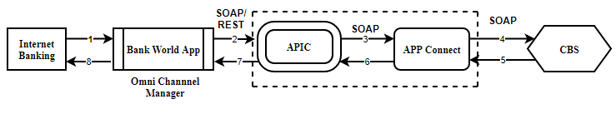

**Sequence of steps:**

1. User Initiate the request to Bank World App.
2. Bank World App sent the user request to APIC Via SOAP/REST Web-service call.
3. APIC will Send the request to APP Connect via SOAP Web-service call.
4. App Connect will send the valid request to Bank Core Banking System via SOAP Web-service call.
5. Core Banking System will Respond bank to App connect with valid response Via SOAP Web-service call.
6. App Connect will send response back to APIC with valid response Via SOAP Web-service call.
7. APIC will send response back to Bank World App via SOAP/REST Web-service call.
8. Bank World App will send response back to the End User.

### **Mini Statement**

### **Full Statement**

**Note: Below sequence Diagram represents all above 2 services**

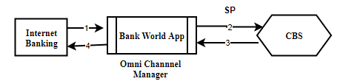

**Sequence of steps:**

1. User Initiate the request to Bank World App.
2. Bank World App sent the user request to Core Banking System via Database Stored Procedure.
3. Core Banking System respond back to Bank world App via Database Stored Procedure.
4. Bank World App respond back to user with valid response.

### **Internal Transfer [ETB to ETB other bank]**

**Note: Below sequence Diagram represents service**

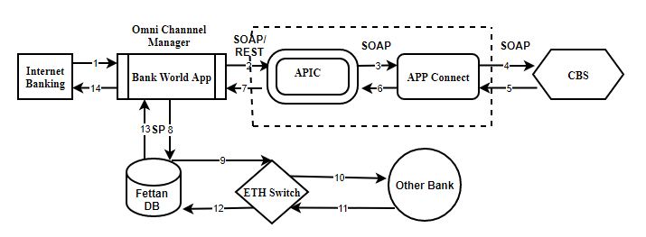

**CBS will debit the customer Dashen bank Account and credit the other bank pool account.**

### **Wallet to Bank Transfer**

**Note: Below sequence Diagram represents service**

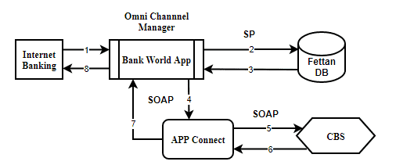

**Sequence of steps:**

1. User Initiate the request to Bank World App.
2. Bank World App sent the user request to Fettan DB to debit the user wallet and credit the GL wallet.
3. After successful debit and credit operation Fettan DB respond back to Bank World APP via Database Stored procedure.
4. Bank world App will initiate Account credit request to App connect via SOAP web-service call.
5. App connect will send the request to Core banking system via SOAP web-service call.
6. Core Banking System will credit the customer account and debit the bank pool account and send the response to App Connect via SOAP web-service call.
7. App Connect will send response to Bank World App via SOAP web-service call.
8. Bank World App will send final response to User.

### **Bank to Wallet Transfer**

**Note: Below sequence Diagram represents service**

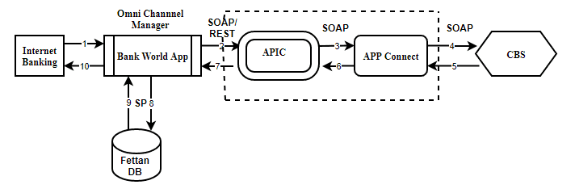

**Sequence of steps:**

1. User Initiate the request to Bank World App.
2. Bank World App sent the user request to APIC debit the user Account and credit the GL Account via SOAP/REST web-service call.
3. APIC will pass the request to App Connect via Soap Web-service call.
4. App connect will send the request to Core banking system Via Soap Web-service call.
5. Once Core banking system receive the request will debit the customer bank account and credit the GL Account and send the response back to App connect.
6. App connect will send the response bank to APIC via SOAP web-service call.
7. After receiving successful response from APP Connect the same will send the response to World Bank App via SOAP/REST web-service call.
8. Bank world App will send request to Fettan DB to credit the customer wallet Via Database stored procedure.
9. After receiving the request from Bank world App Fettan DB will credit the customer wallet and debit the GL wallet and send response back to Bank world App via Database stored procedure.
10. Bank World app will send the final response to user.

### **Bill Payment Using Bank Account**

**Note: Below sequence Diagram represents service**

In the process of bill payment using Bank Account the following steps are involved.

1. **Bill Enquiry**.

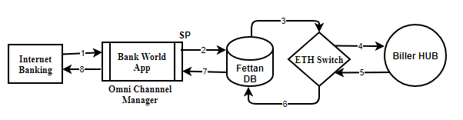

This service helps the customer to know his bill amount to be paid.

**Sequence of steps:**

1. User Initiate the request from Internet Banking to Bank World App.
2. Bank World App sent the user request to Fettan DB via Database Stored Procedure.
3. Fettan DB in-turn send the Bill enquiry request to ETH Switch.
4. ETH Switch send the request back to exact Biller to get the details of bill due details.
5. Biller Hub Respond back to ETH switch which indeed has due amount to be paid by the customer.
6. ETH switch send the response to Fettan DB.
7. Fettan DB send the Bill amount due details to Bank World App.
8. Bank world App send the exact bill amount due details back to the end user.
9. **Bill Payment Using Bank Account**

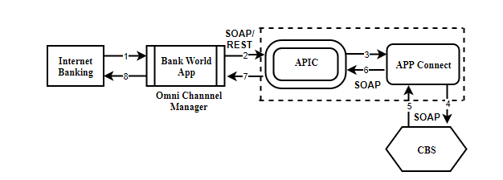

This service helps the customer to pay his bill amount.

**Sequence of steps:**

1. User Initiate the request from Internet Banking to Bank World App.
2. Bank World App sent the user request to APIC Via SOAP/REST web-service call.
3. APIC in-turn send the Bill payment request to APP connect Via SOAP/REST web-service call.
4. APP connect send the request back to Core Banking System (CBS) Via SOAP/REST web-service call.
5. Core Banking System (CBS) based on the available funds in the customer account will debit the customer Account and credit the biller pool account. In case of insufficient funds a valid response is sent by Core Banking System (CBS) to App connect Via SOAP/REST web-service call.
6. App connect send the response back to APIC Via SOAP/REST web-service call.
7. APIC will send the response to Bank World App.
8. Bank world App send the response back to the end user.
9. **Acknowledgement to the Biller.**



This service will update Biller after successful bill amount is paid.

**Sequence of steps:**

1. User Initiate the request from Internet Banking to Bank World App.
2. Bank World App sent the user request to Fettan DB via Database Stored Procedure.
3. Fettan DB in-turn send the Bill acknowledgement request to ETH Switch.
4. ETH Switch send the request back to exact Biller to update the bill details.
5. Biller Hub Respond back to ETH switch.
6. ETH switch send the response to Fettan DB.
7. Fettan DB send the acknowledgement response to Bank World App.
8. Bank world App send the acknowledgement response back to the end user.

### **Reversal Process**



This service will be initiated whenever a fund transfer gets failed in order to credit the funds back to customer account.

**Sequence of steps:**

1. Bank World App Initiate the reversal request to APIC via REST/SOAP Web-service call.
2. APIC sent the reversal request to APP Connect via SOAP/REST Web-service call.
3. App Connect will send the valid request to Bank Core Banking System via SOAP Web-service call.
4. Core Banking System will Respond bank to App connect with valid response by debiting the pool Account and credit the customer Account via SOAP Web-service call.
5. App Connect will send response back to APIC with valid response Via SOAP Web-service call.
6. APIC will send response back to Bank World App via SOAP/REST Web-service call.

# **USSD**

Initially when a customer hits the service the following process take place.

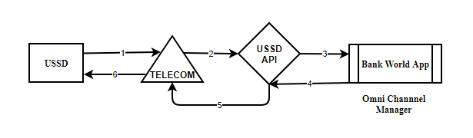

**Sequence of steps:**

1. When a user/Customer initiate the request with USSD Code this will be sent to the exact telecom provider. (#996#)
2. After receiving the request from the user the telecom provider send the request to USSD API.
3. The USSD will send the user request to Channel Manager.
4. Once request received at the channel manager tries to send the available options or menu as a response the USSD API.
5. The Telecom provider will receive the response from USSD API.
6. The available options are displayed to end user.

### **Bank Account Balance Enquiry**

### **Internal Transfer [ETB to ETB, Dollar to ETB within the Bank]**

**Note: Below sequence Diagram represents all above 2 services**

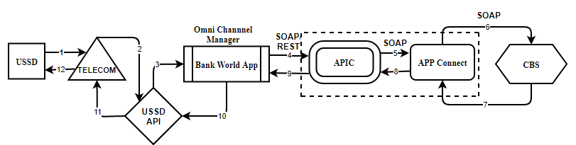

**Sequence of steps:**

1. User Initiate the request to Telecom Provider with valid option.
2. Telecom Provider send the request to USSD API.
3. USSD API Send the user request to Channel Manager (Bank World App).
4. Bank World App sent the user request to APIC Via SOAP/REST Web-service call.
5. APIC will Send the request to APP Connect via SOAP Web-service call.
6. App Connect will send the valid request to Bank Core Banking System via SOAP Web-service call.
7. Core Banking System will Respond bank to App connect with valid response Via SOAP Web-service call.
8. App Connect will send response back to APIC with valid response Via SOAP Web-service call.
9. APIC will send response back to Bank World App via SOAP/REST Web-service call.
10. Bank World App will respond back to USSD API with valid response.
11. USSD API send the response back to Telecom Provider.
12. Telecom provider will send response back to the End User.

### **Mini Statement**

**Note: Below sequence Diagram represents service**

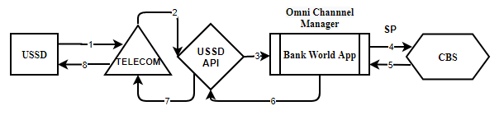

**Sequence of steps:**

1. User Initiate the request to Telecom Provider.
2. Telecom Provider send the request to USSD API.
3. USSD API sends the user request to Channel manager (Bank World App).
4. Bank World App sent the user request to Core Banking System via Database Stored Procedure.
5. Core Banking System respond back to Bank world App via Database Stored Procedure.
6. Bank World App respond back to USSD API with valid response.
7. After receiving the response from Channel Manager USSD API send the response back to Telecom Provider.
8. Telecom provider will send response back to the End User.

### **Wallet to Bank Transfer**

**Note: Below sequence Diagram represents service**

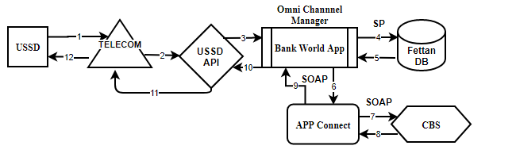

**Sequence of steps:**

1. User Initiate the request to Telecom Provider.
2. Telecom Provider send the request to USSD API.
3. USSD API will send the request to Bank world App (Channel Manager).
4. Bank World App sent the user request to Fettan DB to debit the user wallet and credit the GL wallet.
5. After successful debit and credit operation Fettan DB respond back to Bank World APP via Database Stored procedure.
6. Bank world App will initiate Account credit request to App connect via SOAP web-service call.
7. App connect will send the request to Core banking system via SOAP web-service call.
8. Core Banking System will credit the customer account and debit the bank pool account and send the response to App Connect via SOAP web-service call.
9. App Connect will send response to Bank World App via SOAP web-service call.
10. Bank World App will send final response to USSD API.
11. USSD API will send Wallet to bank account corresponding response back to Telecom Provider.
12. Telecom provider will send response back to the End User.

### **Bank to wallet Transfer**

**Note: Below sequence Diagram represents service**

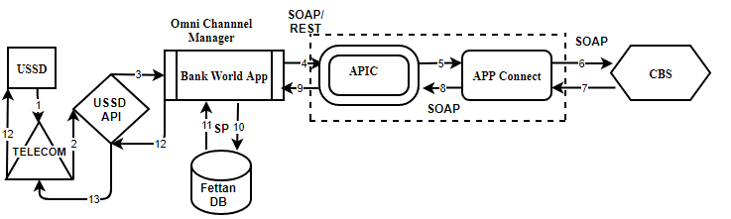

**Sequence of steps:**

1. User Initiate the request to Telecom Provider.
2. Telecom Provider send the request to USSD API.
3. USSD API will send the user request to Channel Manager (Bank world App).
4. Bank World App sent the user request to APIC debit the user Account and credit the GL Account via SOAP/REST web-service call.
5. APIC will pass the request to App Connect via Soap Web-service call.
6. App connect will send the request to Core banking system Via Soap Web-service call.
7. Once Core banking system receive the request will debit the customer bank account and credit the GL Account and send the response back to App connect.
8. App connect will send the response bank to APIC via SOAP web-service call.
9. After receiving successful response from APP Connect the same will send the response to World Bank App via SOAP/REST web-service call.
10. Bank world App will send request to Fettan DB to credit the customer wallet Via Database stored procedure.
11. After receiving the request from Bank world App Fettan DB will credit the customer wallet and debit the GL wallet and send response back to Bank world App via Database stored procedure.
12. Bank World app will send the final response to USSD API.
13. USSD API will send the response back to Telecom Provider.
14. Telecom provider will send response back to the End User.

### **Bill Payment using Bank Account**

In the process of bill payment using Bank Account the following steps are involved.

1. **Bill Enquiry**.

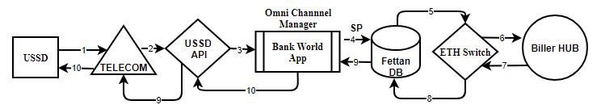

This service helps the customer to know his bill amount to be paid.

**Sequence of steps:**

1. User Initiate the request from USSD to Telecom Provider.
2. Telecom Provider send the request to USSD API.
3. USSD API will send the user request to Channel Manager (Bank world App).
4. Bank World App sent the user request to Fettan DB via Database Stored Procedure.
5. Fettan DB in-turn send the Bill enquiry request to ETH Switch.
6. ETH Switch send the request back to exact Biller to get the details of bill due details.
7. Biller Hub Respond back to ETH switch which indeed has due amount to be paid by the customer.
8. ETH switch send the response to Fettan DB.
9. Fettan DB send the Bill amount due details to Bank World App.
10. Bank world App send the exact bill amount due details back to the USSD API.
11. USSD API will send the response back to Telecom Provider.
12. Telecom provider will send response back to the End User.
13. **Bill Payment Using Bank Account**

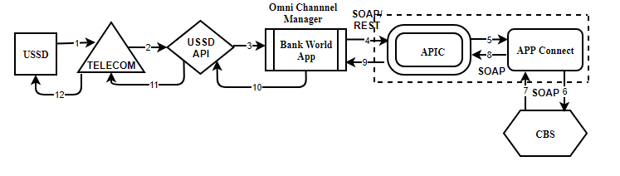This service helps the customer to pay his bill amount.

**Sequence of steps:**

1. User Initiate the request from USSD to Telecom Provider.
2. Telecom Provider send the request to USSD API.
3. USSD API will send the user request to Channel Manager (Bank world App).
4. Bank World App sent the user request to APIC Via SOAP/REST web-service call.
5. APIC in-turn send the Bill payment request to APP connect Via SOAP/REST web-service call.
6. APP connect send the request back to Core Banking System (CBS) Via SOAP/REST web-service call.
7. Core Banking System (CBS) based on the available funds in the customer account will debit the customer Account and credit the biller pool account. In case of insufficient funds a valid response is sent by Core Banking System (CBS) to App connect Via SOAP/REST web-service call.
8. App connect send the response back to APIC Via SOAP/REST web-service call.
9. APIC will send the response to Bank World App.
10. Bank world App send the response back to the USSD API.
11. USSD API will send the response back to Telecom Provider.
12. Telecom provider will send response back to the End User.
13. **Acknowledgement to the Biller.**



This service will update Biller after successful bill amount is paid.

**Sequence of steps:**

1. User Initiate the request from USSD to Telecom Provider.
2. Telecom Provider send the request to USSD API.
3. USSD API will send the user request to Channel Manager (Bank world App).
4. Bank World App sent the user request to Fettan DB via Database Stored Procedure.
5. Fettan DB in-turn send the Bill acknowledgement request to ETH Switch.
6. ETH Switch send the request back to exact Biller to update the bill details.
7. Biller Hub Respond back to ETH switch.
8. ETH switch send the response to Fettan DB.
9. Fettan DB send the acknowledgement response to Bank World App.
10. Bank world App send the acknowledgement response back to the USSD API.
11. USSD API will send the response back to Telecom Provider.
12. Telecom provider will send response back to the End User.

### **Reversal Process**



This service will be initiated whenever a fund transfer gets failed in order to credit the funds back to customer account.

**Sequence of steps:**

1. Bank World App Initiate the reversal request to APIC via REST/SOAP Web-service call.
2. APIC sent the reversal request to APP Connect via SOAP/REST Web-service call.
3. App Connect will send the valid request to Bank Core Banking System via SOAP Web-service call.
4. Core Banking System will Respond bank to App connect with valid response by debiting the pool Account and credit the customer Account via SOAP Web-service call.
5. App Connect will send response back to APIC with valid response Via SOAP Web-service call.
6. APIC will send response back to Bank World App via SOAP/REST Web-service call.

# **Social Banking**

### **Content Shelf**

### **Bill Payment from wallet**

**Note: Below sequence Diagram represents all above 2 services**

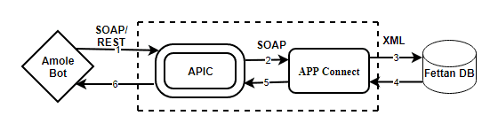

**Sequence of steps:**

1. User Initiate the request from Amole Bot request is send to APIC Via SOAP/REST format.
2. APIC sent the user request to APP Connect via SOAP format.
3. APP Connect will pass the request to Fettan DB to debit customer wallet and credit merchant wallet request Via XML format.
4. Fettan DB will debit customer wallet and credit merchant wallet and send back the valid response to APP Connect via XML format.
5. Once APP Connect receive the response send back to the APIC SOAP format.
6. APIC will respond back to Amole Bot via SOAP/REST format.

# **Agent MPOS**

**Under Agent Mpos there are 5 types’ transactions.**

### **Deposit Wallet -Walk-in customers.**

### **Bill Payment from wallet.**

### **With drawal Wallet -walk-in customers.**

### **Bill payment at Merchant site.**

### **Content shelf**

**Note: Below sequence Diagram represents all above 5 services**

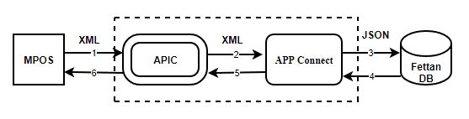

**Sequence of steps:**

1. User Initiate the request to APIC Via XML format.
2. APIC sent the user request to APP Connect via XML format.
3. APP Connect will pass the request to Fettan DB via JSON format.
4. Fettan DB will send back the valid response to APP Connect via JSON format.
5. Once APP Connect receive the response send back to the APIC JSON format.
6. APIC will respond back to user via JSON format.

# **ATM**

**Under ATM there are three types’ transactions**

### **Account Balance Enquiry**

### **Mini Statement**

### **Cash Withdrawal**

**Note: Below sequence Diagram represents all above 3 services**

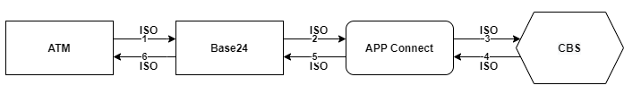

**Sequence of steps:**

1. User Initiate the request to BASE24 via TCP/ISO format.
2. BASE24 sent the user request to APP Connect via TCP/ISO format.
3. APP Connect will pass the request to Core Banking System via TCP/ISO format.
4. Core Banking System will send back the valid response to APP Connect via TCP/ISO format.
5. Once APP Connect receive the response send back to the BASE24 TCP/ISO format.
6. BASE24 will respond back to user via TCP/ISO format.

# **Merchant Pos**

**Under Merchant Pos there are five types’ transactions.**

### **Account Balance Enquiry**

### **Purchase**

### **Refund**

### **Reversal**

### **Manual Card Entry**

**Note: Below sequence Diagram represents all above 5 services**



**In Case of on-us Transaction: (Dashen pos and Dashen Bank Card)**

**Purchase:**

When a customer do purchase using Dashen bank card using purchase service customer account will be debit and merchant pool account will be credit.

**Sequence of steps:**

1. User Initiate the request to BASE24 via TCP/ISO format.
2. BASE24 sent the user request to APP Connect via TCP/ISO format.
3. APP Connect will pass the request to Core Banking System via TCP/ISO format.
4. Core Banking System will send back the valid response to APP Connect via TCP/ISO format.
5. Once APP Connect receive the response send back to the BASE24 TCP/ISO format.
6. BASE24 will respond back to user via TCP/ISO format.

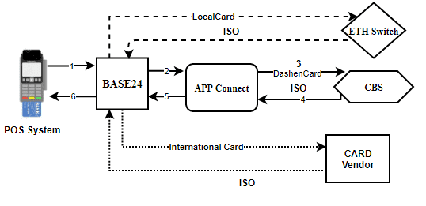

**In the Case of off us transactions**

**Case 1: Local card (Other Bank card)**

Base 24 directly send the request to Eth Switch.

**Case 2: International Card Transaction**

Base 24 directly send the request to International Card Vendor.

### **Purchase [Remote On us]**

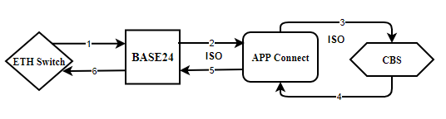

**Sequence of steps:**

1. User Initiate the request from other bank pos to BASE24 via TCP/ISO format.
2. BASE24 sent the user request to APP Connect via TCP/ISO format.
3. APP Connect will pass the request to Core Banking System via TCP/ISO format.
4. Core Banking System will send back the valid response to APP Connect by doing debit in customer account and credit the other bank pool account via TCP/ISO format.
5. Once APP Connect receive the response send back to the BASE24 TCP/ISO format.
6. BASE24 will respond back to user via TCP/ISO format.

# **Branch POS**

**Under Branch Pos there are four types’ transactions.**

### **Account Balance Enquiry.**

### **Reversal.**

### **Cash advance.**

**Note: Below sequence Diagram represents all above 3 services**

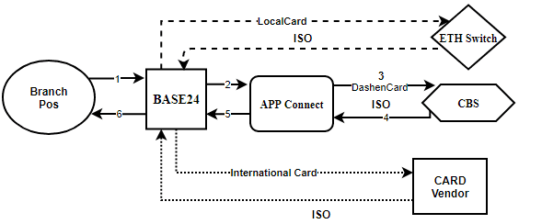

**Sequence of steps:**

1. User Initiate the request to BASE24 via TCP/ISO format.
2. BASE24 sent the user request to APP Connect via TCP/ISO format.
3. APP Connect will pass the request to Core Banking System via TCP/ISO format.
4. Core Banking System will send back the valid response to APP Connect via TCP/ISO format.
5. Once APP Connect receive the response send back to the BASE24 TCP/ISO format.
6. BASE24 will respond back to user via TCP/ISO format.

# **Cheque Point**

**Under Cheque Point there are 3 types’ transactions.**

### **Cheque Point Traffic.**

Customer can pay the traffic due by using the Cheque point Traffic system.

The following steps are involved for doing this process.

**Step 1:** **Get the Due Details from Traffic Management System.**

**Note: Below sequence Diagram represents above service.**

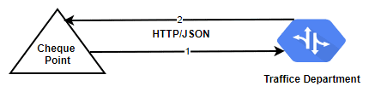

**Sequence of Steps:**

1. Cheque Point Application Initiate the request to Traffic Management System to get the traffic Due details by passing License number as parameter via HTTP/Json format.
2. Traffic Management System respond back to the Cheque point application with exact due amount to be paid via HTTP/Json format.

**Step 2:** **Check the Balance using balance Enquiry Service.**

**Note: Below sequence Diagram represents above service.**

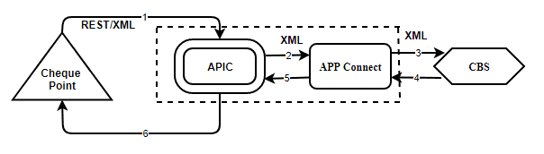

**Sequence of Steps:**

**After successful get due details**

1. Cheque Point Application initiate a request to APIC to get the available funds in the customer via REST/XML format.
2. APIC will send the request to APP connect via HTTP/XML Format.
3. APP Connect will send the request to Core Banking System (CBS) to get available funds in the customer account.
4. Core Banking System will respond back to App connect with available balance in the customer account via HTTP/XML Format.
5. APP Connect will send the response back to APIC via HTTP/XML Format.
6. APIC will send available funds in the customer account as a final response to the Cheque point application via REST/XML format.

**Step 3: Fund Transfer.**

Based on the available funds using step 2, Cheque point will proceed for fund transfer.

**Note: Below sequence Diagram represents above service.**



**Sequence of Steps:**

1. Cheque Point Application initiate a request to APIC via REST/XML format.
2. APIC will send the request to APP connect via HTTP/XML Format.
3. APP Connect will send the request to Core Banking System (CBS) to initiate FT request.
4. Core Banking System will respond back to App connect by doing debit in the customer account and credit the pool account via HTTP/XML Format.
5. APP Connect will send the response back to APIC via HTTP/XML Format.
6. APIC will send a final response to the Cheque point application via REST/XML format.

**Step 4: Acknowledgement to Traffic Management System.**

**Note: Below sequence Diagram represents above service.**



**Sequence of Steps:**

1. After successful fund transfer Cheque Point Application Initiate the Ack to Traffic Management System via HTTP/Json format.
2. Traffic Management System respond back to the Cheque point application via HTTP/Json format.

### **Cheque Point Tax.**

Customer can pay the tax due by using the Cheque point tax system.

The following steps are involved for doing this process.

**Step 1:** **Get the Due Details from Tax System.**

**Note: Below sequence Diagram represents above service.**

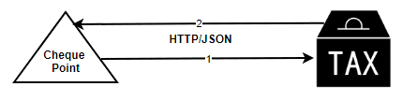

**Sequence of Steps:**

1. Cheque Point Application Initiate the request to Tax System to get the tax Due details by passing PAN number as parameter via HTTP/Json format.
2. Tax System respond back to the Cheque point application with exact due amount to be paid via HTTP/Json format.

**Step 2:** **Check the Balance using balance Enquiry Service.**

**Note: Below sequence Diagram represents above service.**



**Sequence of Steps:**

**After successful get due details**

1. Cheque Point Application initiate a request to APIC to get the available funds in the customer account via REST/XML format.
2. APIC will send the request to APP connect via HTTP/XML Format.
3. APP Connect will send the request to Core Banking System (CBS) to get available funds in the customer account.
4. Core Banking System will respond back to App connect with available balance in the customer account via HTTP/XML Format.
5. APP Connect will send the response back to APIC via HTTP/XML Format.
6. APIC will send available funds in the customer account as a final response to the Cheque point application via REST/XML format.

**Step 3: Blocking the amount.**

**Note: Below sequence Diagram represents above service.**



**Sequence of Steps:**

1. Cheque Point Application initiate a request to APIC to block funds in the customer account via REST/XML format.
2. APIC will send the request to APP connect via HTTP/XML Format.
3. APP Connect will send the request to Core Banking System (CBS) to Block the funds in the customer account.
4. Core Banking System will respond back to App connect by blocking the funds if available balance is there in the customer account via HTTP/XML Format.
5. APP Connect will send the response back to APIC via HTTP/XML Format.
6. APIC will send response to the Cheque point application via REST/XML format.

**Step 4:** **Get approval from NBE (National Bank of Ethiopia).**

**Note: Below sequence Diagram represents above service.**

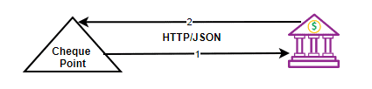

**Sequence of Steps:**

Based on the above step 1, 2, 3 and 4.

1. Cheque point Application send the approval request to NBE (National Bank of Ethiopia) via HTTP/Json format.
2. NBE Respond back for the approval request to Cheque Point Application via HTTP/Json format.

**Step 5: unblocking the amount.**

**Note: Below sequence Diagram represents above service.**



**Sequence of Steps:**

1. Cheque Point Application initiate a request to APIC to unblock funds in the customer account via REST/XML format.
2. APIC will send the request to APP connect via HTTP/XML Format.
3. APP Connect will send the request to Core Banking System (CBS) to unblock the funds in the customer account.
4. Core Banking System will respond back to App connect by unblocking the funds in the customer account via HTTP/XML Format.
5. APP Connect will send the response back to APIC via HTTP/XML Format.
6. APIC will send response to the Cheque point application via REST/XML format.

**Step 6: Fund Transfer.**

Cheque point will proceed for fund transfer.

**Note: Below sequence Diagram represents above service.**



**Tax Due funds will be debit from customer account and credit the GL Pool Account.**

**Sequence of Steps:**

1. Cheque Point Application initiate a request to APIC via REST/XML format.
2. APIC will send the request to APP connect via HTTP/XML Format.
3. APP Connect will send the request to Core Banking System (CBS) to initiate FT request.
4. Core Banking System will respond back to App connect by doing debit in the customer account and credit the pool account via HTTP/XML Format.
5. APP Connect will send the response back to APIC via HTTP/XML Format.
6. APIC will send a final response to the Cheque point application via REST/XML format.

**Step 7:** **Acknowledgement to NBE (National Bank of Ethiopia).**

**Note: Below sequence Diagram represents above service.**



**Once the Tax amount is paid will sent ack to NBE.**

**Sequence of Steps:**

1. Cheque point Application send the approval request to NBE (National Bank of Ethiopia) via HTTP/Json format.
2. NBE Respond back for the approval request to Cheque Point Application via HTTP/Json format.

### **Check application with NBE**

**Step 1:** **Check the Balance using balance Enquiry Service.**

**Note: Below sequence Diagram represents above service.**



**Sequence of Steps:**

1. Cheque Point Application initiate a request to APIC to get the available funds in the customer account via REST/XML format.
2. APIC will send the request to APP connect via HTTP/XML Format.
3. APP Connect will send the request to Core Banking System (CBS) to get available funds in the customer account.
4. Core Banking System will respond back to App connect with available balance in the customer account via HTTP/XML Format.
5. APP Connect will send the response back to APIC via HTTP/XML Format.
6. APIC will send available funds in the customer account as a final response to the Cheque point application via REST/XML format.

**Step 2: Blocking the amount.**

**Note: Below sequence Diagram represents above service.**



**Sequence of Steps:**

1. Cheque Point Application initiate a request to APIC to block funds in the customer account via REST/XML format.
2. APIC will send the request to APP connect via HTTP/XML Format.
3. APP Connect will send the request to Core Banking System (CBS) to Block the funds in the customer account.
4. Core Banking System will respond back to App connect by blocking the funds if available balance is there in the customer account via HTTP/XML Format.
5. APP Connect will send the response back to APIC via HTTP/XML Format.
6. APIC will send response to the Cheque point application via REST/XML format.

**Step 3:** **Get approval from NBE (National Bank of Ethiopia).**

**Note: Below sequence Diagram represents above service.**



**Sequence of Steps:**

Based on the above step 1, 2, 3 and 4.

1. Cheque point Application send the approval request to NBE (National Bank of Ethiopia) via HTTP/Json format.
2. NBE Respond back for the approval request to Cheque Point Application via HTTP/Json format.

**Step 4: unblocking the amount.**

**Note: Below sequence Diagram represents above service.**



**Sequence of Steps:**

1. Cheque Point Application initiate a request to APIC to unblock funds in the customer account via REST/XML format.
2. APIC will send the request to APP connect via HTTP/XML Format.
3. APP Connect will send the request to Core Banking System (CBS) to unblock the funds in the customer account.
4. Core Banking System will respond back to App connect by unblocking the funds in the customer account via HTTP/XML Format.
5. APP Connect will send the response back to APIC via HTTP/XML Format.
6. APIC will send response to the Cheque point application via REST/XML format.

**Step 5: Fund Transfer.**

Cheque point will proceed for fund transfer.

**Note: Below sequence Diagram represents above service.**



**Tax Due funds will be debit from customer account and credit the GL Pool Account.**

**Sequence of Steps:**

1. Cheque Point Application initiate a request to APIC via REST/XML format.
2. APIC will send the request to APP connect via HTTP/XML Format.
3. APP Connect will send the request to Core Banking System (CBS) to initiate FT request.
4. Core Banking System will respond back to App connect by doing debit in the customer account and credit the pool account via HTTP/XML Format.
5. APP Connect will send the response back to APIC via HTTP/XML Format.
6. APIC will send a final response to the Cheque point application via REST/XML format.

# **ECX**

### **Bulk Fund Transfer**

**Step 1: Get Bulk Balance Enquiry**

**Note: Below sequence Diagram represents services**

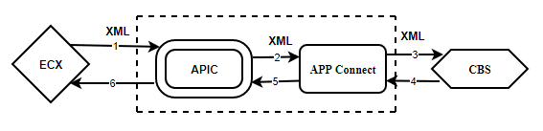

**Sequence of steps:**

1. User Initiate the request to APIC via XML format.
2. APIC sent the user request to APP Connect via XML format.
3. APP Connect will pass the request to Core Banking System via XML format.
4. Core Banking System will send back the valid response with available funds in the customer account to APP Connect via XML format.
5. Once APP Connect receive the response send back to the APIC XML format.
6. APIC will respond back to user via XML format.

**Step 2: ECX system to upload the transaction File and download file from ECX Authority.**

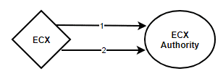

1. ECX system will upload the transaction file into ECX authority System.
2. ECX authority System will download the transaction files.

**Step 3: Bulk Fund Transfer**

**Note: Below sequence Diagram represents services**



**Sequence of steps:**

1. ECX Application initiate a request to APIC via REST/XML format.
2. APIC will send the request to APP connect via HTTP/XML Format.
3. APP Connect will send the request to Core Banking System (CBS) to initiate FT request.
4. Core Banking System will respond back to App connect by doing debit in the ECX customer account and ECX authority account via HTTP/XML Format.
5. APP Connect will send the response back to APIC via HTTP/XML Format.
6. APIC will send a final response to the Cheque point application via REST/XML format.

**Step 4: Ecx system sent Ack to ECX authority**

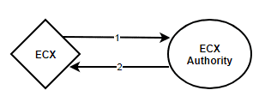

**Sequence of steps:**

1. ECX sends Ack to ECX Authority regarding Bulk fund Transfer.
2. ECX authority respond back to ECX.