Day 8 Lab Exercises

E0121055

1. 1)Using Orders in Global Superstore, which Sub-Category has Standard Deviation for Sales and Profit one point more than the Mean of Sales and Profit?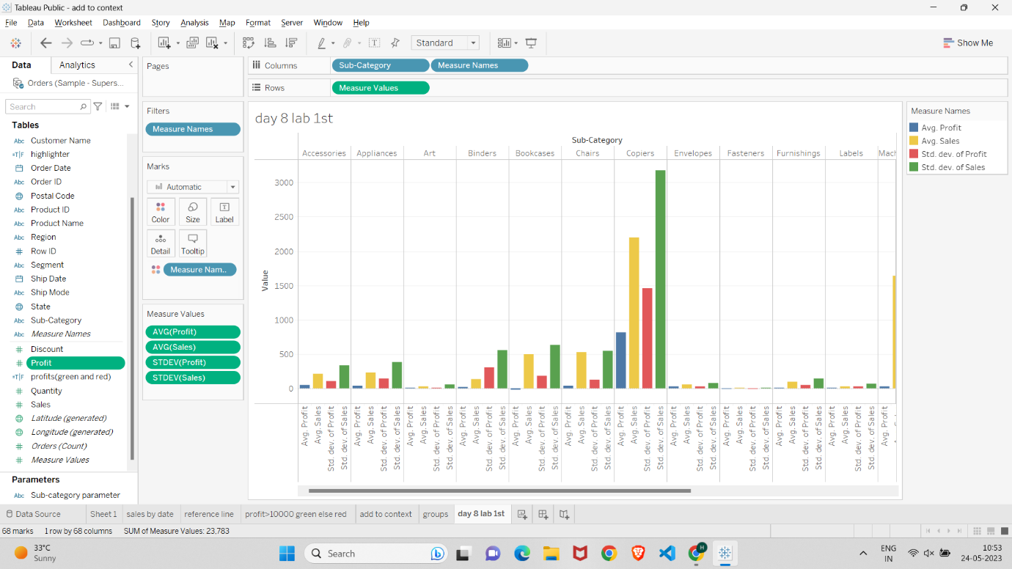
2. Using Global Superstore, identify the Sub-Categories where Top 20 Customers that have Sales more than the other Sub-Categories in the same Region.

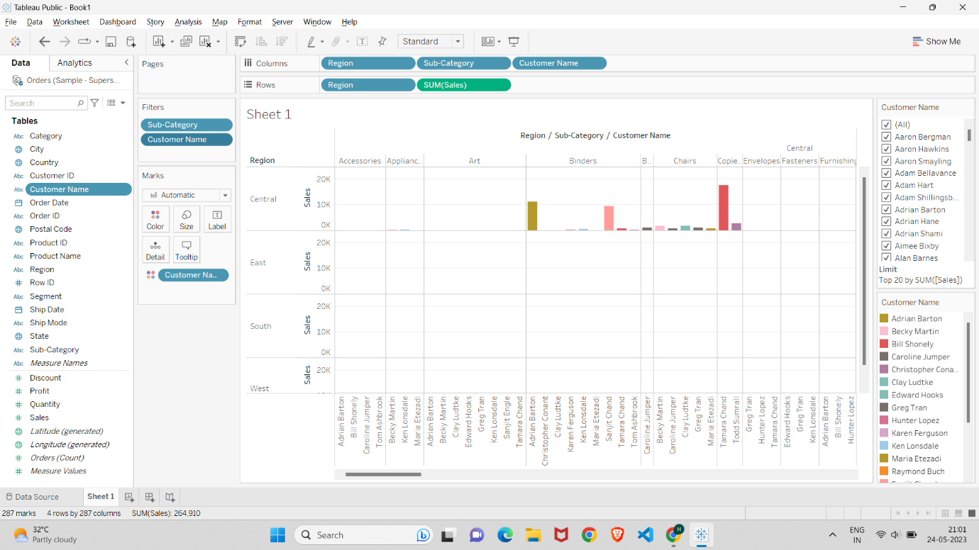

1. Using Global Superstore, identify the Regions where Top 20 Customers that have overall Profit Ratio (Profit as % of Sales) which is double the Profit Ratio of other Customers in the Region.

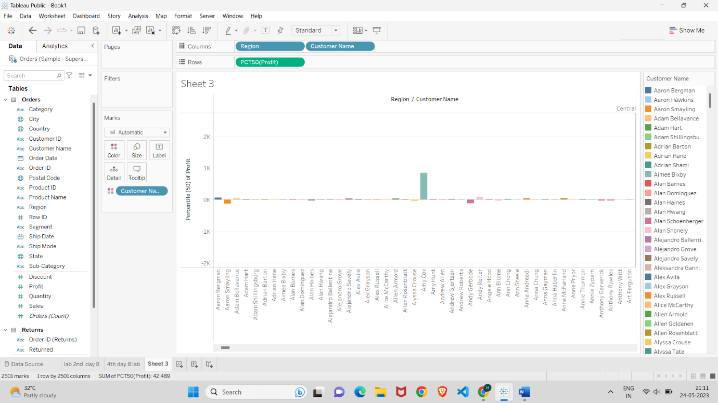

4.Using Orders and Returns on Global Superstore, identify the Manager whose Region Sales were greater than the Overall Average Sales?

