CHAPTER 1
INTRODUCTION

  - CLOUD COMPUTING

Cloud computing is an internet-based computing technology, where shared resources such as software, platform, storage and information are provided to customers on demand. Cloud computing is a computing platform for sharing resources that include infrastructures, software, applications, and business processes. Cloud Computing is a virtual pool of computing resources. It provides computing resources in the pool for users through internet. Cloud computing is an emerging computing paradigm aims to share storage, computation and services transparently among a set of massive users. The exact definition of cloud computing is a large-scale distributed computing paradigm that is driven by economies of scale, in which a pool of abstracted, virtualized, dynamically scalable, managed computing power, storage, platforms, and services are delivered on demand to external customers over the Internet [5].

The three key cloud delivery models are software as a service (SaaS), platform as a service (PaaS), and infrastructure as a service (IaaS). Infrastructure-as-a-Service (IaaS) is offered in the bottom layer, where resources are aggregated and managed physically (e.g., Emulab) or virtually (e.g., Amazon EC2), and services are delivered in forms of storage (e.g., GoogleFS), network (e.g., Open ow), or computational capability (e.g., Hadoop MapReduce). The middle layer delivers Platform-as a-Service (PaaS), in which services are provided as an environment for programming (e.g., Django) or software execution (e.g., Google App Engine). Software- as-a Service (SaaS) locates in the top layer, in which a cloud provider further confines client flexibility by merely offering software applications as a service. Apart from the service provisioning, the cloud provider maintains a suite of management tools and facilities (e.g., service instance life-cycle management, metering and billing, dynamic configuration) in order to manage a large cloud system.

Cloud deployment models include public, private, community, and hybrid clouds Public clouds are external or publicly available cloud environments that are accessible to multiple tenants, whereas private clouds are typically tailored environments with dedicated virtualized resources for particular organizations. Similarly, community clouds are tailored for particular groups of customers [3].

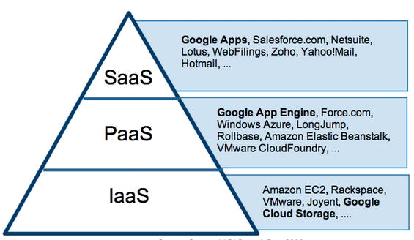

Figure1.1:Cloud delivery model

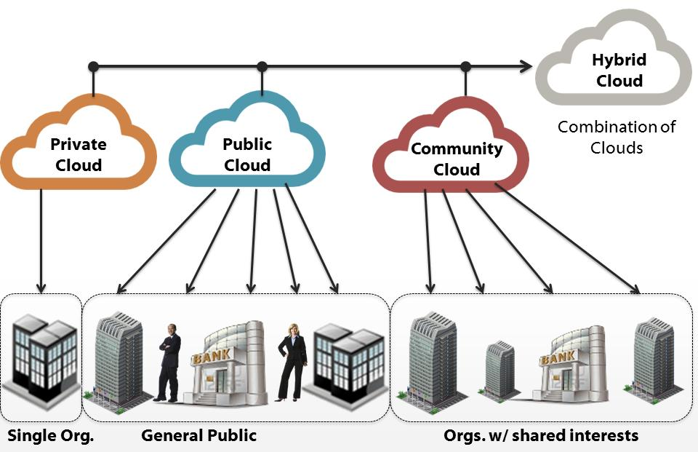

Figure 1.2: Cloud deployment model

  - OBJECTIVE

Our objective is to build a security service which will be provided with a trusted third party, Detailing it further:
- To develop a framework that will maintain the confidentiality of the users’ data.
- To build a client application which would use the above framework while uploading/downloading/deleting the data to and from cloud.

1.3 SCOPE

As a holistic storage system, there are several other factors to be considered, such as cache strategies, geographical data consistency, etc. However, we only focus on the data hosting strategy to minimize monetary cost while meeting flexible availability requirements. Though we have considered the complexity and feasibility when designing this strategy, the system design is out of the scope of this paper, and we put the detailed system design of multi-cloud data hosting into future work. the complexity of this algorithm is mainly the first loop, and the worst case complexity is O(Fn), where Fn is the number of files. In order to reduce the complexity further, we can classify files with similar access patterns into groups, and implement transition in the unit of group. This is out of the scope of this paper

CHAPTER 2
LITERATURE REVIEW

2.1. Z. Li, C. Wilson, Z. Jiang, Y. Liu, B. Y. Zhao, C. Jin, Z.-L. Zhang, and Y. Dai, “Efficient batched synchronization in dropbox-like cloud storage services,” in Proc.ACM/IFIP/USENIX 14th Int. Middleware Conf., 2013, pp. 307–327.

The author addressed traffic overuse problem, proposed the update-batched delayed synchronization (UDS) mechanism. Acting as a middleware between the user’s file storage system and a cloud storage application, UDS batches updates from clients to significantly reduce the overhead caused by session maintenance traffic, while preserving the rapid file synchronization that users expect from cloud storage services. Furthermore, he extend UDS with a backwards compatible Linux kernel modification that further improves the performance of cloud storage applications by reducing the CPU usage.

2.2. H. V. Madhyastha, J. C. McCullough, G. Porter, R. Kapoor, S. Savage, A. C. Snoeren, and A. Vahdat, “scc: Cluster storage provisioning informed by application characteristics and SLAs,” in Proc. USENIX Conf. File, Storage Technol., 2012, p. 23.

Storage for cluster applications is typically provisioned based on rough, qualitative characterizations of applications. Moreover, configurations are often selected based on rules of thumb and are usually homogeneous across a deployment; to handle increased load, the application is simply scaled out across additional machines and storage of the same type. As deployments grow larger and storage options (e.g., disks, SSDs, DRAM) diversify, however, current practices are becoming increasingly inefficient in trading off cost versus performance. To enable more cost-effective deployment of cluster applications, The author developed SCC a Storage Configuration Compiler for cluster applications. SCC automates cluster configuration decisions based on formal specifications of application behaviour and hardware properties. After brief study a range of storage configurations and identify specifications that succinctly capture the tradeoffs offered by different types of hardware, as well as the varying demands of application components. The author applied SCC to three representative applications and find that scc is expressive enough to meet application Service Level Agreements (SLAs) savings in cost on average compared to simple scale-out options. SCC ’s advantage stems mainly from its ability to configure heterogeneous—rather than conventional, homogeneous—cluster architectures to optimize cost.

2.3. H. B. Ribeiro and E. Anceaume, “Datacube: A P2P persistent data storage architecture based on hybrid redundancy schema,” in Proc. 18th Euromicro Int. Conf. Parallel, Distrib. Netw.-Based Process., 2010, pp. 302–306.

This author presented the design of a P2P data persistent platform. Durable access and integrity of the data are ensured despite massive attacks. This platform, named Data Cube, exploits the properties of cluster-based peer-to-peer substrates to implement a compound of full replication and rate less erasure codes. Data Cube guarantees durable access and integrity of data despite adversarial attacks. In particular, the recovery of damaged data is achieved through the retrieval of coded blocks whose integrity is checked on the fly.

2.4. A. Duminuco and E. W. Biersack, “Hierarchical codes: A flexible trade-off for erasure codes in peer-to-peer storage systems,” Peer to Peer Netw. Appl., vol. 3, no. 1, pp. 52–66, 2010.

Redundancy is the basic technique to provide reliability in storage systems consisting of multiple components. A redundancy scheme defines how the redundant data are produced and maintained. The simplest redundancy scheme is replication, which however suffers from storage inefficiency. Another approach is erasure coding, which provides the same level of reliability as replication using a significantly smaller amount of storage. When redundant data are lost, they need to be replaced. While replacing replicated data consists in a simple copy, it becomes a complex operation with erasure codes: new data are produced performing a coding over some other available data. The amount of data to be read and coded is d times larger than the amount of data produced, where d, called repair degree, is larger than 1 and depends on the structure of the code. This implies that coding has a larger computational and I/O cost, which, for distributed storage systems, translates into increased network traffic. Participants of Peer-to-Peer systems often have ample storage and CPU power, but their network bandwidth may be limited. For these reasons existing coding techniques are not suitable for P2P storage. This work explores the design space between replication and the existing erasure codes. The author proposed and evaluate a new class of erasure codes, called Hierarchical Codes, which allows to reduce the network traffic due to maintenance without losing the benefits given by traditional erasure codes.

2.5. H. Abu-Libdeh, L. Princehouse, and H. Weatherspoon, “RACS: A case for cloud storage diversity,” in Proc. 1st ACM Symp. Cloud Comput., 2010, pp. 229–240.

The increasing popularity of cloud storage is leading organizations to consider moving data out of their own data centers and into the cloud. However, success for cloud storage providers can present a significant risk to customers; namely, it becomes very expensive to switch storage providers. In this paper, we make a case for applying RAID-like techniques used by disks and file systems, but at the cloud storage level. The author argued that striping user data across multiple providers can allow customers to avoid vendor lock-in, reduce the cost of switching providers, and better tolerate provider outages or failures. The introduced RACS, a proxy that transparently spreads the storage load over many providers. RACS can reduce the cost of switching storage vendors for a large organization such as the Internet Archive by seven-fold or more by varying erasure-coding parameters.

CHAPTER 3
SYSTEM ANALYSIS

3.1 OVERALL DESCRIPTION
3.1.1 PROBLEM STATEMENT

Cloud service providers request customers to store their account information in the cloud, cloud service providers have the access to these information. This presents a privacy issue to the customer’s privacy information. Many SLAs have specified the privacy of the sensitive information. However, it is difficult for customers to make sure the proper rules are enforced. There is a lack of transparency in the cloud that allows the customers to monitor their own privacy information. When a customer decide to use multiple cloud service, the customer will have to store his/her password in multiple cloud, the more cloud service the customer is subscript to, the more copy of the user’s information will be. This is a security issue for the customers and the cloud service providers. For every cloud service, the customer needs to exchange his/her authentication information. This redundant actions may lead to an exploit of the authentication mechanism. Cloud service providers use different authentication technologies for authenticating users, this may have less impact on SaaS than PaaS and IaaS, but it is present a challenge to the customers. Inspite of all authenticating mechanisms provided by the cloud service providers, the customers privacy is highly lost while storing data in their place. In our project we are providing one secure mechanism in which the cloud service providers cannot access the customers data without the knowledge of the customers. If the cloud service providers want to access the customers data mutual authentication between the customers and cloud service providers. we are introducing third party authority who generates a long key and shares the key with the customers and the cloud service providers. We are addressing the solution for the privacy issue that exists with the customers.

3.1.2 EXISTING SYSTEM

Cloud service providers request customers to store their account information in the cloud, cloud service providers have the access to these information. This presents a privacy issue to the customer’s privacy information. Many SLAs have specified the privacy of the sensitive information, however, it is difficult for customers to make sure the proper rules are enforced. There is a lack of transparency in the cloud that allows the customers to monitor their own privacy information. When a customer decide to use multiple cloud service, the customer will have to store his/her password in multiple cloud, the more cloud service the customer is subscript to, the more copy of the user’s information will be. This is a security issue for the customers and the cloud service providers. For every cloud service, the customer needs to exchange his/her authentication information. This redundant actions may lead to an exploit of the authentication mechanism. Cloud service providers use different authentication technologies for authenticating users, this may have less impact on SaaS than PaaS and IaaS, but it is present a challenge to the customers. Inspite of all authenticating mechanisms provided by the cloud service providers, the customers privacy is highly lost while storing data in their place. In our project we are providing one secure mechanism in which the cloud service providers cannot access the customers data without the knowledge of the customers. If the cloud service providers want to access the customers data mutual authentication between the customers and cloud service providers. we are introducing third party authority who generates a long key and shares the key with the customers and the cloud service providers. We are addressing the solution for the privacy issue that exists with the customers.

3.1.3 PROPOSED SYSTEM

Cloud service providers request customers to store their account information in the cloud, cloud service providers have the access to these information. This presents a privacy issue to the customer’s privacy information. Many SLAs have specified the privacy of the sensitive information, however, it is difficult for customers to make sure the proper rules are enforced. There is a lack of transparency in the cloud that allows the customers to monitor their own privacy information. We are introducing the third party which generates a long secret key and shares the half part of the long key to the cloud service providers and remaining part of the half key to the customers. Customers once registers for a new account they can login into the system using their account. Once after login into the account before performing any operations on file they first request for the third party to generate a long key. Third party as requested by the customers generates a long key and shares their corresponding share to cloud service providers and customers respectively. Now when the cloud service providers tries to access the file without the knowledge of their customers, immediately an mail should be sent to the customers indicating that CSP is trying to access their data. If suppose customers want to share their data to the CSP they can share their half part of the key to the CSP. CSP inturn combines his half key with the customers half key which gives full key which should be verified by the third party. Now the cloud service provider can access the customers file. In our proposed system we are providing privacy to customers data assuring that the customers data cannot be viewed without their knowledge.

But there is one drawback in this scenario once he got users key he can view the users file anytime without the users knowledge. To overcome this difficulty we are setting default logout time for admin and also user once he shares his key with the admin in the certain interval of time his half portion of the key gets updated so that even admin has the key obtained from the user it is invalid now. if he want to see the users file he has to again request the key from the user.

In our proposed system we are going to implement modified shamir's secret sharing algorithm to generate a secret key and shares the key to admin and user side .

3.2 FEASIBILITY STUDY
The feasibility of the project is analyzed in this phase and business proposal is put forth with a very general plan for the project and some cost estimates. During system analysis the feasibility study of the proposed system is to be carried out. This is to ensure that the proposed system is not a burden to the company. For feasibility analysis, some understanding of the major requirements for the system is essential.

3.2.1 ECONOMICAL FEASIBILITY

This study is carried out to check the economic impact that the system will have on the organization. The amount of fund that the company can pour into the research and development of the system is limited. The expenditures must be justified. Thus the developed system as well within the budget and this was achieved because most of the technologies used are freely available. Only the customized products had to be purchased.

3.2.2 TECHNICAL FEASIBILITY

This study is carried out to check the technical feasibility, that is, the technical requirements of the system. Any system developed must not have a high demand on the available technical resources. This will lead to high demands on the available technical resources. This will lead to high demands being placed on the client. The developed system must have a modest requirement, as only minimal or null changes are required for implementing this system.

3.2.3 SOCIAL FEASIBILITY

The aspect of study is to check the level of acceptance of the system by the user. This includes the process of training the user to use the system efficiently. The user must not feel threatened by the system, instead must accept it as a necessity. The level of acceptance by the users solely depends on the methods that are employed to educate the user about the system and to make him familiar with it. His level of confidence must be raised so that he is also able to make some constructive criticism, which is welcomed, as he is the final user of the system.

3.3 SYSTEM REQUIREMENTS
3.3.1 HARDWARE REQUIREMENTS

- System : Pentium IV 2.4 GHz.
- Hard Disk : 40 GB.
- Floppy Drive : 1.44 Mb.
- Monitor : 15 VGA Colour.
- Mouse : Logitech.
- Ram : 512 Mb.

3.3.2 SOFTWARE REQUIREMENTS

- Operating system : Windows XP/7.
- Coding Language : JAVA/J2EE
- IDE : Netbeans 7.4
- Database : MYSQL

CHAPTER 4
SYSTEM DESIGN

4.1 ARCHITECTURE DIAGRAM

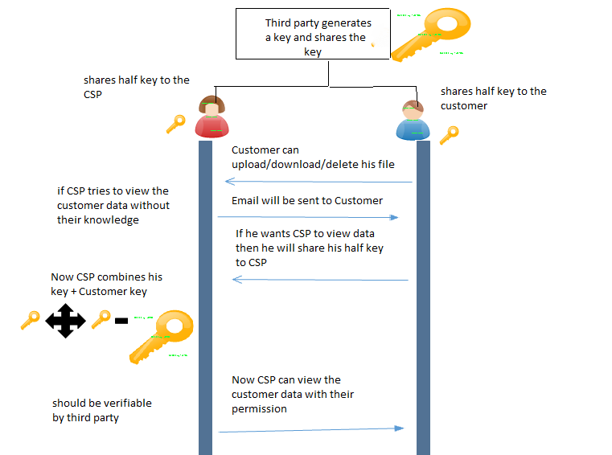

Figure 4.1 Architecture Diagram

4.2 SYSTEM DESCRIPTION

We are introducing the third party which generates a long secret key and shares the half part of the long key to the cloud service providers and remaining part of the half key to the customers. Customers once registers for a new account they can login into the system using their account. Once after login into the account before performing any operations on file they first request for the third party to generate a long key. Third party as requested by the customers generates a long key and shares their corresponding share to cloud service providers and customers respectively. Now when the cloud service providers tries to access the file without the knowledge of their customers, immediately an mail should be sent to the customers indicating that CSP is trying to access their data. If suppose customers want to share their data to the CSP they can share their half part of the key to the CSP. CSP inturn combines his half key with the customers half key which gives full key which should be verified by the third party. Now the cloud service provider can access the customers file. In our proposed system we are providing privacy to customers data assuring that the customers data cannot be viewed without their knowledge.

4.3 DATA FLOW DIAGRAM.
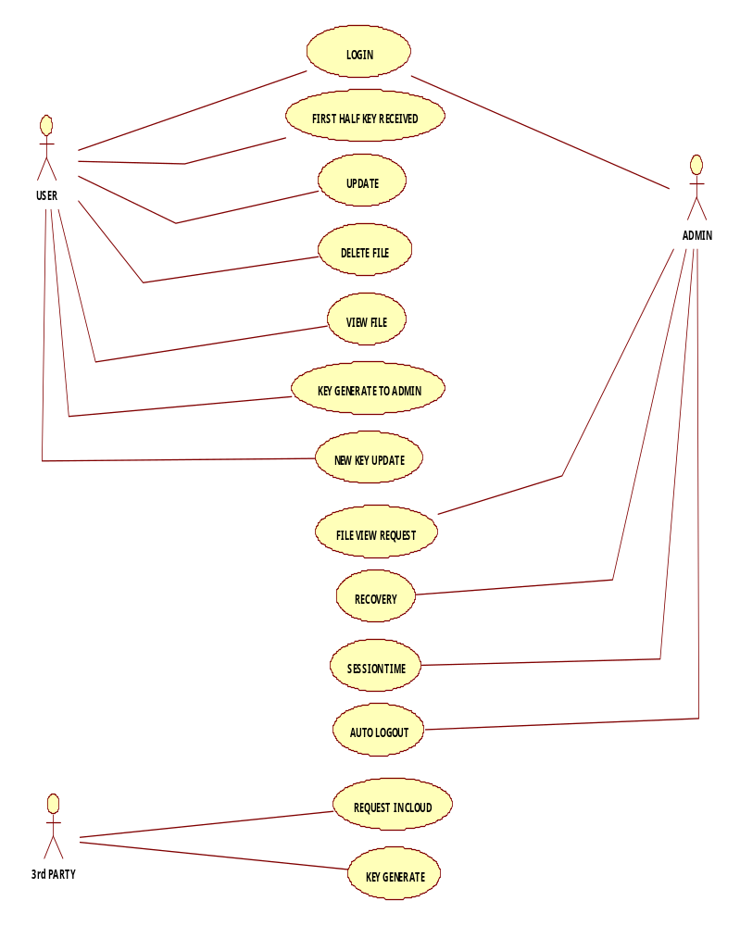
4.3.1 USE CASE DIAGRAM
4.3.2 CLASS DIAGRAM

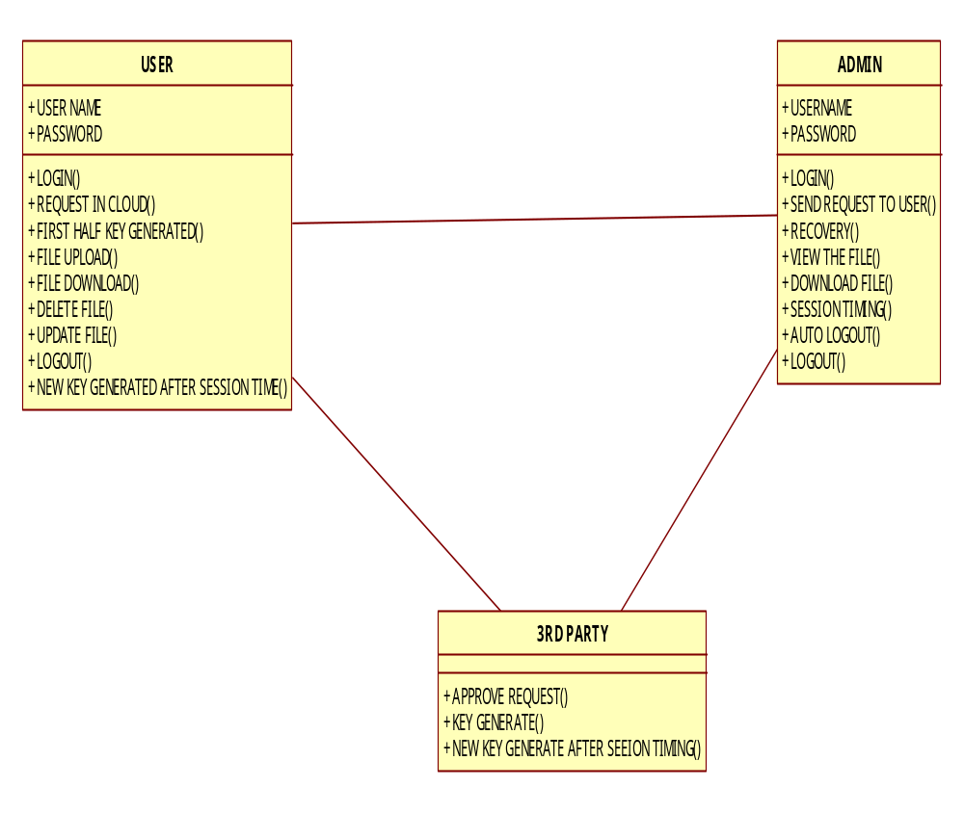

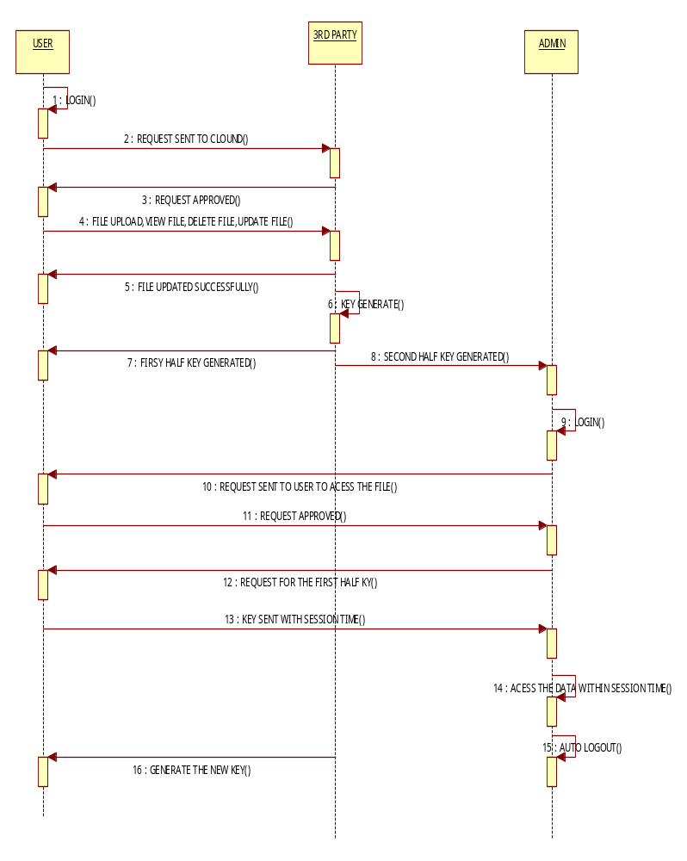
4.3.3 SEQUENCE DIAGRAM
CHAPTER 5
IMPLEMENTATION DETAILS

5.1 ALGORITHM

Secret sharing was invented independently by Adi Shamir [22] and George Blakley [23] in 1979, based on Lagrange interpolating and liner project geometry respectively. A secret sharing scheme consists of one dealer, n participants (or players), an original secret, a secret distribution algorithm and a secret reconstruction algorithm. The dealer shares a secret among a given set of n participants, such that every k of those participants (k≤n) could reconstruct the secret by their shares together, while any group of fewer than k participants gets no information about secret [21-23]. Take Shamir’s scheme for instance, in this scheme, any t out of n shares may be used to recover the secret. The system relies on the idea that 2 points are sufficient to define a line, 3 points are sufficient to define a parabola, 4 points to define a cubic curve and so forth. That is, it takes k points to define a polynomial of degree (k-1). The method is to create a polynomial of degree k-1 with the secret as the first coefficient and the remaining coefficients are picked at random. Next find n points on the curve and give one to each of the players. When at least t out of the n players reveals their points, there is sufficient information to fit a (k-1) degree polynomial to them, the first coefficient being the secret. At the very beginning, the implicit assumption in the original formulation of secret sharing scheme is that each participant is either honest or corrupt, and honest participants are all willing to cooperate when dealer requests reconstruction of the secret. Such schemes include Shamir’s threshold secret sharing scheme [21] based on polynomial interpolation, Blakley’s geometric threshold secret sharing scheme [22], Mignotte’s scheme [24] and Asmuth-Bloom’s scheme [25] based on the Chinese remainder theorem in 1983. Gradually, researchers began to consider the security problems of secret sharing itself, such as how to verify dishonest players. HARN proposed a threshold secret sharing scheme [26] based on digital signature with certification functions in 1995. HSU and WU’s scheme [27] improved HARN’s scheme and proposed an encryption secret sharing scheme based on discrete logarithms with more efficiency for signature verification. Scheme of Han et al [28] used a certification center to verify dishonest shares. Marsh and Schneider designed a secret sharing system [29] which was fault-tolerant and attack-tolerant. All of these made the research on secret sharing scheme more and more mature. Works [30][31][32] were also secret sharing schemes with verification mechanisms. Starting with the work of Halpern and Teague [33], participants in secret sharing are neither honest nor corrupt but are instead viewed as rational and are assumed to act in their own self-interest. Rational secret sharing is a problem at the intersection of cryptography and game theory. In essence, a dealer wishes to engineer a communication game that, when rationally played, guarantees that each of the players learns the dealer’s secret. Yet, all solutions proposed so far did not rely solely on the players’ rationality, but also on their beliefs, and were also quite inefficient. Micali and Shelat exhibited a very efficient and purely rational solution to it with a verifiable trusted channel in their scheme [14]. Fuchsbauer et al also proposed a new methodology for rational secret sharing leading to various instantiations in both the two-party and multi-party settings [15]. Of course, because of its generality, secret sharing schemes step into many fields, such as image secret sharing [16][17]. More and more information security applications consider secret sharing scheme to protect confidential key data, and verifiable and proactive sharing mechanisms are hotly studied [18-21].

Secret sharing scheme can broadly categorized as follows:
- Traditional Secret sharing scheme
- Threshold Secret sharing scheme
- Threshold Changeable Secret sharing scheme
- Verifiable Secret sharing scheme

A Secret sharing is a technique for protecting sensitive data, such as cryptographic keys. It is used to distribute a secret value to a number of parts or shares that have to be combined together to access the original value. These shares can then be given to separate parties that protect them using standard means like memorize, store in a computer etc. Secret sharing is used in modern cryptography to lower the risks associated with compromised data. Sharing a secret spreads the risk of compromising the value across several parties [27].

- Traditional Secret Sharing Scheme

Shamir [21] presented the first secret sharing method in1979. Secret sharing involves transmitting different shares in different channels. With a single share nobody can see the entire secret message. The general idea behind secret sharing is to distribute a secret to n different participants so that any k participants can reconstruct the secret, and any (k - 1) or less participants cannot reveal anything about the secret. Such schemes are also known as (k, n) threshold-based scheme. For any secret sharing schemes it has the following two processes: Distribution Process This process input is the secret k that gets portioned into n number of shares S1, S2,...Sn that is privately delivered to the participants. Reconstruction Process It reconstructs the secret when a suitable set of shares is present using a certain algorithm.

- Threshold Secret Sharing Scheme

These schemes are the first kind of schemes that were constructed individually by both Shamir who uses polynomial interpolation [21] and Blakley who uses finite geometry [28]. To share a secret we can split the secret and spread the pieces to all participants. In some schemes, reconstructing the secret needs combining all shares from participants, but this might not be practical since we might need the secret reconstructed by some of the participants and not all. The reason is as follows: Imagine if a country splits the access codes for its missiles among three officials and they found themselves in a dire need to access the missiles, but one of the officials is not present or he simply refuses to attack. Then, we need to have a different scheme where a subset of the participants can reconstruct the secret. These schemes are secure and do not require all n shares [24]. For example: Consider the Board of Directors of Defense ministry would like to protect missiles secret formula. The president of the company should be able to access the formula when needed, but in an emergency any 3 of the 12 board members would be able to unlock the secret formula together. This can be accomplished by a secret sharing scheme with k = 3 and n = 12, where 3 shares are given to the president, and is given to each board member. These schemes are further classified depending in the size on the shares. Perfect Secret Sharing (PSS) These schemes cannot allow the size of secret shares to become smaller than the size of the secret.Ramp Secret Sharing (RSS) These schemes achieve the goal of reducing the size of the shares, but at the cost of some degraded protection on the secret.

- Threshold Changeable Secret Sharing Scheme

Threshold Changeable secret sharing scheme was invented by the scientist Wang and Wong for changing thresholds in the absence of secure channels after the setup of threshold secret sharing schemes[24]. Initially, we construct a perfect (t, n) threshold scheme that is threshold changeable to t which is optimal with respect to the share size. But these threshold changeable schemes along with most previously known schemes turn out to be insecure under the collusion attack of players holding initial shares [29].

- Verifiable Secret Sharing Scheme

This scheme was first introduced to overcome the problem of dishonest dealers. VSS schemes lets the participants verify that their shares are consistent, thus they can properly reconstruct the secret. To get a clear idea about how these schemes work, let us assume a dealer Trent sends shares to Alice, Bob, Carol and Dave. The only way they can be sure they have a valid share is to reconstruct the secret, but it may happen that Trent sent a bogus share to Bob or Bob received a bad share as a result of a communication error. VSS schemes allow these participants to validate their shares without the need to reconstruct the secret [25]. It is designed to resist an adversary who can corrupt the dealer and some of the participants.VSS requires an additional algorithm called verify that allows participants to verify their shares before any reconstructing attempts [26].

5.2 MODULES
5.2.1 USER SIDE
5.2.1.1 DATA UPLOAD SCENARIO
1. The end user registers for new account
2. The end user login to the system with his/her username & password.
3. Once the user is authenticated, separate folder has created for the user which monitors all the activities of the user
4. before a user upload the files he has to request for the secret key from the third party
5. once the user receives the key from the third party he can upload the files to the cloud

5.2.1.2 DATA DOWNLOAD SCENARIO
1. The end user registers for new account
2. The end user login to the system with his/her username & password.
3. Once the user is authenticated, separate folder has created for the user which monitors all the activities of the user
4. once the user receives the key from the third party he can download the files from the cloud

5.2.1.3 DATA DELETE SCENARIO
1. The end user registers for new account
2. The end user login to the system with his/her username & password.
3. Once the user is authenticated, separate folder has created for the user which monitors all the activities of the user
4. once the user receives the key from the third party he can delete the files from the cloud

5.2.2 ADMIN SIDE
When the admin wants to see the other user files he has to do the following steps
1. Admin enters his half key which is provided by the third party
2. Now he has to request from the user the remaining half key so that by combining his half key and admin half key to view the file
3. once the user wants to share his file to the admin they can provide their half key to admin and grants the admin to view their file

5.3 SECURITY CHECK
The cloud computing uses the internet as the communication media. When we look at the security of data in the cloud computing, the vendor has to provide some assurance in service level agreements (SLA) to convince the customer on security issues
Security can be provided in two ways
- Hardware security (using TPM)
- Software security (using Key approach)
A Trusted Platform module provides secure asymmetric key generation. This paper [11] describes the use of a secure key generating authority in shamir identity based signature scheme implementation. They proposed an idea of identity-based asymmetric cryptosystems (IBC) and together with an identity based asymmetric signature. The proposed IBS scheme in this paper has itself proven secure against forgery under chosen message attacks. This paper also proposed a new concept that assigning TPM as key generating authority and list out the various benefits of implementing it. The paper [12] initially identifies the challenges for establishing the trust in the cloud and then proposes a secure framework which helps in addressing those identified challenges. This paper is actually extension of their previous work. In their previous work they proposed a unique framework for establishing trust in the cloud environment by extending their previous work the current paper addresses those issue it clearly covers applications data and their integration with infrastructure management data. The proposed framework [2] has four types of software agents, each run on trusted devices. The paper also explains about the controlled content sharing between devices.
In [13] Security is ensured using C-code-like formal modeling at application level. As a result of this approach, security of the protocol is ensured not only at the abstract level of protocol l, but also at the concrete level. In [14] the authors proposes the virtualization of trusted platform module, so than not only single machine can use the tpm but also any number of virtual machines can also use the TPM, doing so will support higher level services like remote attestation and so on. Various challenges are addressed in the following table.
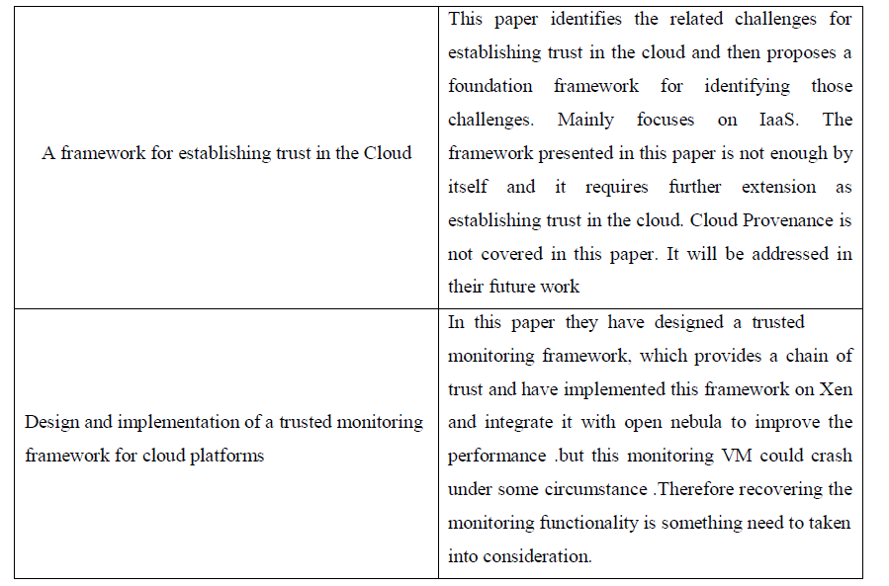
Table 5.3 Challenges in TPM

CHAPTER 6
TESTING

The purpose of testing is to discover errors. Testing is the process of trying to discover every conceivable fault or weakness in a work product. It provides a way to check the functionality of components, sub assemblies, assemblies and/or a finished product It is the process of exercising software with the intent of ensuring that the

Software system meets its requirements and user expectations and does not fail in an unacceptable manner. There are various types of test. Each test type addresses a specific testing requirement.

6.1 TYPES OF TESTS

6.1.1 UNIT TESTING

Unit testing involves the design of test cases that validate that the internal program logic is functioning properly, and that program inputs produce valid outputs. All decision branches and internal code flow should be validated. It is the testing of individual software units of the application .it is done after the completion of an individual unit before integration. This is a structural testing, that relies on knowledge of its construction and is invasive. Unit tests perform basic tests at component level and test a specific business process, application, and/or system configuration. Unit tests ensure that each unique path of a business process performs accurately to the documented specifications and contains clearly defined inputs and expected results.

6.1.2 INTEGRATION TESTING

Integration tests are designed to test integrated software components to determine if they actually run as one program. Testing is event driven and is more concerned with the basic outcome of screens or fields. Integration tests demonstrate that although the components were individually satisfaction, as shown by successfully unit testing, the combination of components is correct and consistent. Integration testing is specifically aimed at exposing the problems that arise from the combination of components.

6.1.3 FUNCTIONAL TESTING

Functional tests provide systematic demonstrations that functions tested are available as specified by the business and technical requirements, system documentation, and user manuals.

Functional testing is centered on the following items:

- Valid Input : identified classes of valid input must be
accepted.
- Invalid Input : identified classes of invalid input must be
rejected.

- Functions : identified functions must be exercised.

- Output : identified classes of application outputs must be
Exercised.
- Systems/Procedures: interfacing systems or procedures must be
Invoked.

Organization and preparation of functional tests is focused on requirements, key functions, or special test cases. In addition, systematic coverage pertaining to identify Business process flows; data fields, predefined processes, and successive processes must be considered for testing. Before functional testing is complete, additional tests are identified and the effective value of current tests is determined.

6.1.4 SYSTEM TESTING

System testing ensures that the entire integrated software system meets requirements. It tests a configuration to ensure known and predictable results. An example of system testing is the configuration oriented system integration test. System testing is based on process descriptions and flows, emphasizing pre-driven process links and integration points.

6.1.5 WHITE BOX TESTING

White Box Testing is a testing in which in which the software tester has knowledge of the inner workings, structure and language of the software, or at least its purpose. It is purpose. It is used to test areas that cannot be reached from a black box level.

6.1.6 BLACK BOX TESTING

Black Box Testing is testing the software without any knowledge of the inner workings, structure or language of the module being tested. Black box tests, as most other kinds of tests, must be written from a definitive source document, such as specification or requirements document, such as specification or requirements document. It is a testing in which the software under test is treated, as a black box .you cannot “see” into it. The test provides inputs and responds to outputs without considering how the software works.

CHAPTER 7
RESULTS AND DISCUSSION

Divide data D into n pieces D1,D2….Dn in such a way that:
Knowledge of any k or more D pieces makes D easily computable.
Knowledge of any k -1 or fewer pieces leaves D completely undetermined
This scheme is called (k,n) threshold scheme.
If k=n then all participants are required together to reconstruct the secret
Choose at random (k-1) coefficients a1,a2,a3…ak-1 , and let S be the a0
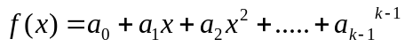

- Construct n points (i,f(i)) where i=1,2…..n which is x1,x2,x3 and so on..
- can be computed by
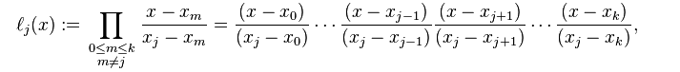

Type | Shares | Representation | Reconstruction | Pros
Traditional SSS | N | k=n | K=n | It is very effective for less number of participants
Threshold SSS | N | k,n | k out of n | It allows only few shares(threshold) to reconstruct the secret
Threshold Changeable SSS | N | t,n | t=t' | It allows to change the threshold in the absence of channel
Verifiable SSS | n | k,n | k,n | It is used as a solution to cheating problems

Table 7 Comparison of secret sharing scheme

CHAPTER 8
CONCLUSION AND FUTURE WORK

Security is an important issue in any application. To provide the security, authentication plays very important role. Authentication is provided through the secret sharing schemes. Cloud service providers request customers to store their account information in the cloud, cloud service providers have the access to these information. This presents a privacy issue to the customer’s privacy information. When a customer decide to use multiple cloud service, the customer will have to store his/her password in multiple cloud, the more cloud service the customer is subscript to, the more copy of the user’s information will be. This is a security issue for the customers and the cloud service providers. our main idea is to secure the users data from the cloud service provider

We are implementing a secure framework by proposing a new scheme in our future work so that without the knowledge of the user the cloud service providers cannot access the customers data though it is saved in the CSP place

APPENDIX 1
SAMPLE CODE

Login.jsp
/*
* To change this license header, choose License Headers in Project Properties.
* To change this template file, choose Tools | Templates
* and open the template in the editor.
*/
importjava.io.IOException;
importjava.io.PrintWriter;
importjava.sql.Connection;
importjava.sql.DriverManager;
importjava.sql.PreparedStatement;
importjava.sql.ResultSet;
importjava.sql.SQLException;
importjava.util.logging.Level;
importjava.util.logging.Logger;
importjavax.servlet.RequestDispatcher;
importjavax.servlet.ServletException;
importjavax.servlet.http.HttpServlet;
importjavax.servlet.http.HttpServletRequest;
importjavax.servlet.http.HttpServletResponse;
importjavax.servlet.http.HttpSession;
importjava.io.File;
public class DO extends HttpServlet {
/**
* Processes requests for both HTTP <code>GET</code> and <code>POST</code>
* methods.
*
* @param request servlet request
* @param response servlet response
* @throws ServletException if a servlet-specific error occurs
* @throws IOException if an I/O error occurs
*/String name1,pass1;String a1,a2,a3,a4,a5;
protected void processRequest(HttpServletRequest request, HttpServletResponse response)
throwsServletException, IOException {
response.setContentType("text/html;charset=UTF-8");
PrintWriter out = response.getWriter();
name1=request.getParameter("name");
pass1=request.getParameter("pass");

File f;
try {
Class.forName("com.mysql.jdbc.Driver");
Connection con = DriverManager.getConnection("jdbc:mysql://localhost:3306/icbusys","root","root");
String s="select * from dolog where name='"+name1+"' and pwd='"+pass1+"'";
PreparedStatementpst = con.prepareStatement(s);
ResultSet r = pst.executeQuery();
if(r.next())
{

out.println("<script>"+"alert('login successful')"+"</script>");
String s1="select * from dolog where name='"+name1+"'";
PreparedStatement pst1 = con.prepareStatement(s1);

ResultSet r1 = pst1.executeQuery();
while(r1.next())
{

a1=r.getString(1);
// out.println(a1);
a2=r.getString(4);
a3=r.getString(6);
a4=r.getString(7);
// a5=r.getString(9);
}
HttpSession session=request.getSession();
session.setAttribute("a", a1);
session.setAttribute("b", a2);
session.setAttribute("c", a3);
session.setAttribute("d", a4);
session.setAttribute("name", name1);

f = new File("C:/Users/Saravanan/Documents/ICBUsys/web/files/"+name1);
if (!f.exists()) {
if (f.mkdir()) {
System.out.println("Directory is created!");
} else {
System.out.println("Failed to create directory!");
}
}

// HttpSession session=request.getSession();
// HttpSession session=request.getSession();
// session.setAttribute("aaa", name1);
// out.println(name1);
RequestDispatcherrd=request.getRequestDispatcher("do2.jsp");
rd.include(request, response);

}
else if(name1.isEmpty()&&pass1.isEmpty())
{
out.println("<script>"+"alert('pls fill all the fields')"+"</script>");
RequestDispatcherrd=request.getRequestDispatcher("do.jsp");
rd.include(request, response);
}
else
{
out.println("<script>"+"alert('Invalid username and password')"+"</script>");
RequestDispatcherrd=request.getRequestDispatcher("do.jsp");
rd.include(request, response);

}
}
catch (ClassNotFoundException ex) {
Logger.getLogger(DO.class.getName()).log(Level.SEVERE, null, ex);
} catch (SQLException ex) {
Logger.getLogger(DO.class.getName()).log(Level.SEVERE, null, ex);
}
}
// <editor-fold defaultstate="collapsed" desc="HttpServlet methods. Click on the + sign on the left to edit the code.">
/**
* Handles the HTTP <code>GET</code> method.
*
* @param request servlet request
* @param response servlet response
* @throws ServletException if a servlet-specific error occurs
* @throws IOException if an I/O error occurs
*/
@Override
protected void doGet(HttpServletRequest request, HttpServletResponse response)
throwsServletException, IOException {
processRequest(request, response);
}

/**
* Handles the HTTP <code>POST</code> method.
*
* @param request servlet request
* @param response servlet response
* @throws ServletException if a servlet-specific error occurs
* @throws IOException if an I/O error occurs
*/
@Override
protected void doPost(HttpServletRequest request, HttpServletResponse response)
throwsServletException, IOException {
processRequest(request, response);
}

/**
* Returns a short description of the servlet.
*
* @return a String containing servlet description
*/
@Override
public String getServletInfo() {
return "Short description";
}// </editor-fold>
}

APPENDIX 2
SCREENSHOTS
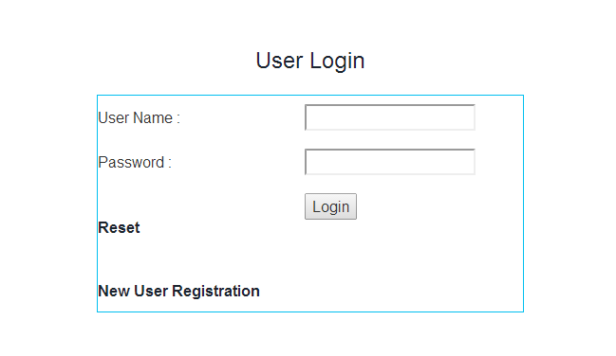
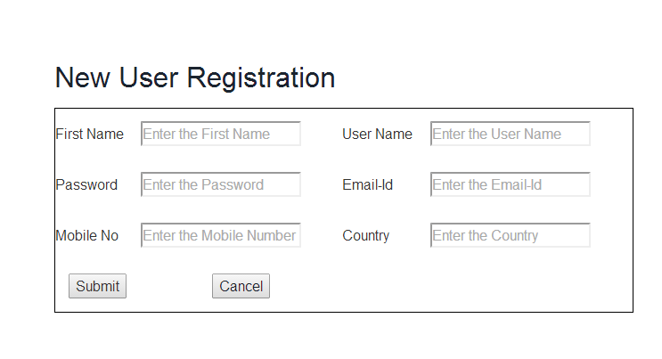
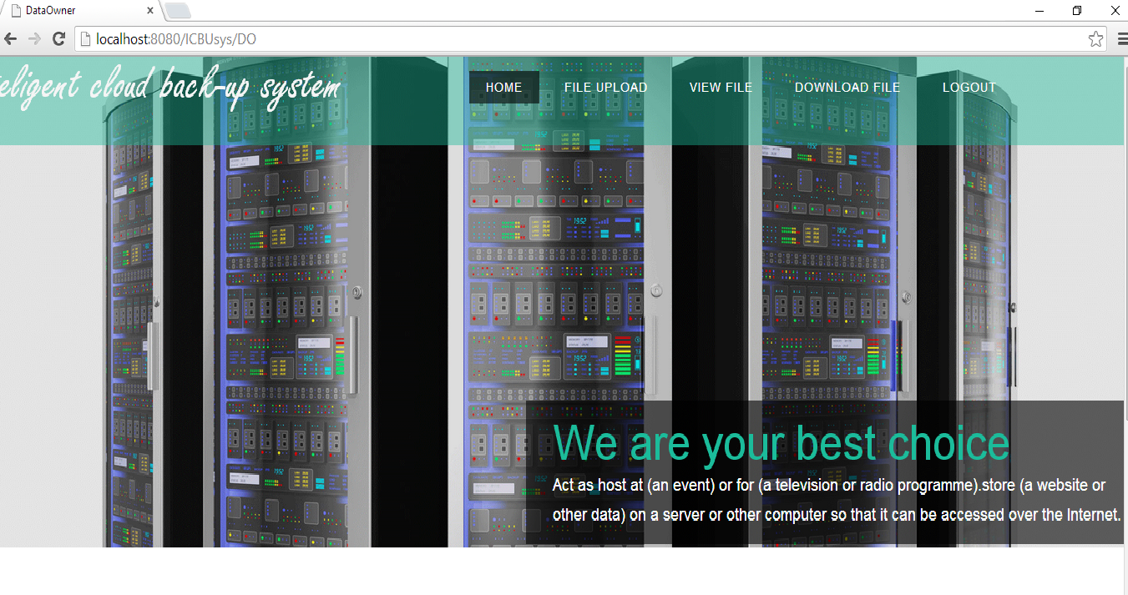

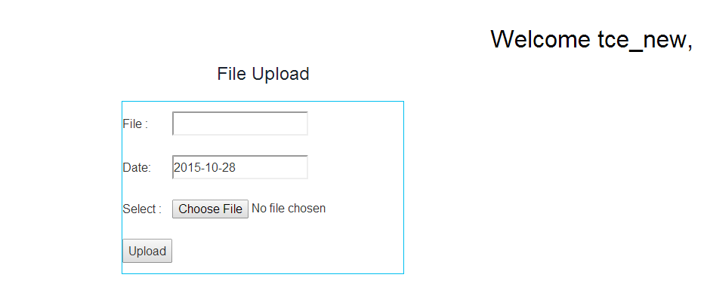
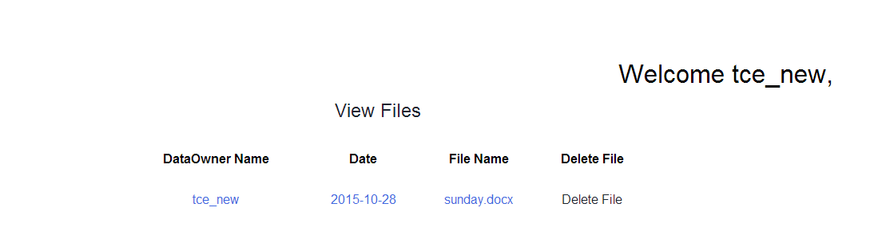
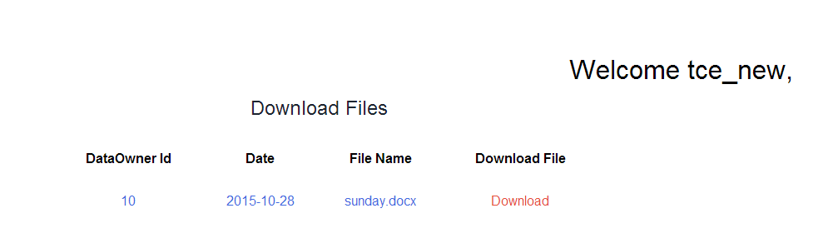

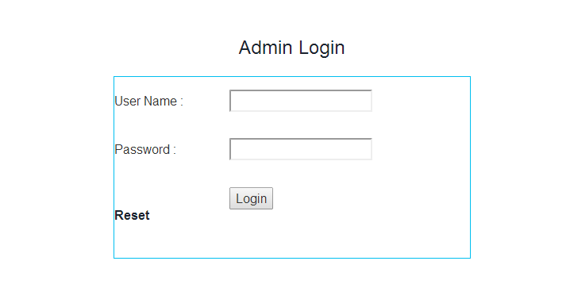

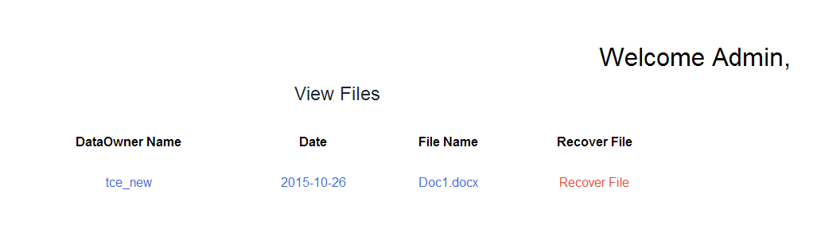

REFERENCES

[1] .C. Wang, Q, Wan, K. Rennd Wenjing Lou, "Privacy-Preserving Public Auditing for Data Storage Security in Cloud Computing", Infocom, Proceedings IEEE, 2010, pp.1-9.
[2] .D. Chen and H. Zhao, "Data Security and Privacy Protection Issues in Cloud Com-puting", in International Conference on Computer Science and Electronics Engineer-ing(ICCSEE), 2012, vol.1, pp.647-651.
[3] .H. Takabi, J. B. D. Joshi and G. J. Ahn, "Security and Privacy Challenges in Cloud Computing Environments" , Security and Privacy, IEEE, vol.8 , no.6, pp.24-31, Nov/Dec 2010.
[4] .K. Ren, C. Wang and Q. Wang, "Security Challenges for the Public Cloud", Internet Computing, IEEE , vol.16, no.1, pp.69-73, Jan/Feb 2012.
[5] .Z. Xiao and Y. Xiao, "Security and Privacy in Cloud Computing ",IEEE Commun. Surveys and Tutorials, vol. 15, no.2, pp.843 - 859, Second quarter 2013.
[6] .Halpern, J., Teague, V.: Rational secret sharing and multiparty computation: Extended abstract. In: 36th Annual ACM Symposium on Theory of Computing (STOC), pp. 623–632. ACM Press, New York.
[7] .Anida Sarajlic, Narcis Behlilovic, Irma Sokolovic, A Modular Concept of E-voting System that Protects User Privacy Using Password Distribution proceeding of IEEE Transaction, 18th International Conference on System, Signal and Image Processing, IWSSIP, June 2011.
[8] .Shamir and Blakey, An Anonymous and Efficient secret sharing Scheme, in proceeding of IEEE Transaction, 18th International Conference on e-Commerce in Developing Countries with focus on e-Security. April 2013.
[9] .Honady Hussien and Hussien Aboelnager, Design of a Secured E-voting System, proceeding of IEEE Transaction, 2013.
[10].Adi Shamir, How to Share a Secret, in communications of ACM, Vol.22, no.11, 1979, pp. 612-613.
[11]. Weihan Goh and Chai Kiat Yeo “Teaching an Old Trusted Platform Module: Repurposing a TPM for an Identity- based Signature Scheme” ,April 2013.
[12]. Imad M. Abbadi , Muntaha Alawneh “A framework for establishing trust in cloud”, Computers and Electrical Engineering 38 (2012) 1073–1087.
[13]. Wenchao Huang, Yan Xiong,Fuyou Miao, Xingfu Wang, Chengyi Wu, Qiwei Lu and Xudong Gong“Fine-Grained Refinement on TPM-Based Protocol Applications”, IEEE TRANSACTIONS ON INFORMATION FORENSICS AND SECURITY, VOL 8,NO. 6, JUNE 2013.
[14]. Micali, S., Shelat, A.: Purely rational secret sharing. LNCS, vol. 5444. Springer-Verlag, Berlin Heidelberg New York. (2014)
[15]. Fuchsbauer, G., Katz, J., Naccache, D.: Efficient Rational Secret Sharing in Standard Communication Networks. LNCS Vol. 5978. Springer-Verlag, Berlin Heidelberg New York. (2013)
[16]. Guo, C., Chang, C. C., Qin, C.: A hierarchical threshold secret image sharing [J]. Pattern Recognition Letters, Vol. 33, No. 1, 83–91. (2012)
[17]. Wang, R. Z., Shyu, S. J.: Scalable secret image sharing. Signal Processing: Image Communication, Vol. 22, No. 4, 363–373. (2014)
[18]. Herzberg, A., Jarecki, S., Hugo, K., Yung, M.: Proactive Secret Sharing Or: How to Cope With Perpetual Leakage. In the proceedings of the 15th Annual International Cryptology Conference on Advances in Cryptology. Springer-Verlag, London, UK, 339–352.
[19]. Yevdokimov, A. A.:Dynamic system of proactive security. In proceedings of International Conference on Application of Information and Communication Technologies. IEEE Press, Baku, Azerbaijan, 1–4.
[20]. HARM L.: Efficient sharing (broadcasting) of multiple secrets. IEEE Proc Comput Digital Tech, Vol. 142, No. 3, 237-240. (1995) 21. TANG C M, WU D O, CHRONOPOULOS A T, et al. Efficient multi-party digital signature using adaptive secret sharing for low-power devices in wireless networks. IEEE Transactions on Wireless Communications, Vol. 8, No. 2, 882-889.
[21]. Shamir, A.: How to share a secret. Communications of the ACM, Vol. 22, No.11, 612-613.
[22]. Blakley, G.: Safeguarding cryptographic keys. In Proceedings of AFIPS National Computer Conference. IEEE Computer Science, NEW YORK, USA, 313-317
[23]. Tamir T.: Hierarchical Threshold Secret Sharing. Journal of Cryptology, Vol. 20: 237–264.
[24]. Mignotte, M.: How to share a secret. Lecture Notes in Computer Science, Vol. 149. Springer-Verlag, Berlin Heidelberg New York.
[25]. Asmuth, C. A., Bloom J.: A modular approach to key safeguarding. IEEE Transactions on Information Theory, Vol. 29, No. 2, 208-210.
[26]. HARN, L.: Digital signature with (t,n) shared verification based on discrete logarithms. ELECTRONICS LElTERS, Vol. 31, No. 3, 177.
[27]. HSU, C. L., WU, T. C.: Authenticated encryption scheme with (t, n) shared verification. IEE ProcComput Digit Tech, Vol. 145, No. 2, 117-120.
[28]. HAN, Y. L., YANG X.Y., SUN, J., Li, D.L.: Verifiable threshold cryptosystems based on elliptic curve. In the proceedings of the International Conference on Computer Network and Mobile Computing. Vol.10, 334-337.
[29]. Marsh, M. A., Schneider, F. B.: CODEX: a robust and secure secret distribution system. IEEE Transactions on Dependable and Secure Computing, Vol. 1, No. 1, 34-47.
[30]. Chor, B., Goldwasser, S., Micali, S, Awerbuch, B.: Verifiable secret sharing and achieving simultaneity in the presence of faults. In Proceedings of the 26th IEEE Symposium on the Foundations of Computer Science. Portland, Oregon, USA, 383–395.
[31]. Feldman P.: A practical scheme for non-interactive verifiable secret sharing. In Proceedings of the 28th IEEE Symposium on the Foundations of Computer Science. IEEE press, Los Angeles, California, USA, 427–437.
[32]. Pedersen, T. P.: Non-interactive and information-theoretic secure verifiable secret sharing. Lecture Notes in Computer Science, Vol. 576. Springer-Verlag, Berlin Heidelberg New York.

