Step 1: Create a maven app with the the name MyMaventoGradle app
mvn archetype:generate -DgroupId=com.example -DartifactId=MyMaventoGradle -DarchetypeArtifactiId=maven-archetype-quickstart -DinteractiveMode=false
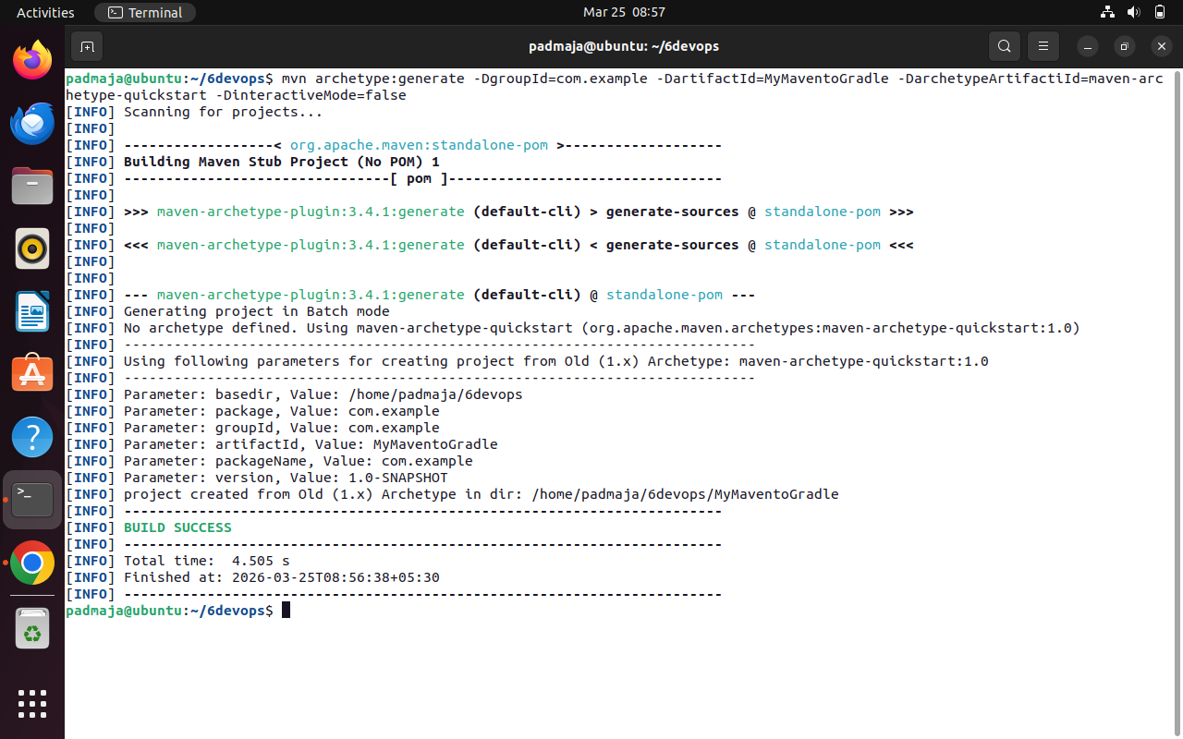
Step 2: edit the pom.xml file to add all the plugins
<project xmlns="http://maven.apache.org/POM/4.0.0" xmlns:xsi="http://www.w3.org/2001/XMLSchema-instance"
xsi:schemaLocation="http://maven.apache.org/POM/4.0.0 http://maven.apache.org/maven-v4_0_0.xsd">
<modelVersion>4.0.0</modelVersion>
<groupId>com.example</groupId>
<artifactId>MyMaventoGradle</artifactId>
<packaging>jar</packaging>
<version>1.0-SNAPSHOT</version>
<name>MyMaventoGradle</name>
<url>http://maven.apache.org</url>
<dependencies>
<dependency>
<groupId>junit</groupId>
<artifactId>junit</artifactId>
<version>3.8.1</version>
<scope>test</scope>
</dependency>
</dependencies>
<!-- Build: Configuring plugins and build settings -->
<build>
<plugins>
<!-- Example: Maven Compiler Plugin to compile Java code -->
<plugin>
<groupId>org.apache.maven.plugins</groupId>
<artifactId>maven-compiler-plugin</artifactId>
<version>3.8.1</version>
<configuration>
<source>1.7</source>
<target>1.7</target>
</configuration>
</plugin>

<!-- Example: Maven Surefire Plugin to run tests -->
<plugin>
<groupId>org.apache.maven.plugins</groupId>
<artifactId>maven-surefire-plugin</artifactId>
<version>2.22.2</version>
</plugin>

<plugin>
<groupId>org.apache.maven.plugins</groupId>
<artifactId>maven-jar-plugin</artifactId>
<version>3.1.0</version>
<configuration>
<archive>
<manifestEntries>
<Main-Class>com.example.App</Main-Class>
</manifestEntries>
</archive>
</configuration>
</plugin>
</plugins>
</build>
</project>
Step 3: compile the maven project
mvn clean install
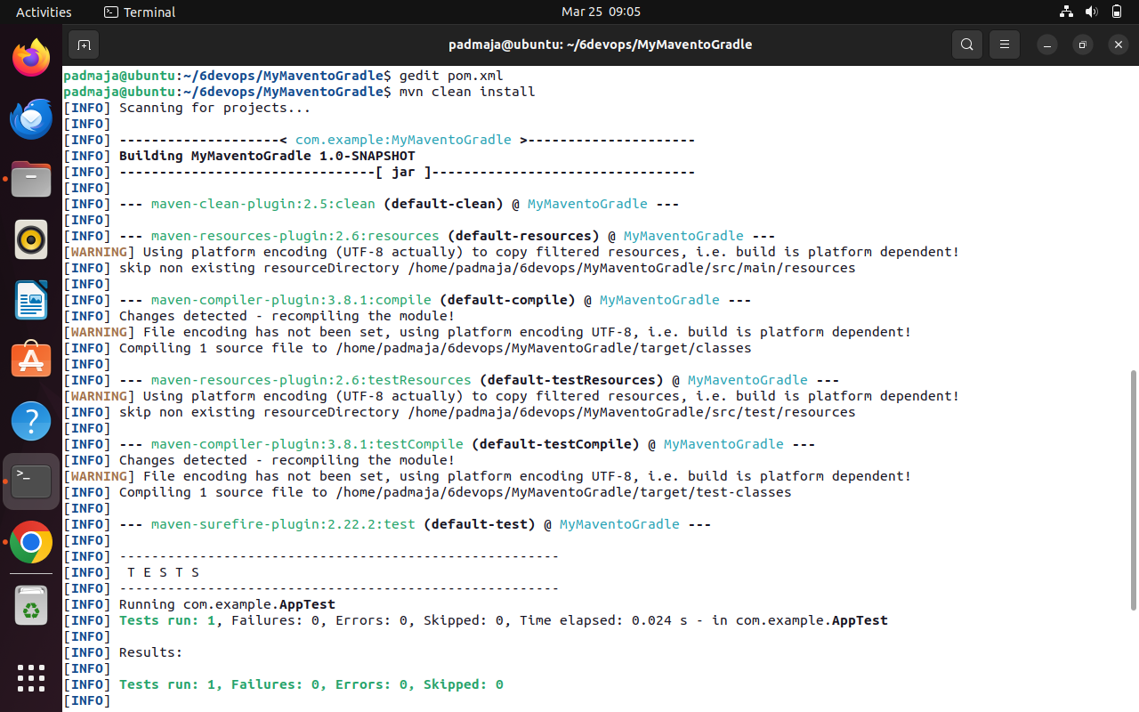
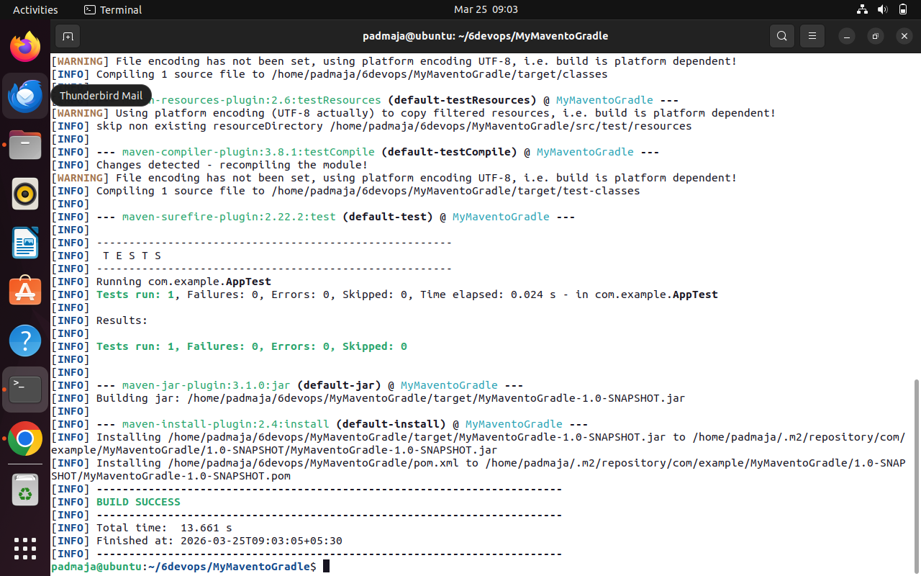
Step 4: inspect with tree structure
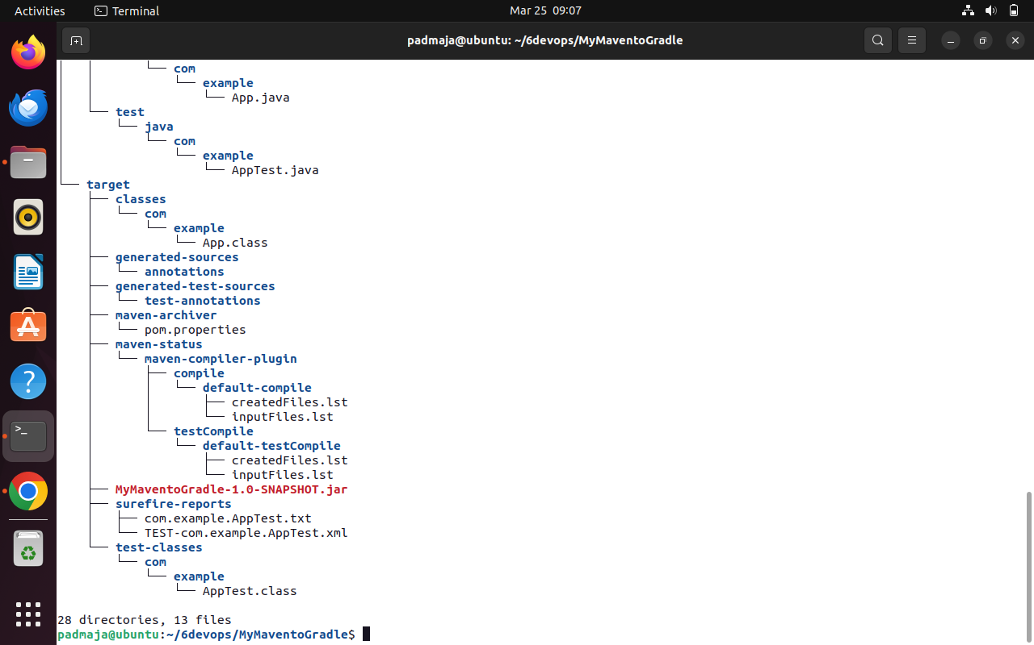
Step 5: Migrate the maven project to gradle project
Gradle init –type pom.xml
There will be an error due to gradle does not support pom.xml. hence not build success
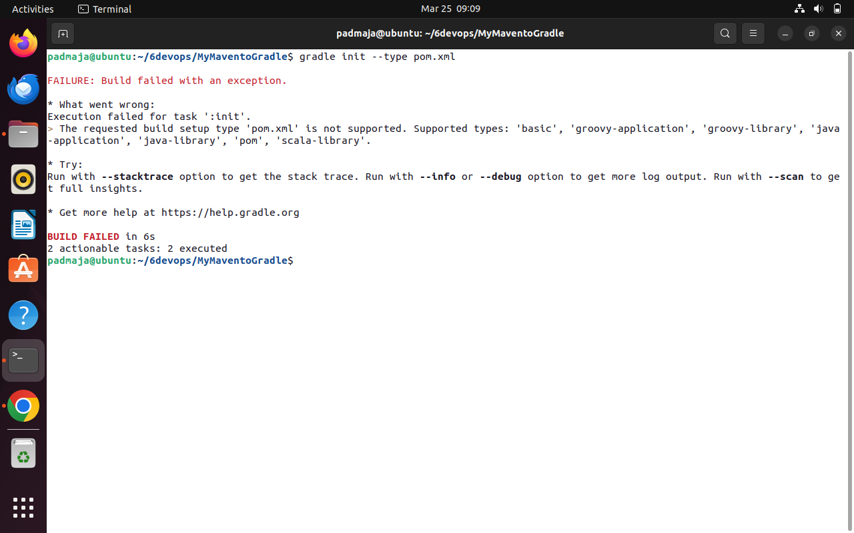
Step 5: check with the file structure
Give ls command
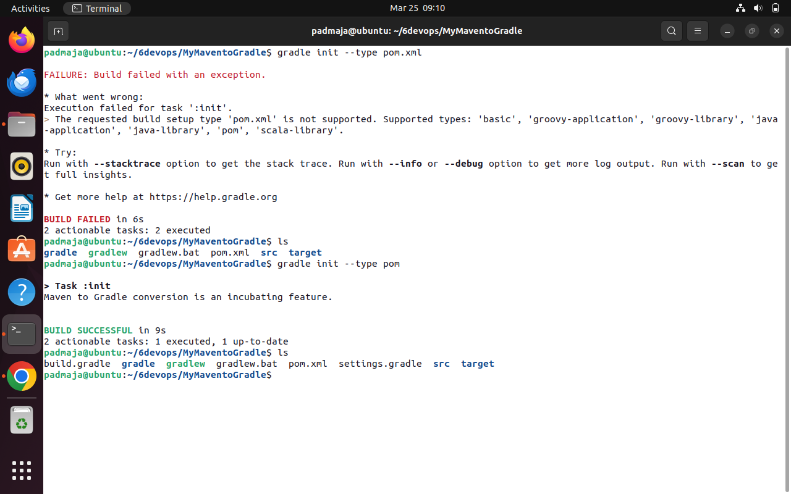
Step 6: try the migrate command again but not with extention .xml
Gradle init –type pom
Step 7: check for build.gradle in files
Give ls command

