Step 1:create a maven project on terminal

Mvn archetype:generate -DgroupId=com.example -DartifactId=MyMavenSeleniumApp02 -DarchetypeArtifactiId=maven-archetype-quickstart -DinteractiveMode=false

Step 2: Change the pom.xml file

<project xmlns=http://maven.apache.org/POM/4.0.0 xmlns:xsi=http://www.w3.org/2001/XMLSchema-instance
Xsi:schemaLocation=http://maven.apache.org/POM/4.0.0 http://maven.apache.org/maven-v4_0_0.xsd>
<modelVersion>4.0.0</modelVersion>
<groupId>com.example</groupId>
<artifactId>MyMavenSeleniumApp02</artifactId>
<packaging>jar</packaging>
<version>1.0-SNAPSHOT</version>
<name>MyMavenSeleniumApp01</name>
<url>http://maven.apache.org</url>

<dependencies>
<dependency>
<groupId>junit</groupId>
<artifactId>junit</artifactId>
<version>3.8.1</version>
<scope>test</scope>
</dependency>

<!—https://mvnrepository.com/artifact/org.seleniumhq.selenium/selenium-java
<dependency>
<groupId>org.seleniumhq.selenium</groupId>
<artifactId>selenium-java</artifactId>
<version>4.29.0</version>
</dependency>
</dependencies>

<!—Build: Configuring plugins and build settings
<build>
<plugins>
<!—Example: Maven Compiler Plugin to compile Java code
<plugin>
<groupId>org.apache.maven.plugins</groupId>
<artifactId>maven-compiler-plugin</artifactId>
<version>3.8.1</version>
<configuration>
<source>1.7</source>
<target>1.7</target>
</configuration>
</plugin>
<!—Example: Maven Surefire Plugin to run tests
<plugin>
<groupId>org.apache.maven.plugins</groupId>
<artifactId>maven-surefire-plugin</artifactId>
<version>2.22.2</version>
</plugin>
<plugin>
<groupId>org.apache.maven.plugins</groupId>

<artifactId>maven-jar-plugin</artifactId>
<version>3.0.1</version>
<configuration>
<archive>
<manifestEntries>
<Main-Class>com.example.App</Main-Class>
</manifestEntries>
</archive>
</configuration>

</plugin>
</plugins>
</build>
</project>

Step 3: App.java for selenium project

package com.example;

import org.openqa.selenium.By;
import org.openqa.selenium.WebDriver;
import org.openqa.selenium.chrome.ChromeDriver;

public class App
{
public static void main(String[] args)
{
WebDriver driver = new ChromeDriver();
try {
driver.get("https://practicetestautomation.com/practice-test-login/");
driver.manage().window().maximize();

Thread.sleep(2000); // wait 2 seconds after page load

driver.findElement(By.id("username")).sendKeys("student");
driver.findElement(By.id("password")).sendKeys("Password123");

Thread.sleep(2000); // wait before clicking login

driver.findElement(By.id("submit")).click();

Thread.sleep(2000); // wait after login
} catch (InterruptedException e) {
e.printStackTrace();
} finally {
driver.quit(); // closes browser
}
}
}

Step 4: compile and run the code
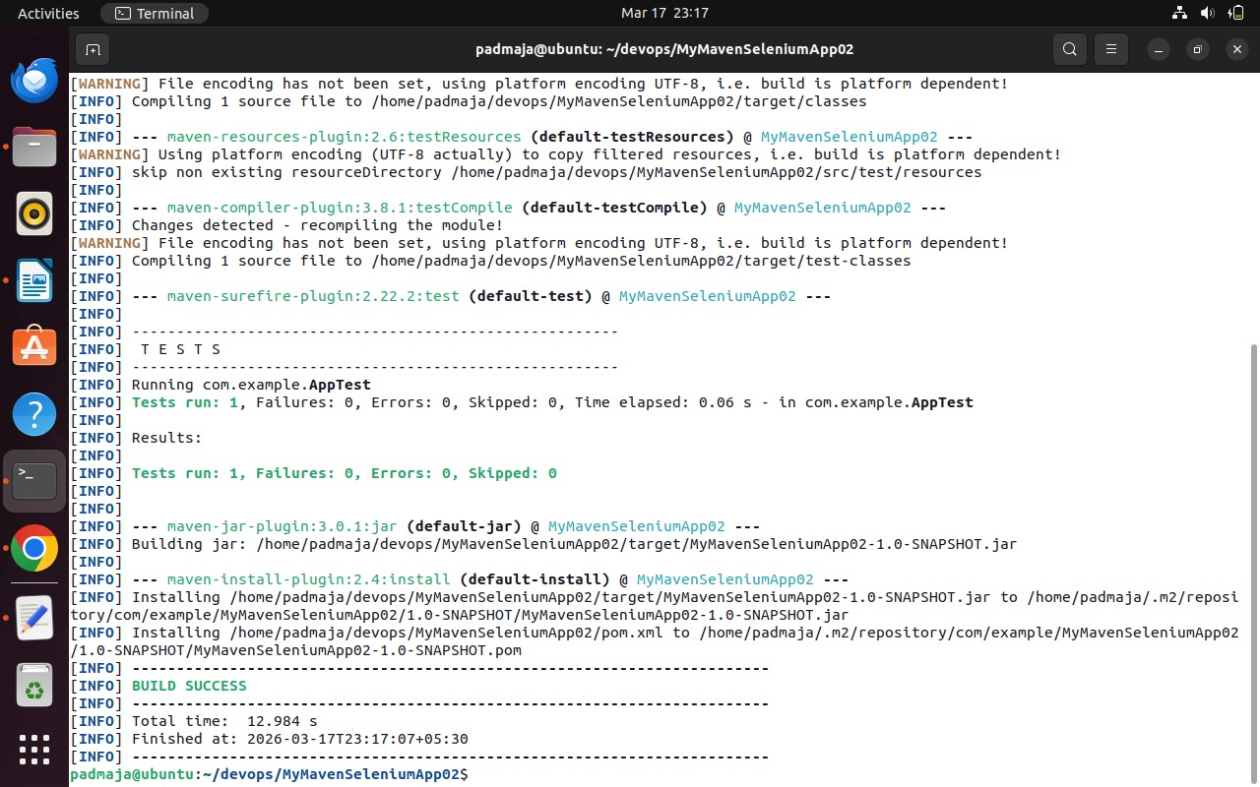
Mvn clean install
Mvn exec:java -Dexec.mainClass=”com.example.App
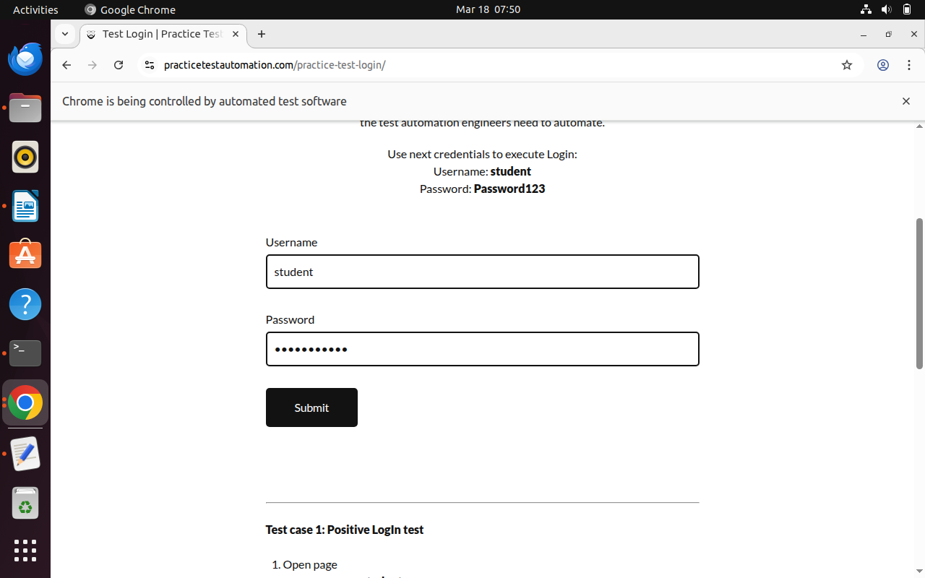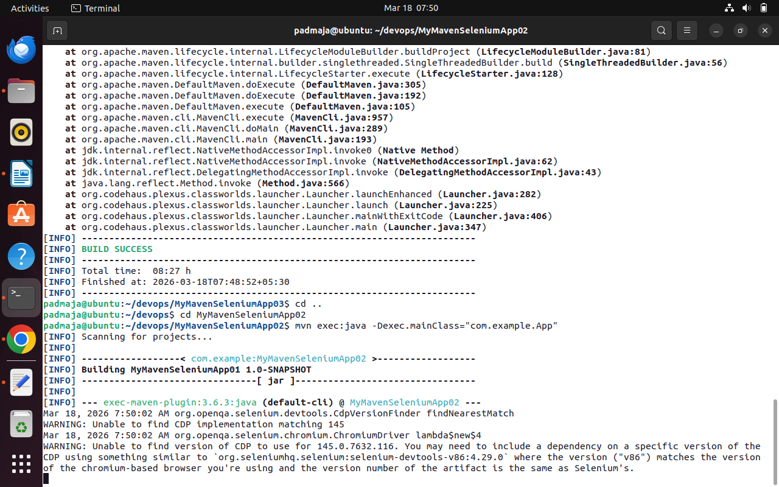

Program: Jenkins Pipeline Setup for Simple Maven
Jenkins is a popular open-source automation server used for continuous integration and continuous delivery (CI/CD). It enables developers to automate the process of building, testing, and deploying applications Efficiently. Jenkins pipelines allow users to define the entire workflow of a project as code using a file called A Jenkinsfile, which ensures consistency and repeatability in the build process.
A Jenkins pipeline is divided into multiple stages such as checkout, where the source code is retrieved from A version control system; build, where the application is compiled; test, where automated tests are executed; And deployment or run, where the application is executed or deployed. These stages help in organizing the Workflow and identifying issues at different phases of development.
In this experiment, a Jenkins pipeline is created and configured to automate the process of fetching a Mavenbased project from a repository, building it, running tests, and executing the application. This demonstrates the basic working of Jenkins pipelines and highlights how automation improves efficiency and reliability in Software development.
Step 1: Access Jenkins Dashboard
Open Jenkins in your browser using the URL: http://localhost:8080
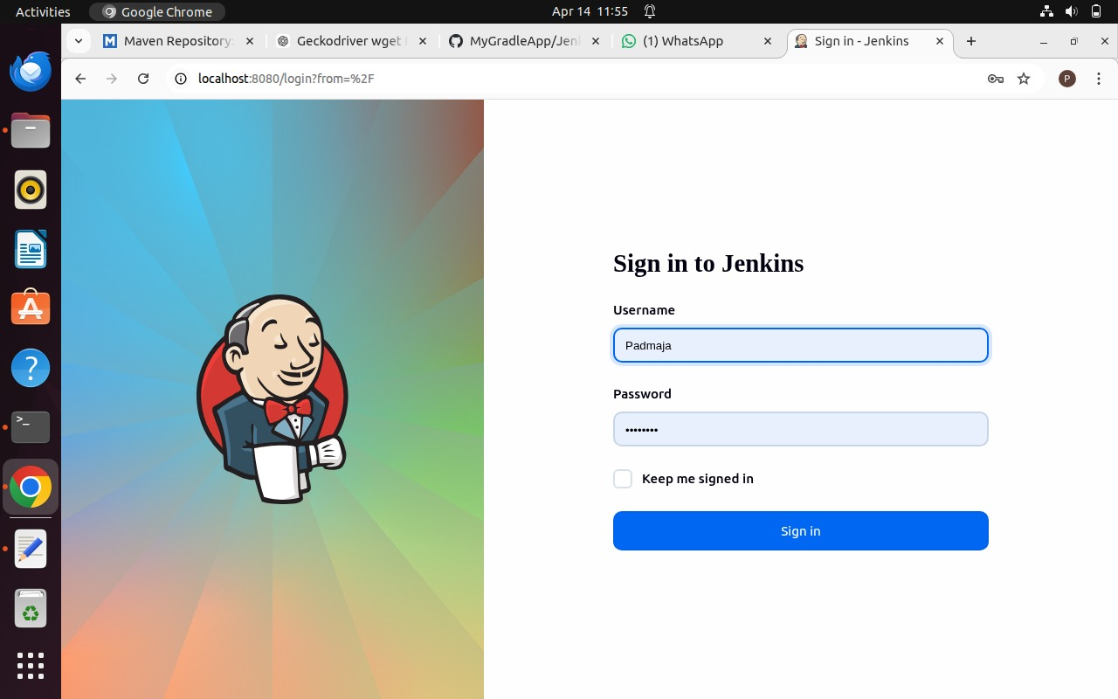
Log in using your username and password. The Dashboard will be visible
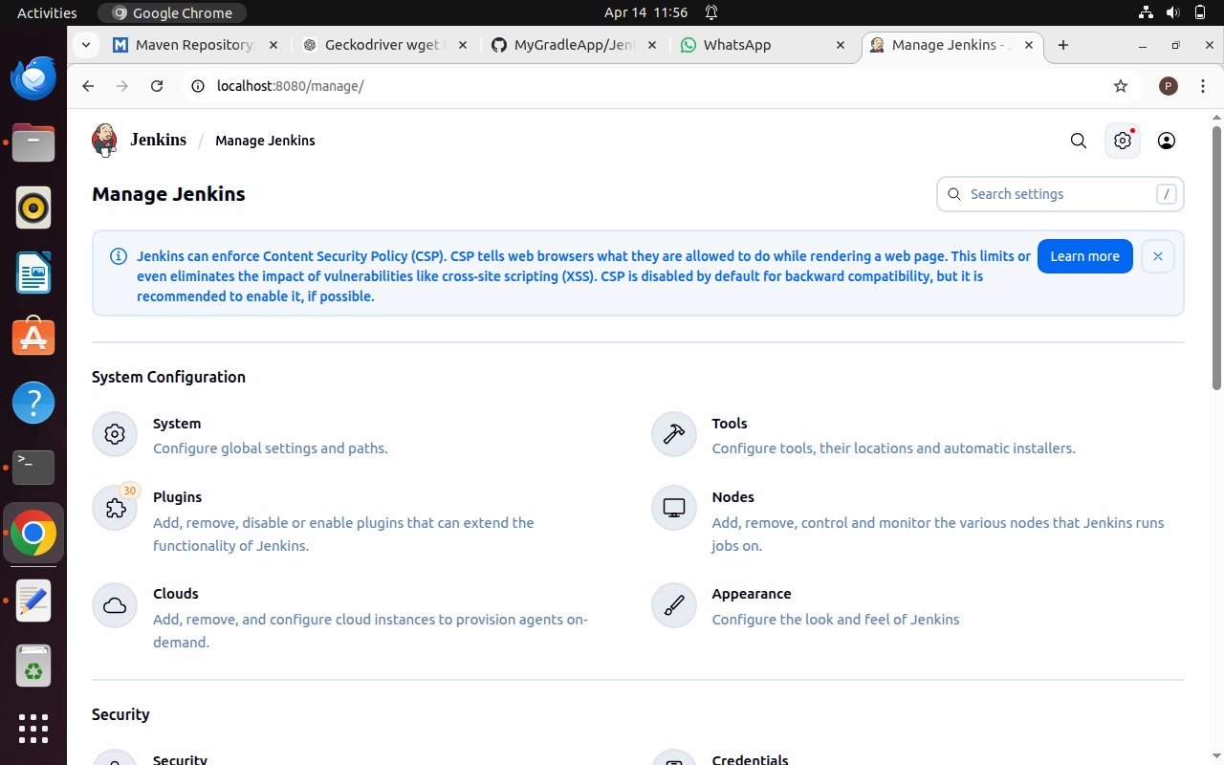
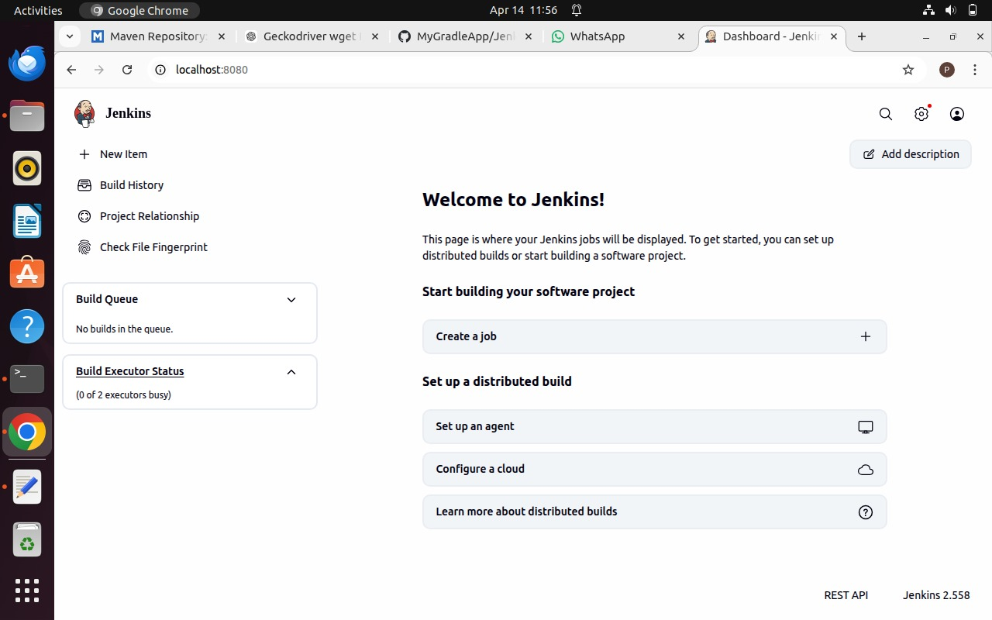
Step 2: Open Manage Jenkins
From the dashboard, click on “Manage Jenkins” by selecting the settings icon located at the top right.
Step 3: Install Required Plugins
Navigate to Manage Jenkins → Plugins → Available Plugins.
Install Maven Integration, Pipeline: Stage View, and GitHub Integration.
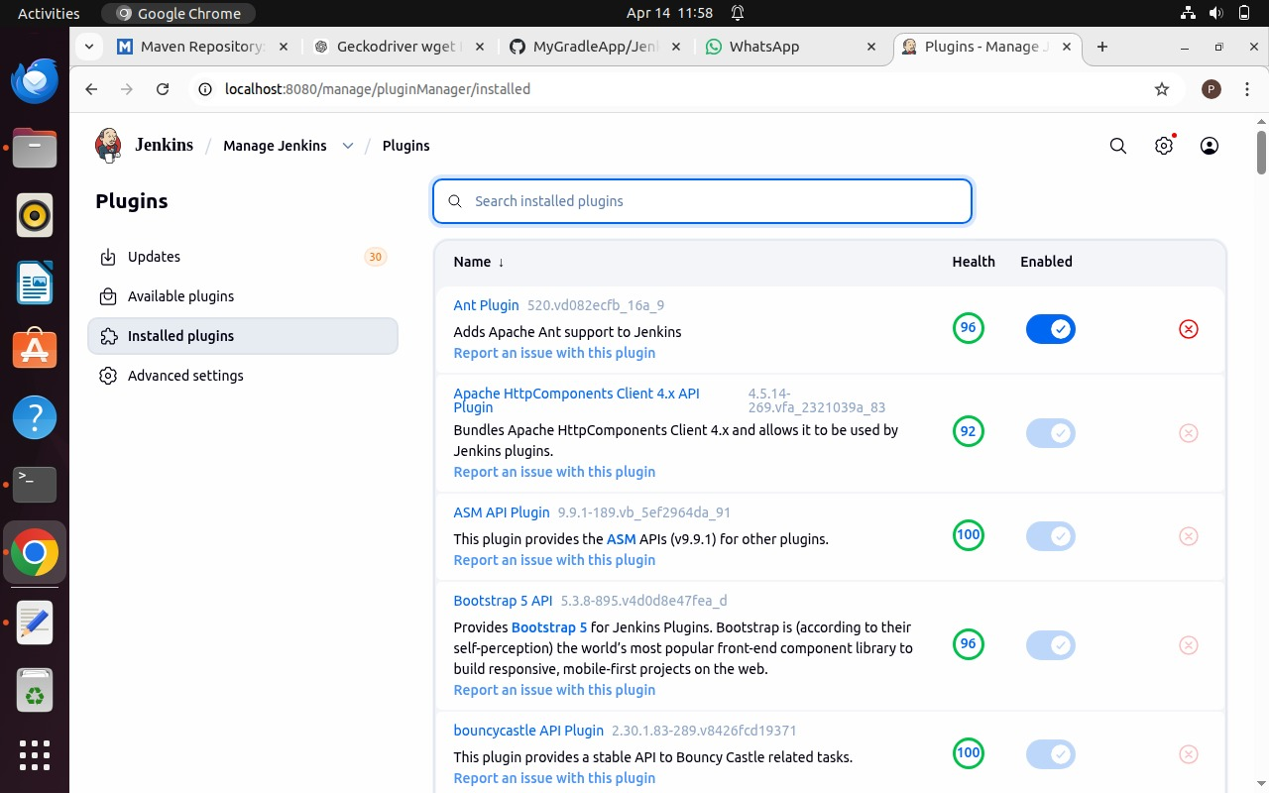
Wait for each plugin to install completely
Step 4: Verify Gradle Plugin
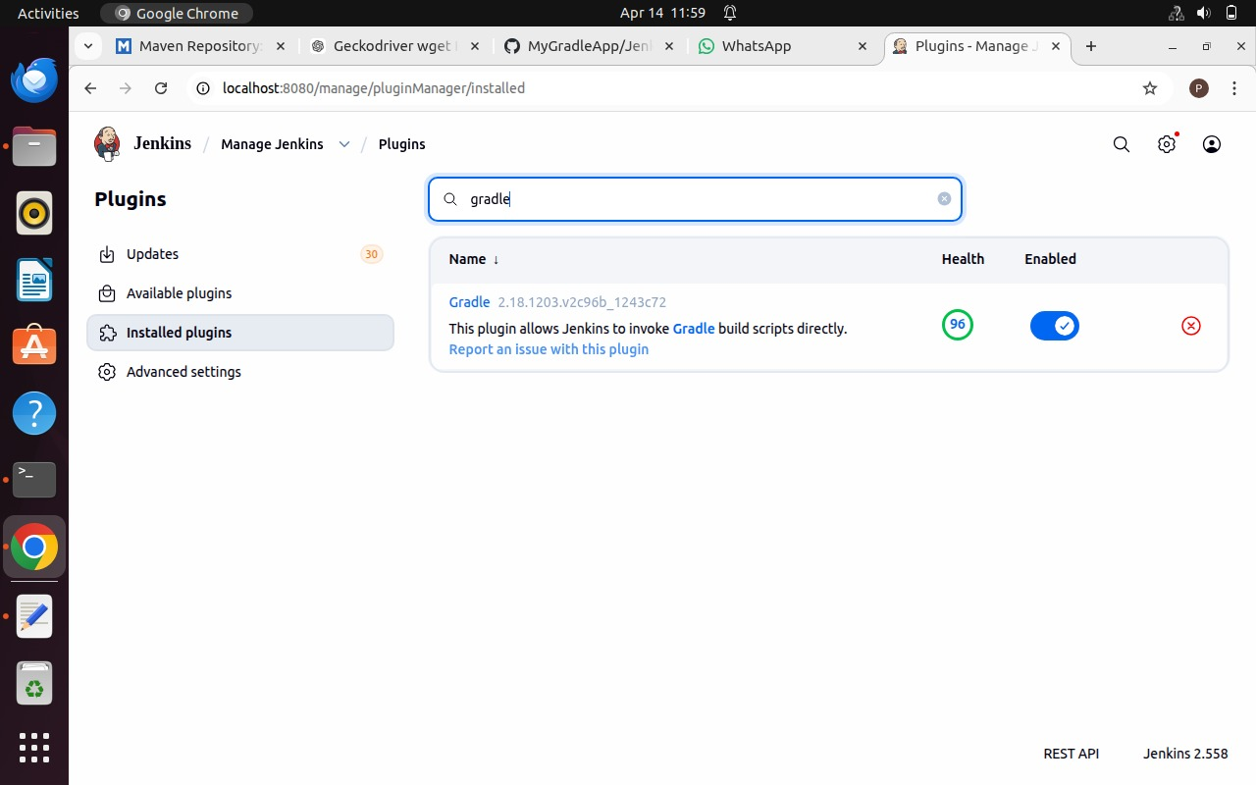
Check the Installed Plugins section for Gradle plugin. If not available, install it.

Step 5: Restart Jenkins
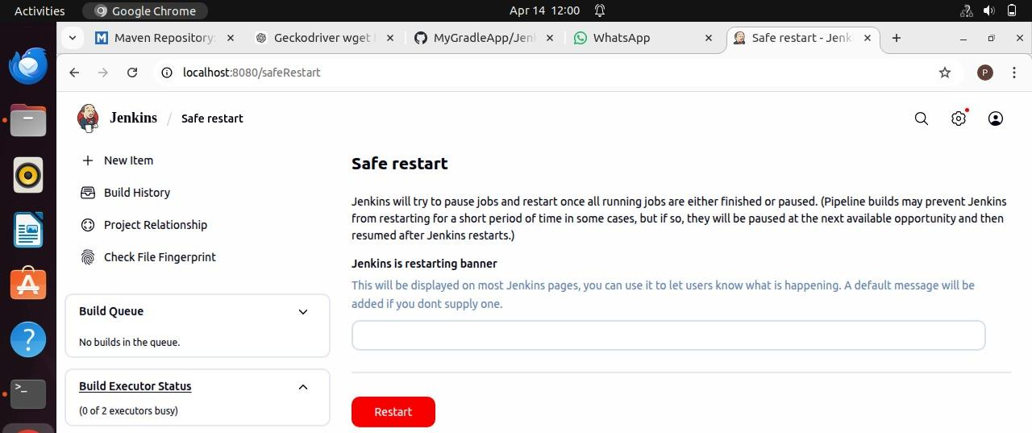
Once the installation is complete restart Jenkins by visiting http://localhost:8080/safeRestart
Step 6: Configure Tools
Go to Manage Jenkins → Tools.
Scroll down and click Add JDK.
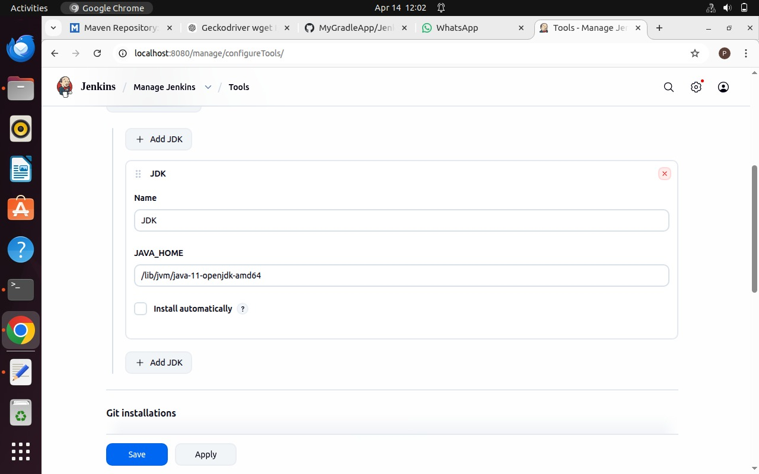
Enter JDK name and path (Computer → lib → jvm → jdk)
Step 7: Configure Build Tools
Find installation paths for Git, Maven, and Gradle using terminal.
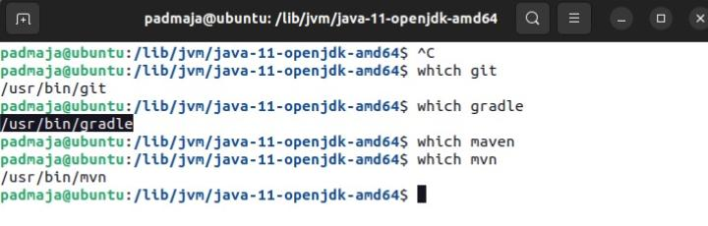
Enter these paths in Jenkins and click Apply and Save.
Step 8: Add GitHub Credentials
Go to Manage Jenkins → Credentials.
Add Username with Password.
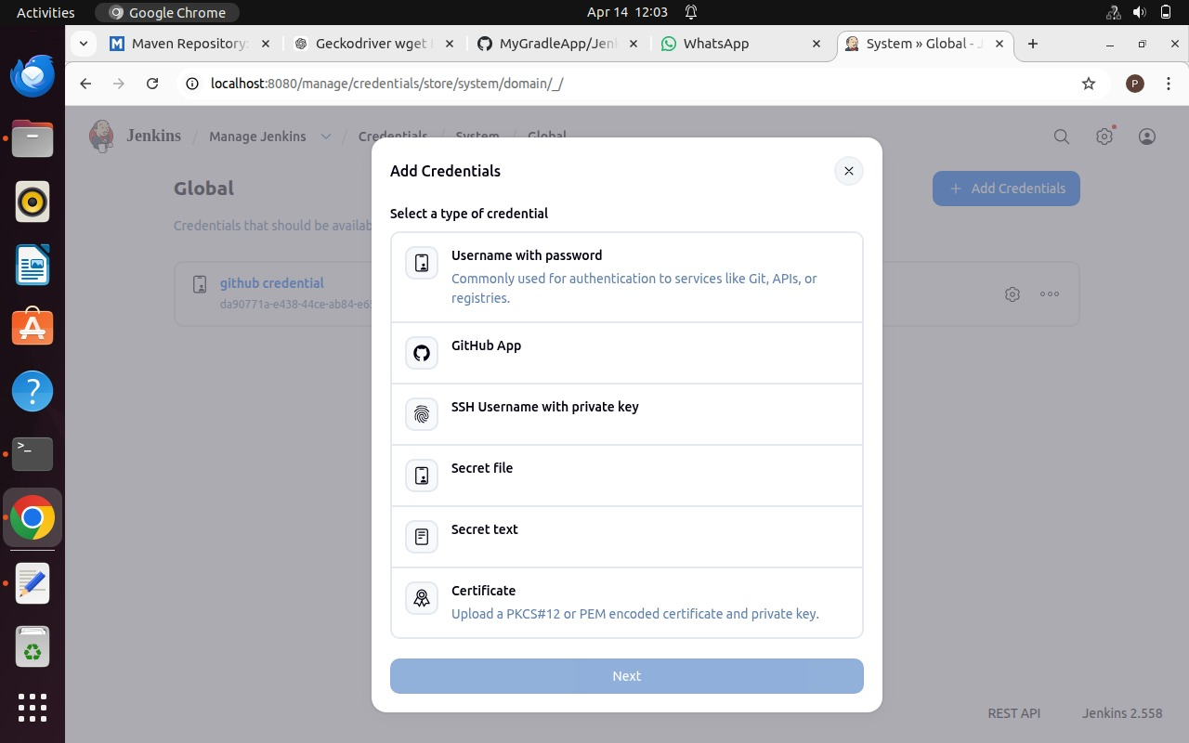
Enter GitHub credentials and description as 'GitHub Credentials'.

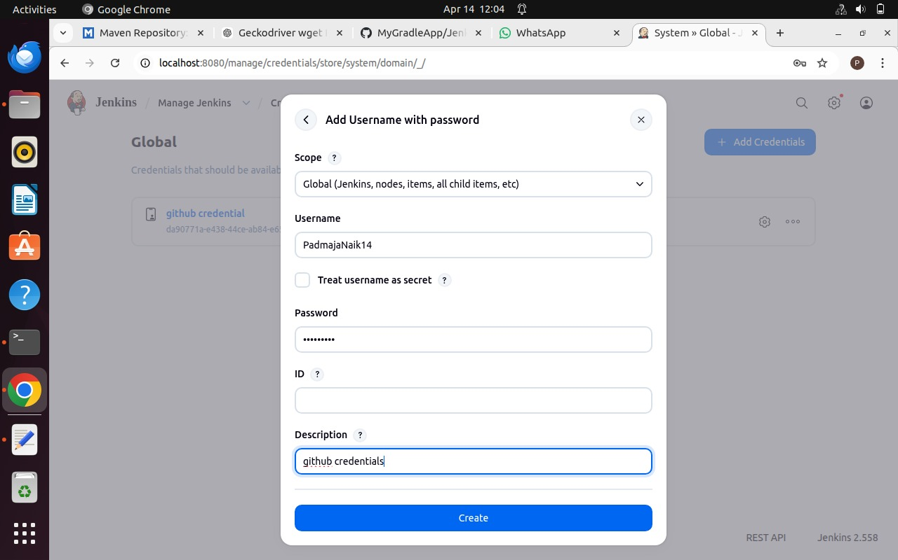
Step 9: Create a New Pipeline Job
Go to Dashboard → + New Item.
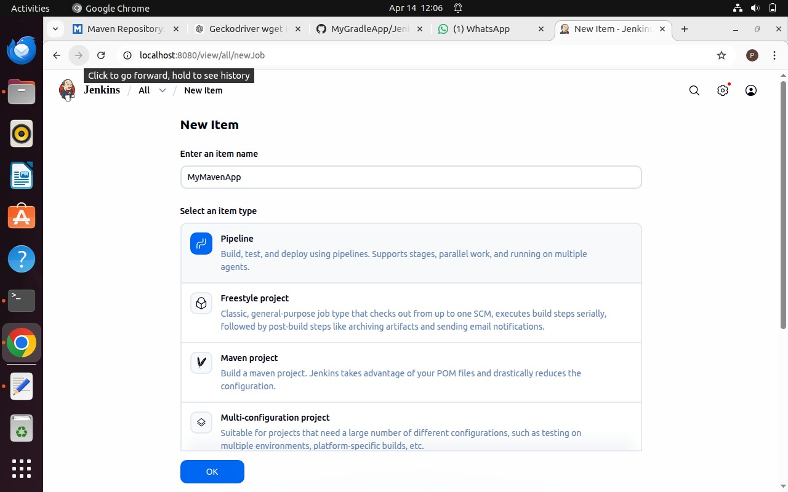
Enter name, select Pipeline, and click OK.
Step 10: Configure Pipeline from SCM
Scroll down and select Pipeline script from SCM.
SCM: Git
Enter repository URL and select GitHub credentials.

Click Apply and Save.
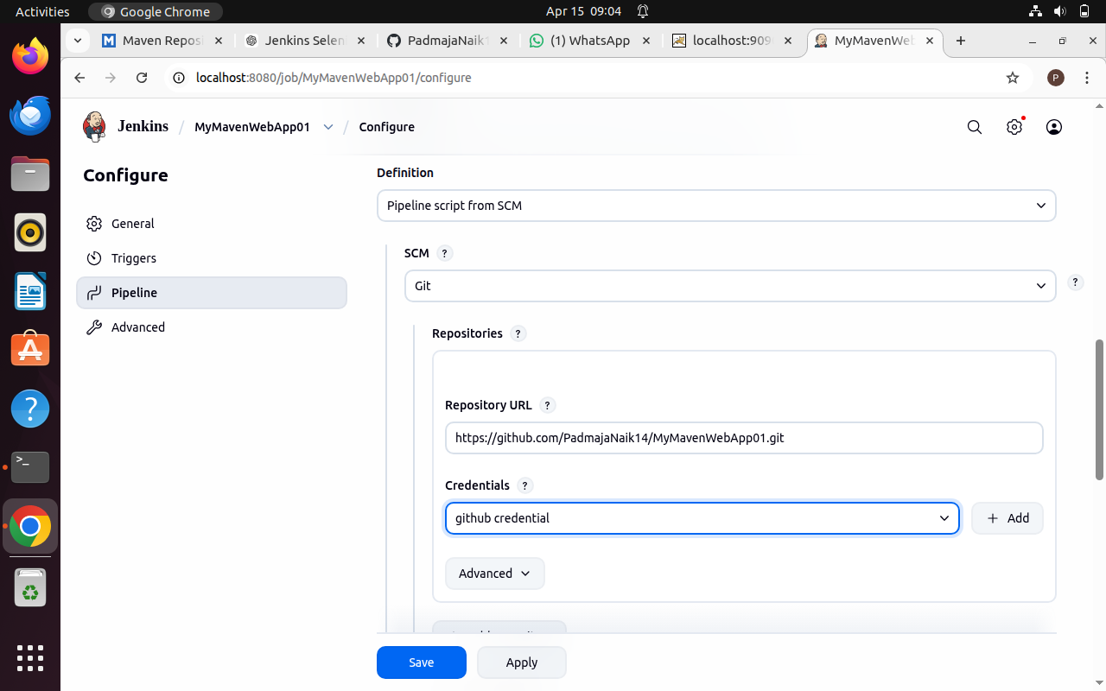

Apply and Save the changes
Step 11: Create Jenkinsfile
Create a Jenkinsfile in your MyMavenApp project and add the pipeline script. 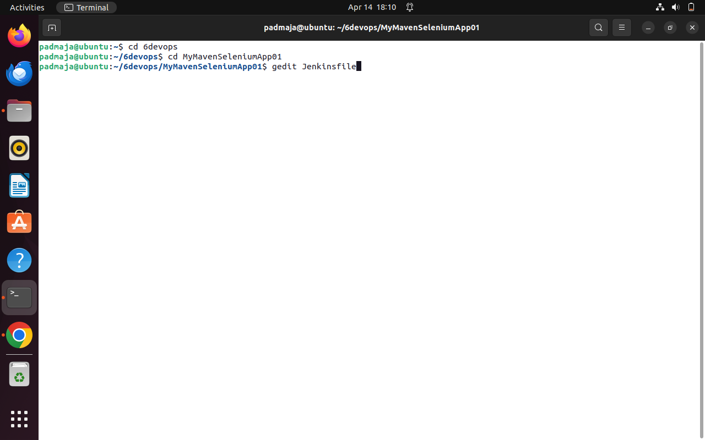
Enter the following code into the Jenkins file – Make sure to Add Your Username and Repo Name
pipeline {
agent any // Use any available agent
tools {
maven 'Maven' // Ensure this matches the name configured in Jenkins
}
stages {
stage('Checkout') {
steps {
git branch: 'master', url: 'https://github.com/PadmajaNaik14/MyMavenApp.git'
}
}
stage('Build') {
steps {
sh 'mvn clean package' // Run Maven build
}
}
stage('Test') {
steps {
sh 'mvn test' // Run unit tests
}
}
stage('Run Application') {
steps {
// Start the JAR application
sh 'java -jar target/MyMavenApp-1.0-SNAPSHOT.jar'
}
}
}
post {
success {
echo 'Build and deployment successful!'
}
failure {
echo 'Build failed!'
}
}
}
Step 12: Update pom.xml
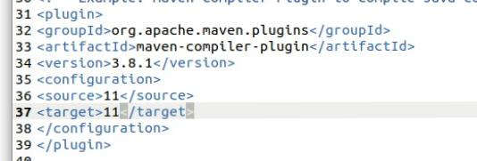
Change source and target versions from 1.7 to 11.
Step 13: Push Changes to GitHub
Commit changes and push to your GitHub repository.
Step 14: Build the Pipeline
Go to Jenkins and click Build Now.
Step 15: Monitor Build Stages
Use Stage View and Full Stage View to monitor execution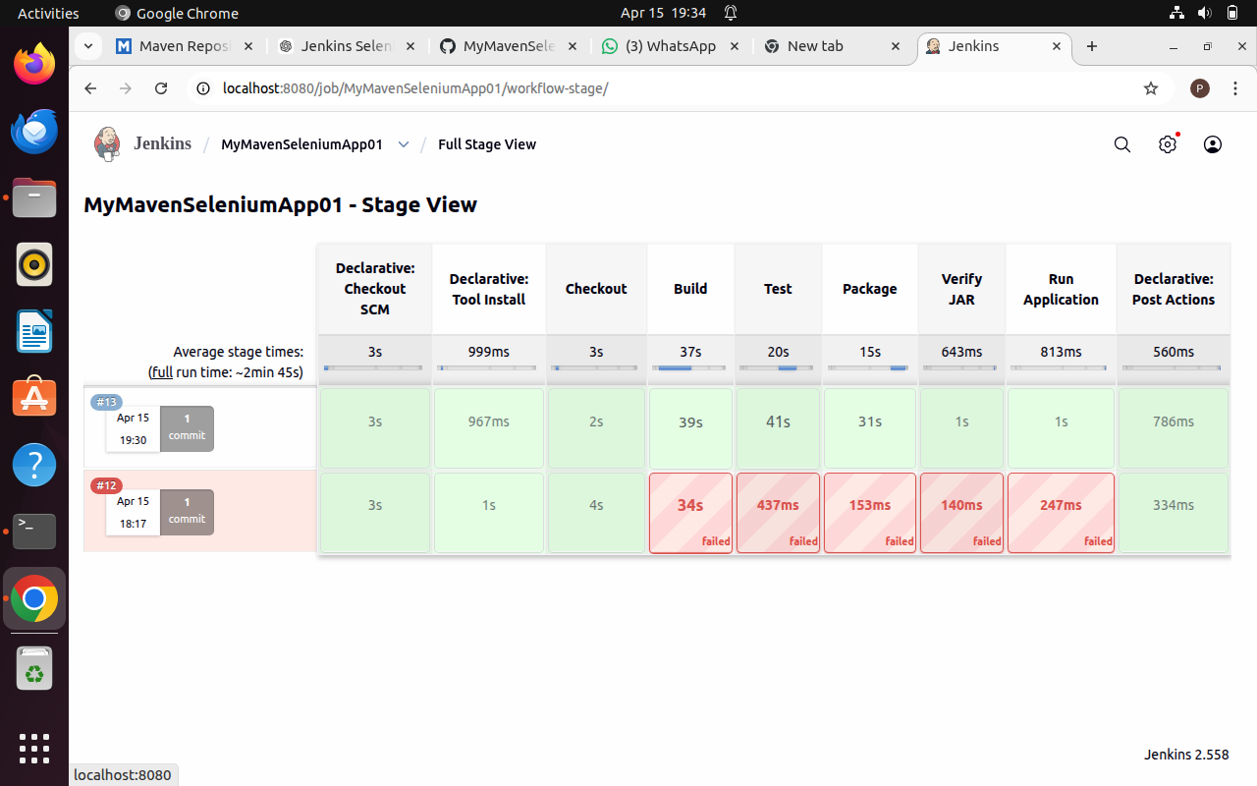

Step 16: Verify Pipeline Execution
If all stages complete successfully, the pipeline is built

