Step 1: Generate a Maven Project
Use the command:
mvn archetype:generate -DgroupId=com.example -DartifactId=MyMavenApp -DarchetypeArtifactiId=maven-archetype-quickstart -DinteractiveMode=false

Step 2: Change the directory to MyMavenApp
Use the command:
Cd MyMavenApp

Step 3: Add Junit dependencies from central maven repository
<dependency>
<groupId>junit</groupId>
<artifactId>junit</artifactId>
<version>4.13.2</version>
<scope>test</scope>
</dependency>

Step 4: Full pom.xml file
<project xmlns=http://maven.apache.org/POM/4.0.0 xmlns:xsi=http://www.w3.org/2001/XMLSchema-instance
Xsi:schemaLocation=http://maven.apache.org/POM/4.0.0 http://maven.apache.org/maven-v4_0_0.xsd>
<modelVersion>4.0.0</modelVersion>
<groupId>com.example</groupId>
<artifactId>MyMavenApp</artifactId>
<packaging>jar</packaging>
<version>1.0-SNAPSHOT</version>

<name>MyMavenApp</name>
<url>http://maven.apache.org</url>

<!—Properties: Customize Java version or plugin versions
<properties>
<maven.compiler.source>11</maven.compiler.source>
<maven.compiler.target>11</maven.compiler.target>
</properties>
<dependencies>
<dependency>
<groupId>junit</groupId>
<artifactId>junit</artifactId>
<version>3.8.1</version>
<scope>test</scope>
</dependency>
</dependencies>

<!—Build: Configuring plugins and build settings
<build>
<plugins>
<!—Example: Maven Compiler Plugin to compile Java code
<plugin>
<groupId>org.apache.maven.plugins</groupId>
<artifactId>maven-compiler-plugin</artifactId>
<version>3.8.1</version>
<configuration>
<source>1.7</source>
<target>1.7</target>
</configuration>
</plugin>

<!—Example: Maven Surefire Plugin to run tests
<plugin>
<groupId>org.apache.maven.plugins</groupId>
<artifactId>maven-surefire-plugin</artifactId>
<version>2.22.2</version>
</plugin>

<plugin>
<groupId>org.apache.maven.plugins</groupId>
<artifactId>maven-jar-plugin</artifactId>
<version>3.1.0</version>
<configuration>
<archive>
<manifestEntries>
<Main-Class>com.example.App</Main-Class>
</manifestEntries>
</archive>
</configuration>
</plugin>

</plugins>
</build>
</project>

Step5 : Complie the code
Mvn clean install
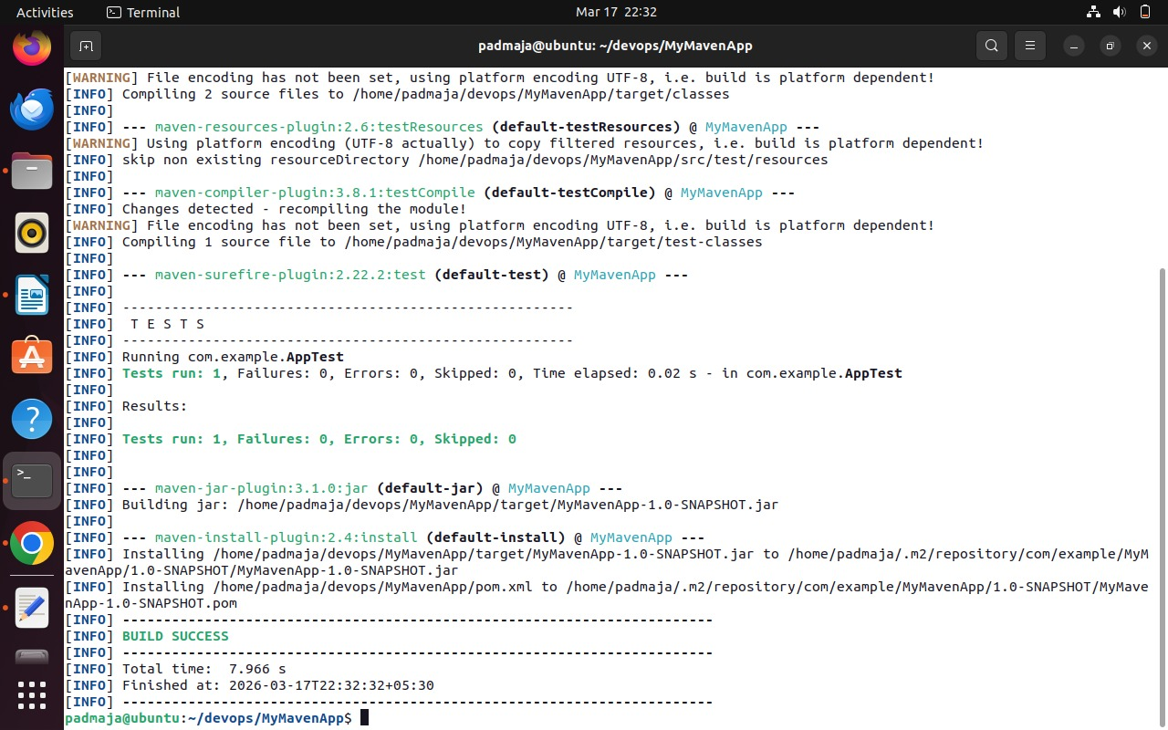

Step 6: Run this packaged Java application file
java -jar target/MyMavenApp-1.0-SNAPSHOT.jar

Step 7: Output
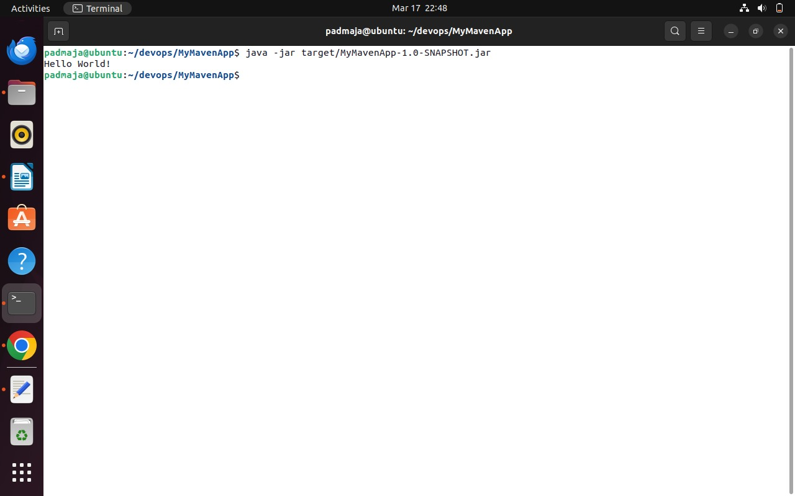
Hello world!
Step 8: Change to Mainclass.java
Cd src/main/java/com/example
Gedit Mainclass.java

package com.example;
public class MainClass{
public static void main(String[] args){
System.out.println("this is main class");
}}

Gedit pom.xml and in plugins section remove App and change to Mainclass
Mvn clean install

Step9: compile the code again
