Installation of Apache Tomcat and Jenkins Pipeline for MyMavenWebApp
Installation of Apache Tomcat:
Step 1: Open Terminal
- sudo -i → Switches the user to root (administrator) mode with full system privileges.
- sudo apt update && sudo apt upgrade -y → Updates the package list and upgrades all installed packages automatically without asking for confirmation.
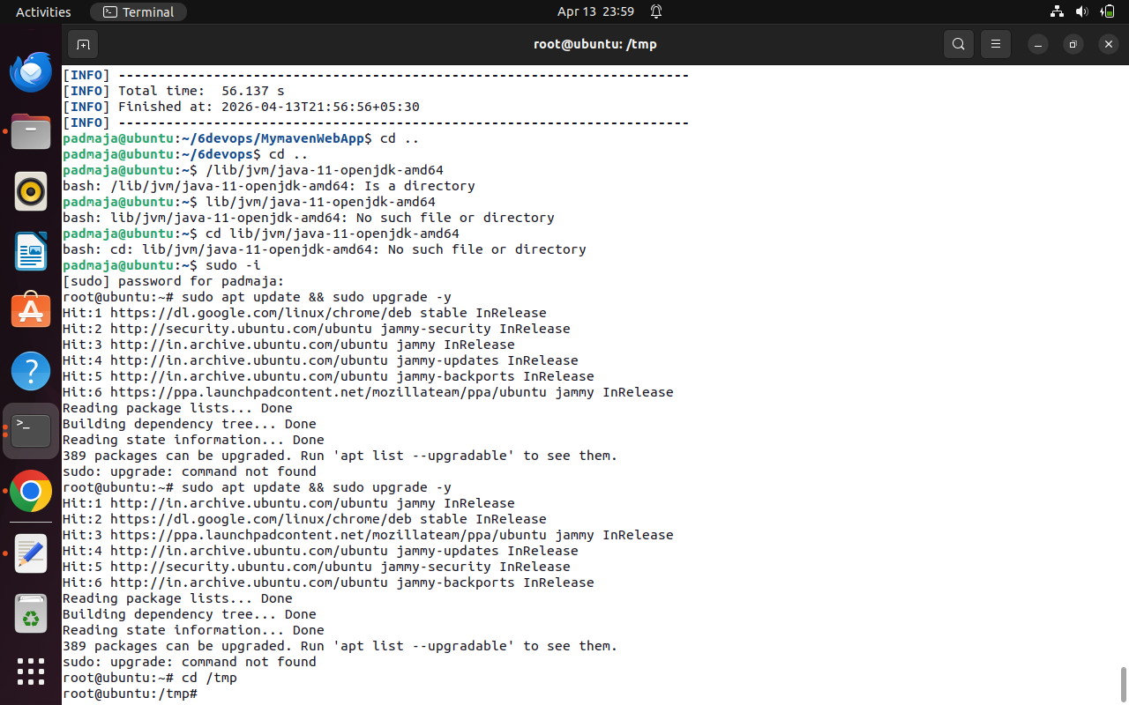

Step 2: Download Apache Tomcat
- cd /tmp → Changes the current directory to the system’s temporary folder.
- wget https://archive.apache.org/dist/tomcat/tomcat-9/v9.0.95/bin/apache-tomcat-9.0.95.tar.gz → Downloads Apache Tomcat 9.0.95 compressed file from the official Apache archive to the system.
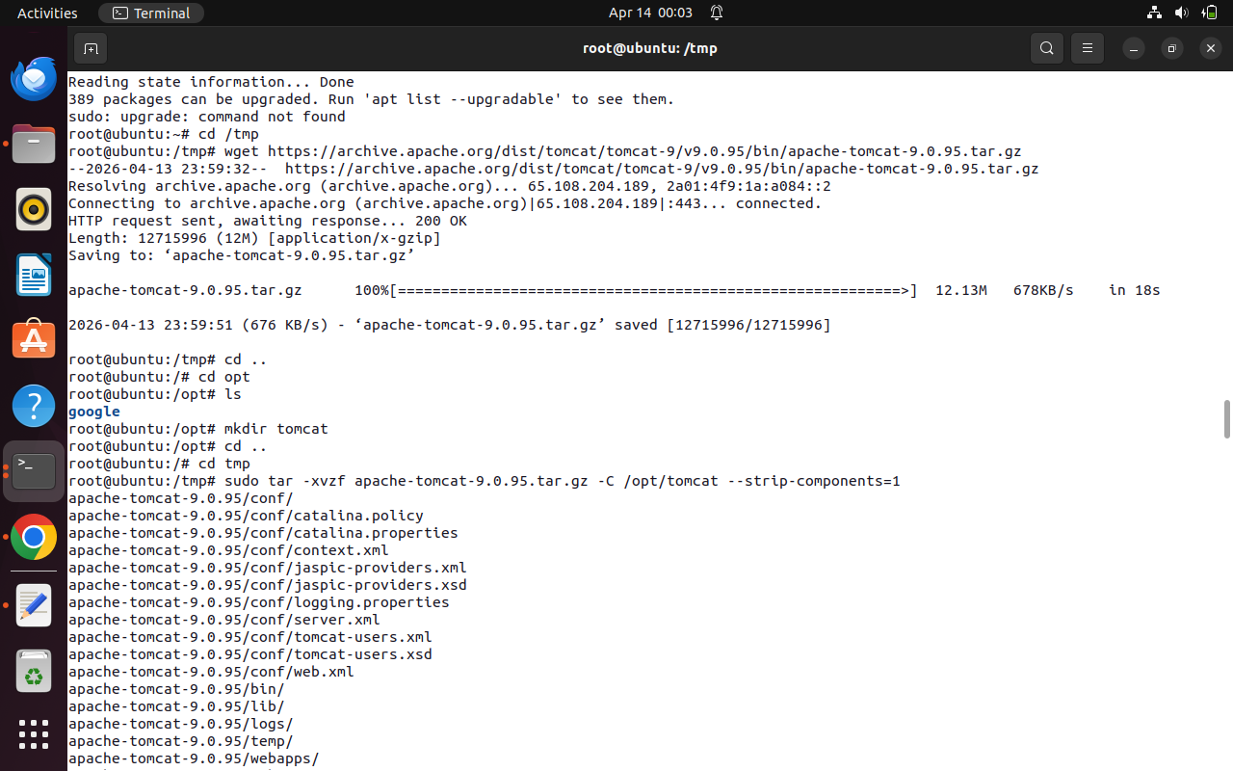

Step 3: Create Directory for Tomcat Installation
- cd .. → Moves one level up from the current directory.
- cd /opt → Navigates to the /opt directory used for installing optional software.
- mkdir tomcat → Creates a new directory named tomcat to store the Tomcat files.
- ls → Lists directory contents to verify that the tomcat folder is created successfully

Step 4: Extract Apache Tomcat Files
- sudo tar -xvzf apache-tomcat-9.0.95.tar.gz -C /opt/tomcat --strip-components=1 → Extracts the downloaded Tomcat archive into /opt/tomcat directory by removing the top-level folder and placing all files directly inside it.


Step 5: Configure Tomcat Server
- cd /opt/tomcat/conf → Navigates to the Tomcat configuration directory.
- ls → Lists configuration files inside the directory.
- gedit server.xml → Opens the main Tomcat configuration file for editing.
- Port Change (8080 → 9090) → Modifies the default Tomcat port to 9090 to avoid conflicts with other services.
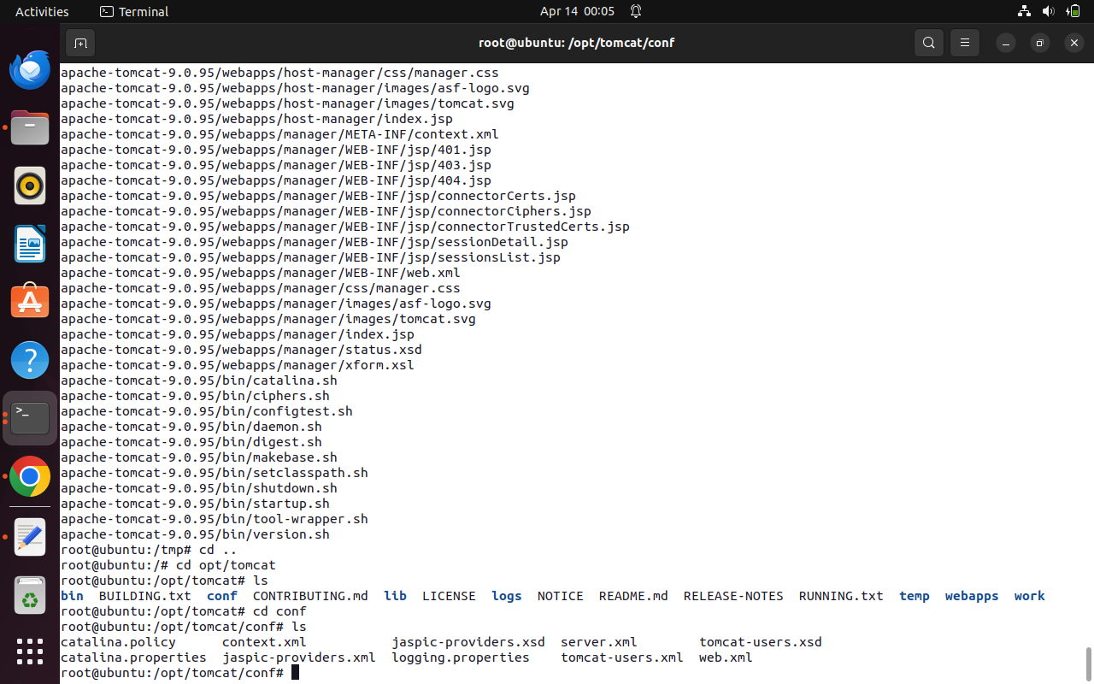
Step 6: Configure Tomcat User Access
- gedit tomcat-users.xml → Opens the Tomcat user configuration file.
- Add user with role → Creates a user (admin) with password and assigns manager-gui role to access the Tomcat Manager dashboard.
Step 7: Start Tomcat Server
- cd /opt/tomcat/bin → Navigates to the Tomcat binary directory.
- ls → Lists all available startup and shutdown scripts.
- sh startup.sh → Starts the Apache Tomcat server successfully.

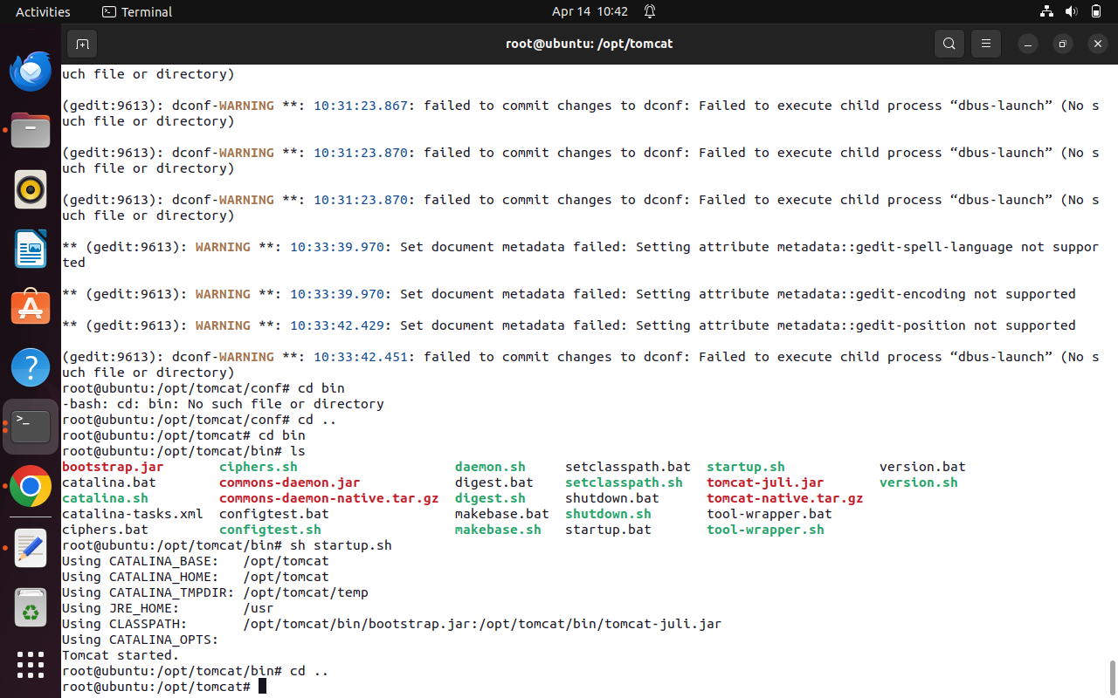
Step 8: Verify Tomcat Installation
- Open Browser (http://localhost:9090) → Confirms Tomcat server is running successfully by displaying the default Tomcat page.
- Access Manager (http://localhost:9090/manager/html) → Logs into the Tomcat Manager dashboard to manage and deploy web applications.
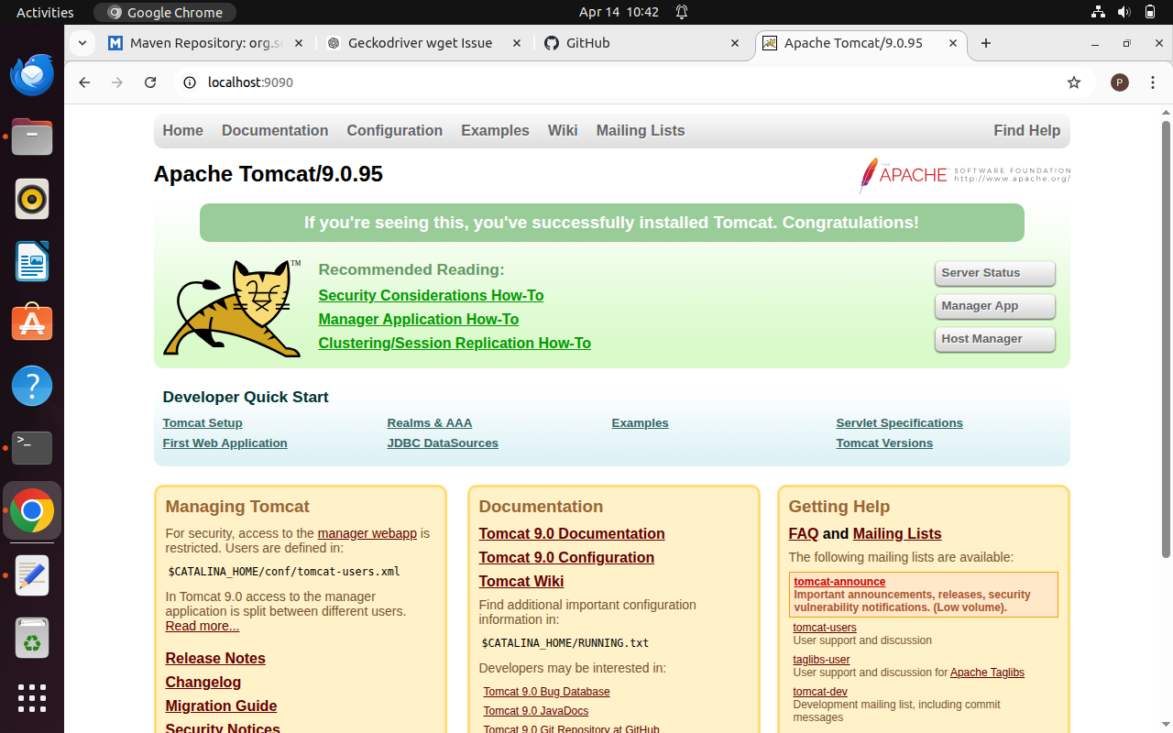
Jenkins Pipeline for MyMavenWebApp
Step 1: To deploy MyMavenWebApp, open the terminal, cd into the MyMavenWebApp folder, create a Jenkinsfile containing the pipeline code, and then commit and push it to GitHub.
pipeline {
agent any // Use any available agent
tools {
maven 'Maven' // Ensure this matches the name configured in Jenkins
}
stages {
stage('Checkout') {
steps {
git branch: 'master', url: 'https://github.com/numankhanssk/MymavenWebApp01.git'
}
}
stage('Build') {
steps {
sh 'mvn clean package' // Run Maven build
}
}
stage('Test') {
steps {
sh 'mvn test' // Run unit tests
}
}
stage('Deploy WAR') {
steps {
sh 'cp target/MymavenWebApp01.war /opt/tomcat/webapps/'
}
}
}
post {
success {
echo 'Build and deployment successful!'
}
failure {
echo 'Build failed!'
}
}
}

Step 2: To deploy MyMavenWebApp, you first need to create a Jenkins pipeline job that will use the Jenkinsfile from your project repository. Then, go to the Jenkins home page and click on “New Item” to create a job, enter the item name (e.g., MyMavenWebApp), and select Pipeline as the project type. This option allows you to build, test, and deploy applications using a Jenkinsfile. After selecting the pipeline type, click “OK” to proceed to the job configuration page.
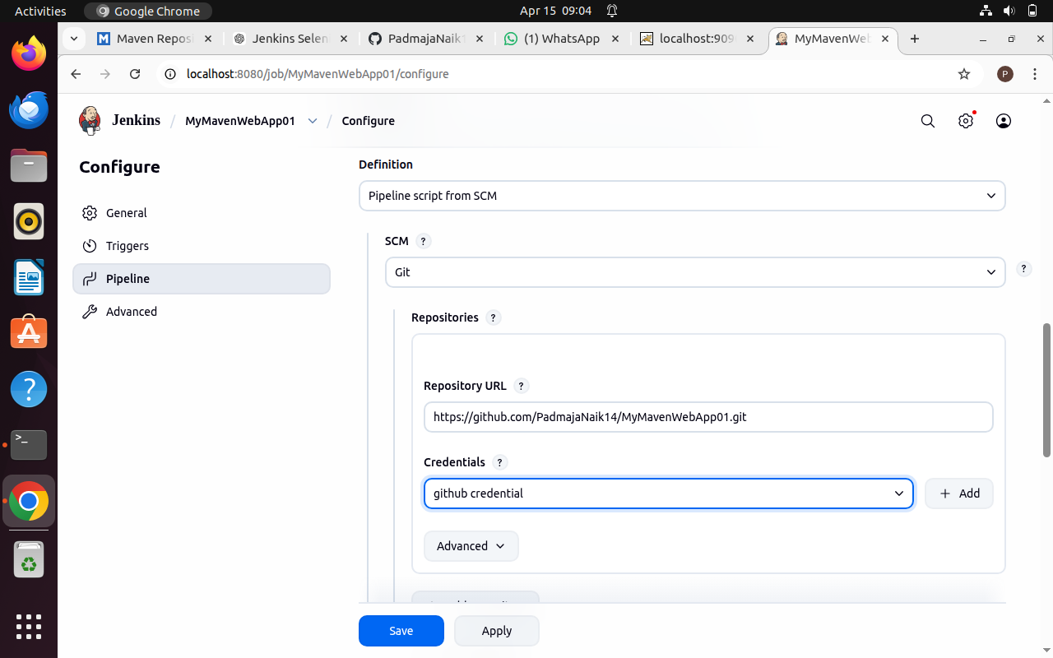
Step 4: After clicking Apply and Save, go back to MyMavenWebApp in Jenkins and click Build Now; the build completes successfully.
