MyGradleApp
Setting Up a Gradle Project: To create a basic Gradle Project, run following commands:
mkdir MyGradleApp: to create a Gradle project directory, cd MyGradleApp: to change directory to project directory
gradle init --type java-application
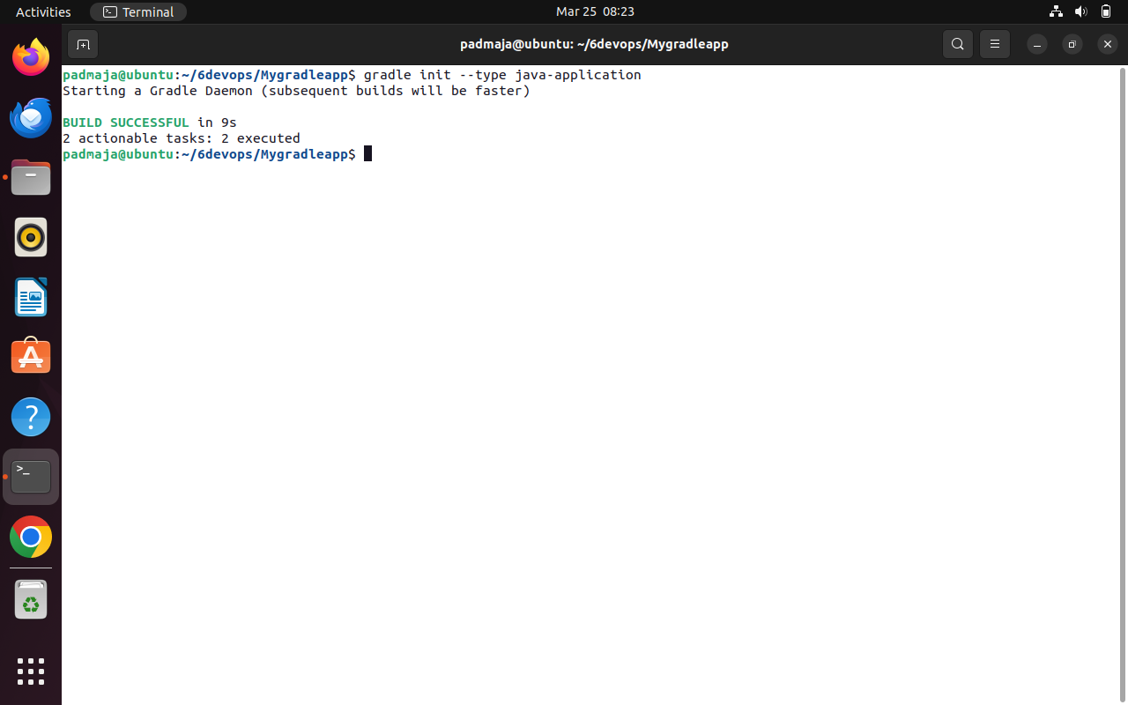
Above command uses Gradle’s init method to create a basic Gradle Java application
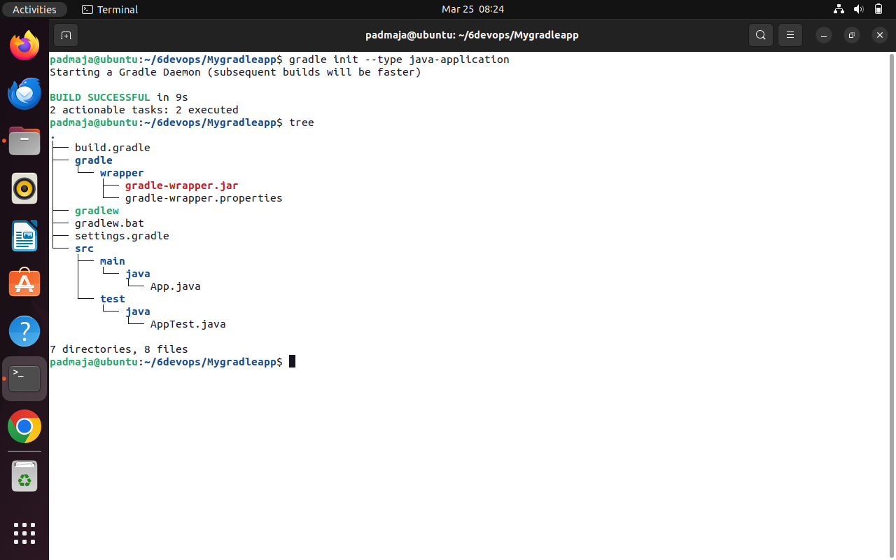
Files Breakdown – instead of pom.xml we have four main files that have several important information regarding the gradle application:
build.gradle – Main build script. Defines project settings, dependencies, and plugins
settings.gradle- sets the project name and can include subprojects (for multi-project builds).
gradlew & gradlew.bat – Gradle Wrapper scripts. Use these to run Gradle without requiring a system install. gradlew for Unix, .bat for Windows
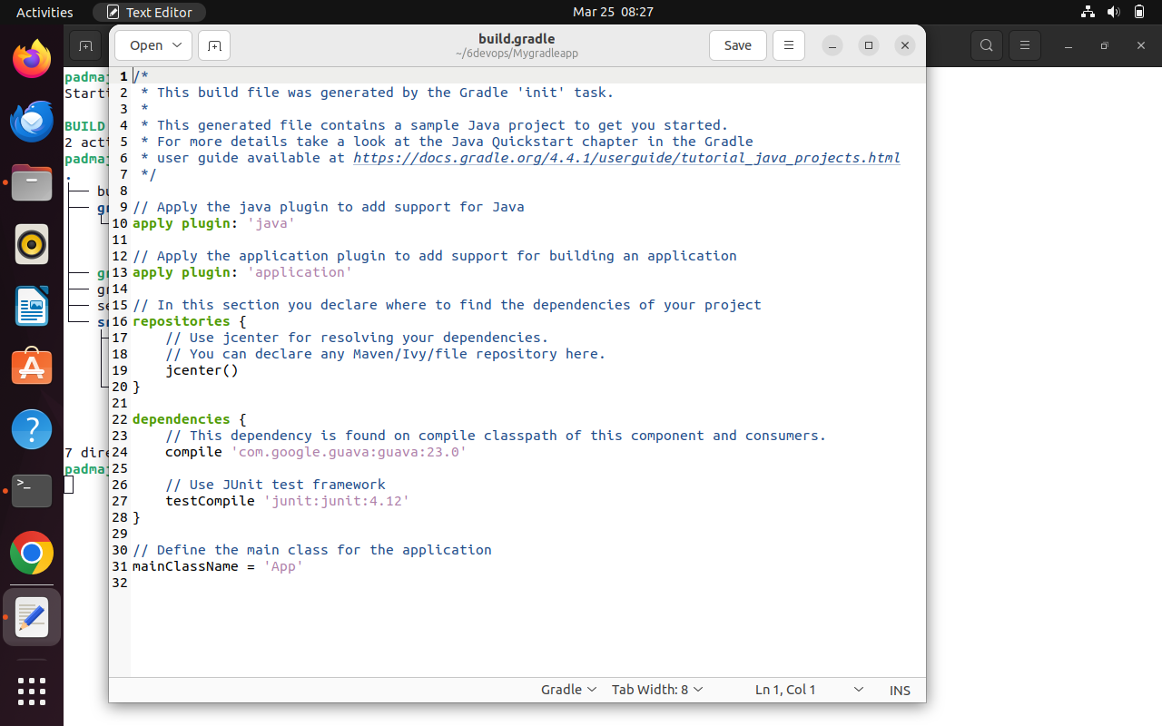
Go to terminal and run following commands: gradle build: it compiles the source code and package the app
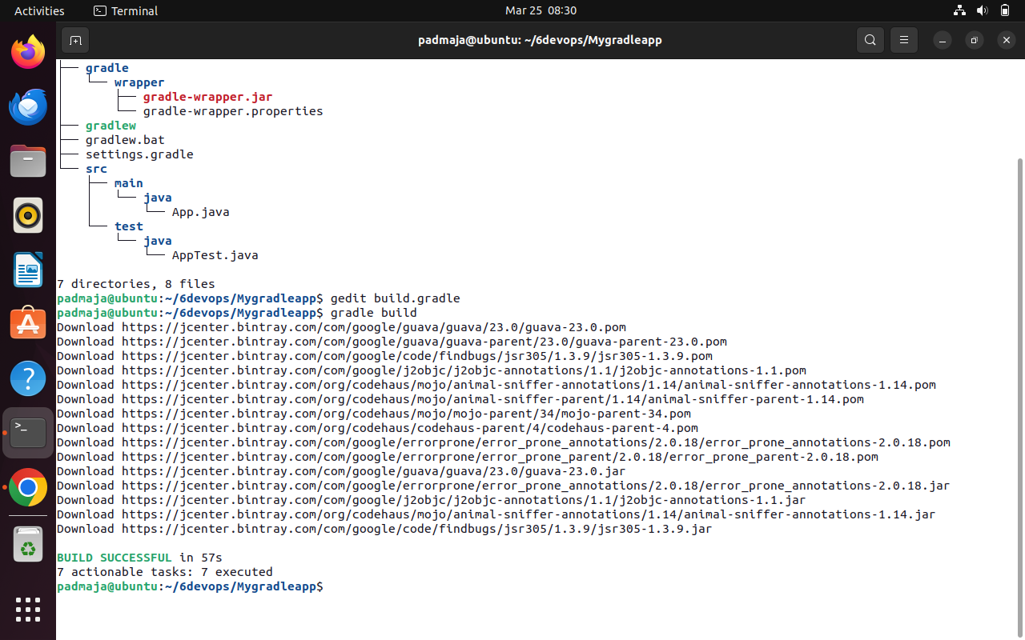
Gradle run: Run the default Hello World application
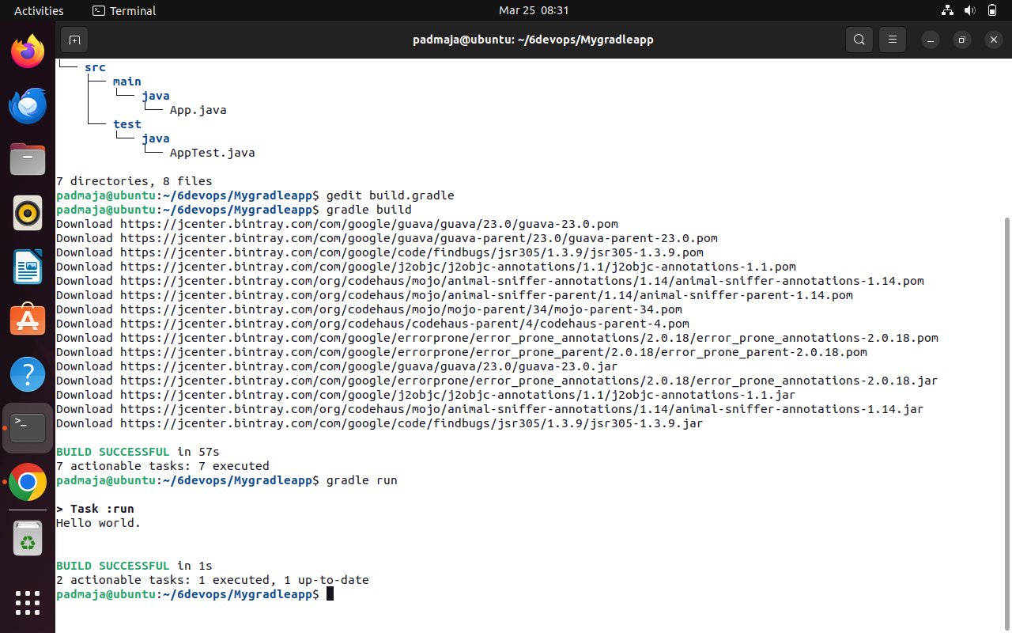
Gradle lets you define and customize tests, or packaging your app. We can use command to view the updated directory structure.4, which are units of work like compiling code, running , or create your own. tree tasks built-in task.
We can add tasks like this to our gradle.build file as shown below:
task display{
doLast{
println ‘Hello devops’
}
}
Here task defines a particular piece of code that is designed to do some work, ‘display’ is the name of the task and ‘doLast’ is used append a task to queue in a way that it executes last (alternative is ‘doFirst’ which prepend a task to queue so that it executes first.
Run the task using following command: gradle <task-name> (e.g. gradle display)
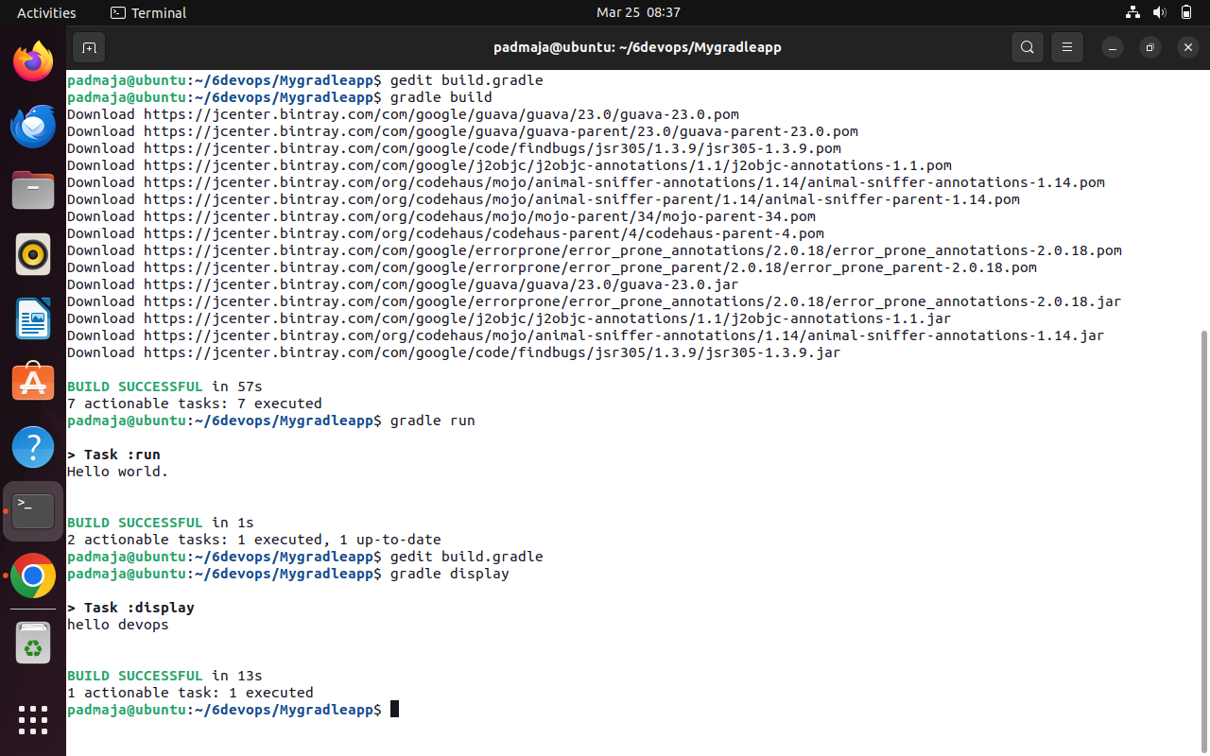

Program: Jenkins Pipeline Setup for Simple Maven
Jenkins is a popular open-source automation server used for continuous integration and continuous delivery (CI/CD). It enables developers to automate the process of building, testing, and deploying applications Efficiently. Jenkins pipelines allow users to define the entire workflow of a project as code using a file called A Jenkinsfile, which ensures consistency and repeatability in the build process.
A Jenkins pipeline is divided into multiple stages such as checkout, where the source code is retrieved from A version control system; build, where the application is compiled; test, where automated tests are executed; And deployment or run, where the application is executed or deployed. These stages help in organizing the Workflow and identifying issues at different phases of development.
In this experiment, a Jenkins pipeline is created and configured to automate the process of fetching a Mavenbased project from a repository, building it, running tests, and executing the application. This demonstrates the basic working of Jenkins pipelines and highlights how automation improves efficiency and reliability in Software development.
Step 1: Access Jenkins Dashboard
Open Jenkins in your browser using the URL: http://localhost:8080
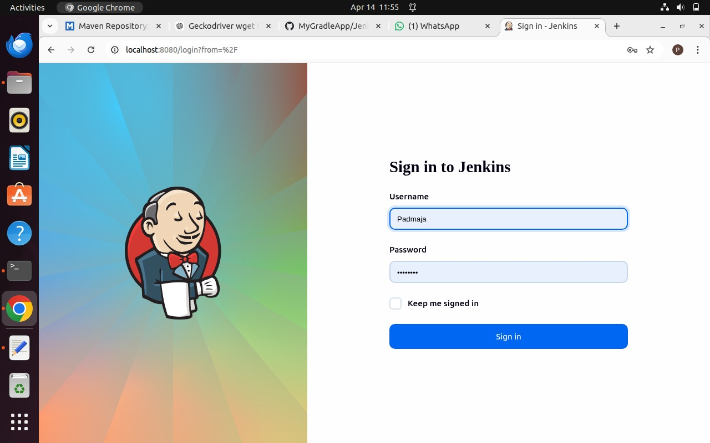
Log in using your username and password. The Dashboard will be visible
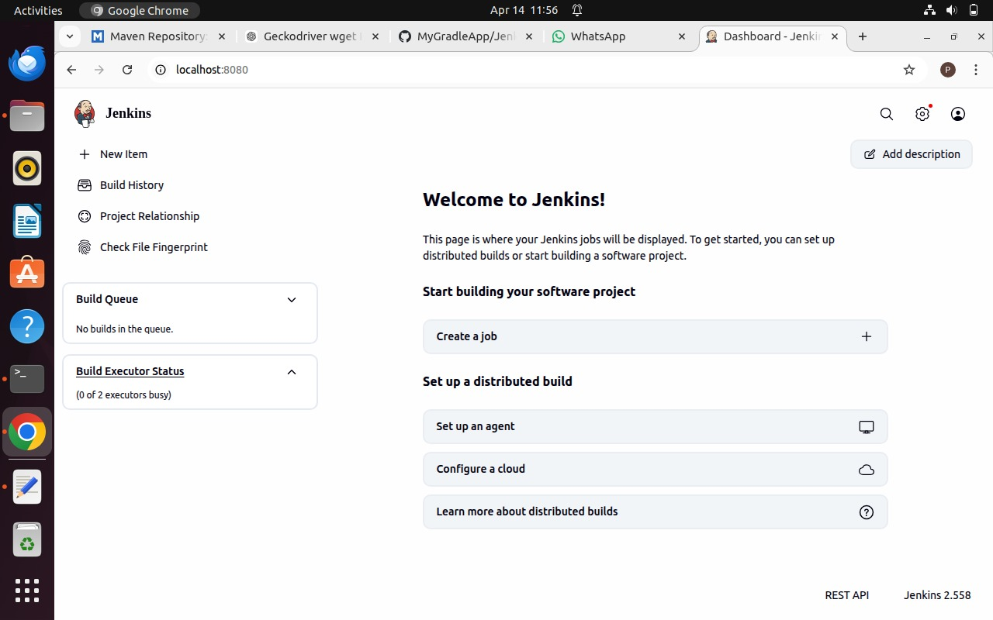
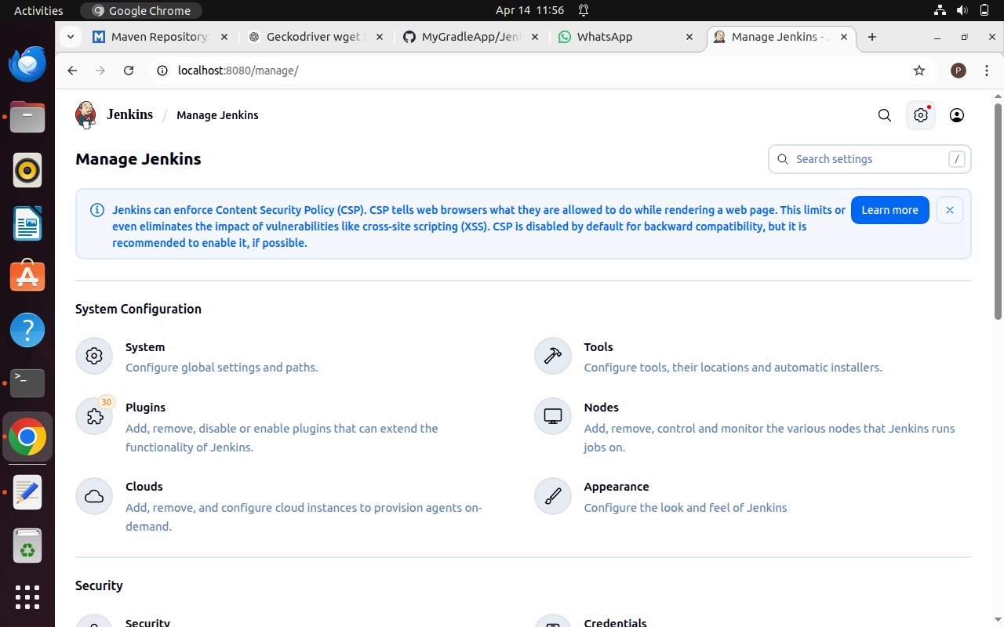
Step 2: Open Manage Jenkins
From the dashboard, click on “Manage Jenkins” by selecting the settings icon located at the top right.
Step 3: Install Required Plugins
Navigate to Manage Jenkins → Plugins → Available Plugins.
Install Maven Integration, Pipeline: Stage View, and GitHub Integration.
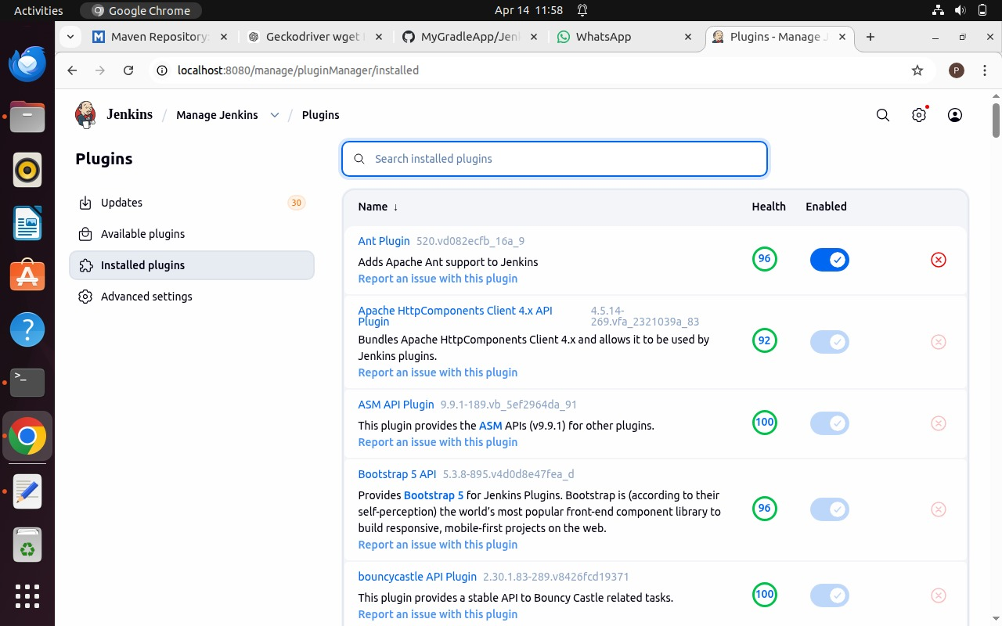
Wait for each plugin to install completely
Step 4: Verify Gradle Plugin
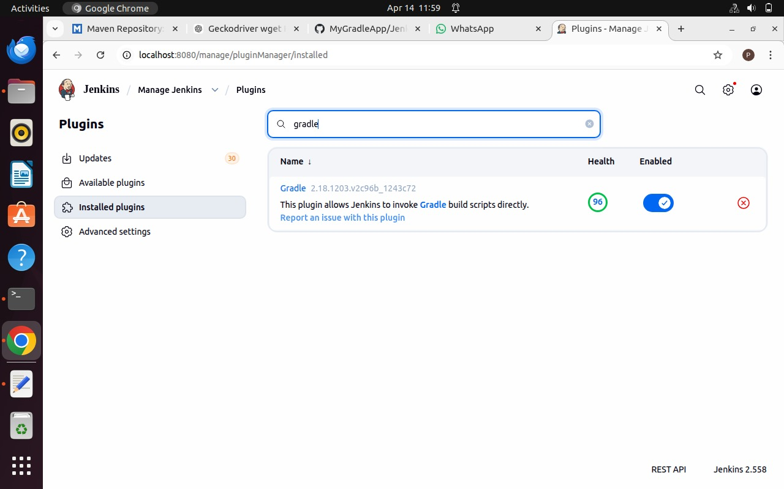
Check the Installed Plugins section for Gradle plugin. If not available, install it.

Step 5: Restart Jenkins
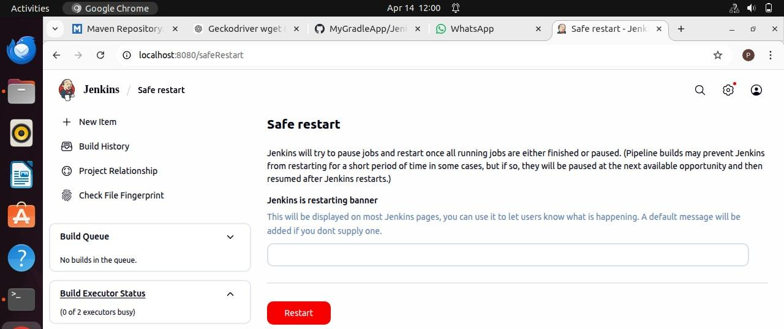
Once the installation is complete restart Jenkins by visiting http://localhost:8080/safeRestart
Step 6: Configure Tools
Go to Manage Jenkins → Tools.
Scroll down and click Add JDK.
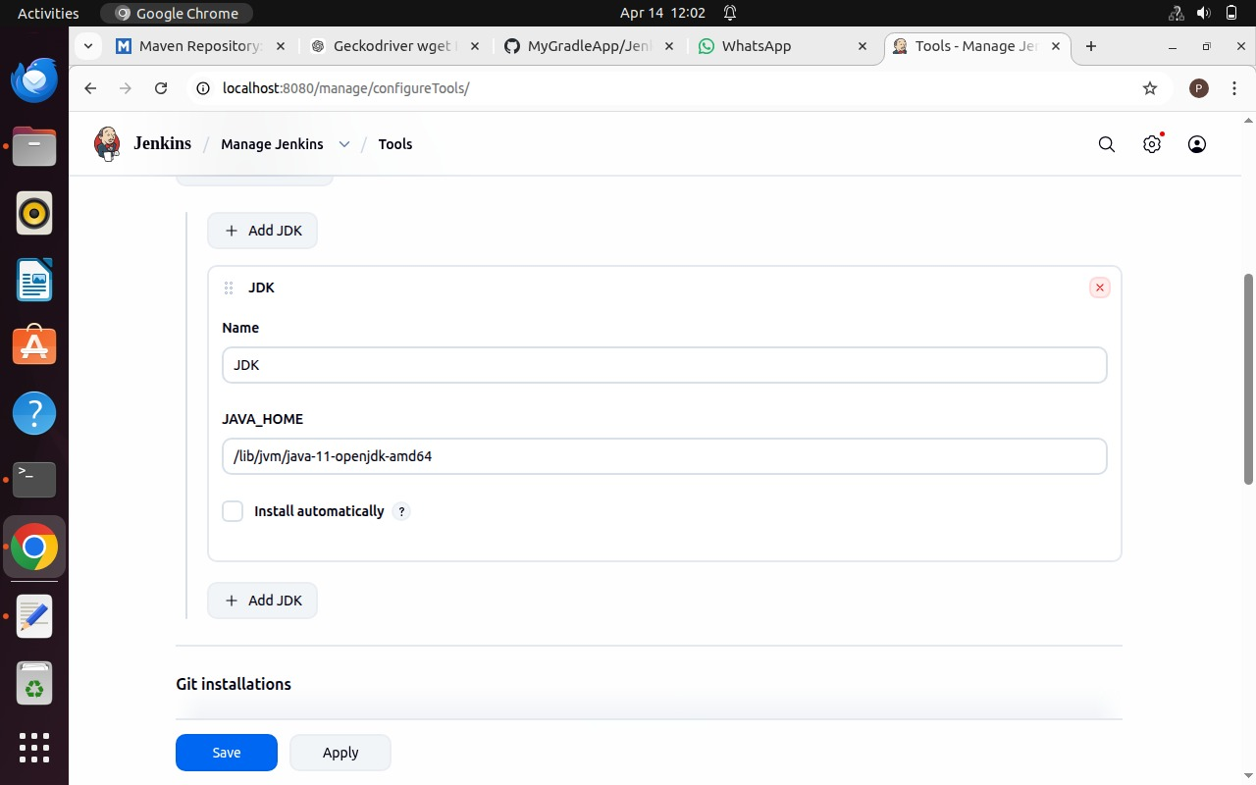
Enter JDK name and path (Computer → lib → jvm → jdk)
Step 7: Configure Build Tools
Find installation paths for Git, Maven, and Gradle using terminal.
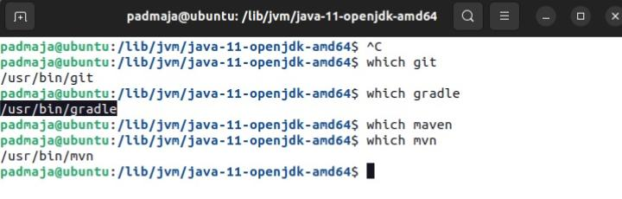
Enter these paths in Jenkins and click Apply and Save.
Step 8: Add GitHub Credentials
Go to Manage Jenkins → Credentials.
Add Username with Password.
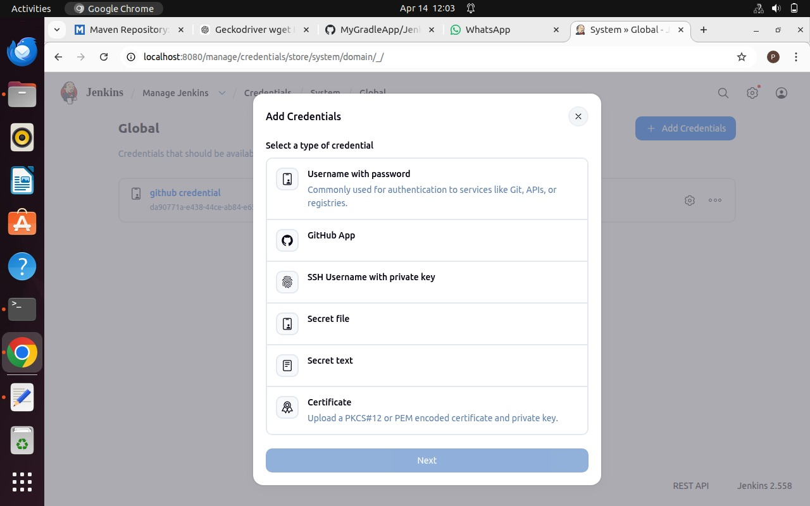
Enter GitHub credentials and description as 'GitHub Credentials'.
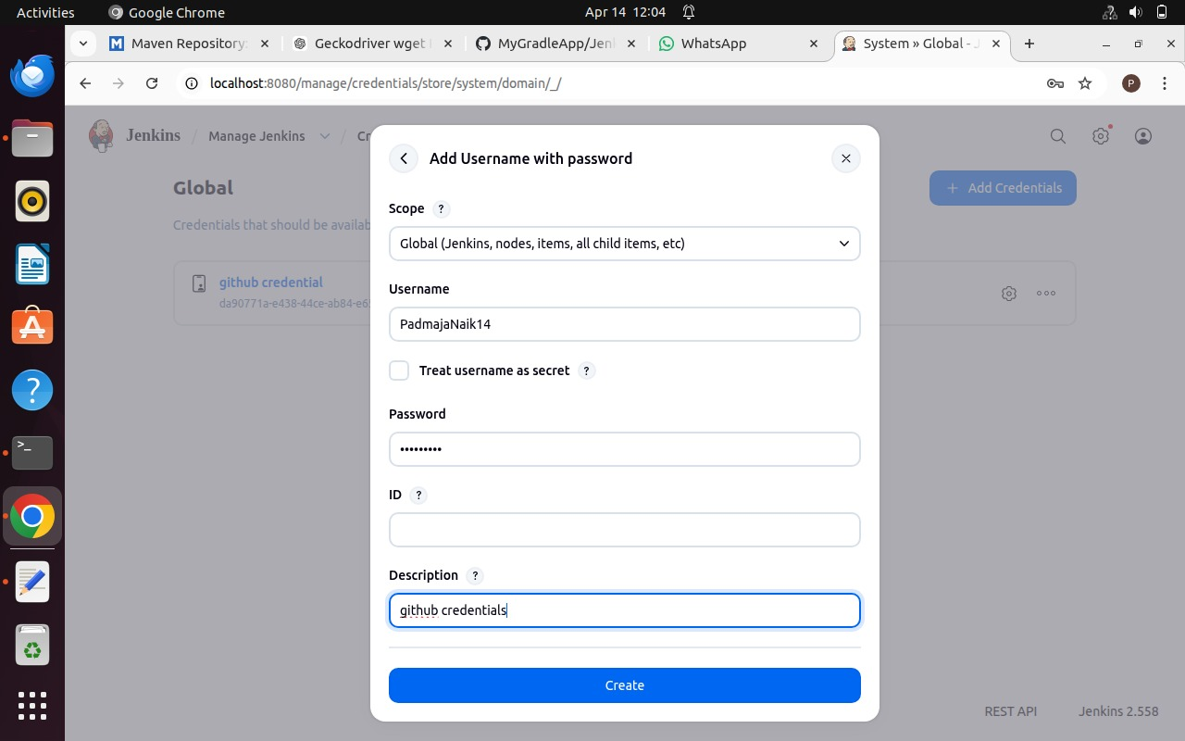
Step 9: Create a New Pipeline Job
Go to Dashboard → + New Item.
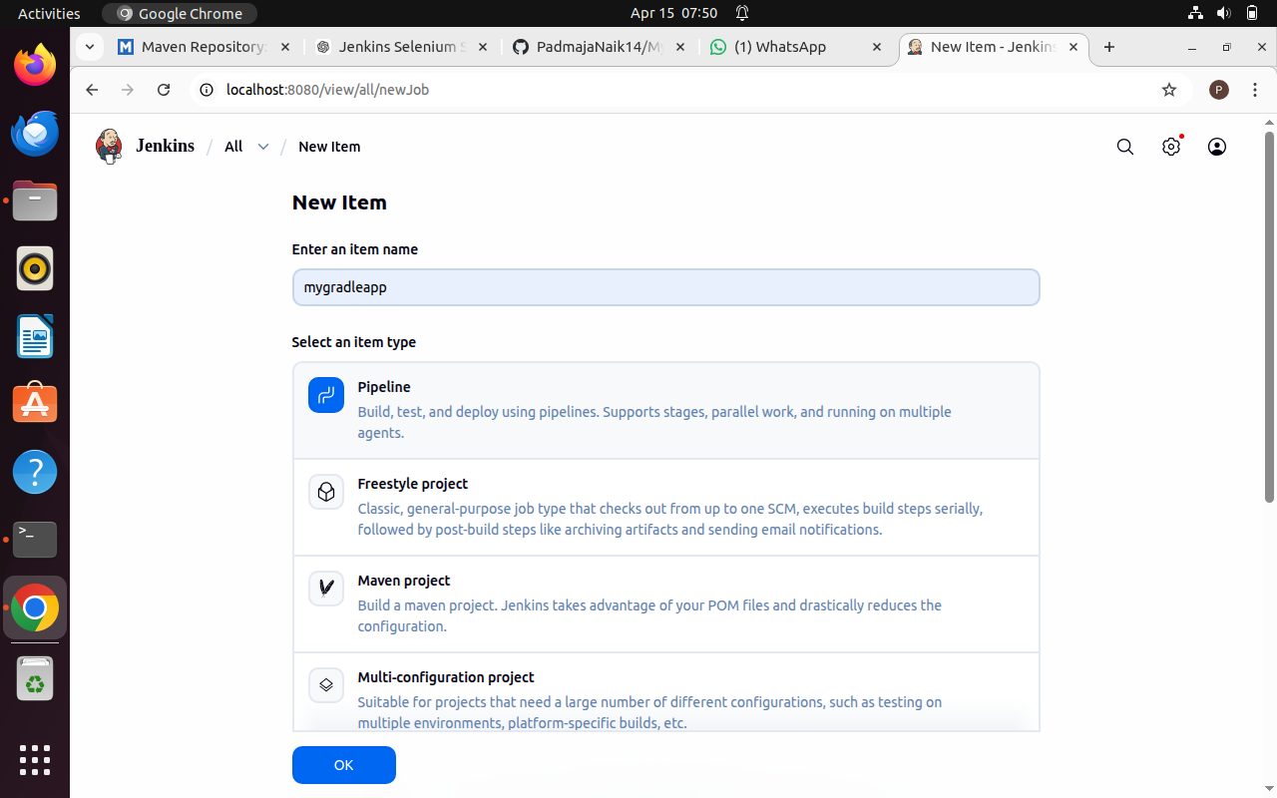Enter name, select Pipeline, and click OK.
Step 10: Configure Pipeline from SCM
Scroll down and select Pipeline script from SCM.
SCM: Git
Enter repository URL and select GitHub credentials.
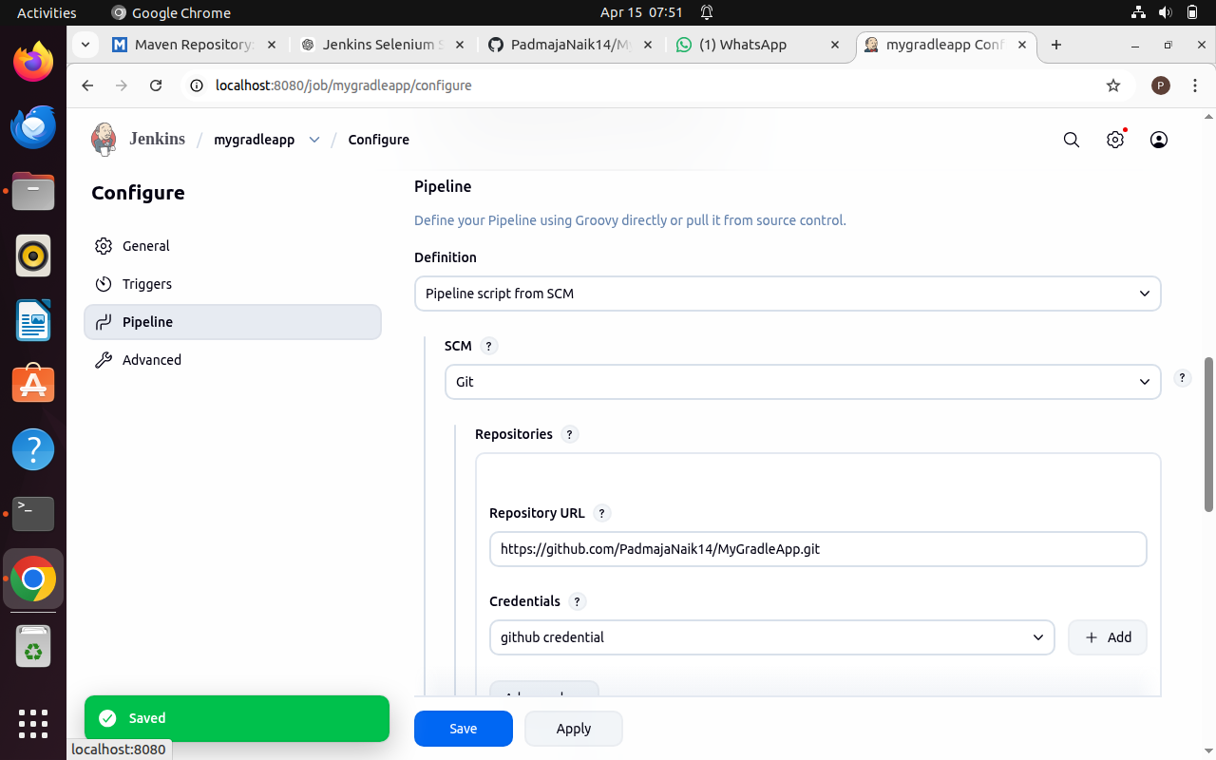Click Apply and Save.
Apply and Save the changes
Step 11: Create Jenkinsfile
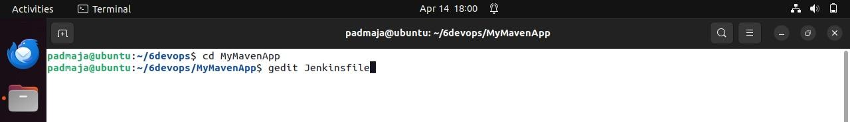
Create a Jenkinsfile in your MyMavenApp project and add the pipeline script.
Enter the following code into the Jenkins file – Make sure to Add Your Username and Repo Name
pipeline {
agent any // Use any available agent
tools {
gradle 'Gradle' // Ensure this matches the name configured in Jenkins
jdk 'JDK'
}
stages {
stage('Checkout') {
steps {
git branch: 'master', url: 'https://github.com/PadmajaNaik14/MyGradleApp.git'
}
}stage('Build') {
steps {
sh 'gradle build' // Run Gradle build
}
} stage('Test') {
steps {
sh 'gradle test' // Run unit tests
} stage('Run Application') {
steps {
// Start the JAR application
sh 'gradle run'
}
}
}
post {
success {
echo 'Build and deployment successful!'
}
failure {
echo 'Build failed!'
}
}
}
Step 12: Update pom.xml
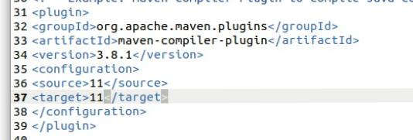
Change source and target versions from 1.7 to 11.
Step 13: Push Changes to GitHub
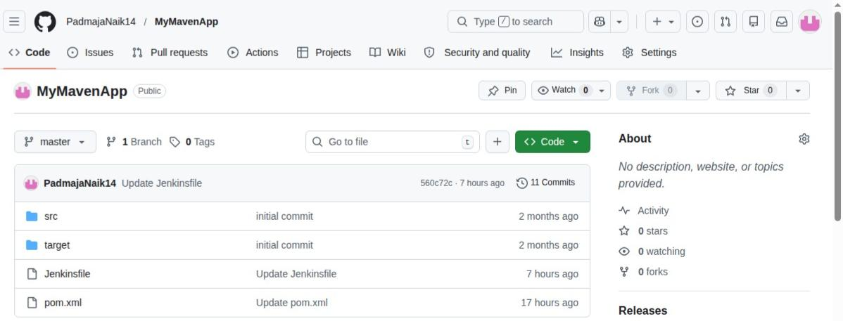
Commit changes and push to your GitHub repository.
Step 14: Build the Pipeline
Go to Jenkins and click Build Now.
Step 15: Monitor Build Stages
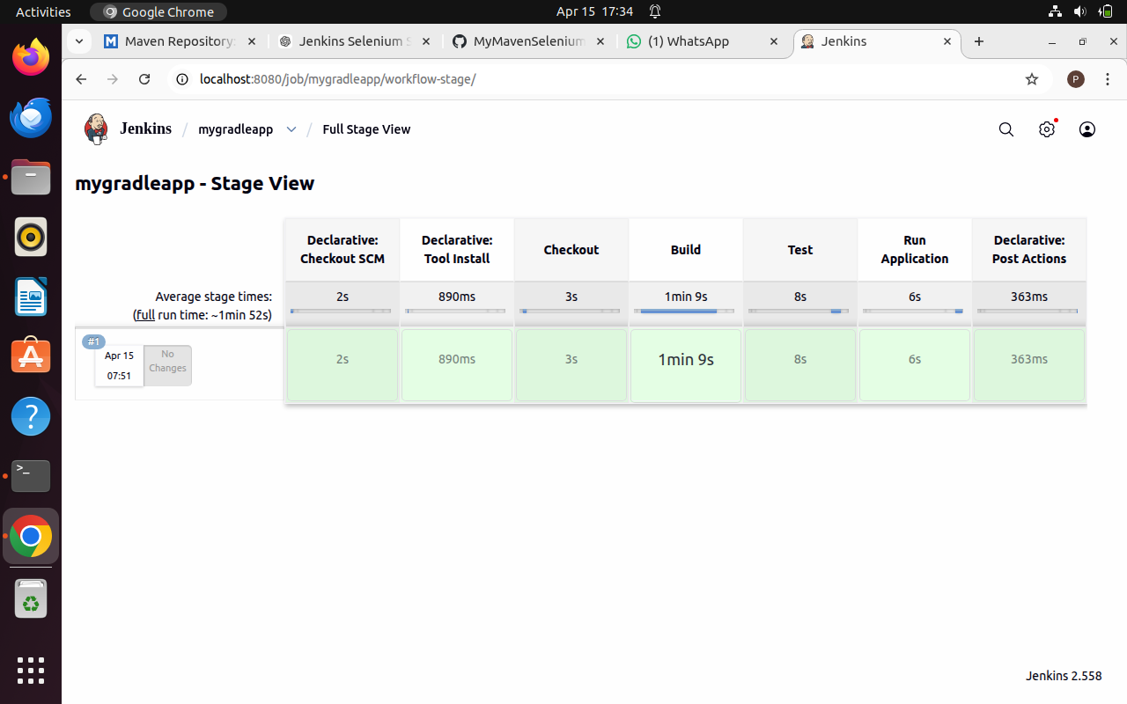Use Stage View and Full Stage View to monitor execution
Step 16: Verify Pipeline Execution
If all stages complete successfully, the pipeline is built.

