**Work Force Management - Final Document**

**Tables Used**

1. **Employee table**

CREATE TABLE Employee (

EmpId int NOT NULL PRIMARY KEY,

EmpName varchar(50) NOT NULL,

Status varchar(50) NOT NULL,

ManagerName varchar (30),

wfm_MemberName varchar (30),

Email varchar(250) NOT NULL ,

LockStatus varchar(50),

Experience decimal (5,0),

Profile varchar(255),

LockId int NOT NULL FOREIGN KEY REFERENCES SoftLock(LockId)

);

**2) Skill table**

CREATE TABLE Skill(

SkillId int NOT NULL PRIMARY KEY ,

SkillName varchar(30) NOT NULL

);

**3) SkillMap**

CREATE TABLE SkillMap(

EmpId int FOREIGN KEY REFERENCES Employee(EmpId) ,

SkillId int FOREIGN KEY REFERENCES Skill(SkillId)

);

**4) User**

CREATE TABLE User(

UserName varchar(50) NOT NULL PRIMARY KEY,

Password varchar(50) NOT NULL,

FirstName varchar(30) NOT NULL ,

Role varchar(30) NOT NULL,

Email varchar(50)

);

**5) SoftLock**

CREATE TABLE SoftLock(

LockId int NOT NULL PRIMARY KEY,

EmpId int NULL,

RequestedManager varchar(50) NULL,

RequestedDate DATETIME,

LockStatus varchar(50) NOT NULL,

IsLocked Bit NULL,

LastUpdatedDate DATETIME,

RequestMessage varchar(255) NOT NULL,

WfmRemark varchar(255) NOT NULL,

ManagerStatus varchar(50) NOT NULL,

ManagerComment varchar(255) NOT NULL,

ManagerLastUpdatedDate DATETIME

)

**LOGIN PAGE :**

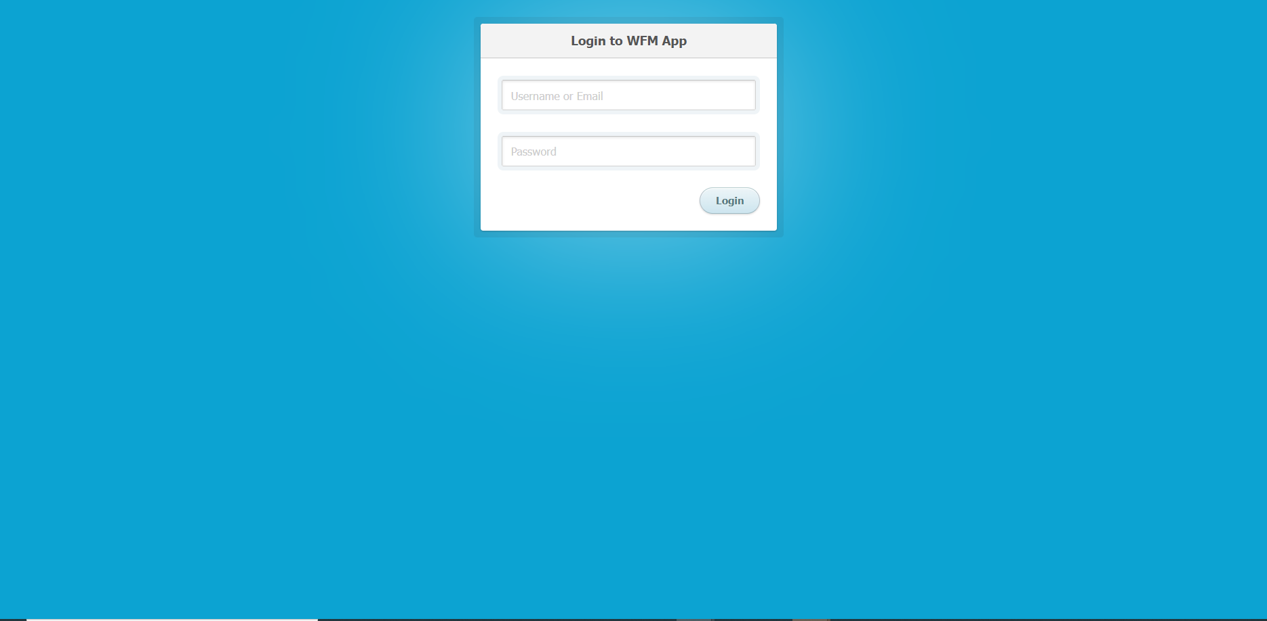

The following sp will be executed. To get the user list based on the Login inputs.

CREATE PROCEDURE sp_GetUserForLogin

(

@UserName varchar(255),

@Password varchar(255)

)

AS

BEGIN

SELECT

UserName,

Password,

FirstName,

Role

Email FROM [User]

WHERE

UserName = @UserName AND Password = @Password

END

Based on the role , UI will be as Manager view and WfmMember view.

**Manager Login View**

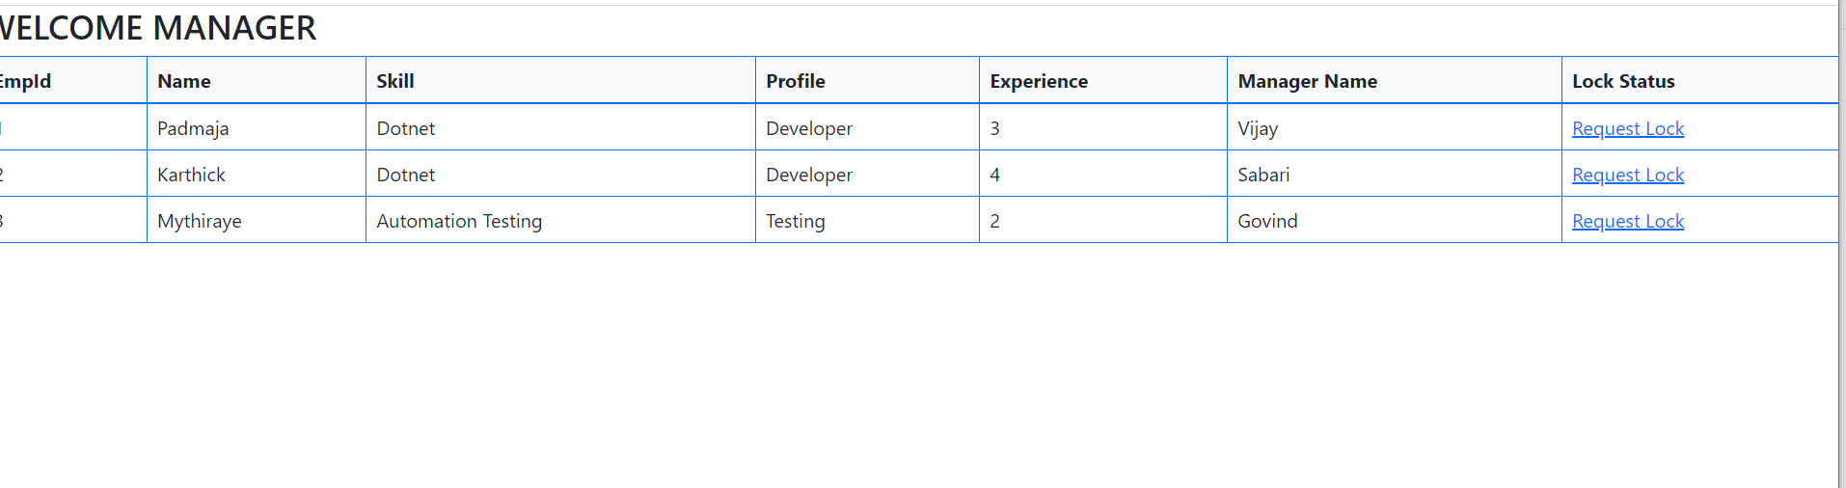

After logging in as Manager , manager page will open. It will call the following method.

public ActionResult Index()

{

List<Manager> details = new List<Manager>();

string Uri = string.Format("http://localhost:44586");

RestRequest request = new RestRequest(Uri);

var response = client.ExecuteTaskAsync<List<Core.Models>>(request);

details=response.Result;

return View("Manager" , details);

}

The api method will call the repo method to execute the following sp to get details.

CREATE PROCEDURE sp_GetDetailsForManagerPage

(

)

AS

BEGIN

SELECT

emp.EmpId,

emp.EmpName,

sk.SkillName,

emp.Profile,

emp.Experience,

emp.ManagerName,

sftlck.IsLocked

FROM Employee emp

JOIN SkillMap skm ON skm.EmpId = emp.EmpId

JOIN Skill sk ON skm.SkillId = sk.SkillId

JOIN SoftLock sftlck ON sftlck.LockId = emp.LockId

where sftlck.IsLocked = 1

END

In this sp joints and conditions for the listing is handled to get the expected result.

After clicking the Lock request button, the following page will be opened.

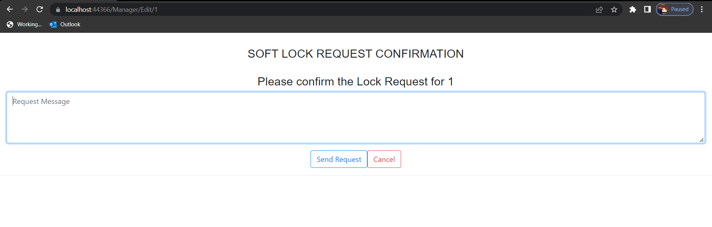

Lock Request id value is dynamically called through view by @Model.EmpId

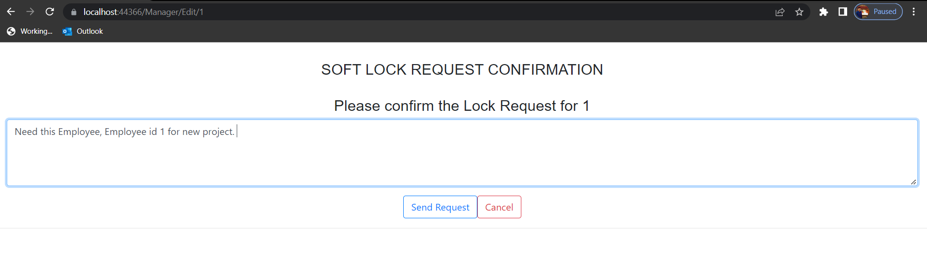

This controller will call the api controller method which in turn call the sp sp_LockStatusChangeForManager.

CREATE PROCEDURE sp_LockStatusChangeForManager

(

@LockId int,

@RequestMessage varchar(255)

@FirstName varchar(50)

)

AS

BEGIN

UPDATE SoftLock

SET

RequestedDate = GETDATE(),

LockStatus = 'Pending',

RequestMessage = @RequestMessage,

LastUpdatedDate = GETDATE(),

RequestedManager = @FirstName

WHERE

LockId = @LockId

END

WFM MANAGER FIRST PAGE :

After logging in as Wfm Member , this page will open. It will call the following method.

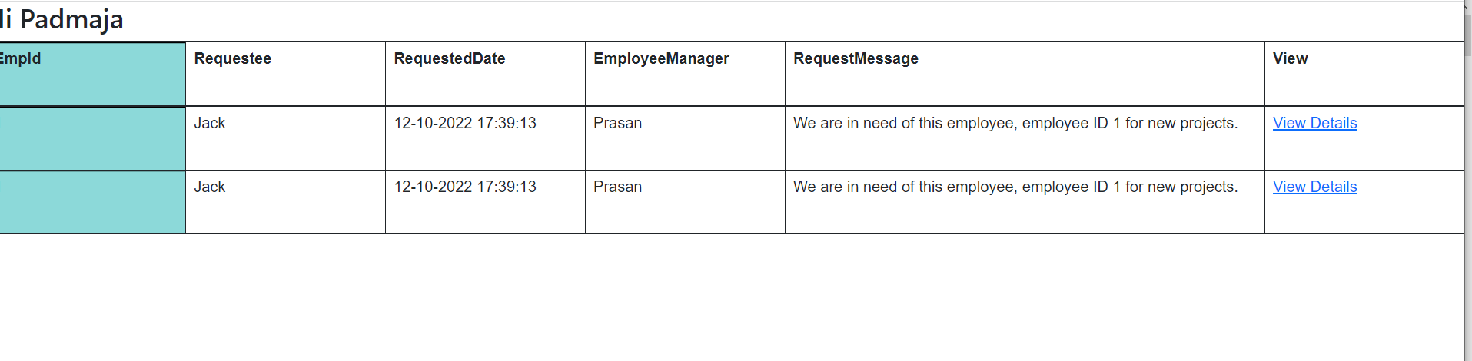

The api method will call the repo method to execute the following sp to get details.

CREATE PROCEDURE sp_wfmMemberLoginGetDetails

(

@UserName varchar(255),

)

AS

BEGIN

SELECT

emp.EmpId,

sftlck.RequestedManager,

sftlck.RequestedDate,

emp.ManagerName,

sftlck.RequestMessage

FROM

Employee emp

JOIN SoftLock sftlck ON SoftLock.LockId = Employee.LockId

WHERE emp.wfm_MemberName = @UserName

END

After clicking the view details the following page will be open.

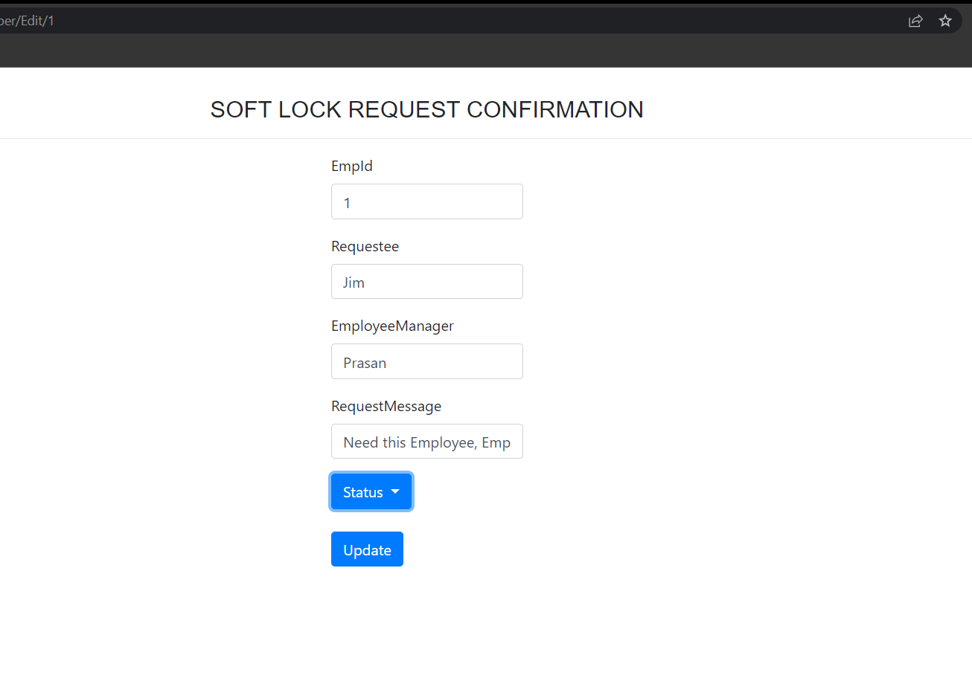

By clicking the status dropdown method, the Wfm Member can select the options. He can approve and reject.

public ActionResult Edit(int id)

{

WfmMember e = details.Where(x => x.EmpId == id).SingleOrDefault();

return View("WfmMemberEdit", e);

}

// POST: WfmMemberController/Edit/5

[HttpPost]

[ValidateAntiForgeryToken]

public ActionResult Edit(WfmMember details)

{

try

{

int id = details.EmpId;

string Uri = string.Format("http://localhost:44586");

RestRequest request = new RestRequest(Uri);

var response = client.ExecuteTaskAsync<List<Core.Models>>(request);

return View("Index");

}

catch

{

return View();

}

}

It will call the following sp for the update.

CREATE PROCEDURE sp_ApprovalStatusForSendRequestByWfmMember

(

@EmpId int ,

@ManagerStatus varchar(255),

@ManagerComment varchar(255)

)

AS

BEGIN

DECLARE @LockId int

Select @LockId = LockId FROM Employee where EmpId = @EmpId

UPDATE SoftLock

SET

IsLocked = CASE WHEN @ManagerStatus = 'Unlock' THEN 0 Else 1 END,

LockStatus = @ManagerStatus,

LastUpdatedDate = GETDATE() ,

ManagerLastUpdatedDate = GETDATE(),

ManagerComment = @ManagerComment

WHERE

LockId = @LockId

END