PRACTICAL 1
Aim: Implementing substitution and transposition cipher.
Design and implement algorithms to encrypt and decrypt message using classical substitution and transposition techniques.
Input: Caesar Cipher
def encrypt(text, s):
cipher_t = ""

for char in text:
if char.isupper():
cipher_t += chr((ord(char) + s - 65) % 26 + 65)
elif char.islower():
cipher_t += chr((ord(char) + s - 97) % 26 + 97)
else:
cipher_t += char

return cipher_t

def decrypt(cipher_t, s):
plain_t = ""

for char in cipher_t:
if char.isupper():
plain_t += chr((ord(char) - s - 65) % 26 + 65)
elif char.islower():
plain_t += chr((ord(char) - s - 97) % 26 + 97)
else:
plain_t += char
return plain_t

text = input("Enter the text to encrypt: ")
s = 3 # Shift value
print("Text:", text)
encrypted_text = encrypt(text, s)
print("Cipher:", encrypted_text)
decrypted_text = decrypt(encrypted_text, s)
print("Plain:", decrypted_text)

Output:
Enter the text to encrypt: chutki
Text: chutki
Cipher: fkxwnl
Plain: chutki

Input: Rail Fence Cipher
def encrypt(message, depth):
array = []

for i in range(depth):
array.append("")

mod = 2 * (depth - 1)

for i in range(len(message)):
array[min(i % mod, mod - i % mod)] += message[i]

return "".join(array)

def decrypt(cipher, depth):
array = []

for i in range(depth):
array.append([])

mod = 2 * (depth - 1)
index = 0

for i in range(depth + 1):
for j in range(0, len(cipher)):
if min(j % mod, mod - j % mod) == i:
array[i].append(cipher[index])
index += 1

message = ""

for i in range(len(cipher)):
message += array[min(i % mod, mod - i % mod)].pop(0)

return message

message = input("Enter message: ")
depth = int(input("Enter depth:"))

cipher = encrypt(message, depth)

print("Encrypted:", cipher)
print("Decrypted:", decrypt(cipher, depth))

Output:
Enter message: Padmaj Jadhav
Enter depth:3
Encrypted: PaavamjJdad h
Decrypted: Padmaj Jadhav

PRACTICAL 2
Aim: Implement the RSA algorithm for public-key encryption and decryption, and explore its properties and security considerations.
Input: RSA Encryption and Decryption
import random

def gcd(a, b):
while b:
a, b = b, a % b
return a

def mod_inverse(e, phi):
for d in range(1, phi):
if (e * d) % phi == 1:
return d
return d

p = 61
q = 53

n = p * q
phi = (p - 1) * (q - 1)

e = 17

d = mod_inverse(e, phi)

public_key = (e, n)
private_key = (d, n)

plaintext = input("Enter the plain text: ")

# Convert string to bytes
plain_bytes = [ord(char) for char in plaintext]
print("String in Bytes:", ''.join(map(str, plain_bytes)))

# Encryption
encrypted = [pow(byte, e, n) for byte in plain_bytes]
print("Encrypted String in Bytes:", '-'.join(map(str, encrypted)))

# Decryption
decrypted_bytes = [pow(byte, d, n) for byte in encrypted]
print("Decrypted String in Bytes:", ''.join(map(str, decrypted_bytes)))

# Convert bytes back to string
decrypted_text = ''.join(chr(byte) for byte in decrypted_bytes)
print("Decrypted String:", decrypted_text)

Output:
Enter the plain text: Padmaj
String in Bytes: 809710010997106
Encrypted String in Bytes: 2933-1632-1773-2271-1632-1696
Decrypted String in Bytes: 809710010997106
Decrypted String: Padmaj

PRACTICAL 3
Aim: Implement algorithms to generate and verify message authentication codes (MACs) for ensuring data integrity and authenticity.
Input: Message Authentication Code
import hmac
import hashlib

# Secret key shared between sender and receiver
key = b"secretkey"

# Input message
message = input("Enter the message: ")

# Generate MAC
mac = hmac.new(key, message.encode(), hashlib.sha256).hexdigest()

print("Generated MAC:", mac)

# Verify MAC
received_mac = input("Enter MAC for verification: ")

if hmac.compare_digest(mac, received_mac):
print("MAC Verified: Message is Authentic")
else:
print("MAC Verification Failed: Message has been Tampered")

Output:
Enter the message: Padmaj Jadhav
Generated MAC: b4b30d229b97e761176bcd7484a9acb72451a7c5c39f01c13fda1c335d49f8b1
Enter MAC for verification: b4b30d229b97e761176bcd7484a9acb72451a7c5c39f01c13fda1c335d49f8b1
MAC Verified: Message is Authentic

PRACTICAL 4
Aim: Implement digital signature algorithms such as RSA-based signatures, and verify the integrity and authenticity of digitally signed messages.
Input: Digital Signatures
import hashlib

# RSA keys (example values)
p = 61
q = 53

n = p * q # 3233
phi = (p - 1) * (q - 1)

e = 17 # Public key
d = 2753 # Private key

# Input message
message = input("Enter the message: ")

# Generate hash of the message
message_hash = int(hashlib.sha256(message.encode()).hexdigest(), 16)

# Create Digital Signature using private key
signature = pow(message_hash, d, n)

print("Digital Signature:", signature)

# Verify Signature using public key
verified_hash = pow(signature, e, n)

if verified_hash == (message_hash % n):
print("Signature Verified: Message is Authentic and Unchanged")
else:
print("Signature Verification Failed: Message has been Tampered")
Output:
Enter the message: Padmaj Jadhav
Digital Signature: 1972
Signature Verified: Message is Authentic and Unchanged

PRACTICAL 5
Aim: Implement the Diffie-Hellman key exchange algorithm to securely exchange keys between two entities over an insecure network.
Input: Diffie-Hellman
Xa = int(input("Enter the value of Xa & Xb\n"))
Xb = int(input())

p = int(input("Enter a Prime no. as p\n"))
a = int(input("Enter Primitive Root a, with condition that a<p\n"))

Ya = (a ** Xa) % p
Yb = (a ** Xb) % p

Ka = (Yb ** Xa) % p
Kb = (Ya ** Xb) % p

if Ka == Kb:
print("Transmission successful")
else:
print("Transmission failed")

Output:
Enter the value of Xa & Xb
35
32
Enter a Prime no. as p
7
Enter Primitive Root a, with condition that a<p
6
Transmission successful

PRACTICAL 6
Aim: Configure IPsec on network devices to provide secure communication and protect against unauthorized access and attacks.
Input: IP Security (IPsec) Configuration
import hashlib
import hmac

# Shared secret key (simulating IPsec pre-shared key)
key = b"ipsec_secret_key"

# Sender side
message = input("Enter message to send: ")

# Step 1: Create hash (Integrity check)
message_hash = hashlib.sha256(message.encode()).hexdigest()

# Step 2: Create HMAC (Authentication + Integrity)
packet = {
"data": message,
"hash": hmac.new(key, message.encode(), hashlib.sha256).hexdigest()
}

print("\n--- Sending Encrypted IPsec Packet ---")
print(packet)

# ---------------- RECEIVER SIDE ---------------- #

print("\n--- Receiving Packet ---")

received_data = packet["data"]
received_hash = packet["hash"]

# Step 3: Verify integrity
verify_hash = hmac.new(key, received_data.encode(), hashlib.sha256).hexdigest()

if verify_hash == received_hash:
print("IPsec Verification Successful!")
print("Message is Authentic and Untampered")
print("Received Message:", received_data)
else:
print("IPsec Verification Failed!")
print("Message may have been Tampered")

Output:
Enter message to send: Hii Padmaj!

--- Sending Encrypted IPsec Packet ---
{'data': 'Hii Padmaj!', 'hash': 'ca5e4bef6c52763b628e2d39a70919c3c8d639e6edc66f0b7f442cae9a4ef88e'}

--- Receiving Packet ---
IPsec Verification Successful!
Message is Authentic and Untampered
Received Message: Hii Padmaj!

PRACTICAL 7
Aim: Configure and implement secure web communication using SSL/TLS protocols, including certificate management and secure session establishment.
Solution:
SSL/TLS provides secure communication between a client and server using encryption, authentication, and data integrity. In this practical, Python is used to create a TLS server and client.
1. Generate Certificate
Install:
python -m pip install cryptography
2. In the VS Code PowerShell terminal, type:
dir
and press Enter.
3. dir is a PowerShell command that shows the files in your current folder.
You should eventually see files like:
generate_certificate.py
server.crt
server.key
ssl_server.py
ssl_client.py
4. Now run this command in the same VS Code terminal: python generate_certificate.py

Input: generate_certificate.py
from cryptography import x509
from cryptography.x509.oid import NameOID
from cryptography.hazmat.primitives import hashes, serialization
from cryptography.hazmat.primitives.asymmetric import rsa
from cryptography.hazmat.primitives.serialization import Encoding, PrivateFormat, NoEncryption
from datetime import datetime, timedelta, timezone
from ipaddress import ip_address

# Generate private key
private_key = rsa.generate_private_key(
public_exponent=65537,
key_size=2048
)

# Certificate subject and issuer
subject = issuer = x509.Name([
x509.NameAttribute(NameOID.COUNTRY_NAME, "IN"),
x509.NameAttribute(NameOID.STATE_OR_PROVINCE_NAME, "Maharashtra"),
x509.NameAttribute(NameOID.LOCALITY_NAME, "Panvel"),
x509.NameAttribute(NameOID.ORGANIZATION_NAME, "Cyber Practical"),
x509.NameAttribute(NameOID.COMMON_NAME, "127.0.0.1"),
])

# Create certificate
certificate = (
x509.CertificateBuilder()
.subject_name(subject)
.issuer_name(issuer)
.public_key(private_key.public_key())
.serial_number(x509.random_serial_number())
.not_valid_before(datetime.now(timezone.utc))
.not_valid_after(datetime.now(timezone.utc) + timedelta(days=365))
.add_extension(
x509.SubjectAlternativeName([
x509.IPAddress(ip_address("127.0.0.1"))
]),
critical=False
)
.sign(private_key, hashes.SHA256())
)

# Save private key
with open("server.key", "wb") as key_file:
key_file.write(
private_key.private_bytes(
encoding=Encoding.PEM,
format=PrivateFormat.TraditionalOpenSSL,
encryption_algorithm=NoEncryption()
)
)

# Save certificate
with open("server.crt", "wb") as cert_file:
cert_file.write(
certificate.public_bytes(Encoding.PEM)
)

print("===================================")
print(" SSL Certificate Generated")
print("===================================")
print("Created: server.crt")
print("Created: server.key")
print("Certificate valid for 365 days.")

You should see:
===================================
SSL Certificate Generated
===================================
Created: server.crt
Created: server.key
Certificate valid for 365 days.

Then run:
dir

Look for:
server.crt
server.key

Input: 5. python ssl_server.py
import socket
import ssl

HOST = "127.0.0.1"
PORT = 5000
# Create SSL/TLS server context
context = ssl.SSLContext(ssl.PROTOCOL_TLS_SERVER)

# Load certificate and private key
context.load_cert_chain(
certfile="server.crt",
keyfile="server.key"
)

# Create TCP socket
server_socket = socket.socket(socket.AF_INET, socket.SOCK_STREAM)
server_socket.setsockopt(socket.SOL_SOCKET, socket.SO_REUSEADDR, 1)

server_socket.bind((HOST, PORT))
server_socket.listen(5)

print("===================================")
print(" SSL/TLS Server")
print("===================================")
print("Server listening on:", HOST, PORT)
print("Waiting for client...")

# Wrap socket with SSL/TLS
with context.wrap_socket(server_socket, server_side=True) as server:

try:
connection, address = server.accept()

print("Client connected:", address)

with connection:

# Receive message
data = connection.recv(1024).decode()

print("Received message:", data)

# Send response
response = "Hello from SSL/TLS Server!"

connection.send(response.encode())

print("Response sent:", response)

except KeyboardInterrupt:
print("\nServer stopped.")

Output:
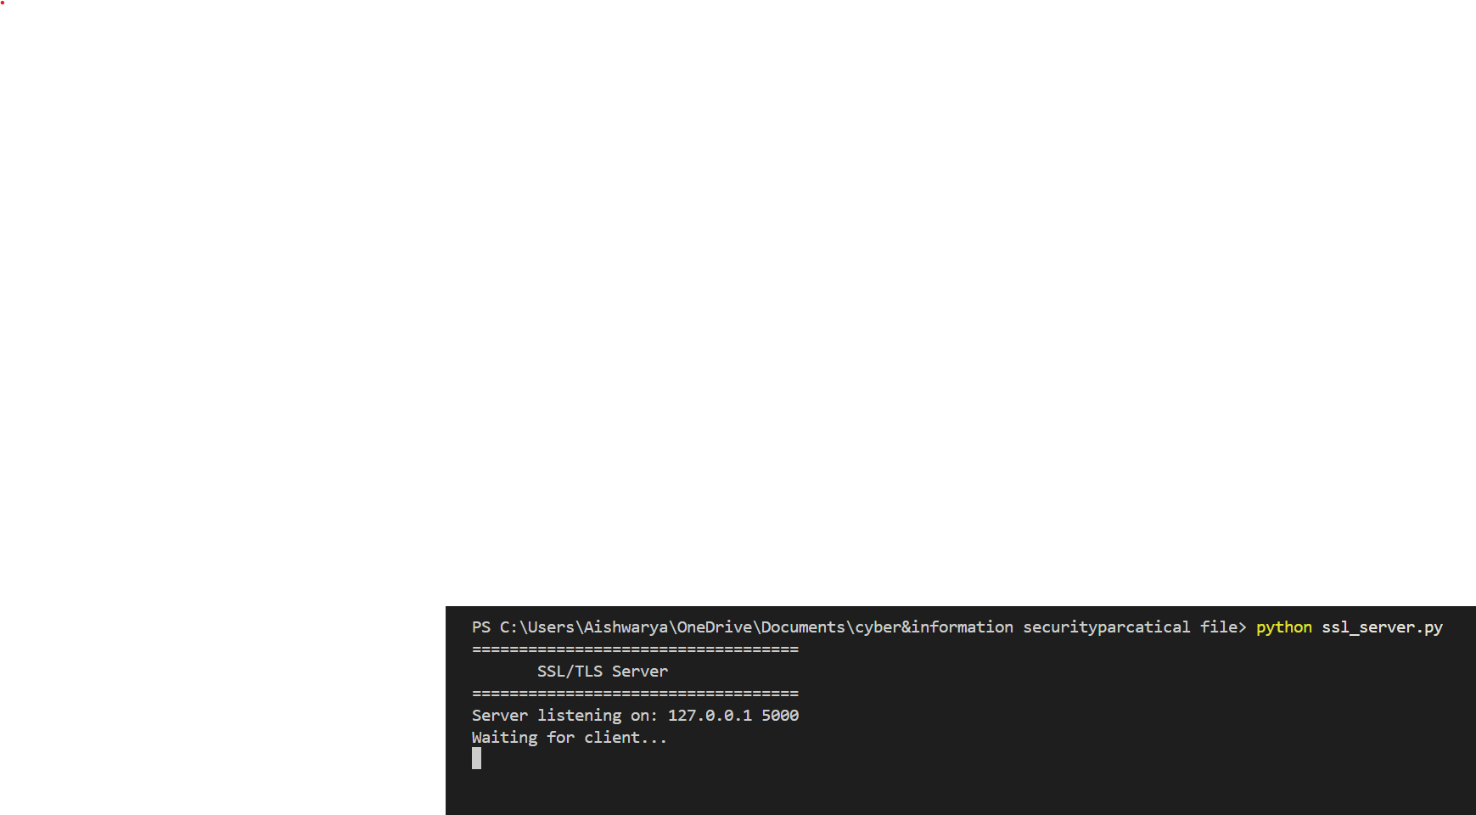

Input: 6. ssl_client.py
import socket
import ssl

HOST = "127.0.0.1"
PORT = 5000

# Create SSL/TLS client context
context = ssl.create_default_context()

# Disable certificate verification for this local practical
context.check_hostname = False
context.verify_mode = ssl.CERT_NONE

# Create TCP socket
sock = socket.socket(socket.AF_INET, socket.SOCK_STREAM)

try:

# Wrap socket with SSL/TLS
with context.wrap_socket(sock, server_hostname=HOST) as client:

# Connect to server
client.connect((HOST, PORT))

print("===================================")
print(" SSL/TLS Client")
print("===================================")
print("Connected to SSL/TLS Server")

# Send message
message = "Hello"

client.send(message.encode())

print("Message sent:", message)

# Receive response
response = client.recv(1024).decode()

print("Server Response:", response)

except ConnectionRefusedError:
print("Connection Error: Server is not running.")
print("Start ssl_server.py first.")

except Exception as e:
print("Connection Error:", e)

Step7: Run the client
In VS Code, open a second terminal:
Terminal → New Terminal
Then run:
python ssl_client.py
OUTPUT:-
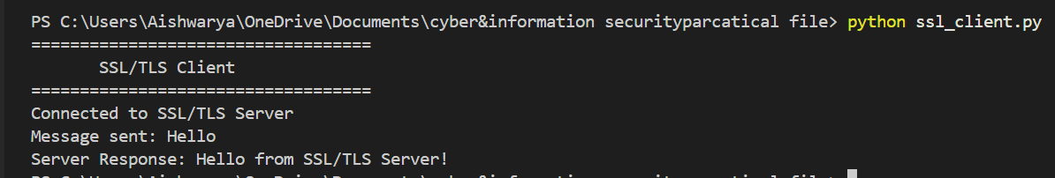

PRACTICAL 8
Aim: Set up and configure an intrusion detection system (IDS) to monitor network traffic and detect potential security breaches or malicious activities.
Steps: Diffie-Hellman
- Install Scapy
Open the VS Code Terminal and run:
pip install scapy
If pip doesn't work, try:
python -m pip install scapy

On Windows, you may need:
py -m pip install scapy

python -c "import sys; print(sys.executable); import scapy; print('Scapy installed successfully')"

- Run the program
Save the file as something like:
network_ids.py
Input:
from scapy.all import sniff, IP, TCP, ICMP
from collections import defaultdict
import time

# Store connection information
connection_count = defaultdict(list)

# Detection thresholds
PORT_SCAN_THRESHOLD = 10
ICMP_FLOOD_THRESHOLD = 20
TIME_WINDOW = 10

def detect_attack(packet):

if not packet.haslayer(IP):
return

source_ip = packet[IP].src
destination_ip = packet[IP].dst
current_time = time.time()

# -------------------------------
# 1. Detect TCP Port Scanning
# -------------------------------
if packet.haslayer(TCP):

destination_port = packet[TCP].dport

key = (source_ip, destination_ip)

connection_count[key].append(
(destination_port, current_time)
)

# Remove old records
connection_count[key] = [
item for item in connection_count[key]
if current_time - item[1] <= TIME_WINDOW
]

# Count unique ports
unique_ports = set(
item[0] for item in connection_count[key]
)

if len(unique_ports) >= PORT_SCAN_THRESHOLD:

print("\n[ALERT] Possible Port Scan Detected!")
print("Source IP :", source_ip)
print("Destination IP :", destination_ip)
print("Ports Scanned :", len(unique_ports))

# Clear records after detection
connection_count[key].clear()

# -------------------------------
# 2. Detect ICMP Flood
# -------------------------------
if packet.haslayer(ICMP):

key = ("ICMP", source_ip)

connection_count[key].append(current_time)

connection_count[key] = [
t for t in connection_count[key]
if current_time - t <= TIME_WINDOW
]

if len(connection_count[key]) >= ICMP_FLOOD_THRESHOLD:

print("\n[ALERT] Possible ICMP Flood Detected!")
print("Source IP :", source_ip)
print("Packets :", len(connection_count[key]))

connection_count[key].clear()

def start_ids():

print("===================================")
print(" Python Network IDS")
print("===================================")
print("Monitoring network traffic...")
print("Press Ctrl+C to stop.\n")

sniff(
prn=detect_attack,
store=False
)

if __name__ == "__main__":
start_ids()

Then in the VS Code terminal: python network_ids.py
Output:
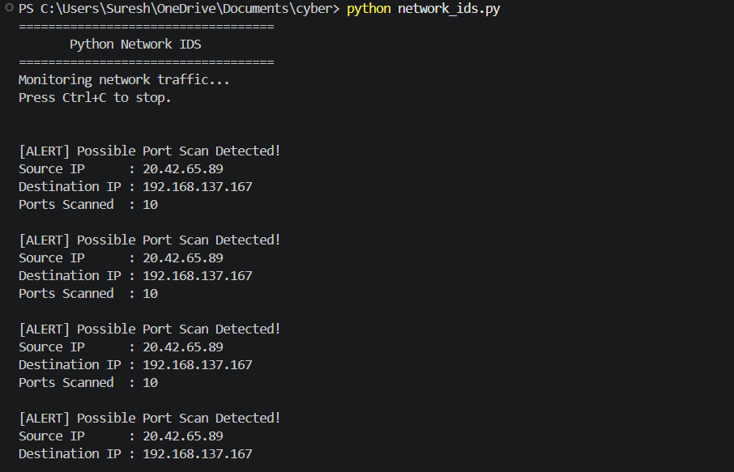

PRACTICAL 9
Aim: Analyze and identify malware samples using antivirus tools, analyze their behavior, and develop countermeasures to mitigate their impact.
Input:
import os
import hashlib

print("=" * 50)
print(" MALWARE ANALYSIS TOOL")
print("=" * 50)

file_path = input("Enter file path: ")

# Check whether file exists
if not os.path.isfile(file_path):
print("\n[ERROR] File not found!")
exit()

# File information
file_name = os.path.basename(file_path)
file_size = os.path.getsize(file_path)

print("\nFile Name :", file_name)
print("File Size :", file_size, "bytes")

# Calculate SHA-256
def calculate_sha256(file_path):
sha256 = hashlib.sha256()

with open(file_path, "rb") as file:
while True:
data = file.read(4096)

if not data:
break

sha256.update(data)

return sha256.hexdigest()

hash_value = calculate_sha256(file_path)

print("\nSHA-256 Hash:")
print(hash_value)

# Check suspicious extensions
extension = os.path.splitext(file_path)[1].lower()

suspicious_extensions = [
".exe",
".dll",
".bat",
".cmd",
".vbs",
".js",
".scr",
".ps1"
]

print("\nFile Extension:", extension)

if extension in suspicious_extensions:
print("\n[WARNING]")
print("This file type can contain executable code.")
print("Further antivirus analysis is recommended.")
else:
print("\n[INFO]")
print("No suspicious executable extension detected.")

print("\n" + "=" * 50)
print("Analysis completed successfully.")
print("=" * 50)

Output:
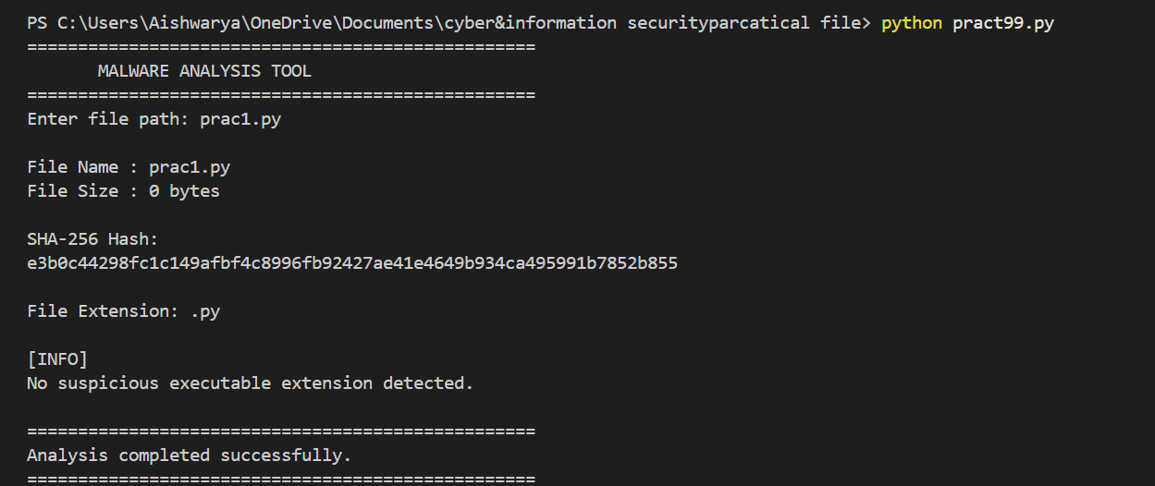

PRACTICAL 10
Aim: Configure and test firewall rules to control network traffic, filter packets based on specified criteria, and protect network resources from unauthorized access.
Input:
# Firewall Rule Simulation
# Cyber & Information Security Practical

ALLOWED_IP = "192.168.1.10"
BLOCKED_PORTS = [21, 23, 445]

def firewall_check(source_ip, destination_port):

print("\nChecking Network Traffic...")
print("Source IP :", source_ip)
print("Destination Port:", destination_port)

# Rule 1: Block unauthorized IP
if source_ip != ALLOWED_IP:
print("Result: BLOCKED")
print("Reason: Unauthorized IP address")
return

# Rule 2: Block specified ports
if destination_port in BLOCKED_PORTS:
print("Result: BLOCKED")
print("Reason: Port is blocked by firewall rule")
return

# Allow legitimate traffic
print("Result: ALLOWED")
print("Reason: Traffic matches firewall rules")

# Test cases
print("======================================")
print(" FIREWALL RULE SIMULATOR")
print("======================================")

firewall_check("192.168.1.10", 80)
firewall_check("192.168.1.20", 80)
firewall_check("192.168.1.10", 23)

Output:

