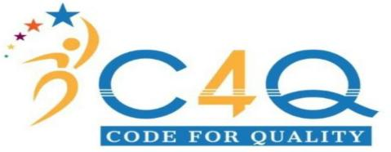

# Relieving and Service Certificate

This is in reference to the resignation letter dated **December 01, 2022.** We have accepted the resignation of **Boddunnolla Naresh** who has worked with us from **November 23, 2022** to **December 01, 2022** in the capacity of **Coding Analyst**.

We have duly relieved him from the services after satisfactory completion of all mandatory formalities.

Boddunnolla Naresh**,** Conduct is good, and he has made noteworthy contribution to the organization.

We wish U Kanta Reddy all the best in his future endeavors.

# For C4Q Healthcare Solutions.



Putla Sai Rakesh Director

C4Q Healthcare solutions

Corporate Office :# 8-2-268/R/5,second floor,Road No.2,Sagar Society SriNagar Colony,Kamalapuri Colony,Banjara Hills,Hyderabad, Telangana-500073

Regd.Office: #1-6-21/107/65/6, Flat no 101, Parsigutta, Gangaputra Colony, Musheerabad, Hyderabad-500020