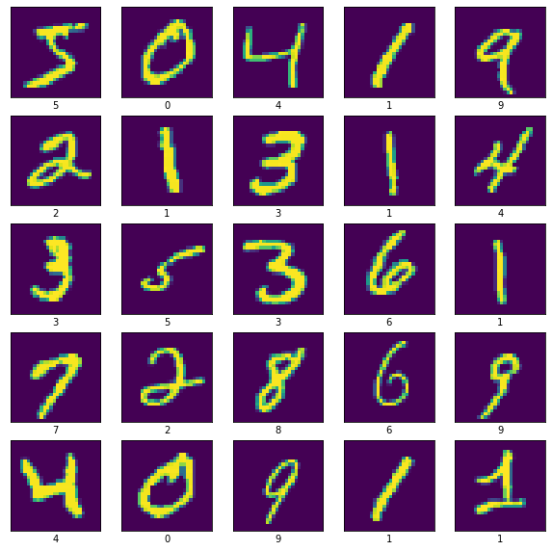

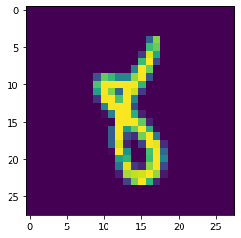

array([[ 974, 1, 1, 0, 0, 0, 0, 1, 2, 1],

[ 0, 1134, 0, 1, 0, 0, 0, 0, 0, 0],

[ 1, 1, 1022, 0, 0, 0, 0, 7, 1, 0],

[ 0, 1, 1, 998, 0, 4, 0, 5, 1, 0],

[ 0, 0, 0, 0, 972, 0, 1, 1, 1, 7],

[ 0, 0, 0, 4, 0, 874, 1, 2, 6, 5],

[ 2, 3, 0, 0, 5, 0, 936, 0, 12, 0],

[ 0, 2, 3, 0, 0, 0, 0, 1023, 0, 0],

[ 1, 0, 3, 0, 0, 0, 0, 2, 967, 1],

[ 0, 0, 0, 0, 3, 4, 0, 4, 2, 996]])

Accuracy: 0.9896

F1 score: 0.9896025288096476

Recall 0.9896

Precision 0.9896666139277382

CodeText