VISVESVARAYA TECHNOLOGICAL UNIVERSITY
“JnanaSangama”, Belgaum -590014, Karnataka.


LAB REPORT

On

ANALYSIS AND DESIGN OF ALGORITHMS (23CS4PCADA)

Submitted by
PADMASHREE S (1BM25CS490 )

in partial fulfillment for the award of the degree of BACHELOR OF ENGINEERING
in
COMPUTER SCIENCE AND ENGINEERING


B.M.S. COLLEGE OF ENGINEERING
(Autonomous Institution under VTU) BENGALURU-560019
February to June 2026

CERTIFICATE

B. M. S. College of Engineering,
Bull Temple Road, Bangalore 560019
(Affiliated To Visvesvaraya Technological University, Belgaum) Department of Computer Science and Engineering



This is to certify that the Lab work entitled “ANALYSIS AND DESIGN OF ALGORITHMS” carried out by PADMASHREE S(1BM25CS490), who is bonafide student
of B. M. S. College of Engineering. It is in partial fulfillment for the award of Bachelor of Engineering in Computer Science and Engineering of the Visvesvaraya Technological University, Belgaum during the year 2025-26. The Lab report has been approved as it satisfies the academic requirements in respect of Analysis and Design of Algorithms Lab - (23CS4PCADA) work prescribed for the said degree.

Manjula S Dr. Kavitha Sooda
Assistant Professor Professor and Head
Department of CSE Department of CSE
BMSCE, Bengaluru BMSCE, Bengaluru

Index Sheet

Sl.  No. | Experiment Title | Page No.
1 | Write program to obtain the Topological ordering of vertices in a give digraph. | n 4-6
2 | Implement Johnson Trotter algorithm to generate permutations. | 7-9
3 | Sort a given set of N integer elements using Merge Sort technique and compute its time taken. Run the program for different values of N and record  the time taken to sort. | 10-12
4 | Sort a given set of N integer elements using Quick Sort technique and compute its time taken. | 13-14
5 | Sort a given set of N integer elements using Heap Sort technique and comput its time taken. | e 15-17
6 | Implement 0/1 Knapsack problem using dynamic programming. (5 Marks) | 18-20
7 | Implement All Pair Shortest paths problem using Floyd’s algorithm. | 21-23
8 | - Find Minimum Cost Spanning Tree of a given undirected graph usin Prim’s algorithm.  - Find Minimum Cost Spanning Tree of a given undirected graph usin Kruskal’s algorithm. | g 24-28  g
9 | Implement Fractional Knapsack using Greedy technique. | 29-31
10 | From a given vertex in a weighted connected graph, find shortest paths to other vertices using Dijkstra’s algorithm. | 32-34
11 | Implement “N-Queens Problem” using Backtracking. | 35-36

Course outcomes:

CO1 | Analyze time complexity of algorithms using asymptotic notations.
CO2 | Apply various algorithm design techniques for the given problem.
CO3 | Evaluate the appropriate algorithm/design technique for solving a given problem.
CO4 | Conduct practical experiments by applying appropriate algorithm design technique to solve problems.

Lab program 1:
Write program to obtain the Topological ordering of vertices in a given digraph.

Code:
#include<stdio.h> #define MAX 10 int main() {
int n, a[MAX][MAX];
int indegree[MAX] = {0}; int visited[MAX] = {0};
printf("Enter number of vertices: "); scanf("%d", &n);
printf("Enter adjacency matrix:\n");
// Input adjacency matrix and calculate indegree for(int i = 0; i < n; i++) {
for(int j = 0; j < n; j++) { scanf("%d", &a[i][j]); if(a[i][j] == 1) {
indegree[j]++;
}
}
}
printf("Topological Order: ");
for(int count = 0; count < n; count++) { for(int i = 0; i < n; i++) {
if(indegree[i] == 0 && visited[i] == 0) { printf("%d ", i);
visited[i] = 1;

// Reduce indegree of adjacent vertices for(int j = 0; j < n; j++) {
if(a[i][j] == 1) {
indegree[j]--;
}
}
}
}
return 0;
}
Output>>>
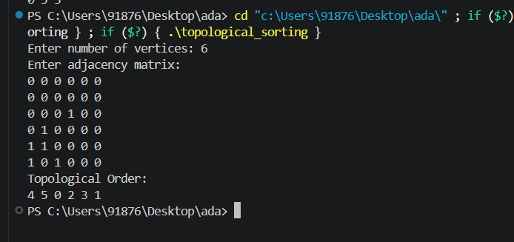

LeetCode Program:
bool canFinish(int numCourses, int** prerequisites, int prerequisitesSize, int* prerequisitesColSize) {
int** graph = (int**)malloc(numCourses * sizeof(int*)); int* graphColSize = (int*)calloc(numCourses, sizeof(int)); for (int i = 0; i < numCourses; i++) {
graph[i] = (int*)malloc(numCourses * sizeof(int));
}
int* indegree = (int*)calloc(numCourses, sizeof(int)); for (int i = 0; i < prerequisitesSize; i++) {
int a = prerequisites[i][0]; int b = prerequisites[i][1];
graph[b][graphColSize[b]++] = a; indegree[a]++;
}
int* queue = (int*)malloc(numCourses * sizeof(int)); int front = 0, rear = 0;
for (int i = 0; i < numCourses; i++) { if (indegree[i] == 0) {
queue[rear++] = i;
}}
int count = 0;
while (front < rear) {
int course = queue[front++]; count++;
for (int i = 0; i < graphColSize[course]; i++) { int neighbor = graph[course][i]; indegree[neighbor]--;

if (indegree[neighbor] == 0) { queue[rear++] = neighbor;
}}}
return count == numCourses;
}

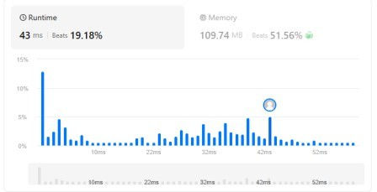

Lab program 2:
Implement Johnson Trotter algorithm to generate permutations. Code:
#include<stdio.h>

#define RIGHT_TO_LEFT 0
#define LEFT_TO_RIGHT 1

// search position of mobile element int searchArr(int a[], int n, int mobile)
{
for(int i=0;i<n;i++)
{
if(a[i]==mobile) return i;
}
}

// find mobile element
int getMobile(int a[], int dir[], int n)
{
int mobile_prev = 0, mobile = 0;

for(int i=0;i<n;i++)
{
// RIGHT TO LEFT
if(dir[a[i]-1]==RIGHT_TO_LEFT && i!=0)
{
if(a[i] > a[i-1] && a[i] > mobile_prev)
{
mobile = a[i]; mobile_prev = mobile;
}
}

// LEFT TO RIGHT
if(dir[a[i]-1]==LEFT_TO_RIGHT && i!=n-1)
{
if(a[i] > a[i+1] && a[i] > mobile_prev)
{
mobile = a[i]; mobile_prev = mobile;
}
}
}

if(mobile==0 && mobile_prev==0) return 0;
else

return mobile;
}

// print one permutation
void printOnePerm(int a[], int dir[], int n)
{
int mobile = getMobile(a, dir, n); int pos = searchArr(a, n, mobile);
// swap
if(dir[a[pos]-1]==RIGHT_TO_LEFT)
{
int temp = a[pos]; a[pos] = a[pos-1]; a[pos-1] = temp;
}

else if(dir[a[pos]-1]==LEFT_TO_RIGHT)
{
int temp = a[pos]; a[pos] = a[pos+1]; a[pos+1] = temp;
}

// reverse directions for(int i=0;i<n;i++)
{
if(a[i] > mobile)
{
if(dir[a[i]-1]==LEFT_TO_RIGHT) dir[a[i]-1]=RIGHT_TO_LEFT;

else if(dir[a[i]-1]==RIGHT_TO_LEFT) dir[a[i]-1]=LEFT_TO_RIGHT;
}
}

// print permutation for(int i=0;i<n;i++) printf("%d ",a[i]);

printf("\n");
}

// factorial int fact(int n)
{
int res = 1;

for(int i=1;i<=n;i++)

res = res * i; return res;
}

int main()
{
int n; printf("Enter n: ");
scanf("%d",&n);

int a[n], dir[n];
// initialize
for(int i=0;i<n;i++)
{
a[i] = i + 1;
dir[i] = RIGHT_TO_LEFT;
}

// print first permutation for(int i=0;i<n;i++)
printf("%d ",a[i]); printf("\n");
// generate permutations for(int i=1;i<fact(n);i++)
printOnePerm(a, dir, n);

return 0;
}

Output>>>
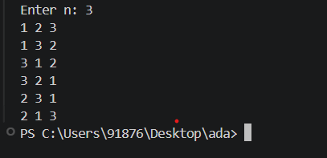

Lab program 3:
Sort a given set of N integer elements using Merge Sort technique and compute its time taken. Run the program for different values of N and record the time taken to sort.

Code:
#include<stdio.h> #include<time.h>

void merge(int a[], int low, int mid, int high)
{
int i = low, j = mid + 1, k = low; int temp[100];

while(i <= mid && j <= high)
{
if(a[i] < a[j]) temp[k++] = a[i++];
else
temp[k++] = a[j++];
}

while(i <= mid) temp[k++] = a[i++];

while(j <= high) temp[k++] = a[j++];

for(i = low; i <= high; i++) a[i] = temp[i];
}

void mergesort(int a[], int low, int high)
{
if(low < high)
{
int mid = (low + high) / 2;

mergesort(a, low, mid); mergesort(a, mid + 1, high);

merge(a, low, mid, high);
}
}

int main()
{

int a[100], n, i; clock_t start, end;

printf("Enter number of elements: "); scanf("%d", &n);

printf("Enter elements:\n"); for(i = 0; i < n; i++)
scanf("%d", &a[i]); start = clock(); mergesort(a, 0, n - 1); end = clock();
printf("Sorted array:\n"); for(i = 0; i < n; i++)
printf("%d ", a[i]);

printf("\nTime taken = %lf seconds", (double)(end - start) / CLOCKS_PER_SEC)
return 0;
}

Output>>>
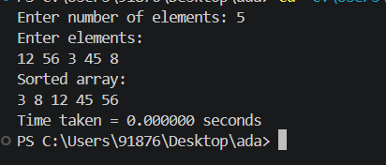

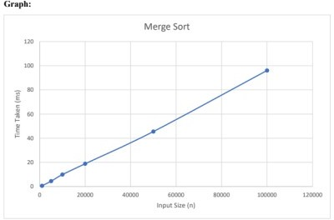

LEETCODE PROGRAM
int reverseBits(int n) { unsigned int result = 0;
unsigned int num = (unsigned int)n;

for (int i = 0; i < 32; i++) {
result = (result << 1) | (num & 1); num >>= 1;
}

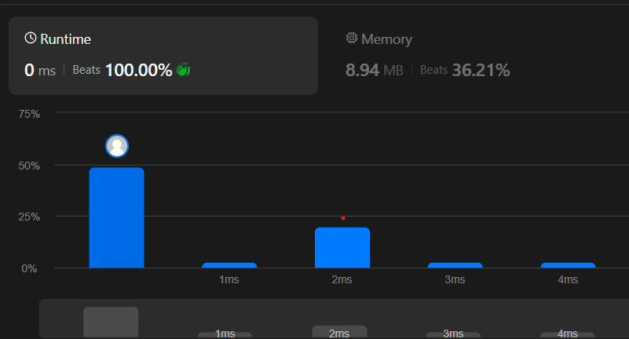

Lab program 4:

Sort a given set of N integer elements using Quick Sort technique and compute its time taken.

Code: #include<stdio.h> #include<time.h>

int partition(int a[], int low, int high)
{
int pivot = a[low]; int i = low + 1; int j = high;
int temp;

while(i <= j)
{
while(a[i] <= pivot && i <= high) i++;

while(a[j] > pivot) j--;

if(i < j)
{
temp = a[i]; a[i] = a[j]; a[j] = temp;
}
}

temp = a[low]; a[low] = a[j]; a[j] = temp;

return j;
}

void quicksort(int a[], int low, int high)
{
if(low < high)
{
int p = partition(a, low, high);

quicksort(a, low, p - 1); quicksort(a, p + 1, high);

}
}

int main()
{
int a[100], n, i; clock_t start, end;
printf("Enter number of elements: "); scanf("%d", &n);

printf("Enter elements:\n"); for(i = 0; i < n; i++)
scanf("%d", &a[i]); start = clock(); quicksort(a, 0, n - 1); end = clock();
printf("Sorted array:\n"); for(i = 0; i < n; i++)
printf("%d ", a[i]);
printf("\nTime taken = %lf seconds", (double)(end - start) / CLOCKS_PER_SEC);
return 0;
}
Output>>>
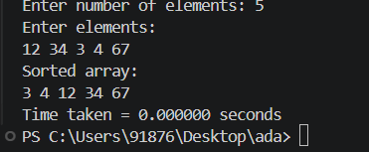
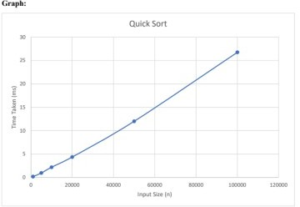

Lab program 5:
Sort a given set of N integer elements using Heap Sort technique and compute its time taken.
#include <stdio.h>
void minHeapify(int arr[], int n, int i)
{
int smallest = i; int left = 2 * i + 1;
int right = 2 * i + 2;
if (left < n && arr[left] < arr[smallest]) smallest = left;
if (right < n && arr[right] < arr[smallest]) smallest = right;
if (smallest != i)
{
int temp = arr[i]; arr[i] = arr[smallest]; arr[smallest] = temp;
minHeapify(arr, n, smallest);

}
}
void buildMinHeap(int arr[], int n)
{
for (int i = (n / 2) - 1; i >= 0; i--)
{

minHeapify(arr, n, i);
}
}

void heapSortDescending(int arr[], int n) { buildMinHeap(arr, n);
for (int i = n - 1; i > 0; i--)
{
int temp = arr[0]; arr[0] = arr[i]; arr[i] = temp;
minHeapify(arr, i, 0);
}
}
void printArray(int arr[], int n) { for (int i = 0; i < n; i++){ printf("%d ", arr[i]);
}
printf("\n");
}
int main()
{
int arr[] = {40, 10, 30, 50, 60, 15, 5}; int n = sizeof(arr) / sizeof(arr[0]); printf("Input Array:\ printArray(arr, n);
buildMinHeap(arr, n); printf("\nMin Heap:\n"); printArray(arr, n); heapSortDescending(arr, n); printf("\nDescending Order:\n"); printArray(arr, n);
return 0;}

Output>>>
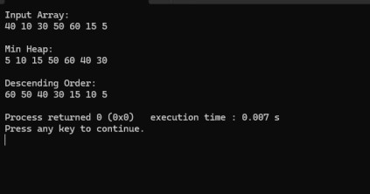
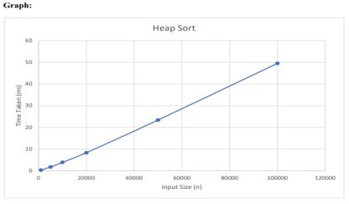

Lab program 6:
Implement 0/1 Knapsack problem using dynamic programming. Code:
#include<stdio.h> int max(int a, int b){
if(a>b){
return a;
}
else
return b;
}
int main(){ int w,n;
printf("Enter no of items:"); scanf("%d",&n);
int wt[n], p[n]; for(int i=0;i<n;i++){
scanf("%d%d",&wt[i],&p[i]);
}
printf("Enter the capacity of sack:"); scanf("%d",&w);
int k[n+1][w+1]; for(int i=0;i<=n;i++){
for(int j=0;j<=w;j++){ if(i==0 || j==0){
k[i][j]=0;

}
else if(wt[i-1]<=j){
k[i][j]=max(p[i-1]+k[i-1][j-wt[i-1]],k[i-1][j]);
}
else{
k[i][j]=k[i-1][j];
}
}
}
printf("maximum profit:%d" ,k[n][w]);
}
Output>>>
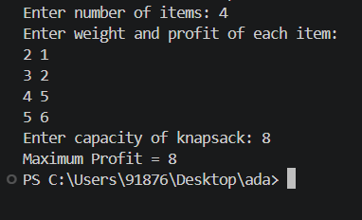

LEETCODE PROGRAM:
int climbStairs(int n) { if(n==1)
return 1;
int dp[n+1]; dp[1]=1;
dp[2]=2;
for(int i=3;i<=n;i++){ dp[i]=dp[i-1]+dp[i-2];
}
return dp[n];}
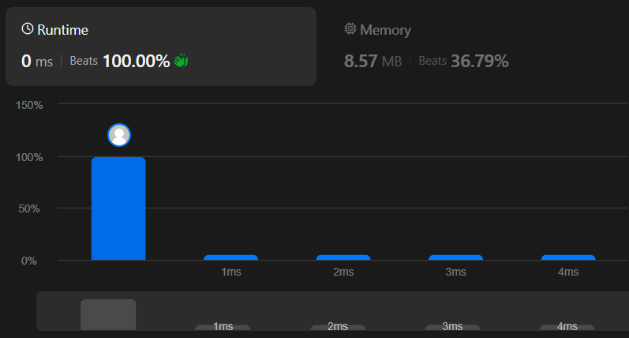

LAB PROGRAM-7
Implement All Pair Shortest paths problem using Floyd’s algorithm. Code:
#include <stdio.h> int main()
{
int n;
int a[10][10]; 7
printf("Enter number of vertices: "); scanf("%d",&n);
printf("Enter cost matrix:\n"); for(int i=0;i<n;i++)
for(int j=0;j<n;j++) scanf("%d",&a[i][j]); for(int k=0;k<n;k++)
{
for(int i=0;i<n;i++)
{
for(int j=0;j<n;j++)
{
if(a[i][j] > a[i][k]+a[k][j])
a[i][j]=a[i][k]+a[k][j];
}
}
}

printf("Shortest path matrix:\n");
}
for(int i=0;i<n;i++)
{
for(int j=0;j<n;j++) printf("%d ",a[i][j]); printf("\n");
}
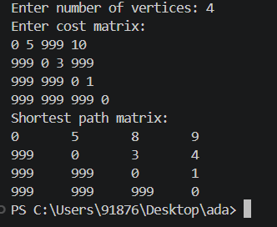
Output>>>

LEETCODE PROGRAM:
int countWays(int nums[], int n, int index, int sum, int target) { if (index == n) {
return (sum == target) ? 1 : 0;
}
int add = countWays(nums, n, index + 1, sum + nums[index], target); int subtract = countWays(nums, n, index + 1, sum - nums[index], target); return add + subtract;
}
int findTargetSumWays(int nums[], int n, int target) { return countWays(nums, n, 0, 0, target);

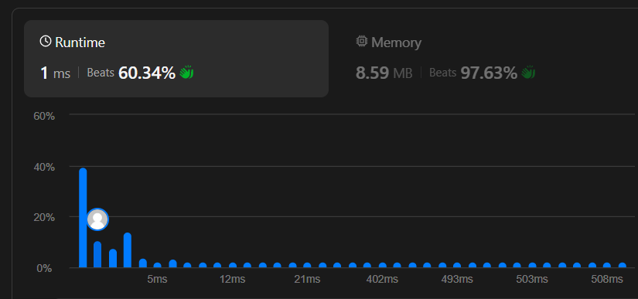

LAB PROGRAM-8
- Find Minimum Cost Spanning Tree of a given undirected graph using Prim’s algorithm.
Code: #include<stdio.h> #define INF 999 int main()
{
int n, i, j, min, u, v; int visited[10] = {0}; int cost[10][10];
int mincost = 0, edges = 0; printf("Enter number of vertices: "); scanf("%d", &n);
printf("Enter cost matrix:\n"); for(i = 0; i < n; i++)
{
for(j = 0; j < n; j++)
{
scanf("%d", &cost[i][j]);

if(cost[i][j] == 0)
cost[i][j] = INF;
}
}
visited[0] = 1;
printf("Edges in Minimum Spanning Tree:\n"); while(edges < n - 1)
{

min = INF;

for(i = 0; i < n; i++){ if(visited[i]){
for(j = 0; j < n; j++){ if(!visited[j] && cost[i][j] < m){
min = cost[i][j]; u = i;
v = j;
}
}}}
printf("%d -> %d = %d\n", u, v, min); mincost += min;
visited[v] = 1; edges++;
}
printf("Minimum Cost = %d", mincost); return 0;
}
Output>>>
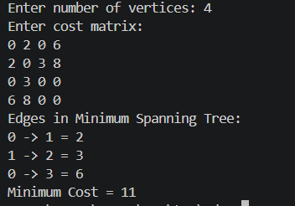

- Find Minimum Cost Spanning Tree of a given undirected graph using Kruskal’s algorithm.
Code: #include<stdio.h> #define INF 999 int parent[10];
int find(int i)
{
while(parent[i]) i = parent[i];
return i;
}
int uni(int i, int j)
{
if(i != j)
{
parent[j] = i; return 1;
}
return 0;
}
int main()
{
int n, i, j, a, b, u, v; int min, mincost = 0; int cost[10][10];
int edges = 0;
printf("Enter number of vertices: "); scanf("%d", &n);

printf("Enter cost matrix:\n"); for(i = 0; i < n; i++)
{
for(j = 0; j < n; j++)
{
scanf("%d", &cost[i][j]);

if(cost[i][j] == 0)
cost[i][j] = INF;
}
}
printf("Edges in Minimum Spanning Tree:\n") while(edges < n - 1)
{
min = INF
for(i = 0; i < n; i++)
{
for(j = 0; j < n; j++)
{
if(cost[i][j] < min)
{
min = cost[i][j];
a = u = i;
b = v = j;
}
}
}

u = find(u); v = find(v); if(uni(u, v))
{
printf("%d -> %d = %d\n", a, b, min); mincost += min;
edges++;
}
cost[a][b] = cost[b][a] = INF;
}
printf("Minimum Cost = %d", mincost); return 0;
}
Output>>>
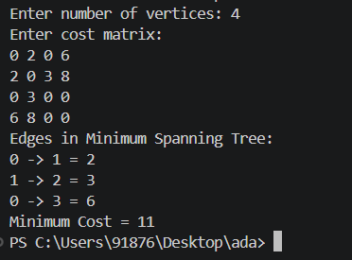

LAB PROGRAM-9:
Implement Fractional Knapsack using Greedy technique.
#include<stdio.h> struct Item
{
int profit, weight; float ratio;
};
int main()
{
int n, i, j;
float capacity, totalProfit = 0; printf("Enter number of items: "); scanf("%d", &n)
struct Item item[n];
printf("Enter profit and weight of each item:\n"); for(i = 0; i < n; i++)
{
scanf("%d%d", &item[i].profit, &item[i].weight); item[i].ratio = (float)item[i].profit / item[i].weight;
}

printf("Enter capacity of knapsack: "); scanf("%f", &capacity);
// Sort by profit/weight ratio for(i = 0; i < n - 1; i++)
{
for(j = i + 1; j < n; j++)

{
if(item[i].ratio < item[j].ratio)
{
struct Item temp = item[i]; item[i] = item[j];
item[j] = temp;
}
}
}
for(i = 0; i < n; i++)
{
if(capacity >= item[i].weight)
{
capacity -= item[i].weight; totalProfit += item[i].profit;
}
else
{
totalProfit += item[i].ratio * capacity; break;
}
}
printf("Maximum Profit = %.2f", totalProfit); return 0;
}

Output>>>
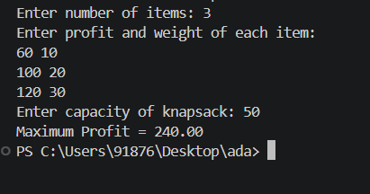

LEET CODE :
int balancedStringSplit(char* s) { int balance = 0;
int count = 0;
for (int i = 0; s[i] != '\0'; i++) { if (s[i] == 'R')
balance++; else balance--;
if (balance == 0) count++;
}
return count;
}
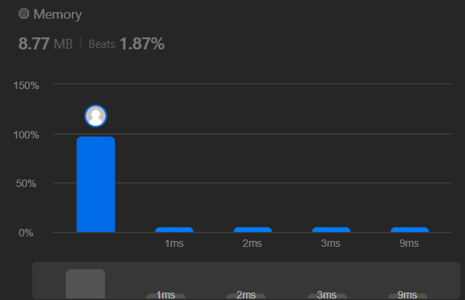

LAB PROGRAM -10
From a given vertex in a weighted connected graph, find shortest paths to other vertices using Dijkstra’s algorithm.
Code: #include<stdio.h> #define INF 999 int main()
{
int n, i, j, u, v, min; int visited[10] = {0};
int cost[10][10], dist[10]; printf("Enter number of vertices: "); scanf("%d", &n);
printf("Enter cost matrix:\n"); for(i = 0; i < n; i++)
{
for(j = 0; j < n; j++)
{
scanf("%d", &cost[i][j]);

if(cost[i][j] == 0)
cost[i][j] = INF;
}
}
int source;
printf("Enter source vertex: "); scanf("%d", &source);

// Initialize distances for(i = 0; i < n; i++)
{
dist[i] = cost[source][i];
}
visited[source] = 1;
dist[source] = 0; for(i = 1; i < n; i++)
{
min = INF;
for(j = 0; j < n; j++)
{
if(!visited[j] && dist[j] < min)
{
min = dist[j]; u = j;
}
}
visited[u] = 1;
for(v = 0; v < n; v++)
{
if(!visited[v] && dist[u] + cost[u][v] < dist[v])
{
dist[v] = dist[u] + cost[u][v];
}
}
}

printf("Shortest distances from vertex %d:\n", source); for(i = 0; i < n; i++)
{
printf("%d -> %d = %d\n", source, i, dist[i]);
}
return 0;
}
Output>>>
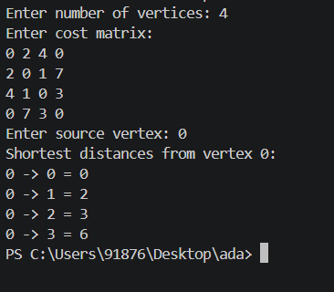

LAB PROGRAM-11
Implement “N-Queens Problem” using Backtracking. Code:
#include<stdio.h> int x[10], count = 0; int place(int k, int i)
{
for(int j = 1; j < k; j++)
{
if(x[j] == i || abs(x[j] - i) == abs(j - k)) return 0;
}
return 1;
}
void nqueen(int k, int n)
{
for(int i = 1; i <= n; i++)
{
if(place(k, i))
{
x[k] = i;

if(k == n)
{
count++;
printf("\nSolution %d:\n", count); for(int j = 1; j <= n; j++)
printf("%d ", x[j]);

}
else
{
nqueen(k + 1, n);
}
}
}
}
int main()
{
int n;
printf("Enter number of queens: "); scanf("%d", &n);
nqueen(1, n); return 0;
}
Output>>>
