Week 2 Task
Advanced Data Visualization and Storytelling with Python
Data Story: How the World Got Richer, Healthier, and More Crowded (1952-2007)
Prepared by: Padala Padma Sri (Chinnu)
Tools: Python (Pandas, Matplotlib, Seaborn, Plotly)
Date: August 2026

Table of Contents
1. Introduction
2. Methods & Approach
3. The Data Story - Six Visual Chapters
4. Business & Scientific Implications
5. Conclusion

1. Introduction
Raw numbers rarely persuade anyone on their own. A table listing 142 countries across 12 survey years is accurate, but nobody outside a statistics department will read it, let alone remember it. This report takes that same underlying data and turns it into a story - one with a beginning, a turning point, and a handful of characters (countries) whose experience doesn't fit the plot.
The dataset behind this story is the Gapminder dataset: life expectancy, GDP per capita, and population for 142 countries, recorded every five years from 1952 to 2007. It was chosen because it supports exactly the kind of narrative arc that data storytelling is meant to serve - a clear overall trend (the world got healthier and wealthier), a strong relationship between two variables (income and health), and enough individual exceptions to keep the story honest rather than tidy.
The narrative built across the six visualizations below follows a simple arc:
- Where we started, and where we ended up (the trend).
- Why it happened - the relationship between wealth and health.
- Who is furthest ahead and furthest behind today (the gap).
- What else changed alongside it - population growth.
- How unequal progress has been within, not just between, continents.
- Who breaks the pattern entirely - and why that matters more than the average.

2. Methods & Approach

Dataset
Source: the Gapminder Foundation's public dataset, accessed via the plotly.express built-in loader (px.data.gapminder()), covering 1,704 records - 142 countries x 12 years (1952-2007) - with no missing values in any of the eight columns (country, continent, year, life expectancy, population, GDP per capita, and ISO codes).

Tools & Library Choices
Three libraries were used deliberately rather than defaulting to one, since different chart types and audiences call for different strengths:
- Matplotlib - for full manual control over annotations and layout (the trend line, bubble comparison, stacked area, and outlier-spotlight charts).
- Seaborn - for fast, well-styled statistical comparison (the box-plot distribution chart).
- Plotly - for the ranked bar chart, which benefits from Plotly's clean horizontal-bar defaults and built-in hover metadata.

Design Principles Applied
- Each chart answers exactly one question - no chart tries to show everything at once.
- Color is used consistently for continent across every chart, so the eye doesn't have to re-learn a legend.
- Titles are written as takeaways ("Life Expectancy Has Risen on Every Continent"), not neutral labels ("Life Expectancy by Year"), since a non-technical reader should get the point from the headline alone.
- Every chart includes a caption explaining why it was chosen and what it contributes to the larger argument (Section 3).

3. The Data Story - Six Visual Chapters

Chapter 1: The World Got Healthier - Almost Everywhere
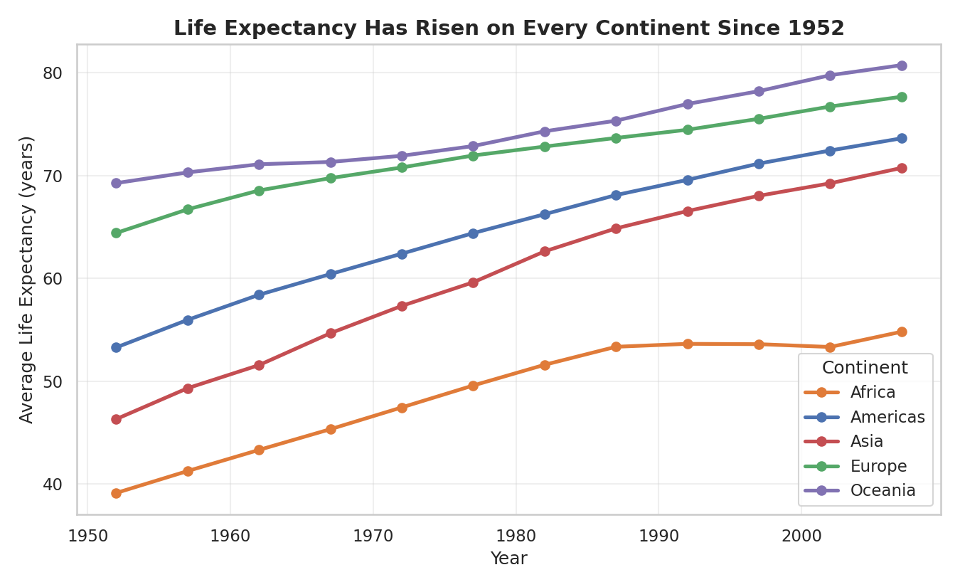
Figure 1. Average life expectancy by continent, 1952-2007.
Why this chart: a line chart is the simplest way to show change over time, and starting the story here establishes the baseline fact everything else explains. Global average life expectancy rose from 49.1 years in 1952 to 67.0 years in 2007 - roughly 18 years gained in half a century.
What it contributes to the narrative: every continent's line moves upward, which rules out the idea that gains were confined to one region. But the lines don't converge - Africa's line sits roughly 20-25 years below Europe and Oceania throughout, and that gap barely narrows. This sets up the question the rest of the story answers: what explains both the shared upward trend and the persistent gap?

Chapter 2: The Wealth-Health Connection
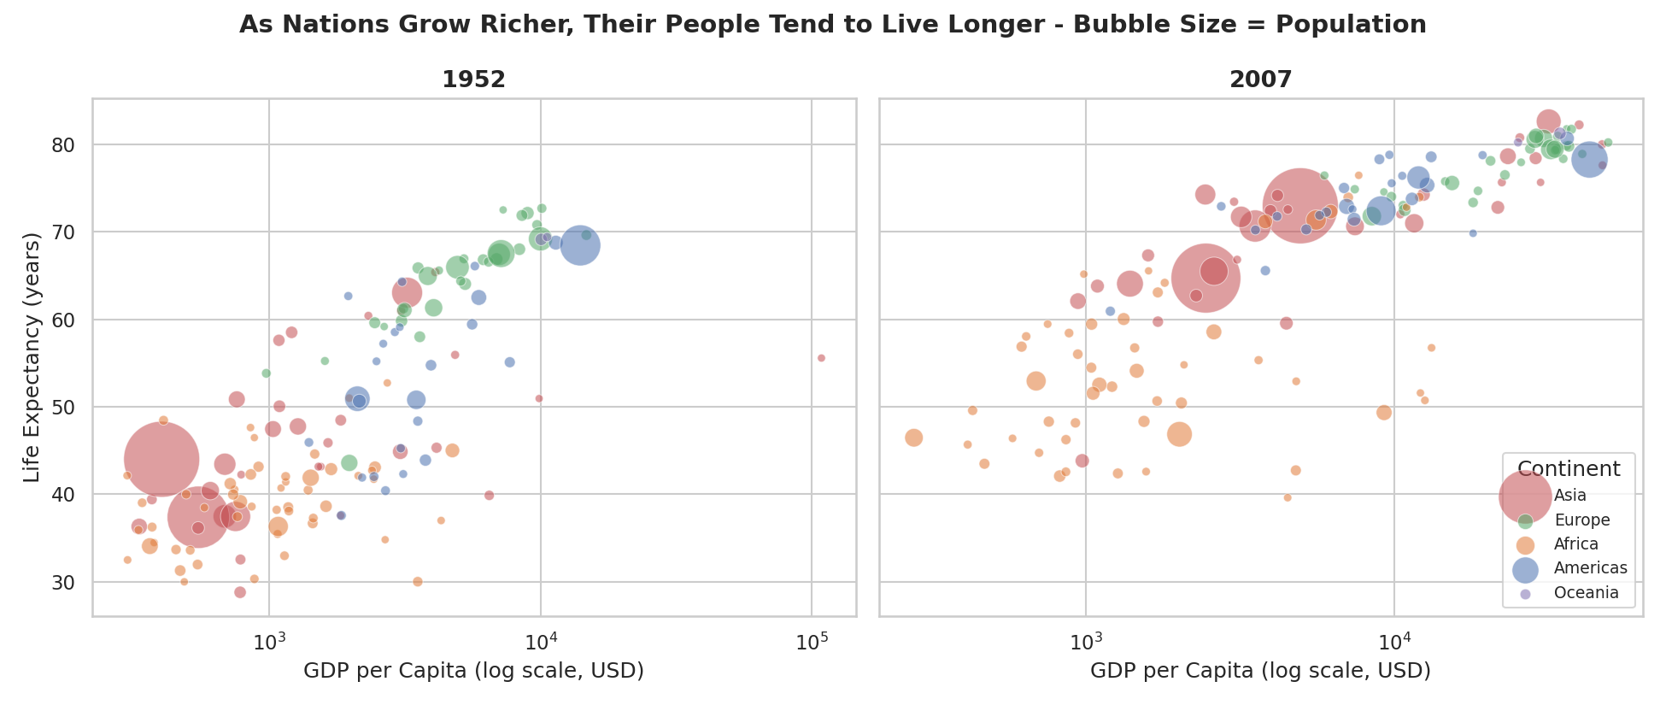
Figure 2. GDP per capita vs. life expectancy, 1952 vs. 2007. Bubble size = population.
Why this chart: a bubble scatter plot is the natural next step once a trend is established - it answers "why" by putting a second variable (income) directly against the first (health), with a third (population) folded in via bubble size at no extra visual cost. Comparing two snapshots side-by-side, rather than animating between them, keeps the comparison legible in a static document.
What it contributes to the narrative: the same upward-sloping relationship appears in both panels - richer countries cluster toward longer lives - and the correlation between (log) GDP per capita and life expectancy in 2007 is 0.81, a strong association. But the whole cloud of points also shifts up and to the right between 1952 and 2007: countries didn't just get richer, they got healthier faster than income growth alone would predict, most visibly among the large Asian bubbles (China, India) that moved from the bottom-left toward the middle of the chart.

Chapter 3: The Gap, Named
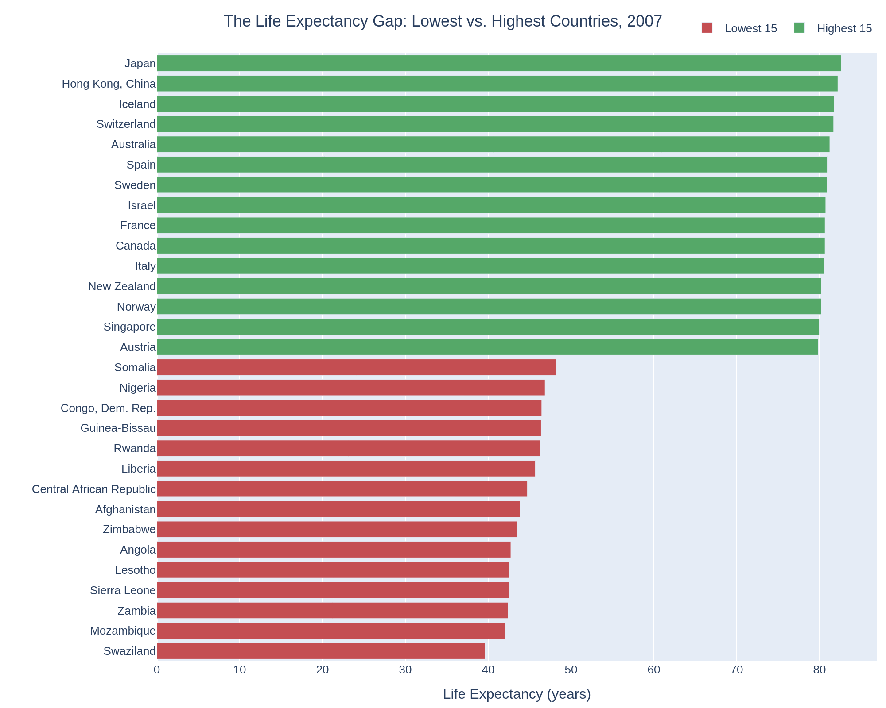
Figure 3. The 15 highest and 15 lowest countries by life expectancy, 2007.
Why this chart: averages and trend lines are honest but abstract. Naming the actual countries at each extreme makes the gap concrete and gives a non-technical reader something to recognize - Japan and Switzerland at one end, Swaziland and Mozambique at the other.
What it contributes to the narrative: the gap between the two groups is stark - roughly 43 years separate top-ranked Japan (82.6 years) from bottom-ranked Swaziland (39.6 years). Notably, the bottom 15 is composed almost entirely of Sub-Saharan African countries, which sharpens Chapter 1's continent-level pattern into a country-level one: this isn't a diffuse global gap, it's concentrated in a specific region.

Chapter 4: A Crowded, Unevenly-Growing World
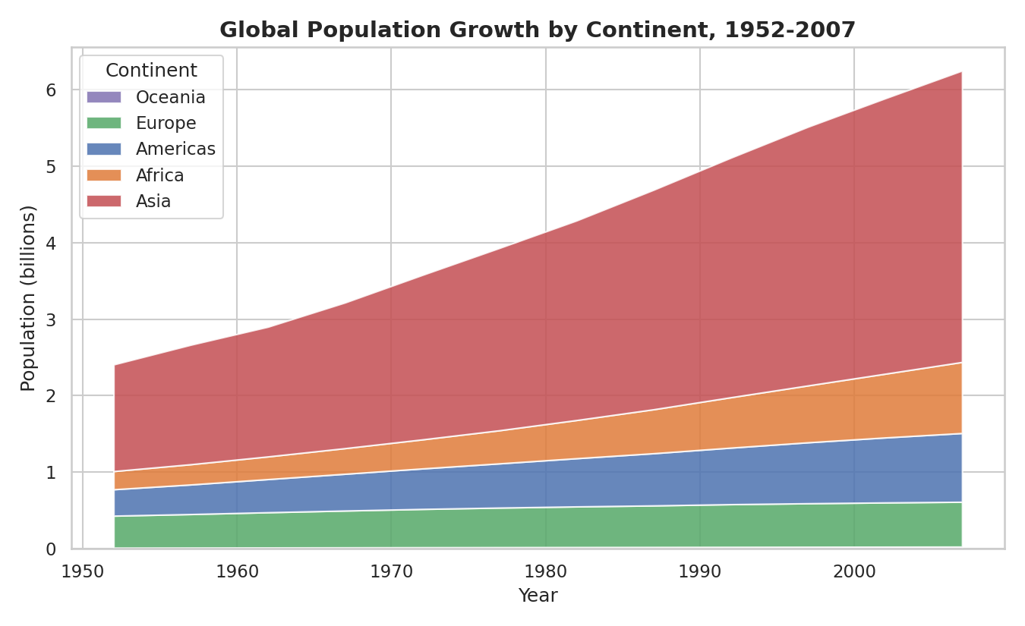
Figure 4. Global population by continent, 1952-2007 (stacked area).
Why this chart: a stacked area chart shows both the total (the outer edge) and the composition (the bands) in one view - useful here because both changed dramatically. World population grew from 2.41 billion to 6.25 billion over the period - more than two and a half times over.
What it contributes to the narrative: Asia's band dominates the chart throughout and widens fastest, meaning most of humanity's population growth - and by extension, most of the health gains from Chapter 1 - happened in Asia. This reframes the earlier charts: the global average improved partly because the world's most populous continent improved fastest, not because gains were evenly spread.

Chapter 5: Progress Wasn't Even Within Continents Either
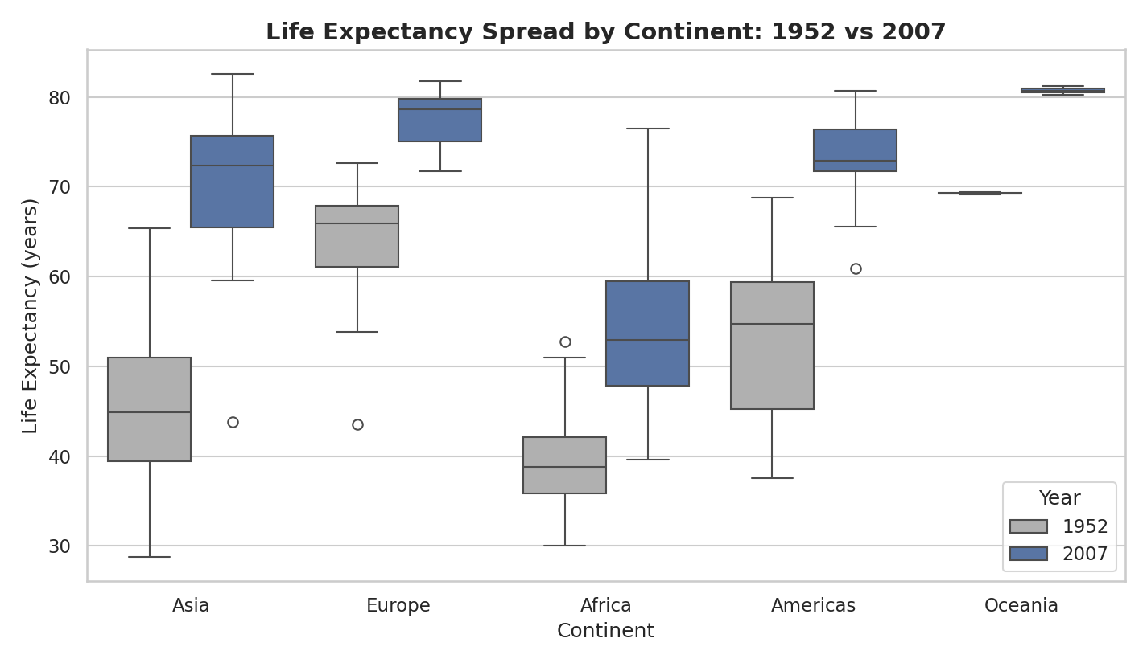
Figure 5. Distribution of life expectancy by continent, 1952 vs. 2007 (box plot).
Why this chart: a box plot shows spread, not just an average - important here because a continent's mean can rise even while some of its countries fall further behind others in the same region.
What it contributes to the narrative: Africa's 2007 box is both higher and wider than its 1952 box, meaning African countries did not improve as a uniform bloc - some pulled far ahead of others. The Americas tell a similar story. Europe and Asia, by contrast, show tighter boxes in 2007 than 1952, suggesting more convergence among their own countries even as the gap to Africa persisted. This complicates the clean story a single trend line would tell.

Chapter 6: The Countries That Break the Rule
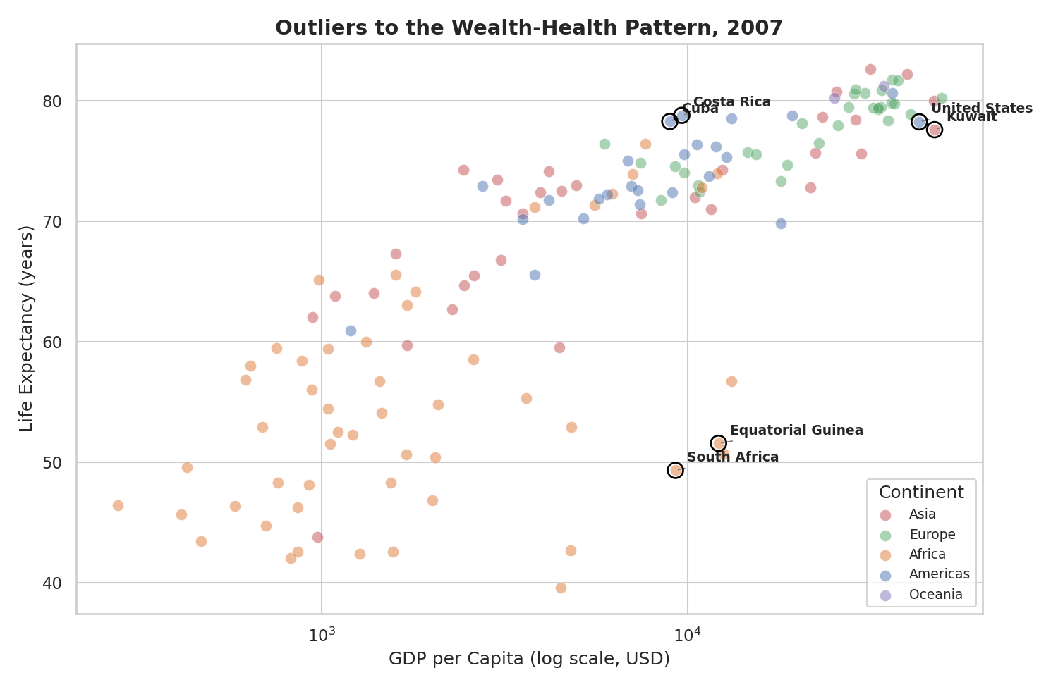
Figure 6. GDP per capita vs. life expectancy, 2007, with notable exceptions annotated.
Why this chart: after five charts building a wealth-equals-health story, the honest close is to show where that story breaks down. Annotating specific countries turns statistical outliers into named cases a reader can investigate further.
What it contributes to the narrative: Cuba (GDP per capita $8,948) and Costa Rica ($9,645) match the life expectancy of the United States ($42,952) and Kuwait ($47,307) - both around 78 years - at a fraction of the income, pointing to public health policy rather than wealth alone as the driver. Conversely, South Africa ($9,270) and Equatorial Guinea ($12,154) have income levels near Cuba's but life expectancy 27-29 years lower, illustrating that GDP per capita can mask how income is distributed and spent. These six countries are the reason the report ends on a caveat rather than a single tidy rule.

4. Business & Scientific Implications

For Policy & Public Health
- The Cuba/Costa Rica cases suggest that targeted public health investment can decouple life expectancy from raw GDP - relevant for any organization or government deciding how to allocate a limited health budget.
- The concentration of the lowest-15 countries in Sub-Saharan Africa (Chapter 3) suggests aid and intervention efforts see more impact concentrated regionally than spread thinly across all low-income countries globally.

For Business & Market Strategy
- The Asia population and income growth shown in Chapters 2 and 4 is consistent with Asia's continued relevance as a demographic and economic center for any market-expansion analysis.
- Widening within-continent spread (Chapter 5) means continent-level averages can be a misleading basis for market or risk assessments - country-level data changes conclusions meaningfully, particularly in Africa and the Americas.

For Data Science Practice
- The strong GDP-life expectancy correlation (0.81) is a reminder that correlation invites investigation, not conclusion - the outlier cases in Chapter 6 show real, well-documented exceptions worth researching before treating GDP as a proxy for health outcomes in any model.

5. Conclusion
Told as a sequence rather than six disconnected charts, this data supports a specific and falsifiable narrative: the world got healthier and wealthier together between 1952 and 2007, the gains were real on every continent, but they were neither even across continents nor uniform within them - and a small set of countries show that the wealth-health relationship, however strong on average, is not the whole story. That combination of a clear trend and honest exceptions is what separates a data story from a single impressive chart.

