WEEK 3 TASK
Unsupervised Learning and Clustering Analysis
Wine Profile Segmentation Using K-Means and Hierarchical Clustering
UCI Wine Dataset • Reproducible Python Analysis
August 2026

1. Executive Summary
This report applies unsupervised learning to the public UCI Wine dataset. The dataset contains 178 observations and 13 continuous chemical measurements. The clustering model is not given the known cultivar labels; it discovers groups from the chemistry alone.
The data audit found 0 missing values and 0 exact duplicate rows. The main preprocessing step was standardization because K-Means is distance-based. Candidate k values from 2 to 8 were evaluated. The best silhouette score was 0.285 at k=3.
At k=3, the supporting Ward hierarchical solution achieved a silhouette score of 0.277. PCA was used only for visualization; PC1 and PC2 together explain 55.4% of standardized variance.

2. Task Requirements at a Glance
Requirement | What this project delivers
Public dataset | UCI Wine, dataset ID 109
Preprocessing | Quality audit + StandardScaler
Clustering | K-Means tested for k=2–8; selected k=3
Parameter rationale | Elbow and silhouette analysis; random_state=42; n_init=20
Visualizations | Elbow, silhouette, PCA clusters, dendrogram, cluster profiles
Second method | Ward hierarchical clustering
Interpretation | Original-scale means and standardized cluster profiles
Validation | Post-hoc ARI only; cultivar labels never used for training
Reproducibility | Python script, notebook, metrics, assignments, figures
Final report | This DOCX

3. Dataset Selection and Source
I selected the UCI Wine dataset because it is compact enough to understand clearly but rich enough to demonstrate a complete clustering workflow. UCI reports 178 instances and 13 features. The measurements are chemical properties such as alcohol, malic acid, magnesium, total phenols, flavanoids, color intensity, hue and proline. The wines come from the same Italian region but from three different cultivars. citeturn0search0
The official UCI source provides the dataset documentation, variable information, DOI 10.24432/C5PC7J and CC BY 4.0 licensing. citeturn0search0

4. Data Acquisition and Exploration
from sklearn.datasets import load_wine
wine = load_wine(as_frame=True)
X = wine.data.copy()
y = wine.target.copy()
print(X.shape)
print(X.isna().sum().sum())
print(X.duplicated().sum())
Audit | Result
Rows | 178
Features | 13
Missing values | 0
Duplicate rows | 0
Feature type | Continuous numeric

UCI reports no missing values, and the programmatic audit confirmed that result. Because the source is already complete, no artificial imputation was introduced.

5. Preprocessing
K-Means uses Euclidean distance. The chemical variables have different numerical ranges, so standardization prevents high-scale variables from dominating the distance calculation.
from sklearn.preprocessing import StandardScaler
scaler = StandardScaler()
X_scaled = scaler.fit_transform(X)
The cultivar label is excluded from preprocessing and model fitting. This keeps the analysis genuinely unsupervised.

6. Choosing the Number of Clusters
I evaluated k from 2 through 8. Inertia shows how compact the clusters are, while the silhouette score balances within-cluster cohesion and between-cluster separation.
from sklearn.cluster import KMeans
from sklearn.metrics import silhouette_score
rows = []
for k in range(2, 9):
model = KMeans(n_clusters=k, random_state=42, n_init=20)
labels = model.fit_predict(X_scaled)
rows.append((k, model.inertia_, silhouette_score(X_scaled, labels)))
metrics = pd.DataFrame(
rows, columns=["k", "inertia", "silhouette"]
)
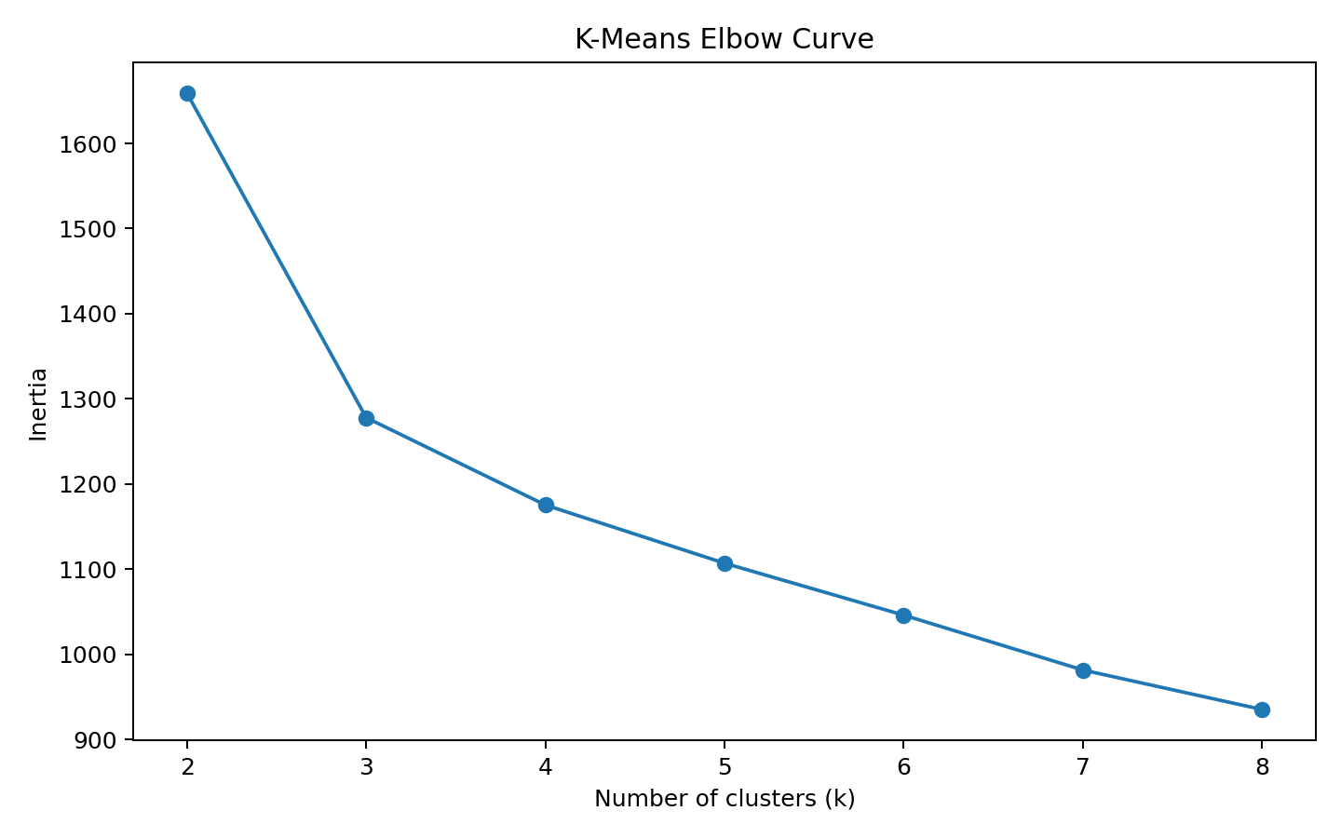
Figure 1. Elbow curve for K-Means candidate cluster counts.
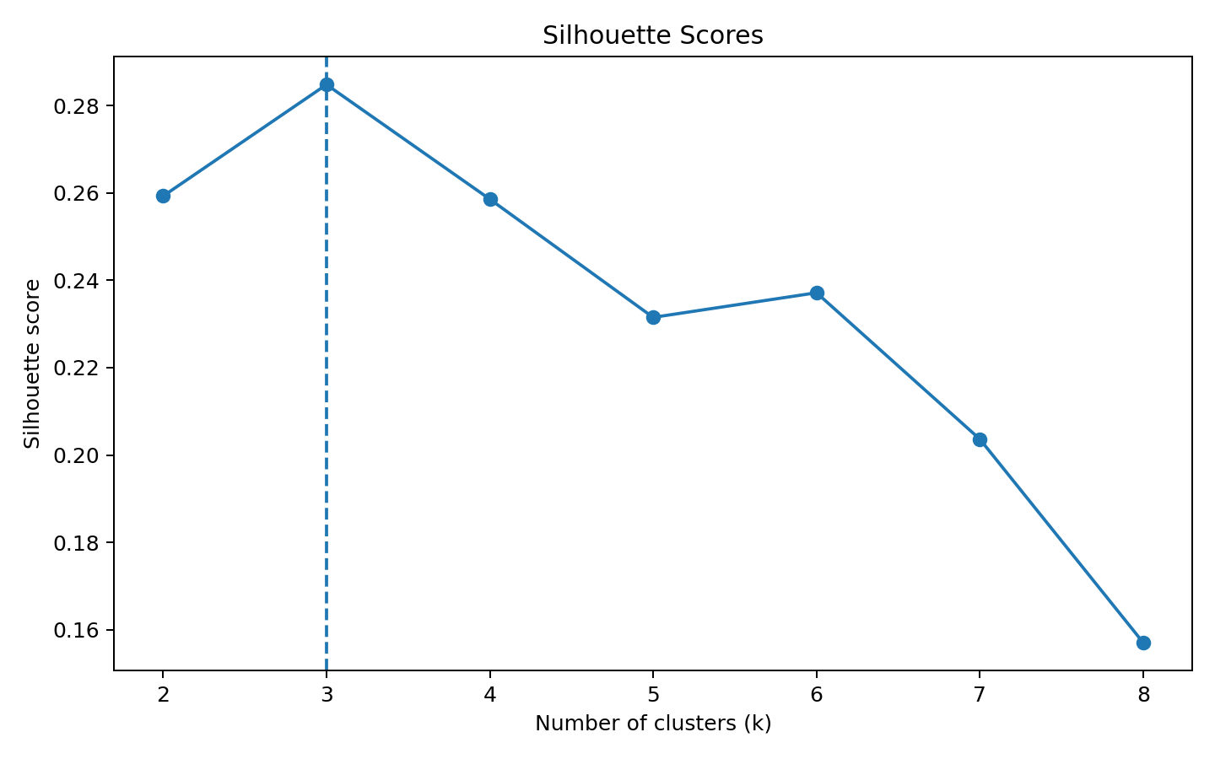
Figure 2. Silhouette scores for candidate cluster counts.
The maximum silhouette score occurs at k=3, so that is the primary model selected. The decision is transparent and reproducible rather than based only on visual preference.

7. K-Means Results
kmeans = KMeans(
n_clusters=3,
random_state=42,
n_init=20
)
labels = kmeans.fit_predict(X_scaled)
print("Silhouette:", silhouette_score(X_scaled, labels))
Metric | Result
Selected k | 3
Silhouette | 0.285
Inertia | 1277.93
Cluster 0 size | 65
Cluster 1 size | 51
Cluster 2 size | 62

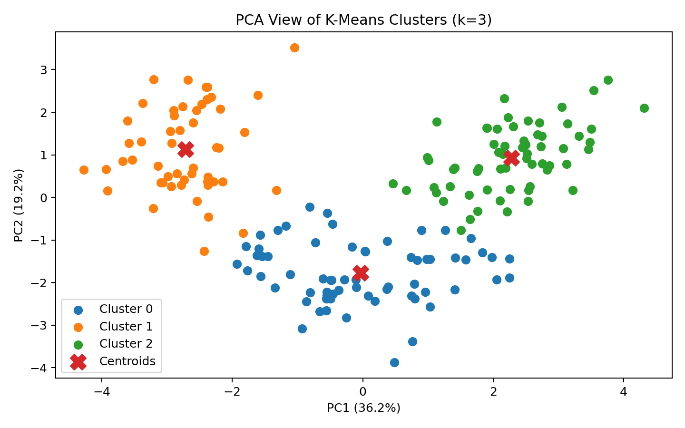
Figure 3. PCA projection of the 13-dimensional standardized data, colored by K-Means cluster.
The PCA chart is a communication device. The K-Means model itself was trained in the full 13-dimensional standardized space, not in the two-dimensional PCA space.

8. Hierarchical Clustering Comparison
from scipy.cluster.hierarchy import linkage, fcluster
Z = linkage(X_scaled, method="ward")
hier_labels = fcluster(
Z, t=best_k, criterion="maxclust"
) - 1
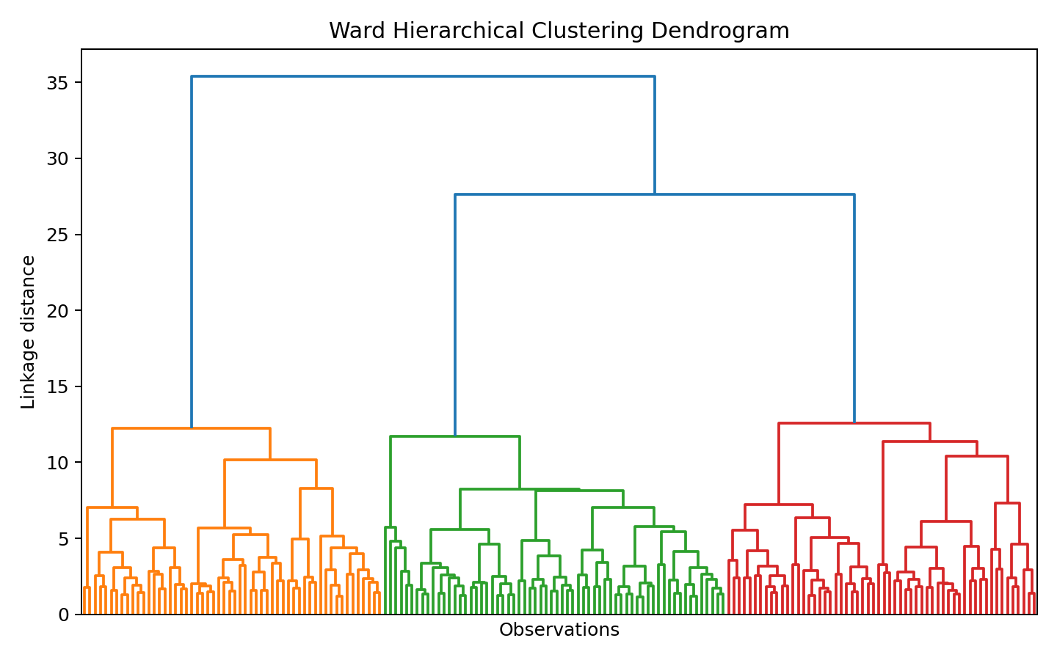
Figure 4. Ward hierarchical clustering dendrogram.
Ward hierarchical clustering at k=3 produced a silhouette score of 0.277. This second method provides a useful robustness check because it builds nested groups rather than assigning points directly to K-Means centroids.

9. Cluster Characteristics
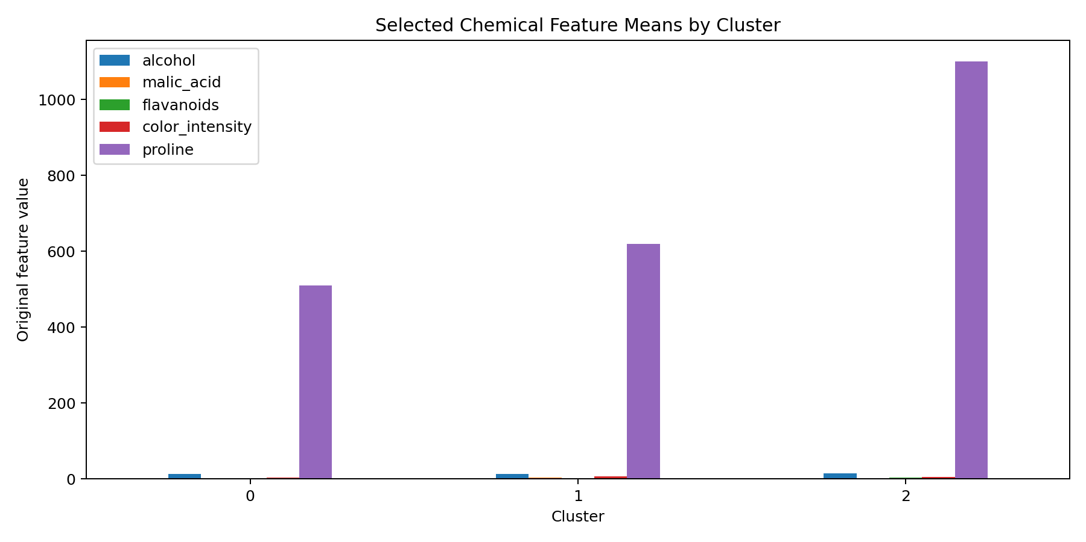
Figure 5. Selected original-scale chemical feature means by cluster.
Cluster numbers are arbitrary identifiers. The meaningful interpretation comes from comparing each cluster's chemistry with the overall average.
Cluster | Size | Most distinctive standardized features
Cluster 0 | 65 | alcohol (-0.92 SD), color_intensity (-0.90 SD), proline (-0.75 SD), ash (-0.49 SD), magnesium (-0.49 SD)
Cluster 1 | 51 | od280/od315_of_diluted_wines (-1.29 SD), flavanoids (-1.21 SD), hue (-1.16 SD), total_phenols (-0.98 SD), color_intensity (+0.94 SD)
Cluster 2 | 62 | proline (+1.12 SD), flavanoids (+0.98 SD), total_phenols (+0.88 SD), alcohol (+0.83 SD), od280/od315_of_diluted_wines (+0.78 SD)

9.1 Cluster 0
Cluster 0 contains 65 wines. Its strongest above-average characteristics are hue, od280/od315_of_diluted_wines, alcalinity_of_ash, while its strongest below-average characteristics are alcohol, color_intensity, proline. This makes the group a chemical-profile segment rather than a pre-defined category.
A useful next step would be to compare this chemical profile with external information such as cultivar, sensory scores, production methods or price. The current clustering alone does not establish causal relationships.

9.2 Cluster 1
Cluster 1 contains 51 wines. Its strongest above-average characteristics are color_intensity, malic_acid, nonflavanoid_phenols, while its strongest below-average characteristics are od280/od315_of_diluted_wines, flavanoids, hue. This makes the group a chemical-profile segment rather than a pre-defined category.
A useful next step would be to compare this chemical profile with external information such as cultivar, sensory scores, production methods or price. The current clustering alone does not establish causal relationships.

9.3 Cluster 2
Cluster 2 contains 62 wines. Its strongest above-average characteristics are proline, flavanoids, total_phenols, while its strongest below-average characteristics are alcalinity_of_ash, nonflavanoid_phenols, malic_acid. This makes the group a chemical-profile segment rather than a pre-defined category.
A useful next step would be to compare this chemical profile with external information such as cultivar, sensory scores, production methods or price. The current clustering alone does not establish causal relationships.

10. Post-Hoc Validation
The known cultivar labels were deliberately withheld during clustering. After the model was fitted, I used Adjusted Rand Index only as a reference comparison.
from sklearn.metrics import adjusted_rand_score
ari = adjusted_rand_score(y, labels)
print("Adjusted Rand Index:", ari)
The post-hoc ARI is 0.897. It should not be described as classification accuracy. It simply measures agreement between two partitions after accounting for chance.

11. Business and Research Implications
- Wine researchers can use the discovered chemical segments as an exploratory basis for studying cultivar or production differences.
- Quality teams could investigate wines near cluster boundaries or far from centroids as potentially unusual profiles.
- Product-development teams could use chemical segmentation as an early exploratory step before incorporating sensory or market variables.
- Future studies could connect clusters with price, sensory ratings, vintage, production method or geography when those variables are available.
- Because clustering is descriptive, any business recommendation should be validated with external outcomes before being used operationally.

12. Challenges and How They Were Overcome
Challenge | Resolution
Different feature scales | Standardized all chemical variables before distance-based clustering.
Choosing k | Tested k=2–8 using inertia and silhouette score.
13 dimensions are difficult to visualize | Used PCA for a 2-D explanatory plot.
Cluster IDs have no inherent meaning | Interpreted groups through feature profiles.
Risk of accidentally doing classification | Cultivar labels were excluded from training.
Reliance on one clustering method | Added Ward hierarchical clustering.
Reproducibility | Fixed random_state and n_init and saved outputs.

13. Potential Impact and Limitations
Choice | Potential impact
Standardization | Balances feature contribution but changes the geometry to relative variance units.
K-Means | Works best for compact centroid-based groups and can miss non-spherical structure.
Silhouette-based k selection | Provides an objective criterion but does not prove that only one k is scientifically meaningful.
PCA visualization | Can hide structure that exists outside the first two components.
Post-hoc ARI | Useful for reference, but it is not supervised accuracy.
Small dataset | The 178 observations are useful for demonstration but should not be treated as representative of every wine population.

14. Reproducibility
The repository contains the complete Python workflow, notebook, figures, cluster assignments, metrics and report. To reproduce the analysis:
python -m venv .venv
# Windows
.venv\Scripts\activate
pip install -r requirements.txt
python src/clustering_analysis.py

15. Conclusion
The analysis produced a defensible 3-cluster segmentation from 13 chemical measurements without using the known cultivar labels during training. Standardization, systematic k selection, PCA visualization, hierarchical comparison and cluster profiling together make the result more informative than a simple K-Means run.
The main lesson is that unsupervised learning is not finished when clusters are generated. The analyst must also justify the cluster count, understand the variables driving each group, test robustness, communicate uncertainty, and explain how the segments could be used in a real research or business context.

16. References
Aeberhard, S. & Forina, M. (1992). Wine [Dataset]. UCI Machine Learning Repository. https://doi.org/10.24432/C5PC7J.
UCI Machine Learning Repository. Wine dataset documentation, Dataset ID 109. https://archive.ics.uci.edu/dataset/109/winedataset.
Pedregosa, F., et al. (2011). Scikit-learn: Machine Learning in Python. Journal of Machine Learning Research, 12, 2825–2830.

