Bazaarsg.com - corrections :

• Change “Tenant” to “Vendor” at both homepage and listing pages. Done
• Update Logo (will send updated logo)
• Check if we can show only districts and HDB estate that is linked to the zones after selecting zones. After selecting districts, can we only show those HDB estates linked to the districts?
• Turn off extra prices in listing page - Done
• Translate to mandarin after finalising website
• Website tagline change to “Space Renting, Simplified For You” at listing page and about us page Done
• Turn off REVIEWS Done
• Check how to charge platform fee to vendor instead of to customers Done
• Cancellation terms – “Free cancellation with 2 hours after booking”
• Check “You might also like” on listing page – how does it work? What will it show? Done
Based on the space location
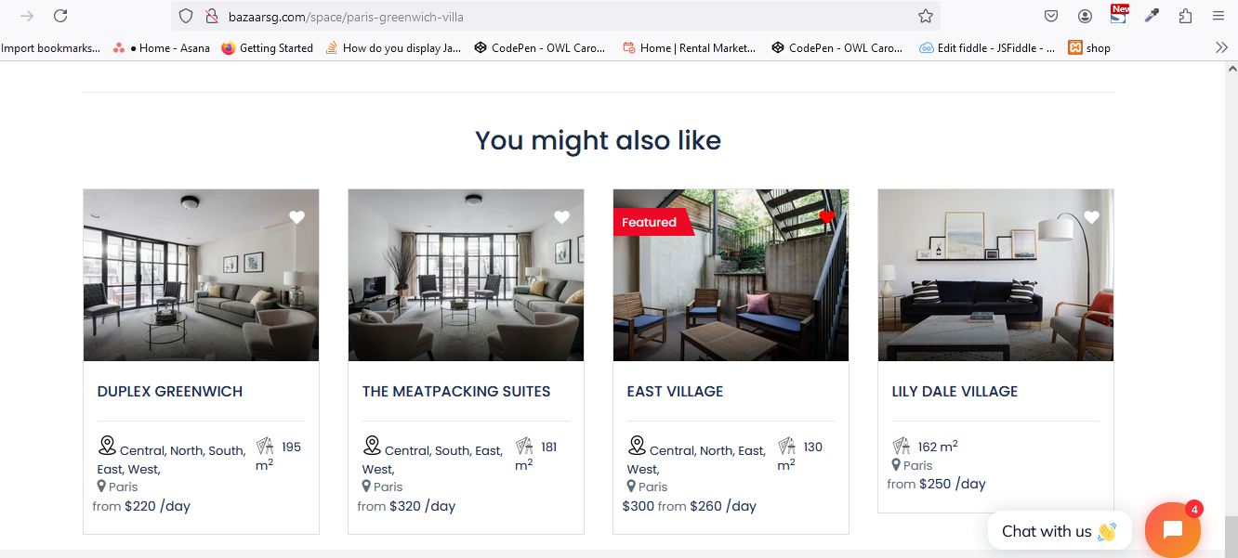
• Check how can the vendor also be a customer? To lease and to rent. Do they need 2 accounts or can they toggle between as a vendor or as a customer.
No, one Vendor Booking to another Vendor Space
• Under “support & resources”, keep the following: Done
o Call Us
o Email Us
o Remove ABOUT COMPANY
o Remove HOSTING
o Keep LEGAL & SUPPORT
• What do you propose for the menu bar for the apps?
Email create and Congfiguration and test it

