Assignment: Simple Notification System Using 3-Tier Architecture

Source code GitHub Url: https://github.com/Padmavathi-SJ/Presidio-training/tree/main/08-05-2026/NotificationSystem

OUTPUT:
Menu to choose operation:
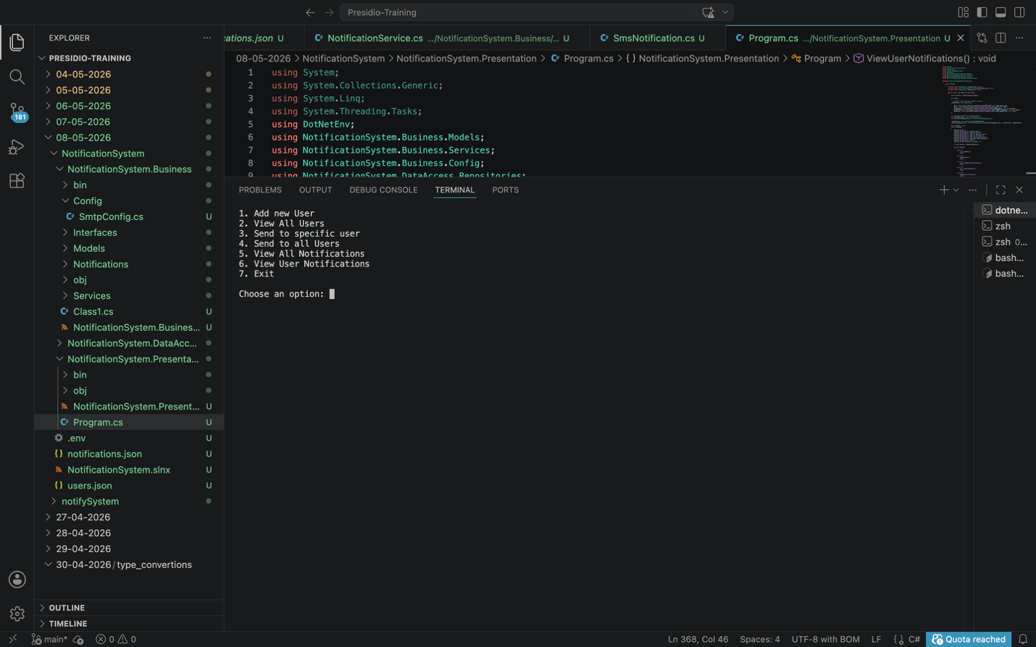

Display all active users:
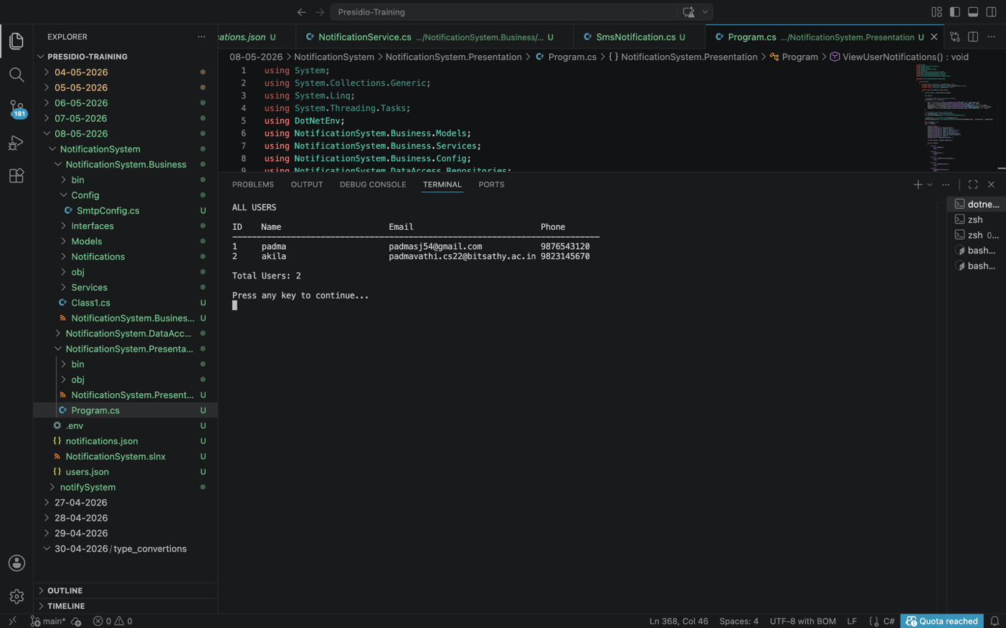
Add new user:
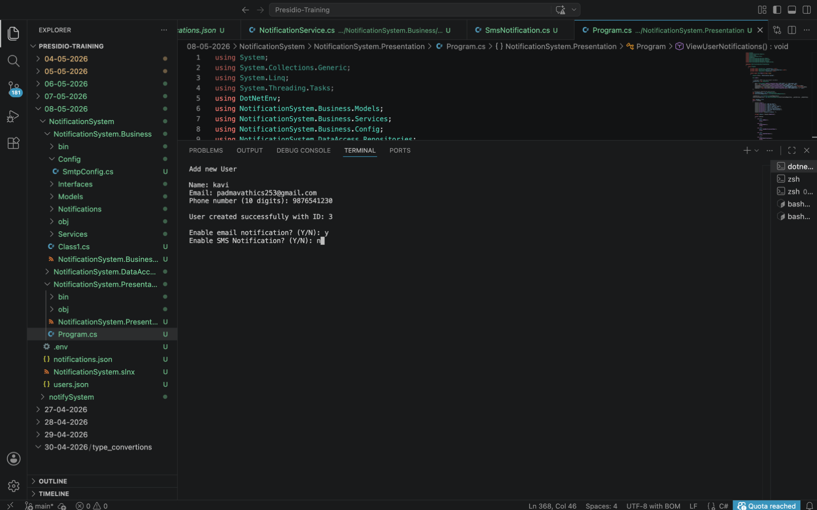
Display all available users
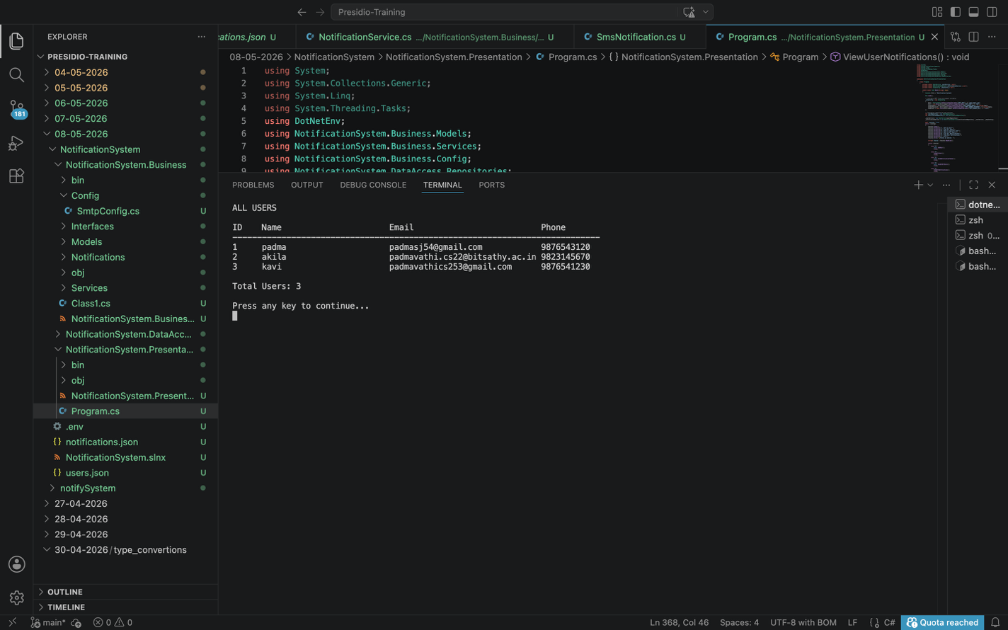
Send email notification to a specific user:
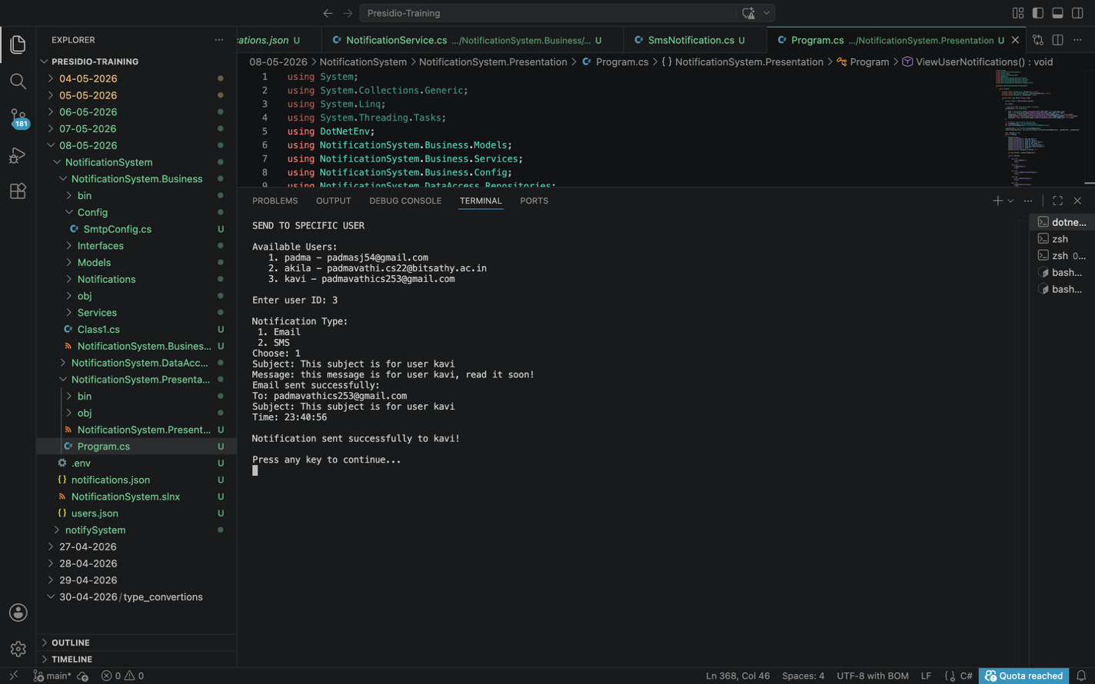
Send email notification to all available users:
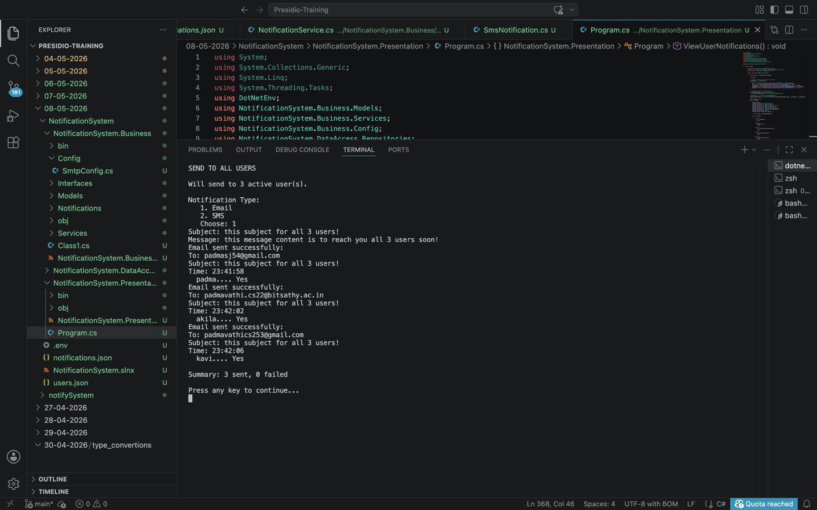
Get and view all sent notifications:
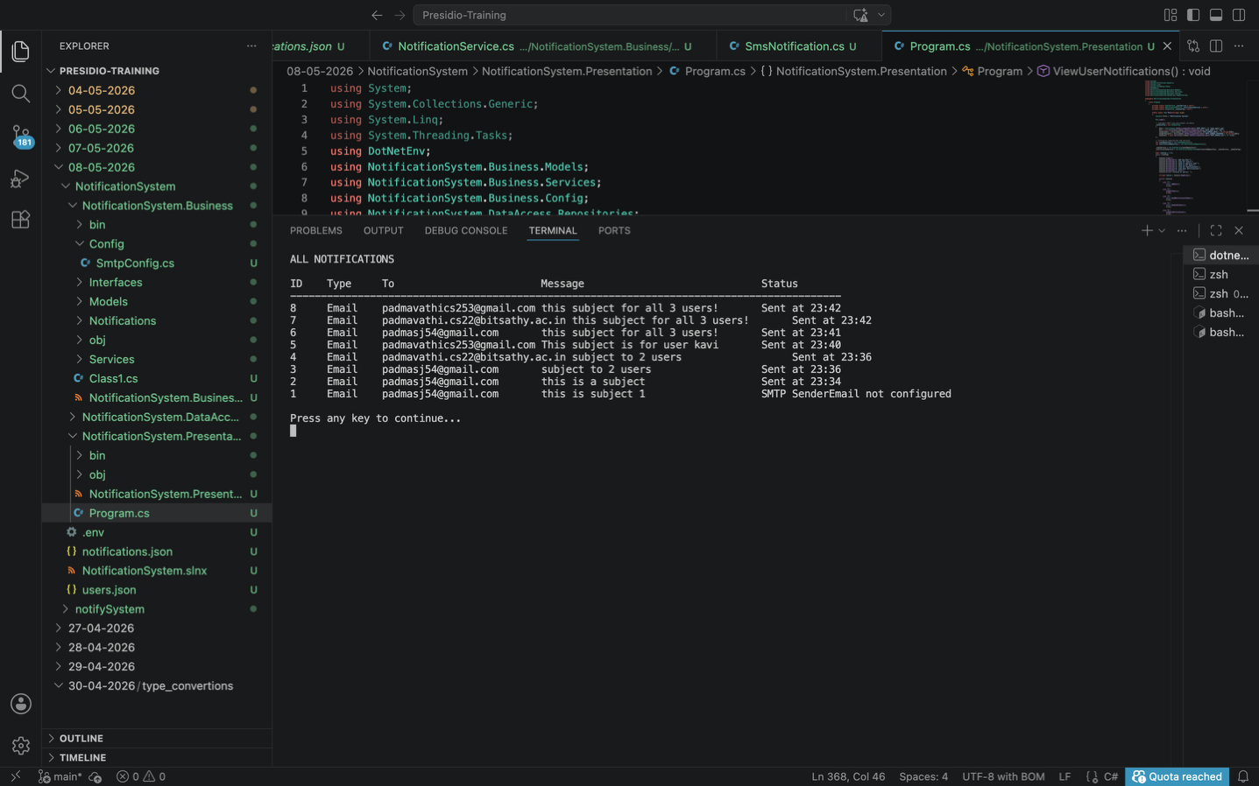
Get and view all sent notifications of a user:
