Date: 11-05-2026
GCR Assignment – Changing the Data Tier in Notification System to work with Database (postgres)
Source Code GitHub Url: https://github.com/Padmavathi-SJ/Presidio-training/tree/main/11-05-2026/NotificationSystem

Outputs:
Menu to choose operation:
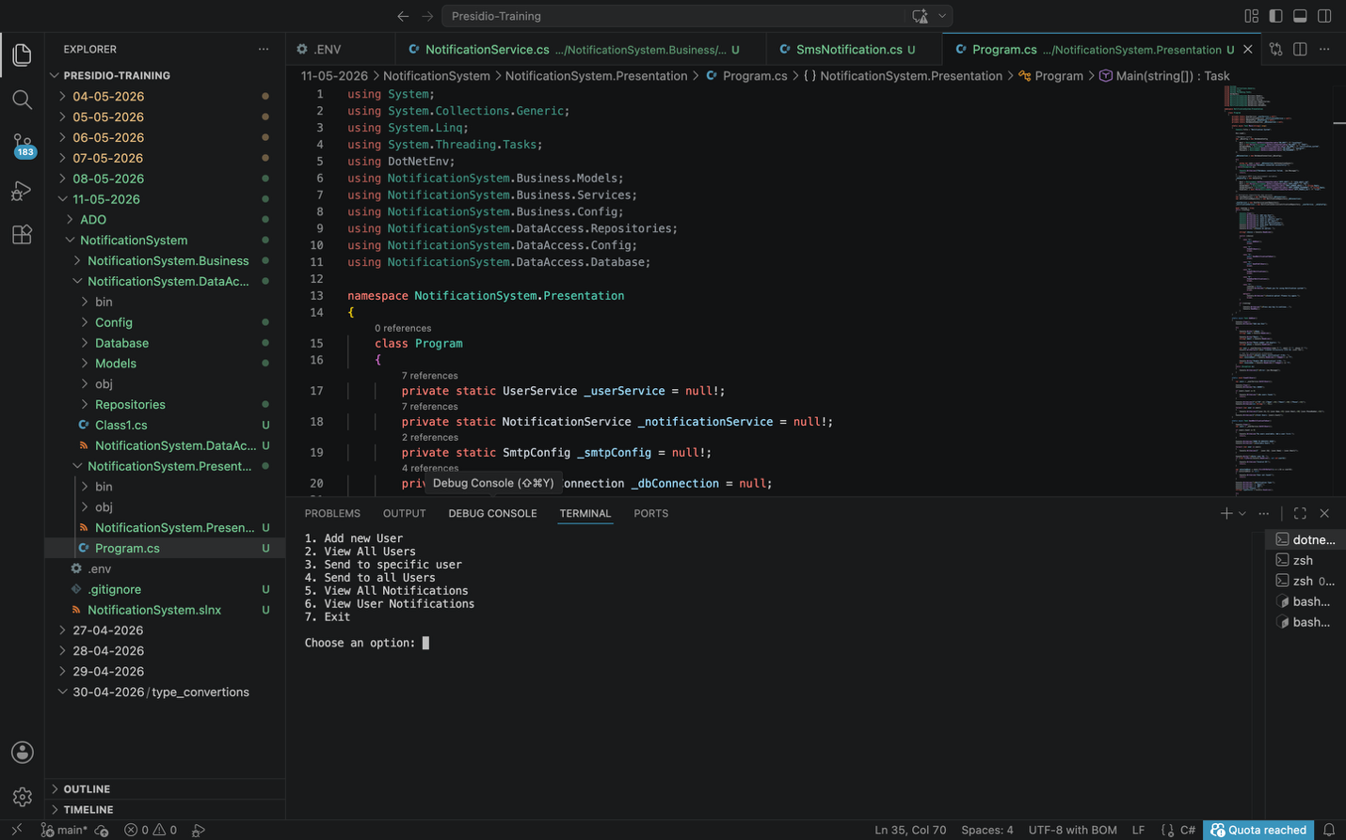

Add new user:
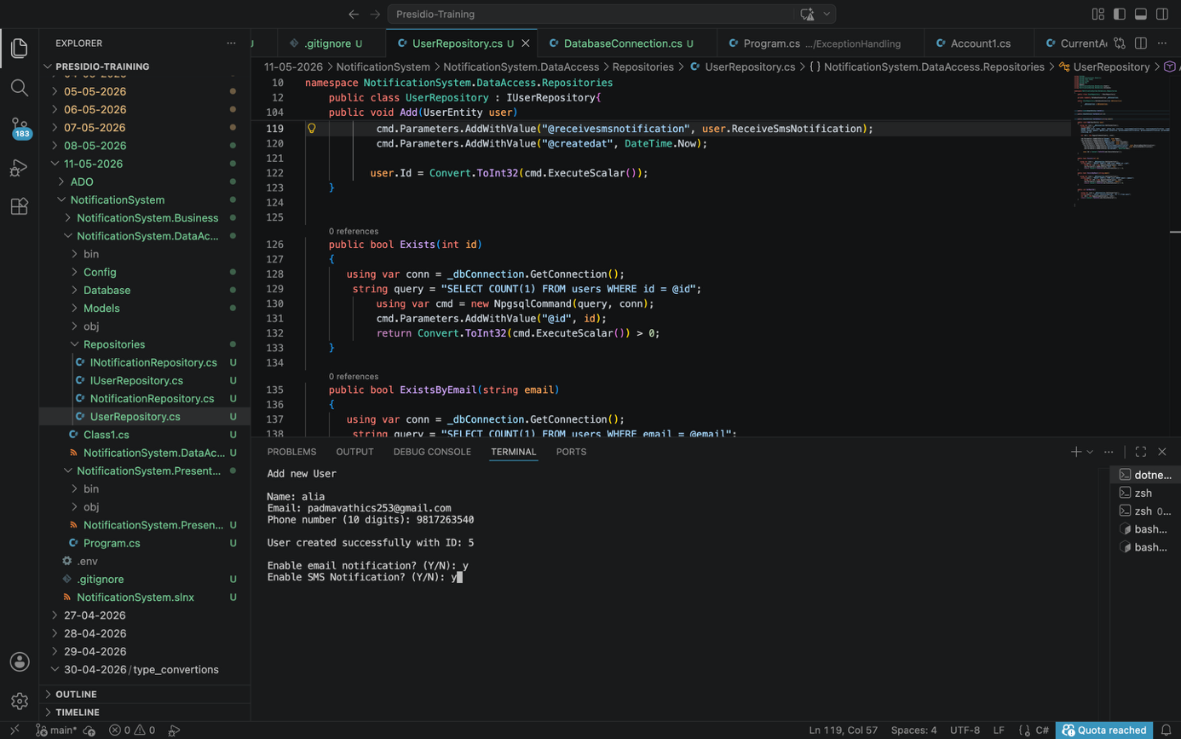

Display all active users:
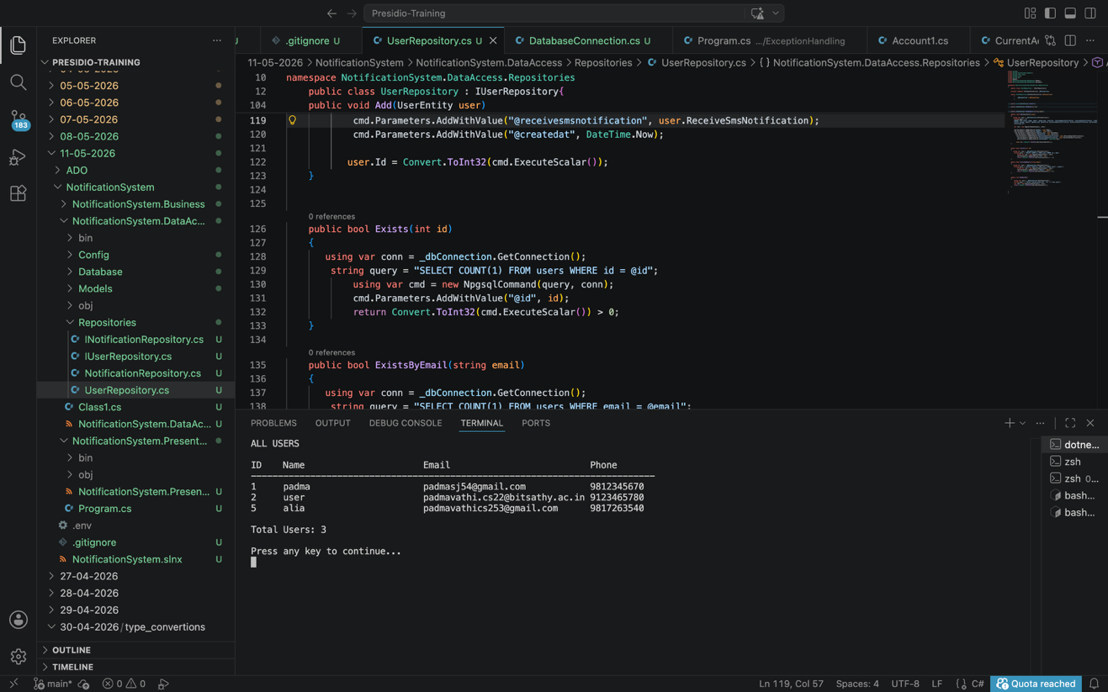
Users table with newly added user(id = 5) in notification_system database:
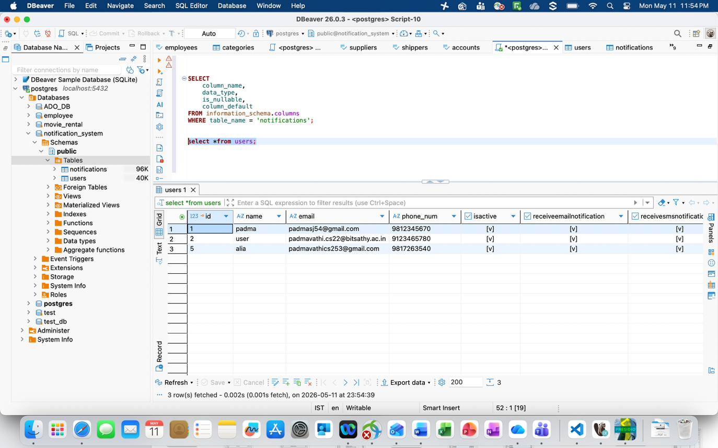
Send email notification to a specific user and save in notifications table:
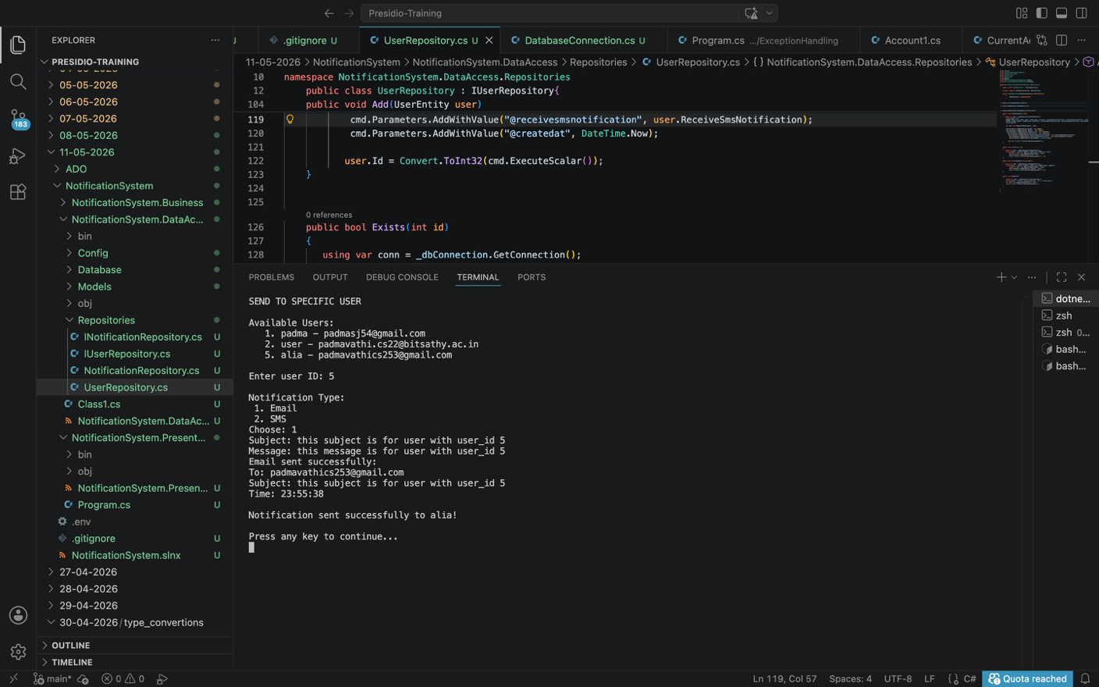
Sent notifiations data in notifications table:
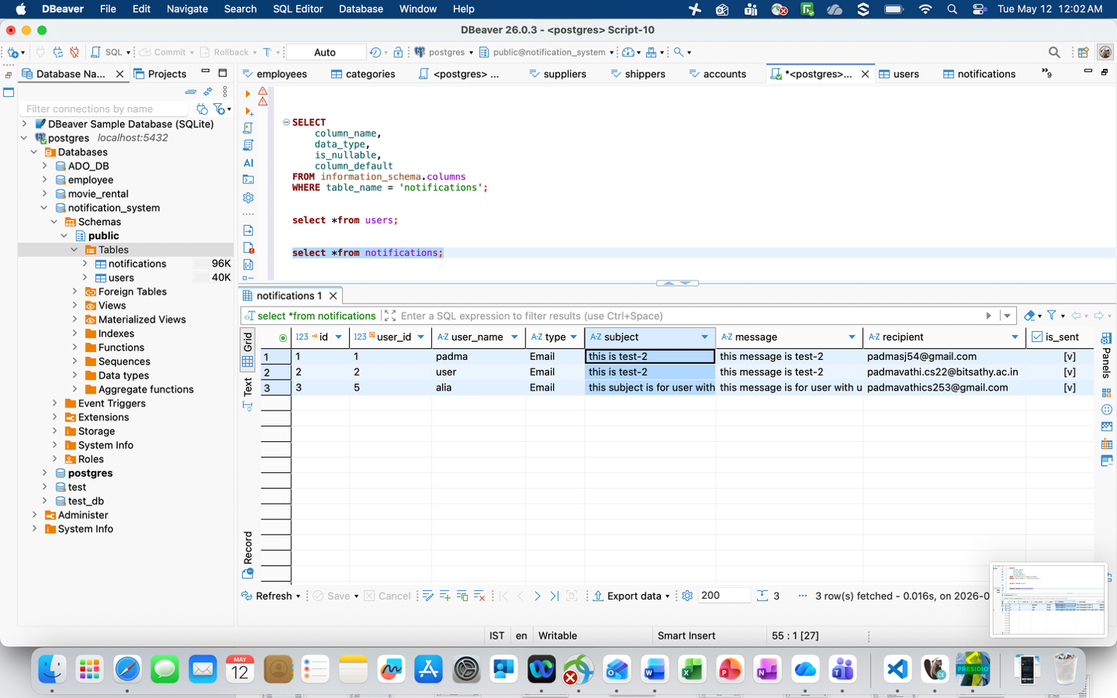
Email notification sent to user(id=5)
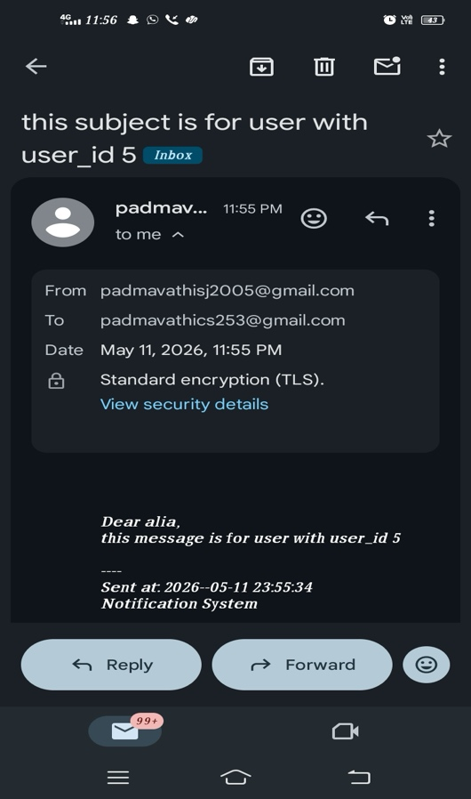
Get and view all sent notifications:
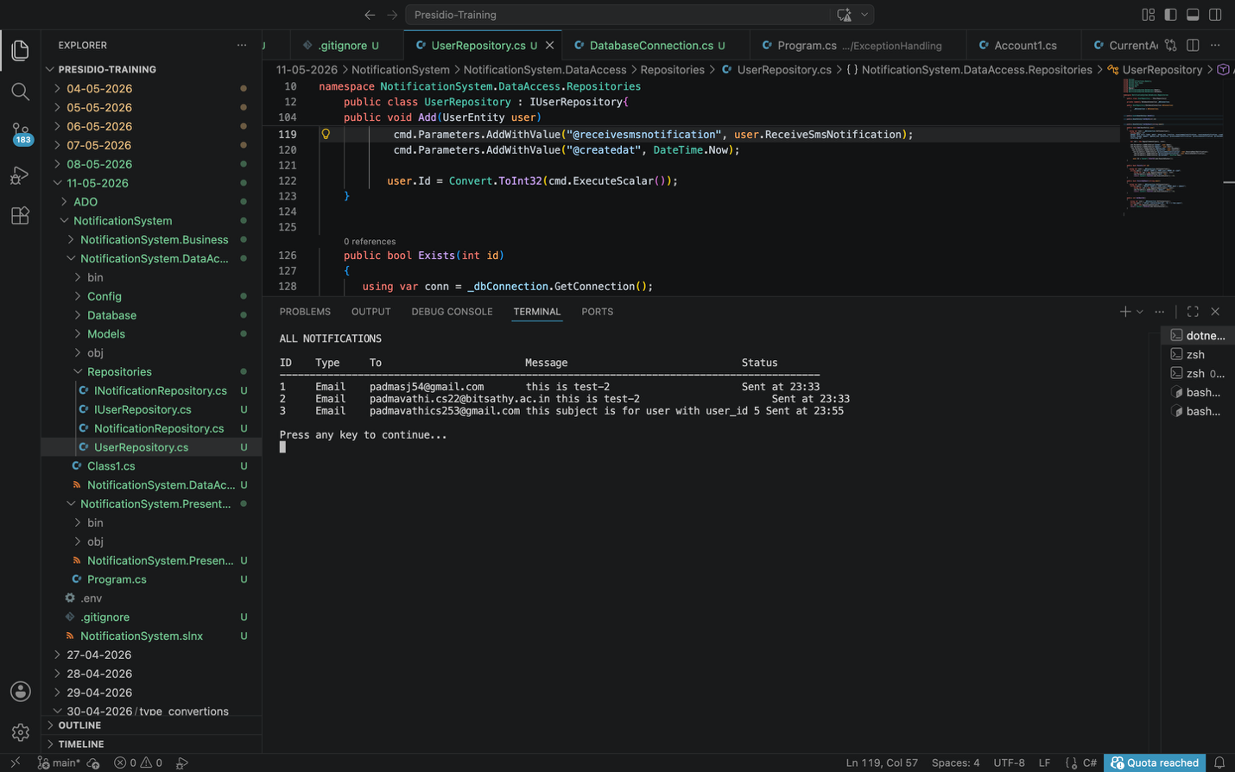
Get and view all sent notifications of a user:
