**Vicco turmeric**

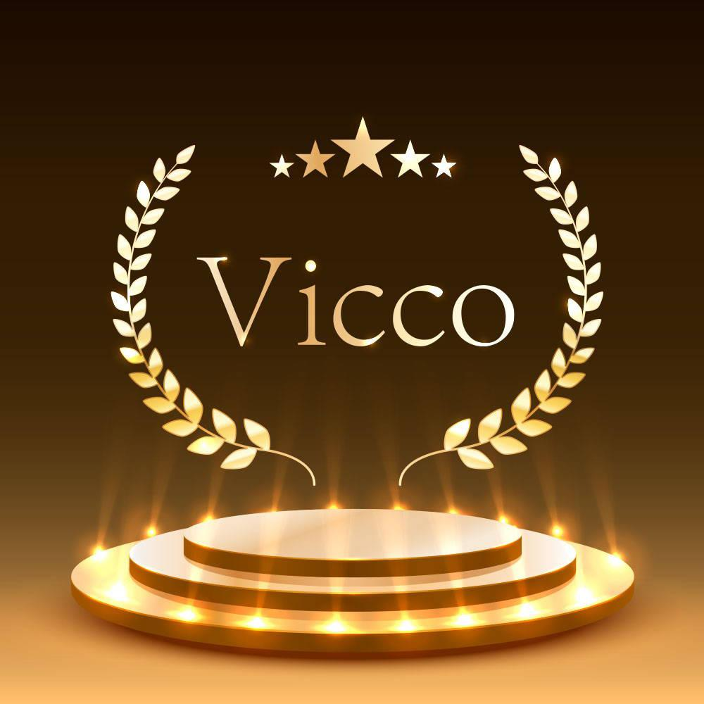

***Digital Marketing Campaigns :***

1) ***Social Media Campaigns:***

* **Content Creation:** Vicco would create engaging and visually appealing content showcasing the benefits of turmeric for skincare and highlighting the features of their Turmeric Face Cream.
* **Hashtag Campaign:** Vicco might createa branded hashtag campaign, encouraging users share their experiences using the Turmeric Face Cream.
* **Engagement and Community Building:** Vicco would actively engage with their audience by responding to comments, messages, and user-generated content. They could also create polls, quizzes, and contests to foster interaction and build a sense of community among their followers.
* **Educational Content:** Vicco might share educational content about turmeric’s benefits for skincare, its history in traditional medicine, and tips for incorporating turmeric-based products into a skincare routine. This helps position the brand as a trusted authority in natural skincare.
* **Paid Advertising:** Vicco might run targeted social media ads to reach a wider audience of potential customers interested in skincare and natural products. These ads could highlight the key features and benefits of the Turmeric Face Cream and direct users to the brand’s website or online store.

***2)#Natural Beauty Revolution:***

The #NaturalBeautyRevolution campaign is a movement initiated by Vicco to celebrate and promote natural beauty while advocating for skincare products with natural ingredients. Here’s an overview of what the campaign might entail:

* **Embracing Natural Beauty:**  The campaign encourages individuals to embrace their natural beauty and feel confident in their skin. It aims to shift the beauty narrative towards authenticity and self-acceptance, emphasizing that true beauty comes from within.
* 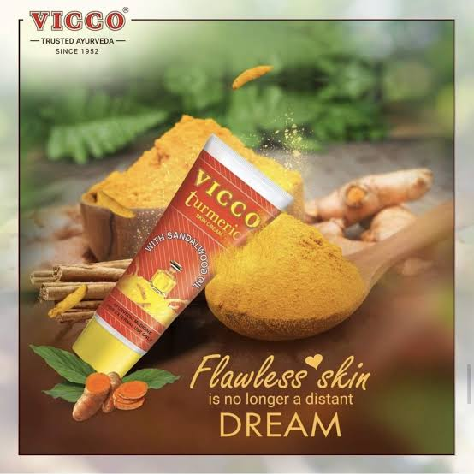**Highlighting Natural Ingredients:**  #NaturalBeautyRevolution shines a spotlight on skincare products formulated with natural ingredients like turmeric, aloe vera, neem, and other botanical extracts. It educates consumers about the benefits of using natural products and the importance of avoiding harsh chemicals and synthetic additives.

***3)Geotargeted Campaigns:***

* ***Localized Messaging:***

By understanding the cultural nuances, preferences, and interests of different regions, marketers can tailor their messaging to resonate with local audiences. This may include language variations, references to regional events or landmarks, and customization of offers or promotions based on local trends.

* ***Precise Targeting:***

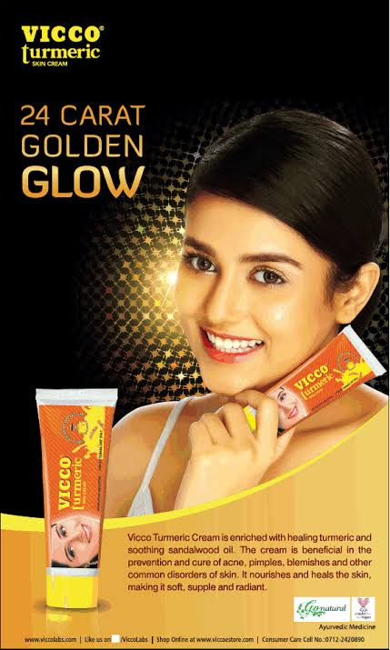Geotargeting allows marketers to pinpoint their audience based on factors such as country, state, city, zip code, or even specific neighborhoods. This precision enables brands to reach consumers in areas where their products or services are most relevant or where there is high demand.