UNIT -4
HARMONY IN THE NATURE AND EXISTENCE
Syllabus: Harmony in the nature – Orders in the nature, existence as co-existence, co-existence of units in space, holistic perception of harmony at all levels of existence.
Learning Outcomes: The students will be able to

- understand harmony in nature and its interconnectedness and mutual fulfillment among the four orders of nature.
- realize existence as co-existence of mutually interactive units in all pervasive space.
- enables to have holistic perception of harmony at all levels of existence.

Learning material
Harmony in Nature
The aggregate of all the mutually interacting units – big or small, sentient or insentient together can be called Nature. It encompasses all the physical objects be it solid, liquid or gas (either or non-living)
There is an inseparable bond between human being and nature but our thoughtless actions disturbing the equilibrium in nature which is the prime cause of the environmental Crisis.
In the name of development, we are exploiting nature which are causing adverse effects Air and water are becoming polluted, rivers are drying up, ozone depleting is taking place, the various diseases are spreading and the list goes on.
This is an alarming situation and if we continue to exploit nature, then our future generation will have to face vital environmental issues. So, there is an urgent need to take necessary to make our world a better place to live in nature.
2. FOUR ORDERS OF NATURE
Everything that we see can be put into any one of the following orders
- Material Order- Soil, Water, Air etc.,
- Plant Oder – Grass, Plants, Trees, Flowers, Fruits, etc.,
- Animal Order – Animals and Birds
- Human Order – Human beings
Let us discuss these orders of nature in detail:
- Material Order:
The big land mass of the continents, large water bodies like Ocean and Seas, Mountains and Rivers, the atmosphere above, the metals and minerals below, the fossil fuels deep below the surface of the earth – all are the part of the material order or padarth avastha. Material Order is not limited to earth only, it is even seen in the space in the space in the form of Stars, Planets, Moons etc.,
- Plant/Bio Order: grass and small shrubs, plants and trees, flora in the Ocean – all are the part of Plant/bio order is far greater in quantity than the animal order.

- Animal Order: Animals and birds from the third largest order and it si call the animal order or jiv avastha. The plant/bio order is far greater in quantity than the animal order.

- Human Order: Humans are the smallest order of nature and they are referred to as human order or gyan avastha. Animals are far greater in quantity as compared to the human order.

The four orders comprise of all the units that we see around us. All these orders are the part of nature and existence. These orders are mutually complementary and supplementary. They are not independent but are mutually interdependent. Each one nurtures and nourishes the others.
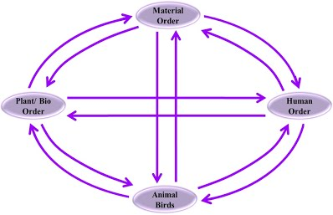
INTERCONNECTENNESS AND MUTURAL FULFILLMENT AMONG THE FOUR ORDERS OF NATURE
Mutual fulfillment implies that every unit of the four orders is related to each other and enriching to each other. Human being is related to all other human beings ( on the basis of feelings and emotions) and is also connected to all the other entities in the nature.
We need to understand the four orders in terms of their characteristics, participation with other units in similar order, activities, pattern of inheritance, etc. These orders of nature are interconnected and they are related to each other in such a way that they all fulfill each other and co-exist with each other.
- Material Order and Plant/Bio-Order:
Material order provides the nutrients to the plant/bio order in the form of soil, minerals, etc. on the other hand, plant/bio order on decomposition gives nutrients back to the soil which helps in its enrichment. Plant/bio order also decays to form substances such as oil and coal that are stored deep within the earth.
Plant order helps in preventing soil erosion as the roots of the plants hold the soil together (which is the part of the material order).
Thus, we can see that there is a mutual interdependency and co-existence between material order and plant/bio-order.

- Material Order, Plant/Bio-Order and Animal Order:
Material orders provide the basis for the movement of all animals, birds and fishes. Water, Oxygen and other gases are necessary for both plants and animals. On the other hand, animal order help in enriching the soil with its excreta (waste) and these excreta provides the plants with essential nutrients. Plant/bio order provides food to animals, birds and fishes. Animal order helps in pollination of the flowers of the plant order.
Thus, it is clear that material order, plant/bio-order and animal order is mutually interdependent and co-exists.

- Material Order, Plant/Bio-Order, Animal Order and Human Order:
Human order has natural acceptance to be mutually fulfilling to these three orders (material order, Plant/bio-order and animal order). However, we are not able to ensure this mutual fulfillment.

We are dependent on the material order for air, water, soil, minerals and metals but only end up polluting the soil and exhausting the fossil fuels.

We are dependent on plant order for our food and holding together the ecosystem but we are destroying forests and numerous species of plants and herbs.

We are dependent on material order for our food, transportation and manufacturing various leather products, etc, but unfortunately because of our actions many animal species are becoming extinct.

DIAGRAM

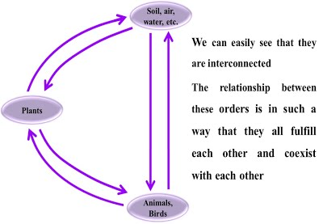

We thus see that the three orders besides the human order are in harmony and are fulfilling to the human order. This is because we have not understood our own needs properly, nor have we understood the harmonious ways to fulfill our needs. This has resulted into disharmony between human order and other three orders.

RECYCLABILITY AND SELF-REGULATION IN NATURE
Recyclability and Self-regulation are the two characteristics of nature the helps us understanding the harmony in nature.
Let us discuss them detail:
There are various cyclic processes that undergo in nature. For example, in the water cycle, the water that gets evaporated from the surface of water fall back to the earth in the form of rain/snow. Thus, the cycles keep the materials self-regulated on the earth.
Plants and animals also keep themselves self-regulated in the environment. For, instance in a forest, the growth of trees takes place in a way so that the amount of soil, plants and animals remains conserved. The number of trees is in proportion to the availability of soil.
The appropriateness of the condition for growth of both plants and animals are self-regulated in nature keeping the population proportions naturally maintained. This phenomenon is termed as self-regulated.
There is an appropriate proportion between the number of males and females in different species, to ensure their continuity. This applies to human beings also but the inhuman practices have led to disproportionate number of men and women.
Due to lack of right understanding, the human order fails to be in harmony with itself and with other three orders. It fails to take care of its own body and other units in nature. To enhance the fulfillment of the human order with the other three orders, we need to work in the direction of development of mankind with the right understanding.
We human beings are largely living like animals. If we do not exercise our capacity to ‘know’ we end up being more like animals. Human order is said to be in knowledge order-gyan avastha, as we have the curiosity to know and live with happiness.
Today, the problem with us is that we don’t know ‘what to do’ and are busy working out ‘how to do’ which has resulted into various environmental hazards.
With knowledge i.e., right understanding (which is the basic need of the human order) harmony in four orders of nature can be attained.

3. UNDERSTANDING EXISTENCE AS CO-EXISTENCE
In the previous chapter, we discussed about ‘units’ be it a material entity, plant, animal, or human being. All the units together constitute nature and these units of nature exist in space. So, existence is nothing but the nature in space. In this chapter, we will study the harmony in existence in the form of co-existence of mutually interacting units in space.

- An introduction to Space (Shunya)
Unit is something that is limited in size be it a tiny blade of grass or the biggest planet. All the units we have studied so far: human beings, animals, plants, atoms and molecules are countable. There is another reality called ‘Space’. We generally don’t pay attention to this reality because it is not a unit. We cannot touch it or smell it, but that doesn’t mean it does not exist. Space exists everywhere, it is all around us.

- Existence
If we want to understand all the levels of our living, we need the know correct meaning of ‘existence’. Existence is the sum total of all the units that exist in nature and space as well.
So,
Existence = Space + Units (in space)
Nature is comprised of four orders and each unit of every order viz. Material, Plant/Bio, Animal and Human Order ‘exist’ in space or they ‘are in space’. We can also say that they are ‘submerged in space’.

Nature = Four Orders (Material, Plant/Bio, Animal and Human Order)
Existence = Nature submerged in Space.
- Co-existence of Units in Space
.
Co-existence is a state in which two or more groups are living together while respecting their differences and resolving their conflicts non-violently. Co-existence has been defined in numerous ways:
1. To exist together (in time or space) and to exist in mutual tolerance.
2. To learn to recognize and live with difference.
3. To have a relationship between persons or groups in which none of the parties is trying to destroy the other
The diagram given below will help you understand co-existence in a better way

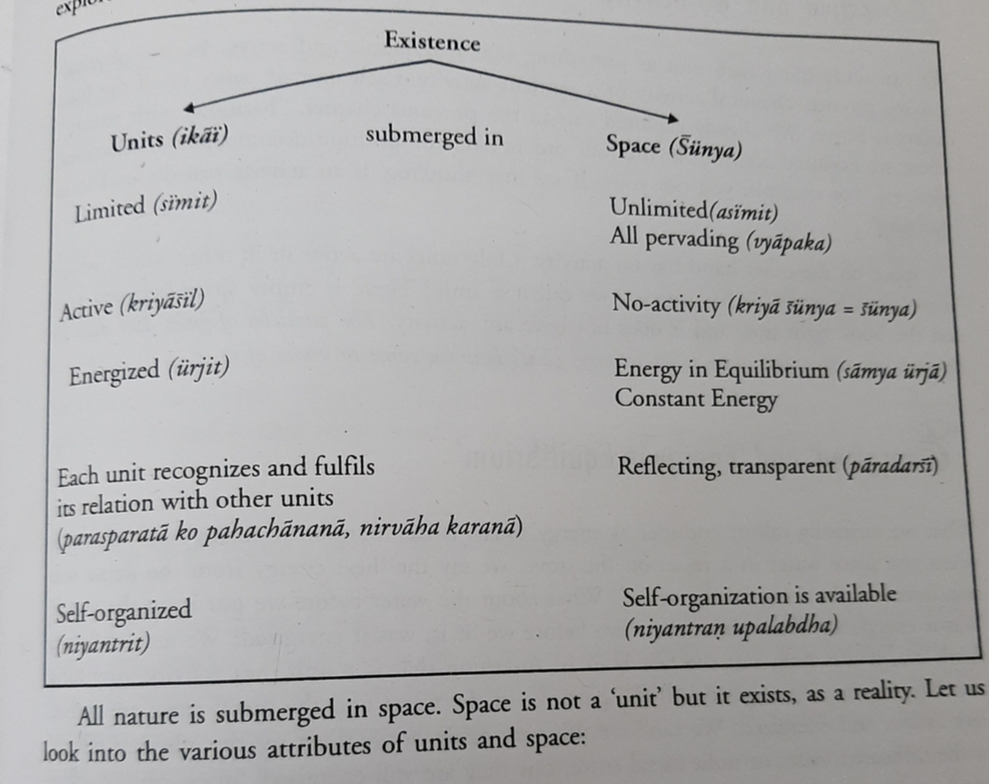

Although space is not a unit, it exists as a reality. All the units in nature are submerged in space.
Let us now discuss the various attributes of units and space.
‘Limited’ and ‘Unlimited’
Nature has four orders and there are units in each other. Each unit is finite and limited in size. The size ranges from being really small (atom) to really big (galaxies).
Space, on the other hand, is limited. Space has no size unlike units. It is not bounded. So, there is no beginning or end of space. There is space behind us, inside us, front of us, and around all of us.
Thus, we can say that:
- Space pervades, i.e. it is ‘all-Pervading’
- Units, on the other hand do not pervade i.e. they are ‘not all prevading’
Space on the other hand has no activity. There is an empty space between two entities and it does not have any activity. For example, the particles of gases and dust(units) present in the air are active, but there is no activity in space.

Thus we can say that:
- When something is ‘active’ or has activity. It can be called as a unit.
- There is ‘no activity’ in space.
‘Energized and ‘Energy in Equilibrium’
Energy can neither be created nor destroyed; it can only be transferred or changed from on from to another. There is a continuous ‘transfer of energy’ taking place around us. For instance, when we heat water, the heat energy from the flame gets transferred to the water.
What about the water before it was heated? Was it energized? Yes! Anything that is a unit has activity and anything that has activity is energized. So, all the practices (unit) in the water are active and energized whether heated or not.
Space, on the other hand, is not a unit and it has no activity. Therefore, we don’t say that the space is energized but we say ‘space is energy in equilibrium’ or it is ‘constant energy’.
Thus we can say that:
- All the units in space are energized.
- Space is ‘energy in equilibrium’.

‘Each Unit Recognizes………. Space is Reflecting and Transparent
All the entities (units) in the four orders of nature recognized some kind of relationship with others. The air recognizes its relationship with the soil, soil with the water, water and soil with trees, etc. For example, when we pour water into the soil, the soil soaks it up, thus water recognizes its relationship with soil and fulfill it.
Space, on the other hand, is not a unit and is reflecting. Every unit is reflected in the other units in space. It is due to this reflection that all the units are related to each other. Space is transparent which means that in space there is no obstruction. Hence, all the units are able to recognize each other and are related to each other.
Thus, we can say that:
- Each unit ‘recognizes and fulfills’ its relationship with other units.
- Space is ‘reflecting and transparent’.
‘Self-organized’ and ‘self-organization is Available’
Starting from the small atoms to the big galaxies, every unit is an organization. A unit recognizes other units and combines to form a bigger organization. For example, cells recognized each other and form organizations such as organs and body.
Human beings are self-organized at the level of the body. We are not organizing the body. We are not doing anything for the coordination between the heart, kidneys, lungs, eyes, brain, hands, legs, etc. All the organs work together in an organized manner. We only provide the required nutrition and assist the body when we fall sick/get injured.
However, we are not self-organized at the level of ‘I’. But in space, self-organization is available to the self (I) which is the reason that we are in pursuit of happiness, which is essentially being in harmony. Whenever we are not in harmony, we are unhappy.

Thus, we can say that:
- All the units of four orders are ‘self-organized’.
- ‘Self-organization is available’ to units in space.

- Existence is Co-existence: Holistic Perception of Harmony at all levels of Existence
Now that we have studied ourselves, our family, society, nature and space, let us understand the inter connectedness between all these units and space. In space, the units are mutually fulfilling in other units. This is being in co-existence.
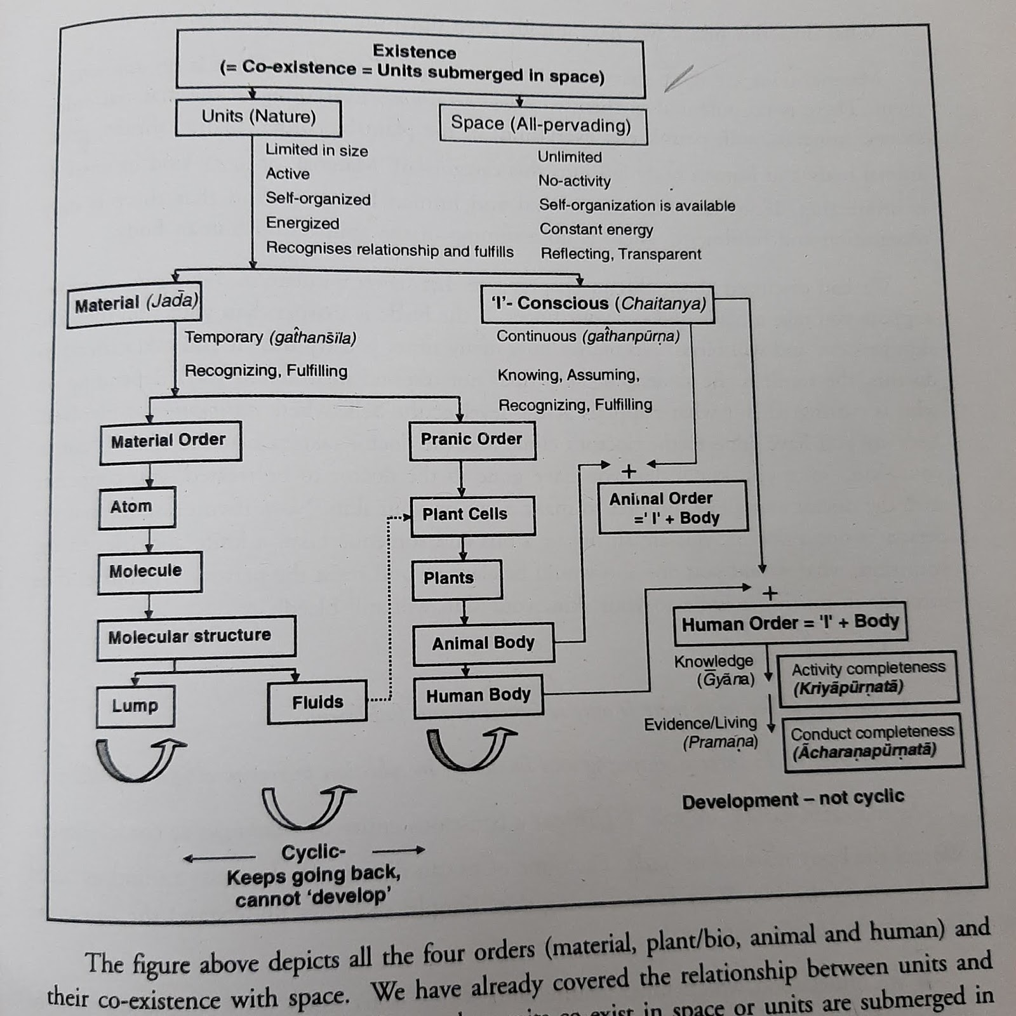
Let us discuss these units in detail:
- Material Units: From Atoms to the Human Body

Material units are temporary and perform the activities of only recognizing and fulfillment. There is no assuming and knowing in them. These units undergo structural changes. We also call them ‘Gathansheel’.
In material order, an atom combines with another atom to form molecular structure. The molecular structure can exist either as lumps or fluids. Fluids are the basis of a plant cell (plant/bio order) and such cells combine to form plants, animal body and human body. Starting from the atom all the way to the highly complex human body, everything takes place in a self-organized and natural manner. Human beings are neither creating it nor controlling it. When we understand the self-organization, we are able to understand our relationship with these units and its fulfillment.
- Conscious (Sentient) Unit: Animal Order and Human Order

Conscious units are continuous and perform the activities of knowing, assuming, recognizing and fulfillment. There is no structural change in them. Only qualitative changes take place in them. We also call them ‘Gathanapurana’. At present, assuming, recognizing and fulfillment are predominant in humans. We have the capacity to know and we have explored it throughout natural acceptance.‘Knowing’means having the ‘right understanding’ i.e. understanding the harmony at all four levels of our living.

Animals and human beings are the co-existence of the (conscious/sentient) (I) unit and the material body.

Basic activity in the four orders in nature:

Order | Things | Basic Activity
Material order | Soil, water, metals, etc. | . Recognizing, fulfillment
Pranic order | Plants and trees | Recognizing, fulfillment
Animal order | Animals and birds | (Recognizing, fulfillment) in body + (assuming, recognizing, fulfillment) in ‘I’
Human order | Human beings | Recognizing, fulfillment in body + (knowing, assuming, recognizing, fulfillment) in ‘I’

Understanding the self (I), the activities in ‘I’, and their interrelation, understanding the reality of ‘I’ as being distinct from the body is called ‘Knowledge of Self (I)’.

The knowledge of Self (I) or Jivan is called Jivan Gyan.
Understanding the harmony at all the levels above means we have understood existence.
This is called knowledge of existence or we also call it Astitva Darshan Gyan
Having understood ‘I’ (Jivan) and the entire existence, we understand our relationship with every unit in existence and fulfill it, leading to mutual happiness and properity.
This is called knowledge of human (e) conduct, also called Mnaviyata Purn Acharan Gyan.
The knowledge of these three put together is called right understanding: understanding of existence, understanding of the self and understanding human (e) conduct. This is the same as understanding the harmony at all four levels of our existence.
When we have the right understanding, the activities of Realization and Understanding – which are currently dormant in ‘I’ also get expressed, hence we also call this ‘activity completeness’ or ‘Kriyapurnata’.
When there is completeness in the ability of ‘I’ to live with right understanding at all the four levels leading to mutual fulfillment, it is called ‘conduct completeness’ or ‘acharanpurnata’.
It is clear that each material and conscious unit is submerged in space and being in space, each unit is active, energized self-organized and recognizes and fulfils its relationship with other entities.
Thus, existence is in the form of co-existence. It is in harmony. We don’t have to create this harmony, it already exists. We only have to understand it to be in it. This means that having the knowledge of self (‘I’) gives us the knowledge of humane conduct (how to live in existence with the four orders), with this knowledge, we can live with humane conduct.
Present Scenario: Problems and its Solution
Take a look at the diagram given below:
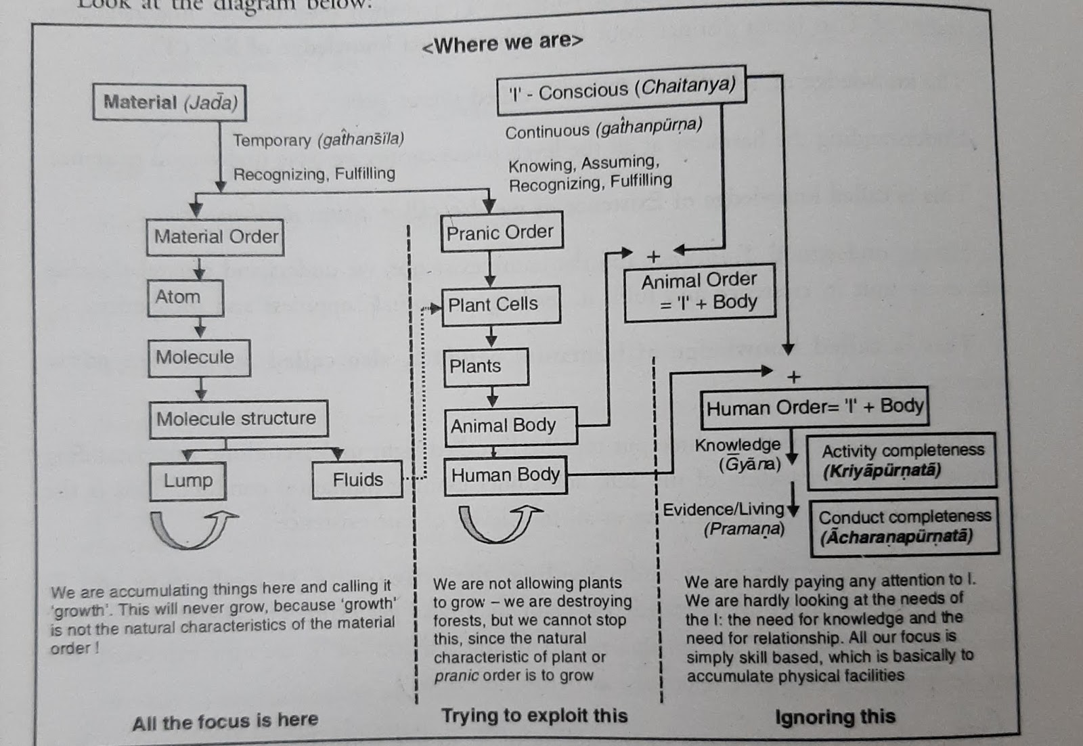

The natural characteristics of material order are composition and decomposition. It does not grow paper does not grow, money does not grow. On the other hand, the nature characteristic of plant order is growth – a plant grows and a shrub grows.
For our growth and development, we are putting all the efforts into material order, creating more and more material units we think that we are growing. But this is not true because the natural characteristic of material order is not growth. However, we try for growth here cannot be satisfied because ultimately it will only result in accumulation, not growth. Howsoever, we try for growth hence accumulates money but we cannot grow money. On the contrary, for the sake of development we are hindering the growth of plants – which naturally grows. Our actions for growth are quite mixed up today. We are ‘growing what does not grow’ and stopping what anyway grows’. We are focusing on material order which does not grow and not saying attention to plant order which anyway grows. This is because we do not have the right understanding. First, we need to understand the natural characteristics of these orders and then we should align our actions according to the natural characteristics of these orders.
Today when we talk about growth and development, we are not ‘growing’ but only accumulation. And this the root cause of our problem today. We are mainly focusing on physical facilities (material order) and totally ignoring the need of the self (I)
Development should not be cyclic. It should be continuous and permanent. If something we do is cyclic i.e. we go back to where we started from, it would not be called development take a look at the diagram.
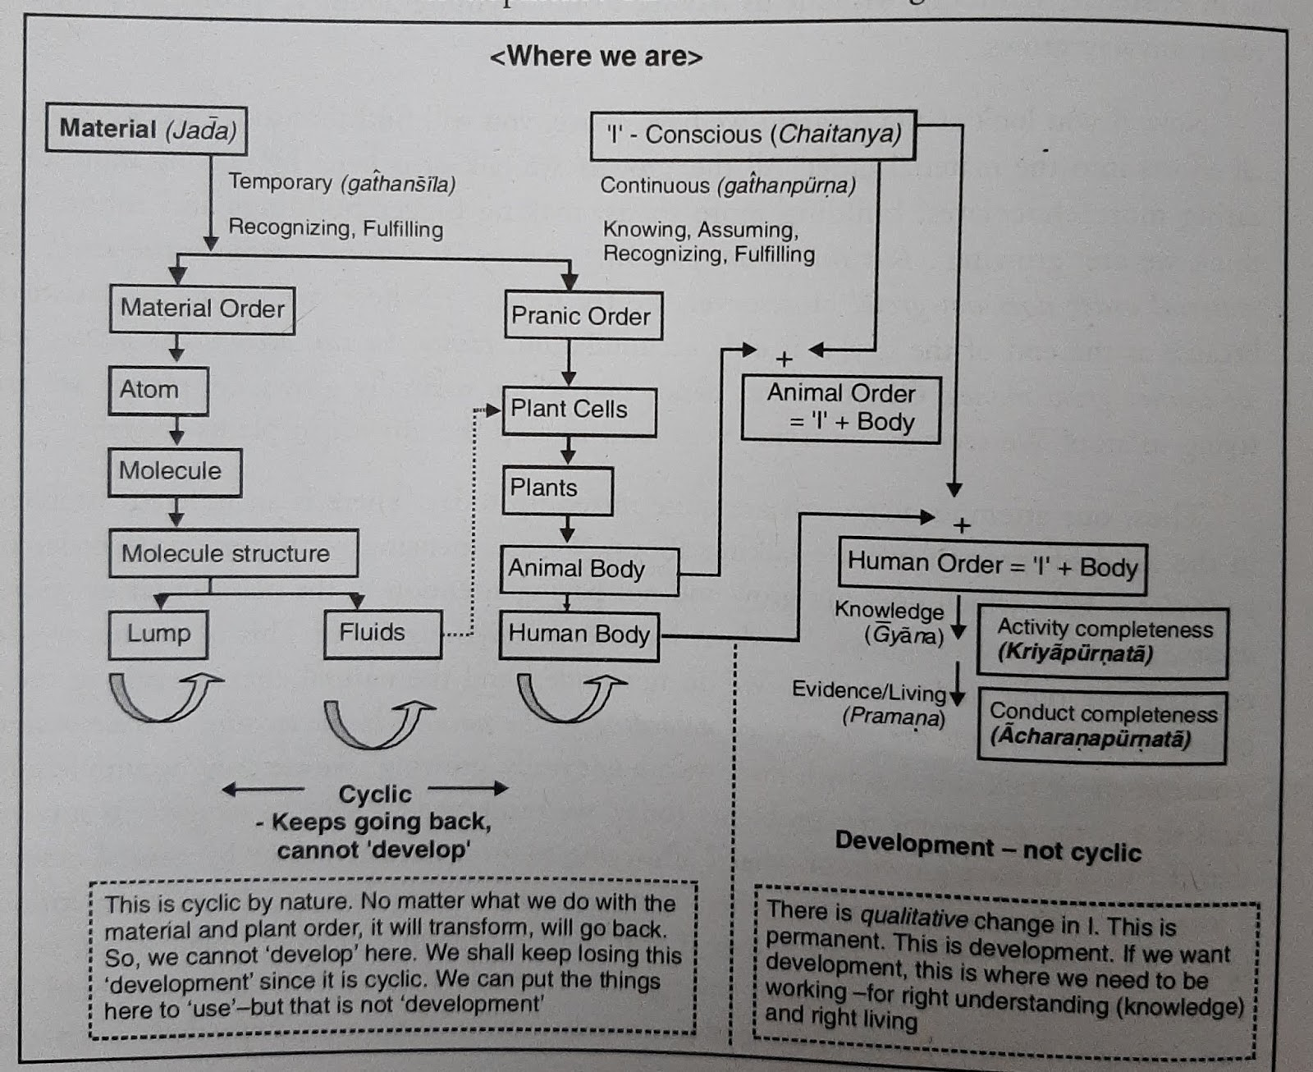

Material and plant order undergo composition/decomposition and they are cyclic in nature. So, if we work on these orders, it will be in a cycle (ending at a point where we started from) which will not lead to development. Now the question is, ‘Where does the development take place?’ The answer is – in human beings (in self ‘I’). By knowing the reality, knowing the entire existence and living in harmony at all levels of existence.
We need to work on the material order for composition and construction, and on plant order for growth. In case of the human order, we need to work on right understanding to develop ourselves as responsible human beings. This is depicted in the diagram given below.
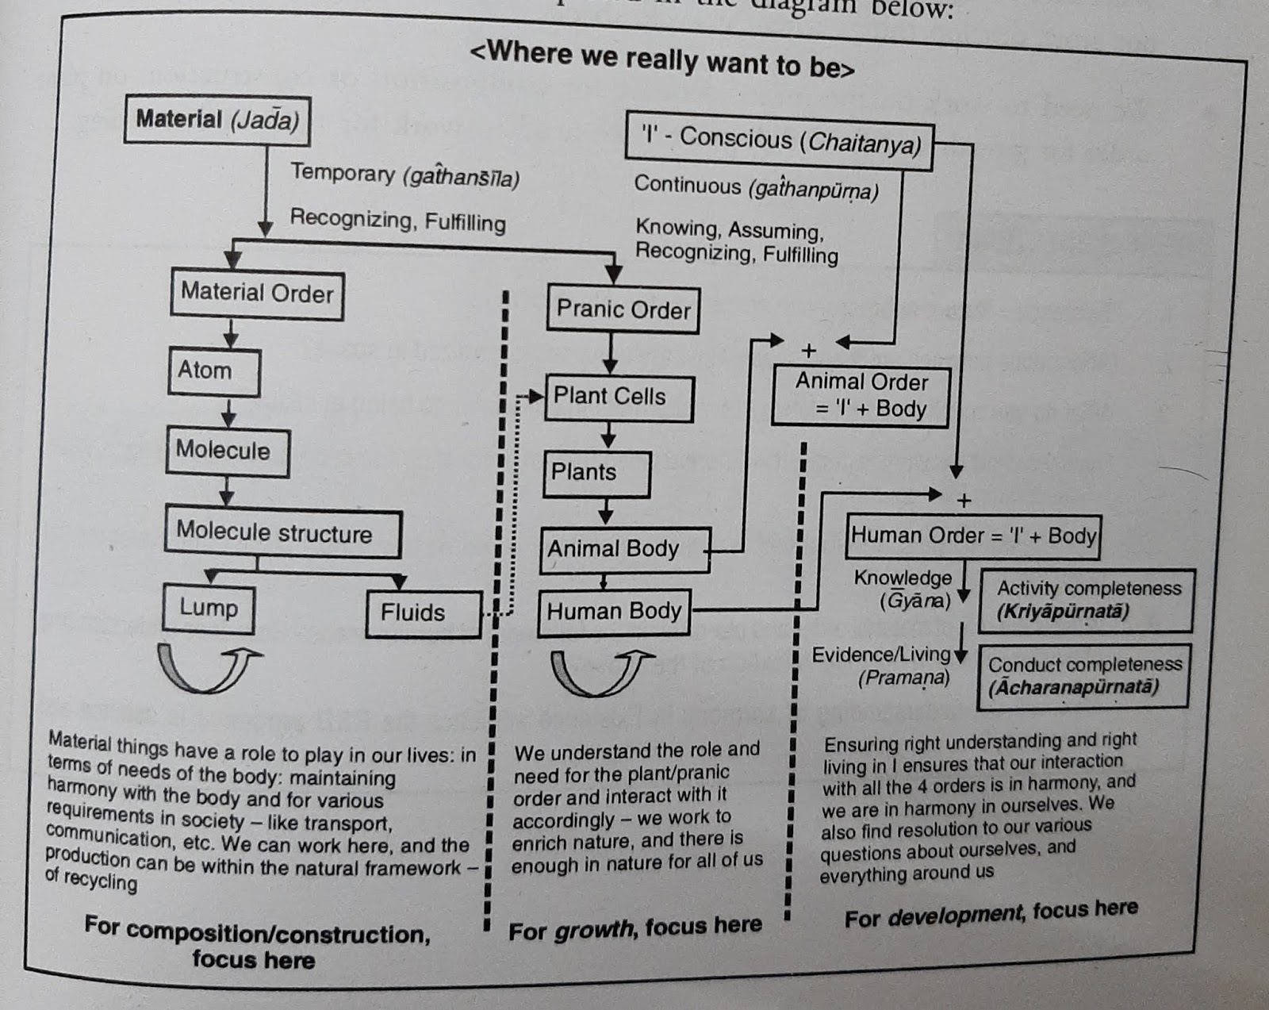

Fill in the Blanks

- Existence is the sum total of all the units that exist in nature and space as well
So, Existence= Space+__________.
- The state in which two or more groups live together while respecting their differences and resolving their conflicts non-violently is known as ‘____________’.
- We can, say that Space pervades i.e. it is ‘___________’.
- According to ‘Limited’ and ‘Unlimited’ Space has ________ units.
- Human beings are ______________ at the level of the body.
- Material units are temporary and perform the activities of only recognizing and fulfillment. There is no _________ and __________ in them.
- According to Conscious (Sentient) Unit: Animal Order and Human Order.
There are no structural changes in them. We can call them ‘_________’.
- Understanding the reality of ‘I’ as being distinct from the body is called _________________.
- Understanding the harmony at all the levels above means we have understood existence known as ___________.
- Having understood ‘I’ and the entire existence, we understand our relationship with every unit in existence and fulfill it, leading to mutual happiness and prosperity knows as_____________.
- The activities of realization and understanding- which are currently dormant in ‘I’ also get expressed; hence we also call this ________________.
- When there is completeness in the ability of ‘I’ to live with right understanding at all the four levels, leading to mutual fulfillment, it is called ‘__________’.
- Animal or Animal Order = ‘I’+ _______________.
- Humans or Human Order = ‘I’ + ______________.
- Today when we talk about growth and development, we are not ‘___________’ but only ‘_____________’.

MCQ Questions

- _________ number of Orders present in Nature. ( )
(a). 4
(b) 3
(c) 2
(d) 2

- The aggregate of all the mutually interacting units – big (or) small, sentient (or) insentient together can be called as _____________.
- Harmony
- Nature
- Entity
- Family
- __________ bond between human being & nature but our _________ actions are disturbing the equilibrium in nature, which is the prime cause of environmental crisis.
- Inseparable, thoughtless
- Separate, thoughts
- Combined, regular
- Living, non-living
- When we learn to live _________ with nature, we could enjoy benefits of nature to the fullest.
- Harmony
- Destroy
- Trust
- Disharmony

- Example for ‘Material Order’
- Plants
- Soil
- Animals
- Micro-organisms.
- The Material Order is far greater in quantity compared to _________
- Will-power
- Human Order
- Animal Order
- Plant/Bio Order
- __________ and ___________ among the four Orders of nature.
- Love & care
- Harmony & disharmony
- Interconnectedness & mutual fulfillment
- Fixed & destroyed
- The fact of something such as ______ of an organization regulating itself without intervention from external bodies.
- Natural acceptance
- Self-regulation
- Pollution
- Order
- ______ are two characteristics of nature that helps us understanding the harmony in Nature.
- Recyclability & self-regulation
- Independent & dependent
- Separable & Inseparable
- Harmony & disharmony
- It is the sum total of all the units that exist in nature & space as well __________.
- Co-existence
- Space
- Existence
- Unit

Short Answer Questions

- Define nature.
- Explain the harmony in nature.
- What do you mean by co-existence?
- Define the terms Gathansheel, Gathanpurna, Kriyapurnata and Acharanpurnata.
- Explain 'Existence is Gathansheel and Gathanpurna and also there is Kriyapurnata and Acharanpurnata in existence'
- What is sanskaar? Explain its effects or the conformance of the human order.
- What exactly is implied by the term- 'nature'? Explain.
- Write a short note on the recyclability and self-regulation in nature.
- How is the activity in human order is different with that of animal and plant order?
- Define 'units' and 'space'.
- Comment on the statement: "Nature is limited and space is unlimited."
- “ Existence is co-existence of mutually interacting units in all-pervasive space ”. Explain.
- How can we say that 'nature is Self Organized and in space Self-Organization Is Available.'
- Explain energized and energy in equilibrium.

Long Answer Questions

- Explain the natural characteristics of the material and pranic orders. Give examples?
- What is the natural characteristics (swabhava) of human order? Explain.
- Define harmony in nature and why is it important. Explain with examples.
- What are the four orders of nature? Briefly explain them.
- What do you understand by 'activity'? Write down the activity of the four orders in nature.
- How will you show interconnectedness and mutual fulfilment in four order of nature with examples.
- Critically examine the attitude of humans today towards the other three orders of nature. Try to make a proper evaluation of human efforts.
- Explain the concept of holistic perception of harmony in existence.

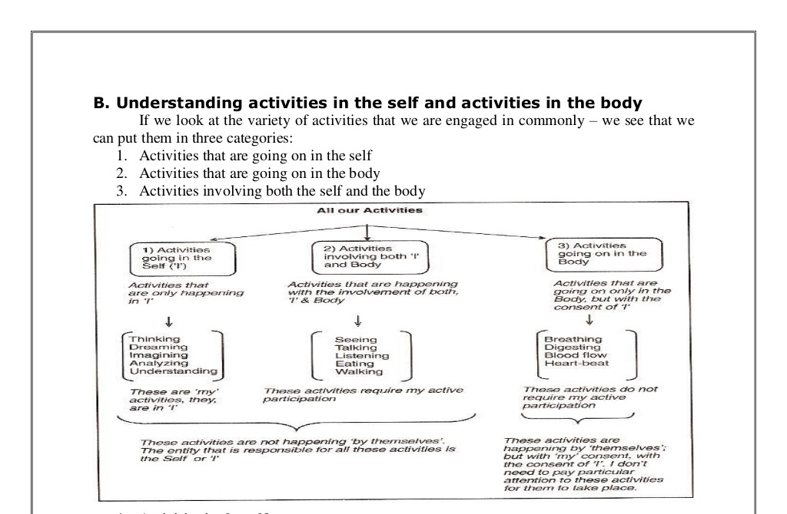

Body as an instrument of ‘I’:
There is a relation between the self and body that body act as an instrument of self. Whatever self thinks body performs it physically. Body does not decide itself. We can verify this by the following discussion. I am the seer: When we are reading a book or listening, when someone is explaining something to us, when we are watching scenery or when we are thinking - we are engaged in the activities of 'seeing' or understanding. Now when we see some nice scenery we say 'I am seeing' that means our self 'I' see via the eyes, the eyes don't see, they are just instruments, that unable me to see something outside. Different images are formed in the eyes every time, but it is I who is able to relate it to the meaning of that image every time. Similarly, I can see inside 'in me' also - without the eyes. For example I can see that I am getting angry. In this case I understand or know or am aware that I am getting angry. When I see outside the body works as an instrument. I am the doer: once I have seen/ understood something, I am the one who decides what to do or not to do. I am the doer. For example, when I see the scenery I am the one who decide to take a picture of the scenery. I use my hands to pick camera and click a picture. The hands in the body are thus used as an instrument. In this way I work with my hands and legs. I am the enjoyer: I saw the scenery and I took the picture. I am the seer and doer so far. When I see the picture I like it. I am the one that enjoys it. Thus there is a continuity of being the seer, doer and enjoyer. Similarly when I eat, I am the one that gets the taste - from the tongue.
Harmony in ‘I’ - Sanyam and Swasthya:
Activities in self:
- Power: This means the basic capacity in the self ('I'). They are: desires, thoughts and expectations.
- Activities: The activities are: imaging, analyzing, and selecting/tasting.
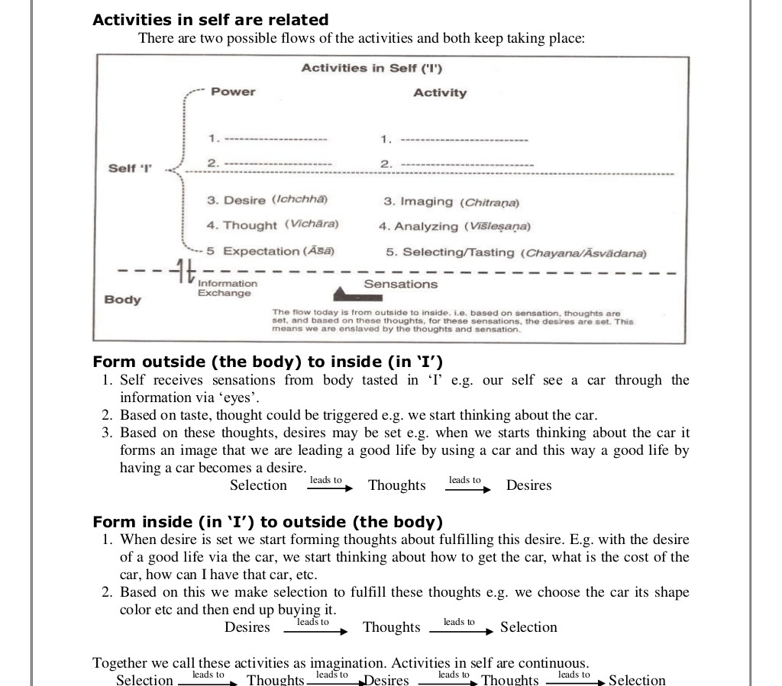

Desires set on the basis of Preconditioning:
Preconditioning means we have assumed something about our desires on the basis of prevailing notion about it. We have not verified the desires in our own right. As a result, we are not clear about what we will get out of fulfillment of that desire. What is the issue with that? Unless we verify our desires, we may not even know whether they are our! We may end up spending an entire lifetime accumulating desires that are not our, and in running about trying to fulfill them! Sensation is a perception associated with stimulation of a sense organ or with a specific body condition: the sensation of heat; a visual sensation. We go into conflicts when our activities are not guided by our natural acceptance: A. Conflicts and contradictions in 'I' as a result of pre-conditioned desire we have not verified the desires, thoughts and expectations in us on the basis of our own natural acceptance. As a result, these desires, thoughts and selections are in conflicts. Since the desires are in conflict, the thoughts they give rise to, are also in conflict and in turn, the selection from the thoughts are also in conflicts. This conflict affects us in different manners:
1. Wavering aspirations: Our goals keep shifting as the inputs from the outside also keep changing. Our desires thus keep shifting, because their source is outside and these preconditioned desires may come from what we read, see, hear, from media, friends, society, etc. hence, we are always wavering in what we want; we are not able to be certain about it.
2. Lack of confidence: Since our desires are shaky, we are not sure about them. As a result, we lack self confidence, in the true sense. Our confidence seems relative i.e. we keep comparing ourselves with others in order to feel confident.
3. Unhappiness/conflicts: Since our desires, thoughts and expectations are in conflict, it becomes the cause for our unhappiness, leading to stress and tension. Such desires will also be in conflict with our natural acceptance
4. Lack of qualitative improvement in us: We focus largely on fulfilling the needs of the body. As a result, we live with a sense of lack of fulfillment. We are doing many things, accumulating a lot, progressing on paper, but we don't feel that we have improved, that we have become better. It seems that only the things around us are changing!
A. State of resignation: Because we do not understand ourselves properly and have contradictions within, we slowly start getting disillusioned (pleasant but mistaken beliefs). We feel that there are no solutions to these issues, and end up in a state of resignation. B. Short lived nature of pleasure from sensations: The pleasure obtained from sensations is short-lived. We have so much dependent on sensations that instead of giving us some sensory pleasure, it becomes the source for our happiness.
This can be understood as follows: The external object is temporary in nature the contact of the external object with the body is temporary in nature. The sensation from the body to 'I' is temporary. And at last the taste of the sensation from the body in 'I' is also temporary. Therefore, if the source for our happiness is temporary by definition, then our need for continuous happiness will never be fulfilled. Hence, any sensation we have from the body can't be the source for our lasting happiness. To sum up, if our desires, thoughts and expectations are based on pre-conditionings, we are generally in a state of great confusion. This leads to confusion, unhappiness, conflict and stress.
Realization and understanding are essential for harmony:
Realization: Means to be able to see the reality as it is. In realization, we get the answer to "what is the reality?" This, for each one of us, translates into the answers to "what to do?" and "why to do?" when we operate on the basis of realization and gains understanding according to the realization then it give definiteness and certainty and makes us self organized.
Understanding: Means to be able to understand the self organization in all entities of nature/existence and their inter-connected organization "as it is". We are able to see the harmonious interconnectedness at all the levels of our living. Understanding plays an important role in desire making. When we do not have the right understanding, our desire keep shifting, and this indefiniteness is reflected in our thoughts, and selections we make, and finally in our behaviour and work. On the other hand, when our understanding is based on realization and we use this understanding in desire making then our desire will be correct and thoughts and selection will be according to the understanding.
Sanyam and Swasthya:
Self control or sanyam is the control of the mind and its desires, urges, emotions and delusions. It is controlling the outgoing tendencies of the mind and the senses and bringing them back to our self within.
Swasthya is the condition of the body where every part of the body is performing its expected function. In other words, swasthya, in Sanskrit means self- dependence (swa = your own). Also, embedded in its meaning are health, sound state, comfort and satisfaction. So we can say that sanyam ensures swasthya. With right understanding, I get self-organized and take care of the body properly. With lack of right understanding body becomes unhealthy.
For example; when I am happy, the temperature and pressure in the body are normal, when I am angry or tense, it means ‘I’ am in disharmony; it immediately starts affecting the body adversely. These are called psychosomatic disease, such as asthma, allergies, migraine, diabetes, hypertension etc. so we can say that sanyam has a strong effect on swasthya.

Present scenario of the body (disharmony in Swasthya):
Today we are facing different problems and they are lack of responsibility towards the body, tendency for medication to suppress the ailment, and polluted air, water, food.
Lack of Responsibility towards the Body: Our lifestyle has become very busy and unnatural. We usually do not give priority to take proper care of the body. We have increasingly stated eating at odd hours, eating junk food, and are largely ignorant about the state of our body.
Tendency for Medication to Suppress the Ailment: Whenever there is a pain in any part of the body, it is a signal of some disorder which needs to be properly attended to. However, our common tendency has become to suppress this pain by immediate medication and then forget about it.
Polluted Air, Water, and Food: We have polluted our environment today and it is directly or indirectly harming us. There is contamination in the air, water, soil, plants and we are responsible for it. Our food has become impure. Due to heavy use of chemical fertilizers, pesticides and a lot of pollutions, our food has all kinds of toxic contents in it. The air we breathe in, is polluted by various chemicals released from industries and vehicles, while our water is also polluted due to industrial effluents (liquid sewage), sewage etc. all this, surely, is not conductive to the health of people.
Program to ensure Sanyam and Swasthya (correct appraisal of our physical needs):
1. Understanding and Living with Sanyam: Sanyam implies that the self takes the responsibility for proper nurturing, and right utilization of the body. For this it is essential to understand the functioning of the body instrument. It is also essential to understand that this instrument has a limited life span and undergoes a pattern of growth and decay. The interaction of the self with the body has to be in consonance with the above objectives which are achieved through sanyam. 2. Understanding the self organization of the body and ensure health of the body:
a). Nurturing of the Body: Proper Food, Air, Water, Etc.: In the process of selecting food for the body, I need to make out the elements which make a complete food so that it gives required nutrients and energy to the body. On the basis of understanding of the harmony of the self with the body, it can be said that the food needs to be eaten only when we feel hungry. The choice of the food has to be such that it is easily digestible and the food needs to be taken with proper posture of the body and in right quantity.
b). Protection of the Body: The second issue is the protection of the body. The clothes we choose for protection need to be such that they ensure proper interaction of the body with the environment. The right amount of exposure of the body to the air, water, and sun is required to ensure its proper functioning.
c). Right Utilization of the Body (Sadupayoga): Right utilization of the body as an instrument necessitates understanding the purpose for which this instrument is to be used. Normally, we tend to believe that the body is an instrument for sensory enjoyment, which is not correct. We also happen to use our body to exploit other human beings or rest of the nature which is not right utilization. It is important to realize that the human body is an instrument to facilitate right understanding and its actualization in life.

